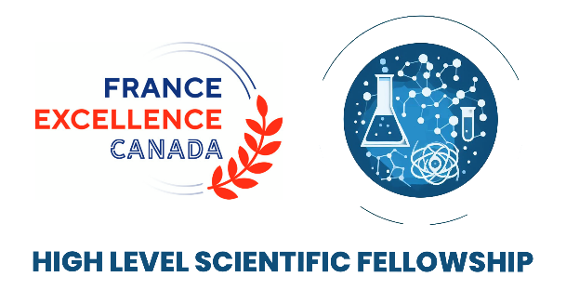
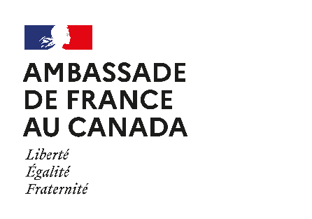

2026 APPLICATION FORM
HIGH LEVEL SCIENTIST FELLOWSHIP

Applicant personal information
First name: Alessia Last name: Romani
Email: aromani2@uwo.ca
Name of the institution: Western University
Name of the research unit’s Director/Head: Joshua M. Pearce (FAST Lab)
Mailing address: 1151 Richmond Street
Postal code: N6A 5B9 City: London (ON)
Website: https://www.uwo.ca/index.html (University) - https://www.appropedia.org/FAST (Research unit)
Host Research Unit information
First name Last name:
Email:
Name of the host:
Name of the host’s research unit (Centre, Department, Institute or School):
Name of the research unit’s Director/Head:
Mailing address:
Postal code: City:
Website:
Research Project
Field of Research:
Advanced Sciences (AI, quantum, societal impact, etc.)
Health (one health, public health policy, genomics, etc.)
Ocean and polar sciences (oceanography, biodiversity, marine ecology, etc.)
Energy (renewable energy, net zero transition, sustainability, etc.)

Please check this box if your project is interdisciplinary

Title of the Project:
Exploring the applicability of the Open Source Technology Readiness Levels (OSTRL) framework to circular economy practices

Description of the project (300 words +/- 50 words):
Open-source (OS) technologies are increasingly adopted to support sustainable and circular economy (CE) practices, especially in local and accessible contexts. Their real-world implementation, however, is often difficult to assess in terms of readiness, transferability, and maturity. Although several evaluation frameworks exist in CE and sustainability, e.g., the material circularity index, most focus on environmental impacts or system-level perspectives, which are often limited for practitioners and researchers working on OS technologies for real-world use.
To support real-world adoption of OS technologies, the OS Technology Readiness Levels (OSTRL) framework was originally developed to translate the concept of “readiness” into OS contexts, facilitating the assessment and development of the openness embedded in OS technologies. This framework has been initially applied to the context of Distributed Recycling for Additive Manufacturing (DRAM) to demonstrate its validity and potential connections with sustainable practices. Its applicability beyond this initial context, however, has not yet been explored, as well as its usability by target users in real-world contexts.
This project aims to refine the existing OSTRL framework and extend its use by testing its applicability within CE contexts beyond DRAM ecosystems. Following a practice-oriented approach, the proposal involves potential target users in evaluating real-world OS projects using OSTRLs and collecting structured feedback on their clarity, usability, and limitations. The OSTRLs are then refined accordingly, and complementary uses with other CE-focused assessment frameworks are evaluated for real-world adoption.
The starting activity is a structured workshop organized within the Horizon 2020 LAUDS project meeting hosted at ERPI in Fall 2026. Researchers, project partners, and practitioners will apply OSTRLs to selected CE-related case studies of the LAUDS project through guided activities. The feedback collected during the workshop, together with further feedback at ERPI during the visiting period, will be used to refine the OSTRL framework and documentation, improving its clarity and applicability. The expected outcomes include: an updated and tested version of the OSTRLs; refined use guidelines and documentation; and additional case studies as examples of OSTRL use. These elements will be the base for a peer-reviewed publication and OS repositories for open dissemination and future follow-up.

Explain how the applicant and the host research partner may each expect to benefit from the program (300 words +/- 50 words):
The visiting period will provide mutual benefits for both the applicant and the host research partner, with goals on this specific project and long-term collaboration between the two research contexts on open-source (OS) technologies and the circular economy (CE). First, this proposal builds on an ongoing research stream on Open Source Technology Readiness Level (OSTRL) currently in progress and involving the applicant’s institution and the host institution. A journal paper defining the OSTRL framework is currently under review, and this proposal represents a natural follow-up to refine the OSTRLs for real-world use.
For the applicant, this program is a tangible opportunity to move beyond the conceptual development toward real-world testing and use of OSTRLs, while connecting them to sustainability and CE contexts. The visiting period allows the applicant to test and refine OSTRL by involving potential target users and connecting them to CE contexts, applying her expertise at the intersection of OS materials and technologies, design research, and CE. This experience is especially relevant to the practical use of OSTRLs, enabling the applicant to assess their interpretation, application, and use in practice-oriented contexts, such as ERPI's Lorraine Fab Living Lab.
For the host research partner, this program supports the introduction of an already-developed evaluation framework aligned with ERPI’s activities and the LAUDS research goals, together with a structured testing and use methodology. The applicant has already demonstrated expertise in testing and assessing open knowledge and evaluation tools in research and learning contexts during her PhD research, e.g., by designing and conducting workshop-based evaluation activities for new tools (OS materials libraries). ERPI will benefit from a more mature version of OSTRLs to support current and future sustainability- and CE-oriented projects, assessing their openness and transferability to increase their real-world impact.
Finally, this program will strengthen the existing collaboration between ERPI and FAST lab, framing the visiting period to extend this connection through the applicant’s involvement. The outcomes of the proposal will support peer-reviewed publications and OS dissemination, creating the basis for follow-up research and long-term collaboration on OS technologies for circular and sustainable transitions.

BiographY of the researcher
Short biography of the applicant (300 words +/- 50 words):
Alessia Romani is a Western Postdoctoral Fellowship Awardee (2024) working as a Postdoctoral Research Associate at the Free Appropriate Sustainable Technology (FAST) Research Group, Department of Electrical and Computer Engineering at Western University (Canada). She holds a M.Sc. in Design & Engineering (2018) and a Ph.D. in Design cum laude (2024) from Politecnico di Milano (Italy), where she worked at the Design Department and the Department of Chemistry, Materials and Chemical Engineering “Giulio Natta”.
Her research focuses on the interconnections between design, materials engineering, digital fabrication, and sustainability, bridging design and materials for sustainability through open-source technologies. Her main current research explores materials and design applications in Distributed Recycling for Additive Manufacturing contexts, ranging from the characterization of recycled plastics and composite materials to the development of applications using both small and large-scale 3D printers. Her research interests also include open design strategies for distributed manufacturing; open-source hardware, e.g., accessible assistive technologies and open-science equipment; product applications based on circular economy practices; experiential knowledge design tools for open dissemination and evaluation, e.g., materials libraries and OSTRLs.
She is the author of more than 35 peer-reviewed publications, and her work has been presented at more than 25 international conferences in the fields of design, engineering, and sustainability. Beyond her research activities, Alessia has gained experience as a guest lecturer, teaching assistant, and course tutor in design and engineering fields at Politecnico di Milano and Western University. She also supervises, co-supervises, and mentors undergraduate and graduate students working on sustainability, materials, and digital fabrication, having co-supervised more than 10 M.Sc. theses at Politecnico di Milano. From August 2025, she is actively involved in institutional sustainability initiatives at Western University through her participation in the President’s Advisory Committee on Environment & Sustainability (PACES) as a Postdoctoral Designate. Alessia also serves as a reviewer for international journals and conferences in sustainability, additive manufacturing, and design, e.g., Journal of Cleaner Production, Additive Manufacturing, or ACM CHI 2026, and has been involved in organizational and committee roles at international conferences, e.g., IASDR 2023 or ACM DIS 2025.

Other information
Mandatory Attached documents:
Cover letter from the applicant
Letter of support from your PhD or post-doc supervisor@
Invitation letter from the host research unit, signed by both the research host and
the unit director/head, and including details on the access to space, equipment
and resources that will be provided to the successful applicant, and the dates
Applicant’s short CV (700 words)
A copy of your passport
Please be advised that if you are selected, you will have to provide an activity report within a month following the completion of your residency.

Once completed, please send the full PDF (< 6Mo) to the following address:
science.vancouver-cslt@diplomatie.gouv.fr
You may also ask your questions by sending it a message.

