Graficas

Victor M. López[1]

Diego Carou[2]

Fabio A. Cruz S.[3]

## 0.1 Phase I: Screening phase

Table 0.1: Results of the Phase I

| **Material** | **Layer Height (mm)** | **Infill Pattern** | **Infill Density (%)** | **Printing Speed (mm/s)** | **Tensile Strength (MPa)** | **Young Modulus (MPa)** |
| --- | --- | --- | --- | --- | --- | --- |
| Virgin | 0.15 | Tri-hex | 60 | 40 | 42.60 | 1,014.53 |
| Virgin | 0.3 | Tri-hex | 60 | 80 | 41.76 | 1,036.88 |
| Virgin | 0.15 | Grid | 60 | 80 | 43.24 | 989.44 |
| Virgin | 0.3 | Grid | 100 | 80 | 55.35 | 1,143.72 |
| Virgin | 0.3 | Tri-hex | 100 | 40 | 55.70 | 1,160.47 |
| Virgin | 0.15 | Tri-hex | 100 | 80 | 58.63 | 1,127.84 |
| Virgin | 0.15 | Grid | 100 | 40 | 58.36 | 1,132.18 |
| Virgin | 0.3 | Grid | 60 | 40 | 41.76 | 1,047.13 |
| Recycled | 0.15 | Tri-hex | 60 | 40 | 41.76 | 1,047.13 |
| Recycled | 0.3 | Tri-hex | 60 | 80 | 41.76 | 1,098.95 |
| Recycled | 0.3 | Grid | 60 | 40 | 41.54 | 1,069.34 |
| Recycled | 0.15 | Tri-hex | 100 | 80 | 51.99 | 1,058.60 |
| Recycled | 0.3 | Tri-hex | 100 | 40 | 51.85 | 1,106.42 |
| Recycled | 0.15 | Grid | 60 | 80 | 39.59 | 1,061.22 |
| Recycled | 0.15 | Grid | 100 | 40 | 54.24 | 1,126.03 |
| Recycled | 0.3 | Grid | 100 | 80 | 53.66 | 1,152.35 |

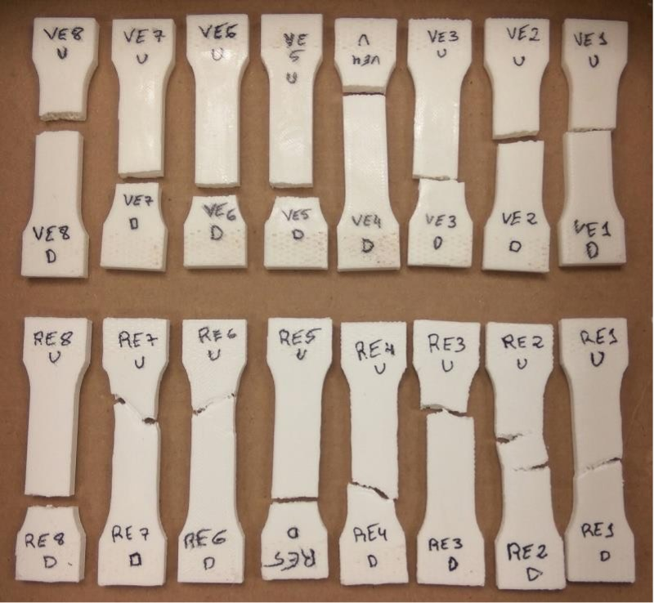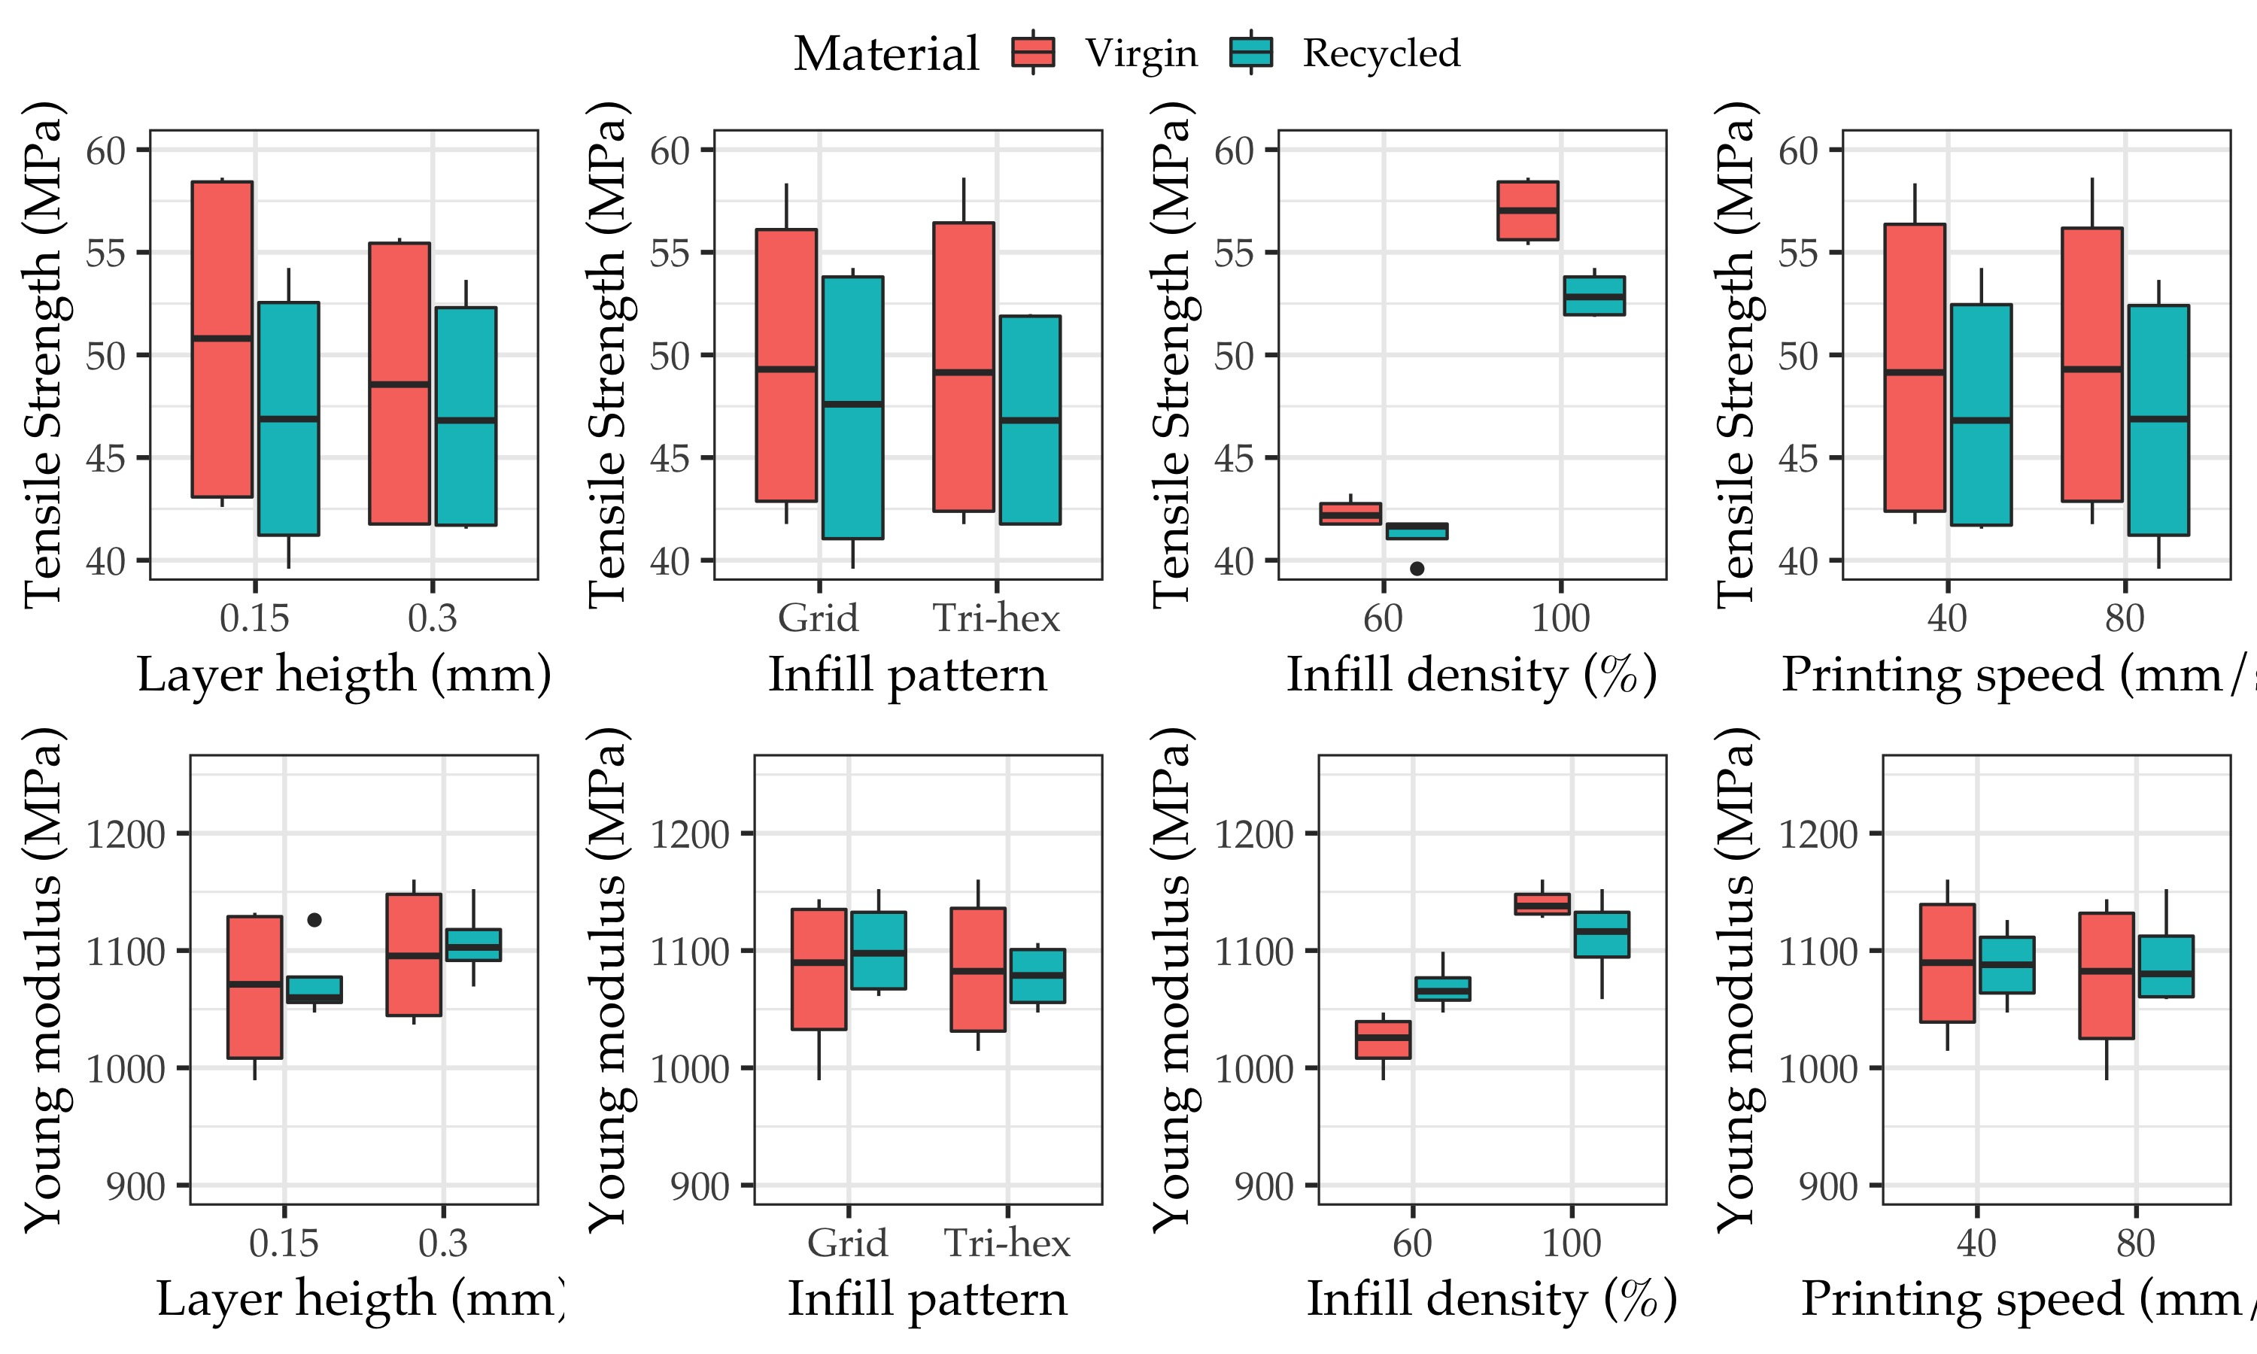

# 1 Anovas Phase I

Table 1.1: ANOVA results at 95% significance level for Maximal load and Young modulus variables

| **Variable** | **Tensile** | | | |  | **Young** | | | | |
| --- | --- | --- | --- | --- | --- | --- | --- | --- | --- | --- |
|  | Df | Sum Sq | Mean Sq | F value | Pr(>F)1 | Df | Sum Sq | Mean Sq | F value | Pr(>F)1 |
| Layer Height (mm) | 1 | 3.089 | 3.089 | 1.342 | 0.274 | 1 | 4169.608 | 4169.608 | 4.097 | 0.07 |
| Infill Density (%) | 1 | 699.206 | 699.206 | 303.79 | <2e-16*** | 1 | 25839.759 | 25839.759 | 25.393 | 0.001*** |
| Infill Pattern | 1 | 0.179 | 0.179 | 0.078 | 0.786 | 1 | 311.434 | 311.434 | 0.306 | 0.592 |
| Printing Speed (mm/s) | 1 | 0.209 | 0.209 | 0.091 | 0.006** | 1 | 73.231 | 73.231 | 0.072 | 0.794 |
| Material | 1 | 27.589 | 27.589 | 11.987 | 0.006 | 1 | 287.726 | 287.726 | 0.283 | 0.607 |
| Residuals | 10 | 23.016 | 2.302 |  |  | 10 | 10176 | 1017.6 |  |  |
| 1Signif. codes: 0 ‘***’ 0.001 ‘**’ 0.01 ‘*’ 0.05 ‘.’ 0.1 ‘ ’ 1 | | | | | | | | | | |

1. University of Jaén, Department of Mechanical and Mining Engineering, 23071 Jaén, Spain
2. Universidade de Vigo, Departamento de Deseño na Enxeñaría, Ourense, Spain, [diecapor@uvigo.es](mailto:diecapor@uvigo.es)
3. Université de Lorraine - ERPI - F-54000, Nancy, France, [cruzsanc1@univ-lorraine.fr](mailto:cruzsanc1@univ-lorraine.fr)