Feasibility study on the use of recycled materials for prototyping purposes: a comparative study based on the tensile strength

Victor M. López[1]

Diego Carou[2]*

Fabio A. Cruz S.[3]

3D printing is seen as a disruptive technology and continues to expand the design space boundaries for prototypes and final products. Sustainability is one of the major objectives for manufacturing and the use of recycled materials is becoming a relevant strategy, particularly for improving material resource efficiency. This paper attempts to evaluate the suitability of the substitution of virgin polylactic acid (PLA) for recycled PLA. An experimental plan divided into three phases to evaluate the tensile strength of the specimens was described. The results showed that recycled PLA may be used thanks to a similar tensile strength, even though this is slightly lower than that of the virgin material. In addition, the infill density and the orientation parameters played a major role on the response. As the infill density approaches 100 %, both the maximum load and tensile strength increase sharply. However, when using an infill density of 40 %, on average, the specimen resists 58.07 % of the maximum load. In addition, because of the anisotropy, it was found that the horizontal orientation allowed to attain a higher tensile strength, while the vertical orientation provided a lower value. These are relevant insights for prescriptions of the 3D printing parameters guaranteeing minimum tensile strength in prototyping.

**Keywords:** 3D *printing*; *Prototyping; Distributed recycling; Tensile strength; PLA*

# 1 Introduction

Fused filament fabrication (FFF) is a major additive manufacturing technology, which has found considerable number of applications in different types of manufacturing sectors.1,2 The layer-by-layer principle of manufacturing objects enables a higher degree of flexibility in the product design phase.3 The set of several available printing technologies4 is pushing forward advantages such as the mass customization5 with complex geometries that involve a great deal of detail, a combination of different materials,6 a reduction in the need for assembly and a high utilization rate of raw materials.7

Nowadays, there is a need to find ways to reduce the ecological impact of manufacturing processes, pursuing sustainable and clean manufacturing processes.8,9 Researchers are making efforts to identify opportunities for 3D printing on the circular economy paradigm.10 Moreover, due to the fact that plastic is one of the most highly used materials in the 3D printing industry11 and given its non-biodegradable nature, plastic is one the most abundant types of waste produced. The impact of plastic pollution in terrestrial and aquatic ecosystems represents a major issue.12 For aquatic ecosystems, main risks are linked to standing water that acts as a breeding niche (to mosquitoes, pests, vector-borne diseases transmission), becomes a vector for toxic chemicals and, ultimately, disturbs the natural cycles (biogeochemical cycle in terrestrial ecosystems). Additionally, the transfer of plastic into the food chain is a clear danger to animal and, certainly, to humans as well. Thus, reducing the consumption of plastics is of great importance in the long term.

A major body of literature arising from the fields of engineering, human–computer interaction, design thinking and software development13 validates the rationale for the prototyping phase in the early design phases of product development. According to the prototyping theory, different kinds of prototypes are needed during the new product development phases (e.g. prototypes for desirability, for feasibility and for viability)14 with the purpose of reducing uncertainties, exploring new ideas, increasing feasibility and/or engaging with users.15 On that basis, a prototype is achieved in terms of certain modelling aims: Model to Link, Model to Test, Model to Communicate, Model to Decide and Model to Interact.14 The use of digital tools allows designers to create highly flexible prototypes that facilitate short learning cycles at an affordable cost. Moreover, the use of 3D printing technology enables the materialization aspect. Regardless of whether the printed object is functional or not, it is found to be valuable in design decisions.13 However, there is a gap in the literature in terms of sustainable manufacturing using 3D printing in the early design phases.9 Although the technology offers high efficiency in the use of materials, the democratization of this technology could cause a rebound impact due to the increasing generation and disposal of huge amounts of waste or polluting emissions to fabricate the virgin feedstock required, particularly, in prototyping. Without a doubt, the roots of FFF are linked to the rapid prototyping concept16 and in recent years it has been widely adopted to create functional objects for their designs. Therefore, one question that remains is how to define the most favorable printing conditions to create prototypes in the early phases without compromising the mechanical properties, even for recycled feedstocks.

Studies on the technical viability of recycled materials as substitutes for conventional virgin materials are still limited to particular applications.17,18 It is important to note that, in most cases, prototypes do not require excellent mechanical properties but the minimum to be handled to allow designers and users to inspect and measure them. Thus, the type of material used and its amount can be further optimized when it comes to prototyping. The mechanical properties are critical for engineering parts, particularly, for 3D printed parts because of the anisotropy,19 which can influence the ultimate tensile strength (UTS) up to about 47 % as it pertains to the manufacturing parameters.20 Using a systematic literature review, Popescu *et al.*21 identified key parameters that influence the printed parts, including the raster-to-raster air gap, raster angle, layer thickness, infill density and build orientation.

In general terms, it is found that for low values of layer height, the tensile strength of the material is improved.22,23 Similarly, Yao *et al.*24 identified the importance of the printing orientation in the UTS. Thus, the alignment of the tensile load with the longitudinal axis of the printed fiber will maximize the UTS. According to Alafaghani *et al.*25, a higher extrusion temperature, an optimized layer thickness, a triangular filling pattern and a higher filling level maximize the strength of the parts. Regarding the printing speed, it has been determined that a higher printing speed with a higher layer thickness leads to lower part strength.

Recently in the literature, distributed recycling via additive manufacturing (DRAM) approach emphasizes the technical steps required to reuse plastic waste through the recycling chains for material-extrusion-based 3D printing.17,26 The use of recycled material, either in the form of raw material or blended with virgin material, is a method of special interest to contribute to sustainable manufacturing.27 In the DRAM methodology, consumers have an economic incentive to recycle. This is because they can use their waste as feedstock for a wide range of consumer products that can be produced for a fraction of the conventional cost of the equivalent products. Moreover, 3D printing is especially well suited because it enables the production of parts with (almost) no waste and could reduce the waste related to the material by more than 40 %, reusing 95 % of the unused material.28 Currently, most of the cost of 3D printing is associated with filament.29 By recycling raw materials such as polylactic acid (PLA), one of the most frequently used materials in 3D printing, it is possible to reduce the carbon dioxide emissions that are incurred by transport to landfills or shipping to customers, offering environmental benefits.30

It is important to evaluate the properties of the recycled materials before substituting virgin for recycled materials. The use of recycled materials is still uncertain because of the potential changes in the material properties when recycling.31 Several authors have studied the printing cycles that PLA can withstand until it loses much of its properties.27,32–34 There is an agreement that PLA adequately withstands two printing cycles since after a third cycle or more the mechanical properties and viscosity decrease considerably. The increase in crystallinity and melting enthalpy and the decrease in cold crystallization enthalpy are attributed to the 3D printing process. For instance, Kumar *et al.*35 compared the elongation at break, load at break, flow index, Young’s modulus and breaking stress of recycled acrylonitrile butadiene styrene (ABS), high impact polystyrene (HIPS) and PLA. The PLA showed the highest elongation at break along with the ABS. In addition, the PLA had a higher breaking load and breaking stress, although a smaller Young’s modulus. Likewise, Babagowda *et al.*36 studied the influence of the percentage of recycled PLA used in the filament, from 10 to 50 %, showing that the smaller the percentage the higher the ultimate tensile strength. In summary, the recycling of PLA has certain limitations due to the reduction in the molecular weight with its reuse, resulting in degradation and a decrease in mechanical properties.37 The viscosity is also reduced with each printing cycle, but it could be corrected by adding virgin plastic.27,38

It might be uncertain whether a set of optimal parameters for a machine/material/application combination can be transferred to other 3D printers due to the issue of intra-3D printer variability and the variations of the quality of the recycled material. Robust methods are needed to develop standards to validate the process setting to guarantee the minimal requirements for the tensile strength, dimensional accuracy, replicability and minimum feature size among the 3D printing technologies.39 Besides, considering the open-source nature of FFF technology, standardized experimental protocols are relevant to enable benchmarking and to serve as a guide for machine selection.40,41 Therefore, it is crucial to identify the most important parameters that may affect the process quality.42 The present study proposes a methodology to evaluate the tensile strength of both conventional and recycled PLA materials. The objective is the assessment of the suitability of the recycled PLA as a replacement in prototyping, though its use may be further extended to other applications. To do so, this research is based on a comprehensive experimental study with three main phases to evaluate the influence of several printing parameters on the outcomes of the printing process.

# 2 Experimental procedure

## 2.1 Materials and equipment

The printing materials tested were commercial virgin (Smart Materials 3D) and recycled PLA (Filamentive) characterized by data listed in Table 2.1. The recycled PLA was comprised of a blend containing 10 % virgin PLA. The recycled filaments are obtained by a mechanical process to produce pellets, followed by extrusion and cooling processes that help to generate the filament that, finally, is wound.43

Table 2.1: Characterization and recommended processing conditions of the PLA used and the recycled PLA

|  | **PLA** | **Recycled PLA** |
| --- | --- | --- |
| Composition | PLA (polylactic resin)- 99 % CAS: 9051-89-2 | PLA – 10 % CAS: 9051-89-2 and recycled PLA 90 % |
| Density | 1.24 g/cm3 | 1.1-1.3 g/cm3 |
| Diameter | 1.75 ± 0.03 mm | 1.75 mm |
| Printing temperature | 220 ± 20 ºC | 205 ± 15 ºC |
| Melting temperature | 180 ºC | 160 ± 10 ºC |

The specimens were printed with a BQ Witbox printer, shown in Figure 2.1a, using the Ultimaker Cura 3.2.1 software. For tensile testing, a MTS Criterion 43 universal testing machine (Figure 2.1b) was used, selecting a strain rate of 0.5 mm/min. The specimens were manufactured according to the dimensions depicted in Figure 2.1c.

(a) (b) (c)

Figure 2.1: Equipment used in the study: a) 3D printer, b) Universal testing machine and c) Test specimen.

## 2.2 Methodology

The experimental plan included three different phases (Figure 2.2) to carry out a comprehensive study with a limited number of tests that do not compromise the reliability of the results.

The main goal of *Phase I* is to identify and discard factors depending on their influence on the response variable. The response variable chosen was the tensile strength calculated by means of the maximum load attained during the testing of the specimen and the initial cross-section in the middle of the specimen.35,44 Fractional designs aims to minimize the number of tests, being used as screening designs. The use of random order made it possible to guarantee that the hypothesis stating that the errors are independently distributed random variables was fulfilled.45 The critical parameters for the study are the layer height (0.15 and 0.3 mm) and infill pattern (tri-hexagonal and grid).46,47 In addition, taking into account the goal of sustainable manufacturing (i.e. trying to optimize the consumption of material), but also productivity (i.e. trying to minimize printing times), infill density (60 and 100 %)25 and printing speed (40 and 80 mm/s)24,48 were considered. The printing temperature was 210 °C, which was the recommended temperature for PLA material. The design included only specimens printed in the horizontal orientation. To conclude this phase, an analysis of variance (ANOVA) allowed to identify the factors influencing the response variable.

The main goal of *Phase II* is to study in more detail the impact of the most influential factor according to *Phase I*. Therefore, the intent is to focus on how the response variable evolves by varying the most influential factors. For that reason, an extension of the factor levels was established. On the other hand, the criteria selection of levels for the other three factors aimed at minimizing the printing time.

Finally, *Phase III* aimed at evaluating the influence of the anisotropy based on the printing orientation, which may notably affect the tensile strength49. Because of the anisotropy, the UNE 116005:20124650 standard requires printing the specimens in three different orientations: edgewise, horizontal and vertical, testing five specimens in each orientation. This phase included the printing of 15 specimens of both materials.

Figure 2.2: Summary of the three phases of the experimental plan.

Figure 2.2: Summary of the three phases of the experimental plan.

# 3 Findings

## 3.1 Phase I: Screening phase

Table 3.1 summarizes the experimental strategy with the results of the tensile strength and Young’s modulus attained during this screening phase. A total of 16 specimens were tested.

Table 3.1: Results of the Phase I

| **Material** | **Layer Height (mm)** | **Infill Pattern** | **Infill Density (%)** | **Printing Speed (mm/s)** | **Tensile Strength (MPa)** | **Young’s Modulus (MPa)** |
| --- | --- | --- | --- | --- | --- | --- |
| Virgin | 0.15 | Tri-hex | 60 | 40 | 42.60 | 1,014.53 |
| Virgin | 0.3 | Tri-hex | 60 | 80 | 41.76 | 1,036.88 |
| Virgin | 0.15 | Grid | 60 | 80 | 43.24 | 989.44 |
| Virgin | 0.3 | Grid | 100 | 80 | 55.35 | 1,143.72 |
| Virgin | 0.3 | Tri-hex | 100 | 40 | 55.70 | 1,160.47 |
| Virgin | 0.15 | Tri-hex | 100 | 80 | 58.63 | 1,127.84 |
| Virgin | 0.15 | Grid | 100 | 40 | 58.36 | 1,132.18 |
| Virgin | 0.3 | Grid | 60 | 40 | 41.76 | 1,047.13 |
| Recycled | 0.15 | Tri-hex | 60 | 40 | 41.76 | 1,047.13 |
| Recycled | 0.3 | Tri-hex | 60 | 80 | 41.76 | 1,098.95 |
| Recycled | 0.3 | Grid | 60 | 40 | 41.54 | 1,069.34 |
| Recycled | 0.15 | Tri-hex | 100 | 80 | 51.99 | 1,058.60 |
| Recycled | 0.3 | Tri-hex | 100 | 40 | 51.85 | 1,106.42 |
| Recycled | 0.15 | Grid | 60 | 80 | 39.59 | 1,061.22 |
| Recycled | 0.15 | Grid | 100 | 40 | 54.24 | 1,126.03 |
| Recycled | 0.3 | Grid | 100 | 80 | 53.66 | 1,152.35 |

In general, shortly after attaining the maximum load, the fracture of the specimen occurred. However, the nature of the fracture was not homogeneous as shown in Figure 3.1a. In most cases, the specimens showed fragile behavior, and the fracture, either horizontally or with a lower inclination angle, was clean. However, for the recycled material, the specimens presented ductile behavior and, properly, the fracture did not occur after the maximum load was attained. In these cases, the tensile tests were cancelled after the maximum load was attained, without reaching a complete fracture. The breakage in these cases occurred at a 45° angle and, in the case of the RE-2 specimen, two parallel fracture lines can be clearly seen. The images of the fractured specimens did not allow to observe a clear relation of the fracture to the printing conditions. However, the fracture behavior may relate to that explained by Yao *et al.*24 The authors identified two different types of fracture: in-layer and interlayer. In general, the interlayer fracture occurs at the interface of two layers when printing in a vertical position, even when varying the printing orientation up to 45° from the vertical position. In-layer fracture is more likely to ocurr when using an edgewise position (or, inclined up to 45° from that position). In this case, the printing direction is the same as the tensile stress direction, which also happens when the horizontal orientation is used. In these cases, the material layer is not intact after the fracture. As a result, it is likely that both modes (in-layer and interlayer fractures) coexist in this study, which may explain the heterogeneity of the different fractures.

Table 3.2 lists the ANOVA results, obtained using R software to identify the influential factors on the tensile strength and Young’s modulus. As a criterion, critical factors for the response variable were those with p-values lower than 0.05. Shapiro-Wilk normality tests were conducted to verify the normality of the residuals for both models. Thus, it can be clearly identified how only the infill density (lowest p-value) was a statistically significant factor for both the tensile strength and Young’s modulus. Moreover, the type of material was also a significant factor for the tensile strength. The contribution to the total variance in the tensile strength model was 92.8 % and 3.7 % for the infill density and type of material, respectively. In the case of the Young’ modulus, the infill density presented a contribution of 63.2 %. Thus, when manufacturing new parts, infill density is a key factor for guaranteeing adequate tensile strength.

The infill density influences the cross-sectional area that withstands the tensile load. This factor was also identified as a significant one for the tensile strength, along with the build orientation and nozzle diameter, by Hikmat *et al.*51 The use of recycled PLA in the blend affects also the tensile load accordingly to the study presented by Babagowda *et al.*36 The authors identified how the larger the percentage of recycled PLA, the lower the tensile load. In the present study, the percentage of recycled material was 90 %, so this result provided by the ANOVA was expected. On contrary, the layer height was not found to be a statistically significant source of variation as expected22,23,52. Regarding the Young’s modulus, on average, the recycled materials shown slightly higher Young’s modulus than virgin ones. Figure 3.1b illustrates the boxplots of the results considering each of the factors. In the figures, it is possible to see how the factors affect the response variables, particularly the influence of the infill density and type of material may be noticed.

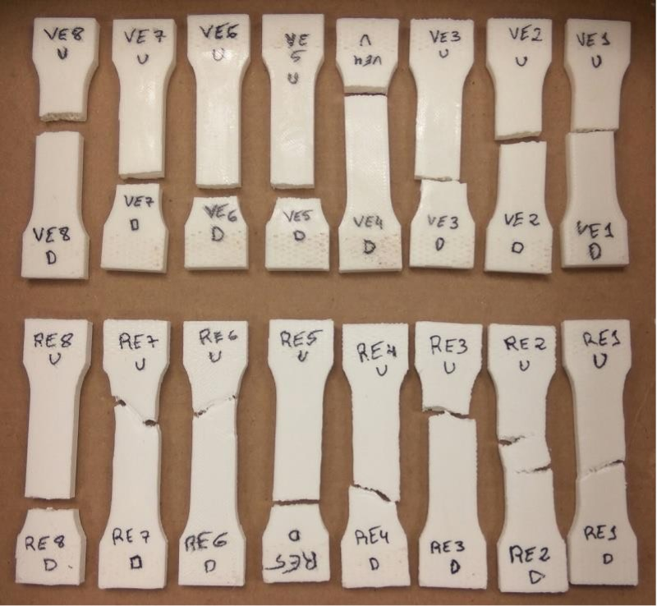

(a)

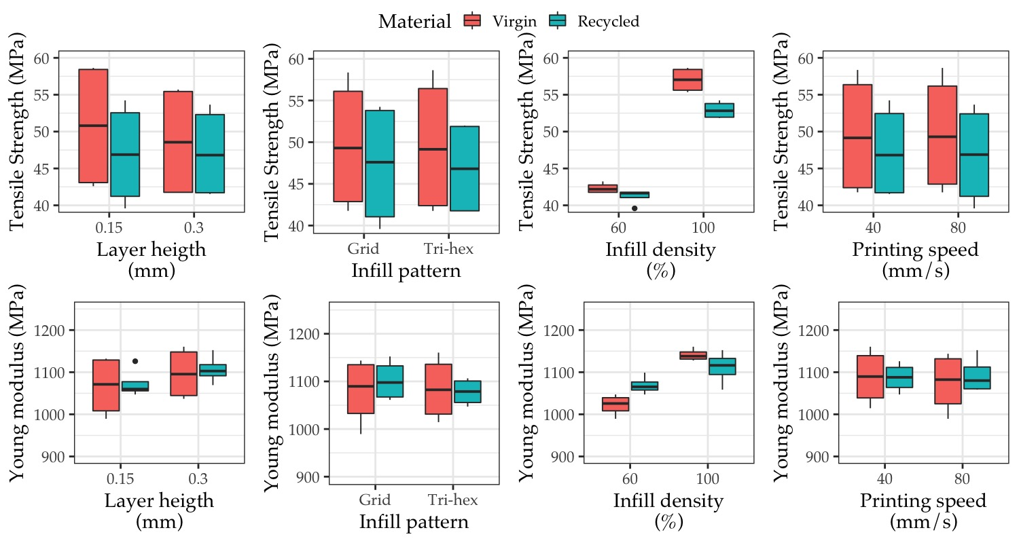

(b)

Figure 3: Phase I: screening tests to identify significant factors based on DoE. (a) Tensile specimens of the Phase I. (b) Boxplots to identify significant factors based on DoE

Table 3.2: ANOVA results at 95 % significance level for tensile strength and Young´s modulus variables

|  |  |  |  |  |  |  |  |  |  |  |  |  |  |  |  |  |  |  |  |  |  |  |  |  |  |  |  |  |  |  |  |  |  |  |  |  |  |  |  |  |  |  |  |  |  |  |  |  |  |  |  |  |  |  |  |  |  |  |  |  |  |  |  |  |  |  |  |  |  |  |  |  |  |  |  |  |  |  |  |  |  |  |  |  |  |  |  |  |
| --- | --- | --- | --- | --- | --- | --- | --- | --- | --- | --- | --- | --- | --- | --- | --- | --- | --- | --- | --- | --- | --- | --- | --- | --- | --- | --- | --- | --- | --- | --- | --- | --- | --- | --- | --- | --- | --- | --- | --- | --- | --- | --- | --- | --- | --- | --- | --- | --- | --- | --- | --- | --- | --- | --- | --- | --- | --- | --- | --- | --- | --- | --- | --- | --- | --- | --- | --- | --- | --- | --- | --- | --- | --- | --- | --- | --- | --- | --- | --- | --- | --- | --- | --- | --- | --- | --- | --- | --- |
| | **Variable** | **Tensile strength** | | | | | **Young’s modulus** | | | | | | --- | --- | --- | --- | --- | --- | --- | --- | --- | --- | --- | |  | Df | Sum Sq | Mean Sq | F value | Pr(>F) | Df | Sum Sq | Mean Sq | F value | Pr(>F) | | Layer height (mm) | 1 | 3.089 | 3.089 | 1.342 | 0.274 | 1 | 4169.608 | 4169.608 | 4.097 | 0.07 | | Infill density (%) | 1 | 699.206 | 699.206 | 303.79 | <2e-16 | 1 | 25839.759 | 25839.759 | 25.393 | 0.001 | | Infill pattern | 1 | 0.179 | 0.179 | 0.078 | 0.786 | 1 | 311.434 | 311.434 | 0.306 | 0.592 | | Printing speed (mm/s) | 1 | 0.209 | 0.209 | 0.091 | 0.769 | 1 | 73.231 | 73.231 | 0.072 | 0.794 | | Material | 1 | 27.589 | 27.589 | 11.987 | 0.006 | 1 | 287.726 | 287.726 | 0.283 | 0.607 | | Residuals | 10 | 23.016 | 2.302 |  |  | 10 | 10176 | 1017.6 |  |  | |

## 3.2 Phase II: Focusing on the infill density

The main goal of *Phase II* is to evaluate in more detail the influence of the infill density on the tensile strength based on the results of *Phase I*. Therefore, five levels of the infill density were chosen: 40, 55, 70, 85 and 100 %. Regarding the selection of the other printing parameters, the main criterion was the reduction of the printing time. Thus, the experimental conditions were layer height of 0.3 mm, tri-hexagonal infill pattern and printing speed of 80 mm/s with an estimated printing time of 20 min. A total of 10 specimens were manufactured.

Figure 4a shows the fracture of the specimens tested in *Phase II*. Regarding the fracture, the results were similar to those of the *Phase I* (i.e., more ductile behavior for the recycled PLA specimens). The interesting element in this phase is presented in Figure 4b where the maximum load (left) and the tensile strength (right) versus infill density for both materials are illustrated.

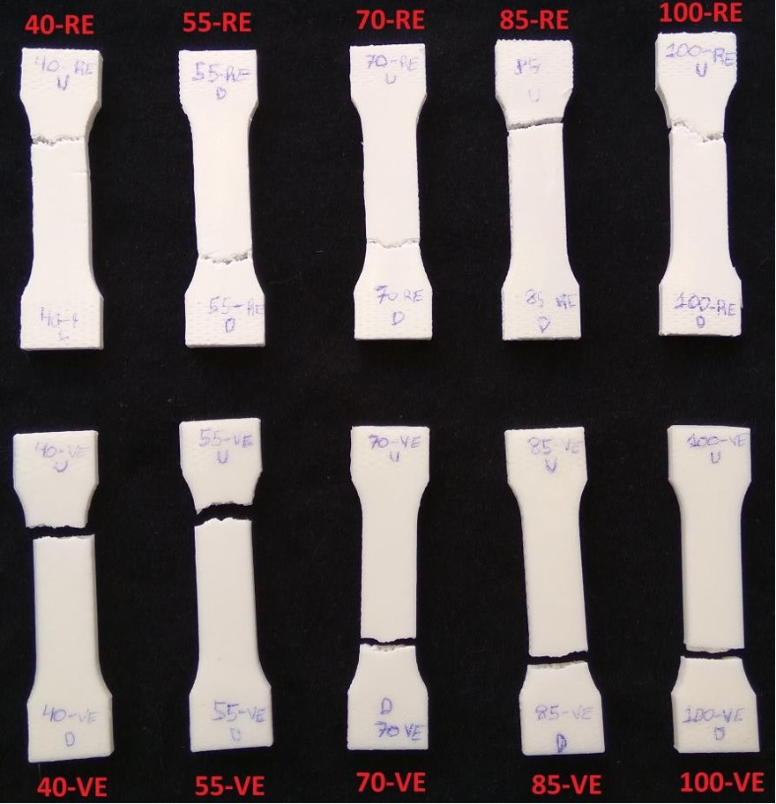

(a)

Note: V: virgin; R: recycled

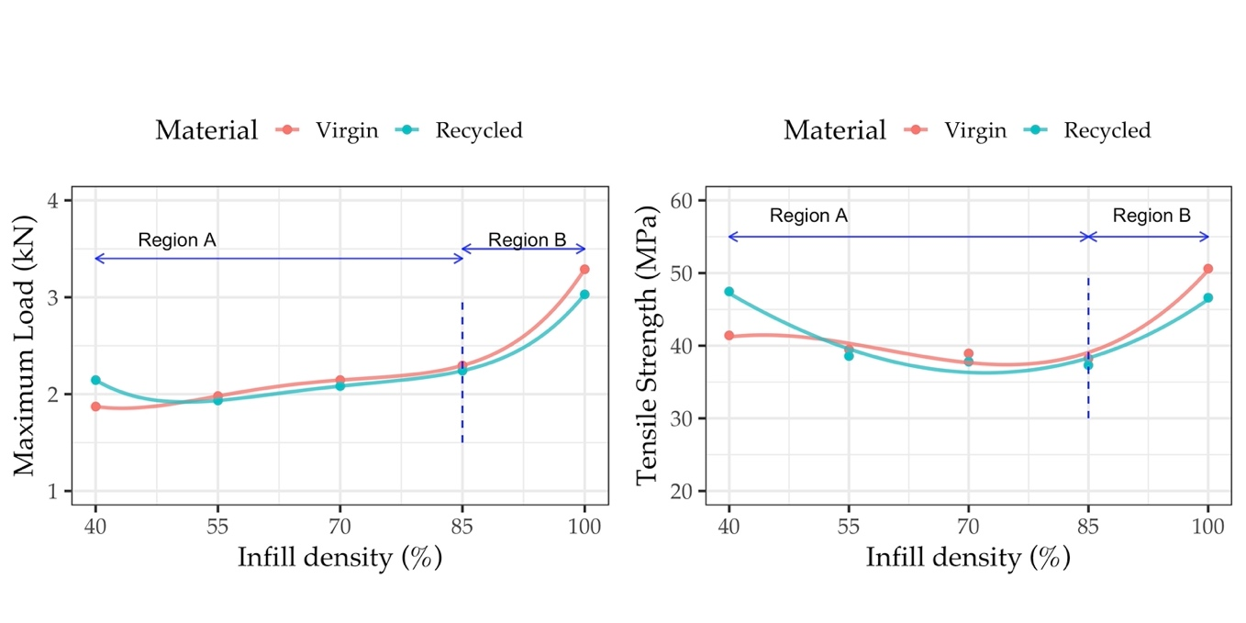

(b)

Figure 4: Phase II: Evaluation of the infill density in the mechanical load. a) Testing specimens used in Phase II. b) Influence of the infill density on the: left, maximum load; right, tensile strength.

From Figure 4b, the experimental data was used to create two regions. For the maximum load (Figure 4b left), in the A region, which comprises infill densities ranging from 40 to 85 %, the slope of the curve grows slowly with an approximately linear trend. In the B region, from 85 to 100 %, the increase of the maximum load becomes more pronounced resembling a quadratic function. Regarding the type of material, in general, the virgin PLA moderately outperforms recycled PLA. Based on the results in Figure 4b left, it appears that a reduction from 100 to 40 % of the infill density implies a reduction of the maximum load of 41.93 %, from 3.16 kN to 1.84 kN (on average for both materials).

On the other hand, regarding the tensile strength (Figure 4b right), it is possible to observe that the tensile strength remains mainly constant in the A region. This is explained by the effect of the perimeter. Thus, it should be note that the area in the cross-section depending on the perimeter is notably high (wall thickness of 1 mm). So, when evaluating the tensile strength the result mainly depends on the resistance provided by the perimeter, which is the same for all the specimens. However, in the B region, the effect of the infill density is more evident when approaching to 100 % and the tensile strength sharply increases as shown for the maximum load. The results obtained closely match those presented by Wang *et al.*53 . The authors studied infill densities from 20 to 100 % and identified an increasing trend for the tensile strength with a sharp increase from 80 to 100 %. When approaching the 100 % infill density, the air gap diminishes and the specimen becomes fully solid, thus the tensile strength is increased.51 Regarding the material, the results are in agreement with studies on the comparison of the performance of recycled and virgin PLA32 in which there was found to be a difference of about 10 % in the tensile strength in the first recycling cycles. However, the difference notably increased as the infill density approached 100 %.

## 3.3 Phase III: Study on the printing orientation

In this final phase, the main goal is to test the influence of the building orientation according to the UNE 116005:201250,54 standard.

Five specimens for each of the orientations (edgewise, horizontal and vertical) for both materials were manufactured. The selected printing conditions were infill density of 50 %, printing speed of 80 mm/s, tri-hexagonal infill pattern and layer height of 0.3 mm, with the objective of limiting the use of material and the time required for printing. A total of 30 specimens were tested.

Figure 5a shows the images of the tested specimens displaying the same type of fracture as in the first two phases. It is interesting to evaluate the reduction in the tensile strength depending on the type of material and the orientation in which the specimens were printed. Thus, Figure 5b details the tensile strength of the specimens including the mean values for the five specimens at each orientation. From the results, it is clear that the horizontal orientation is the one that provided the higher tensile strength as found by Corapi *et al.*55, followed by the edgewise orientation. Likewise, the virgin specimens performed better than the recycled ones. According to Kiendl and Gao56, for unidirectional layups, when the fibers are aligned with the loading direction, toughness, strength and stiffness attain the highest values.

Comparing the inter-variation between materials, the results proved that the vertical orientation had the worst results due to the deposition of the layers perpendicular to the tensile direction which was 31.04 MPa (average virgin) and 27.01 MPa (average recycled), representing a reduction of 12.98 % for the recycled material with respect to the virgin one. These results correspond to those by Chacón *et al.*44, Corapi *et al.*55 and Wang *et al.*53 For the edgewise orientation, a decrease of 6.71 % was evidenced from 35.89 MPa (virgin) to 33.48 MPa (recycled). Likewise, a decrease of 7.91 % for horizontal orientation (from 41.33 MPa virgin to 38.06 MPa recycled). The larger differences appear when comparing horizontal and vertical orientations. In this sense, comparing the intravariation of the vertical with respect to the horizontal orientation in both materials, it was found that there was a reduction of 24.90 % and 29.03 % for virgin and recycled, respectively. This demonstrates the influence of the orientation on the tensile strength. Nevertheless, this reduction for recycled material remains in the same order of magnitude regardless the orientation. These results give an estimate of the substitution of a virgin material for a recycled one, in terms of tensile strength reduction using printing parameters that can be considered as ‘draft mode’, which are usable as a prototyping setup.

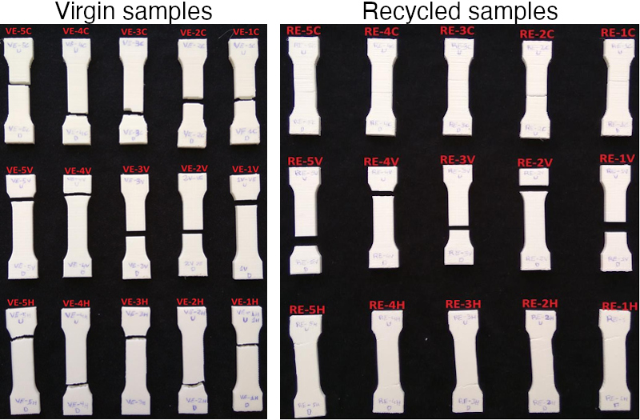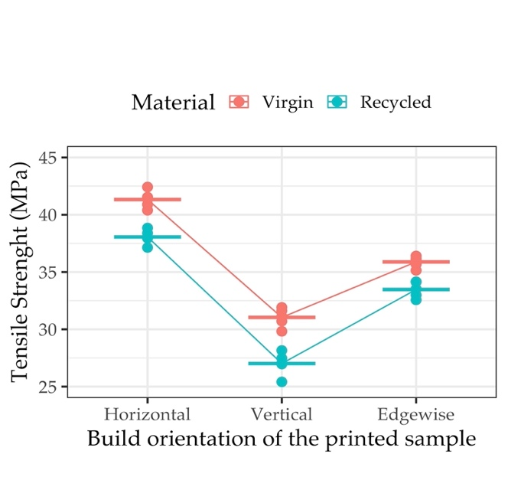

(a) (b)

*Figure 5: Phase III: Evaluation of the anisotropy. a) Specimens after tensile test in Phase III.* *b)Average of the maximum load obtained for each build orientation.*

# 4 Discussion and limitation of the study

One of the systemic problems of plastic waste involves dependency of the indiscriminate disposal of plastics, which carries multiple risks because many plastic products contain additives that modify their physico-mechanical properties, making recycling/reuse difficult.57 The use of 3D printing technology for prototyping is not exempt from this societal issue. The main purpose of this article is to assess the extent to which the influence of printing parameters affects the tensile strength. While a large body of literature is focused on the optimization of the parameters for obtaining functional printed objects using 100 % of the printed material, the approach taken here is to observe the influence of a wide range of factors that are critical within conventional printing ranges. This type of approach enables designers and users to utilize printing setups that are designed for object prototypes, providing certainty about the quality of the printed products.

One main point to highlight from Phase I is that among the parameters tested, it was found that the infill density is a central parameter to characterize the tensile strength of the printed part for both virgin and recycled materials. Certainly, more experimental data is needed to have a robust comprehensive understanding given the fact that fractional experimental designs were used in this study. Nevertheless, one interesting perspective from here is the the possibility of constructing conservative models for the tensile strength in FFF.58 Promoting the design efficiency of FFF products needs an accurate modeling and better failure criteria for predicting the mechanical strength properties. The fracture of the specimens in this study confirms that in-layer and interlayer failure modes are present, and this behaviour might lead to errors and inconsistency in the predictions of the tensile properties. Thus, the generation of a precise conservative model needs to be explored in detail based on the infill density and recycling assets to provide a safety margin for designers in their products.

Another main result of this study is that there is a reduction about 41.93 % (on average) in the maximum load supported for PLA (virgin and recycled) when the infill density changes from 100 to 40 % as identified in Phase II. To put it another way, it could be inferred from the results that an infill density of 40 % guarantees attaining 58.07 % of the maximum load. The results are even closer when attending to the tensile strength but, they did not show the same trend as the maximum load. In this sense, it seems clear that the cross-section related to the perimeter plays a major role on the tensile strength and, thus, it brings additional opportunities to attain the required minimum tensile strength while diminishing the material usage.

Indeed, from Phase III, even in the worst scenario (vertical building orientation), a reduction of the 12.98 % was estimated from virgin to recycled. These order of magnitudes are relevant insights for prescriptions of minimal conditions for 3D printing. Moreover, the use of recycled assets in the printing process may be a relevant method, considering the current priorities of the European Union in regard to circular economy and carbon-neutral strategy ambitions.59 Also, there is great development in applications using distributed recycling approaches. For instance, Nur-A-Tomal *et al.*60 presented a valuable example of waste-to-wealth to use waste plastic toys retaining the original color of waste plastic to fabricate new products. Certainly more research is required for the development of complete closed-loop case studies for prototyping purposes based on the type of material, validating technical, ecological and economic feasibility.17,61

There are certain limitations to this work in the perspective of materials and parameters tested. Fon instance, the use of other materials is needed to confirm the main findings. Moreover, other factors are needed in order to consider the quality of a prototype. Clearly, other variables, such as aesthetic design, dimensional accuracy and surface quality62 are also key to analyze for the printed objects in addition to the mechanical properties in the prototypes where the main goal is user acceptability.63,64 Nevertheless, this is an ongoing study in which the main purpose is the statistical validation of the minimal conditions to promote the use of recycled materials in prototyping.

# 5 Conclusions

The 3D printing technology expands the boundaries of the design space for prototypes and final products. For designers and practitioners, the rational use of material is required in prototyping stages for sustainable manufacturing. The present study proposes a comprehensive experimental program in three steps (*Screening, Focalise, Anysotropy*) based on Design of Experiments approach to better understand the influence of manufacturing parameters in the tensile strength of Fused Filament Fabrication process. Moreover, commercial virgin and recycled PLA were used to compare the technical feasibility. The paper aims to improve the sustainability of the 3D printing process towards the validation the technical feasibility of the substitution of virgin materials for recycled ones by means of a better knowledge on the influence of the printing conditions. The final purpose in the long term is to recognize the technology affordance of prototyping side of additive manufacturing as a design tool to better ensure consumer acceptance and less waste.65 The main conclusions of the study are:

* In Phase I, five key printing parameters (infill pattern, layer height and printing speed and infill density) were study. The results showed that the highest influence of the tensile strength and Young’s modulus was the infill density due to its influence on the cross-section that resists the tensile load. Moreover,
* In Phase II, both the maximum load and tensile strength showed similar trends depending on the infill density. Particularly, a sharp increase was noticed when the infill density increases from 85 to 100 % for both outcomes. At low infill densities, the influence of the perimeters is critical due to they are mostly the part that supports the tensile load.
* Finally in Phase III, the selected orientation for printing is of great importance because of the anisotropy. The horizontal orientation allowed to attain a higher tensile strength, while the vertical orientation provided a lower value due to the fact that no layers were deposited in the tensile direction.
* The results support the main argument for the substitution of virgin PLA for recycled PLA, advancing towards sustainable manufacturing. It was found that, when using an infill density of 40 %, on average, the specimen reached 58.07 % of the maximum load. Despite the fact that recycled PLA offers slightly lower tensile strength, by properly selecting the printing conditions, it could be close to that of the virgin PLA. Particularly, when using the edgewise and horizontal orientations.

Based on these results, future research needs to evaluate the quality of a (recycled) prototypes including key aspects other than tensile strength such as aesthetics, accuracy, surface finish. Moreover, the acceptability of recycled products by final users that can be technical printable is a major milestone.

# 6 Acknowledgements

The authors would like to thank the “Mechanical and Energy Engineering” TEP 250 research group and the Lorraine Fab Living Lab. This research has received funding from the European Union’s Horizon 2020 research and innovation program under grant agreement No. 869952.

# 7 Declaration of interest statement

The authors report no declarations of interest.

# References

1. Singh S, Singh G, Prakash C, *et al.* Current status and future directions of fused filament fabrication. *J Manuf Process* 2020; 55: 288–306.

2. Sartal A, Carou D, Dorado-Vicente R, *et al.* Facing the challenges of the food industry: Might additive manufacturing be the answer? *Proc Inst Mech Eng Part B J Eng Manuf* 2019; 233: 1902–1906.

3. Akhoundi B, Behravesh AH, Bagheri Saed A. An innovative design approach in three-dimensional printing of continuous fiber–reinforced thermoplastic composites via fused deposition modeling process: In-melt simultaneous impregnation. *Proc Inst Mech Eng Part B J Eng Manuf* 2020; 234: 243–259.

4. Nam J, Jo N, Kim JS, *et al.* Development of a health monitoring and diagnosis framework for fused deposition modeling process based on a machine learning algorithm. *Proc Inst Mech Eng Part B J Eng Manuf* 2020; 234: 324–332.

5. Jiang P, Leng J, Ding K, *et al.* Social manufacturing as a sustainable paradigm for mass individualization. *Proc Inst Mech Eng Part B J Eng Manuf* 2016; 230: 1961–1968.

6. Askari M, Hutchins DA, Thomas PJ, *et al.* Additive manufacturing of metamaterials: A review. *Addit Manuf* 2020; 36: 101562.

7. Wang L, Jiang S, Zhang S. Mapping technological trajectories and exploring knowledge sources: A case study of 3D printing technologies. *Technol Forecast Soc Change* 2020; 161: 120251.

8. Niaki MK, Torabi SA, Nonino F. Why manufacturers adopt additive manufacturing technologies: The role of sustainability. *J Clean Prod* 2019; 222: 381–392.

9. Peng T, Kellens K, Tang R, *et al.* Sustainability of additive manufacturing: An overview on its energy demand and environmental impact. *Addit Manuf* 2018; 21: 694–704.

10. Despeisse M, Baumers M, Brown P, *et al.* Unlocking value for a circular economy through 3D printing: A research agenda. *Technol Forecast Soc Change* 2017; 115: 75–84.

11. González-Henríquez CM, Sarabia-Vallejos MA, Rodriguez-Hernandez J. Polymers for additive manufacturing and 4D-printing: Materials, methodologies, and biomedical applications. *Prog Polym Sci* 2019; 94: 57–116.12.

12. Kumar, R, Verma, A., Shome, A., et al. Impacts of Plastic Pollution on Ecosystem Services, Sustainable Development Goals, and Need to Focus on Circular Economy and Policy Interventions. *Sustainability* 2021, 9963.

13. Elverum CW, Welo T, Tronvoll S. Prototyping in New Product Development: Strategy Considerations. *Procedia CIRP* 2016; 50: 117–122.

14. Menold J, Jablokow K, Simpson T. Prototype for X (PFX): A holistic framework for structuring prototyping methods to support engineering design. *Des Stud* 2017; 50: 70–112.

15. Hansen CA, Özkil AG. From Idea to Production: A Retrospective and Longitudinal Case Study of Prototypes and Prototyping Strategies. *J Mech Des*; 142. Epub ahead of print March 2020. DOI: [10.1115/1.4045385](https://doi.org/10.1115/1.4045385).

16. Campbell I, Bourell D, Gibson I. Additive manufacturing: rapid prototyping comes of age. *Rapid Prototyp J* 2012; 18: 255–258.

17. Cruz Sanchez FA, Boudaoud H, Camargo M, *et al.* Plastic recycling in additive manufacturing: A systematic literature review and opportunities for the circular economy. *J Clean Prod* 2020; 264: 121602.

18. Mikula K, Skrzypczak D, Izydorczyk G, *et al.* 3D printing filament as a second life of waste plastics—a review. *Environ Sci Pollut Res*. Epub ahead of print September 2020. DOI: [10.1007/s11356-020-10657-8](https://doi.org/10.1007/s11356-020-10657-8).

19. Lovo JFP, Fortulan CA, Silva MM da. Optimal deposition orientation in fused deposition modeling for maximizing the strength of three-dimensional printed truss-like structures. *Proc Inst Mech Eng Part B J Eng Manuf* 2019; 233: 1206–1215.

20. Laureto JJ, Pearce JM. Anisotropic mechanical property variance between ASTM D638-14 type i and type iv fused filament fabricated specimens. *Polym Test* 2018; 68: 294–301.

21. Popescu D, Zapciu A, Amza C, *et al.* FDM process parameters influence over the mechanical properties of polymer specimens: A review. *Polym Test* 2018; 69: 157–166.

22. Tymrak BM, Kreiger M, Pearce JM. Mechanical properties of components fabricated with open-source 3-D printers under realistic environmental conditions. *Mater Des* 2014; 58: 242–246.

23. Altan M, Eryildiz M, Gumus B, *et al.* Effects of process parameters on the quality of PLA products fabricated by fused deposition modeling (FDM): Surface roughness and tensile strength. *Mater Test* 2018; 60: 471–477.

24. Yao T, Deng Z, Zhang K, *et al.* A method to predict the ultimate tensile strength of 3D printing polylactic acid (PLA) materials with different printing orientations. *Compos Part B Eng* 2019; 163: 393–402.

25. Alafaghani A aldin, Qattawi A. Investigating the effect of fused deposition modeling processing parameters using Taguchi design of experiment method. *J Manuf Process* 2018; 36: 164–174.

26. Little HA, Tanikella NG, J. Reich M, *et al.* Towards Distributed Recycling with Additive Manufacturing of PET Flake Feedstocks. *Materials (Basel)* 2020; 13: 4273.

27. Zhao P, Rao C, Gu F, *et al.* Close-looped recycling of polylactic acid used in 3D printing: An experimental investigation and life cycle assessment. *J Clean Prod* 2018; 197: 1046–1055.

28. Petrovic V, Vicente Haro Gonzalez J, Jordá Ferrando O, *et al.* Additive layered manufacturing: sectors of industrial application shown through case studies. *Int J Prod Res* 2011; 49: 1061–1079.

29. Wittbrodt BT, Glover AG, Laureto J, *et al.* Life-cycle economic analysis of distributed manufacturing with open-source 3-D printers. *Mechatronics* 2013; 23: 713–726.

30. Santander P, Cruz Sanchez FA, Boudaoud H, *et al.* Closed loop supply chain network for local and distributed plastic recycling for 3D printing: a MILP-based optimization approach. *Resour Conserv Recycl* 2020; 154: 104531.

31. Suárez L, Domínguez M. Sustainability and environmental impact of fused deposition modelling (FDM) technologies. *Int J Adv Manuf Technol* 2020; 106: 1267–1279.

32. Cruz Sanchez FA, Boudaoud H, Hoppe S, *et al.* Polymer recycling in an open-source additive manufacturing context: Mechanical issues. *Addit Manuf* 2017; 17: 87–105.

33. Lanzotti A, Martorelli M, Maietta S, *et al.* A comparison between mechanical properties of specimens 3D printed with virgin and recycled PLA. *Procedia CIRP* 2019; 79: 143–146.

34. Anderson I. Mechanical Properties of Specimens 3D Printed with Virgin and Recycled Polylactic Acid. *3D Print Addit Manuf* 2017; 4: 110–115.

35. Kumar R, Singh R, Farina I. On the 3D printing of recycled ABS, PLA and HIPS thermoplastics for structural applications. *PSU Res Rev* 2018; 2: 115–137.

36. C, Kadadevara Math RS, Goutham R, *et al.* Study of Effects on Mechanical Properties of PLA Filament which is blended with Recycled PLA Materials. *IOP Conf Ser Mater Sci Eng* 2018; 310: 012103.

37. Pinho AC, Amaro AM, Piedade AP. 3D printing goes greener: Study of the properties of post-consumer recycled polymers for the manufacturing of engineering components. *Waste Manag* 2020; 118: 426–434.

38. Zhao XG, Hwang K-J, Lee D, *et al.* Enhanced mechanical properties of self-polymerized polydopamine-coated recycled PLA filament used in 3D printing. *Appl Surf Sci* 2018; 441: 381–387.

39. Rebaioli L, Fassi I. A review on benchmark artifacts for evaluating the geometrical performance of additive manufacturing processes. *Int J Adv Manuf Technol* 2017; 93: 2571–2598.

40. Cruz Sanchez FA, Boudaoud H, Muller L, *et al.* Towards a standard experimental protocol for open source additive manufacturing. *Virtual Phys Prototyp* 2014; 9: 151–167.

41. Roberson Da, Espalin D, Wicker RB. 3D printer selection: A decision-making evaluation and ranking model. *Virtual Phys Prototyp* 2013; 8: 201–212.

42. Jaisingh Sheoran A, Kumar H. Fused Deposition modeling process parameters optimization and effect on mechanical properties and part quality: Review and reflection on present research. In: *Mater. Today proc.* 2020, pp. 1659–1672.

43. Park S, Kun Fu K(K), Polymer-based filament feedstock for additive manufacturing, Compos Sci Technol 2021; 213:108876.

44. Chacón JM, Caminero MA, García-Plaza E, *et al.* Additive manufacturing of PLA structures using fused deposition modelling: Effect of process parameters on mechanical properties and their optimal selection. *Mater Des* 2017; 124: 143–157.

45. Montgomery DC. *Design and Analysis of Experiments*. John Wiley; Sons Inc, 2001.

46. Singh R, Singh H, Farina I, *et al.* On the additive manufacturing of an energy storage device from recycled material. *Compos Part B Eng* 2019; 156: 259–265.

47. Tanveer MdQ, Haleem A, Suhaib M. Effect of variable infill density on mechanical behaviour of 3-D printed PLA specimen: an experimental investigation. *SN Appl Sci* 2019; 1: 1–12.

48. Pérez M, Medina-Sánchez G, García-Collado A, Gupta M, Carou D. Surface Quality Enhancement of Fused Deposition Modeling (FDM) Printed Samples Based on the Selection of Critical Printing Parameters. *Materials* 2018, 11 :1382.

49. Zhao Y, Chen Y, Zhou Y, Novel mechanical models of tensile strength and elastic property of FDM AM PLA materials: Experimental and theoretical analyses. *Mater Des* 2019, 181 :108089

50. UNE. UNE 116005:2012 Fabricación por adición de capas en materiales plásticos. Fabricación aditiva. Preparación de probetas.

51. Hikmat M, Rostam S, Ahmed YM. Investigation of tensile property-based Taguchi method of PLA parts fabricated by FDM 3D printing technology. Results Eng 2021 ; 11:100264

52. Pazhamannil RV, Govindan P, Sooraj P. Prediction of the tensile strength of polylactic acid fused deposition models using artificial neural network technique. Materials Today: Proceedings 2021, 46(19):9187-9193,

53. Wang S, Ma Y, Deng Z, *et al.* Effects of fused deposition modeling process parameters on tensile, dynamic mechanical properties of 3D printed polylactic acid materials. Polym Test 2020; 86: 106483.

54. García-Domínguez A, Claver J, Camacho AM, *et al.* Considerations on the Applicability of Test Methods for Mechanical Characterization of Materials Manufactured by FDM. *Materials* 2019; 13: 28.

55. Corapi D, Morettini G, Pascoletti G, *et al.* Characterization of a polylactic acid (PLA) produced by Fused Deposition Modeling (FDM) technology. In: *Procedia struct. integr.* Elsevier B.V., 2019, pp. 289–295.

56. Josef Kiendl, Chao Gao, Controlling toughness and strength of FDM 3D-printed PLA components through the raster layup. *Composites Part B: Engineering* 2020, 180:107562

57. Wagner S, Schlummer M. Legacy additives in a circular economy of plastics: Current dilemma, policy analysis, and emerging countermeasures. *Resour Conserv Recycl* 2020; 158: 104800.

58. Rahmati, A., Heidari-Rarani, M., Lessard, L., 2021. A novel conservative failure model for the fused deposition modeling of polylactic acid specimens. Addit. Manuf. 48, 102460. https://doi.org/10.1016/j.addma.2021.102460

59. Schwarz AE, Ligthart TN, Godoi Bizarro D, *et al.* Plastic recycling in a circular economy; determining environmental performance through an LCA matrix model approach. *Waste Manag* 2021; 121: 331–342.

60. Nur-A-Tomal MS, Pahlevani F, Sahajwalla V. Direct transformation of waste children’s toys to high quality products using 3D printing: A waste-to-wealth and sustainable approach. *J Clean Prod*; 267. Epub ahead of print 2020. DOI: [10.1016/j.jclepro.2020.122188](https://doi.org/10.1016/j.jclepro.2020.122188).

61. Sauerwein M, Doubrovski E, Balkenende R, *et al.* Exploring the potential of additive manufacturing for product design in a circular economy. *J Clean Prod* 2019; 226: 1138–1149.

62. Jin Y, Wan Y, Zhang B, *et al.* Modeling of the chemical finishing process for polylactic acid parts in fused deposition modeling and investigation of its tensile properties. *J Mater Process Technol* 2017; 240: 233–239.

63. Sauer J, Sonderegger A. The influence of prototype fidelity and aesthetics of design in usability tests: Effects on user behaviour, subjective evaluation and emotion. *Appl Ergon* 2009; 40: 670–677.

64. Sauer J, Seibel K, Rüttinger B. The influence of user expertise and prototype fidelity in usability tests. *Appl Ergon* 2010; 41: 130–140.

65. Kohtala C. Addressing sustainability in research on distributed production: an integrated literature review. *J Clean Prod* 2015; 106: 654–668.

1. University of Jaén, Department of Mechanical and Mining Engineering, 23071 Jaén, Spain
2. Universidade de Vigo, Departamento de Deseño na Enxeñaría, Ourense, Spain, [diecapor@uvigo.es](mailto:diecapor@uvigo.es) - *Corresponding author
3. Université de Lorraine - ERPI - F-54000, Nancy, France, cruzsanc1@univ-lorraine.fr