Requirement: 2
Solution: 2
Environment setup: 3
DynamoDB: 3
IAM Role 3
AWS Lambda 4
Amazon Connect 4
Problems and Solutions 6
Bad practices and shortcuts: 10
Future work If I had more time: 10

Requirement:
Create a serverless function that convert phone number to vanity numbers and saves the result in NoSQL database service. Also create the functionality which looks at the caller’s phone number and returns 3 vanity possibilities.

Solution:
The goal of the project is to use an Amazon connect as a call centre. Store the user phone number in the database. Once the call is connected it triggers the Lambda function and it converts the phone number and gets stored in DynamoDB with 5 different vanity number. Also looks at the caller number and returns 3 vanity number possibilities.
This can be achieved by using AWS services like Amazon connect, AWS Lambda, Amazon DynamoDB, IAM as shown in the work-flow diagram.
Once user dials in Amazon Connect phone number; Lambda function will be triggered. It will store the customer phone number in DynamoDB table as well as assign a 5 different vanity number.

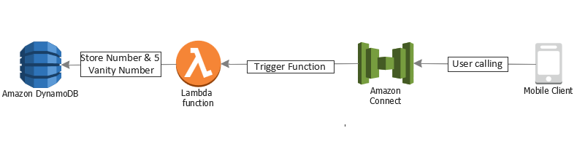

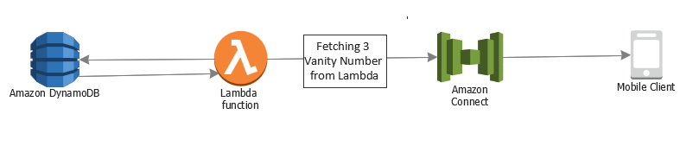

Environment setup:

DynamoDB:
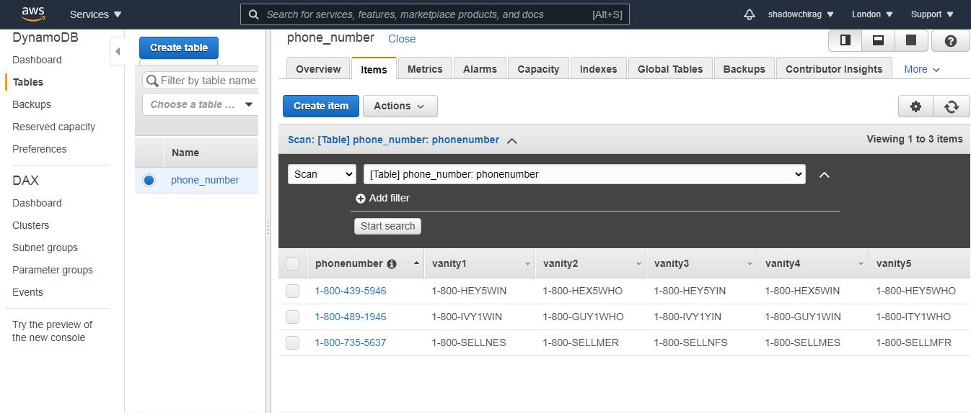
At first, in DynamoDB a table is created. Assign a name to the table, phone_number, and partition key (phonenumber). Copy ARN number (Unique Identifier) of the table from the overview tab and paste it in the notepad which is required to assign the policies (IAM Role).

IAM Role
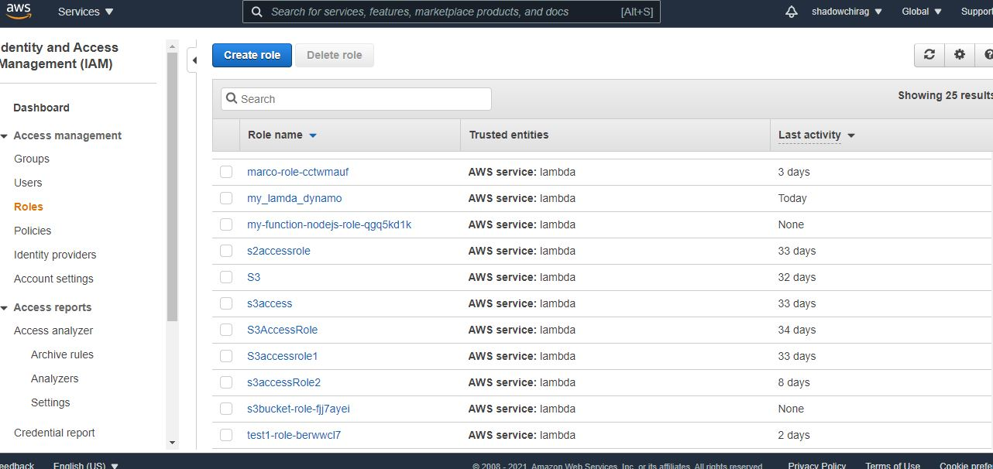
Create an IAM role which will give permission to Lambda function to work with DynamoDB table by adding the appropriate policies and assign a role name. Add inline policy where in the service section allows lambda function to call DynamoDB and specify actions which are allowed in DynamoDB. “GetItem” and “PutItem”. In the resources section add the ARN number, which is a unique identifier for the Dynamodb table, and provide permissions for which they are assigned to. After reviewing and configuring a role assign role to Lambda function so it can access to the DynamoDB table.

AWS Lambda
In the search area select the Lambda ensuring region is selected correctly. Create a lambda with appropriate name. For the runtime use Python 3.6. For the permission use the existing role (my_lambda_dynamo) created in the previous section and create the function accordingly.
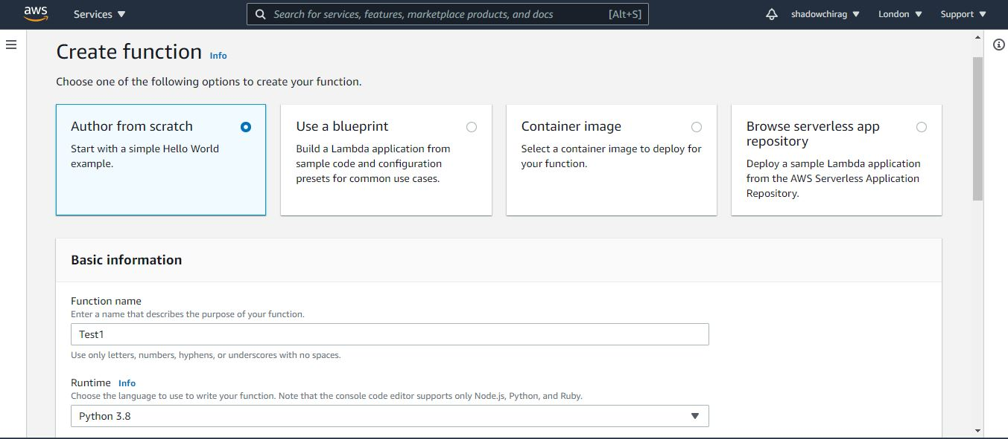

Amazon Connect
First, create the instance of Amazon connect service on Amazon connect resource in configuration page, give a unique name for instance as URL will be used to access the instance. Next step, is to create an Administrator by providing username, password, email address. Select whether instance is used for inbound or outbound calls or both. Next step would be data storage and all the Amazon connect flow logs will be stored in the cloud watch, and leave the default options as it is. Review and create the Instance which will take few moments to be created.
Claim a phone number: Select the country, select toll free or Direct dial number and there will be list of number to choose from, it will allow the user to make a call to the number and it will route the call to the embedded soft phone on the screen.
Amazon connect contact flow: After login into the Dashboard of the Instance and select the connect flow. Create a new flow and from the Integrate section Invoke AWS lambda function.
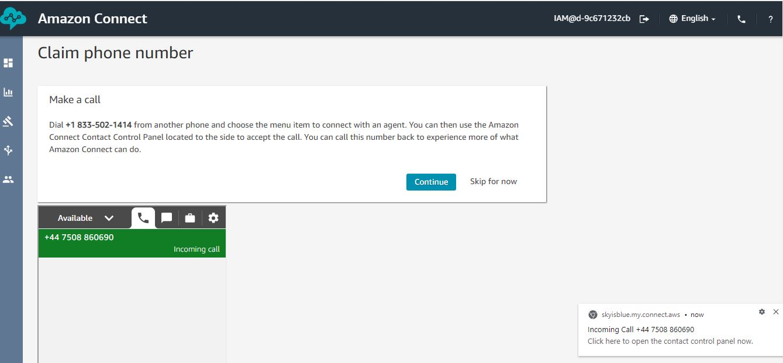

Problems and Solutions
Creating a Python function which converts phone number to vanity number. Initially I was not aware of what is vanity number, as in UK it is not a very familiar concept - vanity number. I did some research on Google to broaden my knowledge. It took me a little longer than usual how I will implement the function. By investing some time on researching, I came across vanity number, library (vanitnumber 0.5) where I read the documentation. I installed it on my laptop using command line “pip install vanitynumber” and then I imported in .py file, I thought it would be better to start implementing the function on IDE(PyCharm).
Initial code on Pycharm, function is called convert() which prints the message for the user that Only “1-800-000-0000” is allowed. Variable ‘n’ takes the user input, the if length of n is not equal to 14 then it will return the error with provided length also it formats the value which has been used. If user enters the valid format and length, it accepts and returns 5 different vanity number in format of e.g., “1-800-CFALIKE”
import vanitynumber
def convert():
# print("Enter One of the area code: 'London 0208, Manchester 0161, Edinburgh 0131, Leicester 0116, Birmingham 0121'")
print("Please enter the phone number in format of: '1-800-###-####'")
n = input("Enter your number: ")
if len(n) != 14:
print(f"Length: {len(n)}, Only 14 digits are allowed and has to be digits..")
else:
print(f"Length: {len(n)}, Number accepted: ", n)
print(vanitynumber.all_wordifications(n, 5))
convert()

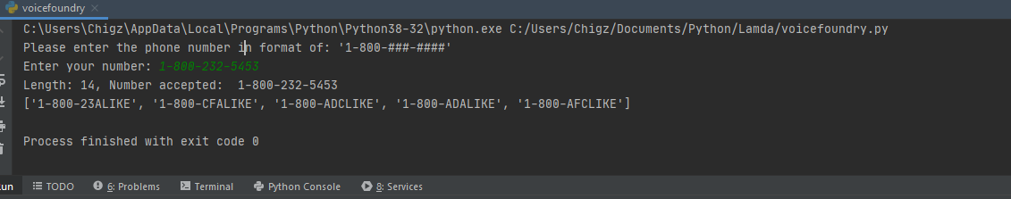
Outcome: Below screen shot shows, User input value is “1-800-232-5453” which has accepted the phone number and returns 5 different vanity number.

(Challenge #1) Lambda handler: Once the function starts working. I wrote the code on Lambda console editor. I realised that Lambda handler will not accept a user input.
Solution: After a few trial and error, it accepted “n = event["phone"]” where event is an object contains information from the invoking service.
(Challenge #2) Uploading .zip files archive: "errorMessage": "Unable to import module 'lambda_function': No module named 'vanitynumber’”
Solution: To overcome the error, I imported the module, created a folder on my desktop and installed virtualization “virtualenv venv” and installed vanitynumber. Created lamda_function.py file with my function dependencies. Bundled all the files with zip and uploaded on console to run the function.
(Challenge #3) re-writing a function with try and except (error handling)
Solution: I re-wrote the function which was written in the beginning in PyCharm using try and except in the function, which handles the error for the code. If exception rise within try block it will go to the except block.
import vanitynumber
"""boto3 library is used for interacting with AWS services"""
"""variable table is selecting a table from the dynamoDB"""
"""variable phone is selecting a event document in JSON"""
"""Vanity library has been installed and used to convert the toll-free number to vanity number"""
def lambda_handler():
print("Please enter the phone number in format of: '1-800-###-####'")
phone = input("Enter your phone number: ")
print("phonenumber:", phone)
try:
if len(phone) == 14:
print(f"Length: {len(phone)}, Number accepted: ", phone)
table_entry = {"phonenumber": phone}
sample = vanitynumber.all_wordifications(phone, 5)
print(sample)
except ValueError:
print(f"Length: {len(phone)}, Only 14 are allowed..")
lambda_handler()

(Challenge #4) After creating the instance and claiming the toll-free number, trying to connect it with my private number.
Solution: After connecting couple of times with my toll-free number, it did not connect again next day. After trying it for number of occasions, I called my phone network service provider and was informed that they had blocked “+1 800” numbers.
(Challenge #5) Amazon connect service
Solution: To understand the Amazon connect service, I got some help from Google trying to understand what services it has to offer. To understand better, I watched YouTube videos as well as referred Amazon connect documentation (https://docs.aws.amazon.com/connect/latest/adminguide/what-is-amazon-connect.html)
(Challenge #6) Amazon connect contact flow and Invoke Lambda function
Solution: To implement the structure of the contact flow. I tried multiple attempts to create the connect flow to achieve my goal. I uploaded the permission to my function through CLI. Also, to invoke AWS Lambda function on connect flow.
https://docs.aws.amazon.com/connect/latest/adminguide/connect-lambda-functions.html#function-contact-flow
https://docs.aws.amazon.com/lambda/latest/dg/gettingstarted-awscli.html

(Challenge #7) Test Event error which stores the phone number and vanity numbers in DynamoDB.
Solution: After re-writing the function in my local PyCharm IDE I took my code on Lambda to test, but it kept showing the error. After a detailed analysis on the same error, realised Test Event was not saved and format of the phone number was incorrect. So, I changed the format of the number saved it and tested the code. Result = Successful!
(Challenge #8) Understanding of using boto3 library, when writing a Lambda handler
Solution: Boto3 was inbuilt python library which is on the default script installed in the function to help achieve the results. It also helps to connect with other AWS services from the codes. I have used boto3 documentation to understand more about the library.
https://boto3.amazonaws.com/v1/documentation/api/latest/reference/services/lambda.html

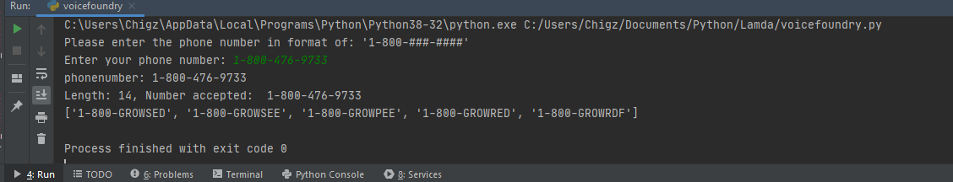
“Best” – my views
The importance of vanity number is widely used in business especially start up business which will benefit them the most. Here is an example of the 5 best vanity number which is associated with “1-800-476-9733”.
1. Its memorable and easy way to remember:
e.g. I would not remember a phone number of a friend, but the phone number of any organization called “GROWRED” for an example. It would be easy way to remember “1-800-GROWRED” A vanity number is much easier to remember than a phone number.
2. Marketing tools:
Many companies would print their number on their own cars or vans.
e.g. If I am driving a car on a motor way and there is a break down and I do not have the number stored on my phone or don’t remember. It would be easier to remember the vanity number displayed on the side of a van or car.
3. Professional and care:
As a business owner If I care about my customer then I would keep the number toll-free for them, as its free and affordable to all the customers. Since I will also prefer to maintain the same as a future business owner.

Bad practices and shortcuts:
- Used a root account and not an admin account to create the project
- Resource based policy is granted, instead of identity-based policy to grant the principal access to the resources
- Names and tags have not been used to identify the resources
- Name of the functions and tests are not given appropriate

Future work If I had more time:
If I had more time, would have thought of implementing an extra functionality by exploring other AWS services and how to integrate it with Amazon connect. How the system could effectively communicate with the customers. I would have focussed on the right metrics e.g., Customer Satisfaction, AHT (average handle time), Service Levels, Average Wait Time. I would have thought of Automation techniques to be more impactful for the inbound calls to reduce the inbound traffic with accuracy. There are so many functionalities on Amazon connect which would help to enhance better customer service.
In regards to the bad practices, I would have given the right names and tags to resources to categorize them and identify the resources based on the tags. I will provide Identity based policy to the resources instead of granting full access policy. I will also ensure that I use IAM admin user instead of using root account.

