ALEVIN for Developers

Adding new algorithms

Basic Structure
- Any algorithm used with VNREAL must be derived from MuLaViTo's mulavito.IAlgorithm interface which
  - defines a common way to access status information of a running algorithm
  - allows to show a GUI progress bar
- The package vnreal.algorithms contains several base classes (implementing mulavito.IAlgorithm) to derive own algorithms from
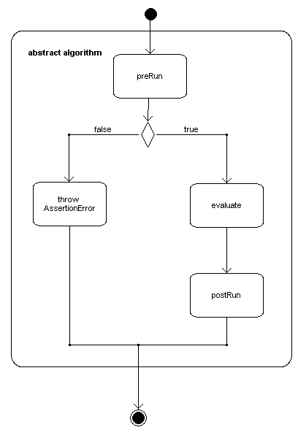
  - AbstractAlgorithm merely provides abstract methods for doing stuff before and after running the algorithm
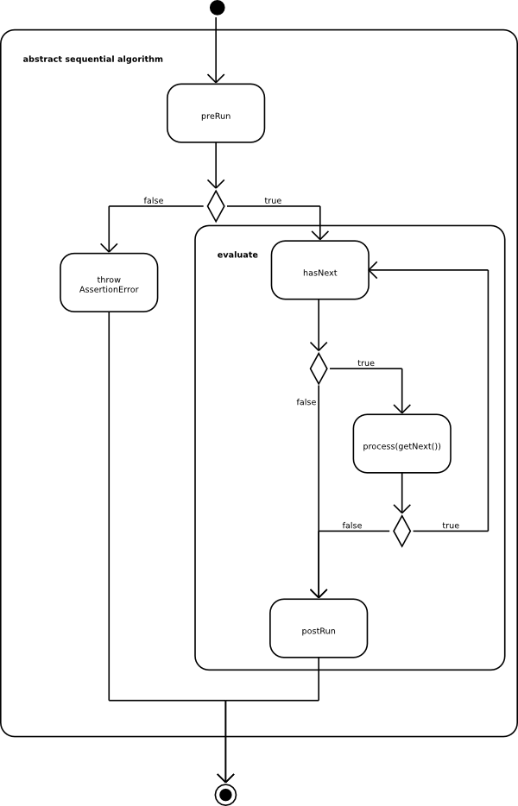
  - AbstractSequentialAlgorithm performs a sequential processing providing abstract methods hasNext and getNext
  - AbstractRevokableSequentialAlgorithm additionally provides an abstract revoke method
- Basic Algorithmic Principle
  - The algorithm gets a vnreal.network.NetworkStack which consists of
    - a substrate network with resources,
    - a list of virtual networks with demands
  - The algorithm performs the VNM and VLM by search for resources that are able to fulfill the given demands

Example
The package vnreal.algorithms.samples contains experimental algorithms, like the SimpleDijkstraAlgorithm. This exemplary algorithm performs
- an arbitrary virtual node mapping (choosing the node mapping in an arbitrary way among the substrate nodes accomplishing the virtual node demands),
- the virtual link mapping is implemented by connecting each pair of mapped virtual nodes by the shortest path in the substrate network calculated using the Dijkstra algorithm.
The first part of the class SimpleDijkstraAlgorithm implementation looks like
public final class SimpleDijkstraAlgorithm extends
AbstractSequentialAlgorithm<VirtualLink> {
private final NetworkStack stack;//Set of networks including the substrate network and the set of virtual network requests.
private Iterator<? extends Network<?, ?, ?>> curNetIt;//Iterator over the set of virtual network requests
private Iterator<VirtualLink> curIt;//Interator over the set of virtual links of a virtual network request
This is the hasNext function of this algorithm which simply update the iterator over the set of virtual network requests. If one virtual network request have been already served, it moves the curNetIt to the next virtual network request and updates curNetIt iterator. If there is no more virtual network requests it returns false.
@Override
protected boolean hasNext() {
if (curIt == null || !curIt.hasNext()) {
if (curNetIt.hasNext()) {
Network<?, ?, ?> tmp = curNetIt.next();
if (tmp instanceof SubstrateNetwork)
tmp = curNetIt.next();
curIt = ((VirtualNetwork) tmp).getEdges().iterator();
return hasNext();
} else
return false;
} else
return true;
}
The getNext method returns the following virtual link that will be mapped in the process method. To see in detail the code of the example please go to the vnreal.algorithms.samples package.
@Override
protected VirtualLink getNext() {
if (!hasNext())
return null;
else
return curIt.next();
}

Easily Reusing Existing Node/Link Mapping Algorithms
The SimpleDijkstraAlgorithm is an example of how to implement an algorithm to solve the virtual network mapping, when the virtual link and node mapping are performed as a single stage. However, most of the algorithms to solve the VNE are divided in two stages:
- Virtual node mapping (performed in first place) and
- Virtual link mapping (performed in second place).
To facilitate the task of implementing a VNE algorithm, the abstract GenericMappingAlgorithm class should be used.
The GenericMappingAlgorithm class takes two parameters: NodeMapping and LinkMapping. These need to be derived from the two classes AbstractNodeMapping and AbstractLinkMapping, respectively. In this way, the node mapping and link mapping stages can be implemented independently of each other. This has an important advantage: the node and link mapping stages of different algorithms can be combined, possible obtaining different results.
GenericMappingAlgorithm, AbstractNodeMapping and AbstractLinkMapping are part of the vnreal.algorithms package.
GenericMappingAlgorithm works by processing each time a different virtual network request so the getNext() method returns a virtual network request. The process(VirtualNetwork p) method, receive this virtual network request and performs node mapping and link mapping stages. If at least one of them were not successful, all the mappings over that virtual network are undone and the method finishes (without realizing the mapping of that network); if they were both successful, the method finishes. The flow chart of the algorithm is shown next (different methods of AbstractNodeMapping and AbstractLinkMapping are detailed after the figure.
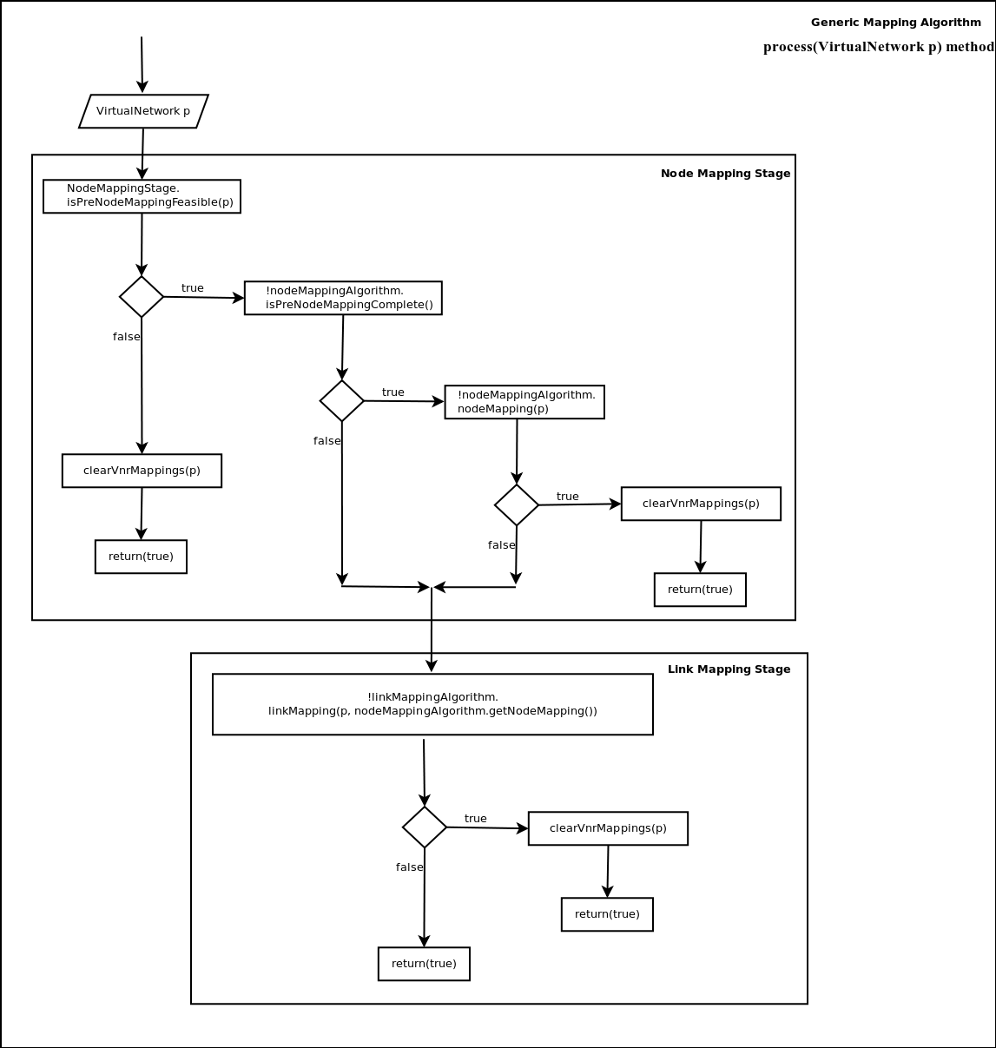
To implement a new algorithm that has both: node and link mapping stage, two classes need to be implemented. Node mapping class that extends from AbstractNodeMapping and the link mapping class that extends from AbstractLinkMapping.

AbstractNodeMapping
Let's now check the methods and variables of AbstractNodeMapping:
public abstract class AbstractNodeMapping {
protected Map<VirtualNode, SubstrateNode> nodeMapping;
private List<VirtualNode> unmappedvNodes;
private List<SubstrateNode> unmappedsNodes;
protected List<SubstrateNode> mappedsNodes;
The previous global variables have the following meaning:
- nodeMapping: It is a list of Map type that contains the mapping of each Virtual Node to its corresponding SubstrateNode after the node mapping is realized. This variable should be updated while mapping is being performed.
- unmappedvNodes: It is a list with the virtual nodes that have not been mapped, for the current virtual network request, after a predefined node mapping have been performed. ALEVIN supports the possiblity of predefining the mapping of a set of virtual nodes (possibly all) into its corresponding substrate nodes.
- unmappedsNodes: It is a list with the substrate nodes that have not been mapped, for the current virtual network request, after a predefined node mapping have been performed.
- mappedsNodes: It is a list with the substrate nodes that have been mapped, for the current virtual network request, performing the predefined node mapping.
public boolean isPreNodeMappingFeasible(VirtualNetwork vNet)
ALEVIN supports a resource/demand called id in nodes: In this way it is possible to realize a predefined node mapping before the algorithm runs, it is enough to assign in the IdDemand of the virtual nodes the IdResource of the substrate nodes that are chosen to realize the mapping. The isPreNodeMappingFeasible method is responsible of realizing this predefined mapping and ensures that the resources of the mapped substrate nodes are enough to cover the demands of the virtual nodes. The method returns a false value if the mapping could not be performed. This method is already implemented in AbstractNodeMapping and used in GenericMappingAlgorithm. After the method is performed; nodeMapping, unmappedvNodes, unmappedsNodes and mappedsNodes are updated.
public boolean isPreNodeMappingComplete() {
return unmappedvNodes.isEmpty();
}
The method isPreNodeMappingComplete() checks if in the predefined node mapping stage, the virtual node mapping has been performed completely or not. It is complete if all virtual nodes have been mapped, in this case no virtual node mapping should be performed. This method is already implemented in AbstractNodeMapping and used in GenericMappingAlgorithm.
protected abstract boolean nodeMapping(VirtualNetwork vNet);
The nodeMapping method is the most important method of the class. This method is the one that has to be implemented in a new class (extending AbstractNodeMapping). It is important to know, when implementing this method, that probably a predefined mapping has been performed and some virtual nodes of the virtual network request have already been mapped (take into account nodeMapping, unmappedvNodes, unmappedsNodes and mappedsNodes variables). After the nodeMapping has been performed, the nodeMapping variable should be updated and the method should return a boolean value (true if the node mapping was successful, false otherwise) To see some implementations of the nodeMapping() method, please go to vnreal.algorithms.nodemapping package.

AbstractLinkMapping
Let's now check the methods and variables of AbstractLinkMapping:
public abstract class AbstractLinkMapping {
protected int processedLinks, mappedLinks;
The AbstractLinkMapping variables processedLinks and mappedLinks are used to update the progress bar of the algorithm. When a virtual link is being mapped, processedLinks should be incremented by 1, and when it have been already mapped, mappedLinks should also be incremented by 1.
protected abstract boolean linkMapping(VirtualNetwork vNet,Map<VirtualNode, SubstrateNode> nodeMapping);
The main method of the AbstractLinkMapping class is the abstract linkMapping method. This method is the one that has to be implemented in a new class (extending AbstractLinkMapping). The input is the virtual network request and the already performed node mapping. The output of the method should be a boolean true if the node mapping was successful, false otherwise).

Required GUI adoptions
If you want your new algorithm to appear in the GUI, simply extend the class vnreal.gui.menu.AlgorithmsMenu.

Adding of New Pair of Resource/Demand Types

Overview
- All resource types are derived from AbstractResource
- Resources may only be added to the entities of the SubstrateNetwork
- The SubstrateNetwork consists of SubstrateLinks and SubstrateNodes
- All demand types are derived from AbstractDemand
- Demands may only be added to the entities of a VirtualNetwork
- A VirtualNetwork consists of VirtualLinks and VirtualNodes
We use the Visitor pattern and Adapter pattern to avoid
- casts to concrete demand/resource classes,
- the use of Java's instanceof as far as possible.
N.b.: We use these design pattern in an entangled way.
- A resource is a visitor for a demand providing the occupy and free visitors
- A demand is a visitor for a resource providing the accepts and fulfills visitors
- Do not get confused about this.
- Every Resource and Demand has a name. When you create a clone (with getCopy) you have to copy the name over to the clone. So that the equals()-Method can do matches with clones.
- The if you don't provide a name the name is sat as “Name of owner”_”this.hashCode()”

About the visitor pattern
Normally the visitor pattern is used to be able to add new operations to an existing object structure, without altering every single object. The operations get encapsulated in visitors, which then visit the objects and interacts with them. The object only have to provide a simple interface to accept visitors.
Here we do already know all operations we need (free, occupy, accepts, fulfills), but want to be able to add new resource / demand pairs to our network, e.g. new objects, which then can handle all upcoming resource / demand requests.

Constraints
For ALEVIN's XML exchange format documentation, resource and demand classes need to meet the following constraints
- The constraint classes must implement one or both of the INodeConstraint, ILinkConstraint interfaces. This shows whether the Constraint is applicable to nodes, links or both.
- For each parameter that shall be included in the exchange format, a getter and a setter method must be declared and annotated with @ExchangeParameter
  - Getters are required for export
  - Setters are required for import
- The parameters for these methods must not be simple types (int, double) but classes such that it can be used via Java Reflection
  - N.B. Currently, the exchange format supports the following types: Integer, Double, String, and Boolean
- Resources
  - Getter methods must be named according to the following pattern: get + <parameter name>
  - Setter methods must be named according to the following pattern: get + <parameter name>
- Demands
  - Getter methods must be named according to the following pattern: getDemanded + <parameter name>
  - Setter methods must be named according to the following pattern: setDemanded + <parameter name>

Procedure
To add the new demand type MyNewDemand and the corresponding resource type MyNewResource perform the following steps:
- Add dummy methods to
  - vnreal.demands.DemandVisitorAdapter
public boolean visit(MyNewDemand req) {
return false;
}
  - vnreal.resources.ResourceVisitorAdapter
public boolean visit(MyNewResource req) {
return false;
}
- Create a new class MyNewResource in package vnreal.resources extending AbstractResource
- Create a new class MyNewDemand in package vnreal.demands extending AbstractDemand
- Implement all abstract methods (imitate existing code, like IdDemand and IdResource)

How Demands are Mapped to Resources and Vice Versa
Mappings between demands and resources are established by the mapping algorithms. For each demand, the algorithms determine the resources fulfilling it.
To create a mapping between a demand an a resource the following steps ar needed:
- The resource must accept the demand. In this step, it is determined if the resource and demand are compatible.
- The resource must fulfill the demand. This assures that the resource is sufficient for the demand's requirements.
- Finally, the demand occupies the resource. In this step, the free capacity of the resource is reduced and a mapping between the two constraints is created.
To remove an existing mapping, the demand must free the occupied resource.

How to Deal with Demand-Resource Mappings
- Access
  - Get occupied resource from a demand:
AbstractDemand d;
for (vnreal.mapping.Mapping m : d.getMappings()) {
AbstractResource r = m.getResource();
// ...
}
  - Get occupying demands of a resource:
AbstractResource r;
for (vnreal.mapping.Mapping m : r.getMappings()) {
AbstractDemand d = m.getDemand();
// ...
}
- Removal
AbstractDemand d;
AbstractResource r;
d.getMapping(r).unregister(); // unlinks both elements

Example for occupying and freeing resources
To occupy a resource for a virtual network, the occupy() method of the corresponding Demand gets called. The occupy() method retrieves the occupy visitor from the Resource, which then visits the Resource.
At first it checks, if the Resource is able to fulfill the Demand by calling the fulfills() method of the Resource. The fulfills() method retrieves the fulfills visitor from the Demand, which then visits the Resource and returns if it is able to fulfill the demand. This result gets forwarded to the occupy visitor, which then creates a new Mapping to occupy the demanded resource. The Mapping registers itself at the Demand and the Resource.
At last the occupy visitor returns if the resource occupation was successful. This results gets forwarded to the caller of the occupy() method.

<occupy svg>

To free a resource, which is no longer needed, the free() method of the corresponding Demand gets called. The free() method retrieves the free visitor from the Resource, which then visits the Resource.
The free visitor takes the corresponding mapping and advises it to unregister itself from the Demand and the Resource. If this was successful, the Resource is freed and the result gets forwarded to the Demand and from there to the caller of the free() method.

<free svg>

Adding New Metrics

Overview
- Metrics are in the package vnreal.evaluations.metrics
- All Metrics are derived from the EvaluationMetric interface
- Metrics are supposed to set the NetworkStack as a private member using the setStack(NetworkStack<?,?,?,?> stack) method
- Metrics extend the getValue() method in order to compute the value on a particular NetworkStack
- getStat() can be used to return a textual representation of the status of the metric
- It is also possible to derive from AbstractEvaluation (which, in turn, derives from EvaluationMetric)
  - In this case, one should override the calculate() method to get the metric for a single run
  - getValue() can then be used to get aggregate values (e.g. by introducing private members)
  - toString() is expected to return a short textual description of the metric

Example
package vnreal.evaluations.metrics;
import vnreal.network.NetworkStack;
import vnreal.algorithms.utils.energy.Utils;
import vnreal.network.substrate.SubstrateNetwork;
import vnreal.network.substrate.SubstrateNode;
public abstract class SimpleHiddenHops extends AbstractEvaluation {
int i = 0;
double sum = 0;
@Override
public double getValue() {
++i;
double result = calculate();
sum += result;
return result;
}
@Override
public String getStat() {
return i == 0
? "no computed evaluation results"
: ("average: " + (sum / i) + " (" + i + " computed evaluation results)");
}
@Override
public double calculate() {
SubstrateNetwork sNetwork = stack.getSubstrate();
int result = 0;
for (SubstrateNode sn : sNetwork.getVertices()) {
if (Utils.isHiddenHop(sn)) {
result++;
}
}
return result;
}
public String toString() {
return "CountHiddenHops";
}
}

