**TEMA 2 – JIGLAU FABRIZZIO 133**

--Ex 1: Folosind clauza with, pentru fiecare departament afisati

--informatii despre angajatii cu cel mai mare salariu din acel departament.

--Daca intr-un departament nu lucreaza nimeni, veti afisa

--un mesaj corespunzator (diferit de "nu lucreaza nimeni").

WITH max_salaries AS (

SELECT department_id, MAX(salary) AS max_salary

FROM employees

GROUP BY department_id

),

max_sal_employees AS (

SELECT e.department_id, e.employee_id, e.first_name,

e.last_name, e.salary

FROM employees e, max_salaries ms

WHERE e.department_id = ms.department_id

AND e.salary = ms.max_salary

)

SELECT d.department_name,

CASE WHEN e.employee_id IS NULL THEN

'Departamentul nu are angajati!'

ELSE

TO_CHAR(e.employee_id)

END AS employee_id,

NVL(e.first_name, '-') AS fn, NVL(e.last_name, '-') AS ln, NVL(e.salary, '0') AS sal

FROM departments d

LEFT OUTER JOIN max_sal_employees e ON d.department_id = e.department_id

ORDER BY sal DESC;

-- 27 rezultate

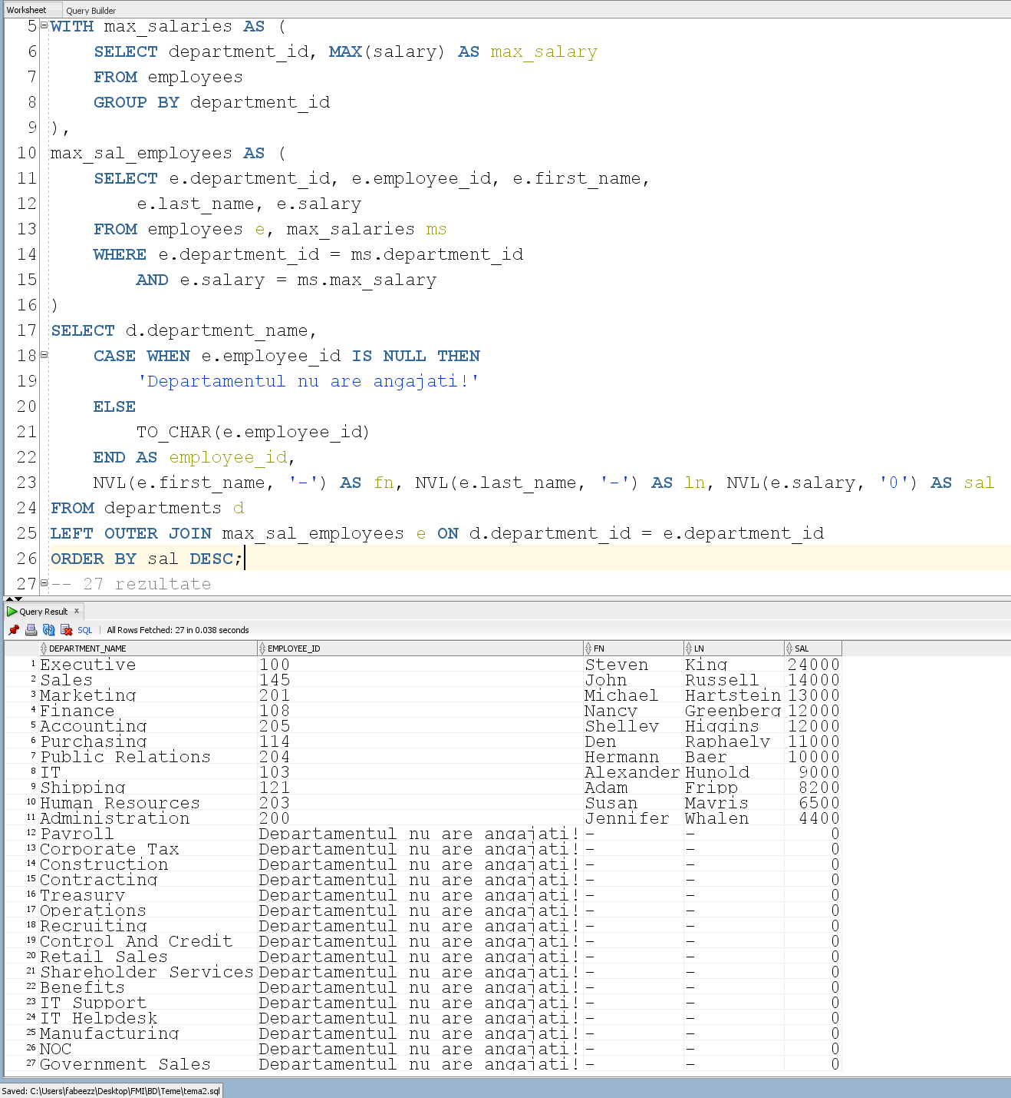

--Ex 2: Afisati codul si numele departamentului si numele complet

--al managerului departamentelor pentru managerii de departament

--avand salariul mai mare decat media salariilor angajatilor

--al caror sef direct are un numar de telefon ce contine sirul "67".

WITH emp_67 AS (

SELECT avg(e.salary) as avg_salary

FROM employees e, employees m

WHERE e.manager_id = m.employee_id

AND m.phone_number LIKE '%67%'

)

SELECT d.department_id, d.department_name,

m.first_name || ' ' || m.last_name as manager_name

FROM departments d, employees m

WHERE d.manager_id = m.employee_id

AND m.salary > (SELECT avg_salary FROM emp_67)

ORDER BY d.department_id;

-- 7 rezultate

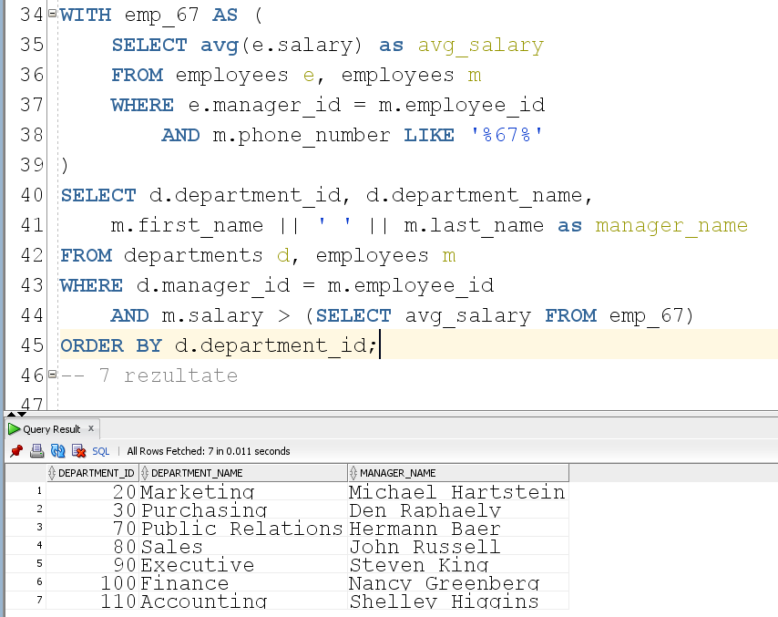

--Ex 3: Afisati departamentele in care lucreza angajati

--al caror manager direct are un numar de telefon ce contine fix 10 CIFRE.

--(Atentie la forma actuala a numerelor de telefon din baza de date.

--Folositi doar functiile prezente in fisierele oferite ca suport la laborator.)

--Se vor afisa doar departamentele a caror medie salariala

--este mai mare decat media salariala a intregii firme.

WITH dep_10 AS (

SELECT DISTINCT d.department_id, d.department_name,

ROUND(AVG(e.salary)) avg_sal_dep

FROM departments d, employees e, employees m

WHERE d.department_id = e.department_id AND e.manager_id = m.employee_id

AND LENGTH(REPLACE(m.phone_number, '.', '')) = 10

GROUP BY d.department_id, d.department_name),

company AS (

SELECT ROUND(AVG(e1.salary)) avg_sal_comp

FROM employees e1)

SELECT d.department_id, d.department_name

FROM dep_10 d, company c

WHERE d.avg_sal_dep > c.avg_sal_comp;

-- 7 rezultate

