

**PAF KIET**

**REPORT**

**Submitted to: SIR M. ARSALAN**

**GROUP MEMBERS**

**MAHNOOR KHAN 12949**

**VANIZA BATOOL 13183**

**TEHREEM FATIMA 13108**

**MAHNOOR FATIMA 12564**

**REPORT**

**OF**

**COST AND MANAGERIAL ACCOUNTING**

**PROJECT TOPIC**

**ORIFLAME**

**----------------SWEDEN----------------**

**Your Dreams, Our inspiration**

**INTRODUCTION:**

**Who we are**

**A beauty company like no other**

For over 50 years we have enabled people from all over the world to celebrate their personal beauty and fulfil their dreams. We create and offer high quality, safe, trend-driven products to beauty lovers and the unique possibility to become part of a global beauty community.

**Beauty by Sweden**

As a Swedish beauty brand we believe that when you look and feel good you have the opportunity to reach your full potential. And together with a passionate and supportive global community anything is possible. That’s beauty from a Swedish perspective.

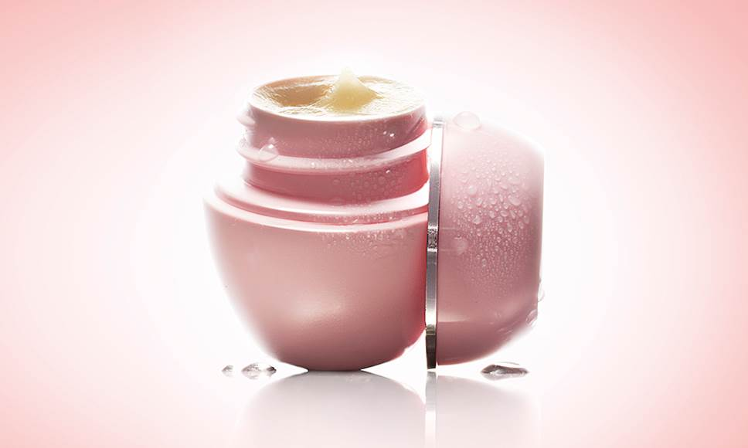

**Our history**

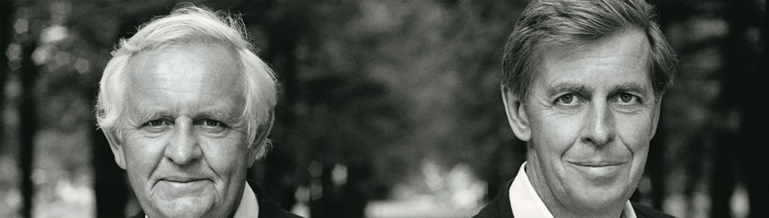

**A different kind of company**

It all began in 1967, in a small two-room office in central Stockholm. Two brothers, Jonas and Robert af Jochnick, and their friend, Bengt Hellsten, sat down and talked about their dreams. They wanted to create a different kind of company that offered a different kind of product. They came up with the idea of giving people the opportunity to benefit from high quality beauty products inspired by our Swedish nature. At the time, this was not an obvious road to success – especially not in Sweden. But that conversation marked the beginning of an incredible journey that continues to inspire more than 50 years later.  
  
Today Oriflame is present in over 60 markets with over 3 million independent Beauty Consultants who share, promote and sell our beauty and wellness products.

### **Our product philosophy**

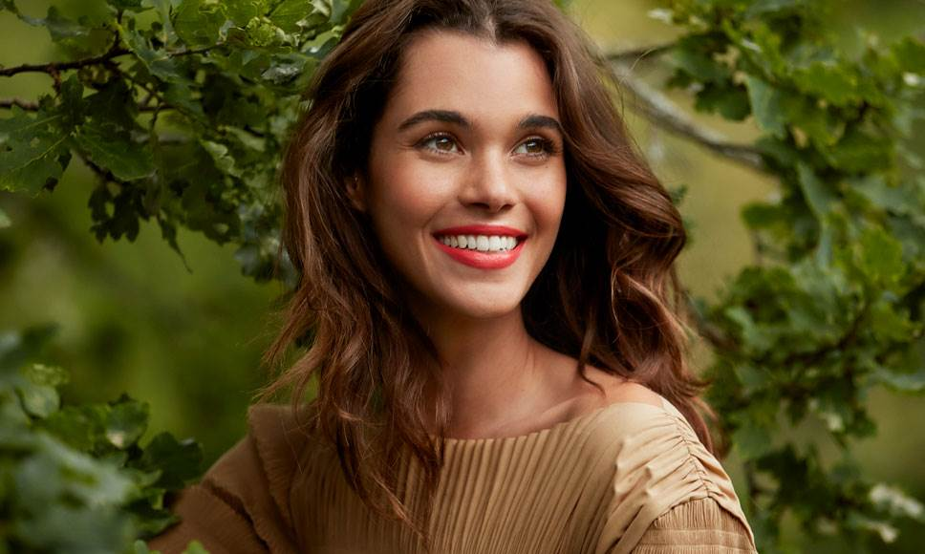

For us, beauty is a way of life - to be healthy, enjoy beautiful skin, express oneself and have fun together. At the same time, our products must be safe, reliable and deliver the results they promise. This philosophy is what guides us in creating products you can trust and fall in love with.

## Inspired by nature

Our Swedish nature has always played an important role for us. The plants that thrive and survive in our harsh Nordic climate have always inspired us and we were amongst the first in the world to create cosmetics with natural extracts such as birch sap extract, decades before other brands started doing so.

Today, we continue to turn to natural ingredients, whether we are working with plant stem cells in our clinically proven premium skin care or using natural exfoliants in our rinse-off products. In fact, all of our extracts are sourced from nature and our cosmetic ingredients all undergo our rigorous Eco-Ethical Screening to assess their source, safety and quality. So, we ensure it’s good for you and doesn’t harm the planet either.

**Our Values**

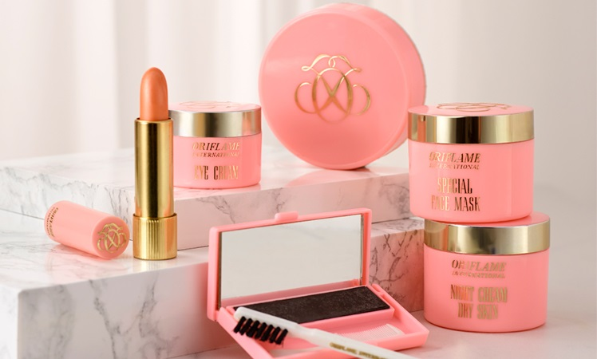

### **Togetherness**

Togetherness is a fundamental principle that our dynamic community is built upon and it is what makes us truly global. We believe that people who work together and share the same goals achieve greater results and have more fun along the way

### **Spirit**

Oriflame is a company built by true entrepreneurs. We believe that everything is possible. We are committed to do what it takes to succeed and deliver great results.

### **Passion**

We are passionate about beauty, our business and, most importantly, about our people – Oriflame employees and everyone who enjoys our products, who starts their own business, changes their lives and fulfils their dreams. Passion fuels our belief in the power of dreams to inspire, sustain, and change lives.

**OUR BUSINESS MODEL**



**Make money today and fulfil your dreams tomorrow**

We believe that starting your own business should be affordable and accessible to everyone. Our business opportunity offers you low-risk entrepreneurship and more: for a modest joining fee, you can start your own business, enjoy earning money from day one by selling our products and become part of our global community. You decide on how to combine your beauty business with your life and you choose whether you want to build an extra side income or grow it into a business of your own, and we will support you with tools and trainings to help you succeed.

**SO HERE ARE THE SCREEN SHOTS OF OUR PPT**

