**COURSE TITILE:**

**INTERNET AND INTRANET ARCHITECTURE**

**INTRUCTOR: KASHIF BASHIR**

**Project Report**

**INTERCAMPUS SCHOOL NETWORK ARCHITECTURE**

**GROUP MEMBERS:**

|  |  |  |  |
| --- | --- | --- | --- |
| **SNO.** | **STUDENT ID** | **NAME** | **CLASS ID** |
| **01**  **02**  **03** | **8845**  **8684**  **7953** | **MUKASHFA KAMRAN**  **SAHAR SALEEM**  **SAIMA FAZAL** | 102326 |

**INDEX**

|  |  |  |
| --- | --- | --- |
| **SERIAL NO.** | **CONTENTS** | **PAGE NO.** |
| 01 | Project Description | 4 |
| 02 | Main Topology | 4 |
| 2-1 | Inside cluster topology | 5 - 7 |
| 03 | **Protocols** | - |
| 3-1 | EIGRP | 8 |
| 3-2 | OSPF | 9 |
| 3-3 | RIP v2& Redistribution | 11 – 12 |
| 04 | **Project configuration** | - |
| 4-1 | Show ip interface brief (outside cluster) | 13-16 |
| 4-2 | Show ip interface brief (Inside cluster) | 16-23 |
| 4-3 | Show running-config (outside cluster) | 24 – 30 |
| 4-4 | Show running-config (Inside cluster) | 30 – 42 |
| 4-5 | Show ip route (Outside cluster) | 43- 50 |
| 4-6 | Show ip route (Inside cluster) | 51 – 60 |
| 05 | **Ping results** | - |
| 5-1 | From router to router and pc | 61 – 62 |
| 5-2 | From pc to router and pc (for natting) | 63 |
| 5-3 | From pc to router and pc (for natting) | 64 |
| 06 | Description of ACL | 65 |
| 07 | Description of NAT | 66 |

**Project description**:

We have design **Mukashfa ,sahar and saima , INTERCAMPUS SCHOOL NETWORK ARCHITECTURE.**

We have 5 branches all over Pakistan.Branches name are:

Main head office in Karachi

And other branches are:

Quetta

Peshawar

Islamabad

And Lahore

These all branches are communicating with each other and share their information among the branches

And these branches have E-mail server, Database server, Web server and Dns server.

Protocols are used in our branches area and we redistribute these all protocols to communicate all protocols.

OSPF (Open Shortest Path First)

EIGRP (Enhanced interior Gateway Routing Protocol)

RIP

Static (it is not a protocol but its techniques)

And our project topology is :

**MIAN TOPOLOGY** : 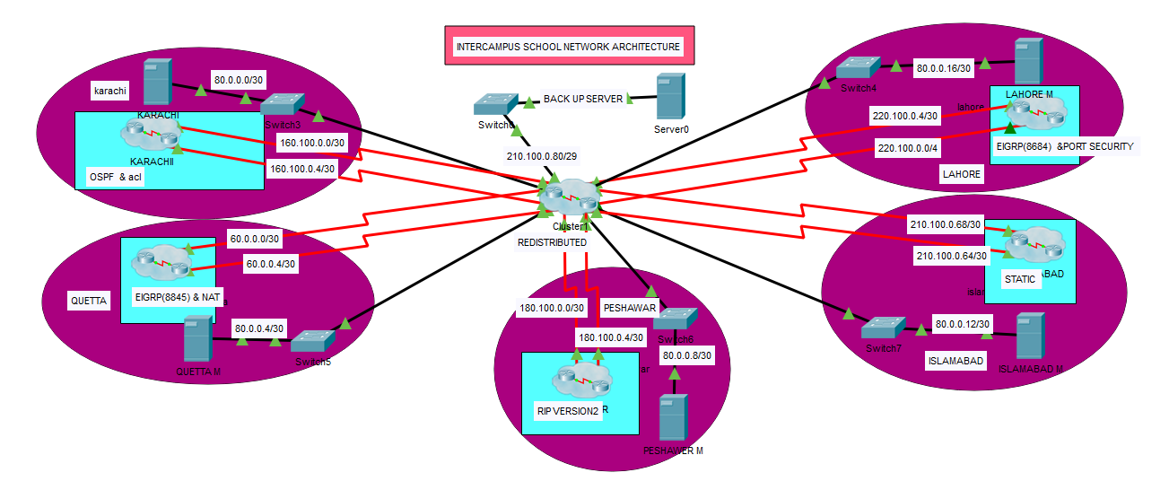

**INSIDE CLUSTER:**

1. **KARACHI**

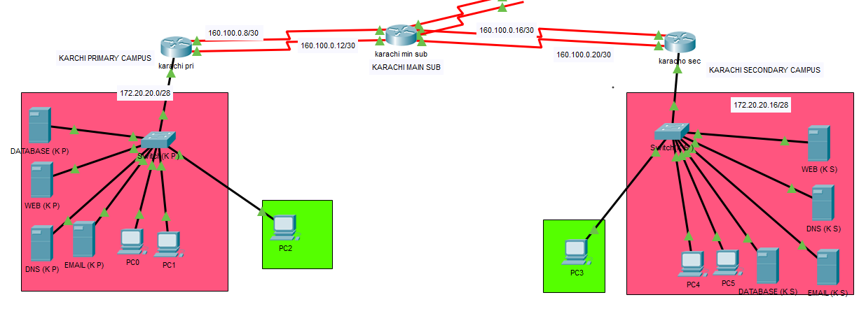

1. **QUETTA** 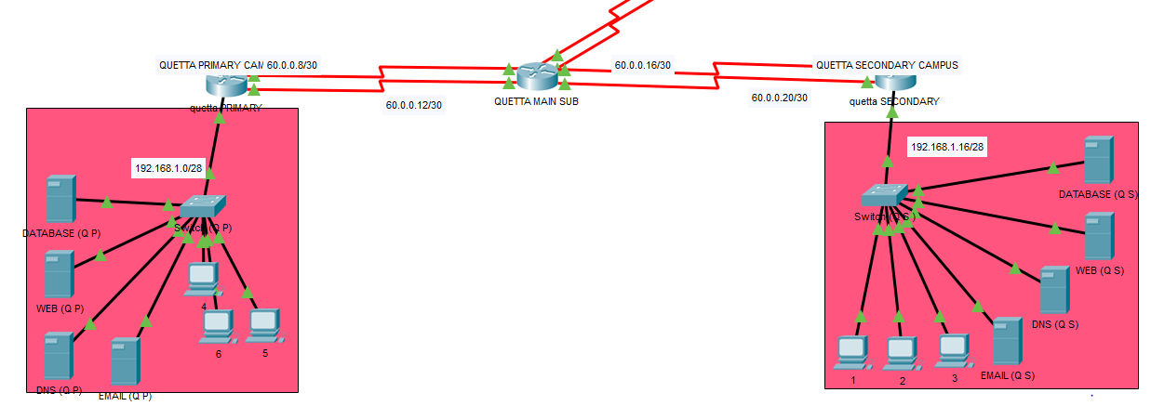
2. **PESHAWER**

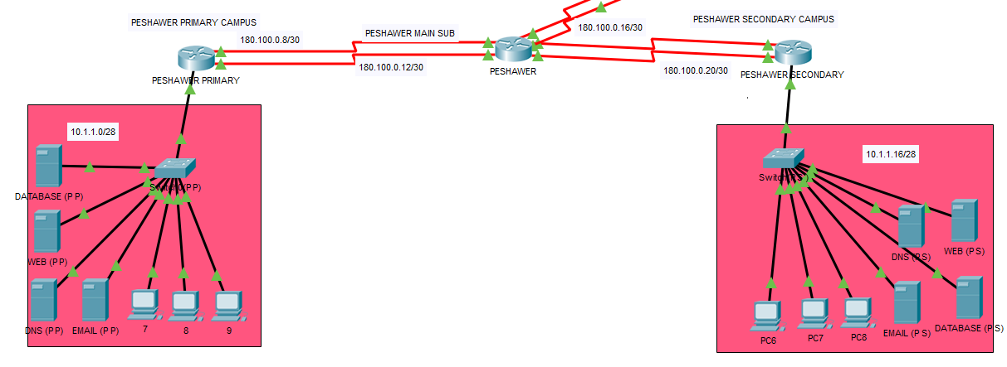

1. **ISLAMABAD**

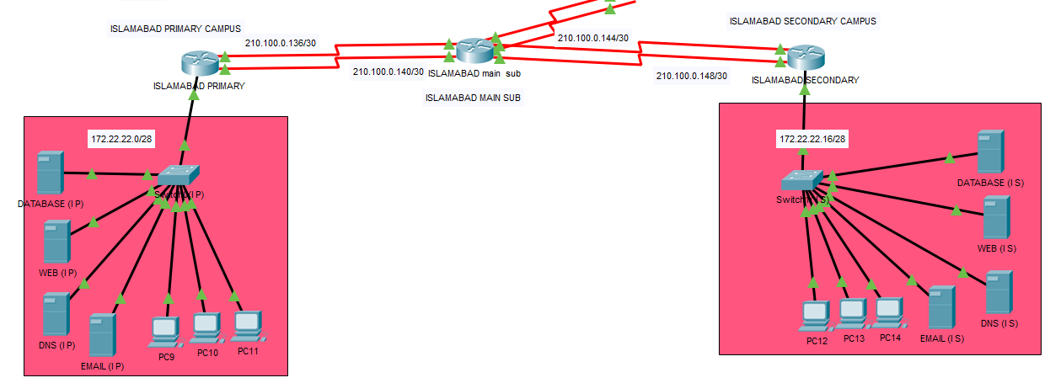

1. **LAHORE**

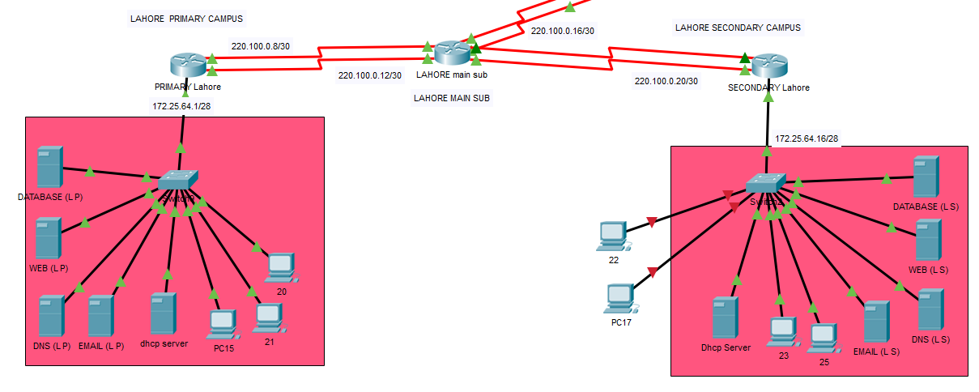

**PROTOCOLS:**

1. ***EIGRP (Enhanced Interior Gateway Routing Protocol)***

**Introduction**

Enhanced Interior Gateway Routing Protocol (EIGRP) is an interior gateway protocol suited for many different topologies and media. In a well-designed network, EIGRP scales well and provides extremely quick convergence times with minimal network traffic.

**EIGRP Theory of Operation**

Some of the many advantages of EIGRP are:

* Very low usage of network resources during normal operation; only hello packets are transmitted on a stable network
* When a change occurs, only routing table changes are propagated, not the entire routing table; this reduces the load the routing protocol itself places on the network
* Rapid convergence times for changes in the network topology (in some situations convergence can be almost instantaneous)

**Configuring EIGRP**

The basic configuration of EIGRP is so similar to the basic configuration of IGRP that instructors occasionally will instruct beginners to "configure IGRP, but add an E." As mentioned in the previous section, the metric weights command is used the same way with EIGRP and IGRP. The traffic-share and variance commands are also used identically.

**Basic EIGRP Configuration**

The process ID may be any number between 1 and 65535 (0 is not allowed), and it may be arbitrarily chosen by the network administrator, as long as it is the same for all EIGRP processes in all routers that must share information.

Use the router eigrp and network commands to create an EIGRP routing process:

Router(config)#router eigrp autonomous-system-number

Router(config-router) #network network-number

Autonomous-system-number identifies all routers that belong within the internetwork. The number does not have to be registered, but it must match all routers within the internetwork.

The network command assigns a major network number to which the router is directly connected.

Indicate which networks belong to the EIGRP autonomous system (AS) on the local

router with the network-number. The EIGRP routing process associates interface addresses with

the advertised network number and begins EIGRP packet processing on the specified interfaces.

## Summing Up

EIGRP offers the following radical improvements over RIP and IGRP:

* Fast convergence--convergence is almost instantaneous when a feasible successor is available.
* Variable Length Subnet Masks are supported--subnet mask information is exchanged in EIGRP updates. This allows for efficient use of the address space, as well as support for discontinuous networks.
* Route summarization at arbitrary bit boundaries, reducing routing-table size.
* No regular routing updates--network bandwidth and router CPU resources are not tied up in periodic routing updates, leading to improved network manageability.
* Ease of configuration--EIGRP can be configured with almost the same ease as IGRP. However, troubleshooting DUAL can be difficult.

1. **OSPF (Open Shortest Path First)**

**Introduction**

Open Shortest Path First (OSPF) is a dynamic routing protocol for use in Internet Protocol (IP) networks. Specifically, it is a link-state routing protocol and falls into the group of interior gateway protocols, operating within a single autonomous system (AS).

OSPF is used to determine the best route for delivering the packets within an IP networks.

### **Enabling the OSPF Routing Protocol**

The following command is needed in order to enable OSPF routing protocol on the router:

Router(config)#**router ospf** *process-number*

The *process-number* is nothing more than a number local to the router. It’s only used to distinguish processes within a router and can be given an arbitrary value. This value does not have to be the same on every router within the area. However, it is always good practice to keep this number the same for better administration.

### **Defining OSPF Networks**

Enabling OSPF is not enough to activate it. The OSPF process needs to know the networks that are going to be advertised (i.e. the interfaces on which OSPF will run) and the area they reside in. Therefore, the following command is needed to make OSPF operational:

Router(config-router) #**network** *address wildcard-mask* **area** *area-number*

The *address* can be the network address, subnet, or the address of a specific interface.

The **network** command is used to identify the interfaces on the router that are going to participate in the OSPF process. Adjacencies will be created with these interfaces and LSAs will be received and transmitted on these interfaces.

Therefore, the wildcard-mask parameter needs to be defined for accurately identifying the necessary interfaces.

The *wildcard-mask* consists of 4 groups of 8-bits each. Each 0 bit indicates a “must” and each 1 bit indicates an “any”. This will become clearer in the next section on Defining OSPF Networks Examples.

The *area-number* specifies the area to be associated with the specific address and consequently the interfaces to be grouped within that area.

By default, **area 0** is used; if more than one area is to be created in a network, **area 0** is the first one that needs to be defined.

**Advantages of OSPF**

* OSPF is an open standard, not related to any particular vendor.
* OSPF is hierarchical routing protocol, using area 0 (Autonomous System) at the top of the hierarchy.
* OSPF uses Link State Algorithm, and an OSPF network diameter can be much larger than that of RIP.
* OSPF supports Variable Length Subnet Masks (VLSM), resulting in efficient use of networking resources.
* OSPF uses multicasting within areas.
* After initialization, OSPF only sends updates on routing table sections which have changed, it does not send the entire routing table, which in turn conserves network bandwidth.
* Using areas, OSPF networks can be logically segmented to improve administration, and decrease the size of routing tables.

**Disadvantages of OSPF**

* OSPF is very processor intensive due to implementation of SPF algorithm. OSPF maintains multiple copies of routing information, increasing the amount of memory needed.
* OSPF is a more complex protocol to implement compared to RIP.

1. **Rip V2**

**Introduction**

Classless Routing Protocols

The true characteristic of a classless routing protocol is the ability to

carry subnet masks in their route advertisements.

Classless Routing Protocol, sent over UDP port 520

• Includes the subnet mask in the routing updates.

• Automatic summarization at major network boundaries can be disabled.

• Updates sent as multicasts unless the neighbor command is uses which Sends them as unicasts.

**Configuring RipV2**

Router rip

Version 2

Network directly connected

No auto-summary

Ex

**Discontiguous subnets and classless routing**



* RIP v1 always uses automatic summarization.
* The default behavior of RIP v2 is to summarize at network boundaries the same as RIP v1.

1. **Redistribution**

**Introduction**

Using a routing protocol to advertise routes that are learned by some other means, such as by another routing protocol, static routes, or directly connected routes, is called redistribution. While running a single routing protocol throughout your entire IP internetwork is desirable, multi-protocol routing is common for a number of reasons, such as company mergers, multiple departments managed by multiple network administrators, and multi-vendor environments. Running different routing protocols is often part of a network design. In any case, having a multiple protocol environment makes redistribution a necessity.

Differences in routing protocol characteristics, such as metrics, administrative distance, classful and classless capabilities can affect redistribution. Consideration must be given to these differences for redistribution to succeed.

EIGRP & IGRP need five metrics when redistributing other protocols: bandwidth, delay, reliability, load, and MTU, respectively.

|  |  |
| --- | --- |
| **Metric** | **Value** |
| **Bandwidth** | In units of kilobits per second; 10000 for Ethernet |
| **Delay** | In units of tens of microseconds; for Ethernet it is100 x 10 microseconds = 1 ms |
| **Reliability** | 255 for 100 percent reliability |
| **Load** | Effective load on the link expressed as a number from 0 to 255 (255 is 100 percent loading) |
| **MTU** | Minimum MTU of the path; usually equals that for the Ethernet interface, which is 1500 bytes |

OSPF need 1 metric and rip v2 also need 1 metric

|  |  |
| --- | --- |
| Metric | **value** |
| Bandwidth (for ospf) | In units of kilobits per second |
| Hope count | Reachable way |

**SHOW IP INTERFACE BRIEF(OUSIDE CLUSTER);**

**COMMAND**

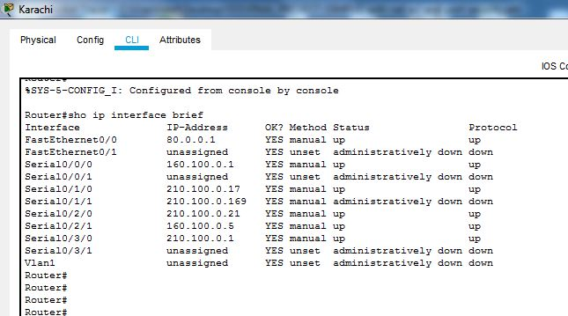Show ip interface brief on Karachi

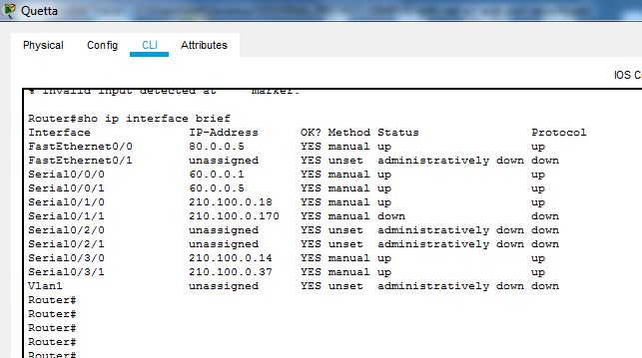Show ip interface brief on Quetta

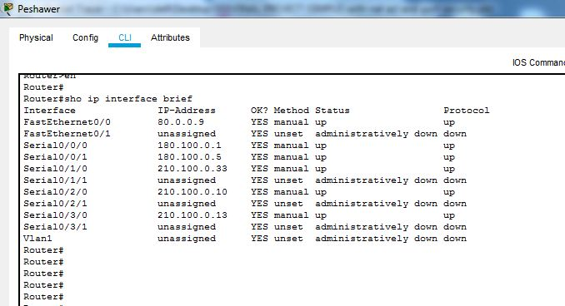Show ip interface brief on Peshawar

Show ip interface brief on Islamabad

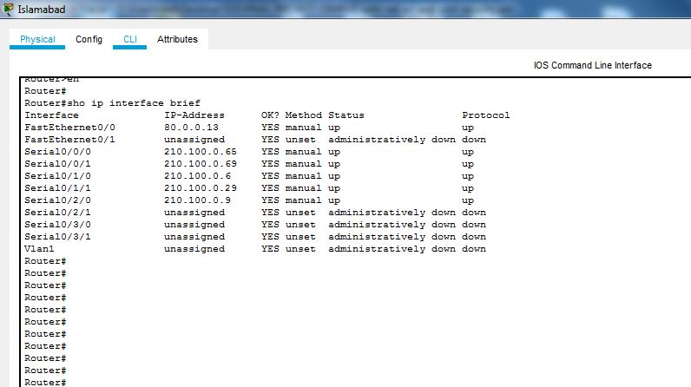

Show ip interface brief on Lahore

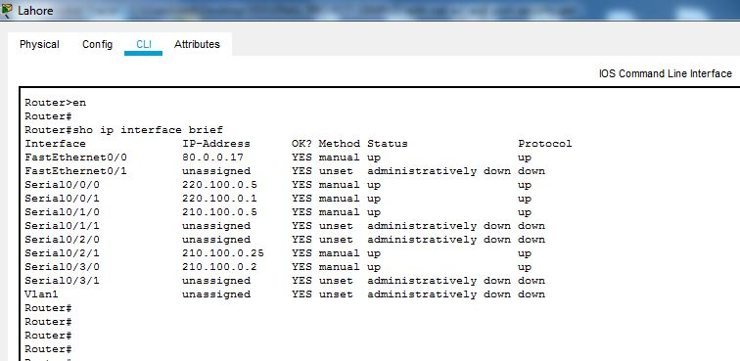

Show ip interface brief on main link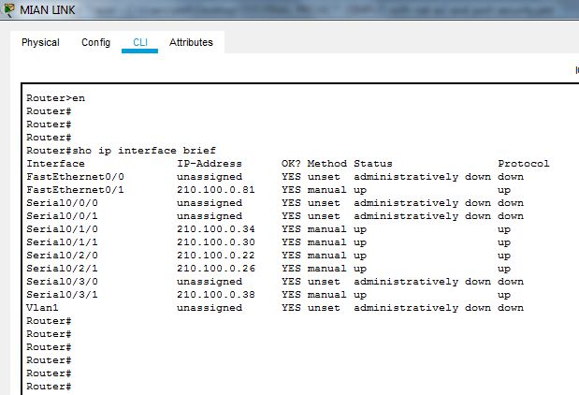

**SHOW IP INTERFACE BRIEF (INSIDE CLUSTER);**

Show ip interface brief on Karachi Cluster

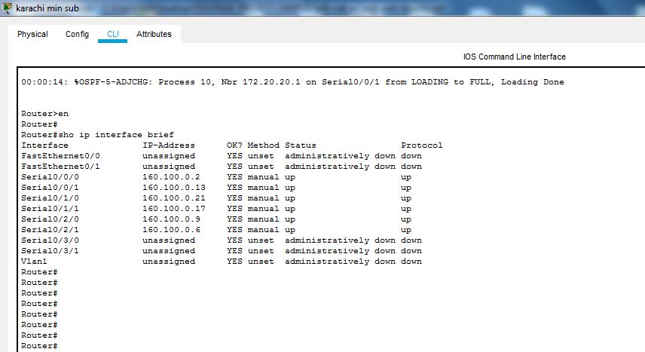

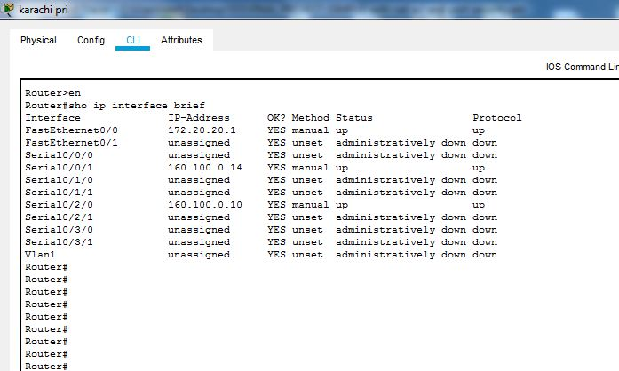

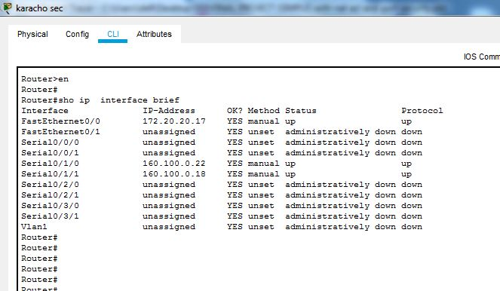

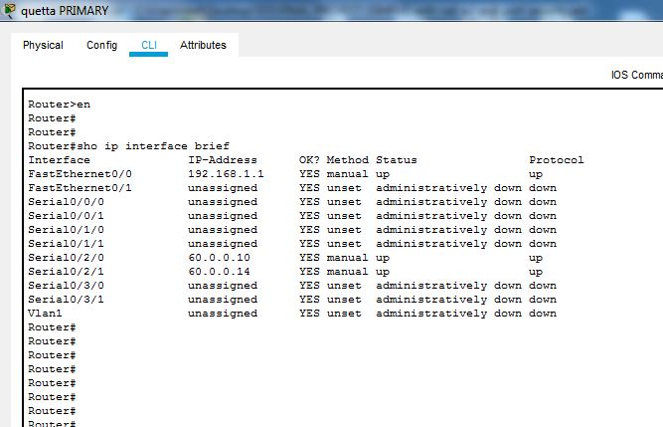Show ip interface brief on Quetta Cluster

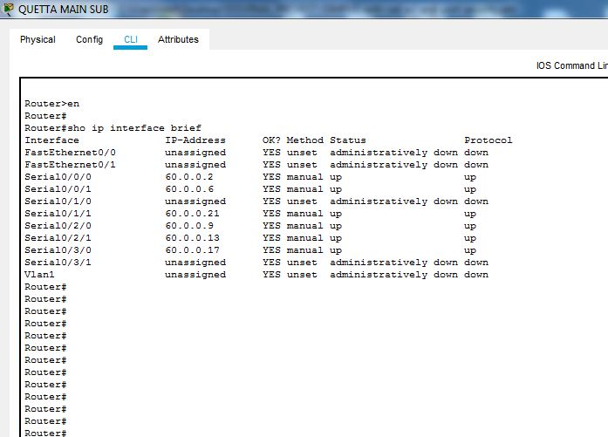

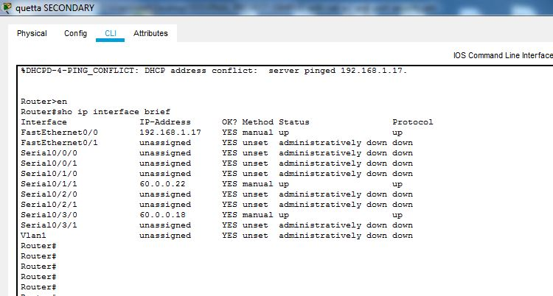

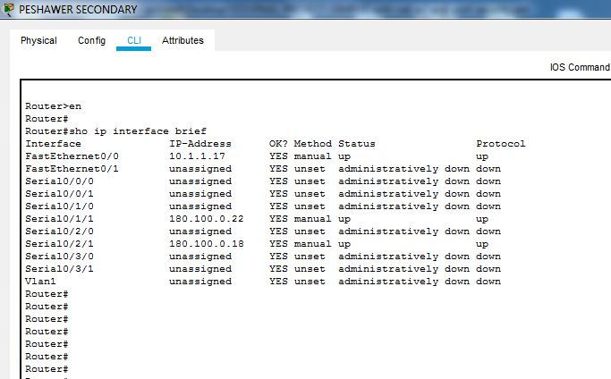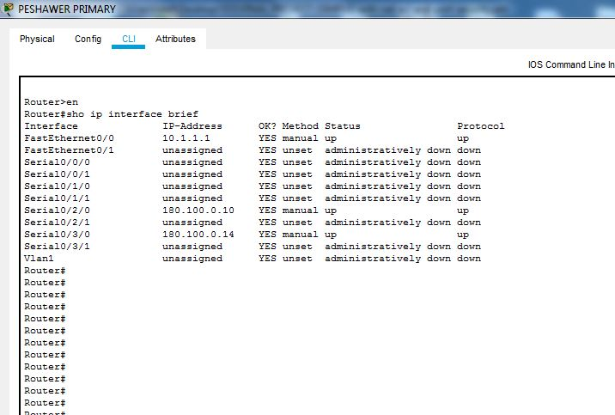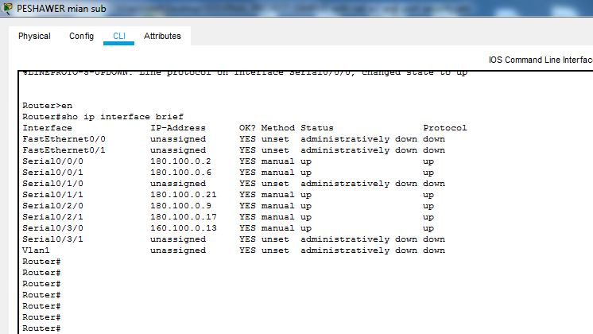Show ip interface brief on Peshawar Cluster

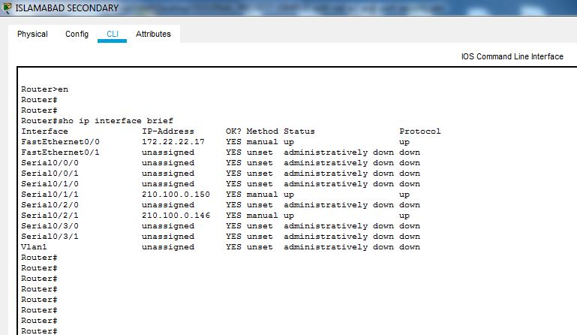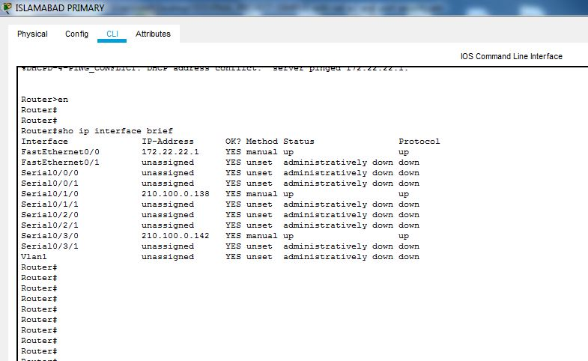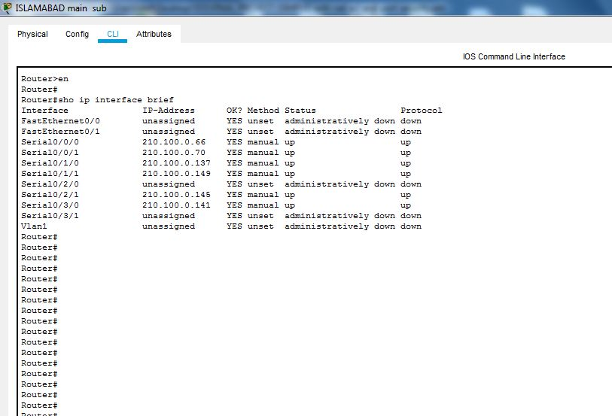Show ip interface brief on Islamabad Cluster

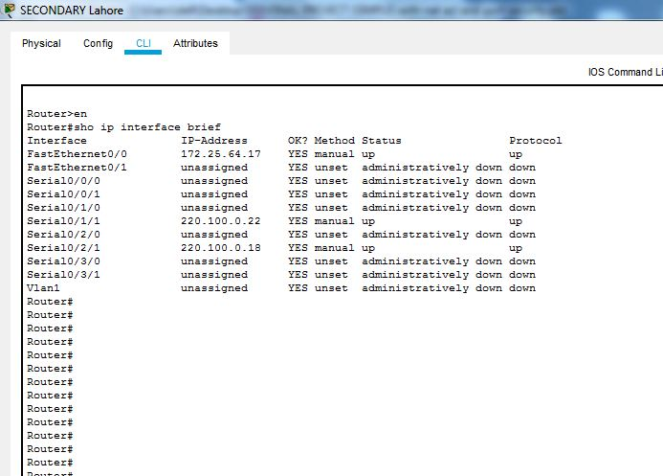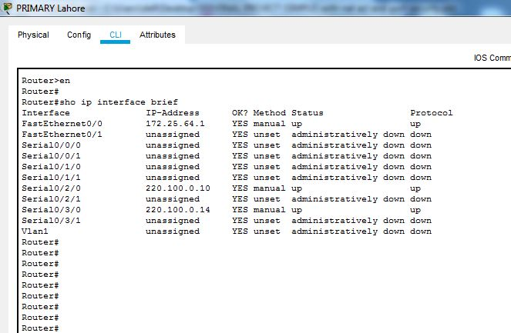Show ip interface brief on Lahore Cluster

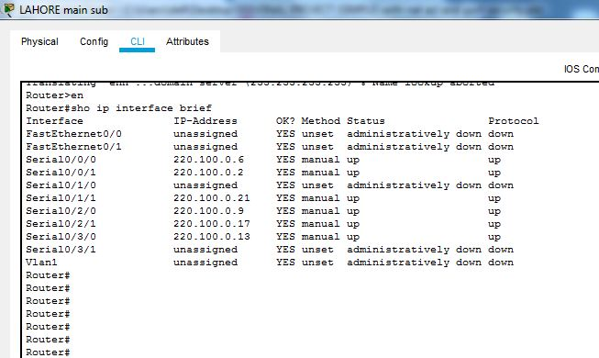

**SHOW RUNNING-CONFIG (OUSIDE CLUSTER);**

**COMMAND**

SHOW RUNNIG-CONFIG ON KARACHI

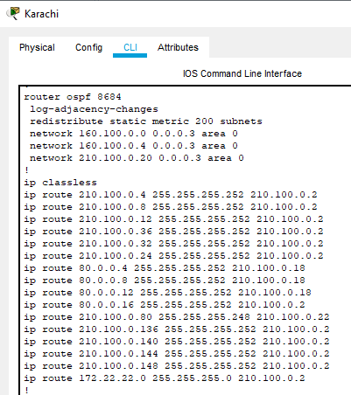

SHOW RUNNIG-CONFIG ON QUETTA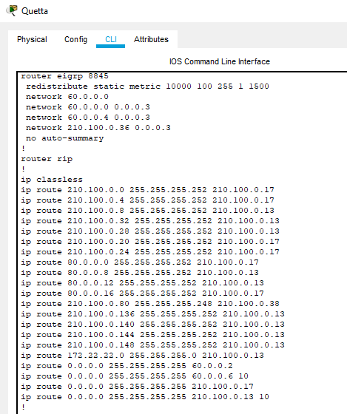

SHOW RUNNIG-CONFIG ON Peshawar

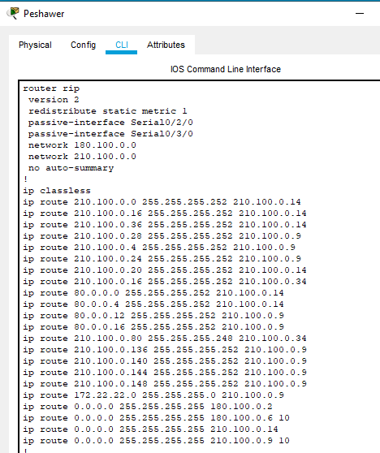

­­SHOW RUNNIG-CONFIG ON ISLAMABAD

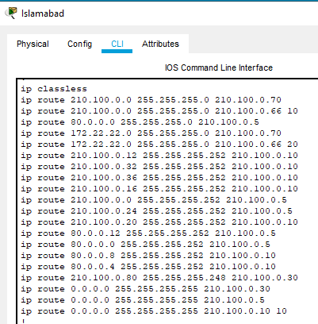

SHOW RUNNIG-CONFIG ON LAHORE

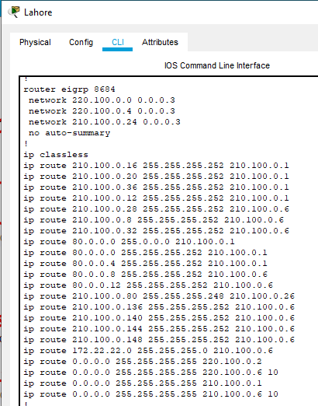

SHOW RUNNIG-CONFIG ON MAIN LINK

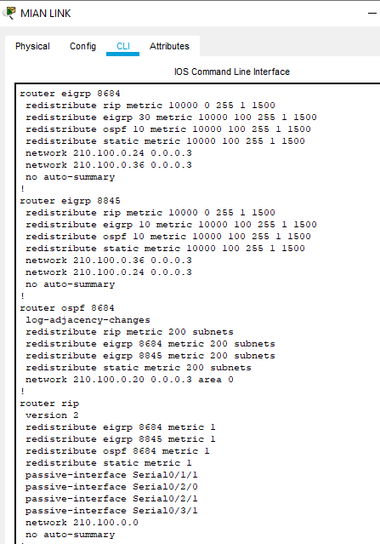

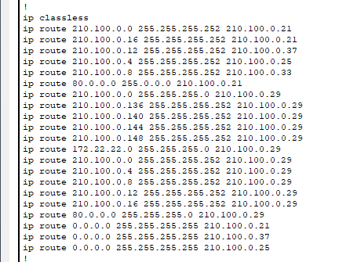

**SHOW RUNNING-CONFIG (INSIDE CLUSTER);**

Show running-config on Karachi Cluster

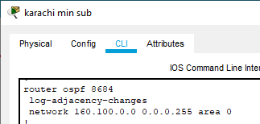

Karachi primary: Karachi secondary :

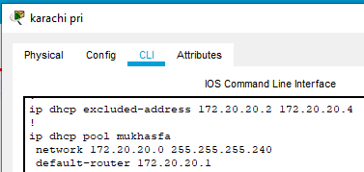 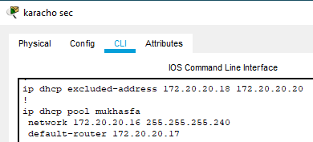

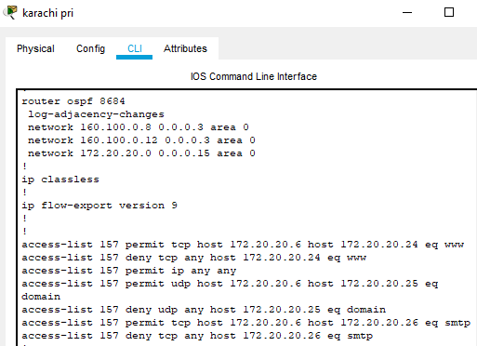 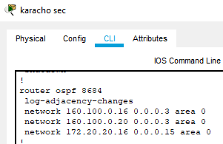

Show ip running-config on Quetta Cluster

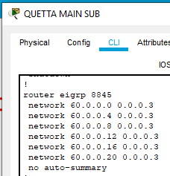

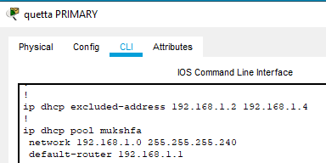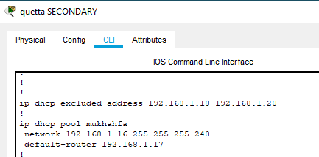

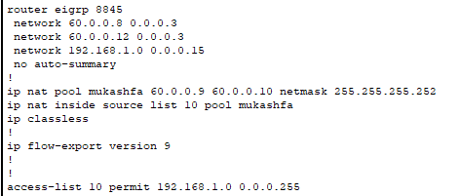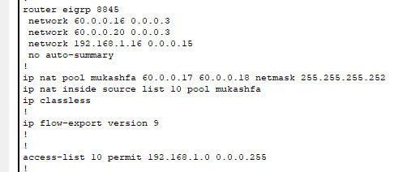

Show running-config on Peshawar Cluster

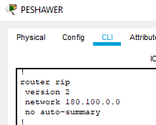

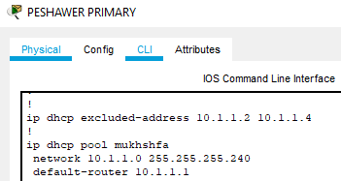 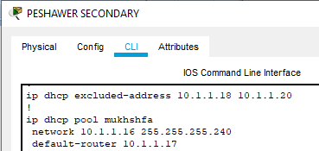

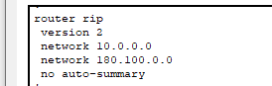 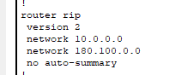

how running-config on Islamabad Cluster

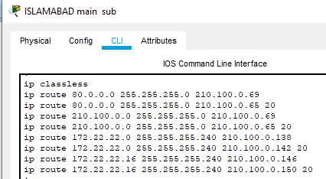

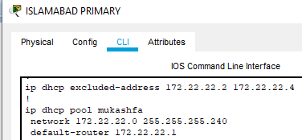 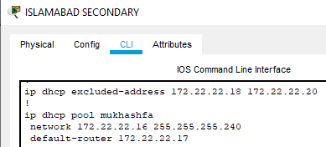

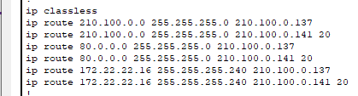 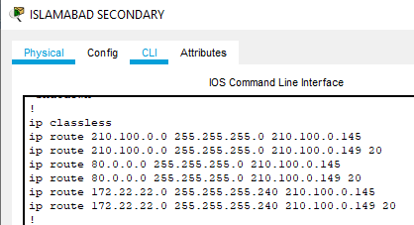

Show running-config on Lahore Cluster

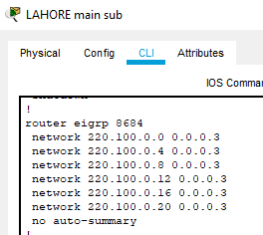

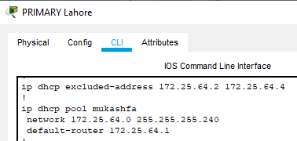 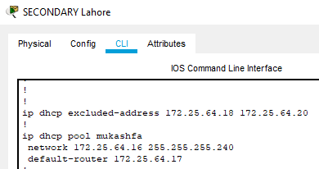

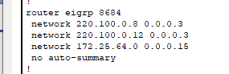 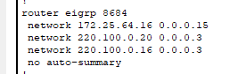

**Show ip route (INSIDE MAIN CLUSTER);**

Show ip route on Karachi

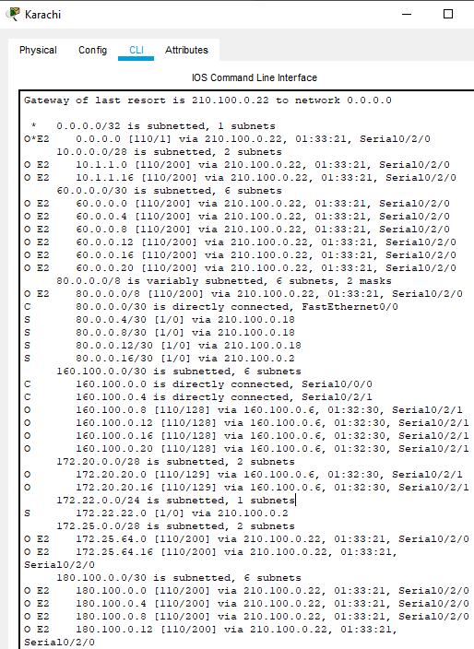

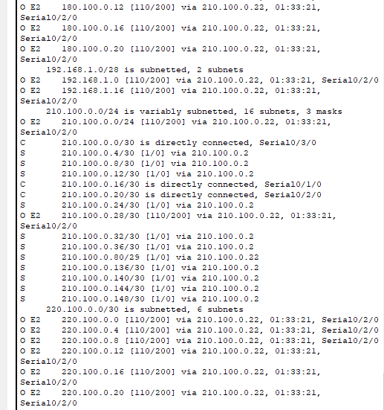

Show ip route on Quetta

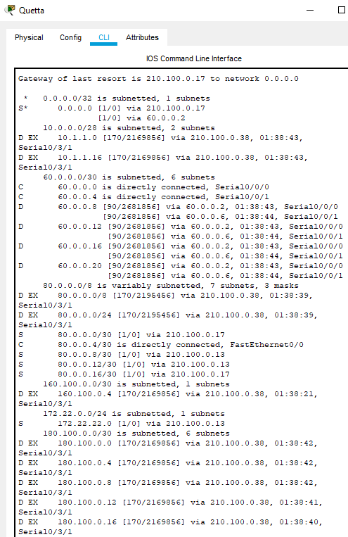

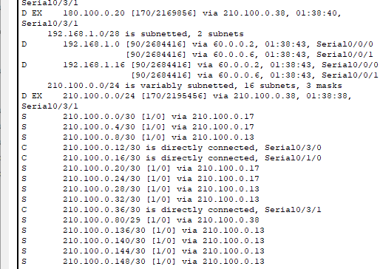

Show ip route in Peshawar

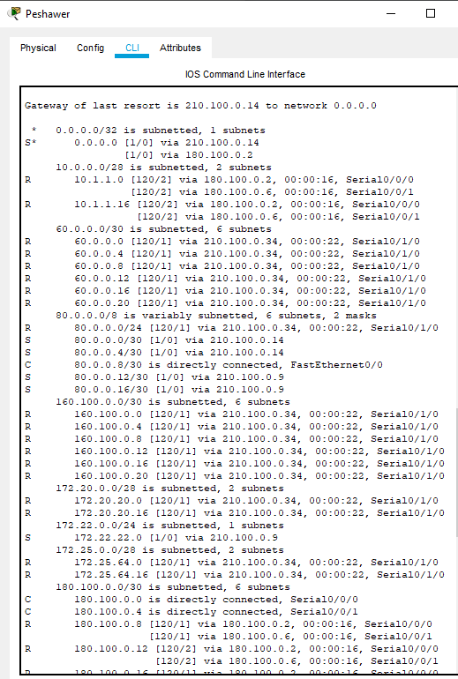

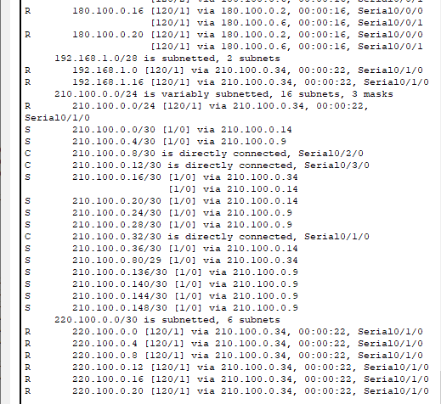

Show ip route on Islamabad

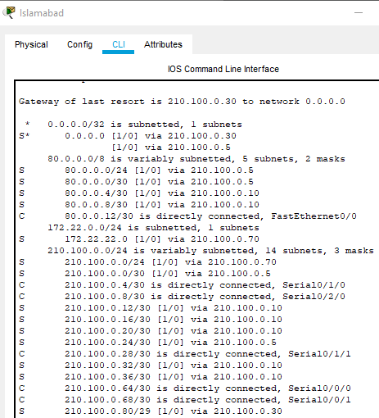

Show ip route on Lahore

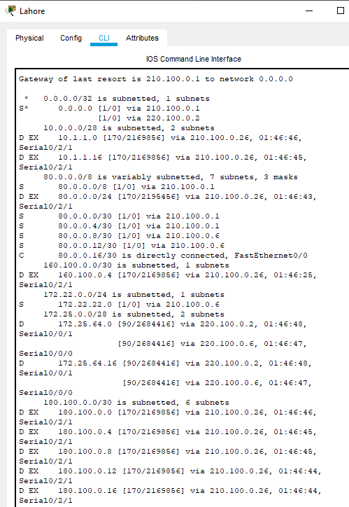

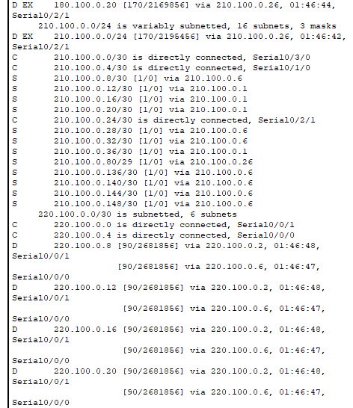

Show ip route on Main link

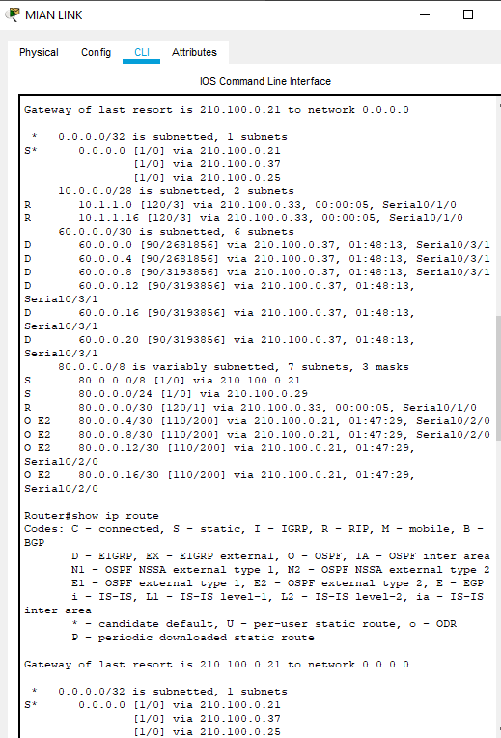

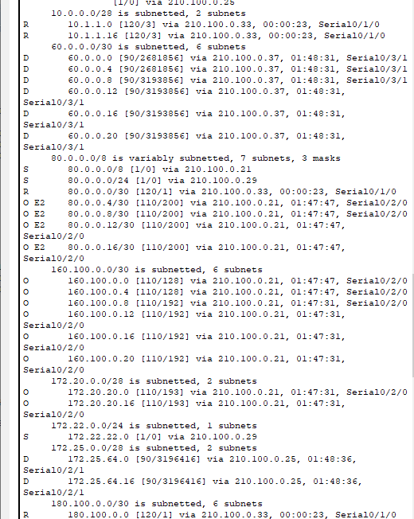

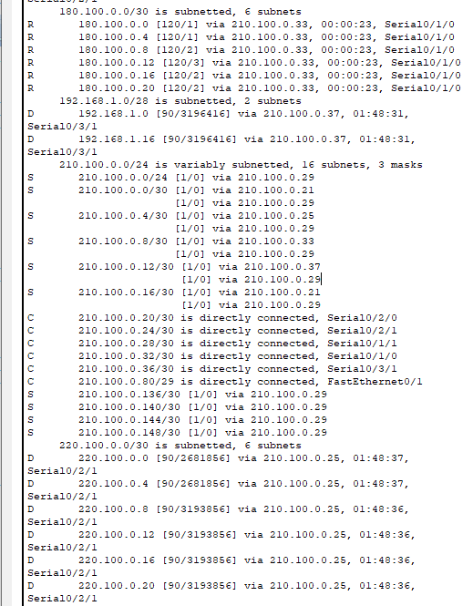

**SHOW IP ROUTE (INSIDE CLUSTER)**

Show ip route on Karachi min sub

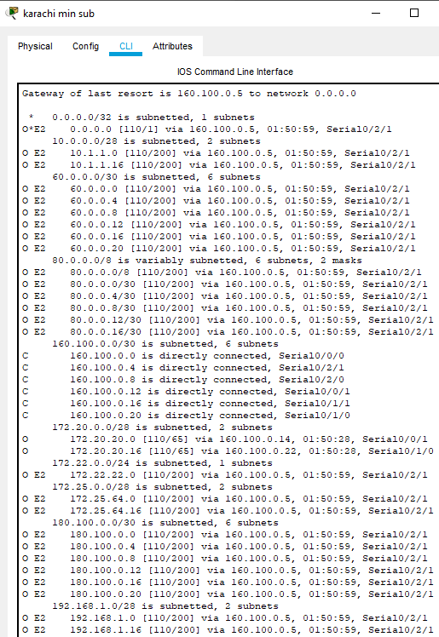

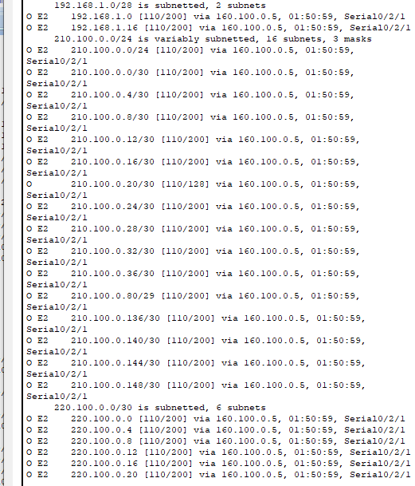

Show ip route on karachi PRIMARY

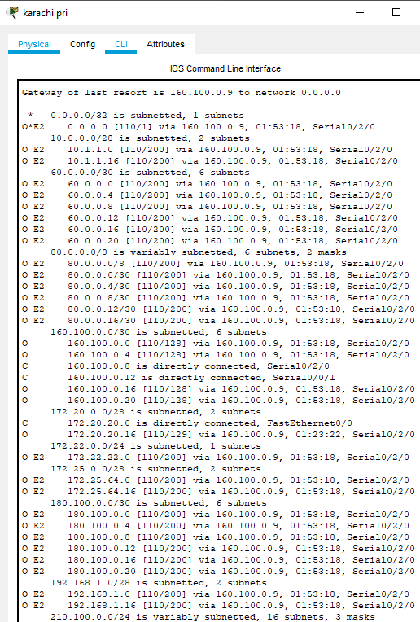

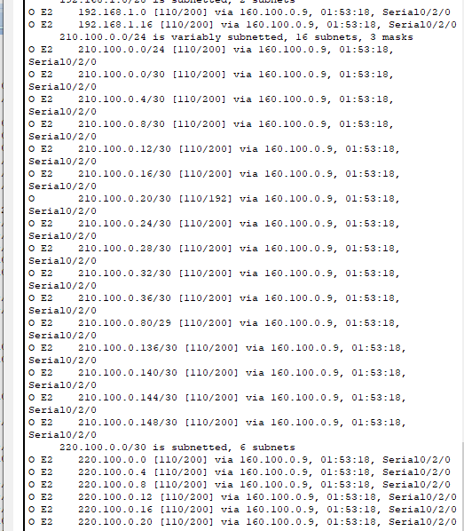

Show ip route on karachi secondary

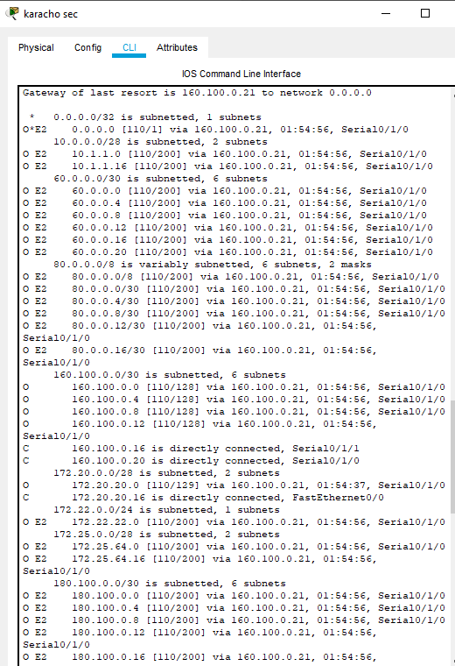

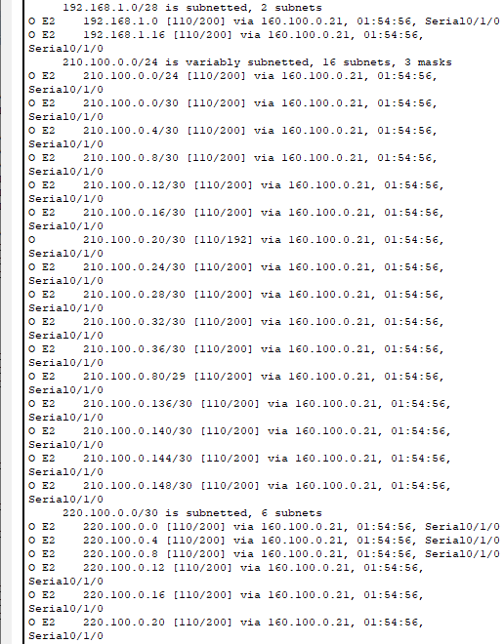

Show ip route on Quetta main sub

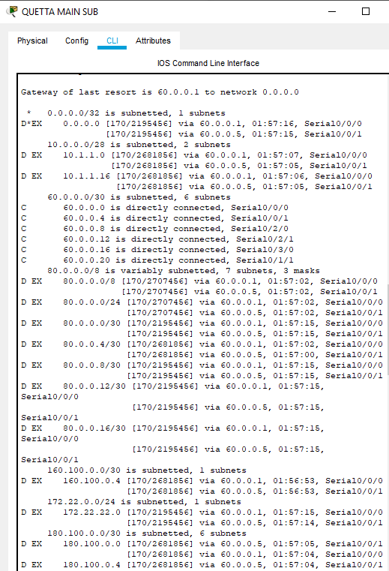

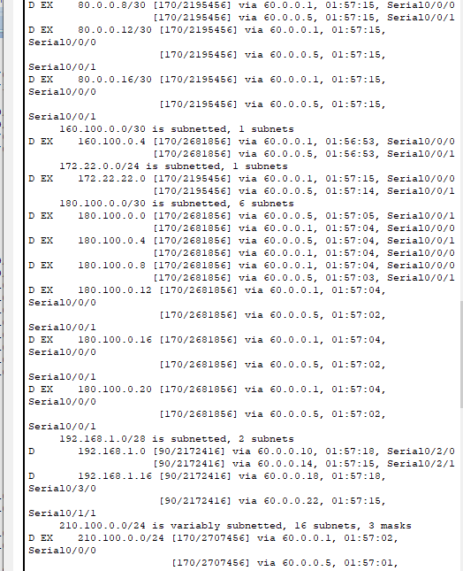

Show ip route on Quetta PRIMARY

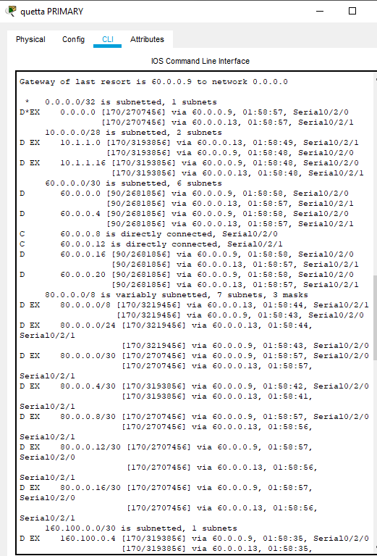

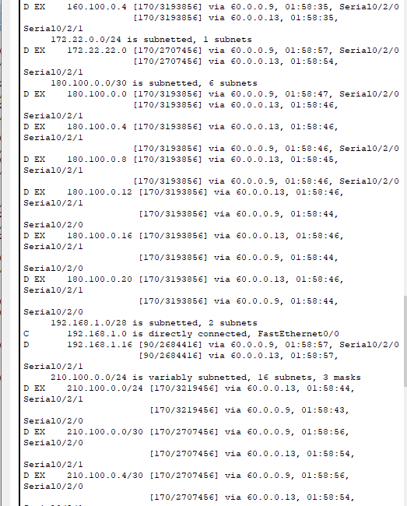

Show ip route on Quetta secondary

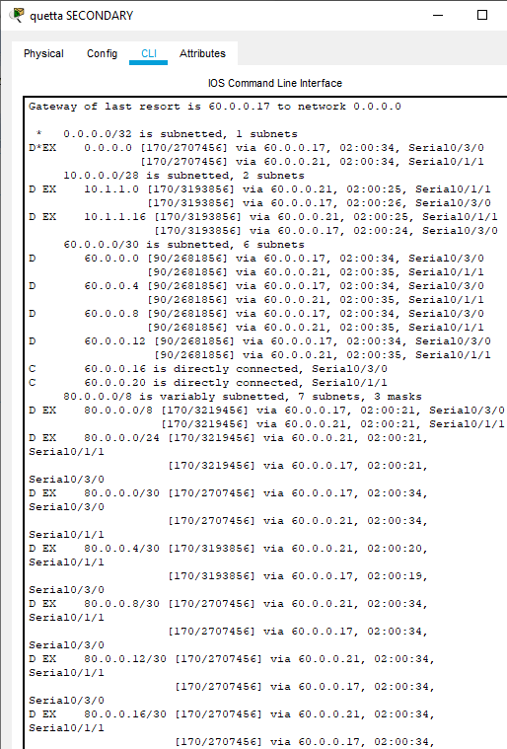

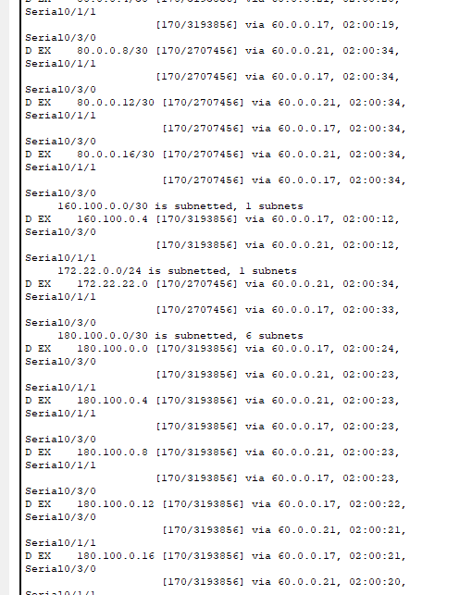

Show ip route on Peshawar PRIMARY

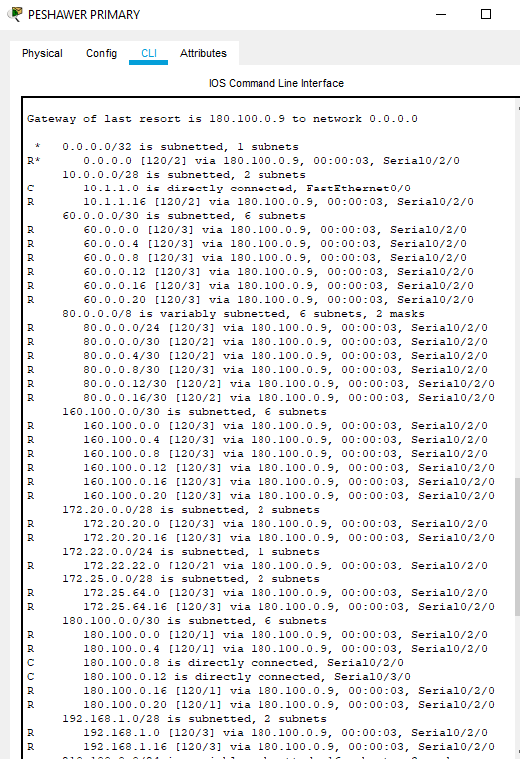

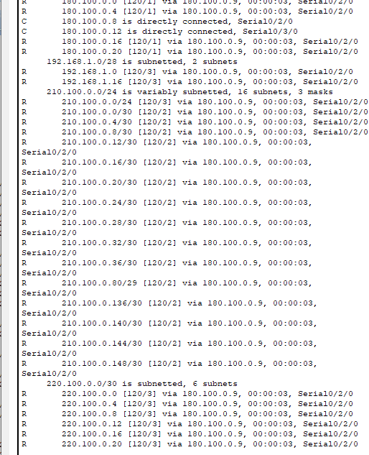

Show ip route on lahore primary

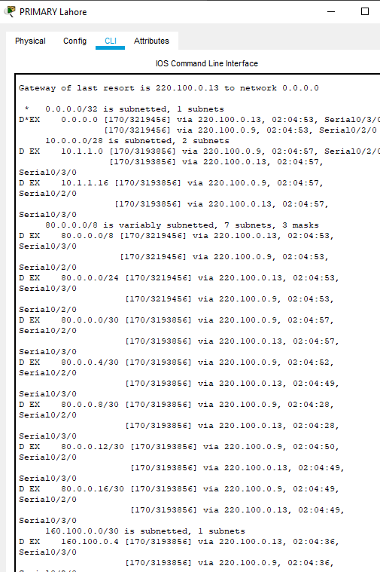

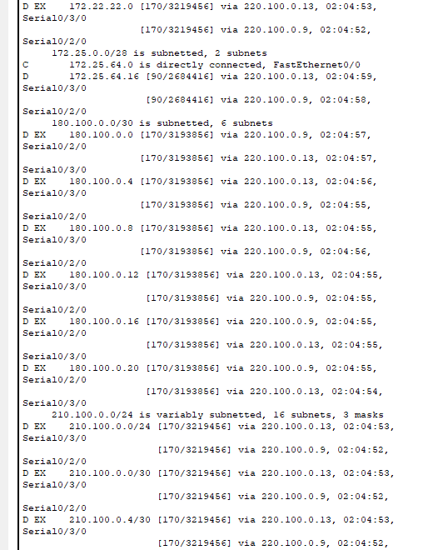

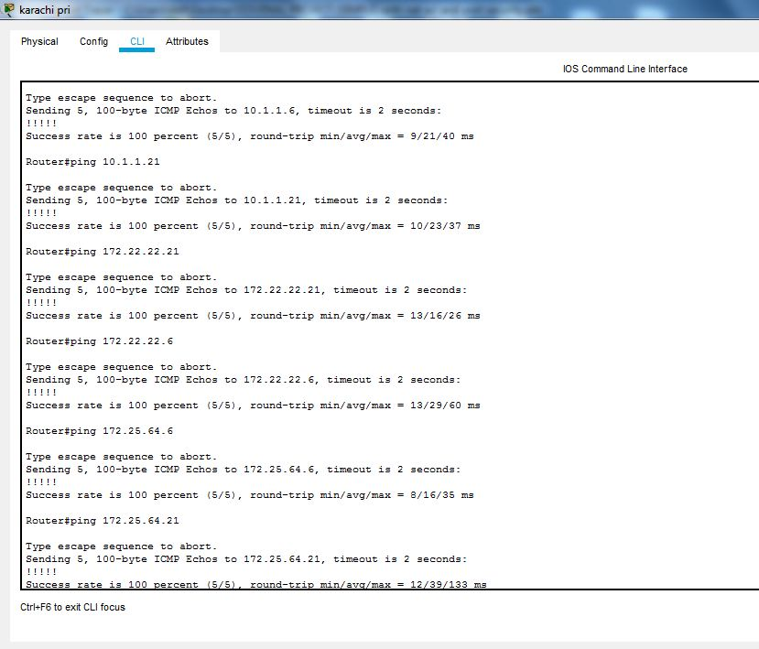**PING RESULTS**

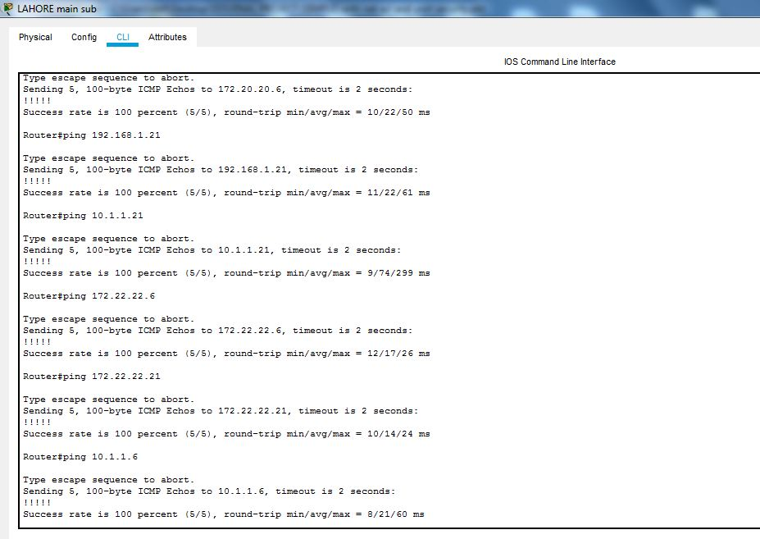

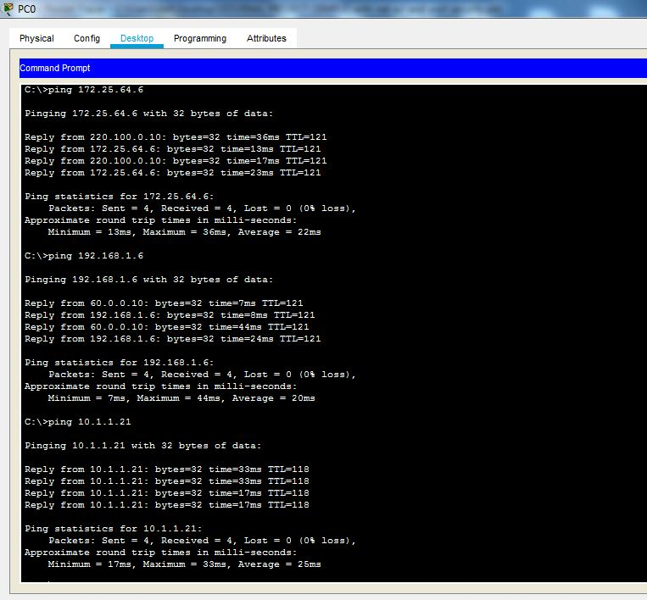*PING RESULT FOR NATTING

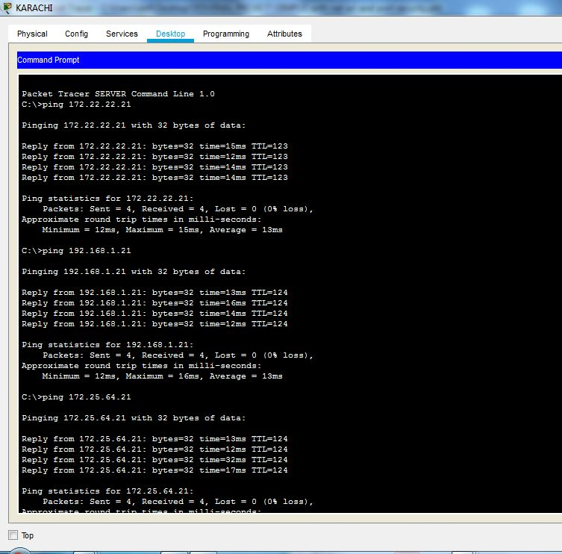PING FROM SERVER

**ACCESS CONTROL LIST (ACL)**

An **access control list** (**ACL**), with respect to a [computer](https://en.wikipedia.org/wiki/Computer) [file system](https://en.wikipedia.org/wiki/File_system), is a list of [permissions](https://en.wikipedia.org/wiki/File_system_permissions) attached to an [object](https://en.wikipedia.org/wiki/Computer_file). An ACL specifies which users or system processes are granted access to objects, as well as what operations are allowed on given objects.[[1]](https://en.wikipedia.org/wiki/Access_control_list#cite_note-1) Each entry in a typical ACL specifies a subject and an operation. For instance, if a file object has an ACL that contains (Alice: read, write; Bob: read), this would give Alice permission to read and write the file and Bob to only read it.

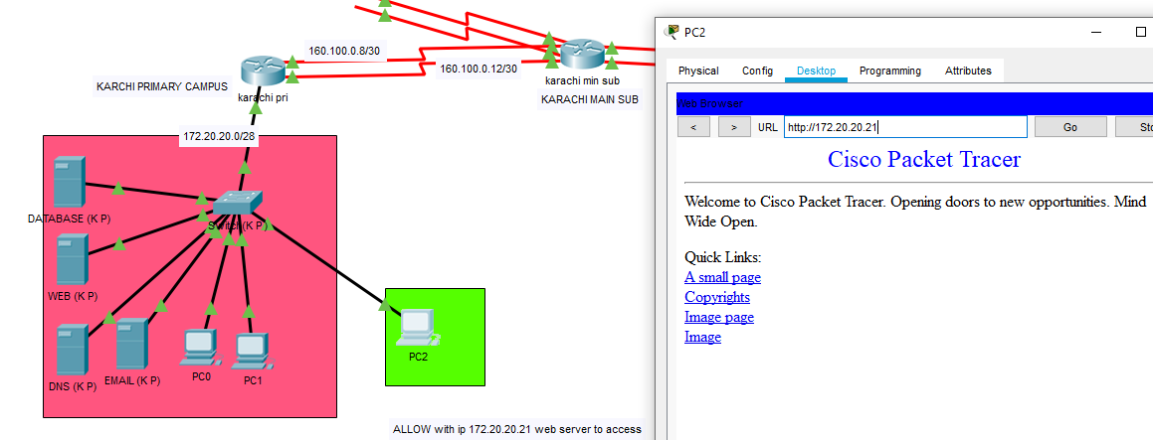

**NETWORK ADDRESS TRANSLATION (NAT)**

"Network Address Translation." NAT translates the IP addresses of computers in a local network to a single [IP address](https://techterms.com/definition/ip_address). This address is often used by the [router](https://techterms.com/definition/router) that connects the computers to the Internet. The router can be connected to a DSL modem, cable modem, T1 line, or even a dial-up modem. When other computers on the Internet attempt to access computers within the local network, they only see the IP address of the router. This adds an extra level of security, since the router can be configured as a [firewall](https://techterms.com/definition/firewall), only allowing authorized systems to access the computers within the network.



**Port security:**