

User Requirements Specification

PROCP Project





Team members:   
Kaloyan Dragiev - 3214311  
Yanis Dimov - 3258033  
Nikolay Nikolaev - 3235106  
Rosen Panayotov - 3334643  
Nikolay Kolev - 3235106

**Table of content**

**Introduction 3**

**Scope of the project 3**

**Functional requirements 4**

**Use case diagram 4**

**Use cases 4**

**Non-functional requirements 5**

**Testability 5**

**Performance 5**

**Documentation 5**

**Introduction**

This document will list and explain all functional and non-functional requirements of the simulation application. In addition, it will display the use cases for the applications and the use case diagrams respectively.

# **Scope of the project**

First, the user would not be able to draw the airport himself, it will be pre-set. The user will be able to configure the data by putting in different values. Therefore, the airport design will be generated based on the input values of the user. The main processes that the application will show are airplanes landing and taking off, taxiing to the gate, baggage carts going to the plane and going back to the gate. Moreover, the system will show at what capacity is one of the carts using different colours i.e. when a baggage cart is full it will be marked in red, respectively when it is free it will be green, and when it is near reaching the capacity - it will be yellow. In addition, the system will consider that not all planes are full and that not all passengers have baggage that needs to be transported. Also, delays of the flights will be part of the simulation. They will affect the statistics. Lastly, the weather conditions will play a role in the simulation affecting the activities i.e. the baggage carts will move slower during rain or snow.

# **Functional requirements**

|  |  |  |  |  |
| --- | --- | --- | --- | --- |
| # | Name | Actor | Description | Goal |
| 1 | Start simulation | User | The user will set the following configurations: the number of planes that will land, the duration of the simulation, how many employees, baggage carts and belts there are. In addition, there would be possible to set weather conditions. | The actor starts a simulation of the airport based on the configuration. |
| 2 | Save simulation | User | In a certain state, the user can decide to save the simulation and run it later. This would be possible by saving the configurations of the current simulation. | The actors saves simulation configurations so that they can be used again. |
| 3 | Load simulation | User | The user will be able to load a simulation that was already saved. | The actor loads simulation that was previously saved. |
| 4 | Save simulation results | User | At the end of the simulation, the user would be able to save the results in a file. | The actor saves the results in a file, so that they would be evaluated in a later stage. |
| 5 | Pause simulation | User | In a certain state, the user can decide to pause the simulation in order to see current statistics or to modify the simulation variables. | The actor pause the simulation and the current results and data are shown. |
| 6 | Change intensity of speed | User | The user will be able to modify the intensity of the speed on which the simulations operates with the help of a slider. | The actor changes the speed of the simulation resulting in a different data in the statistics. |
| 7 | Change weather condition | User | The user will be able to modify the weather conditions, in order to see how they affect the simulation process. In the application, the actor will be able to select three weather conditions: normal, raining and snowing. | The actor modifies the weather conditions resulting in different times of completing the simulation goal. |

## **Use case diagram**

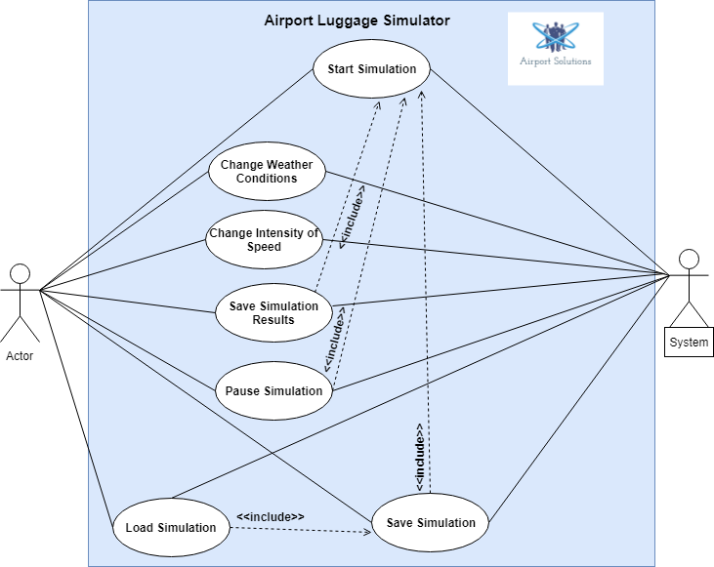

## **Use Cases**

***Start Simulation***

**Actor:** User

**Goal:** The actor successfully starts the simulator based on given configurations

**Description:** The user sets certain values for number of planes, how long will the simulation last, how many employees for transporting the baggage there are and how many baggage belts there are. In addition, the user can choose the weather and the intensity of the simulation.

**Pre-condition:** The application is running.

**Main Success Scenario:**

1. User fills configuration values
2. User presses start simulation button
3. System indicates that the simulation starts
4. System shows statistics based on the simulation

**Extension:**

**2. a** User has entered wrong data

**2. a.1** System shows a message that the data is incorrect

**2. a.2** Use case ends

**Post-condition:** System shows the statistics of the simulation on the screen.

***Save Simulation***

**Actor:** User

**Goal:** The actor successfully saves the simulation

**Description:** The user saves the simulation configurations, so that they can be used in the future.

**Pre-condition:** The application is running and the user has already set configuration values.

**Main Success Scenario:**

1. User presses save button
2. System asks the user if wants to save or cancel the operation
3. System saves the configuration
4. System indicates that the configuration for the simulation has been saved successfully

**Extension:**

**1. a** User has not entered data on the configuration

**1. a.1** System shows a message that the data must be filled in order to save

**1. a.2** Use case ends

**2. a** User presses “Cancel” button

**2. a.1** Use case ends

**2. b** User presses ‘’Save” button

**2. b.1** Go to MSS step 3

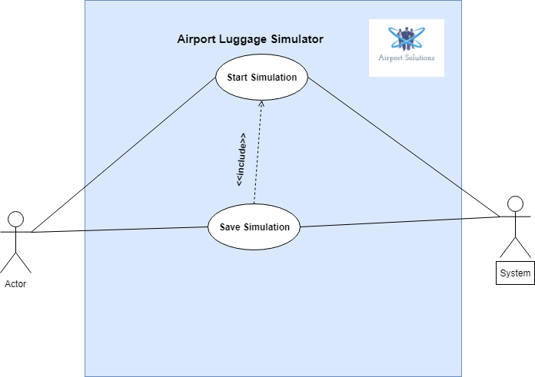

***Load Simulation***

**Actor:** User

**Goal:** The actor successfully loads configuration values

**Description:** The user loads configuration values from previously saved simulation in order to run the application with previous values rather than entering new.

**Pre-condition:** The application is running.

**Main Success Scenario:**

1. User presses load button
2. System opens a window with simulation files
3. User selects specific file
4. System asks the user if he/she wants to load or cancel the operation
5. System loads the file
6. System displays a message that the file was loaded successfully

**Extension:**

**4.a** User presses “Load” button

**4. a.1** Go to MSS Step 5

**4. b** User presses “Cancel” button

**4. b.1** Use case ends

***Save Simulation Results***

**Actor:** User

**Goal:** The actor successfully saves the results of the simulation

**Description:** The user saves the simulation results in a file that can be executed in the future and they can be compared with other data.

**Pre-condition:** The application is running and the simulation either has ended or has been stopped by the user.

**Main Success Scenario:**

1. User presses on button “Save Results”
2. System shows a window where user can choose destination for the file
3. User enters the name of the file
4. System asks the user if he/she wants to save or cancel the operation
5. System saves the data in a file
6. System displays a message that the results have been saved successfully

**Extension:**

**1. a** There is no information that can be saved

**1. a.1** System displays a message

**4. a** User presses on “Confirm” button

**4. a.1** Go to MSS 5

**4. b** User presses on “Cancel” button

**4. b.1** Use case ends

***Pause Simulation***

**Actor:** User

**Goal:** The actor successfully pauses the simulation

**Description:** The user pauses the simulation when he/she wants to see current statistics or to modify the simulation i.e. to change some data.

**Pre-condition:** The application is running and the simulation has started.

**Main Success Scenario:**

1. User presses on button “Pause Simulation”
2. System shows a message that the simulation has been paused
3. System shows a current statistic in a window

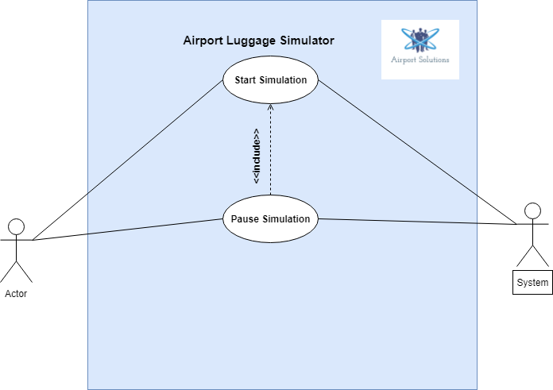

***Change Intensity of Speed***

**Actor:** User

**Goal:** The actor successfully changes the speed of the simulation

**Description:** The user changes the simulation speed in order to see how different speed affects the simulation and the statistic.

**Pre-condition:** The application is running

**Main Success Scenario:**

1. User enters a new speed intensity in the box
2. System changes the speed of the simulation
3. System displays in a label the current speed of the simulation

**Extension:**

**1. a** The new speed is out of the range or is in wrong format

**1. a.1** System displays a message

**1. b** Reached maximum or minimum speed

**1. b.1** System displays a message

**1. b.2** System sets the simulation speed to a default

***Change Weather Conditions***

**Actor:** User

**Goal:** The actor successfully modifies the weather conditions of the simulation

**Description:** The user changes the weather conditions, in order to see how the affect the simulation process and the statistic respectively.

**Pre-condition:** The application is running

**Main Success Scenario:**

1. User chooses a new weather condition specified in the GUI
2. System changes the weather condition of the simulation
3. System displays in a label the current weather mode of the simulation

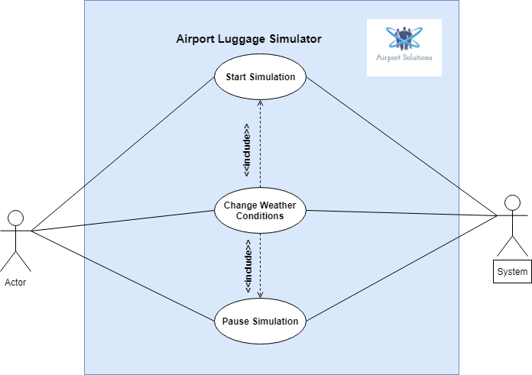

# **Non-Functional requirements**

### Testability

The software will be tested before being released.

### Performance

The application should not lag or have any bugs during the simulation.

### Documentation

The application will have a basic documentation (manual) with the main functions, buttons etc. explained.