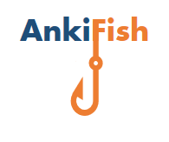

AnkiFish is a program that takes English input and from it creates flashcards for the program Anki. These flashcards next to direct translations of the English words contain their pronunciation as an audio file, a related picture and an example sentence. Currently we support translation from English into Spanish, Italian, and French. Nevertheless, our goal is to expand the languages as this would only involve minor changes in the code. We currently run on Windows 10 and MacOSX although since we do not own Macintosh computers we only had very limited testing availability, which is why we hope you excuse us for any issues here.

Motivation:

We are enthusiastic language learners, that wanted to use spaced repetition as a learning tool. However, creating your own flashcards takes an immense amount of time, as you have to gather all the media and translations manually. We wanted to have a program do this part for us, so that we could concentrate more on actual learning.

# Getting started:

* Python 3.6 with the following modules installed:
  + Manual installation: google_images_download, bs4, selenium, getpass, requests
  + Pre-installed with python 3.6: sys, tkinter, os, csv, urllib
* Google Chrome Browser
* Chromedriver for Mac or Windows (provided in zipfile)
* Anki 2.0.5.1 from https://apps.ankiweb.net/ (install everything in the standard directories)
  + Explanation on how to use Anki and AnkiFish provided in appendix
* An internet connection.

# Future plans:

1. Currently we only support Anki import if anki was a) installed in the standard directory and b) The user uses the standard Username that is ‘User 1’. We want to change this in the next iteration of AnkiFish.
2. With the release of the new version of Chrome we have experienced error messages popping up in terminal windows. This is all due to the chromedriver not being updated yet by the responsible team. Luckily the error messages are only distracting and don’t influence our programme. We have remedied this insofar that we provide a version of AnkiFish that does not show the terminal at all called ‘AnkiFish.pyw’ (included in Zipfile). We are working on a more permanent fix.
3. In the future we would like to support more languages and also use different sources than Google’s services.

# Credits:

Philipp Spengler & Fabian Bubla, 2018

# Appendix

**How to import the AnkiFish csv into Anki:**

To use the flashcards in Anki, you will have to make custom flashcards. We hereby provide a template:

Follow the following steps

1. 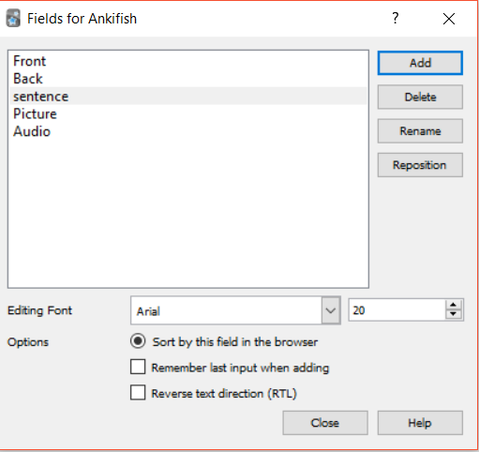Open Anki
2. Go to Tools > Manage Note Types > Add > Add Basic
3. Now give a name to your new flash card type e.g. ‘AnkiFish’ and press ok
4. Now select e.g. ‘AnkiFish’ and press Fields
5. Now add new fields according to the screenshot then press close
6. Press ‘Cards’ type or copy the text from the screenshot below. (raw text provided below)

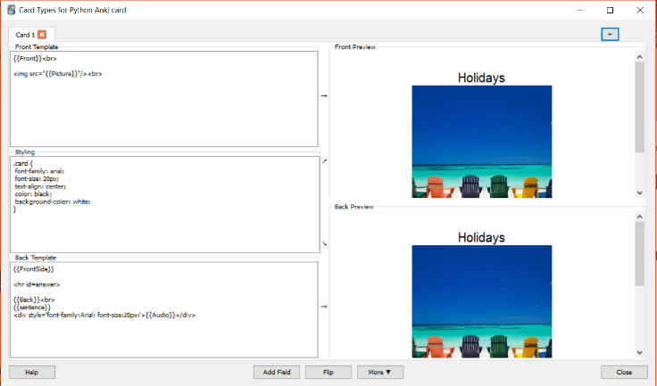

**Front template:**

{{Front}}<br>

<img src="{{Picture}}"/><br>

**Styling:**

.card {

font-family: arial;

font-size: 20px;

text-align: center;

color: black;

background-color: white;

}

**Back template:**

{{FrontSide}}

<hr id=answer>

{{Back}}<br>

{{sentence}}

<div style='font-family:Arial: font-size:20px:'>{{Audio}}</div>

1. Close the note types window, then press decks > create deck and give the deck a name e.g. ‘AnkiFish Spanish’
2. Click on the name of the deck you just created and then go on File > Import > and select the csv created by AnkiFish that you want to import into Anki
3. Now you can go select your deck and finally study. Have Fun!