AI in Finance: Understanding key drivers of AI-assisted decision-making in Financial Institutions

*Jérôme Pacher*

*Fabian Gubler*

The AI Economy: Business Strategies and Policy Issues

Summer School 2022, University of Basel

# Introduction

Financial institutions around the globe are increasingly incorporating technological advances into their business operations. Here, the entrepreneurial startup community plays a key role through the development of new Financial Tech (FinTech) applications, which “dramatically change the way financial services and products are delivered” (Hill, 2018). The biggest challenge for these institutions will be to break free from the patterns and comfort level of the past (Marous, 2015). Similarly, Matteo Rizzi (2015) argues that the duty of the financial sector shouldn’t be to fight the disruption, but to embrace it.

Artificial intelligence in FinTech is now playing an important role in differentiating financial services by replacing both simple and complex human activities (Abdul, 2019). Investment Banking increasingly incorporates the growing discipline of Data Science and its subset Artificial Intelligence into their decision-making processes. Here, both the information gathering and the actual undertaking of decisions are empowered through software systems.

In the following, the paper will provide insight into the potential of AI within the financial sector. The first chapter gives an overview of Rules-Based Investment and investigates its opportunities. Following, the second chapter will examine the potential of Natural Language Processing for the gathering of financial information. At last, the paper closes with a conclusion, which summarises the main findings and discusses their relevance.

# Rules-Based Investing

...

# Natural Language Processing

At the basis of Rules-Based Investment lies the information that powers these decisions. To achieve real-time applications, these systems rely on the inflow of structured and quantitative data. This approach ignores the huge set of relevant textual data that can be found in articles, press release statements and increasingly posts on social networks that could be used to inform investment decisions. In order to utilise these forms of data in a Rules-Based environment, Natural Language Processing (NLP) shows many opportunities to process textual information in a short period of time.

Hirschberg and Manning (2015) define Natural language processing as the employment of “computational techniques for the purpose of learning, understanding, and producing human language content”. Whereas earlier approaches focused on analysing the structure of language and developing basic technologies such as machine translation, today’s real-world applications are able to mine social media for information and subsequently are able to identify sentiment and emotion. As a consequence, the processing of natural language is deeply tied to various areas of Artificial Intelligence, as understanding text requires reasoning, understanding intentions and social conventions (Eisenstein, 2019)

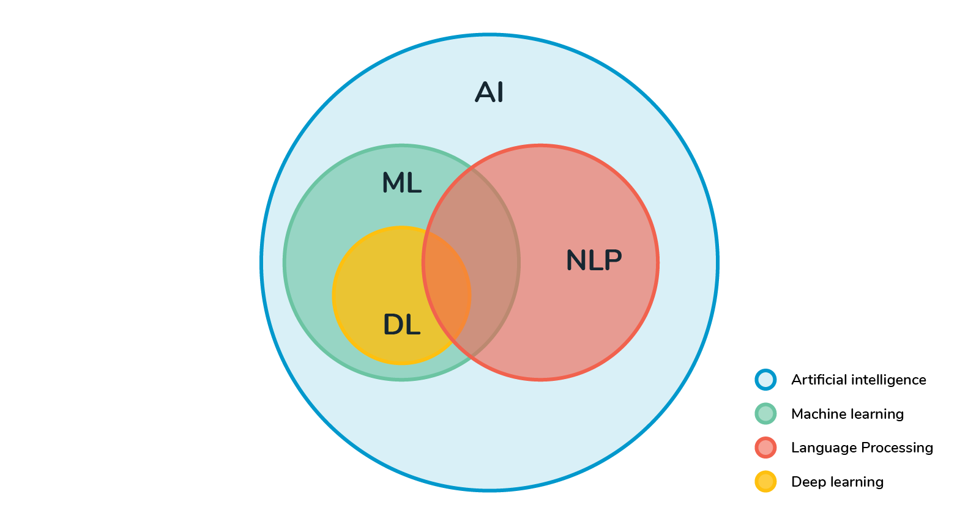

Figure 1: NLP in the context of Artificial Intelligence (Sathiyakugan, 2018)

In the context of a Rules-Based Investment approach, NLP, machine learning, and text analytics has the potential of classifying and discovering patterns from electronic financial documents to inform these decisions. In particular, NLP enables the transformation of unstructured data into a structured form that is suitable for analysis and the application of machine learning algorithms. (Raghupathi et al., 2020)

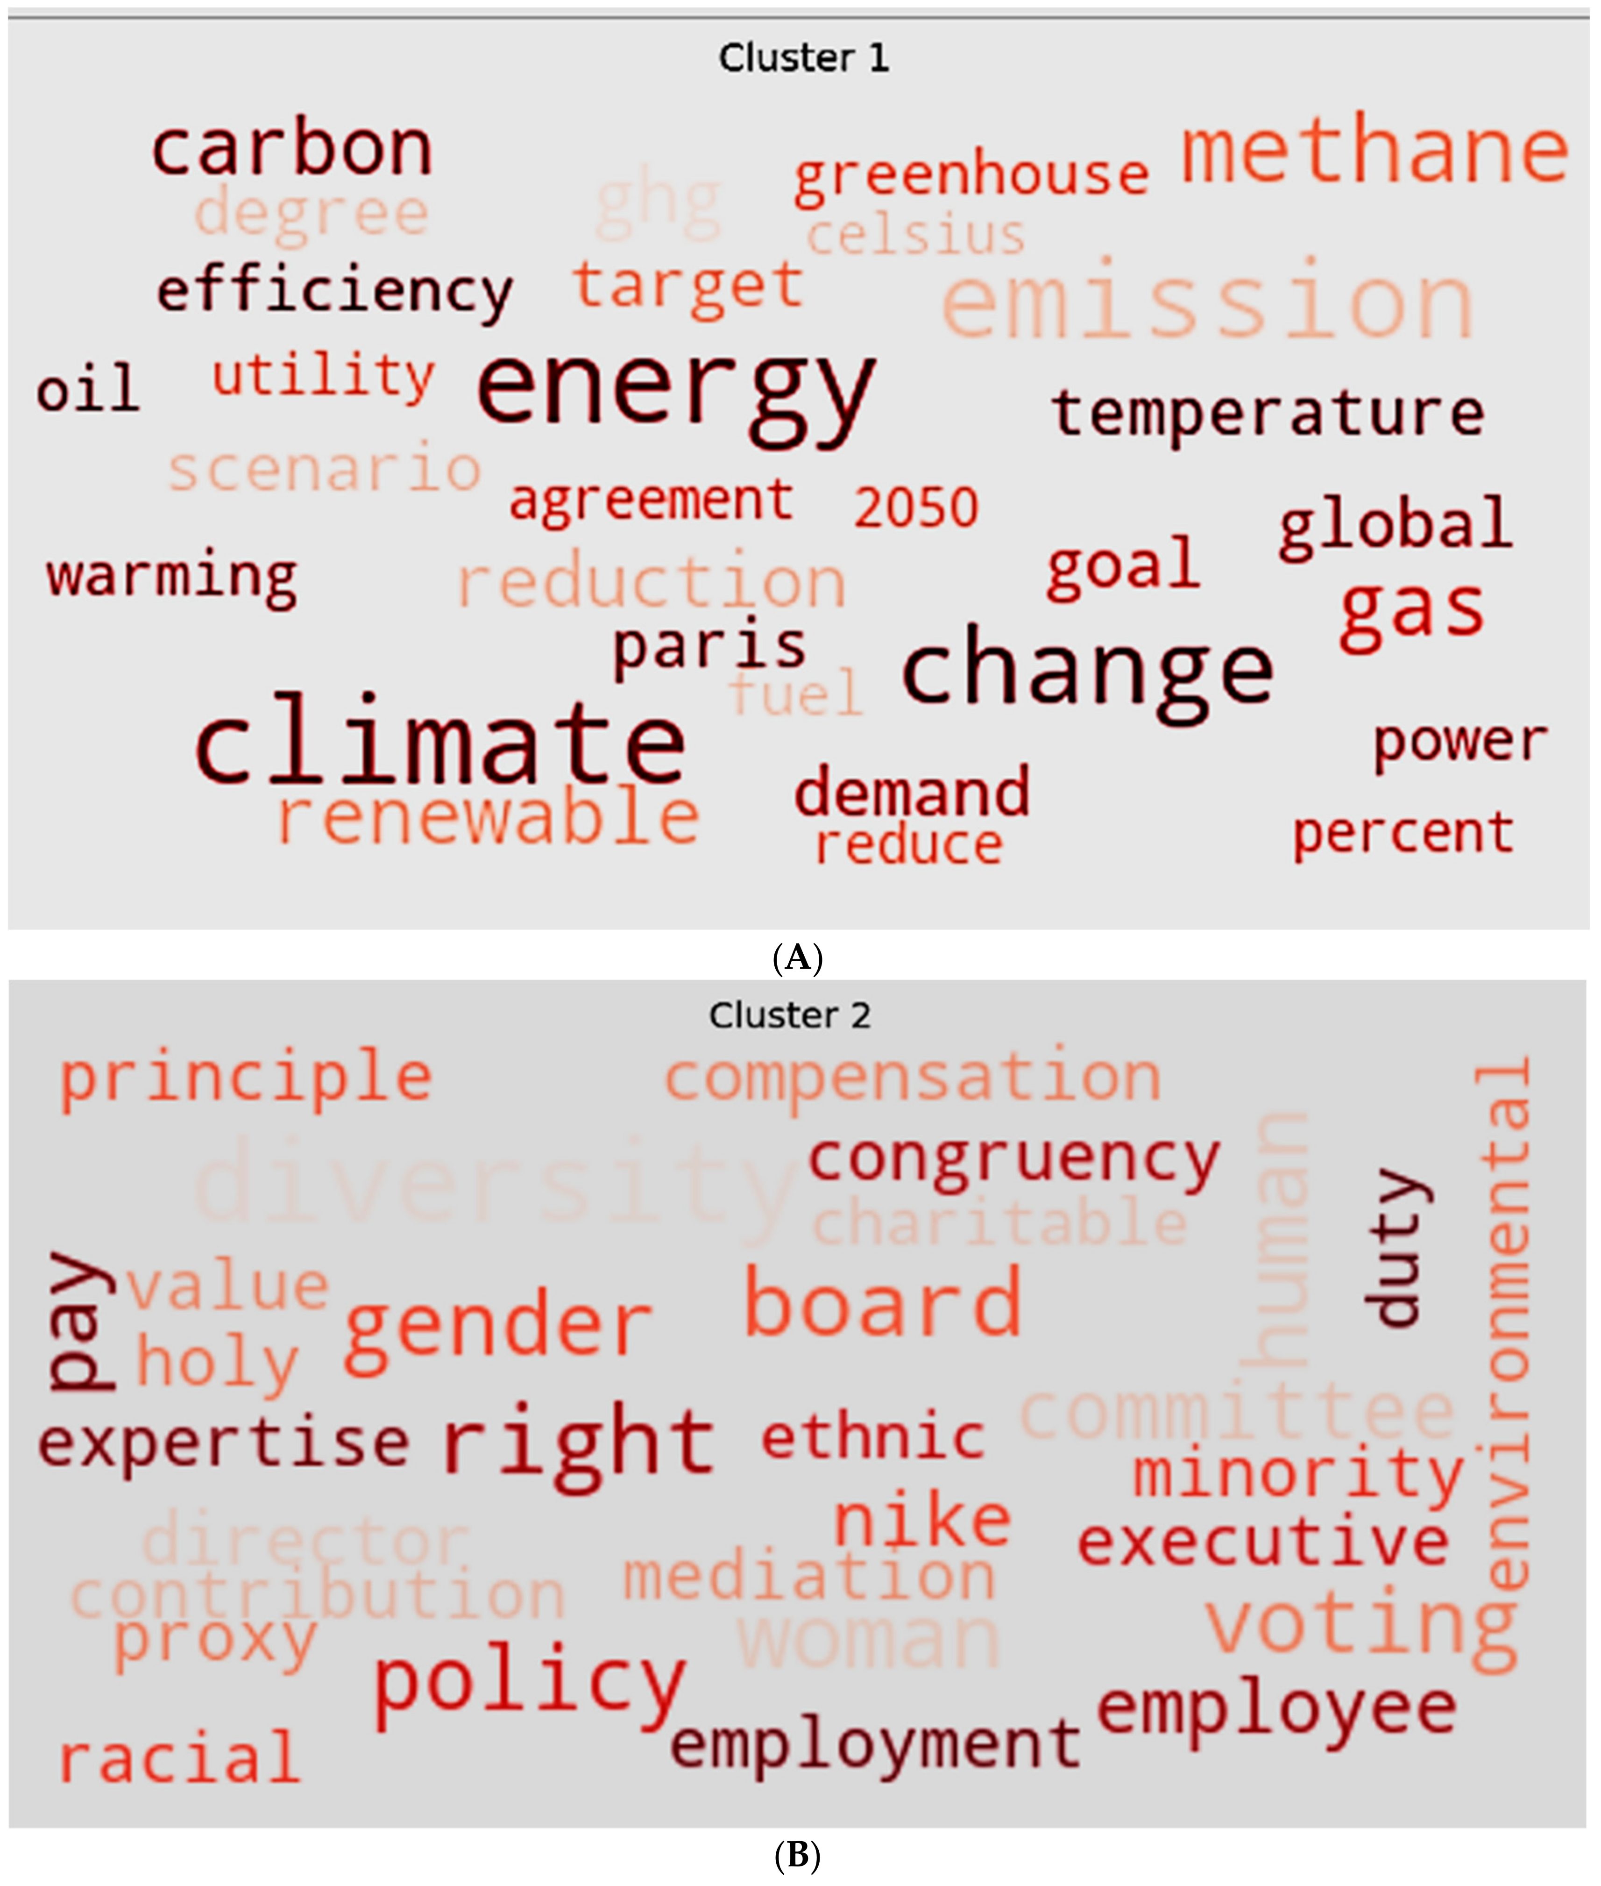

Figure 2: Prevalence of Words associated with energy emission

Figure 2 provides a concrete example of using NLP to provide assistance in investing decisions regarding environmental, social and governance (ESG) data. On the basis of 449 sustainability resolutions Raghupathi et al. (2020) identified internal sustainability efforts regarding energy emissions using machine-learning text analytics. By making use of Big Data in combination with NLP models, investment decisions can be improved in order to allocate capital towards companies that “manage themselves in a socially responsible way” (Antoncic, 2020). By uncovering hidden signals in unstructured text, NLP provides mechanism to combat self-reported bias and greenwashing carried out by companies.

As a consequence implementing NLP into existing investment decisions allows to increase the input of relevant financial information. Moreover, by using unstructured textual data investors can alleviate biases created by benchmarks and ratings. By incorporating unstructured data powered through NLP models, Rules-Based Investment can be enhanced and risks associated with confidence biases of quantitative data analysis can be reduced.

# Conclusion

...

# 

# References

[Abdul, R. (2019). *FinTech as a Disruptive Technology for Financial Institutions*. IGI Global.](https://www.zotero.org/google-docs/?ztps1D)

[Antoncic, M. (2020). Uncovering hidden signals for sustainable investing using Big Data: Artificial intelligence, machine learning and natural language processing. *Journal of Risk Management in Financial Institutions*, *13*(2), 106–113.](https://www.zotero.org/google-docs/?ztps1D)

[Eisenstein, J. (2019). *Introduction to Natural Language Processing*. MIT Press.](https://www.zotero.org/google-docs/?ztps1D)

[Hill, J. (2018). *Fintech and the Remaking of Financial Institutions*. Academic Press.](https://www.zotero.org/google-docs/?ztps1D)

[Hirschberg, J., & Manning, C. D. (2015). Advances in natural language processing. *Science*. https://doi.org/10.1126/science.aaa8685](https://www.zotero.org/google-docs/?ztps1D)

[Marous, J. (2015, April 27). The Most Influential Voices In Banking. *FinServ 25*. https://www.linkedin.com/pulse/finserv-25-most-influential-voices-banking-jim-marous/](https://www.zotero.org/google-docs/?ztps1D)

[Raghupathi, V., Ren, J., & Raghupathi, W. (2020). Identifying Corporate Sustainability Issues by Analyzing Shareholder Resolutions: A Machine-Learning Text Analytics Approach. *Sustainability*, *12*(11), 4753. https://doi.org/10.3390/su12114753](https://www.zotero.org/google-docs/?ztps1D)

[Rizzi, M. (2015, April 27). *28 of The Most Influential Voices In Banking*. The Financial Brand. https://thefinancialbrand.com/news/banking-trends-strategies/top-25-influencers-leaders-finserv-banking-51541/](https://www.zotero.org/google-docs/?ztps1D)

[Sathiyakugan, B. (2018, July 26). *Learn Natural Language Processing from scratch*.](https://www.zotero.org/google-docs/?ztps1D)

Medium. https://blog.goodaudience.com/learn-natural-language-processing-from-

scratch-7893314725ff