Project Plan

Software Project Management

Course | Software Project Management
Team Name | Agile-ish  Members: Jasmine Barchetti, Fabiana Molinaro, Saba Rafaqat and Ilaria Graiff
Project Title | Dolomeets
Submission Date | 30/03/2026
Repository URL | https://github.com/Ilaria-Graiff/Dolomeets

Sommario
1. Executive Summary 3
2. Product Vision and Value Proposition 3
(a) Target Users 3
(b) The Problem (Pain Points) 4
(c) Product Vision 4
(d) Expected Value for Users 4
Elevator Pitch 4
3. Stakeholders and Roles 4
4. Scope Definition 5
5. Requirements and Initial Product Backlog 6
6. System Context Diagram 7
7. Domain Model or Core Data Model 8
8. Architecture Overview 9
9. Technology Stack and Development Environment 9
10. Team Organization and Responsibility Allocation 10
11. Agile Process Plan 10
12. Iteration Roadmap 11
13. Definition of Done 11
14. Testing Strategy 12
Overview 12
Manual Functional Testing 12
Usability Testing 12
Defect Tracking 12
Acceptance Testing 12
15. GitHub Workflow and CI/CD Plan 13
Repository Strategy 13
Pull Request (PR) Policy 13
CI/CD Automation 13
16. Risk Register 14
17. Assumptions and Constraints 14
Assumptions 14
Constraints 15
18. Milestones and Deliverables 15
Project Timeline 15
Student Summary of Evidence 16

1. Executive Summary
Dolomeets is a mobile application that helps people discover and join local events by using an intuitive and map-based interface. The app displays real-time event pins across the map of the city of Bolzano, allowing users to tap on an event, view essential information and join with a single click. Dolomeets aims to make event discovery immediate, social and personalized to individual interests.
The target users are university students, young adults and residents who want to participate more actively in Bolzano’s social and cultural life. Lots of users currently rely on different single sources, like social media pages, posters or word of mouth, making it difficult to know what is happening nearby.
The secondary users include the event organizers, like universities, associations, venues and local businesses) and tourists that are looking for nearby activities during their stay.
The main problem addressed by the project is the fragmentation of event information across multiple channels, such as social media, websites, posters and word of mouth. As a result, users often miss interesting events, spend excessive time searching for information or are unaware of activities happening close to them in real time. In addition, existing solutions rarely integrate social elements, making it difficult for users to see who else is attending or to feel part of a local community. Dolomeets solves this problem by offering a single, location-based solution that simplifies discovery and encourages participation.
By the end of the course, the expected result of the project is a clearly defined digital product concept supported by a structured prototype or mockup and a detailed project plan. The project aims to demonstrate the application of agile and user-centered design principles, focusing on feature prioritization, user flows and overall system structure rather than on full technical implementation. The final outcome will provide a solid foundation for potential future development.
The project focuses on three highest-priority capabilities. First, the app provides an interactive map of Bolzano that displays events as pins in real time, allowing users to visually explore nearby activities. Second, it enables one-click event participation, making it easy for users to join events, save them to a personal agenda and receive notifications. Third, the app offers personalized event suggestions based on user interests, location and social signals, enhancing relevance and user engagement.

2. Product Vision and Value Proposition

(a) Target Users
The primary users are university students (unibz) and young professionals living in Bolzano who seek spontaneous social engagement. Secondary users include local event organizers (associations, bars and cultural hubs) looking to increase visibility and tourists seeking authentic local experiences during their stay.

(b) The Problem (Pain Points)
Currently, event information in Bolzano is highly fragmented across Telegram groups, Instagram stories, physical posters under the porticos and word-of-mouth. Users suffer from "Fear of Missing Out" (FOMO) because they often find out about events only after they have started. There is no central "pulse" of the city that shows what is happening right now and where.

(c) Product Vision
To become the digital heartbeat of Bolzano, transforming the city’s streets into an interactive social playground where every event is discoverable in a single tap.

(d) Expected Value for Users
Users gain immediate awareness of their surroundings, saving time spent scrolling through multiple apps. The value lies in the frictionless transition from digital browsing to physical participation, fostered by the "one-click join" and the ability to see the local community’s interest in real-time.

Elevator Pitch
For students and residents in Bolzano who want to stay active in the local social scene, Dolomeets is a map-based mobile platform that provides real-time event discovery and instant participation.
Unlike static Facebook events or fragmented WhatsApp groups, our product offers a localized, visual interface that combines geographical proximity with social signals, making it easier than ever to step out and join the community.

3. Stakeholders and Roles
Stakeholder | Role | Interest / Expectation | Influence on Project
Client team | Define the product vision, set key features, validate the implementation of the development team | - Functional prototype  - App based on their requirements  - Alignment with user needs | They approve the work of the development team and have the final decision
Development team | Responsible for implementing the prototype, conducting research and translating requirements into tangible outputs | Expect clear requirements, realistic workload and constructive feedback | Their skills, time management and technical decisions determine what is realistically achievable
Professor | Provides guidance and evaluates deliverables | Expects coherence to course structure, proper documentation and demonstration of learning outcomes | Can provide feedback through the evaluation of the deliverables
End users | They discover and join events. They provide insights through testing and feedback | Expect an intuitive, real‑time map interface, easy event participation and relevant suggestions | User feedback determines usability

4. Scope Definition
In Scope | Out of Scope
Interactive map prototype showing event pins in Bolzano | Full backend infrastructure (databases, servers, real‑time data pipelines)
User flows for discovering events, viewing event details and joining with one click | Legal compliance work (GDPR and data‑sharing agreements)
Clickable prototype (Figma) demonstrating the main user journey end‑to‑end. | Fully functional mobile app available on App Store / Play Store
User profile and smart suggestions

5. Requirements and Initial Product Backlog
Story ID | User Story | Priority | Story Points | Acceptance Criteria
1. | As a student in Bolzano, I want to view a map with event pins, so that I can see what is happening near me in real-time | High | 5 | Given the user is on the main map screen, When there are active events in Bolzano, Then pins should appear at their precise geographic locations
2. | As a user, I want to click on an event pin, so that I can see the event title, time and description | High | 3 | Given a map with event pins, When the user taps a specific pin, Then an information card pops up showing essential details
3. | As a student, I want to join an event with one click, so that I can easily participate in social activities | High | 3 | Given an event detail card is open, When the user clicks the "Join" button, Then the user's status is updated to "Attending."
4. | As a unibz student, I want to log in using my university credentials, so that I can access student-exclusive events safely | Medium | 8 | Given the login screen, When the user enters a valid @unibz.it email, Then the system authenticates the user and grants access
5. | As a user, I want to view my history of past events, so that I can keep track of the activities I have joined | Low | 5 | Given the user profile section, When the user selects "History," Then a list of all previously joined events is displayed
6. | As a user, I want to filter events by category (e.g., Sports, Culture), so that I only see pins relevant to my interests | Medium | 5 | Given the map is populated with pins, When the user selects the "Sports" filter, then only sports-related pins remain visible
7. | As a student, I want to receive a notification 30 minutes before a joined event, so that I don’t forget to attend | Medium | 3 | Given the user has joined an event, when it is 30 minutes before the start, Then the system sends a push notification reminder
8. | As a user, I want to see how many people are already attending an event, so that I can gauge the popularity of the activity | Medium | 2 | Given the event detail card, when the card is opened, then a "Current Attendees" count is displayed and updated
9. | As an organizer, I want to create a new event pin by long-pressing on the map, so that I can quickly broadcast a local activity | High | 8 | Given the user has organizer permissions, when they long-press the map, then a form appears to enter event details
10. | As a user, I want to receive "Smart Suggestions" on my home screen, so that I can discover events tailored to my past interests | Low | 13 | Given the user has joined 3+ events, when they open the app, then a "Recommended for You" section highlights matching categories

6. System Context Diagram
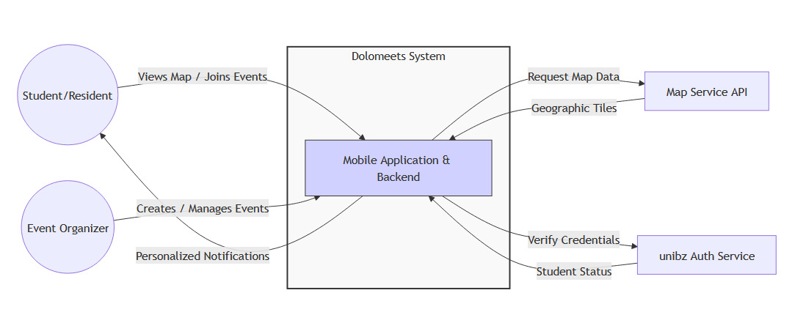

Our System Context Diagram defines the “where and how” of Dolomeets by showing exactly where our app ends, and the rest of the world begins. The central System Boundary represents the mobile application and backend we are building, acting as the hub for all social activity. Outside this boundary, we have our human actors such as “Students/Residents” who discover events and “Event Organizers” who post them, as well as external services like the “Map Service API” and “unibz Auth. Service” that provide the essential infrastructure for navigation and secure login.
The arrows in the diagram track the flow of information between these entities and our system. For users, the bi-directional arrows show them sending actions like "Joining Events" and receiving "Personalized Notifications" in return. On the technical side, the arrows toward the APIs represent the app requesting specific data, such as map coordinates or identity verification, and receiving Geographic Tiles or Student Status confirmations. This clear mapping of inputs and outputs ensures we understand how the app functions as an integrated part of the university ecosystem.

7. Domain Model or Core Data Model
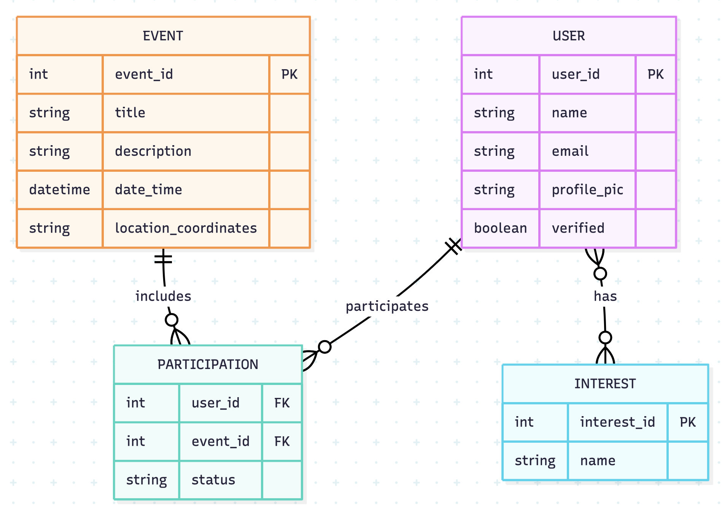
The Dolomeets domain model is centered around the interaction between Users and Events. The core of the system is the Participation entity, which acts as a bridge (associative entity) to manage the many-to-many relationship between users and events. This allows the system to track not only which users are attending which events, but also their specific status (e.g., "interested" vs. "joined").
Furthermore, the model includes an Interest entity linked to the User. This is critical for the "Smart Suggestions" feature mentioned in the project scope, as it allows the system to store user preferences (like "Sports" or "Music") and cross-reference them with event categories. Each user is also marked with a verified boolean, ensuring the system can distinguish between authenticated student profiles and general residents.

8. Architecture Overview
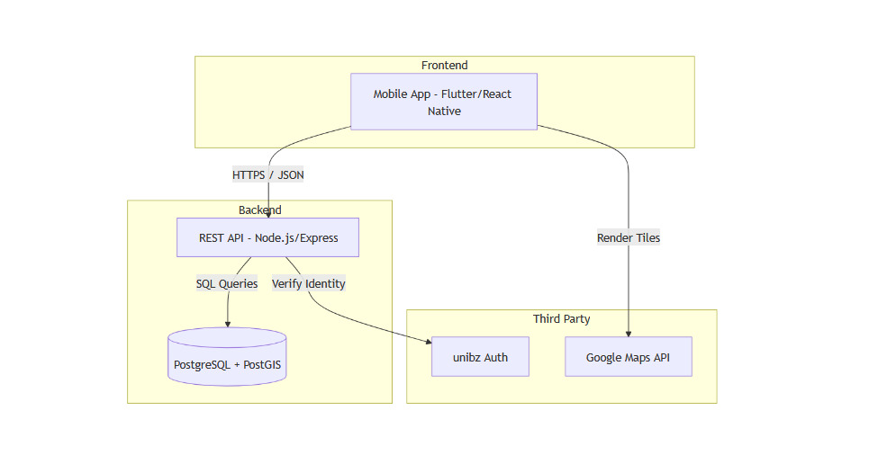
This architecture is appropriate because it separates concerns: the frontend handles the high-intensity UI/UX (map rendering), the Backend manages the business logic and security and the Database is specialized for spatial data. This separation allows the team to work on the Figma UI independently of the backend logic, while ensuring the system can scale as the number of events in Bolzano grows.

9. Technology Stack and Development Environment
Category | Chosen Tool / Technology | Reason for Choice
Design/Prototyping | Figma | Industry standard for high-fidelity interactive mockups and team collaboration
Frontend Framework | React Native | Allows for rapid cross-platform mobile development using JavaScript
Backend/API | Node.js | Lightweight and highly efficient for handling real-time API requests
Database | PostgreSQL | Essential for storing event coordinates and performing spatial queries
Version Control | GitHub | Necessary for tracking code changes and managing documentation asynchronously

10. Team Organization and Responsibility Allocation
Team Member | Main Responsibilities | Secondary Responsibilities
Jasmine Barchetti | Frontend development (React), UI components, interactive map integration (Leaflet/Mapbox) | Supports UX design and contributes to API integration testing
Saba Rafaqat | Backend development (Node.js + Express), API design, database schema (PostgreSQL) | Assists with DevOps setup and CI workflows
Fabiana Molinaro | Testing coordination (manual tests, acceptance tests), GitHub Issues management, QA checklists | Supports frontend bug fixing and documentation updates
Ilaria Graiff | Documentation owner (project plan, iteration notes, README), team coordination, meeting facilitation | Supports backend debugging and manages deployment pipeline

11. Agile Process Plan
We will work using an agile approach with short iterations and continuous feedback.
We will have a weekly team meeting to plan tasks, review progress and align on priorities. If needed, we will also do quick check-ins during the week.
Before each iteration, we will refine the backlog, clarify user stories and split tasks to keep them manageable.
At the start of each iteration, we will select the most important tasks and assign them to team members.
At the end of each iteration, we will do a review with the client to present our progress and collect feedback. After that, we will have a short retrospective to improve how we work.
For communication, we will use WhatsApp for quick messages, GitHub for tasks and code and Figma for design.
We will sync with the client at the end of each iteration and whenever needed.

12. Iteration Roadmap
Phase / Iteration | Theme / Goal | Major Features | Planned Evidence / Demo
Iteration1 | Core Discovery & Identity | Map interface with event pins, User login (unibz Auth.), Event details popup (US-01, US-02, US-04) | Clickable Figma flow showing a user logging in and finding an event on the Bolzano map
Iteration 2 | Social Interaction & Retention | One-click "Join" functionality, User Profile history and Event category filtering (US-03, US-05, US-06) | Interactive prototype showing the transition from "Discovering" to "Attending" and viewing history
Final Deliverable | Personalization & Polish | Smart suggestions, Push notification mockups and UI/UX refinement based on feedback (US-07, US-10) | Full end-to-end walkthrough of the app, including the personalized home screen and "Organize" flow

13. Definition of Done
Done Criterion | How It Will Be Verified
Acceptance Criteria Met | Each "Given/When/Then" scenario from the user story is manually tested and passes
Figma Consistency | The UI components match the project’s defined style guide (colors, fonts, Bolzano-theme branding)
Code/Doc Hygiene | All relevant documentation (README, API notes) is updated and the code is pushed to the GitHub repository
No Blocking Defects | The feature is free of "critical" bugs that prevent the user from completing the primary flow
Peer Review | At least one other team member has reviewed the feature/prototype flow to ensure it is intuitive
Demo Ready | The feature can be demonstrated smoothly in a live environment or through the interactive Figma link

14. Testing Strategy

Overview
Our goal is to ensure that Dolomeets is reliable and easy to use for students in Bolzano. Since we are working with a mix of a Figma prototype and a development plan, our testing focuses on making sure the user flow makes sense and that all features work as described in our backlog.

Manual Functional Testing
We will perform manual tests for every User Story after it is completed. We’ll use the Acceptance Criteria (Given/When/Then) as our test cases.
- Example: For the "One-click Join" feature, a team member will manually go through the flow to ensure the app correctly updates the user's status without errors.

Usability Testing
Because this app is for students like us, we will conduct quick usability tests. We’ll ask a peer from outside the team to try and find an event on the map without any help. If they get stuck, we’ll mark that as a "UX Bug" and refine the Figma design.

Defect Tracking
We won't just remember the bugs, we’ll track them properly.
- GitHub Issues: Every time we find a bug or a broken link in the prototype, we will create an issue on GitHub.
- Priority: We will label bugs as Critical (the app crashes), Major (a feature doesn't work), or Minor (UI alignment issues).
- Review: Before every milestone or presentation, we will check our "Open Issues" to make sure all Critical and Major bugs are fixed.

Acceptance Testing
At the end of each iteration, we will present our progress to the "Client" (the course instructor). We consider a feature officially "Accepted" only when the instructor confirms it meets the requirements and the team is happy with the final result.
Test Type | Responsibility
Functional | Development Team
UI/UX Review | Design Lead
Bug Tracking | Scrum Master
Final UAT | Client / Instructor
Test Type | Responsibility
Functional | Development Team

15. GitHub Workflow and CI/CD Plan
Workflow Element | Planned Rule / Practice
Branching Strategy | main for stable versions; feature/US-ID for development.
Pull Requests | Mandatory for all merges; requires 1 peer approval.
Issue Tracking | Every User Story from the backlog is a GitHub Issue.
Commit Messages | Must include the Story ID (e.g., "Fix: US-03 join button alignment").
CI Automation | GitHub Actions for linting and build verification.
Documentation | The README.md is updated whenever a major feature is added.

Repository Strategy
We will follow a Feature Branch Workflow. This means we never work directly on the main branch. Instead, we create a new branch for every User Story or bug fix. This keeps the project stable while we are still building new parts.

Pull Request (PR) Policy
Before any code or documentation is merged into main, a Pull Request must be opened. At least one other team member must review the changes and leave a "LGTM" (Looks Good To Me) or request fixes. This ensures that at least two people have seen every update.

CI/CD Automation
Since we are in the early stages, our "Continuous Integration" will be simple but effective using GitHub Actions:
- Linter Check: Every time someone pushes code, an automated script will check for formatting errors to keep the code clean
- Build Check: We will set up a workflow to ensure the project still "builds" (compiles) successfully before a merge is allowed
- Automated Testing: If we add unit tests for the backend, these will run automatically on every Pull Request to prevent us from breaking existing features

16. Risk Register
Risk | Type | Probability | Impact | Mitigation
Map API Complexity (Difficulty implementing real-time pins and clusters) | Technical | Medium | High | Start with a static Figma map for the first demo and use a well-documented library (like Leaflet or Google Maps SDK) early in development
Inaccurate Event Data (No real events to show in the Bolzano prototype) | Requirements | High | Medium | Create a "Mock Data" set of 10-15 realistic social events in Bolzano (unibz parties, sports, etc.) to ensure the demo looks live and active
Authentication Bottleneck (Trouble integrating with unibz login) | Technical | Medium | High | Research OAuth 2.0 early. If it's too complex for the first sprint, use a simplified "Mock Login" while keeping the UI consistent with the unibz brand
Team Imbalance (Heavy workload on one person for Figma or Backend) | Organizational | Low | High | Use a shared Trello board to visualize the workload. If one person is stuck, we will re-allocate tasks during our weekly sync
Scope Creep (Adding too many social features like chat or friend lists) | Requirements | Medium | Medium | Strictly follow the "In Scope" list from Section 4. Any new ideas will be moved to a "Future Work" backlog instead of the current sprint

17. Assumptions and Constraints

Assumptions
These are conditions we expect to be true during the project:
- All team members will remain actively available for weekly coordination meetings, iteration work and reviews until the final delivery
- The customer team will be available to provide feedback and validation at the end of each iteration
- The selected technologies (React Native, Node.js, PostgreSQL, GitHub and Figma) will remain accessible, stable and sufficiently supported during the project
- Free-tier or educational hosting services will be adequate for demonstrations and prototype validation
- Team members will have compatible local development environments and basic familiarity with the chosen technologies
- Core functional requirements for the MVP will remain relatively stable, allowing the project to be completed within two iterations plus final delivery
- If real event data is limited, realistic mock data can be created to support prototyping and validation
- geolocation and map visualization features will function reliably on commonly used devices

Constraints
These are limitations the project must respect and cannot change:
- Course deadlines strictly define the delivery schedule (Deliverable 1 → Iteration 1 → Iteration 2 → Final Delivery)
- Team size is fixed; responsibilities must be handled within the existing members without adding external developers
- Development must follow the agile process established by the course (iterations, reviews, retrospectives)
- All code must be hosted in the official GitHub repository, using the required branching and PR workflow
- The system must operate within free or low‑cost hosting constraints—no paid infrastructure
- The MVP scope must remain realistic, focusing on core features: event map, event participation and user profiles
- Privacy and GDPR rules apply: user data and location data must be stored and processed responsibly
- The architecture must remain lightweight, avoiding complex ML systems, real‑time communication, or heavy infrastructure

18. Milestones and Deliverables

Project Timeline
We have divided the project into four main milestones. Each stage requires specific documentation and a demonstration of the progress made. We will use GitHub as our central "source of truth" for all evidence.
Milestone / Deliverable | Date | Expected Output | Evidence
Deliverable 1: Project Plan | 01/04/2026 | Initial Project Plan, Product Backlog, System Architecture, and Repository Setup. | Submitted PDF report and link to the GitHub repository with the initial README.md.
Iteration 1: Core Features | 15/04/2026 | High-fidelity Figma prototype for Map and Login; Basic backend structure (API endpoints). | Interactive Figma link and a GitHub branch with initial code/scripts.
Iteration 2: Social Flow | 29/04/2026 | "Join" functionality logic, Event filtering and User Profile history views. | Recorded video demo of the user flow or a live walkthrough of the updated prototype.
Final Delivery | 06/05/2026 | Refined digital product concept, Final Project Report and Presentation. | Final GitHub repository containing all code, docs and the link to the final interactive prototype.

Student Summary of Evidence
To prove that we have reached these milestones, we won't just say "it's done." We will provide:
- GitHub Commit History: To show consistent work throughout the semester.
- Figma "Play" Links: So the client/instructor can click through the app themselves to verify the user experience.
- Documentation: Updated technical notes in the repository explaining how the components work together.

