Iteration 1 Report

Software Project Management

Jasmine Barchetti, Ilaria Graiff, Fabiana Molinaro & Saba Rafaqat

Sommario
1. Iteration Overview 2
2. Planning vs Actual (Traceability Required) 2
STORY ID 2
USER STORIES 2
COMPLETED? 2
FIGMA SCREEN NAME 2
3. Implemented Features (Evidence-Based) 3
Figma link: Figma Prototype 3
4. Design Decisions and Architecture Updates 6
5. UI/UX Design 7
6. Demonstration (Reproducible) 7
7. Testing and Quality Metrics 7
8. GitHub Activity and Collaboration 8
9. Challenges and Problem Solving 8
10. Retrospective 8
11. Plan for Iteration 2 8

1. Iteration Overview
Sprint Goal: Implement the core event‑discovery flow: interactive map, event pins, event detail view and unibz login.
Scope Summary: we planned to complete three user stories (US‑01, US‑02, US‑04). However, in our Figma prototype, we successfully implemented eight user stories, covering not only the discovery flow but also joining events, filtering, personalized recommendations and event history.
Planned vs Achieved Outcome:
- Planned: US‑01, US‑02, US‑04
- Achieved: US‑01, US‑02, US‑03, US‑04, US‑05, US‑06, US‑08, US‑10
- Not Implemented: US‑07 (notifications), US‑09 (organizer event creation)
Achieved Outcome: All planned user stories were completed in their prototyped form (Figma). The team produced a complete end‑to‑end flow allowing a user to:
- Log in
- Access the Bolzano map
- View active events
- Open event details by tapping a pin
- User profile
Measurable Outcomes:
- 8/10 user stories implemented
- Figma prototype

2. Planning vs Actual (Traceability Required)
STORY ID | USER STORIES | COMPLETED? | FIGMA SCREEN NAME
1 | As a student in Bolzano, I want to view a map with event pins, so that I can see what is happening near me in real-time | Yes | Main map
2 | As a user, I want to click on an event pin, so that I can see the event title, time and description | Yes | Pinpoint map
3 | As a student, I want to join an event with one click, so that I can easily participate in social activities | Yes | Pinpoint map
4 | As a unibz student, I want to log in using my university credentials, so that I can access student-exclusive events safely | Yes | Login with email / login with student card
5 | As a user, I want to view my history of past events, so that I can keep track of the activities I have joined | Yes | myevents
6 | As a user, I want to filter events by category (e.g., Sports, Culture), so that I only see pins relevant to my interests | Yes | root
7 | As a student, I want to receive a notification 30 minutes before a joined event, so that I don’t forget to attend | No
8 | As a user, I want to see how many people are already attending an event, so that I can gauge the popularity of the activity | Yes | Event details
9 | As an organizer, I want to create a new event pin by long-pressing on the map, so that I can quickly broadcast a local activity | No
10 | As a user, I want to receive "Smart Suggestions" on my home screen, so that I can discover events tailored to my past interests | Yes | Root (“For you” filter)

3. Implemented Features (Evidence-Based)

Figma link: Figma Prototype
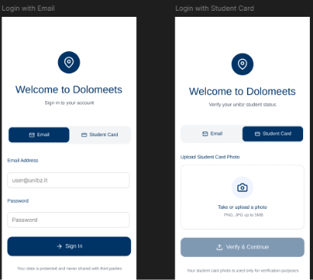 | The first screen lets users sign in with their email and password, using a simple form and a “Sign In” button. The second screen allows login through student card verification, where users upload or take a photo of their unibz student card and tap “Verify & Continue.”  ACCEPTANCE CRITERIA  Given the login screen, When the user enters a valid @unibz.it email, Then the system authenticates the user and grants access
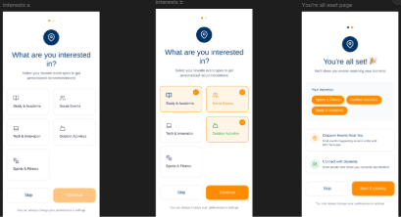 | 3 screens where users select their interests for personalized event recommendations. The first screen displays several interest categories (like Study, Social Events, Outdoor Activities) with a “Skip” and “Continue” button. The second screen shows the same list but with some categories selected and highlighted. The final screen confirms the setup with a “You’re all set!” message, shows the chosen interests and offers a “Start Exploring” button to enter the app.
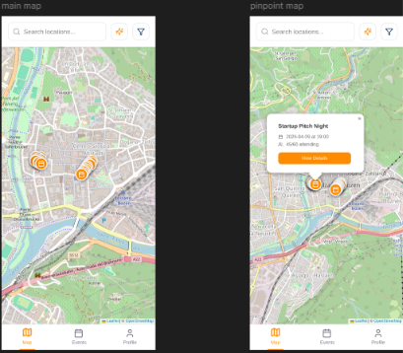 | The first screen is the main map, displaying multiple event pins across the city along with a search bar and bottom navigation tabs (Map, Events, Profile). The second screen is the pin‑selected view, where tapping a pin opens a small preview card showing the event name, date and time, number of attendees and a “View Details” button.  ACCEPTANCE CRITERIA  - Given the user is on the main map screen, when there are active events in Bolzano, then pins should appear at their precise geographic locations.  - Given a map with event pins, when the user taps a specific pin, then an information card pops up showing essential details.  - Given the map is populated with pins, When the user selects the "Sports" filter, then only sports-related pins remain visible.
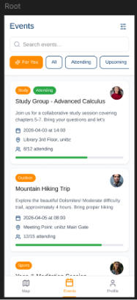 | The image shows the Events page. At the top, there is a search bar and four filters: For You, All, Attending and Upcoming. Below, event cards are displayed with category tags, titles, short descriptions, dates, locations and an attendance progress bar. The bottom navigation bar highlights the Events tab, with Map and Profile as the other options.  ACCEPTANCE CRITERIA  Given the user has joined 3+ events, when they open the app, then a "For You" section highlights matching categories
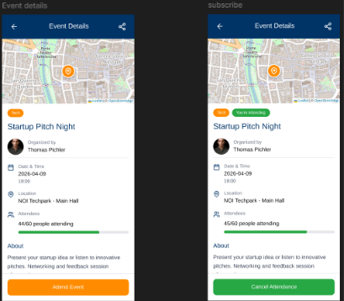 | In the first screen, the user has not yet joined the event: the page displays the event tag, organizer, date, location, a progress bar showing attendees, an “About” section and a large orange “Attend Event” button. In the second screen, the user is already attending: the tag includes “You’re Attending,” the attendee count increases by one and the bottom button changes to a green “Cancel Attendance” option  ACCEPTANCE CRITERIA  - Given an event detail card is open, When the user clicks the "Join" button, Then the user's status is updated to "Attending”.  - Given the event detail card, when the card is opened, then a "Current Attendees" count is displayed and updated.
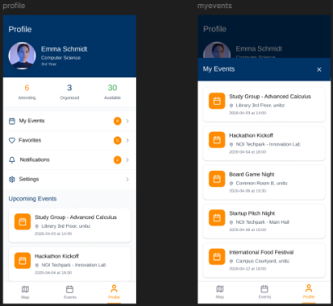  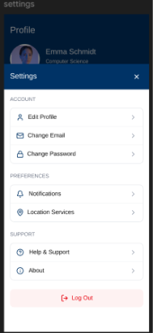 | The first is the Profile page, displaying the user’s photo, name, study program, quick stats (Attending, Organized, Available) and shortcuts like My Events, Favorites, Notifications and Settings. It also shows a small preview of upcoming events. The second is the My Events page, which expands into a full list of all events the user is attending, each with its location and date  ACCEPTANCE CRITERIA  Given the user profile section, When the user selects "History," Then a list of all previously joined events is displayed

4. Design Decisions and Architecture Updates
- Map‑first navigation: Chosen because the primary user value is discovering nearby events. Alternative (list‑first) was rejected due to lower spatial clarity.
- Card‑based event detail: Ensures consistency across event types and supports future extensibility (attendee list, organizer info).
- Join flow kept minimal: One‑click join improves usability and reduces friction for spontaneous events.
- Organizer creation via long‑press: Faster than navigating through menus; aligns with mobile UX patterns.

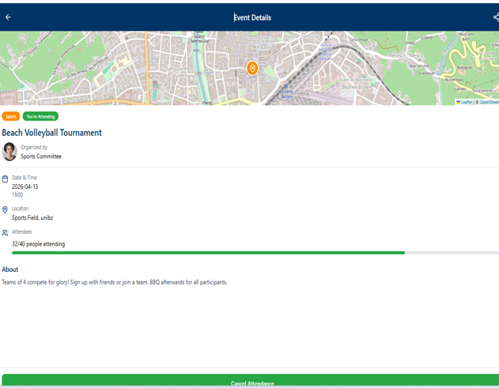
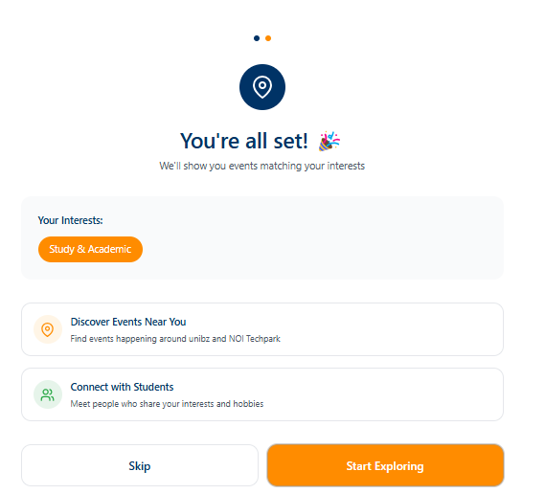
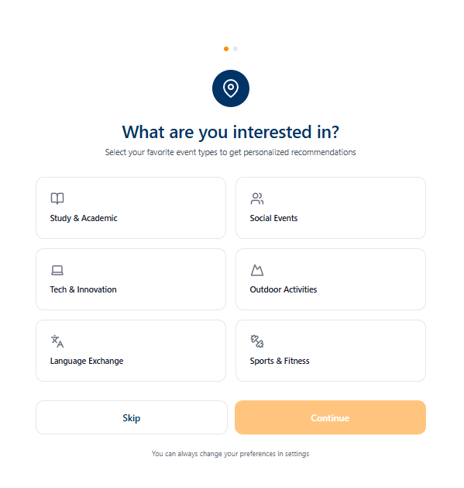
5. UI/UX Design

The onboarding screens are design to be: simple, clear and user-friendly, it uses a direct question “What are you interested in?” and a card-based option with icons, so it enable a fast recognition, it’s also large and has a touch-friendly elements that can improve the accessibility and reduce errors.
The confirmation screen provides immediate feedback “You are all set” reinforcing the system status. The last screen provide the key event information (title, category, date location and attendance) is also presented in a hierarchical layout, this supports usability and the principle of aesthetic and minimalism design. Finally there is a CTA to mange users participation (“Cancel attendence”)

6. Demonstration (Reproducible)
- Open the Figma prototype
- Screen 1: login → enter valid email or upload photo of the student card
- Screen 2: select interests → skip button (do it later) or continue button after selecting the categories
- Screen 3: “All set screen”: summary of categories selected → skip button or start exploring
- Screen 4: Bolzano map → view event pins
- Tap a pin → event detail card opens
- Scroll to view additional details
- Click on “Attend event” if the user wants to join

7. Testing and Quality Metrics
We tested the App as end users by checking the navigation and if the flow was smooth.
We found 3 bugs and we managed to resolve all of them. One was related to the maps of Bolzano, another was related to input validation and the third one affected the navigation between screens.

8. GitHub Activity and Collaboration
Our team in total produced 15 commits starting from March 19th, with contributions from different team members, it started with the initial setup and documentation about the architecture, user stories and iterations, after that the commits included updates to deliverables and README improvements (delete, add, update)

9. Challenges and Problem Solving
A challenge was ensuring a smooth UX across devices, so we improved the page by fixing issues with the responsive design, another problem that we faced was with the user preferences not reappearing after login, caused by stored data. This was solved by adding a reset option in settings.

10. Retrospective
What Went Well
- Communication was smooth and decisions were made quickly.
- The team delivered far more user stories than originally planned.
- The prototype feels cohesive and polished
What Didn’t Go Well
- Some screens required multiple revisions due to unclear early decisions

11. Plan for Iteration 2
Iteration 2: Recorded video demo of the user flow or a live walkthrough of the updated prototype. US‑07 (notifications), US‑09 (organizer event creation)

