ECO 110 – Assignment #2
Name: ______________________ Professor M. McKay Due: November 1, 2026

1. Samsung Tablet (Qd = 1200 − P, Qs = −400 + P)

a. Equilibrium price and quantity
Set Qd = Qs:
1200 − P = −400 + P
1600 = 2P
P* = $800
Q* = 1200 − 800 = 400 tablets (check: −400 + 800 = 400 ✓)

b. Graph
Demand intercepts: P = 1200 when Q = 0, and Q = 1200 when P = 0. Supply starts at P = 400 when Q = 0 and passes through the equilibrium (400, $800). The graph also shows the surpluses (part e) and the price ceiling (parts f–g).
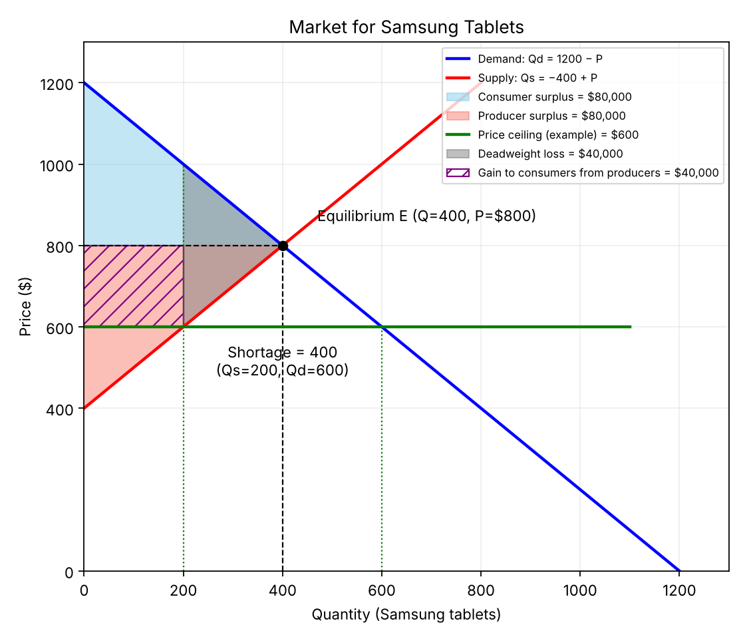

c. Price where demand no longer exists
Set Qd = 0: 0 = 1200 − P → P = $1,200. At $1,200 or more, nobody buys a tablet (the choke price).

d. If tablets were free
Set P = 0: Qd = 1200 − 0 = 1,200 tablets.

e. Consumer and producer surplus
Consumer surplus = ½ × base × height = ½ × 400 × (1200 − 800) = $80,000
Producer surplus = ½ × 400 × (800 − 400) = $80,000
(The supply curve starts at P = $400, since 0 = −400 + P → P = 400.) Total surplus = $160,000.

f. Price floor or price ceiling?
A price ceiling, because it lowers the price so tablets are cheaper for schools. It goes between $400 and $800: below $800 so it has an effect, and above $400 so producers still supply tablets.

g. Who benefits?
Consumers, specifically those who manage to buy a tablet at the lower price. Example with a $600 ceiling (shown on the graph):
• Consumers now pay $600 instead of $800 on the 200 tablets sold. The purple rectangle (200 × $200 = $40,000) is surplus moved from producers to consumers.
• New consumer surplus = ½ × 200 × (1200 − 1000) + 200 × (1000 − 600) = 20,000 + 80,000 = $100,000 (up from $80,000).
• New producer surplus = ½ × 200 × (600 − 400) = $20,000 (down from $80,000).
• The grey triangle is deadweight loss = ½ × 200 × (1000 − 600) = $40,000. These are tablets that would have been traded at equilibrium but are no longer produced.
Producers lose because they receive a lower price and sell fewer units. Consumers as a group gain, but consumers who face the shortage and cannot get a tablet are worse off.

2. Subway “Foot Long” – price elasticity of demand
Midpoint (arc) method:
%ΔQ = (4.2 − 2.3) / [(4.2 + 2.3)/2] = 1.9 / 3.25 = 58.46%
%ΔP = (5.00 − 7.50) / [(5.00 + 7.50)/2] = −2.50 / 6.25 = −40.00%
Ed = 58.46% / −40.00% = −1.46 → |Ed| = 1.46 > 1, so demand is ELASTIC.
(Simple percentage method from the original values: 82.6% / −33.3% = −2.48, also elastic.)
Check with total revenue: before = $7.50 × 2.3M = $17.25M per day; after = $5.00 × 4.2M = $21.0M per day. Revenue rose when the price fell, which is what happens when demand is elastic.
What this says about subs and other products: elastic demand means Foot Longs have many close substitutes, such as subs from Jimmy John's, Jersey Mike's or Quiznos, fast-food burgers, pizza, or a sandwich made at home. Consumers are price-sensitive: when Subway cuts its price, many customers switch to Subway from these substitutes. A Foot Long is also a non-essential purchase, which makes demand more elastic.

3. Friendly’s Ice Cream
From the graph: on S1 the equilibrium is P = $4.99, Q = 2,000 gallons; on S2 the equilibrium is P = $2.99, Q = 5,000 gallons.

a. Elastic or inelastic?
Elastic. Ice cream is a luxury or treat rather than a necessity, and Friendly's has many close substitutes: other brands (Ben & Jerry's, Häagen-Dazs, Breyers, store brands) and other desserts (frozen yogurt, gelato). The graph confirms this. A $2.00 drop in price (about 40%) raises quantity demanded from 2,000 to 5,000 gallons, which is a much larger percentage change.

b. Mathematical proof
Midpoint method:
%ΔQ = (5,000 − 2,000) / 3,500 = 85.7%
%ΔP = (2.99 − 4.99) / 3.99 = −50.1%
Ed = 85.7% / −50.1% = −1.71 → |Ed| = 1.71 > 1, so demand is ELASTIC.
(Simple method: 150% / −40.1% = −3.74, also elastic.)

c. Which S curve would the company prefer?
Total revenue = P × Q
S1: $4.99 × 2,000 = $9,980
S2: $2.99 × 5,000 = $14,950
The company would prefer S2. Revenue is $4,970 higher, about 50% more.
Why this makes sense: demand is elastic (|Ed| > 1), so the percentage increase in quantity (85.7%) is larger than the percentage decrease in price (50.1%). When demand is elastic, price and total revenue move in opposite directions, so a lower price raises total revenue. S2 is also a rightward shift in supply, which usually reflects lower production costs (better technology, cheaper inputs). Friendly's can therefore sell much more at a lower price while its cost per gallon is also lower.

d. If Ben & Jerry’s, Häagen-Dazs and Breyers went out of business
Friendly's would lose its closest substitutes, which affects its demand curve in two ways:
1. Demand increases (shifts right). Former customers of those brands would switch to Friendly's, so it sells more at every price.
2. Demand becomes more inelastic (steeper). With fewer substitutes, customers have fewer alternatives and are less price-sensitive.
Friendly's should then increase its price. When demand is inelastic (|Ed| < 1), a price increase reduces quantity by a smaller percentage than the price rises, so total revenue goes up. Friendly's would also gain market power, close to a monopoly in branded ice cream, so it could raise prices without losing many customers. Its remaining competition would be other desserts and store brands.

4. Energy Drinks – $1.00 per bottle production tax
From the graph: before the tax (S), P = $3.00 and Q = 10,000,000 bottles. After the tax (S'), P = $3.20 and Q = 5,000,000 bottles.

a. Why does supply shift from S to S'?
The tax is a cost of production: producers must pay the government $1.00 for every bottle they make. To supply any given quantity, producers now need $1.00 more per bottle to cover that cost. Supply therefore decreases. The curve shifts up by the amount of the tax ($1.00) and to the left, from S to S'.

b. Price elasticity of demand
Midpoint method:
%ΔQ = (5M − 10M) / 7.5M = −66.7%
%ΔP = (3.20 − 3.00) / 3.10 = 6.45%
Ed = −66.7% / 6.45% = −10.33 → |Ed| = 10.33, so demand is HIGHLY ELASTIC.
(Simple method: −50% / 6.67% = −7.5, also highly elastic.)

c. Tax paid by consumers
Consumers pay the price increase: $3.20 − $3.00 = $0.20 per bottle.

d. Tax paid by producers
$1.00 − $0.20 = $0.80 per bottle. Producers collect $3.20 but send $1.00 to the government, so they keep only $2.20, compared with $3.00 before the tax.

e. Total tax revenue
Tax revenue = tax per unit × quantity sold after the tax = $1.00 × 5,000,000 = $5,000,000.

f. Revenue from consumers
$0.20 × 5,000,000 = $1,000,000 (20% of the revenue).

g. Revenue from producers
$0.80 × 5,000,000 = $4,000,000 (80% of the revenue).

h. Why producers pay the larger share
The tax burden falls mostly on whichever side of the market is less elastic, meaning less able to walk away. Here demand is highly elastic (|Ed| ≈ 10) and the demand curve is much flatter than the supply curve.
Consumers have many substitutes for energy drinks: coffee, tea, soda and caffeine pills. Energy drinks are also not a necessity. If producers tried to pass the full $1.00 on to consumers by raising the price to $4.00, quantity demanded would fall sharply because consumers would switch to those alternatives.
Producers have fewer options in the short run. They have already invested in factories, equipment and brands, and cannot easily switch to producing something else. To keep selling, they must absorb most of the tax through a lower net price ($2.20 instead of $3.00).
As a result, the market price rises only $0.20 and producers absorb $0.80 of each $1.00. The more elastic side of the market (consumers) avoids most of the tax, and the less elastic side (producers) bears most of it. The tax also cut sales in half, from 10M to 5M bottles. This is consistent with the government's goal of discouraging consumption of an unhealthy product.

