Component:

Package:

Deployment:

MER

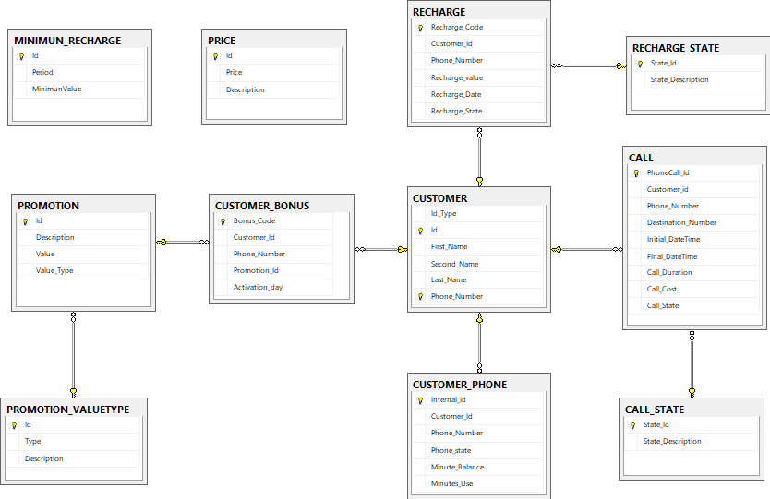

Application Structure: