PREPAID CELLPHONE SOFTWARE

Architecture/Technical Design Document

Version. | Date | Author(s) | Description
1.0 | 05/06/2017 | Fabian Andres Moreno Ch. | Architecture document Creation for the prepaid cellphone software

MasterTIPSS Architecture Document

Table of Contents
1.0 Introduction 4
2.0 High-Level Hierarchy 4
2.1 Hierarchy Description 4
2.2 Components Diagram 4
2.3 Packages Diagram 5
2.4 Deployment Diagram 6
2.5 Database Design 8

1.0 Introduction

The Prepaid Cellphone Software Architecture document is designed to illustrate and identify the high-level architecture systems used to design and implement the WCF Service. The document contains an overall view of the system hierarchy, logical views of the systems components.

2.0 High-Level Hierarchy

2.1 Hierarchy Description

The architecture system for the Prepaid Cellphone Software is a Representational state transfer architecture.

2.2 Components Diagram

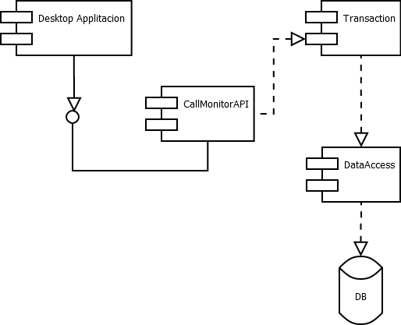
Figure 1. Components Diagram

2.3 Packages Diagram
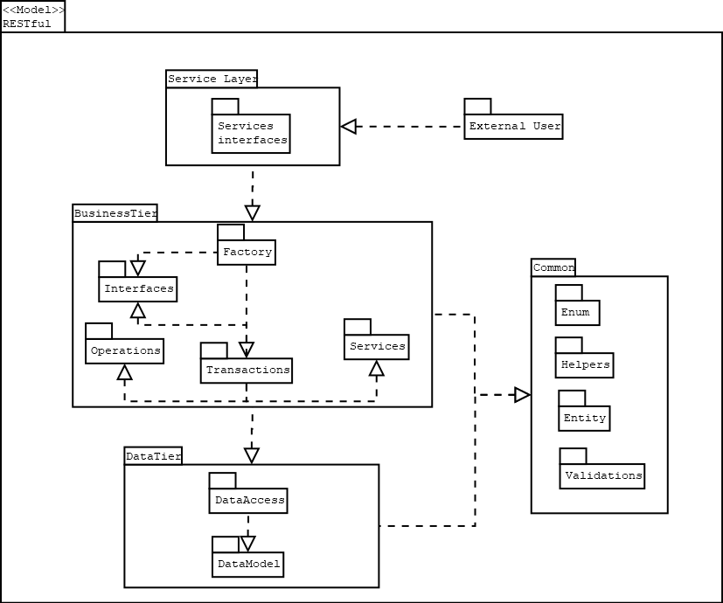

Figure 2. Packages Diagram

2.4 Deployment Diagram

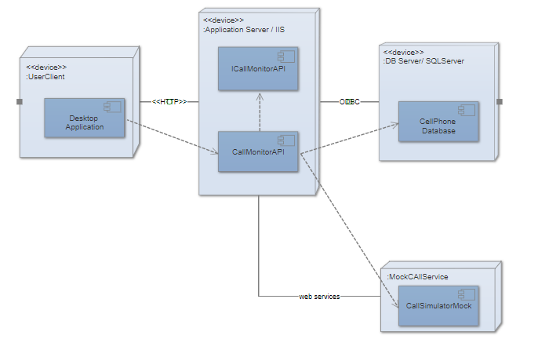

Figure 3. Deployment Diagram

2.5 Database Design
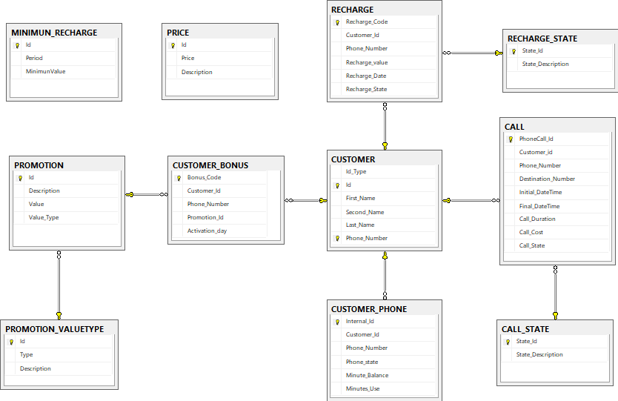

Figure 4. Database Design

