**MicroCode Quick Start Guide**

# A picture containing electronic device, gadget, text, electronics Description automatically generatedEDITING MODES

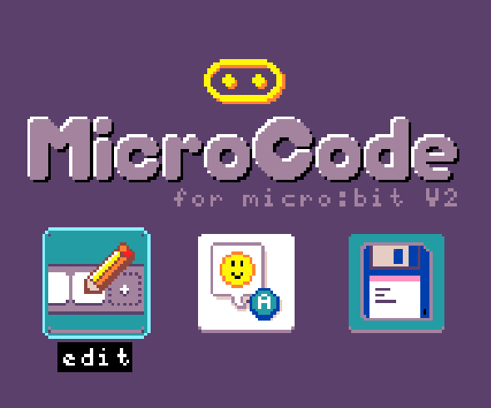

<https://microsoft.github.io/microcode/>

The MicroCode language is defined in terms of **pages**, where a page has a list of **rules**, and each rule consists of a **When** section and a **Do** section, each with a list of programming **tiles**.

# A RULE

# EVENTS

|  |
| --- |
| press |
| release imagerelease |
| move imageaccelerometer |
| hear imagesound |
| temperature change imagetemperature |
| light sensorlight sensor |
| radio receive imageradio receiver |
| start page imagestart page |
| timer imagetimer |
| variable X imagevariable Y imagevariable Z imagevariable |
| wall and line |

# Event parameters

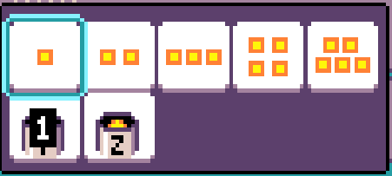Some events can have parameters. Push events indicate the button required. Those for the variable event are used or evaluated in order for the event to proceed. Timer events indicate the seconds for starting the timer.

# Command tiles

|  |  |
| --- | --- |
| screen show image | radio sendradio send |
| show numbershow number | radio set groupradio set group |
| speakersound emoji | switch pageswitch page |
| play notesplay notes | set variable Xset variable |
|  | robot |

# Command parameters

Each command tile can have parameters. There are defaults, which gives an idea of the options

|  |
| --- |
| screenscreen shows a happy face |
| speakersound emoji plays emoji gigglegiggle |
| radio sendradio send sends the number 1 |
| switch pageswitch page switches to page 1 |
| get variable Xget variable or defaults to 0 |

# Pages

All rules on a single Microcode page are active. Rules on another page become active with a switch-page command.

<https://microsoft.github.io/microcode/docs/samples/hot-potato>