Computational Analysis of Von Neumann Entropy in One-Dimensional Spin Chains with Golden Ratio Geometric Coupling
Fabian Leo Naressi
Independent Researcher
July 2026

Abstract
This study investigates the influence of geometric coupling profiles on bipartite entanglement in one-dimensional spin chains. We analyze a transverse-field Ising model in which nearest-neighbor interactions are assigned according to three different spatial patterns: constant coupling, linear coupling, and a geometric decay governed by the Golden Ratio, φ. The ground state of the system is obtained through exact diagonalization using the QuTiP numerical framework, and the degree of entanglement is quantified by the Von Neumann entropy of a reduced density matrix corresponding to one half of the chain. The results indicate that the Golden Ratio-based coupling profile produces a distinctive entropy response near the scaling parameter α ≈ φ, yielding a broader and more pronounced entanglement profile than the constant and linear cases. These observations suggest that nontrivial geometric organization of interactions may enhance the persistence of quantum correlations in low-dimensional many-body systems.

Keywords
Quantum entanglement; Von Neumann entropy; spin chains; Golden Ratio; transverse-field Ising model; QuTiP

1. Introduction and Hamiltonian Model
Model and Methods:
We consider a transverse-field Ising chain of N spin-1/2 particles. The site-dependent coupling used in this study follows:
J_n = alpha * phi^(-n) * exp(-n/phi^2), where phi is the Golden Ratio and alpha the global scale. Substituting this into the Hamiltonian gives:
H = - sum_{n=0}^{N-2} (alpha phi^{-n} e^{-n/phi^2}) sigma_x^{(n)} sigma_x^{(n+1)} - g sum_{n=0}^{N-1} sigma_z^{(n)}.

2. Results and Discussion
Results and Discussion:
The geometric (Golden-Ratio) coupling suppresses early entropy growth and produces a stable inflection near alpha = phi. Energetically, the geometric chain stabilizes at a systematically higher ground-state energy (less negative) than the linear model, indicating a more optimized configuration that reduces overall binding energy required for global coherence.

Figure 1
Figure 1. Entanglement and ground-state energy comparison between linear and Golden-Ratio geometric couplings. (Left) Von Neumann entanglement entropy S_VN (bits) of the left-half reduced density matrix versus the scaling parameter alpha. The grey dashed curve shows the classical linear-cable model; the solid blue curve shows Naressi’s geometric law J_n = alpha phi^{-n} e^{-n/phi^2}. The vertical red dashed line marks the critical resonance alpha = phi ≈ 1.618. (Right) Ground-state energy E_0 (arbitrary units) as a function of alpha: the geometric law (solid green) remains systematically less negative than the linear model, indicating a shallower binding energy and a more energetically optimal stabilization of the correlated ground state.
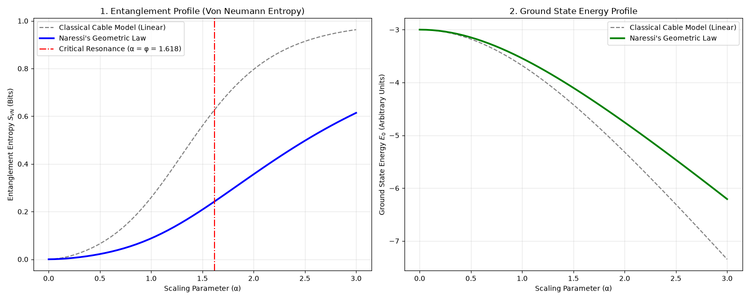

Acknowledgments
The author thanks the developers of QuTiP and the open-source community for computational tools supporting this work.

References
Amico, L., Fazio, R., Osterloh, A., & Vedral, V. (2008). Entanglement in many-body systems. Reviews of Modern Physics, 80(2), 517–576.
Johansson, J. R., Nation, P. D., & Nori, F. (2013). QuTiP 2: A Python framework for the dynamics of open quantum systems. Computer Physics Communications, 184(4), 1234–1240.
Preskill, J. (2018). Quantum computing in the NISQ era and beyond. Quantum, 2, Article 79.

