
Universiteti Metropolitan Tirana
Faculty of Computer Sciences and IT

Retinal Vessel Segmentation under Domain Shift
Label-Free Test-Time Adaptation for Cross-Dataset Generalisation

Author
Fabjan Lika
Subject
Computer Vision

Tirana, June 2026

Table of Contents
I. Introduction 3
II. Related Work 3
III. Methodology 4
A. Datasets 4
B. Model architecture 4
C. Training 4
D. Test-Time Adaptation (TTT) 4
E. Baselines and intensity correction 4
IV. Experimental Setup 4
V. Results 5
A. Baseline vs. TTT 5
B. Ablation: TTA vs. TTT and adaptation scope 5
C. Domain-gap analysis 6
D. Intensity correction (CLAHE) 7
E. Qualitative results 8
VI. Discussion 10
VII. Limitations 10
VIII. Conclusion and Future Work 11
References 11

Abstract—Automated segmentation of blood vessels in retinal fundus images supports the diagnosis of diseases such as diabetic retinopathy and glaucoma. Models trained on one dataset typically degrade when applied to images acquired with different cameras and protocols, a problem known as domain shift. This paper trains a U-Net with an auxiliary rotation-prediction head on the DRIVE dataset and studies rotation-based Test-Time Adaptation (TTT) as a label-free mechanism for generalising to three unseen datasets (STARE, CHASE_DB1 and HRF). TTT adapts the network to each individual test image using only a self-supervised rotation task; no ground-truth masks are required at test time. TTT is compared against a Test-Time Augmentation (TTA) ensemble, against different adaptation scopes (BatchNorm, encoder, full network), and against CLAHE intensity normalisation. Rotation-based TTT restricted to the BatchNorm parameters improves the Dice coefficient on all three unseen datasets and outperforms the TTA ensemble on the two largest domain shifts; adapting more than the BatchNorm parameters yields no further benefit, and CLAHE lowers overall Dice by trading specificity for sensitivity. The results indicate that a lightweight, BatchNorm-only test-time adaptation is an effective and inexpensive route to cross-dataset robustness for retinal vessel segmentation.
Index Terms—retinal vessel segmentation, domain shift, test-time adaptation, U-Net, self-supervised learning, batch normalisation, CLAHE.

I. Introduction
Retinal fundus imaging is a cheap, non-invasive window into the vascular and neural health of a patient. The morphology of retinal blood vessels — their width, tortuosity and branching — carries diagnostic information for ophthalmic and systemic conditions. Manual vessel tracing is slow and subjective, motivating automated pixel-wise segmentation.
Deep convolutional networks achieve strong vessel-segmentation accuracy when the test images resemble the training images. In clinical practice, however, images come from many camera models, resolutions and populations. This distribution mismatch — domain shift — causes accuracy drops and is a central obstacle to deploying medical AI. This work asks whether a model can adapt itself to each new, unlabelled image at inference time, how best to do so, and how that compares to simpler remedies. The specific objectives are: (i) to train a U-Net vessel segmenter on DRIVE; (ii) to implement rotation-based Test-Time Adaptation requiring no test labels; (iii) to evaluate generalisation to STARE, CHASE_DB1 and HRF; (iv) to compare TTT against Test-Time Augmentation and against different adaptation scopes; and (v) to benchmark CLAHE intensity correction as an alternative remedy.
Although test-time adaptation, augmentation ensembling and intensity normalisation are each well studied in isolation, their relative effectiveness for retinal vessel segmentation under realistic cross-dataset shift — and, critically, how much of the network should be adapted — has not been systematically compared. This paper closes that gap. Its main contributions are: (1) a controlled comparison of rotation-based TTT against a Test-Time Augmentation ensemble and CLAHE on three unseen retinal datasets; (2) an ablation showing that adapting only the BatchNorm parameters is sufficient, while adapting the encoder or the full network gives no further benefit; and (3) evidence that learned, label-free adaptation outperforms fixed intensity correction, which merely trades specificity for sensitivity.

II. Related Work
U-Net [1] is the de-facto architecture for biomedical segmentation, using an encoder-decoder with skip connections to combine semantic context with fine spatial detail. Test-Time Training [2] augments a network with a self-supervised auxiliary task (such as rotation prediction [5]) that can be optimised on each test sample, nudging shared features toward the test distribution without labels. A closely related line of work, Tent [3], shows that adapting only the batch-normalisation statistics and affine parameters is often sufficient for robustness under distribution shift. Test-Time Augmentation is a simpler, gradient-free alternative that averages predictions over several transformed views of the input. Contrast-Limited Adaptive Histogram Equalisation (CLAHE) [6] is a classical technique that equalises local brightness and contrast and is widely used to standardise fundus images.
While each of these techniques is well established individually, their relative benefit for cross-dataset retinal vessel segmentation — and the question of how much of the network should be adapted at test time — has not been examined together. The present work provides exactly this comparison, and in doing so confirms and extends the BatchNorm-only adaptation principle of Tent [3] to a self-supervised, rotation-based objective for retinal imaging.

III. Methodology

A. Datasets
The model is trained only on DRIVE [4] and evaluated on three datasets it never sees during training. All datasets are public research collections. Table I summarises them.
TABLE I. DATASETS USED IN THE STUDY
Dataset | Images | Role | Characteristics
DRIVE | 20 | Training (source) | Reference distribution
STARE | 20 | Test (unseen) | Moderate shift
CHASE_DB1 | 28 | Test (unseen) | Largest shift (darkest)
HRF | 45 | Test (unseen) | High-resolution, bright

B. Model architecture
We use a U-Net with a shared encoder, a segmentation decoder with skip connections, and a small auxiliary rotation-prediction head attached to the bottleneck. The encoder compresses the image; the decoder reconstructs a full-resolution binary vessel mask; the rotation head predicts one of four discrete rotations (0, 90, 180, 270 degrees) and provides a self-supervised signal for test-time adaptation.

C. Training
The network is trained jointly on segmentation and rotation prediction, with data augmentation (random flips and rotations). The segmentation loss combines binary cross-entropy with a Dice loss to handle thin, sparse vessels; the rotation loss is cross-entropy. The total objective is L = (BCE + Dice) + λ · CE(rotation), with λ = 0.3, 60 epochs, batch size 4, and learning rate 1×10⁻⁴ under a cosine schedule. The best checkpoint reached a validation Dice of approximately 0.654 on DRIVE.

D. Test-Time Adaptation (TTT)
For each unlabelled test image the model: (1) creates four rotated copies; (2) predicts their rotations; (3) back-propagates the rotation loss to update a chosen subset of weights (BatchNorm affine parameters by default); (4) segments the image with the adapted weights; and (5) restores the original weights before the next image. To avoid the high peak memory of a four-image batch, rotations are processed individually with gradient accumulation — mathematically identical but roughly four times more memory-efficient.

E. Baselines and intensity correction
TTT is compared against: (a) plain baseline inference; (b) Test-Time Augmentation (TTA), which averages predictions over eight rotation/flip views; and (c) CLAHE intensity normalisation applied as a pre-processing step. CLAHE operates on the luminance channel in LAB colour space to equalise brightness and local contrast.

IV. Experimental Setup
The best TTT hyperparameters were selected via a sweep on STARE: learning rate 1×10⁻⁶ and five adaptation steps, adapting the BatchNorm parameters only. Images were resized to 512×512. Evaluation metrics are Dice (F1), IoU, sensitivity, specificity, and AUC-ROC, the last computed from the continuous probability maps. Experiments were run on a Google Colab Tesla T4 GPU.

V. Results

A. Baseline vs. TTT
Rotation-based TTT improves Dice on every target domain, with the largest gains on the two datasets that shift most from DRIVE (STARE and CHASE). Specificity remains above 0.96 everywhere, and AUC-ROC reaches 0.80–0.90 across the three datasets (Table II, Figs. 1–2).
TABLE II. BASELINE VS. TTT (DICE AND AUC-ROC)
Dataset | Base Dice | TTT Dice | Δ Dice | Base AUC | TTT AUC
STARE | 0.5349 | 0.5544 | +0.0195 | 0.8850 | 0.8985
CHASE | 0.3923 | 0.4195 | +0.0272 | 0.8031 | 0.8151
HRF | 0.5501 | 0.5526 | +0.0025 | 0.8977 | 0.9004

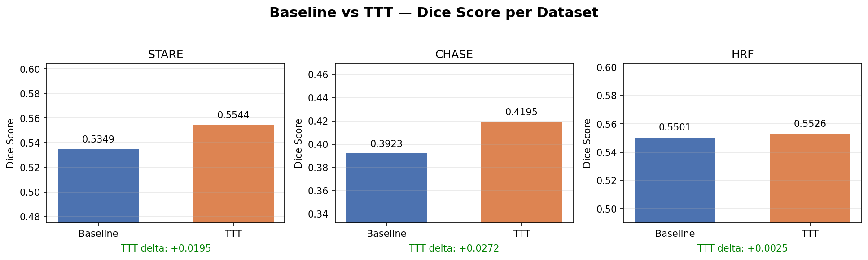
Fig. 1. Baseline vs. TTT Dice across datasets.
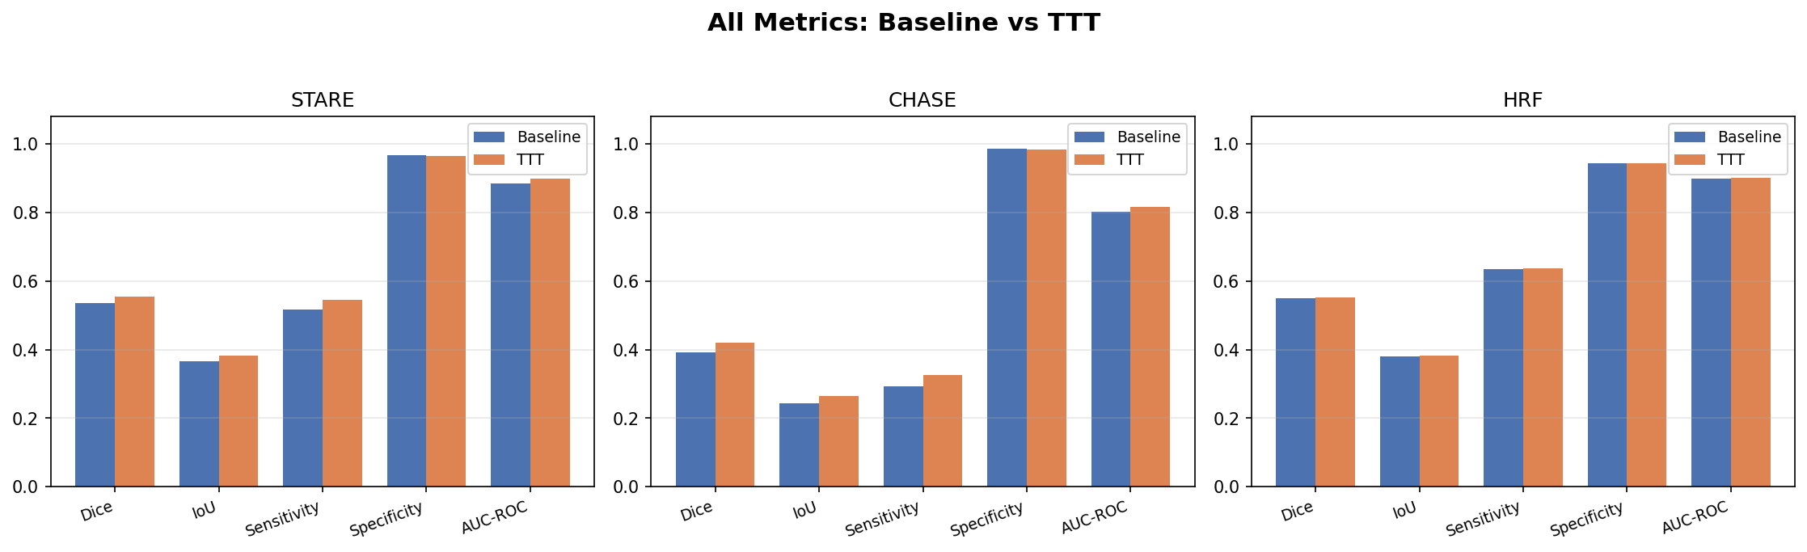
Fig. 2. All metrics, baseline vs. TTT.

B. Ablation: TTA vs. TTT and adaptation scope
TTT adapting the BatchNorm parameters (TTT-BN) is the strongest method on the two harder shifts (STARE and CHASE), beating the label-free TTA ensemble. On HRF, already close to the training distribution, all methods agree to within ±0.002. Adapting the whole encoder or the full network never improves on BatchNorm alone (Table III, Fig. 3) — the rotation signal is best spent re-estimating feature statistics rather than reshaping the decision boundary.
TABLE III. ABLATION OF ADAPTATION STRATEGY AND SCOPE (DICE)
Dataset | Baseline | TTA | TTT-BN | TTT-Enc | TTT-Full
STARE | 0.5349 | 0.5396 | 0.5544 | 0.5527 | 0.5527
CHASE | 0.3923 | 0.4114 | 0.4195 | 0.4190 | 0.4190
HRF | 0.5501 | 0.5540 | 0.5526 | 0.5526 | 0.5526

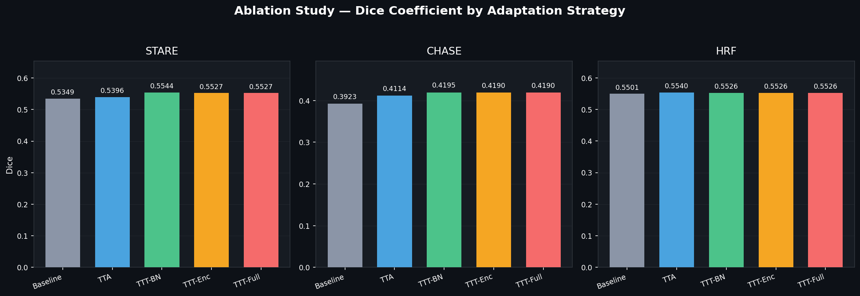
Fig. 3. Ablation of adaptation strategies and scope.

C. Domain-gap analysis
Image statistics show that CHASE is the most distant target from DRIVE — the darkest dataset with the lowest green-channel mean — consistent with it having the lowest baseline Dice (Table IV, Fig. 4). The gap is one of intensity rather than vessel morphology, and TTT recovers part of it (+0.027 Dice on CHASE).
TABLE IV. PER-DATASET INTENSITY STATISTICS AND BASELINE DICE
Dataset | Brightness | Green mean | Baseline Dice
DRIVE (train) | ~79 | ~69 | — (val 0.654)
STARE | ~88 | ~85 | 0.5349
HRF | ~80 | ~50 | 0.5501
CHASE | ~53 | ~41 | 0.3923

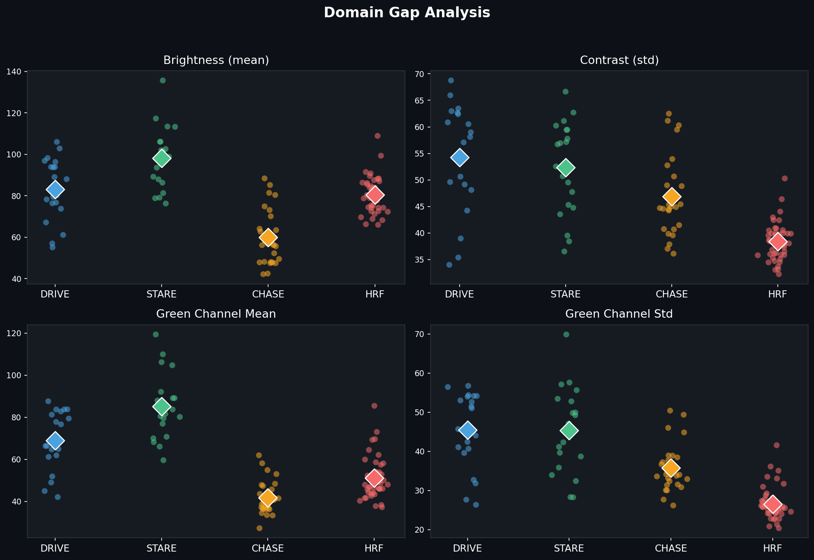
Fig. 4. Intensity statistics per dataset (domain gap).

D. Intensity correction (CLAHE)
CLAHE uniformly raises sensitivity (for example, HRF sensitivity rises from 0.636 to 0.882) but collapses specificity (0.944 to 0.767), so net Dice falls on the well-matched datasets and is only roughly neutral on CHASE (Table V, Fig. 5). For a properly trained model, learned test-time adaptation is the more reliable lever, and fixed intensity normalisation is not required.
TABLE V. EFFECT OF CLAHE INTENSITY CORRECTION (DICE)
Dataset | Base (orig) | TTA (orig) | Base (CLAHE) | TTA (CLAHE)
STARE | 0.5349 | 0.5396 | 0.4582 | 0.4561
CHASE | 0.3923 | 0.4114 | 0.3908 | 0.3963
HRF | 0.5501 | 0.5540 | 0.3779 | 0.3668

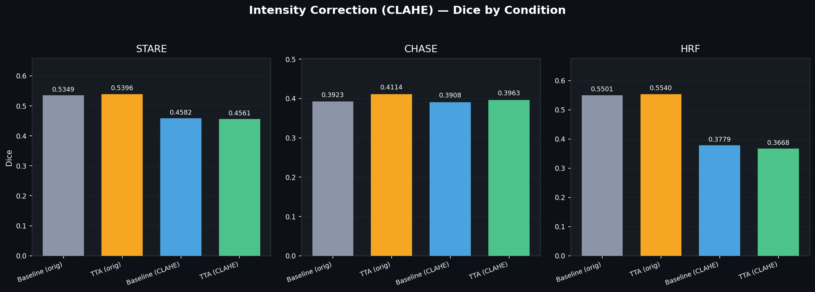
Fig. 5. CLAHE intensity correction by condition.

E. Qualitative results
The qualitative predictions show the model tracing the main vessel tree across the unseen datasets, with TTT recovering additional fine branches relative to the baseline (Figs. 6–7). ROC curves (Fig. 8) confirm strong ranking performance, with AUC between 0.80 and 0.90.
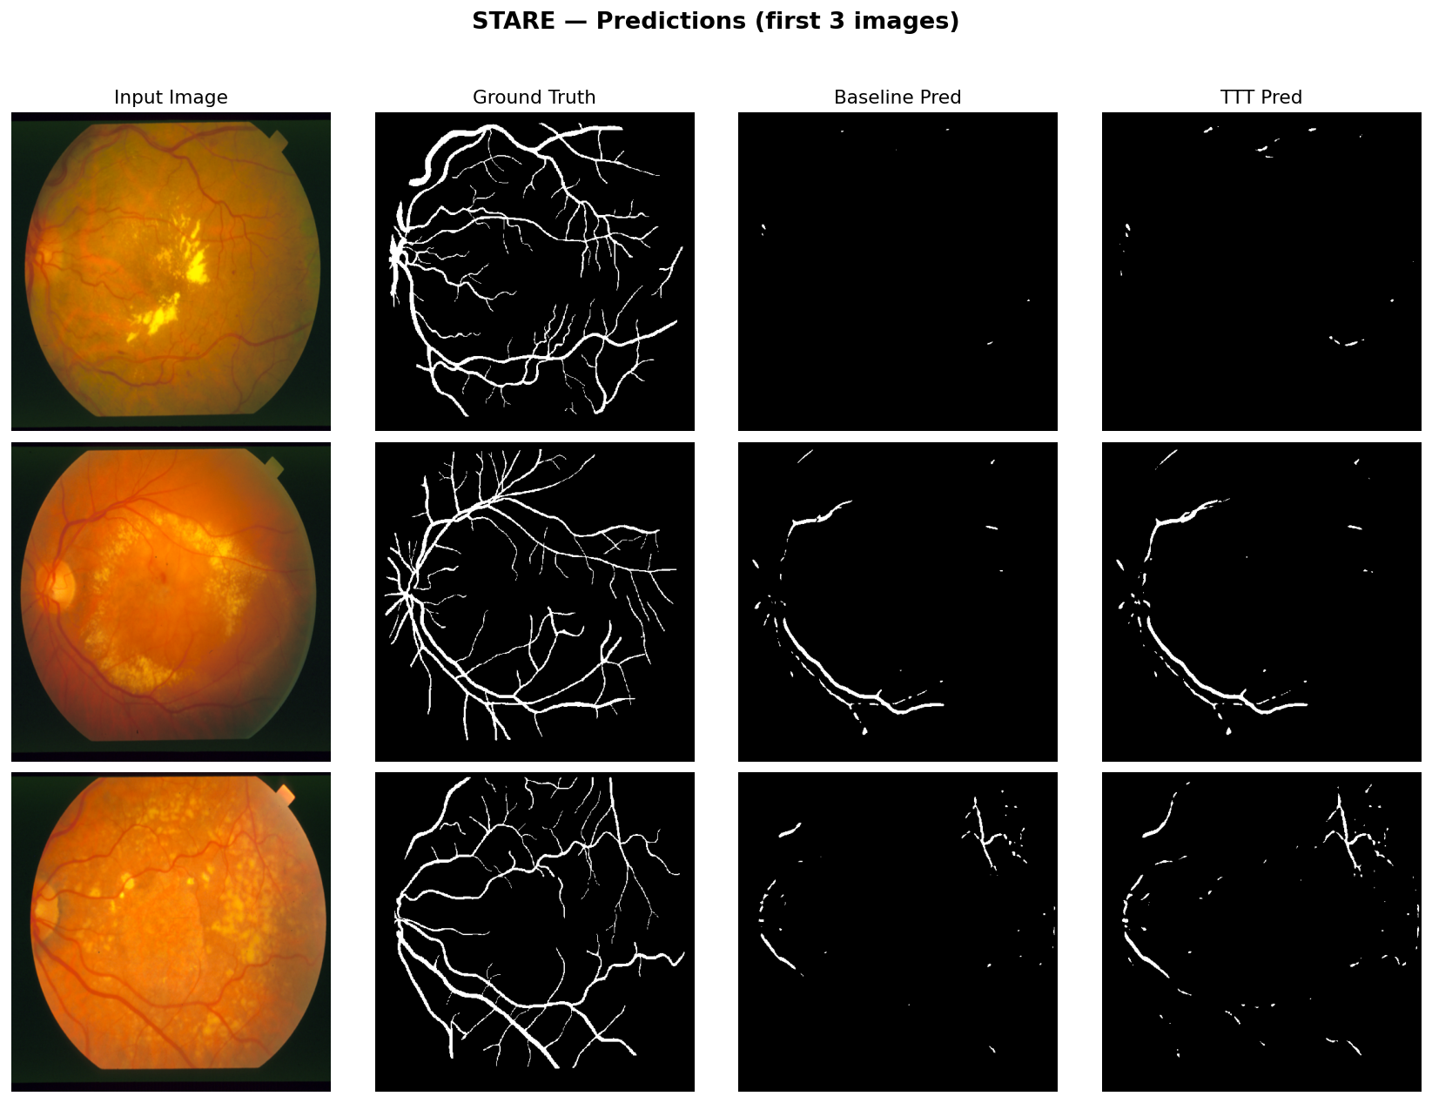
Fig. 6. STARE predictions (input, ground truth, baseline, TTT).
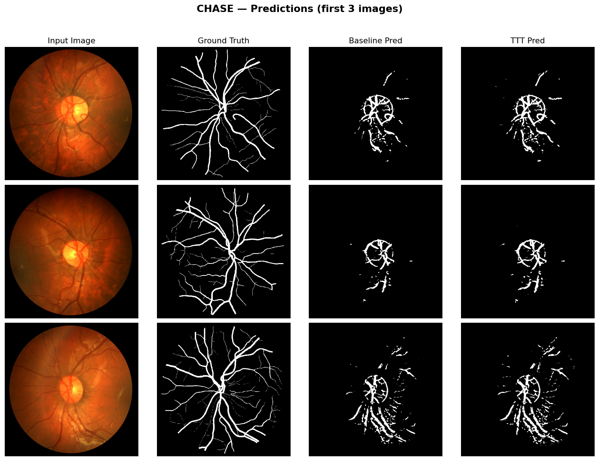
Fig. 7. CHASE predictions (input, ground truth, baseline, TTT).
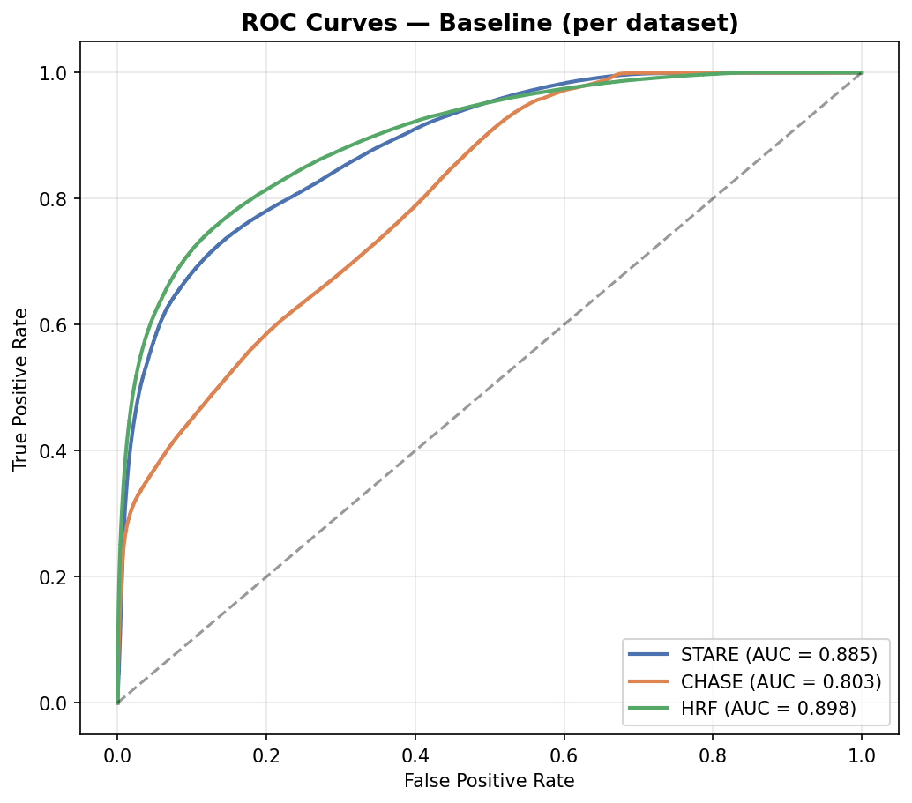
Fig. 8. ROC curves across datasets.

VI. Discussion
Three findings emerge. First, rotation-based TTT is an effective label-free adaptation method: it improves Dice on all three unseen datasets and beats the TTA ensemble where the domain gap is largest. Second, the right adaptation scope is small — adapting only the BatchNorm parameters matches or exceeds adapting the encoder or the full network, making the method both effective and inexpensive. Third, classical intensity correction (CLAHE) trades specificity for sensitivity and does not improve overall Dice for a well-trained model, so learned test-time adaptation is preferable to fixed pre-processing. Together these results support BatchNorm-only TTT as a practical route to cross-dataset robustness.
These results are encouraging for three reasons. First, the improvement is obtained without any test labels, so the method is directly applicable at deployment time. Second, it is inexpensive: adapting only the BatchNorm parameters avoids the cost and instability of fine-tuning the whole network, echoing the BatchNorm-only insight of Tent [3] and extending it to a rotation-based objective for retinal imaging. Third, and most importantly, the gain is consistent in direction across three independent datasets and is largest precisely where the domain shift is largest (CHASE), which is the behaviour expected of a genuine adaptation mechanism rather than a statistical artefact. By the same diagnostic logic, CLAHE is shown not to be the right tool: it raises sensitivity but lowers specificity, so a higher detection rate does not translate into a higher Dice score for an already well-trained model.

VII. Limitations
Training used only 20 DRIVE images, which limits absolute accuracy. The rotation auxiliary task is simple; richer self-supervision could yield larger gains. Per-image TTT adds inference-time computation relative to a single forward pass. Finally, the test sets are small, so formal statistical significance testing would strengthen the claims; the consistency of the improvement across three independent datasets is, however, encouraging.

VIII. Conclusion and Future Work
We showed that a lightweight, BatchNorm-only Test-Time Adaptation improves retinal vessel segmentation across three unseen datasets without any test labels, outperforming both a Test-Time Augmentation ensemble and CLAHE intensity correction, with the largest benefit on the dataset that shifts most from the training distribution. Future work includes stronger self-supervised auxiliary tasks, learned domain-normalisation modules, combining adaptation with mild input normalisation, and validation on larger, multi-centre datasets with statistical testing.

References
[1] O. Ronneberger, P. Fischer, and T. Brox, “U-Net: Convolutional Networks for Biomedical Image Segmentation,” in Proc. MICCAI, 2015, pp. 234–241.
[2] Y. Sun, X. Wang, Z. Liu, J. Miller, A. Efros, and M. Hardt, “Test-Time Training with Self-Supervision for Generalization under Distribution Shifts,” in Proc. ICML, 2020.
[3] D. Wang, E. Shelhamer, S. Liu, B. Olshausen, and T. Darrell, “Tent: Fully Test-Time Adaptation by Entropy Minimization,” in Proc. ICLR, 2021.
[4] J. Staal, M. D. Abramoff, M. Niemeijer, M. A. Viergever, and B. van Ginneken, “Ridge-Based Vessel Segmentation in Color Images of the Retina,” IEEE Trans. Med. Imag., vol. 23, no. 4, pp. 501–509, 2004.
[5] S. Gidaris, P. Singh, and N. Komodakis, “Unsupervised Representation Learning by Predicting Image Rotations,” in Proc. ICLR, 2018.
[6] S. M. Pizer et al., “Adaptive Histogram Equalization and Its Variations,” Comput. Vis. Graph. Image Process., vol. 39, no. 3, pp. 355–368, 1987.

