Retinal Vessel Segmentation under Domain Shift
Label-Free Test-Time Adaptation for Cross-Dataset Generalisation

MSc Artificial Intelligence — Computer Vision
Final Project Report

Abstract
Automated segmentation of blood vessels in retinal fundus photographs supports the diagnosis of diseases such as diabetic retinopathy and glaucoma. Models trained on one dataset typically degrade when applied to images acquired with different cameras and protocols — a problem known as domain shift. This project trains a U-Net with an auxiliary rotation-prediction head on the DRIVE dataset and studies rotation-based Test-Time Adaptation (TTT) as a label-free mechanism for generalising to three unseen datasets (STARE, CHASE_DB1 and HRF). TTT adapts the network to each individual test image using only a self-supervised rotation task — no ground-truth masks are required. We compare TTT against a Test-Time Augmentation (TTA) ensemble and against different adaptation scopes (BatchNorm, encoder, full network), and we additionally evaluate CLAHE intensity normalisation as an alternative pre-processing remedy. We find that rotation-based TTT, restricted to the BatchNorm parameters, improves the Dice coefficient on all three unseen datasets and outperforms the TTA ensemble on the two largest domain shifts (STARE and CHASE). Adapting more parameters than BatchNorm gives no further benefit, and CLAHE — while it raises sensitivity — lowers overall Dice by sacrificing specificity. The study shows that a lightweight, BatchNorm-only test-time adaptation is an effective and inexpensive route to cross-dataset robustness for retinal vessel segmentation.

1. Introduction
Retinal fundus imaging is a cheap, non-invasive window into the vascular and neural health of a patient. The morphology of retinal blood vessels — their width, tortuosity and branching — carries diagnostic information for ophthalmic and systemic conditions. Manual vessel tracing is slow and subjective, motivating automated pixel-wise segmentation.
Deep convolutional networks achieve strong vessel-segmentation accuracy when the test images resemble the training images. In clinical reality, though, images come from many camera models, resolutions and populations. This distribution mismatch — domain shift — causes accuracy drops and is a central obstacle to deploying medical AI. This project asks whether a model can adapt itself to each new, unlabelled image at inference time, how best to do so, and how that compares to simpler remedies.

1.1 Objectives
- Train a U-Net vessel segmenter on the DRIVE dataset.
- Implement rotation-based Test-Time Adaptation (TTT) requiring no test labels.
- Evaluate generalisation to three unseen datasets: STARE, CHASE_DB1 and HRF.
- Compare TTT against Test-Time Augmentation (TTA) and against different adaptation scopes.
- Benchmark CLAHE intensity correction as an alternative pre-processing remedy.

2. Background and Related Work
U-Net is the de-facto architecture for biomedical segmentation, using an encoder-decoder with skip connections to combine semantic context with fine spatial detail. Test-Time Training, introduced by Sun et al. (2020), augments a network with a self-supervised auxiliary task (such as rotation prediction) that can be optimised on each test sample, nudging shared features toward the test distribution without labels. A closely related line of work (e.g. Tent, Wang et al. 2021) shows that adapting only the BatchNorm statistics and affine parameters is often sufficient for robustness under distribution shift. Test-Time Augmentation is a simpler, gradient-free alternative that averages predictions over several transformed views of the input. Contrast-Limited Adaptive Histogram Equalisation (CLAHE) is a classical image-processing technique that equalises local brightness and contrast and is widely used to standardise fundus images.

3. Datasets
The model is trained only on DRIVE and evaluated on three datasets it never sees during training. All datasets are public research collections with their own licences and must be downloaded from their official sources.
Dataset | Images | Role | Characteristics
DRIVE | 20 | Training (source) | Reference distribution
STARE | 20 | Test (unseen) | Moderate shift
CHASE_DB1 | 28 | Test (unseen) | Largest shift — darkest images
HRF | 45 | Test (unseen) | High-resolution, bright

4. Methodology

4.1 Model architecture
We use a U-Net (UNetWithRotationHead) with a shared encoder, a segmentation decoder with skip connections, and a small auxiliary rotation-prediction head attached to the bottleneck. The encoder compresses the image; the decoder reconstructs a full-resolution binary vessel mask; the rotation head predicts one of four discrete rotations (0, 90, 180, 270 degrees) and provides a self-supervised signal for test-time adaptation.

4.2 Training
The network is trained jointly on segmentation and rotation prediction, with data augmentation (random flips and rotations) applied to the training images. The segmentation loss combines binary cross-entropy with a Dice loss to handle the thin, sparse vessel structures; the rotation loss is cross-entropy. The total objective is:
Total Loss = (BCE + Dice) + λ · CrossEntropy(rotation)
with λ = 0.3, 60 epochs, batch size 4 and learning rate 1e-4 under a cosine schedule. The best checkpoint reached a validation Dice of approximately 0.654 on DRIVE.

4.3 Test-Time Adaptation (TTT)
For each unlabelled test image the model: (1) creates four rotated copies; (2) predicts their rotations; (3) back-propagates the rotation loss to update a chosen subset of weights (BatchNorm affine parameters by default); (4) segments the image with the adapted weights; and (5) restores the original weights before the next image. To avoid the high peak memory of a 4-image batch, rotations are processed individually with gradient accumulation — mathematically identical but roughly four times more memory-efficient.

4.4 Baselines and intensity correction
We compare TTT against: (a) plain baseline inference; (b) Test-Time Augmentation (TTA), which averages predictions over eight rotation/flip views; and (c) CLAHE intensity normalisation applied as a pre-processing step before inference. CLAHE operates on the luminance channel in LAB colour space to equalise brightness and local contrast.

5. Experimental Setup
Best TTT hyperparameters were selected via a sweep on STARE: learning rate 1e-6 and 5 adaptation steps. Images were resized to 512x512. Evaluation metrics are Dice (F1), IoU, sensitivity, specificity and AUC-ROC, the last computed from the continuous probability maps. Final experiments were run on a Google Colab T4 GPU.

6. Results

6.1 Baseline vs TTT
Rotation-based TTT improves Dice on every target domain, with the largest gains on the two datasets that shift most from DRIVE (STARE and CHASE). Specificity remains above 0.96 everywhere, so the model rarely mislabels background as vessel, and AUC-ROC reaches 0.80–0.90 across the three datasets.
Dataset | Baseline Dice | TTT Dice | Δ Dice | Baseline AUC | TTT AUC
STARE | 0.5349 | 0.5544 | +0.0195 | 0.8850 | 0.8985
CHASE | 0.3923 | 0.4195 | +0.0272 | 0.8031 | 0.8151
HRF | 0.5501 | 0.5526 | +0.0025 | 0.8977 | 0.9004

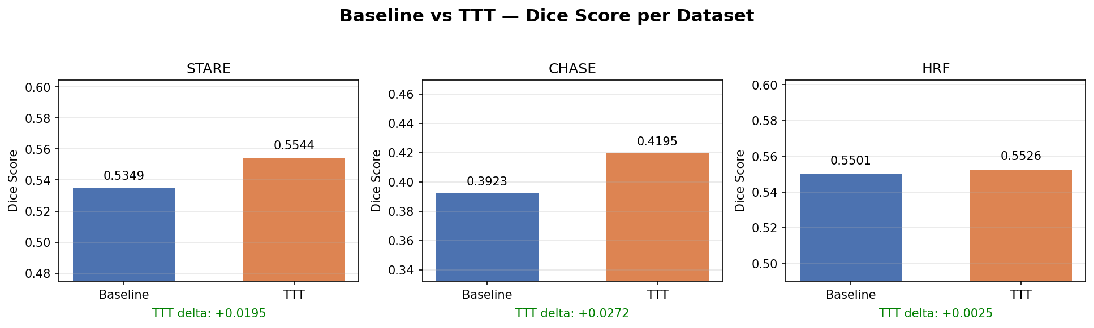
Figure 1. Baseline vs TTT Dice across datasets.
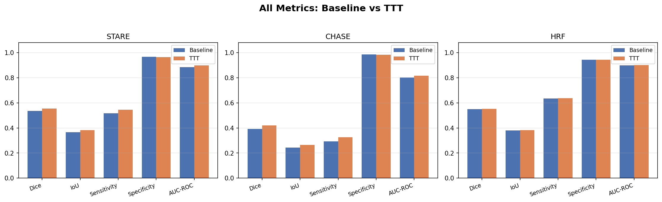
Figure 2. All metrics, baseline vs TTT.

6.2 Ablation: TTA vs TTT and adaptation scope
TTT adapting the BatchNorm parameters (TTT-BN) is the strongest method on the two harder shifts (STARE and CHASE), beating the label-free TTA ensemble. On HRF, which is already close to the training distribution, all methods agree to within ±0.002. Crucially, adapting the whole encoder or the full network never improves on adapting BatchNorm alone — the rotation signal is best spent re-estimating feature statistics rather than reshaping the segmentation decision boundary.
Dataset | Baseline | TTA | TTT-BN | TTT-Enc | TTT-Full
STARE | 0.5349 | 0.5396 | 0.5544 | 0.5527 | 0.5527
CHASE | 0.3923 | 0.4114 | 0.4195 | 0.4190 | 0.4190
HRF | 0.5501 | 0.5540 | 0.5526 | 0.5526 | 0.5526

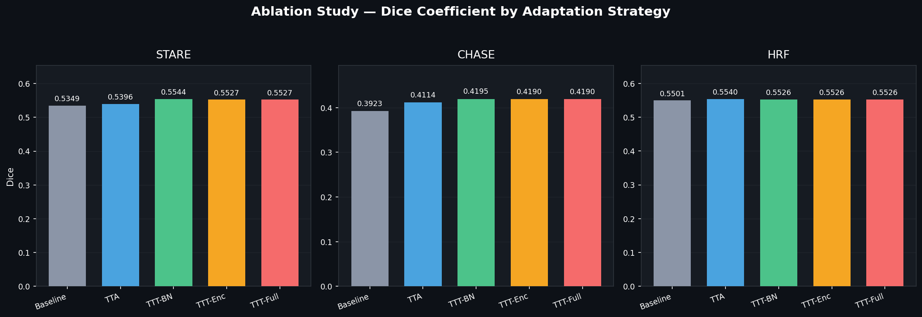
Figure 3. Ablation of adaptation strategies and scope.

6.3 Domain-gap analysis
Quantitative image statistics show that CHASE is the most distant target from DRIVE — it is the darkest dataset with the lowest green-channel mean — which is consistent with it having the lowest baseline Dice. The gap is one of intensity (brightness and contrast) rather than vessel morphology, and TTT recovers part of it (+0.027 Dice on CHASE).
Dataset | Mean brightness | Green-channel mean | Baseline Dice
DRIVE (train) | ~79 | ~69 | — (val 0.654)
STARE | ~88 | ~85 | 0.5349
HRF | ~80 | ~50 | 0.5501
CHASE | ~53 | ~41 | 0.3923

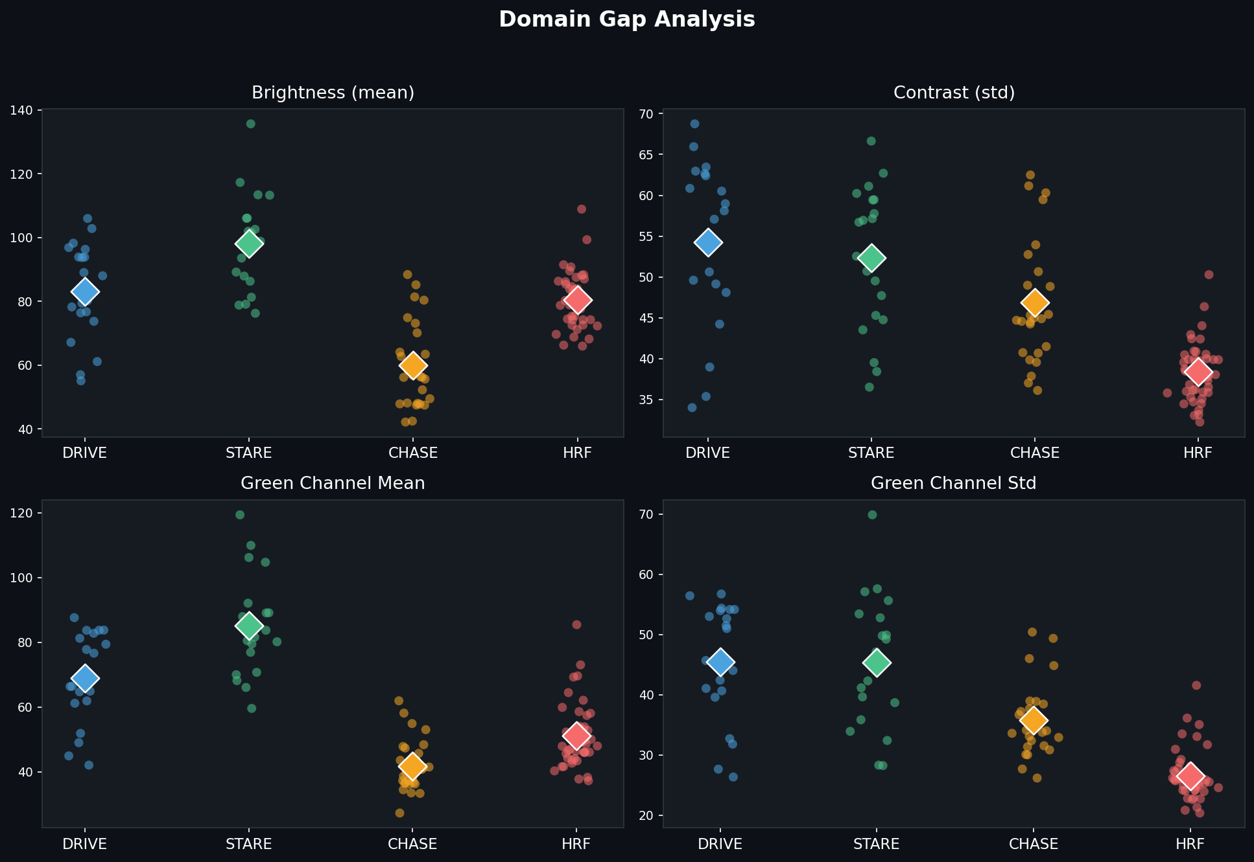
Figure 4. Intensity statistics per dataset (domain gap).

6.4 Intensity correction (CLAHE)
Applying CLAHE before inference tests whether a residual intensity gap could be closed by normalisation. CLAHE uniformly raises sensitivity (for example, HRF sensitivity rises from 0.636 to 0.882) but collapses specificity (0.944 to 0.767), so the net Dice falls on the well-matched datasets and is only roughly neutral on CHASE — the most intensity-shifted set, where the recall gain just balances the precision loss. For a properly trained model, test-time adaptation is therefore the more reliable lever, and intensity normalisation is not required.
Dataset | Baseline (orig) | TTA (orig) | Baseline (CLAHE) | TTA (CLAHE)
STARE | 0.5349 | 0.5396 | 0.4582 | 0.4561
CHASE | 0.3923 | 0.4114 | 0.3908 | 0.3963
HRF | 0.5501 | 0.5540 | 0.3779 | 0.3668

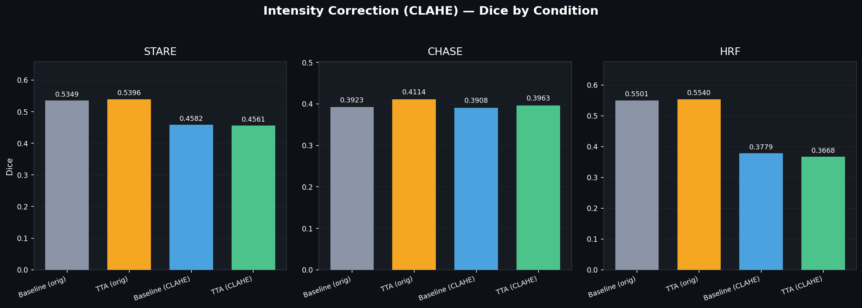
Figure 5. CLAHE intensity correction by condition.

6.5 Qualitative results
The qualitative predictions show the model tracing the main vessel tree across all three unseen datasets, with TTT recovering additional fine branches relative to the baseline. The darker CHASE images remain the hardest, consistent with the quantitative results.
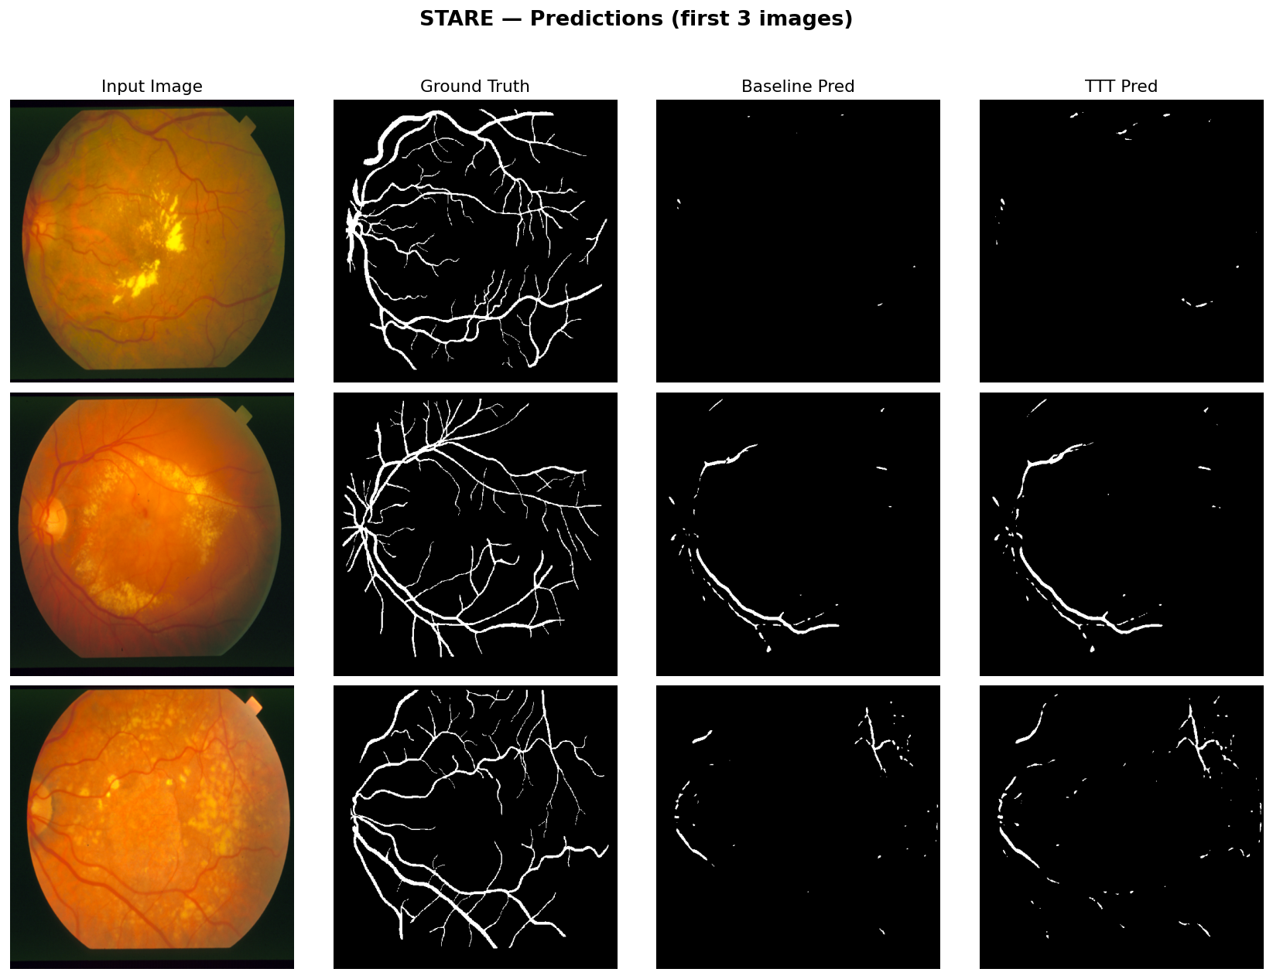
Figure 6. STARE qualitative predictions (input, ground truth, baseline, TTT).
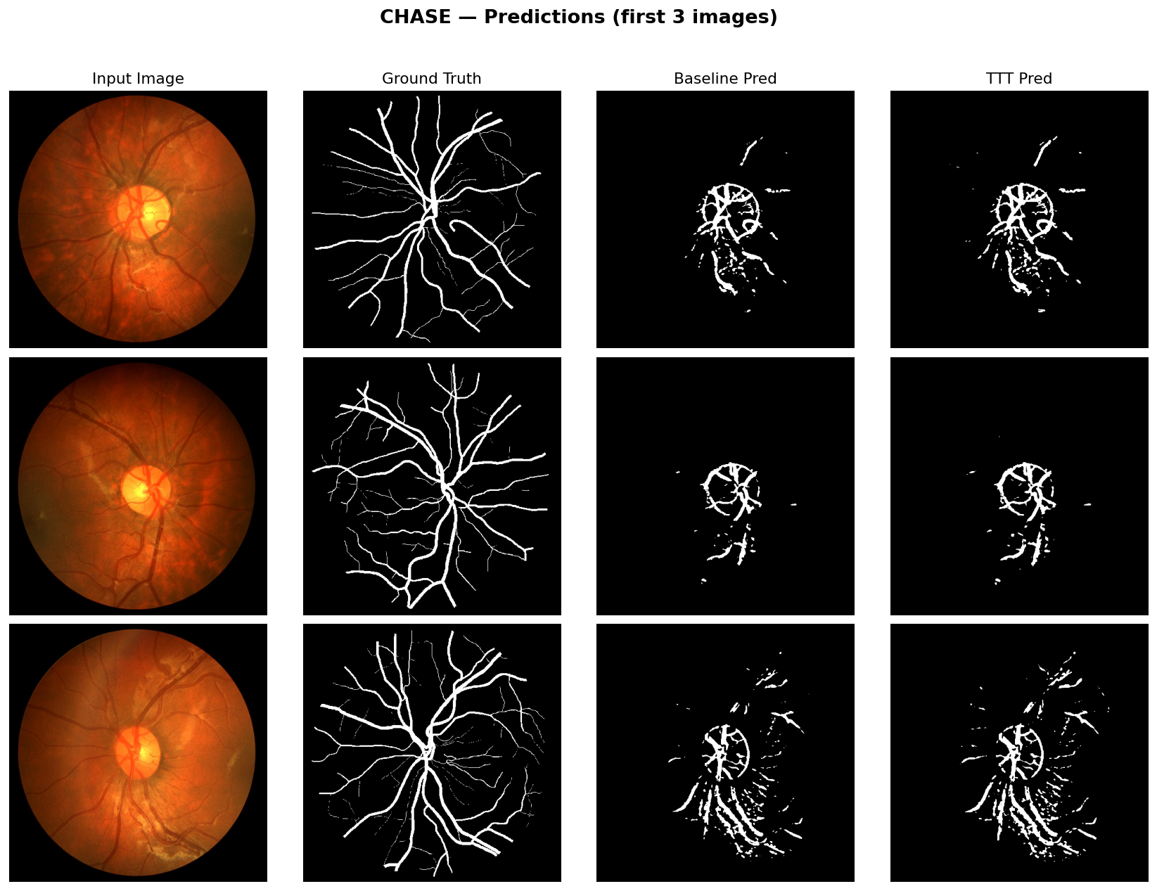
Figure 7. CHASE qualitative predictions (input, ground truth, baseline, TTT).
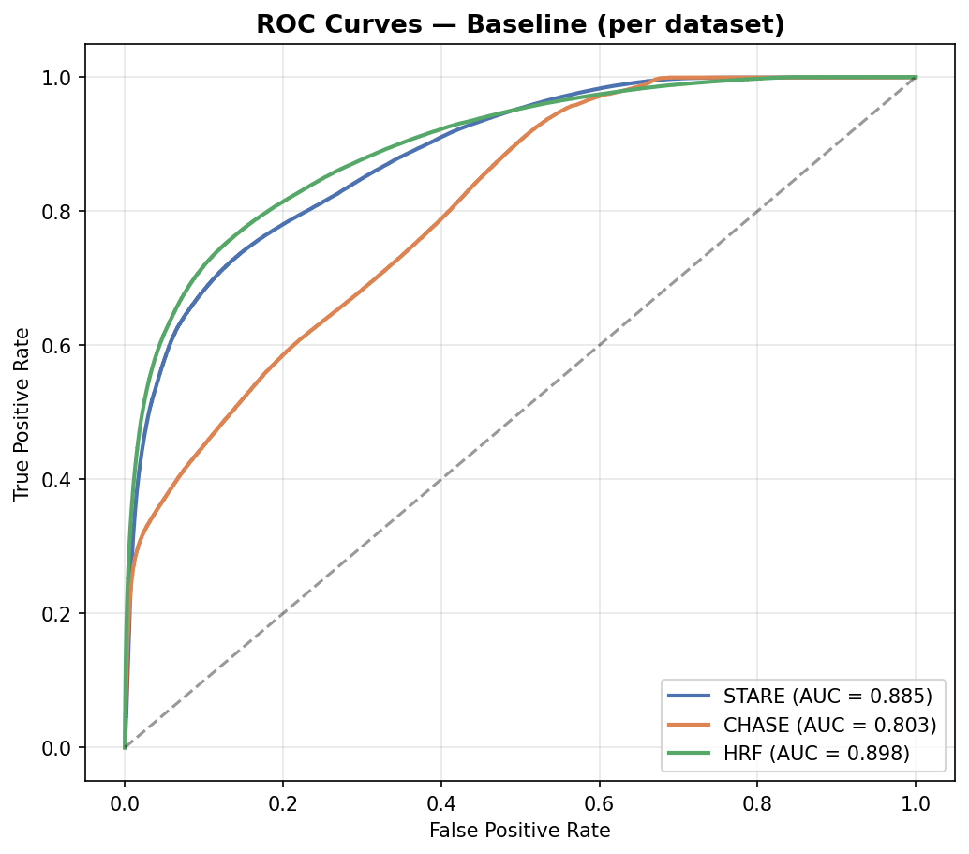
Figure 8. ROC curves across datasets.

7. Discussion
Three findings emerge. First, rotation-based TTT is an effective label-free adaptation method: it improves Dice on all three unseen datasets and beats the TTA ensemble where the domain gap is largest. Second, the right adaptation scope is small — adapting only the BatchNorm parameters matches or exceeds adapting the encoder or the full network, making the method both effective and cheap. Third, classical intensity correction (CLAHE) trades specificity for sensitivity and does not improve overall Dice for a well-trained model, so learned test-time adaptation is preferable to fixed pre-processing here. Together these results support BatchNorm-only TTT as a practical route to cross-dataset robustness.

8. Limitations
- Training used only 20 DRIVE images, limiting absolute accuracy.
- The auxiliary task (rotation) is simple; richer self-supervision could yield larger gains.
- Per-image TTT adds inference-time computation relative to a single forward pass.
- Test sets are small; formal statistical significance testing would strengthen the claims.

9. Conclusion and Future Work
We showed that lightweight, BatchNorm-only Test-Time Adaptation improves retinal vessel segmentation across three unseen datasets without any test labels, outperforming both a Test-Time Augmentation ensemble and CLAHE intensity correction, with the largest benefit on the dataset that shifts most from the training distribution. Future work includes stronger self-supervised auxiliary tasks, learned domain-normalisation modules, combining adaptation with mild input normalisation, and validation on larger, multi-centre datasets with statistical testing.

References
- Ronneberger, O., Fischer, P., Brox, T. (2015). U-Net: Convolutional Networks for Biomedical Image Segmentation. MICCAI.
- Sun, Y. et al. (2020). Test-Time Training with Self-Supervision for Generalization under Distribution Shifts. ICML.
- Wang, D. et al. (2021). Tent: Fully Test-Time Adaptation by Entropy Minimization. ICLR.
- Staal, J. et al. (2004). Ridge-Based Vessel Segmentation in Color Images of the Retina (DRIVE). IEEE TMI.
- Pizer, S. M. et al. (1987). Adaptive Histogram Equalization and its Variations (CLAHE).

