Training history and model choice in forecasting monthly cardiovascular mortality in São Paulo, Brazil: foundation, classical and boosting models compared with paired uncertainty
Fabiano Novaes Barcellos Filho
Isabela Venancio da Silva
Victor Hugo Ovani Marchetti
Alexandre Chiavegatto Filho
Running title: Forecasting cardiovascular mortality in São Paulo
Keywords: cardiovascular mortality; time series forecasting; foundation models; prediction intervals; health surveillance; Brazil

Abstract
Health services that plan for the winter rise in cardiovascular deaths need monthly forecasts, and a growing number of studies propose pre-trained foundation models for this task. We compared SARIMA, Prophet, the TimesFM foundation model, XGBoost and CatBoost on the monthly count of cardiovascular deaths in São Paulo state, Brazil, from 2010 to 2023 (1,217,427 deaths), using 103 rolling origin windows with a 6-month horizon and paired block bootstrap intervals. Prophet, SARIMA and TimesFM reached sMAPE between 4.70% and 4.83%, and none of the three pairwise differences was distinguishable from zero. Both boosting models were worse than all three and did not improve on repeating the same month of the previous year. On identical target months, nine additional years of training reduced error by 1.23 to 1.71 percentage points, about ten times the spread among the three leading models. When training was limited to the last five years, SARIMA and Prophet lost accuracy and TimesFM did not. The native 95% intervals of SARIMA and Prophet covered 84.5% and 77.2% of observations. For a single indicator with a long record, the choice among these models matters less than the length of the series and the calibration of the intervals.

1 Introduction
Cardiovascular diseases cause about 17.9 million deaths a year worldwide (Roth et al. 2020) and have been the leading cause of death in Brazil since the 1960s, around 30% of all deaths in recent decades (Oliveira et al. 2020; Brant et al. 2017). Age-standardised rates have fallen since the 1990s (Ribeiro et al. 2016), but population growth and ageing keep the absolute number rising (Brant et al. 2025): in São Paulo, the most populous state, annual cardiovascular deaths went from 79,933 in 2010 to 95,538 in 2023. The burden is also seasonal. Mortality from myocardial infarction in the city of São Paulo rises in winter (Sharovsky and César 2002), and among six Brazilian micro-regions studied by Ferreira et al. (2019), São Paulo had the largest number of deaths from myocardial infarction attributed to cold. Coronary and stroke beds, emergency staff and drug supply have to be arranged before that peak, which is the use a monthly forecast of deaths serves. [OPEN: one or two sentences from the authors on how forecasts of this series are, or could be, used in state planning]
Forecasts of cardiovascular mortality in Brazil have addressed long-range trends: Siqueira and Souza (2020), for example, projected mortality from myocardial infarction, stroke and heart failure to 2030 in five-year intervals. Monthly forecasting over a horizon of a few months is a different problem, and the methods on offer for it have changed. Seasonal ARIMA (Box et al. 2015) and Prophet (Taylor and Letham 2018) estimate a model from the target series itself. Foundation models such as TimesFM (Das et al. 2024) and Chronos (Ansari et al. 2024) are pre-trained on large collections of series and forecast a new one without task-specific training, and health-specific variants are appearing (Li et al. 2025). Gradient boosting, which dominated the M5 competition (Makridakis et al. 2022), is the usual choice when forecasting is posed as a tabular problem.
How these families compare on one health series is less settled than benchmark leaderboards suggest. Foundation models are evaluated on archives of thousands of series (Godahewa et al. 2021; Aksu et al. 2024), and an average rank across an archive does not say which model to use for a particular indicator. Backtesting a single series produces forecasts from overlapping windows that share training data, so aggregate errors carry wide intervals, and differences of a few tenths of a percentage point are easily within them (Hewamalage et al. 2023). The question for a surveillance team is therefore twofold: whether any of these models is measurably better on its own series, and what else affects accuracy that the team can control.
We addressed both on the monthly series of cardiovascular deaths in São Paulo state from 2010 to 2023. We compared five models and three naive references on identical rolling origin windows, with paired intervals for every comparison. We then varied the amount of training history while holding the test months fixed, measured the coverage of the prediction intervals that two of the models produce, and tested monthly temperature as a covariate.

2 Methods

2.1 Data
We used individual death records from the Mortality Information System (SIM) of the Brazilian Ministry of Health, distributed by DataSUS (Ministério da Saúde, Brazil, n.d.), for residents of São Paulo state from January 2010 to December 2023. Of 4,317,224 records, 1,217,427 had an underlying cause in ICD-10 chapter IX, diseases of the circulatory system (I00–I99) (World Health Organization, n.d.). Aggregated by month of death, they form a series of 168 points with a mean of 7,247 deaths (median 7,177), a minimum of 5,811 in February 2011 and a maximum of 9,582 in January 2022 (Figure 1). Death registration in the state is close to complete, estimated at 99.9% in 2016 by record linkage (Costa et al. 2020). We did not redistribute ill-defined causes (garbage codes), so counts are not directly comparable with Global Burden of Disease estimates.
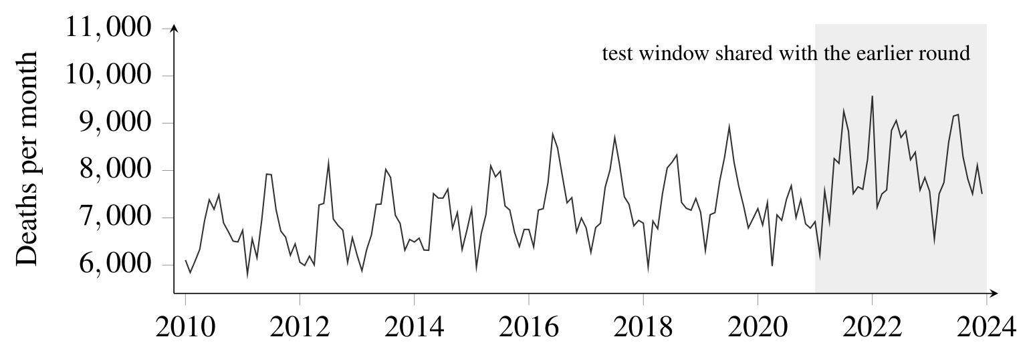
Monthly cardiovascular deaths (ICD-10 I00–I99) among residents of São Paulo state, January 2010 to December 2023. The shaded region marks the 36 target months used in Table 3.

2.2 Models
SARIMA used order $(1,1,1)$ and seasonal order $(0,1,1,12)$ (Box et al. 2015). Prophet used yearly seasonality, with weekly and daily components turned off for monthly data (Taylor and Letham 2018). TimesFM used the public timesfm-2.5-200m-pytorch checkpoint with a 512-point context, zero-shot, without fine-tuning (Das et al. 2024). XGBoost (Chen and Guestrin 2016) and CatBoost (Prokhorenkova et al. 2018) were each wrapped in a recursive multi-step forecaster with lags 1 to 12 of the target as the only inputs. No forecast was clipped or otherwise post-processed. Three naive references completed the comparison: the last observed value (naive), the same month of the previous year (seasonal naive), and the seasonal naive with an annual drift.
XGBoost accuracy on this task varied with library version and number of threads (sMAPE 6.80% to 6.98% across seven versions and five thread counts with code, data and seed fixed), so we pinned the version and fitted it on one thread. Across two machines with different processors the remaining variation was up to 0.10 percentage points (Supplementary Section 6).

2.3 Evaluation
We used rolling origin evaluation (Tashman 2000) with an expanding window, a minimum of 60 months of training, a one-month step and a 6-month horizon. This gives 103 windows and 618 out-of-sample forecasts per model, on identical test months for every model. We report mean absolute error (MAE), root mean squared error (RMSE), symmetric mean absolute percentage error (sMAPE) and the mean absolute scaled error (MASE) (Hyndman and Koehler 2006).
Forecasts from overlapping windows are dependent, so intervals were obtained by a block bootstrap that resamples whole windows, with the six horizons of a window kept together ($B=10,000$, seed 20260817). In each replicate the same windows were used for every model, and differences between models were computed within replicate, which gives an interval for the paired difference. We also applied the Diebold-Mariano test (Diebold and Mariano 1995) with the small-sample correction of Harvey et al. (1997) at each horizon, with absolute error as loss. A HAC variance with a Bartlett kernel and Newey-West bandwidth left all 90 pairwise cells on the same side of the 5% threshold.
Before running the comparisons we set the rule for calling a difference established: the 95% interval of the paired difference excludes zero and the Diebold-Mariano test reaches $p<0.05$ in at least three of the six horizons. A difference that meets only the first condition is reported as suggestive.

2.4 Training history
We isolated the effect of history length in two ways. First, we compared forecasts for the same 36 target months (January 2021 to December 2023) from a run on 2019–2023 data, where training windows held 24 to 54 months, and from the main analysis, where they held 132 to 168 months. Second, we repeated the main analysis on the same 103 origins with training limited to the most recent 60 months.

2.5 Prediction intervals
SARIMA and Prophet produce native prediction intervals. For both we computed empirical coverage of the nominal 95% interval, mean interval width and the interval score of Gneiting and Raftery (2007) by horizon. TimesFM, XGBoost and CatBoost, as configured, produce point forecasts only.

2.6 Temperature
Cold is the main candidate driver of the winter excess (Analitis et al. 2008; Phung et al. 2016; Ferreira et al. 2019). We took hourly records from the automatic station A701 of the National Institute of Meteorology (São Paulo, Mirante de Santana) (Instituto Nacional de Meteorologia (INMET), Brazil, n.d.) and computed the monthly mean of daily minimum temperature, discarding days with fewer than 18 valid hours and months with fewer than 20 valid days; all 168 months were complete. A forecast cannot use future observed temperature, so the future value of the covariate was the month-of-year mean computed from data up to the end of each training window. As a ceiling, we also ran the models with the observed future temperature, which bounds what a perfect weather forecast could add. SARIMA, XGBoost and CatBoost received the covariate as a regressor and Prophet through add_regressor; TimesFM has no covariate interface in the version used.

2.7 Supplementary analyses
To check that the boosting results did not depend on a weak configuration, we ran six feature engineering variants, a Bayesian hyperparameter search of 40 trials restricted to the first 60 months, and TabPFN, a pre-trained tabular transformer, under the same protocol. We also repeated the main comparison excluding the COVID-19 period, dropping whole windows whose test months overlap March 2020 to December 2021, or January 2020 to December 2022. Details are in the Supplementary Material.

2.8 Reproducibility
All tables and figures are generated by one script from the per-forecast files, and every number in the text was checked against a file written by the same script. Code, the aggregated series and all forecasts are in the study repository.

3 Results

3.1 Accuracy of the five models
Accuracy of five forecasting models and three naive references for monthly cardiovascular deaths in São Paulo state, 618 out-of-sample forecasts from 103 rolling origin windows with a 6-month horizon.
Model | MAE | RMSE | sMAPE (%) | 95% CI of sMAPE | Width | MASE
Prophet | 355.2 | 515.8 | 4.70 | $[4.17,5.27]$​ | 1.10 | 0.860
SARIMA | 363.3 | 508.1 | 4.80 | $[4.29,5.33]$​ | 1.04 | 0.880
TimesFM | 366.0 | 513.4 | 4.83 | $[4.32,5.39]$​ | 1.06 | 0.887
CatBoost | 500.9 | 673.6 | 6.59 | $[5.92,7.27]$​ | 1.35 | 1.213
XGBoost | 521.3 | 691.6 | 6.88 | $[6.22,7.58]$​ | 1.36 | 1.263
Seasonal naive + drift | 468.1 | 637.9 | 6.18 | $[5.58,6.81]$​ | 1.23 | 1.134
Seasonal naive | 474.0 | 654.4 | 6.27 | $[5.62,6.96]$​ | 1.34 | 1.148
Naive | 810.7 | 1003.0 | 10.74 | $[9.81,11.68]$​ | 1.87 | 1.964
MAE and RMSE in deaths per month; sMAPE, symmetric mean absolute percentage error. MASE divides MAE by the in-sample one-step MAE of the seasonal naive method (412.9 deaths); since the scored forecasts are out of sample and up to six steps ahead, the seasonal naive row (1.148) is the benchmark, not the value 1. Bold, best value among the five models. The 95% CI is a percentile bootstrap over whole windows ($B=10,000$), and Width is its span in percentage points. The interval describes uncertainty about the metric, not about an individual forecast.
Prophet, SARIMA and TimesFM reached sMAPE of 4.70%, 4.80% and 4.83% (Table 1, Figure 2). With about 7,250 deaths a month, the best MAE of 355 deaths is an error near 4.9%. The three are separated by 0.13 percentage points, while the mean width of their individual intervals is 1.07 points. None of the three paired differences excluded zero, and none of the 18 Diebold-Mariano cells reached significance (Table 2).
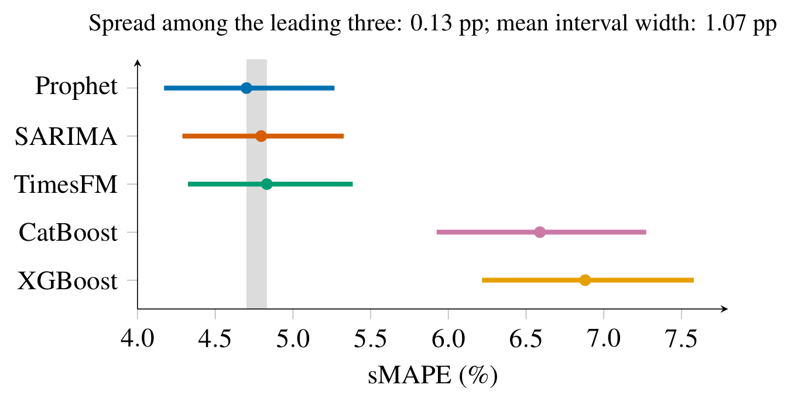
sMAPE by model with 95% block bootstrap intervals over the 103 rolling origin windows. The grey band spans the point estimates of the three most accurate models.
Paired differences in sMAPE among the three most accurate models. A positive difference means the first model has the larger error.
Comparison | Difference (pp) | 95% CI | $p$ (bootstrap) | DM cells $p<0.05$
Prophet $−$ SARIMA | $−0.095$​ | $[−0.367,+0.157]$​ | 0.512 | 0 of 6
Prophet $−$ TimesFM | $−0.132$​ | $[−0.319,+0.056]$​ | 0.171 | 0 of 6
SARIMA $−$ TimesFM | $−0.037$​ | $[−0.303,+0.262]$​ | 0.768 | 0 of 6
pp, percentage points. Bootstrap differences are computed within each replicate on the same resampled windows. DM, Diebold-Mariano test with the Harvey-Leybourne-Newbold correction, run separately at each of the six horizons; the column counts horizons with $p<0.05$.
The two boosting models were at least 1.76 points behind. All 36 Diebold-Mariano comparisons of a boosting model with one of the three leading models had $p<0.05$, and the bootstrap $p$ for each pooled difference was below 0.001.
The seasonal naive method reached 6.27% (MASE 1.148) and the drift variant 6.18%. The three leading models reduced the error of the seasonal naive by about a quarter (MASE 0.860 to 0.887). CatBoost (6.59%) and XGBoost (6.88%) did not improve on it. For CatBoost the paired interval against the seasonal naive was $[−0.056,+0.716]$, and for XGBoost the interval excluded zero but no Diebold-Mariano cell did, so neither is established as worse than the reference. The naive method that ignores the annual cycle reached 10.74%. Most of what there is to forecast in this series is the annual cycle.

3.2 Boosting configurations and a tabular foundation model
No configuration of the tabular models we tried was established as better than the seasonal naive method (Supplementary Tables 7 and 8). Rolling window statistics made both boosting models worse. The changes that helped were those that gave them the annual cycle: calendar terms and forecasting the seasonal difference $y_{t}−y_{t−12}$. The best variant reached 6.09%, with a paired interval against the seasonal naive of $[−0.45,+0.10]$. Hyperparameter search restricted to the training period moved CatBoost from 6.59% to 6.42% and XGBoost from 6.88% to 7.02%.
TabPFN reached 5.85%, the best of the tabular models. Its advantage over the seasonal naive (0.42 points, interval $[−0.698,−0.128]$) was significant only at the one-month horizon ($p=0.0012$), so it does not meet the criterion over the six-month horizon. It remained 1.14 points behind Prophet. Because TabPFN was run through a hosted API, its result is tied to the service version: an earlier client release gave 6.04%.

3.3 Removing the pandemic period
Excluding the COVID-19 windows lowered the error of all three leading models by about the same amount; Prophet went from 4.70% to 3.60% and 3.47% under the two exclusions, which remove 27 and 41 of the 103 windows (Supplementary Table 9). No pair among the three separated in any of the three test periods, and under the wider exclusion SARIMA moved ahead of Prophet by 0.06 points.

3.4 Training history
sMAPE on the same 36 target months (January 2021 to December 2023) with short and long training history.
Model | sMAPE, 24–54 months | sMAPE, 132–168 months | Gain (pp)
Prophet | 7.68 | 5.97 | 1.71
SARIMA | 7.45 | 6.18 | 1.27
TimesFM | 7.30 | 6.07 | 1.23
The short-history column comes from a run on 2019–2023 data, in which each window had 24 to 54 months of training ($n=186$ forecasts per model); the long-history column is the subset of the main analysis that falls on the same target months ($n=201$). Only the amount of training data differs.
On the same 36 target months, the long-history forecasts had 1.23 to 1.71 points lower sMAPE than the short-history ones (Table 3), about ten times the spread among the three leading models. With short history, the point ordering was different: TimesFM first at 7.30% and Prophet last at 7.68%, a spread of 0.38 points with a mean interval width of 2.45 points.
sMAPE with an expanding training window and with a window limited to the most recent 60 months, on identical test origins. A negative difference means the expanding window is more accurate.
Model | Expanding | Sliding 60 | Expanding $−$ Sliding (pp) | 95% CI | $p$​ | DM cells $p<0.05$
Prophet | 4.70 | 5.39 | $−0.69$​ | $[−1.159,−0.219]$​ | 0.005 | 0 of 6
SARIMA | 4.80 | 5.46 | $−0.66$​ | $[−1.008,−0.346]$​ | 0.000 | 3 of 6
TimesFM | 4.83 | 4.74 | $+0.09$​ | $[−0.125,+0.307]$​ | 0.424 | 0 of 6
CatBoost | 6.59 | 6.64 | $−0.05$​ | $[−0.288,+0.176]$​ | 0.661 | 0 of 6
XGBoost | 6.88 | 6.86 | $+0.02$​ | $[−0.258,+0.303]$​ | 0.879 | 0 of 6
The expanding window uses 60 to 162 months of training; the sliding window uses the last 60. The bootstrap is paired by window. DM as in Table 2.
Limiting training to the most recent 60 months cost SARIMA 0.66 points, meeting the established criterion, and Prophet 0.69 points, with an interval that excluded zero and no significant Diebold-Mariano cell (Table 4, Figure 3). TimesFM did not change ($+0.09$, $p=0.42$). With five years of history, TimesFM had 4.74% against 5.46% for SARIMA.
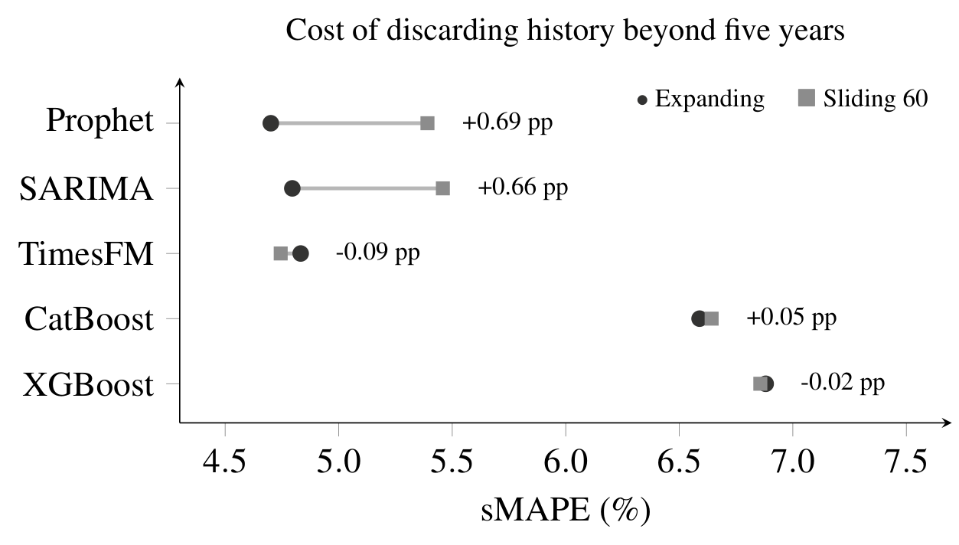
sMAPE with an expanding training window and with the last 60 months only, on identical test origins. The annotation on each row is sliding minus expanding sMAPE, so a positive value is the accuracy lost by discarding older history.

3.5 Prediction intervals
Empirical coverage and interval score of the nominal 95% prediction intervals of SARIMA and Prophet, by forecast horizon, over the 103 windows.
 | Forecast horizon (months)
2-7 Model and metric | $h=1$​ | $h=2$​ | $h=3$​ | $h=4$​ | $h=5$​ | $h=6$​ | All | MPIW
SARIMA, coverage | 0.854 | 0.854 | 0.845 | 0.854 | 0.825 | 0.835 | 0.845 | 1288
Prophet, coverage | 0.796 | 0.786 | 0.796 | 0.767 | 0.738 | 0.748 | 0.772 | 1045
SARIMA, interval score | 2792 | 3460 | 3577 | 3532 | 3667 | 3969 | 3500 | —
Prophet, interval score | 4208 | 4342 | 4340 | 4572 | 4640 | 4706 | 4468 | —
Coverage is the fraction of observed values inside the interval (target 0.950). MPIW, mean interval width in deaths per month. Interval score as in Gneiting and Raftery (2007): width plus a penalty for each observation outside the interval, proportional to the miss; lower is better.
At a nominal 95%, SARIMA intervals covered 84.5% of observations and Prophet intervals 77.2% (Table 5). A manager told the outcome would fall inside the interval nineteen times in twenty would see it fall inside about seventeen times with SARIMA and fifteen with Prophet. Prophet had the narrower intervals (1,045 against 1,288 deaths a month) and the worse interval score (4,468 against 3,500), and its coverage fell from 0.796 at one month to 0.748 at six; SARIMA stayed between 0.854 and 0.835. The model with the lowest sMAPE had the worse intervals.

3.6 Temperature
sMAPE with and without monthly minimum temperature as a covariate. TimesFM has no covariate interface in the version used and is not included.
Model | Without | With temp. | Gain (pp) | 95% CI | DM cells $p<0.05$ | Ceiling
Prophet | 4.70 | 4.74 | $−0.035$​ | $[−0.081,+0.013]$​ | 0 of 6 | 4.63
SARIMA | 4.80 | 4.66 | $+0.136$​ | $[+0.034,+0.257]$​ | 1 of 6 | 4.63
CatBoost | 6.59 | 6.33 | $+0.258$​ | $[+0.073,+0.452]$​ | 1 of 6 | 6.30
XGBoost | 6.88 | 6.51 | $+0.368$​ | $[+0.190,+0.548]$​ | 3 of 6 | 6.53
With temp.: the future covariate is the month-of-year mean of temperature computed from data up to each window’s training end, so no future value is used. Ceiling: the observed future temperature, which no real forecast could use; it bounds what a perfect weather forecast could add. Gain is positive when temperature reduces error. DM as in Table 2.
Temperature reduced the error of SARIMA (0.136 points), CatBoost (0.258) and XGBoost (0.368), with intervals excluding zero, and increased the error of Prophet by 0.035 points, within its interval (Table 6). Only XGBoost met the established criterion, with 3 of 6 significant horizons, and this verdict depended on the computing environment: on a second machine it had 4 of 6, and with an earlier, unpinned library version 2 of 6. When calendar terms and seasonal differencing were added to the boosting models, the gain from temperature fell to 0.076 points for CatBoost and disappeared for XGBoost ($−0.010$) (Supplementary Table 10). Replacing the climatological covariate with the observed future temperature improved SARIMA by a further 0.03 points.
The series peaks in July, with a mean of 8,247 deaths, and reaches its trough in February, with 6,273, an amplitude of 27.2% around the mean. The seasonal shape was stable over the fourteen years, including the pandemic period (Figure 1).

4 Discussion
On a 14-year monthly series of cardiovascular deaths in São Paulo state, three models of different families, a seasonal ARIMA, Prophet and a pre-trained foundation model, could not be told apart, while nine more years of training history reduced error by about ten times their spread. The foundation model was the only one that did not lose accuracy when history was cut to five years. The intervals that two of the models produce covered far less than their nominal level.

4.1 Comparison with other studies
The order of the model families agrees with the large forecasting competitions. In M4, with 100,000 series of several frequencies, combinations of statistical methods were among the most accurate, and none of the six pure machine learning methods beat the combination benchmark (Makridakis et al. 2018, 2020). In M5 most methods, the winner included, were built on LightGBM (Makridakis et al. 2022), but there the task was 42,840 related series of Walmart unit sales with calendar and price information, the setting in which a single model learns across series. Our boosting models had one series and twelve lags. They improved when given the calendar, through calendar terms, seasonal differencing or temperature, which in this series acts as a proxy for the month of the year. The similarity between TimesFM and the classical models also fits evidence that simple models remain competitive with transformer architectures on standard forecasting benchmarks (Zeng et al. 2023).
Foundation model benchmarks summarise performance across archives of many series (Godahewa et al. 2021; Aksu et al. 2024). Our result does not contradict them, because a single series cannot. It shows that the difference between models on one series can be much smaller than the uncertainty of the comparison, one of the ways in which, as Hewamalage et al. (2023) show, evaluation practice produces spurious conclusions about forecasting methods. In our case, the point ordering on the shorter series placed TimesFM first by 0.38 points inside intervals of 2.45 points, and with more data Prophet had the lowest error. Neither ordering is informative.
The July peak agrees with the winter excess in myocardial infarction mortality reported for the city of São Paulo (Sharovsky and César 2002), and the stability of the seasonal shape over fourteen years, the pandemic included, is what makes a seasonal model sufficient here. Unlike the long-range projections of Siqueira and Souza (2020), our horizon is six months, which is what capacity planning for a winter needs.

4.2 Interpretation
Most of the predictable structure of this series is the annual cycle: repeating last year already gives 6.27% sMAPE, and the naive method that ignores the cycle gives 10.74%. Any model that represents the cycle well reaches about the same accuracy, and the remaining error is dominated by events no model sees coming, such as the pandemic, which raised the error of all three leading models alike. This also explains why longer history helps: more years give a better estimate of the seasonal shape and of the trend, which for absolute counts includes population growth and ageing.
TimesFM was insensitive to history length because it does not estimate its parameters from the target series. It brings its prior from pre-training and reads a bounded context. That is a disadvantage on a long, clean series, where the classical models can learn the same structure, and an advantage on a short one.
Temperature at monthly resolution added little beyond the calendar: the gain disappeared once the boosting models had calendar terms, and a perfect future temperature improved SARIMA by 0.03 points. The cardiovascular effect of cold acts over days (Analitis et al. 2008; Ferreira et al. 2019), and averaging to monthly minima removes most of that signal. Weekly or daily series would be needed to test it.

4.3 Limitations
We modelled counts, not rates. Part of what the long history adds is therefore population growth and ageing, and this probably overstates the benefit of long history for epidemiological change. The series is a single state aggregate, longer and smoother than any municipal or regional series, which probably makes all models look better than they would on subunits. We did not stratify by age, sex or cause subgroup, which have different seasonal patterns. TimesFM was used zero-shot; fine-tuning could change its relative position. Only two models produced prediction intervals, and both undercovered by 10 to 18 percentage points, so none of the forecasts here can be given to a planner with a reliable interval. Ill-defined causes were not redistributed; a change in their share over time would appear in the series as a change in trend.

4.4 Implications
For a team forecasting one well-recorded indicator with more than a decade of data, the choice among SARIMA, Prophet and a foundation model can rest on cost, transparency and maintenance; SARIMA is the cheapest and had the better intervals. Effort spent extending and cleaning the historical series is likely to pay more than effort spent on model selection. A foundation model is a reasonable default where series are short, as for new indicators, municipalities or strata, though this needs testing on such series. In either case the intervals should be recalibrated before use; conformal prediction wraps any point forecaster and offers finite-sample coverage under exchangeability (Angelopoulos and Bates 2023).

5 Conclusion
For monthly cardiovascular mortality in São Paulo state, the three best models from three different families were statistically indistinguishable, the length of the training series mattered about ten times more than the choice among them, and the available prediction intervals undercovered. The foundation model’s advantage appeared only when history was short.

Declarations
Author contributions (CRediT). Fabiano Novaes Barcellos Filho: Conceptualization, Methodology, Software, Formal analysis, Data curation, Writing – original draft, Visualization. Isabela Venancio da Silva: Validation, Formal analysis, Investigation, Writing – review & editing, Visualization. Victor Hugo Ovani Marchetti: Investigation, Validation, Writing – review & editing. Alexandre Chiavegatto Filho: Conceptualization, Resources, Supervision, Writing – review & editing.
Funding. This study was financed in part by the Coordenação de Aperfeiçoamento de Pessoal de Nível Superior, Brazil (CAPES), Finance Code 001.
Ethics. The study used public, de-identified mortality records. Under Resolution No. 510/2016 of the Brazilian National Health Council, research on publicly accessible databases without individual identification is exempt from ethics committee review.
Competing interests. The authors declare no competing interests.
Data and code availability. The aggregated monthly series, the temperature series, all forecasts, uncertainty outputs and the code that produces every table and figure are in the study repository
(https://github.com/fabianofilho/cardiovascular-timeseries-prediction). Individual records are not redistributed; the extraction script retrieves them from DataSUS.
Use of artificial intelligence. The authors used an AI assistant (Claude, Anthropic) to write analysis code and to draft and revise the manuscript text. The authors chose the questions and design, reviewed every analysis and number, and take full responsibility for the content. The tool is not an author.
Supplementary Material

6 Computing environment
XGBoost is deterministic within one environment, but its accuracy on this task changed with the library version and the number of fitting threads. With code, data and seed fixed, sMAPE ranged from 6.80% to 6.98% across seven released versions and five thread counts. CatBoost did not move by more than a tenth of a basis point under the same variation. We therefore pinned the XGBoost version and fitted it on one thread; the reported 6.88% comes from that environment. On a second machine with a different processor architecture, the same versions and one thread gave 6.83% for XGBoost and 6.41% for its temperature variant (6.51% in the pinned environment). This difference is small against every comparison between models in the paper, but it changes the count of significant horizons for the temperature gain of XGBoost (main text, Temperature).
Prophet derives its interval bounds from a finite sample of posterior draws, which we seeded at every window. Without the seed the bounds moved by 34 to 53 deaths between two fits of the same window. Across machines, 63 of the 103 Prophet point forecasts differed by up to 49 deaths, which left coverage at 0.772 and moved sMAPE from 4.701% to 4.700%.
TabPFN was run through a hosted inference API, so its model version is outside the pinned environment. The same protocol gave 6.04% with an earlier client release and 5.85% with the current one.

7 Boosting configurations
Feature engineering variants for the two gradient boosting models, under the protocol of Table 1. The last two columns compare each CatBoost variant with the seasonal naive method.
 | CatBoost |  | XGBoost |  | CatBoost vs seasonal naive
2-3 (lr)4-5 (lr)6-7 Variant | sMAPE | MASE | sMAPE | MASE | 95% CI of $Δ$ | DM
Lags only (as reported) | 6.59 | 1.213 | 6.88 | 1.263 | $[−0.06,+0.72]$​ | 0/6
+ rolling window statistics | 6.79 | 1.248 | 6.95 | 1.275 | $[+0.16,+0.90]$​ | 0/6
+ Fourier calendar terms | 6.27 | 1.150 | 6.61 | 1.214 | $[−0.37,+0.39]$​ | 0/6
Seasonal differencing | 6.20 | 1.142 | 6.35 | 1.166 | $[−0.37,+0.23]$​ | 0/6
Differencing + windows + calendar | 6.14 | 1.129 | 6.44 | 1.181 | $[−0.43,+0.14]$​ | 0/6
As above, direct multi-step | 6.09 | 1.126 | 6.39 | 1.183 | $[−0.45,+0.10]$​ | 0/6
Seasonal naive (benchmark) | 6.27 |  |  |  | — | —
$Δ$, CatBoost minus seasonal naive sMAPE, with a paired bootstrap 95% CI. DM, horizons with $p<0.05$ out of six. Direct multi-step fits one model per horizon.
Bayesian hyperparameter search for the two gradient boosting models.
 | sMAPE (%) |  |  | Gain (pp)
2-4 (lr)5-6 Model | Untuned | Training-only | Test-exposed | Training-only | Test-exposed | Trials | Hours
CatBoost | 6.59 | 6.42 | 6.35 | $+0.17$​ | $+0.24$​ | 40 + 60 | 2.1
XGBoost | 6.88 | 7.02 | 6.25 | $−0.13$​ | $+0.63$​ | 40 + 60 | 1.1
Seasonal naive | 6.27 |  |  | — | — | — | —
Training-only: 40 trials with the search restricted to the first 60 months, so no test window enters it. Test-exposed: 60 trials allowed to score on the test windows, an upper bound that a real procedure cannot reach. Gain is positive when the search improved on the untuned configuration of Table 1.
Table 7 changes one element of the boosting feature set at a time. Rolling window statistics made both models worse. Fourier calendar terms and forecasting the seasonal difference helped, and the best combination with one model per horizon reached 6.09% for CatBoost against 6.27% for the seasonal naive method, with a paired interval containing zero and no significant horizon. In Table 8, the search restricted to the training period improved CatBoost by 0.17 points and made XGBoost 0.13 points worse. With the test windows exposed, CatBoost reached 6.35% and XGBoost 6.25%, 0.02 points ahead of the seasonal naive method; these values come from configurations selected on the test set and bound what tuning could achieve.
The best feature engineering variant also lost accuracy under the 60-month sliding window: 0.50 points for CatBoost and 0.41 for XGBoost. Only the aggregate metrics of that run were kept, so it has no paired interval.

8 TabPFN
TabPFN received the same twelve lags as the boosting models. Its sMAPE of 5.85% was 0.74 points ahead of CatBoost and 1.03 ahead of XGBoost. Against the seasonal naive method its advantage was 0.42 points (interval $[−0.698,−0.128]$), and against the drift variant 0.33 points ($[−0.622,−0.031]$). The Diebold-Mariano test was significant only at the one-month horizon ($p=0.0012$ and $p=0.0044$), with $p$ above 0.35 from the third horizon onward, so the advantage is confined to the first month. SARIMA was ahead of TabPFN in four of six horizons.

9 COVID-19 period
sMAPE of the three most accurate models with and without the COVID-19 period in the test set.
 |  | sMAPE (%) |  |  | Leading three
3-5 (lr)6-7 Test period | Windows | Prophet | SARIMA | TimesFM | Pairs separated | Worst DM
Full test period | 103 | 4.70 | 4.80 | 4.83 | 0 of 3 | 0 of 6
Excluding 2020-03 to 2021-12 | 76 | 3.60 | 3.74 | 3.66 | 0 of 3 | 0 of 6
Excluding 2020-01 to 2022-12 | 62 | 3.47 | 3.41 | 3.59 | 0 of 3 | 0 of 6
Windows whose test months overlap the excluded range are dropped whole, so the pairing is kept; no model is refitted. Pairs separated: paired comparisons among the three whose interval excludes zero and whose DM test reaches $p<0.05$ in at least three horizons. Worst DM: the largest count of significant horizons in any pair.

10 Temperature and the calendar
Temperature gain for the boosting models with and without explicit calendar terms and seasonal differencing.
Model and feature set | Without temp. | With temp. | Gain (pp)
CatBoost, lags only | 6.59 | 6.33 | $+0.258$​
CatBoost, + calendar and seasonal difference | 6.13 | 6.05 | $+0.076$​
XGBoost, lags only | 6.88 | 6.51 | $+0.368$​
XGBoost, + calendar and seasonal difference | 6.37 | 6.38 | $−0.010$​
Gain in percentage points, positive when temperature reduces error. The lags-only rows reproduce Table 6.
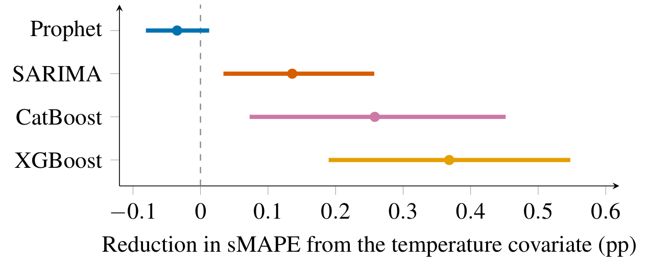
Reduction in sMAPE from adding monthly minimum temperature under the climatology policy, with 95% paired bootstrap intervals. Positive values favour the model with temperature.

11 Error by horizon and seasonal profile
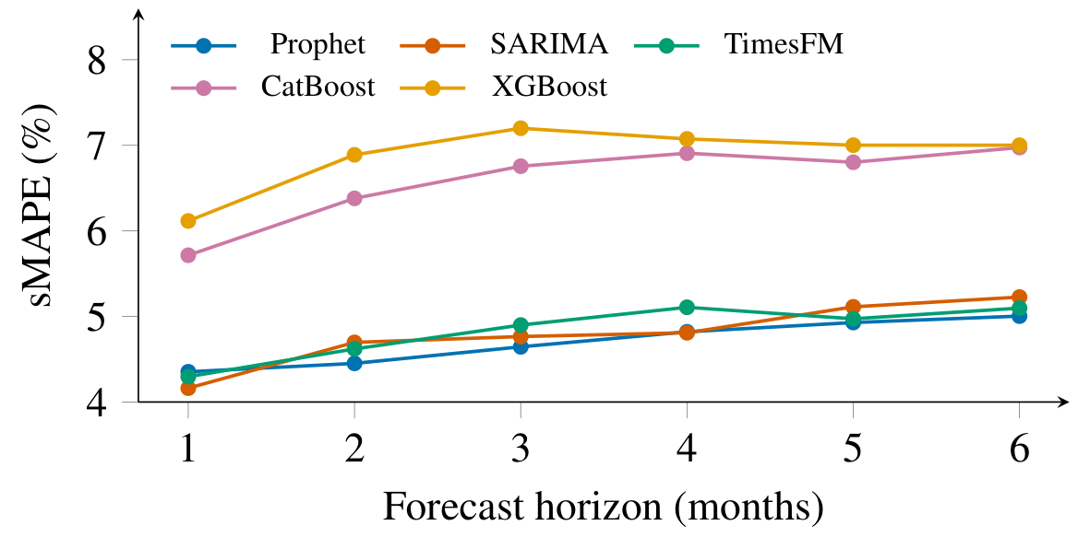
sMAPE by forecast horizon, $n=103$ windows per cell.
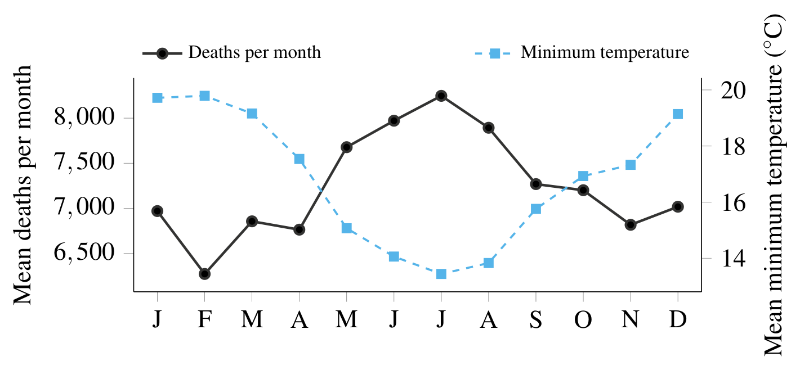
Mean cardiovascular deaths by month of year (left axis) and mean monthly minimum temperature at station A701 (right axis), 2010–2023.
Aksu, Taha, Gerald Woo, Juncheng Liu, et al. 2024. GIFT-Eval: A Benchmark for General Time Series Forecasting Model Evaluation. https://arxiv.org/abs/2410.10393.
Analitis, Antonis, Klea Katsouyanni, Annibale Biggeri, et al. 2008. “Effects of Cold Weather on Mortality: Results from 15 European Cities Within the PHEWE Project.” American Journal of Epidemiology 168 (12): 1397–408. https://doi.org/10.1093/aje/kwn266.
Angelopoulos, Anastasios N., and Stephen Bates. 2023. “Conformal Prediction: A Gentle Introduction.” Foundations and Trends in Machine Learning 16 (4): 494–591. https://doi.org/10.1561/2200000101.
Ansari, Abdul Fatir, Lorenzo Stella, Caner Turkmen, et al. 2024. “Chronos: Learning the Language of Time Series.” Transactions on Machine Learning Research.
Box, George E. P., Gwilym M. Jenkins, Gregory C. Reinsel, and Greta M. Ljung. 2015. Time Series Analysis: Forecasting and Control. 5th ed. John Wiley & Sons.
Brant, Luisa C. C., Bruno R. Nascimento, Valéria M. A. Passos, et al. 2017. “Variations and Particularities in Cardiovascular Disease Mortality in Brazil and Brazilian States in 1990 and 2015: Estimates from the Global Burden of Disease.” Revista Brasileira de Epidemiologia 20 (Suppl 1): 116–28. https://doi.org/10.1590/1980-5497201700050010.
Brant, Luisa C. C., Bruno R. Nascimento, Antonio L. P. Ribeiro, et al. 2025. “Cardiovascular Diseases Mortality in Brazilian Municipalities: Estimates from the Global Burden of Disease Study, 2000–2018.” The Lancet Regional Health – Americas 46: 101106. https://doi.org/10.1016/j.lana.2025.101106.
Chen, Tianqi, and Carlos Guestrin. 2016. “XGBoost: A Scalable Tree Boosting System.” Proceedings of the 22nd ACM SIGKDD International Conference on Knowledge Discovery and Data Mining, 785–94. https://doi.org/10.1145/2939672.2939785.
Costa, Lenice F. L., Marli de M. S. Montenegro, Dacio de L. Rabello Neto, et al. 2020. “Estimating Completeness of National and Subnational Death Reporting in Brazil: Application of Record Linkage Methods.” Population Health Metrics 18: 22. https://doi.org/10.1186/s12963-020-00223-2.
Das, Abhimanyu, Weihao Kong, Rajat Sen, and Yichen Zhou. 2024. “A Decoder-Only Foundation Model for Time-Series Forecasting.” Proceedings of the 41st International Conference on Machine Learning (ICML).
Diebold, Francis X., and Roberto S. Mariano. 1995. “Comparing Predictive Accuracy.” Journal of Business & Economic Statistics 13 (3): 253–63. https://doi.org/10.1080/07350015.1995.10524599.
Ferreira, Letícia de Castro Martins et al. 2019. “Ambient Temperature and Mortality Due to Acute Myocardial Infarction in Brazil: An Ecological Study of Time-Series Analyses.” Scientific Reports 9: 13790. https://doi.org/10.1038/s41598-019-50235-8.
Gneiting, Tilmann, and Adrian E. Raftery. 2007. “Strictly Proper Scoring Rules, Prediction, and Estimation.” Journal of the American Statistical Association 102 (477): 359–78. https://doi.org/10.1198/016214506000001437.
Godahewa, Rakshitha, Christoph Bergmeir, Geoffrey I. Webb, Rob J. Hyndman, and Pablo Montero-Manso. 2021. “Monash Time Series Forecasting Archive.” Neural Information Processing Systems Track on Datasets and Benchmarks. https://arxiv.org/abs/2105.06643.
Harvey, David, Stephen Leybourne, and Paul Newbold. 1997. “Testing the Equality of Prediction Mean Squared Errors.” International Journal of Forecasting 13 (2): 281–91. https://doi.org/10.1016/S0169-2070(96)00719-4.
Hewamalage, Hansika, Klaus Ackermann, and Christoph Bergmeir. 2023. “Forecast Evaluation for Data Scientists: Common Pitfalls and Best Practices.” Data Mining and Knowledge Discovery 37 (2): 788–832. https://doi.org/10.1007/s10618-022-00894-5.
Hyndman, Rob J., and Anne B. Koehler. 2006. “Another Look at Measures of Forecast Accuracy.” International Journal of Forecasting 22 (4): 679–88. https://doi.org/10.1016/j.ijforecast.2006.03.001.
Instituto Nacional de Meteorologia (INMET), Brazil. n.d. Dados Históricos Anuais, Estações Automáticas. Https://portal.inmet.gov.br/dadoshistoricos.
Li, Hao, Bowen Deng, Chang Xu, Zhiyuan Feng, et al. 2025. “MIRA: Medical Time Series Foundation Model for Real-World Health Data.” arXiv Preprint.
Makridakis, Spyros, Evangelos Spiliotis, and Vassilios Assimakopoulos. 2018. “The M4 Competition: Results, Findings, Conclusion and Way Forward.” International Journal of Forecasting 34 (4): 802–8. https://doi.org/10.1016/j.ijforecast.2018.06.001.
Makridakis, Spyros, Evangelos Spiliotis, and Vassilios Assimakopoulos. 2020. “The M4 Competition: 100,000 Time Series and 61 Forecasting Methods.” International Journal of Forecasting 36 (1): 54–74. https://doi.org/10.1016/j.ijforecast.2019.04.014.
Makridakis, Spyros, Evangelos Spiliotis, and Vassilios Assimakopoulos. 2022. “M5 Accuracy Competition: Results, Findings, and Conclusions.” International Journal of Forecasting 38 (4): 1346–64. https://doi.org/10.1016/j.ijforecast.2021.11.013.
Ministério da Saúde, Brazil. n.d. Sistema de Informações Sobre Mortalidade (SIM/DataSUS). Https://datasus.saude.gov.br/.
Oliveira, Gláucia M. M., Luisa C. C. Brant, Carisi A. Polanczyk, et al. 2020. “Cardiovascular Statistics – Brazil 2020.” Arquivos Brasileiros de Cardiologia 115 (3): 308–439. https://doi.org/10.36660/abc.20200812.
Phung, Dung, Phong K. Thai, Yuming Guo, Lidia Morawska, Shannon Rutherford, and Cordia Chu. 2016. “Ambient Temperature and Risk of Cardiovascular Hospitalization: An Updated Systematic Review and Meta-Analysis.” Science of The Total Environment 550: 1084–102. https://doi.org/10.1016/j.scitotenv.2016.01.154.
Prokhorenkova, Liudmila, Gleb Gusev, Aleksandr Vorobev, Anna Veronika Dorogush, and Andrey Gulin. 2018. “CatBoost: Unbiased Boosting with Categorical Features.” Advances in Neural Information Processing Systems (NeurIPS).
Ribeiro, Antonio L. P., Bruce B. Duncan, Luisa C. C. Brant, Paulo A. Lotufo, José G. Mill, and Sandhi M. Barreto. 2016. “Cardiovascular Health in Brazil: Trends and Perspectives.” Circulation 133 (4): 422–33. https://doi.org/10.1161/CIRCULATIONAHA.114.008727.
Roth, Gregory A., George A. Mensah, Catherine O. Johnson, et al. 2020. “Global Burden of Cardiovascular Diseases and Risk Factors, 1990–2019: Update from the GBD 2019 Study.” Journal of the American College of Cardiology 76 (25): 2982–3021. https://doi.org/10.1016/j.jacc.2020.11.010.
Sharovsky, Rodolfo, and Luiz Antônio Machado César. 2002. “Increase in Mortality Due to Myocardial Infarction in the Brazilian City of São Paulo During Winter.” Arquivos Brasileiros de Cardiologia 78 (1): 106–9. https://doi.org/10.1590/s0066-782x2002000100009.
Siqueira, Camila Alves dos Santos, and Dyego Leandro Bezerra de Souza. 2020. “Reduction of Mortality and Predictions for Acute Myocardial Infarction, Stroke, and Heart Failure in Brazil Until 2030.” Scientific Reports 10: 17856. https://doi.org/10.1038/s41598-020-73070-8.
Tashman, Leonard J. 2000. “Out-of-Sample Tests of Forecasting Accuracy: An Analysis and Review.” International Journal of Forecasting 16 (4): 437–50. https://doi.org/10.1016/S0169-2070(00)00065-0.
Taylor, Sean J., and Benjamin Letham. 2018. “Forecasting at Scale.” The American Statistician 72 (1): 37–45. https://doi.org/10.1080/00031305.2017.1380080.
World Health Organization. n.d. International Statistical Classification of Diseases and Related Health Problems, 10th Revision (ICD-10). Https://www.who.int/standards/classifications/classification-of-diseases.
Zeng, Ailing, Muxi Chen, Lei Zhang, and Qiang Xu. 2023. “Are Transformers Effective for Time Series Forecasting?” Proceedings of the AAAI Conference on Artificial Intelligence 37: 11121–28. https://doi.org/10.1609/aaai.v37i9.26317.

Faculdade de Saúde Pública, Universidade de São Paulo, São Paulo, Brazil. Corresponding author.

