# Management Essentials

# Exercise #1

(In this and subsequent exercises I will refer to “your coach.” You may have, and I recommend that you have, a coach to provide feedback and assistance in your development. Or, this coach may simply be the manager to whom you report.)

1. 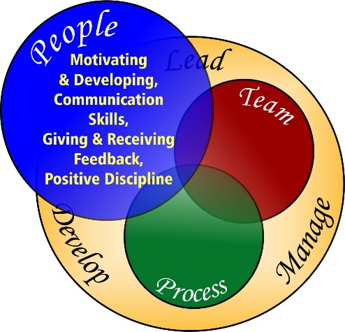With your coach, review the three circles of influence as they are outlined in this course. Ask your coach if he/she agrees that these encompass the core areas for your development as a manager. Note that these do not include technical or functional skills. In addition to these management skills which technical skills are important for your development?

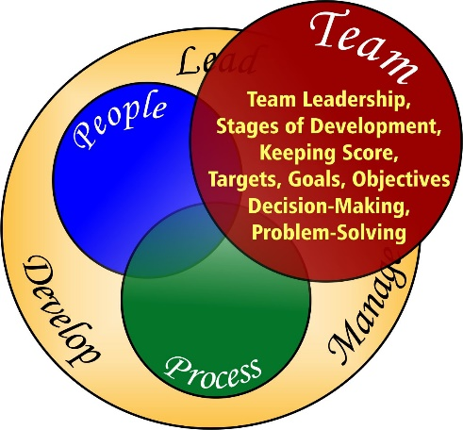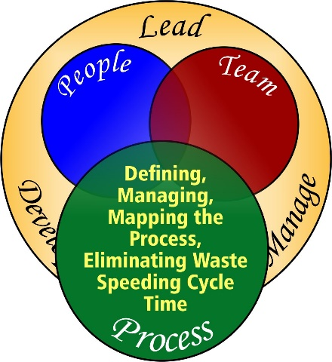

What additional people/team management skills are important for your development?

What additional technical/functional skills or knowledge are important for your development?

1. Is it clear what team of people you are responsible for leading and developing? Is it clear what process you and this team are responsible for managing and continuously improving? Define this process and the team members?
2. We discussed the values that may guide your behavior as a manager in your organization. With your coach, discuss the core values of your organization and how they might guide your actions as a manager.
3. We discussed five core values that have proven important in other organizations and for other managers. Do you and your coach agree that these are important values for you and your organization? Are they generally part of the culture of your organization now?

* Respect for People
* Continuous Improvement
* The Scientific Method
* Unity of Purpose and People
* Challenge