# Management Essentials

# Exercise # 10

# Keeping Score

Develop a balanced scorecard with your team. Follow the following guidelines for developing a scorecard. Share this with your coach and get his or her feedback.

After you have developed your scorecard assess your measures against the characteristics given in the chart below.

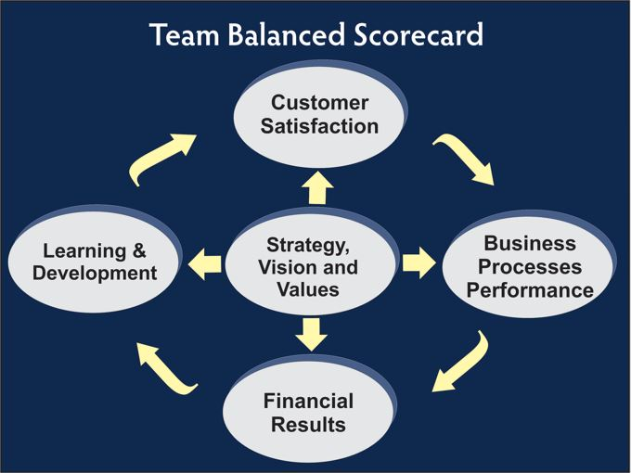**The Process Steps to Establish a Balanced Scorecard:**

1. Define the measure, the score, for each of the four components.
2. Establish Baseline Data.
3. Set improvement targets.
4. Plan, Do, Check, Act.
5. Evaluate results and repeat the process.
6. Celebrate Success

**Selecting Measures**

1. Select measures that are most important.
2. Those that indicate actual team performance.
3. Those that can be measured (without too much difficulty).
4. Those that can be measured frequently.
5. Those that will be meaningful over time.
6. That create a balance of the four components.
7. Check out your scorecard with your manager or team leader to get his/her input and agreement.

|  |  |  |
| --- | --- | --- |
| **Assess Your Team’s Scorekeeping** | | |
| **Scores for Your Team** | **Characteristic of Effective Scorekeeping** | **How Can You Improve Effectiveness?** |
|  | * **Immediacy** * **Frequency** * **Variety** * **Visibility** * **Team Ownership** * **Balanced** |  |
|  |  |
|  |  |
|  |  |
|  |  |
|  |  |