# Management Essentials

# Exercise #2

# Communication Responsibilities

1. The performance of your team depends on frequent, immediate and high quality feedback to your suppliers and from your customers. You may remember the following graphic from the lecture.

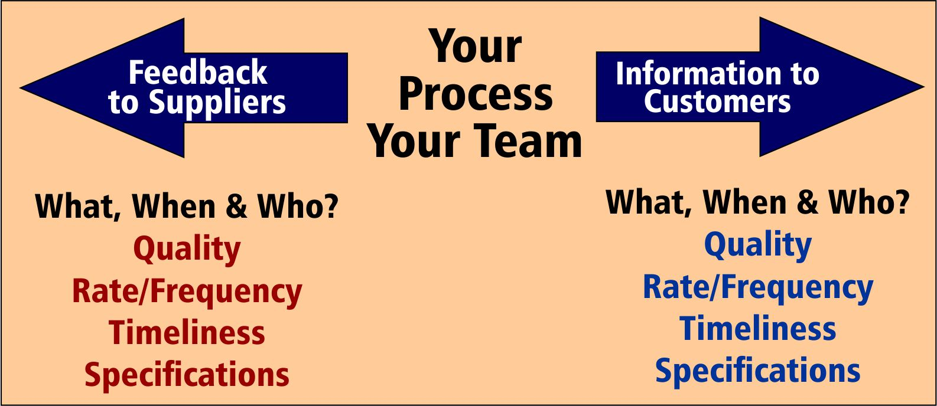

Complete the following table and discuss this with your coach. Does he or she agree that this defines your horizontal communication responsibilities? Be sure to include feedback that you should receive, or would like to receive, from your customers (whoever receives and makes use of your work, internal or external.)

|  |  |  |  |
| --- | --- | --- | --- |
| Horizontal Communication Responsibilities | | | |
| Feedback to Suppliers | What? | When? | Who? |
|  |  |  |  |
|  |  |  |  |
|  |  |  |  |

|  |  |  |  |
| --- | --- | --- | --- |
| Horizontal Communication Responsibilities | | | |
| Information to Customers | What? | When? | Who? |
|  |  |  |  |
|  |  |  |  |
|  |  |  |  |

|  |  |  |  |
| --- | --- | --- | --- |
| Horizontal Communication Responsibilities | | | |
| Feedback from Customers | What? | When? | Who? |
|  |  |  |  |
|  |  |  |  |
|  |  |  |  |

1. You also have vertical communication responsibilities. What information should you be conveying to your manager and when; and, what information should you be providing to your team members? Again, it will be wise to discuss this with your coach.

|  |  |  |
| --- | --- | --- |
| Vertical Communication Responsibilities | | |
| Information to my Manager | What? | When? |
|  |  |  |
|  |  |  |
|  |  |  |
|  |  |  |
|  |  |  |

|  |  |  |
| --- | --- | --- |
| Vertical Communication Responsibilities | | |
| Information to my Team Members | What? | When? |
|  |  |  |
|  |  |  |
|  |  |  |
|  |  |  |
|  |  |  |