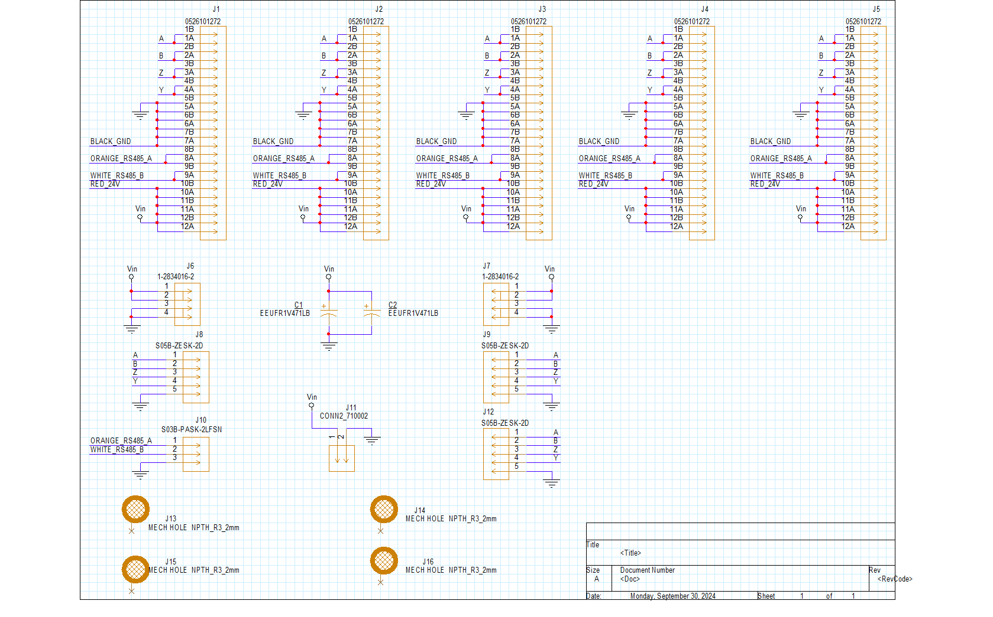

PCB1： Motor connections board schematic

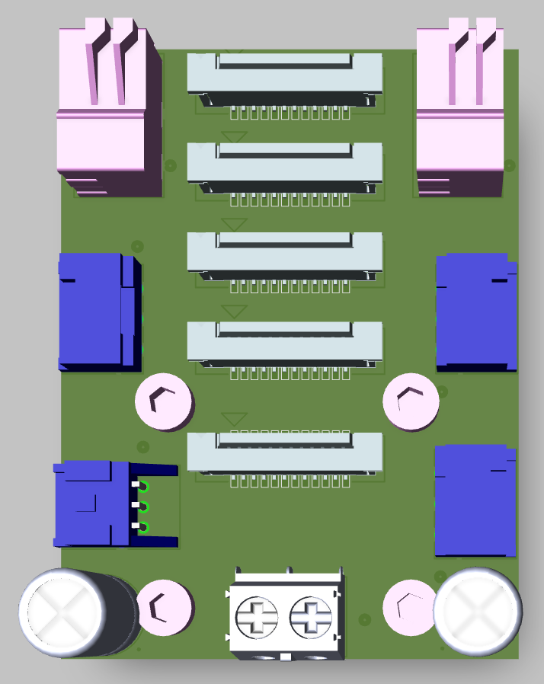

PCB1：Motor connections board 3D View

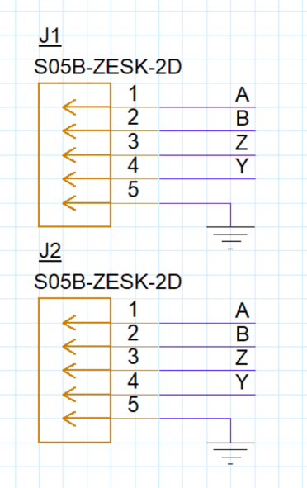

PCB2：2xrs422 board schematic

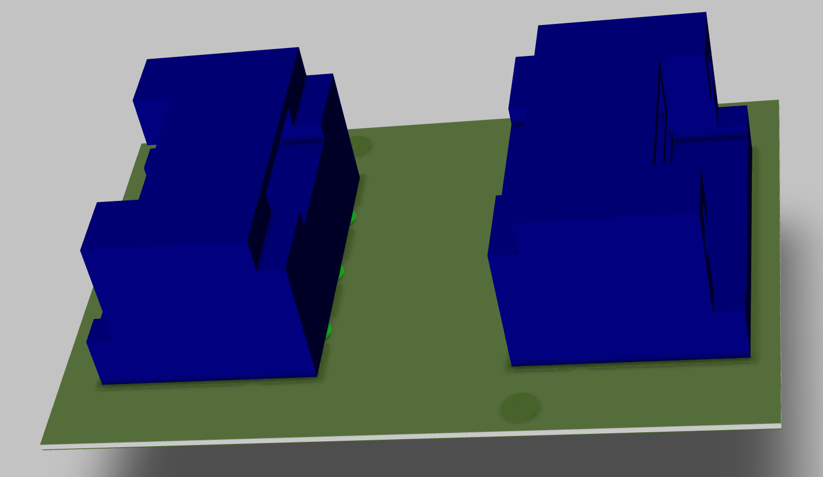

PCB2：2xrs422 board 3D View

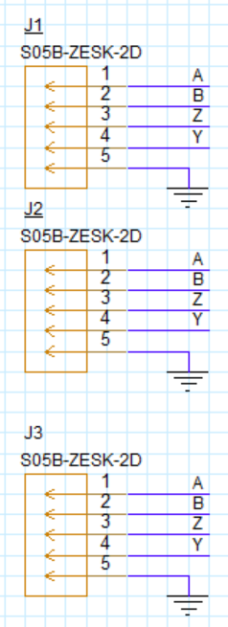

PCB3：3xrs422 board schematic

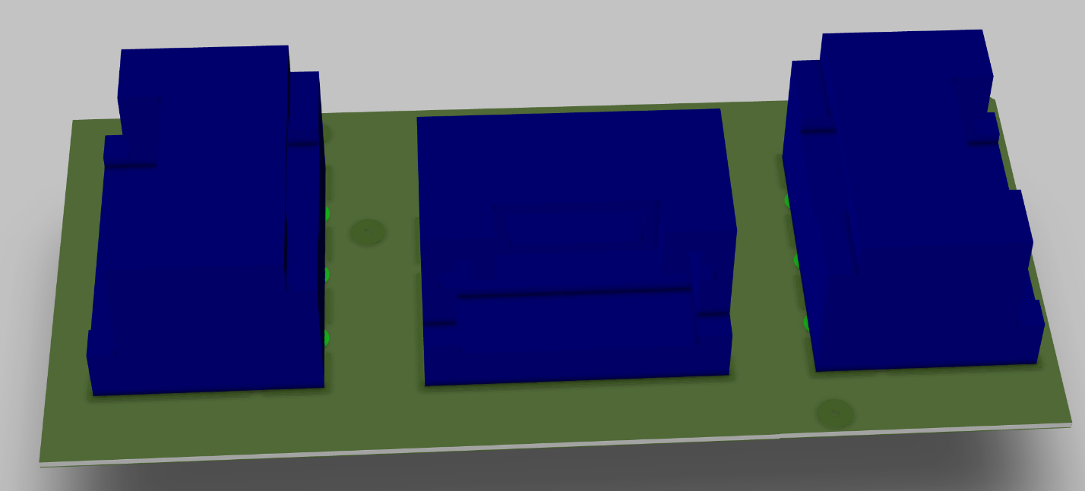

PCB3：3xrs422 board 3D View