Appendices

Power-Plot for performed t-tests
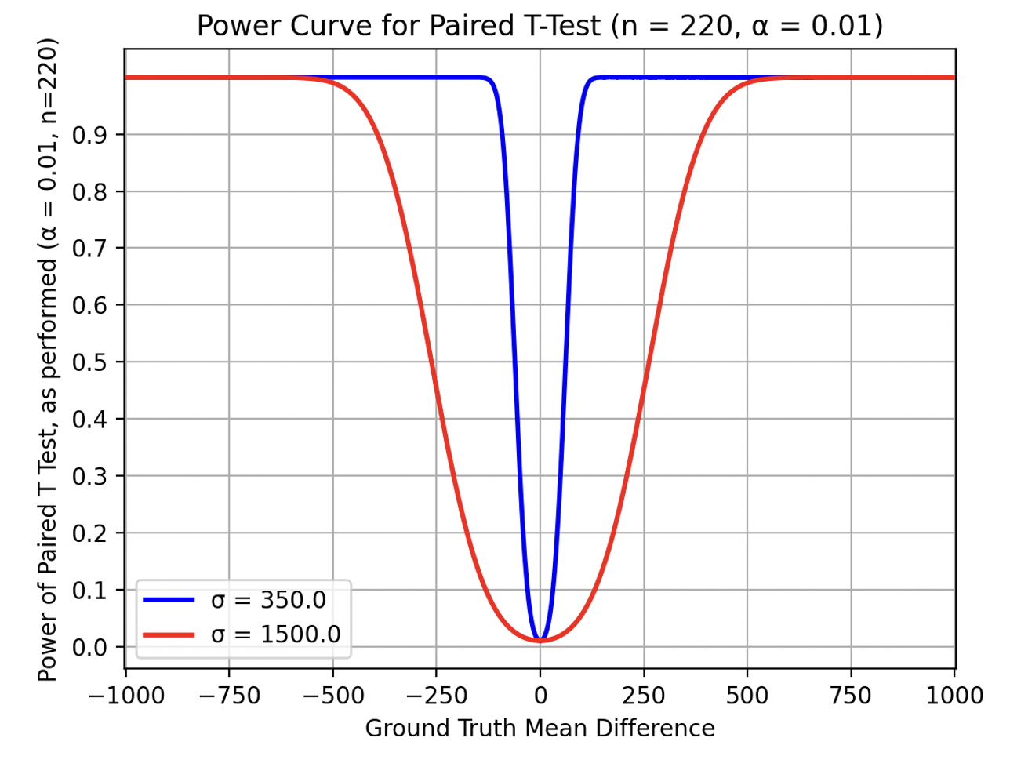
Appendix Figure 1: Power curve for t-tests in main body of paper (Figure 5). The two shown curves are according to the min and max standard deviations in differences across all performed comparisons, and accordingly bound the power-plots for all comparison tests.

Equity Analysis

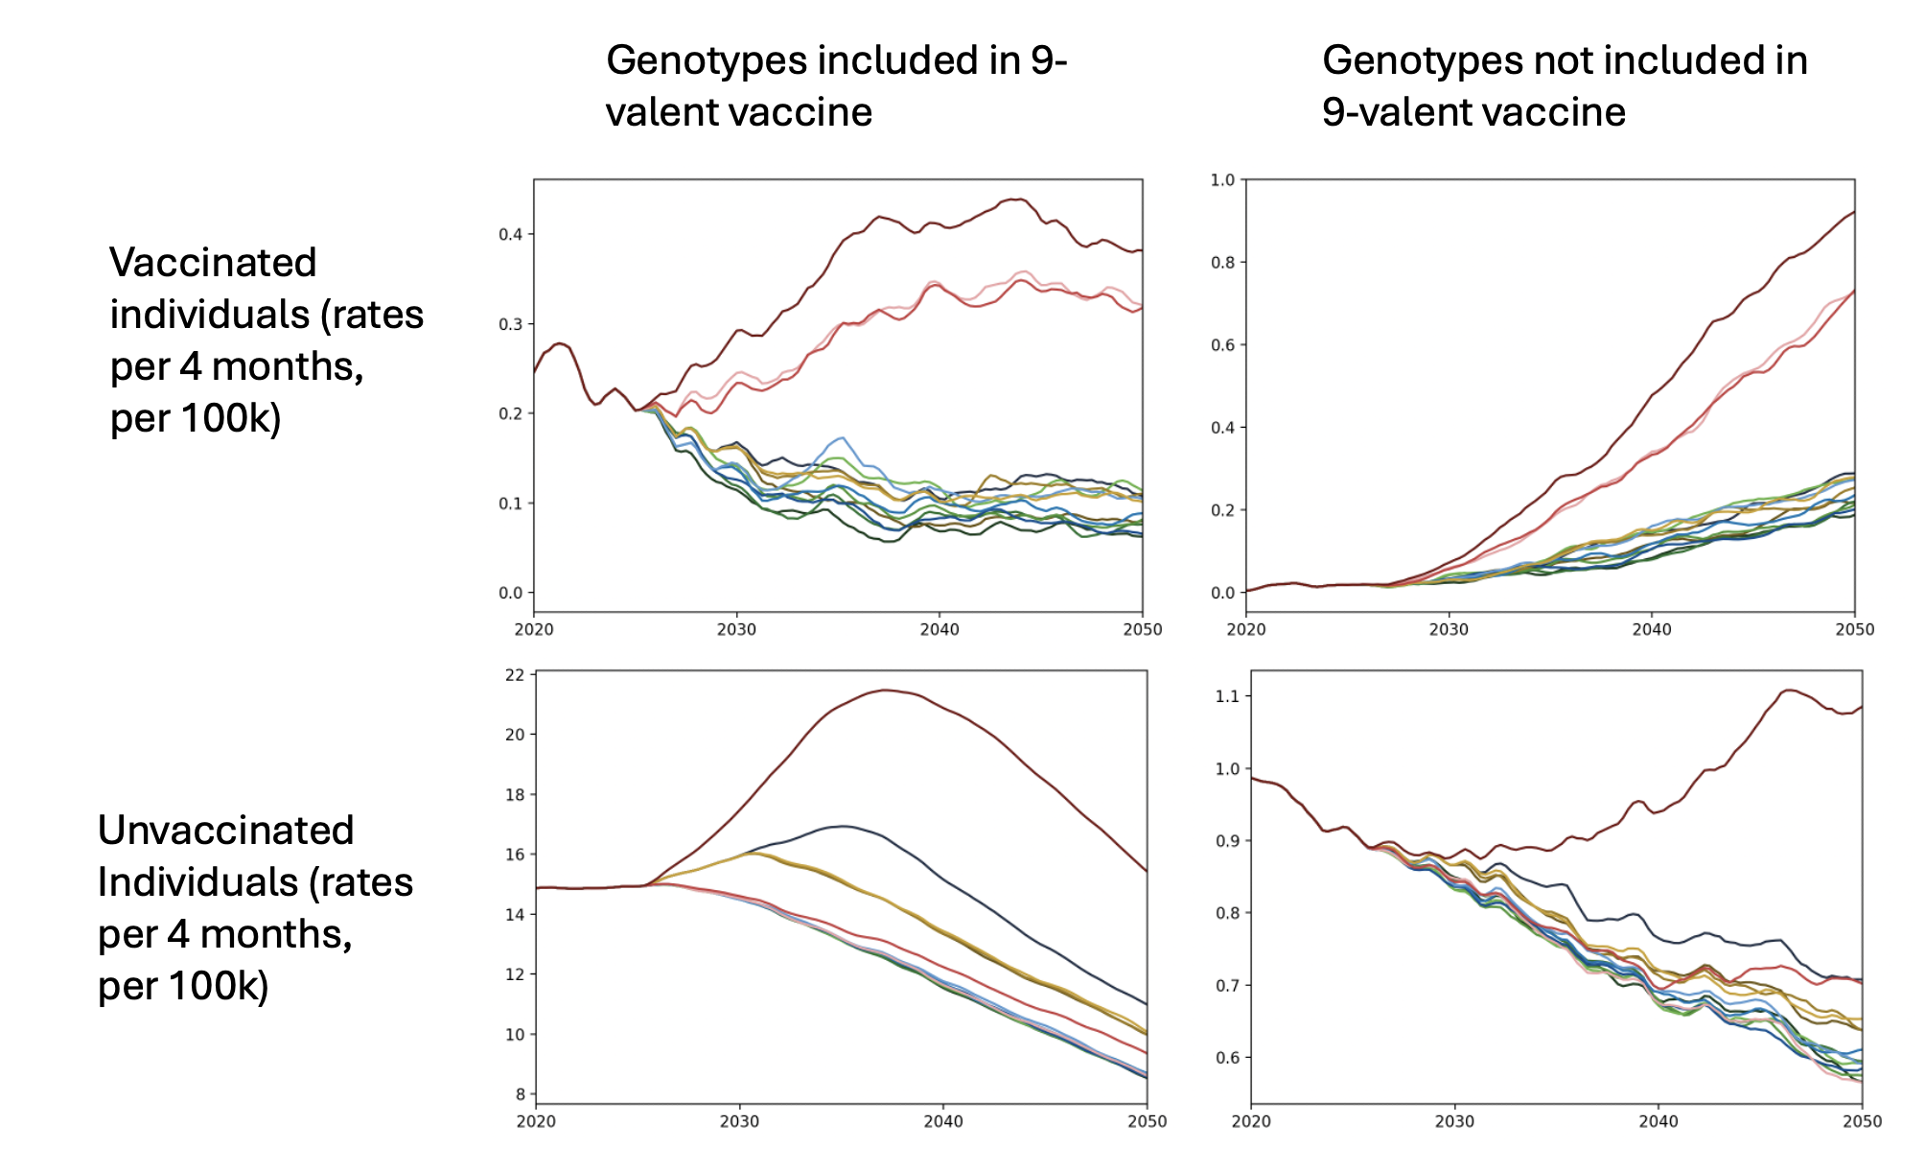
Appendix Figure 2: Undiagnosed Cancers After 5 Years of Development for vaccinated and unvaccinated subpopulations, split by HPV genotype to which the cancer is attributable
alg | LQ (_LV) | Median (_LV) | UQ (_LV) | P(less than target 4) (_LV) | LQ () | Median () | UQ () | P(less than target 4) () | LQ (_HV) | Median (_HV) | UQ (_HV) | P(less than target 4) (_HV)
5_5 | 3.55 | 4.19 | 4.74 | 0.436 | 3.76 | 4.36 | 5.08 | 0.336 | 3.86 | 4.53 | 5.21 | 0.295
5_7 | 3.55 | 4.16 | 4.82 | 0.441 | 3.76 | 4.52 | 5.14 | 0.345 | 3.91 | 4.49 | 5.09 | 0.282
5_10 | 3.59 | 4.17 | 4.81 | 0.441 | 3.79 | 4.51 | 5.20 | 0.336 | 3.95 | 4.47 | 5.21 | 0.291
5_15 | 3.65 | 4.26 | 4.90 | 0.400 | 3.75 | 4.45 | 5.01 | 0.332 | 3.96 | 4.50 | 5.16 | 0.277
10_10 | 3.91 | 4.60 | 5.31 | 0.282 | 4.16 | 4.91 | 5.57 | 0.205 | 4.33 | 4.99 | 5.72 | 0.155
10_15 | 3.87 | 4.52 | 5.32 | 0.327 | 4.06 | 4.84 | 5.63 | 0.236 | 4.21 | 4.90 | 5.65 | 0.214
15_15 | 4.20 | 4.86 | 5.57 | 0.173 | 4.30 | 5.18 | 5.87 | 0.145 | 4.44 | 5.25 | 6.02 | 0.132
5plus7 | 3.59 | 4.20 | 4.82 | 0.405 | 3.85 | 4.41 | 5.11 | 0.323 | 3.96 | 4.52 | 5.18 | 0.277
5plus10 | 3.56 | 4.18 | 4.96 | 0.423 | 3.74 | 4.46 | 5.05 | 0.341 | 3.83 | 4.57 | 5.19 | 0.318
5plus15 | 3.66 | 4.25 | 4.92 | 0.405 | 3.78 | 4.43 | 5.19 | 0.359 | 3.86 | 4.64 | 5.30 | 0.318
10plus15 | 3.95 | 4.57 | 5.35 | 0.282 | 4.27 | 4.94 | 5.63 | 0.164 | 4.30 | 4.99 | 5.79 | 0.195
none_none | 4.96 | 5.93 | 6.93 | 0.045 | 5.27 | 6.25 | 7.20 | 0.036 | 5.59 | 6.59 | 7.40 | 0.027
5_none | 3.55 | 4.21 | 4.81 | 0.386 | 3.79 | 4.41 | 5.14 | 0.323 | 3.86 | 4.49 | 5.26 | 0.300
5plusnone | 3.75 | 4.39 | 5.16 | 0.359 | 3.90 | 4.51 | 5.42 | 0.282 | 3.98 | 4.65 | 5.38 | 0.268
Appendix Table 1: Elimination Probabilities at 2040, when restricting to unvaccinated population only
alg | LQ (_LV) | Median (_LV) | UQ (_LV) | P(less than target 4) (_LV) | LQ () | Median () | UQ () | P(less than target 4) () | LQ (_HV) | Median (_HV) | UQ (_HV) | P(less than target 4) (_HV)
5_5 | 0.00 | 0.00 | 0.33 | 0.986 | 0.00 | 0.00 | 0.28 | 0.995 | 0.00 | 0.00 | 0.26 | 0.995
5_7 | 0.00 | 0.00 | 0.33 | 1.000 | 0.00 | 0.00 | 0.28 | 0.995 | 0.00 | 0.00 | 0.26 | 0.995
5_10 | 0.00 | 0.00 | 0.33 | 0.986 | 0.00 | 0.00 | 0.28 | 1.000 | 0.00 | 0.00 | 0.26 | 0.986
5_15 | 0.00 | 0.00 | 0.33 | 0.986 | 0.00 | 0.00 | 0.28 | 0.991 | 0.00 | 0.00 | 0.26 | 0.986
10_10 | 0.00 | 0.00 | 0.33 | 0.995 | 0.00 | 0.00 | 0.28 | 0.995 | 0.00 | 0.00 | 0.26 | 0.995
10_15 | 0.00 | 0.00 | 0.33 | 0.982 | 0.00 | 0.00 | 0.28 | 0.982 | 0.00 | 0.00 | 0.26 | 0.991
15_15 | 0.00 | 0.00 | 0.33 | 0.982 | 0.00 | 0.00 | 0.28 | 0.991 | 0.00 | 0.00 | 0.26 | 0.995
5plus7 | 0.00 | 0.00 | 0.33 | 0.991 | 0.00 | 0.00 | 0.28 | 0.986 | 0.00 | 0.00 | 0.26 | 0.991
5plus10 | 0.00 | 0.00 | 0.33 | 0.986 | 0.00 | 0.00 | 0.28 | 0.986 | 0.00 | 0.00 | 0.26 | 0.986
5plus15 | 0.00 | 0.00 | 0.33 | 0.995 | 0.00 | 0.00 | 0.28 | 0.991 | 0.00 | 0.00 | 0.26 | 0.991
10plus15 | 0.00 | 0.00 | 0.33 | 0.986 | 0.00 | 0.00 | 0.28 | 0.986 | 0.00 | 0.00 | 0.26 | 0.991
none_none | 0.00 | 0.32 | 0.65 | 0.977 | 0.00 | 0.28 | 0.56 | 0.977 | 0.00 | 0.26 | 0.52 | 0.977
5_none | 0.00 | 0.32 | 0.65 | 0.977 | 0.00 | 0.28 | 0.55 | 0.982 | 0.00 | 0.26 | 0.52 | 0.986
5plusnone | 0.00 | 0.32 | 0.65 | 0.977 | 0.00 | 0.28 | 0.56 | 0.982 | 0.00 | 0.26 | 0.33 | 0.982
Appendix Table 2: Elimination Probabilities at 2040, when restricting to vaccinated population only

