**Customer Requirements Specification**

**(Lastenheft)**

TINF20C, SWE I, Praxisprojekt 2021/2021

Project: Modelling Wizard for Cable Models

Customer: Rentschler & Holder

Rotebühlplatz 41

70178 Stuttgart

Supplier: Team 2 (Leon Amtmann, Calvin Friedrich, Max Gohlke, Kevin Pauer, Thorsten Rausch, Tim Sellemann, Fabian Thomé)

|  |  |  |  |
| --- | --- | --- | --- |
| **Version** | **Date** | **Author** | **Comment** |
| 0.1 | 21.10.2021 | Max Gohlke | First Draft of the CRS |
| 0.2 | 24.10.2021 | Kevin Pauer | Improvements |
| 0.3 | 02.11.2021 | Fabian Thome | Final Draft of the CRS |
|  |  |  |  |
|  |  |  |  |
|  |  |  |  |
|  |  |  |  |
|  |  |  |  |

CONTENTS

1. Goal 3

2. Product Environment 4

*3.* Product Usage 5

3.1. Business Processes 5

3.2. Use Cases 5

3.2.1. <UC.001> Surfing 5

3.2.2. <UC.002> Deprecated cable 9

3.2.3. <UC.003> Lookup 10

3.3. Features 11

3.3.1. /LF10/ Login & User Authentication 11

3.3.2. /LF20/ Deprecation of Cable Model 11

*4.* Product Data 12

4.1. /LD10/ Data 12

4.2. /LD20/ Interfaces 12

*5.* Other Product Characteristics 13

1.1 Usability 13

1.2 Efficiency 13

1.3 Performance 13

1.4 System Environment 14

# Goal

A web-based application should be developed, that provides an accessible and easy GUI for the configuration of cables and the addition of device-interfaces (e.g. physical ports) and file attachments [1]. Such configurations can be found in the catalogues of almost every cable-provider. A usability-analysis should give insight to existing solutions, the following results influence the development then. The file-output format should be in form of an AutomationML-Package, which must apply to the rules for AML-Component models (AML-DDs). Furthermore, the electrical interface-library should be expanded with new connector-types for single-pair-ethernet from the IEC63171-6 and M12-Push/Pull from the IEC 61076-2 010.

Following tasks must be completed:

1. Analysis of existing solutions (e.g. Balluff, Murr-Elektronik, Harting, Phoenix-Contact)

2. Mockup of a GUI and an appropriate usability-concept

3. Support for CAEX 2.15 and CAEX 3.0 as output format (customizable)

4. Input fields for all necessary parameters

5. Definition of an exchangeable data-model for the product-logic

6. Use and expansion of the AML-interface-library for electrical connectors

7. Use of the ANGULAR-framework to create a GUI

8. Creation of an extensive user-documentation

[1] 2021_Steckverbinderkongress_Rentschler_1v0.pdf

[2] <https://www.automationml.org/download-archive/>

[3] IEC 61076-2-010

# Product Environment

The usage environment of the modelling wizard for cable-models is characterized by its web-GUI for online-shops for cables. This web-GUI is implemented with ANGULAR.

ANGULAR is a TypeScript (JavaScript deviation) based front-end framework for web development.

The project will be deployed in a Docker Container. When the container is running, the Modeling Wizard can be accessed locally in a common web browser.

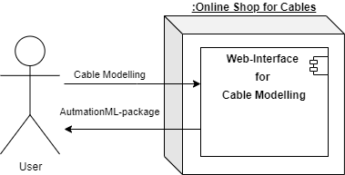

# Product Usage

The Modelling Wizard for Cables should support the creation of new cable models with additional information for each created cable model, such as the number of contacts, layout of contacts and common connector names and descriptions.

## Business Processes

The main goal for the software solution is to make it easy for a customer to buy a cable that fits his needs. As this is an open-source project, profit is not the aspect the processes are driven by, but rather customer satisfaction.

## Use Cases

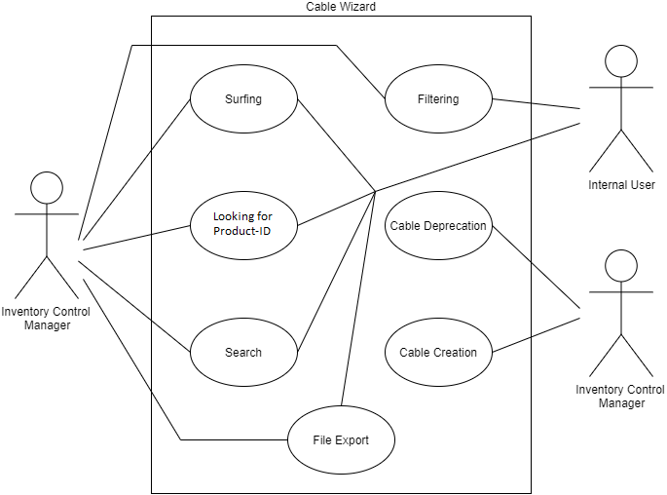

### <UC.001> Surfing

|  |  |
| --- | --- |
| **Related Business Process:** | <BP.001>: Discover Products |
| **Use Cases Objective:** | The user surfs the web, gets to website by accident and starts playing around with the Wizard. |
| **System Boundary:** | Cable Wizard |
| **Precondition:** | The user is not familiar with the Wizard’s functionality. |
| **Postcondition on success:** | The user now knows how to use the Wizard. |
| **Involved Users:** | User, Internal User |
| **Triggering Event:** | Coincidence |

### <UC.002> Looking for Product ID

|  |  |
| --- | --- |
| **Related Business Process:** | <BP.002>: Find Products |
| **Use Cases Objective:** | User has specific product in mind and looks it up in the Wizard. |
| **System Boundary:** | Cable Wizard |
| **Precondition:** | User has specific article ID. |
| **Postcondition on success:** | User got all the information needed contained in an AML Package. |
| **Involved Users:** | User, Internal User |
| **Triggering Event:** | Need of user for a specific cable. |

### <UC.003> Search

|  |  |
| --- | --- |
| **Related Business Process:** | <BP.003>: Find Products |
| **Use Cases Objective:** | User is in need of a cable and starts searching for one that meets his requirements. |
| **System Boundary:** | Cable Wizard |
| **Precondition:** | Wizard has to provide an intuitive and goal-driven workflow. |
| **Postcondition on success:** | User has found a cable that meets his requirements. |
| **Involved Users:** | User, Internal User |
| **Triggering Event:** | Need of user for a cable that meets specific requirements. |

## Features

### /LF10/ Login & User Authentication

The Login & Authentication system shall check if the entered credentials match the credentials saved in the authentication storage location and, in case of failure to authenticate, inform the user and deny access to the cable wizards modification functions.

After too many successive authentication failures, the system administrator will be informed about an unauthorized access attempt.

### /LF20/ Deprecation of Cable Model

If the Cable Wizard receives a command for deletion of a cable model, it will check if the command for deletion came from an authenticated user. If not, the cable is not deleted, otherwise the model is purged from the database and the display page is refreshed, now without displaying the deleted cable.

# Product Data

## /LD10/ Data

Since AutomationML is built upon CAEX the data output format will support CAEX in both, Version 2.15 and its most recent Version 3.0.

The data output itself will be an AutomationML-Package.

## /LD20/ Interfaces

The Modelling Wizard has to provide data for the web-based GUI. And has to respond to input from the GUI properly.

# Other Product Characteristics

This section describes the already known non-functional requirements for the product.

## Usability

The interface shall consist of an easily readable and intuitively understandable layout, with elements conveying their meaning and given functionality to the user.

The interface shall enable an inexperienced to quickly understand how to access and use key features, with the meaning and given functionality of icons, buttons and other means of interaction being self-explanatory.

The software should be accessible for people with disabilities or impairments, such as colorblindness, by using distinguishable colors for highlighting, easily readable fonts and clearly visible icons and imagery

The software shall reduce mental effort required to achieve desired results to a minimum by utilizing a simple and intuitive layout and providing utility features.

The interface shall respond to user inputs without noticeable delay.

The software shall have the capacity to handle large amounts of users interacting with the system simultaneously.

## Efficiency

The software shall enable the user to put together their desired parts quickly, by requiring low amounts of steps taken by the user to achieve their desired result.

The software shall perform individual steps in a minimal amount of time.

The software shall generate and provide the resulting files upon request within a minimal amount of time.

## Performance

The software shall load and render on common browsers and devices without disruptive delays.

## System Environment

The website should be able to run on any browser supporting the HTML5 standard.

The system will require a computer with network access to communicate with its users.