Content

1. Purpose 2

2. Product Environment 2

3. Use Cases 3

3.1. <UC.001> New Cable Registration 3

3.2 <UC.002> Lookup/Search of Cable Information 4

3.3 <UC.003> Download of Cable Information in AML format 4

4. Product Requirements 5

4.1. /LF10/ Display Available Cables 5

4.2. /LF20/ Navigation 5

4.3. /LF30/ Filter Display List by Cable Attributes 5

4.4. /LF40/ Delete File from File System 6

4.5. /LF50/ Search Display List for String 6

4.6. /LF60/ Cable Detail View 6

4.7. /LF70/ Save New Cable Data 6

4.8. /LF80/ Export Cable Data as AML 6

5. Non-functional Requirements 7

5.1. /NF10/ Security 7

5.2. /NF20/ Reliability 7

5.3. /NF30/ Performance 7

5.4. /NF40/ Maintainability 7

5.5. /NF50/ Scalability 7

5.6. /NF60/ Future-Proofing 7

6. Cable Data Model 7

6.1. /LD10/ Cable Sleeve 7

6.2. /LD20/ Cable Diameter 7

6.3. /LD30/ Cable Material(s) 8

6.4. /LD40/ Cable Connector Side 1 & 2 8

6.5. /LD50/ Cable Max Current Rating 8

6.6. /LD60/ Cable Length 8

6.7. /LD70/ Cable Color 8

7. Analysis of Existing Solutions 8

7.1. Balluff 8

Strengths 8

Weaknesses: 9

7.2. LAPP Deutschland 10

Strengths 10

Weaknesses 10

7.3. MURR Elektronik 11

Strengths 11

Weaknesses 11

7.4. PHOENIX CONTACT 11

Strengths 11

Weaknesses 12

7.5. Harting 12

Strengths 12

Weaknesses 13

# 1. Purpose

The ultimate end goal of this software shall be to create cable models though a web-based interface written in Angular. The software shall then be capable of exporting the created cable models in AutomationML-Format utilizing CAEX 2.0 and 3.15.

# 2. Product Environment

The resulting application shall be able to run in a docker container, ensuring portability between systems and future-proofing for a cloud-native environment.

The product shall be designed to assist in managing cables, not as an inventory management system with counts and locations, instead as a repository of potentially available cables inside or from a company.

# 3. Use Cases

## 3.1. <UC.001> New Cable Registration

| <UC.001> | New Cable Registration |
| --- | --- |
| Related Business Process | New Cable is registered in inventory system |
| Use Cases Objective | User wants to store information about a new cable in a safe environment where it is easily accessible |
| System Boundary | Inventory system |
| Precondition | The cable must not be already registered, the program has to run without errors. |
| Postcondition on success | The cable is successfully registered with all specifications |
| Involved Users | User and inventory system |
| Triggering Event | The user acquires a new cable which they want to be registered in the inventory system |

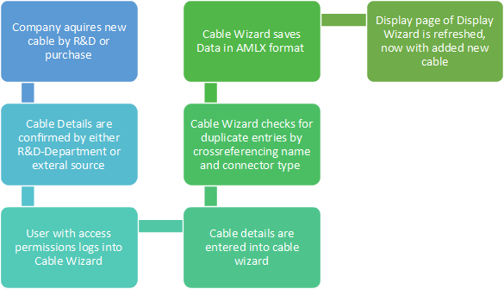

UC.001 Diagram

## 3.2 <UC.002> Lookup/Search of Cable Information

| <UC.002> | Lookup/Search of Cable Information |
| --- | --- |
| Related Business Process | Customer Lookup of Cable Information |
| Use Cases Objective | User wants to access the information and data of a specific cable with known identifier |
| System Boundary | Application |
| Precondition | The user must be aware of the exact identifier of the cable |
| Postcondition on success | The correct cable is returned to the user |
| Involved Users | User and Application |
| Triggering Event | The user requires information on a specific cable for any reason |

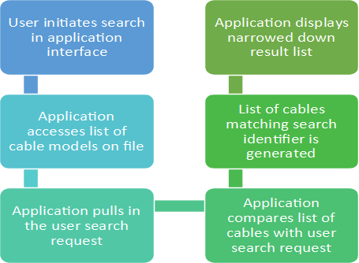

UC.002 Diagram

## 3.3 <UC.003> Download of Cable Information in AML format

| <UC.003> | Download of Cable Information in AML format |
| --- | --- |
| Related Business Process | Customer Lookup of Cable Information |
| Use Cases Objective | User wants to download the information of a cable in AML format |
| System Boundary | Application |
| Precondition | The user must be aware of the exact identifier of the cable the user wants to download |
| Postcondition on success | The download of cable information is initiated by the application |
| Involved Users | User and Application |
| Triggering Event | The user requires the portability of cable data for any reason, such as compatibility or use-case-analysis on the user side |

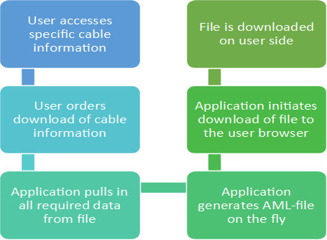

UC.003 Diagram

# 4. Product Requirements

The following functions shall be implemented in the applications.

## 4.1. /LF10/ Display Available Cables

To ensure a pleasant user experience, the application must be able to present the user with a listing of currently available cables. To this end, the application must request a listing of all cables from a backend server and display them to the user.

| Input Description | Expected Output |
| --- | --- |
| REST Endpoint | String containing the requested cable IDs |

## 4.2. /LF20/ Navigation

The user shall be able to navigate through the application by clickable user interface. For example, the user shall be able to open the cable details editor by clicking on a cable name or image.

| Input Description | Expected Output |
| --- | --- |
| User input | Change of user interface based on user input |

## 4.3. /LF30/ Filter Display List by Cable Attributes

The application shall be able to filter the cable overview list for specific cable attributes and hide cables not fitting the search and filtering criteria.

| Input Description | Expected Output |
| --- | --- |
| Attribute and value to filter by | New display list containing only cables matching the filtered-for attribute |

## 4.4. /LF40/ Delete File from File System

The application must be able to delete a cable connector from the file system to remove it from the list of available cable connectors.

| Input Description | Expected Output |
| --- | --- |
| Path to file to delete | Acknowledgement of successful file deletion |

## 4.5. /LF50/ Search Display List for String

The application shall be capable of receiving a search string by a user and then filter the current display list for that string. This way, the listed cable connectors can be narrowed down.

| Input Description | Expected Output |
| --- | --- |
| Search string | New display list containing only listings matching the search string |

## 4.6. /LF60/ Cable Detail View

The application shall be able to display the details to any cable model in a list of cables.

| Input Description | Expected Output |
| --- | --- |
| Click on cable model | Cable detail view containing the cable model and a way to initiate data download as well as a way to edit cable details |

## 4.7. /LF70/ Save New Cable Data

The application shall be able to take user input data and permanently save it for later reference.

| Input Description | Expected Output |
| --- | --- |
| User input data | Created/Amended file at location on disk not accessible to user |

## 4.8. /LF80/ Export Cable Data as AML

If not yet so, the application shall be able to convert a cable model to AML compliant format and export it for user download.

| Input Description | Expected Output |
| --- | --- |
| File path to cable model | AML-compliant file |

# 5. Non-functional Requirements

## 5.1. /NF10/ Security

The system shall not need authentication by password, because the application shall only be run internally and should be accessible by all personnel dealing with the creation and management of cables inside the company. Storage of proprietary information in the application will neither be supported nor recommended.

## 5.2. /NF20/ Reliability

The application must be designed for optimal uptime. In the event of a fatal crash, the application container shall signal failure using an integrated health check. Outside action will be necessary to determine cause of failure and to rectify any bugs.

## 5.3. /NF30/ Performance

The application shall be as performant as possible. Angular is known for its relatively high resource consumption in comparison to native applications, but any sufficiently powerful server that can run company operations shall also be capable of running this application.

## 5.4. /NF40/ Maintainability

The application container shall be easy to maintain by employing a code version control system that makes code changes over time obvious to any future maintainer.

## 5.5. /NF50/ Scalability

Each instance of the application shall be able to support one concurrent user. If more users are desired to work simultaneously with different cable models, more application instances shall be able to be spun up using docker or some other container orchestration tool.

## 5.6. /NF60/ Future-Proofing

The application shall be delivered packaged inside a docker container, ensuring compatibility with the emerging industry trend of running on premise applications in cloud-like container orchestration software.

# 6. Cable Data Model

## 6.1. /LD10/ Cable Sleeve

The cable data model shall support the definition of a cable sleeve material.

## 6.2. /LD20/ Cable Diameter

The cable data model shall support setting a cable diameter.

## 6.3. /LD30/ Cable Material(s)

The cable data model shall define the cable material.

## 6.4. /LD40/ Cable Connector Side 1 & 2

The cable data model shall define the connectors on both ends of the cable according to an existing list of available connector types.

## 6.5. /LD50/ Cable Max Current Rating

The cable data model shall define the maximum rated electrical current supported by the cable.

## 6.6. /LD60/ Cable Length

The cable data model shall support the definition of length of a particular cable.

## 6.7. /LD70/ Cable Color

The cable data model shall support the definition of the color of a cable.

# 7. Analysis of Existing Solutions

## 7.1. Balluff

### Strengths

* Products are easy to locate in list
* Sidebar for filtering
* Pictures next to cables

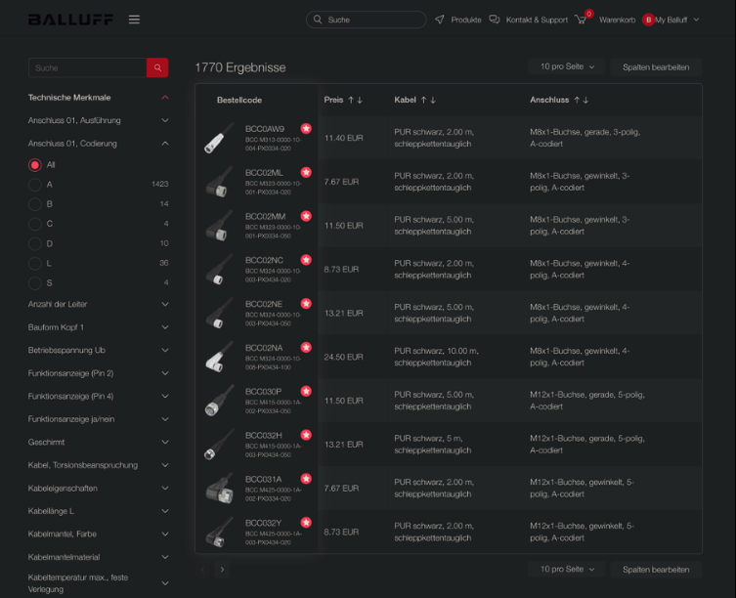

Image

### Weaknesses:

* Product search jarring, interrupts experience with full screen loading animation

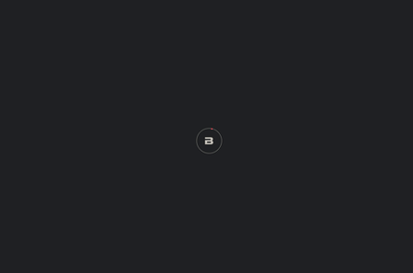

Image

* Two separate search bars visible at once

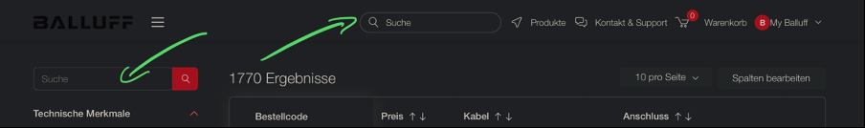

Image

## 7.2. LAPP Deutschland

### Strengths

* Easy to find products
* Wide range of specifications for in cable configurator

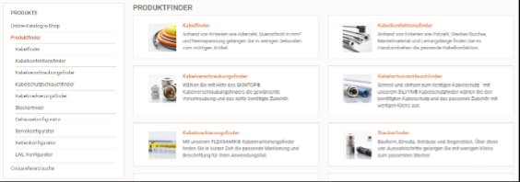

Image

### Weaknesses

* Outdated design
* Cable configuration design is overwhelming
* No pictures for cables

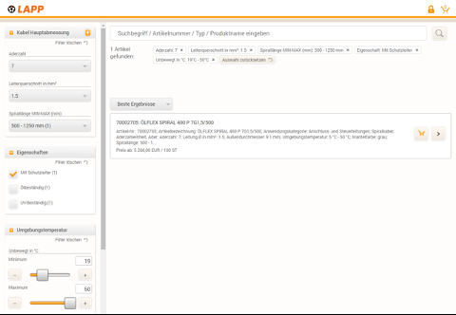

Image

## 7.3. MURR Elektronik

### Strengths

* Aesthetically pleasing design

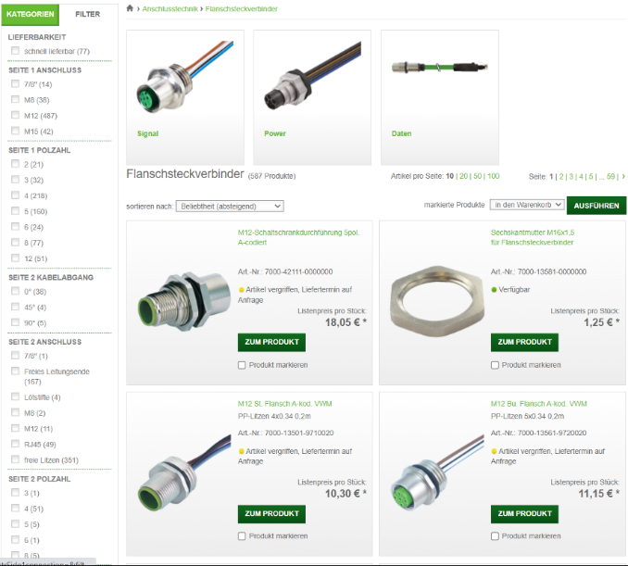

Image

### Weaknesses

* Hard to find configurator

## 7.4. PHOENIX CONTACT

### Strengths

* Pictures of cables in configurator
* Easy selection process for specifications

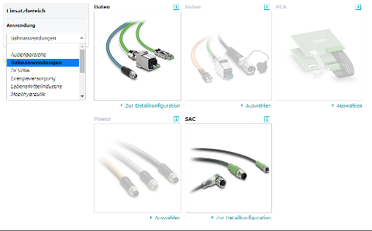

Image

### Weaknesses

* Outdated design
* Overwhelming number of options in product navigation

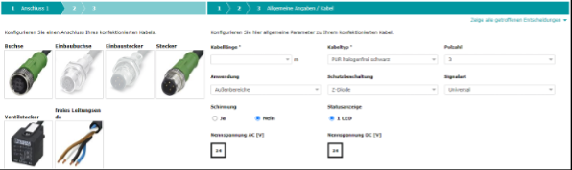

Image

## 7.5. Harting

### Strengths

* Wide range of specifications for in cable configurator
* Can compare different cable models
* Easy download of a type sheet with product Data
* Has a Wishlist option
* Can sort by article number or release date
* Most important details and picture already visible from list

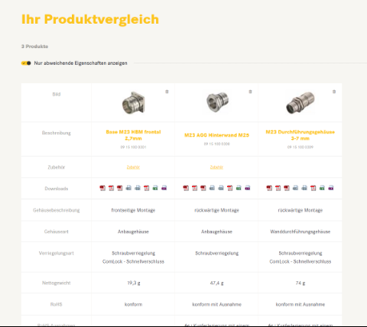

Image

### 

### Weaknesses

* Due to the wide variety of different selection options, it is hard to keep a good overview

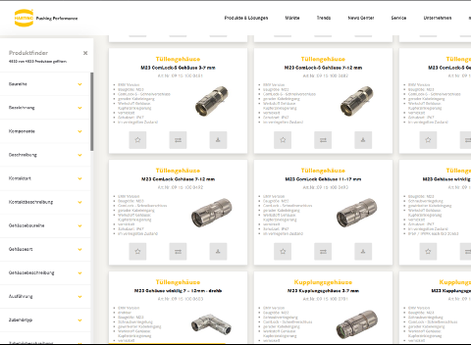

Image