Records

Logistics Case Study

IVF6ILV

Integrated Value Flows

**Created on:** 03 March 2025

**Author:** Fabian Zaiser

Table of Contents

SD Challenge 3

Task 3

Datasheet 3

Process steps 3

Step 1: Create .... 3

Step 2: Create .... 3

PP Challenge 4

Task 4

Datasheet 4

Process steps 4

Step 1: Create .... 4

Step 2: Create .... 4

MM Challenge 5

Task 5

Datasheet 5

Process steps 5

Step 1: Create .... 5

Step 2: Create .... 5

Logistics Case Study 6

Task 6

Datasheet 6

Process steps 6

Step 1: Create .... 6

Step 2: Create .... 6

# SD Challenge

## Task

## Datasheet

|  |  |  |
| --- | --- | --- |
| Type (Organizational Data  /Master Data/Transaction Data) | Data | Number |
| Master Data | Business Partner (Customer) | 1003422 |
| Transaction Data | Sales Order | 220 |
|  |  |  |
|  |  |  |
|  |  |  |
|  |  |  |
|  |  |  |
|  |  |  |

## Process steps

### Step 1: Create Alster Adventures S25 014

Created it by copying from Capital Bikes 140001, Berlin location

Customer Number: 1003422

Ein Bild, das Text, Screenshot, Software, Zahl enthält.

We can see here by copying from capital bikes, we also have the DN00 Wholesales BI division which is needed later.   
Note: We only have 2 divisions but the task description SD challenge states we need to create it for all three divisions, which right now is not clear to me what this means.

Ein Bild, das Text, Reihe, Zahl, Schrift enthält.

### Step 2: Create Standard Order Part 1

Description & Screenshots

Standard Order

Ein Bild, das Text, Screenshot, Software, Schrift enthält.

....

### Step 3: Create Standard order Part 2

Ein Bild, das Text, Software, Zahl, Reihe enthält.

### Step 4: Details about pricing

Women Bikes

RA00 Discount from Net : 3%

RC00 Quantity Discount: -50,- (this is per bike so 250 total)

Ein Bild, das Text, Screenshot, Zahl, Software enthält.

Men Bikes (same as Women above)

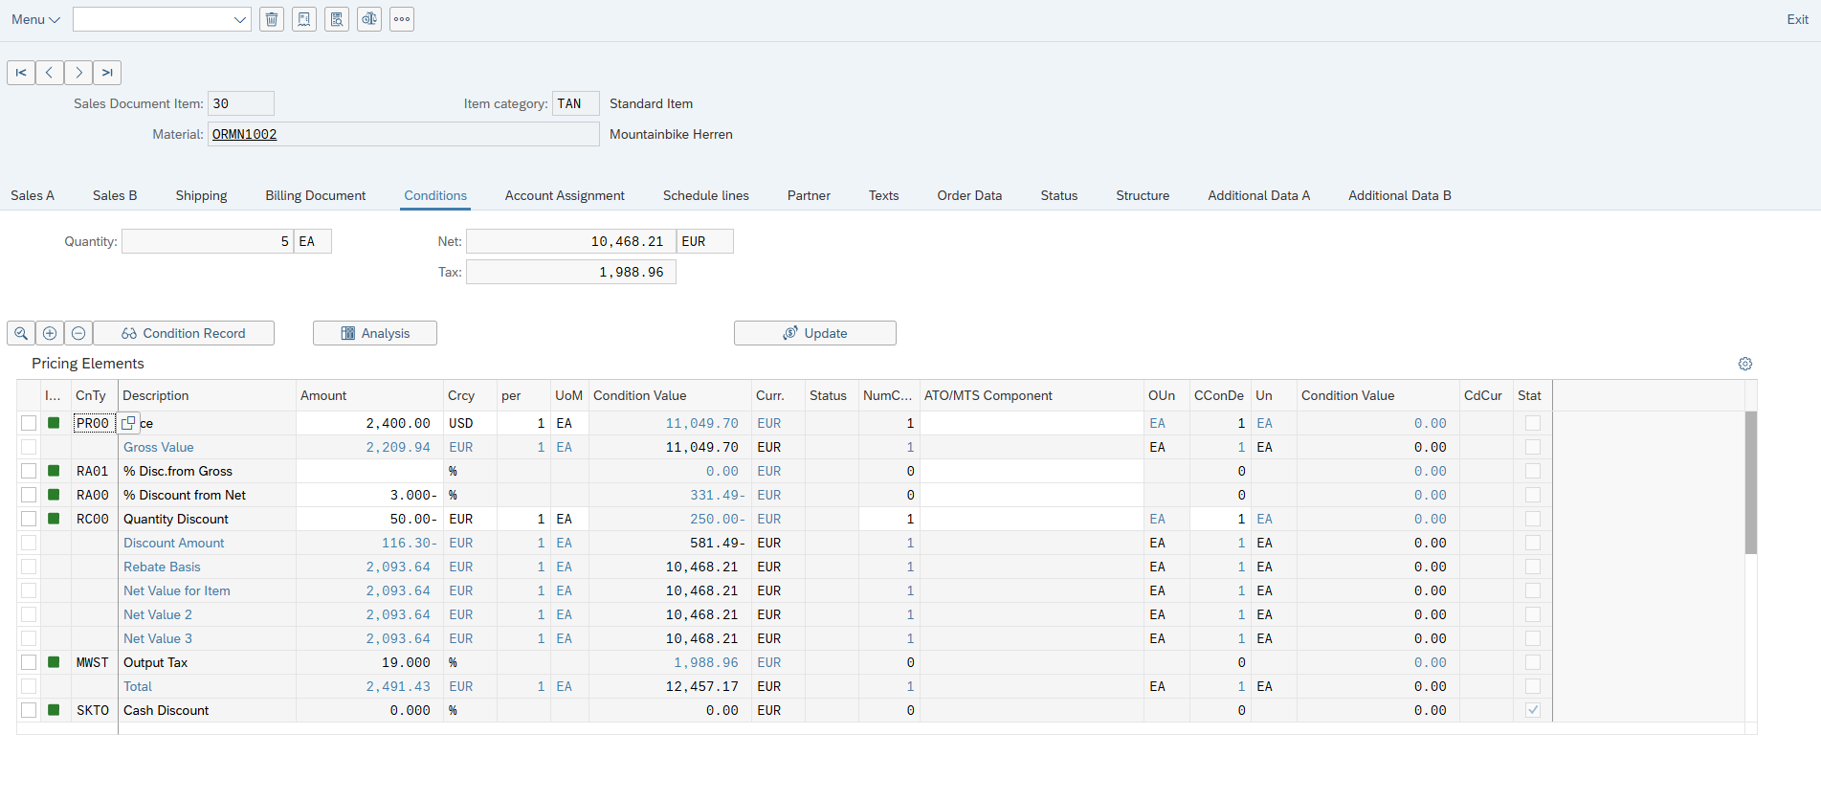

### Step 5: Finish Sales Order



# PP Challenge

## Task

## Datasheet

|  |  |  |
| --- | --- | --- |
| Type (Organizational Data  /Master Data/Transaction Data) | Data | Number |
|  |  |  |
|  |  |  |
|  |  |  |
|  |  |  |
|  |  |  |
|  |  |  |
|  |  |  |
|  |  |  |

## Process steps

### Step 1: Create ....

Description & Screenshots

### Step 2: Create ....

Description & Screenshots

....

# MM Challenge

## Task

## Datasheet

|  |  |  |
| --- | --- | --- |
| Type (Organizational Data  /Master Data/Transaction Data) | Data | Number |
| Master Data | Business Partner (Customer) | 1003425 |
|  |  |  |
|  |  |  |
|  |  |  |
|  |  |  |
|  |  |  |
|  |  |  |
|  |  |  |

## Process steps

### Step 1: Create ....

Description & Screenshots

### Step 2: Create ....

Description & Screenshots

....

# Logistics Case Study

## Task

## Datasheet

|  |  |  |
| --- | --- | --- |
| Type (Organizational Data  /Master Data/Transaction Data) | Data | Number |
|  |  |  |
|  |  |  |
|  |  |  |
|  |  |  |
|  |  |  |
|  |  |  |
|  |  |  |
|  |  |  |

## Process steps

### Step 1: Create ....

Description & Screenshots

### Step 2: Create ....

Description & Screenshots

....