Opening a new gym in Aventura, Florida

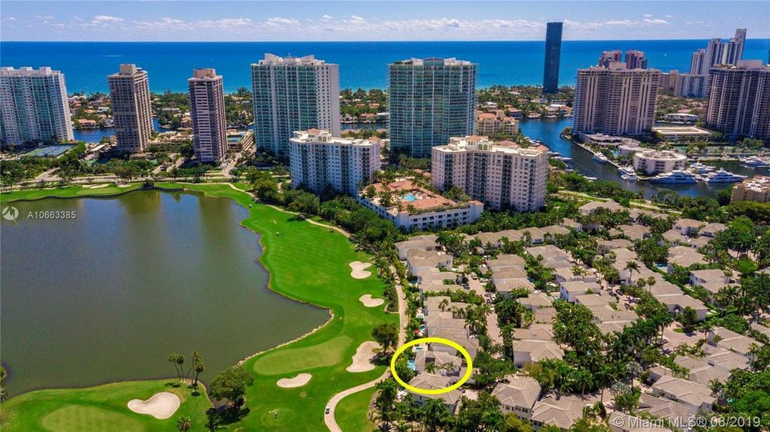

**Capstone Final Project**

# Brief:

* A group of international investors wants to open up a gym, and they have hired us to advise them on how to protect and maximize the return for their investment.
* They decided they want to work with luxury equipment, targeting a wealthy demographics in hopes of being able to charge a premium to them.
* They identified the area of Aventura, Florida as one where the gym is likely to succeed for its past growth and average household income.
* However, if they open too close to one competitor (or two), they will not be able to make as much money as they want and will in fact lose all their money and reputation.

We have been hired to minimize the competition the investor group faces by identifying every single nearby gym and have crafted a strategy to help them succeed.

# A little History:

### The Dark Ages and Rebirth of Fitness

After the fall of the Greco-Roman Empires, gyms along with art and music disappeared as the appreciation and pursuit of a healthy and sculpted body was frowned upon. It was not until the early 1800s that gyms made a minor resurgence in Germany. Still, though, these were not gyms as we think of them today. However, by the middle of the 19th Century schools began to build gymnasiums to help bolster their burgeoning athletic programs, which rekindled the public’s fascination and appreciation of not only the health benefits of exercise but the aesthetics of looking more fit.

### Early Commercial Gyms

The first commercial gym is typically credited to French gymnast and vaudeville-strongman, [Hippolyte Triat](https://www.britannica.com/biography/Hippolyte-Triat). He opened his first club in Brussels and then added a second in Paris in the late 1840s. At the end of the 19th century, another gym was established by an entrepreneurial music hall strongman, [Eugen Sandow](http://www.thehumanmarvels.com/eugen-sandow-father-of-bodybuilding/). In 1901 Sandow staged the world’s first physique contest, and he later promoted the burgeoning fitness lifestyle by marketing various publications, equipment, and dietary products and by operating a chain of fitness centers throughout Great Britain. To this day, the prize presented at the Mr. Olympia contest is named for this health club and fitness pioneer.

Founded in 1844 in London England, [The YMCA](http://www.ymca.net/history/) would eventually lead the way for fitness for many men. According to the YMCA website, The first buildings constructed with gymnasiums opened in 1869. In 1881, Boston YMCA staffer Robert J. Roberts coined the term “body building” and developed exercise classes, which are the forerunner of today’s health club model. YMCA came into existence. At the forefront of the health club model that would grow through the 20th Century.

In 1939, fitness legend Jack LaLanne opened what is believed to be the first U.S. health club in Oakland, Calif. At that time, doctors advised patients that there were dangers associated with lifting weights and rigorous exercise, LaLanne found success and designed and introduced many of the machines that are still mainstays on traditional gym floors such as first leg extension machines and pulley-cable based strength equipment. He even was an early proponent of women lifting weights, although very few took him up on it in the early days.

Of course, today, women make up more than half of the gym-going population and some of that rise can be credited to the birth of health club chains in the 1960s and 1970s. Prior to the birth of the health club chain, fitness centers were primarily fringe dingy boxes with rusty iron and maybe a boxing ring where predominantly men lifted weights in pursuit of perfection or trained for sports—not much different than the motivation for the first gyms in ancient Greece.

While still fringe and a Mecca for early bodybuilders, the birth of Gold’s Gym in Venice, Calif. in 1965 signaled the beginning of the rise of a new big-box concept for health and fitness that could –and would be—recreated to open the doors to the masses.  Joe Gold followed his success with Gold’s gym by founding the World Gym chain in 1977.

Of course, today, women make up more than half of the gym-going population and some of that rise can be credited to the birth of health club chains in the 1960s and 1970s. Prior to the birth of the health club chain, fitness centers were primarily fringe dingy boxes with rusty iron and maybe a boxing ring where predominantly men lifted weights in pursuit of perfection or trained for sports—not much different than the motivation for the first gyms in ancient Greece.

While still fringe and a Mecca for early bodybuilders, the birth of Gold’s Gym in Venice, Calif. in 1965 signaled the beginning of the rise of a new big-box concept for health and fitness that could –and would be—recreated to open the doors to the masses.  Joe Gold followed his success with Gold’s gym by founding the World Gym chain in 1977.

### Mainstream and the Women’s Movement

The adrenaline-and-big-hair-fueled 80s gave rise to an increasing number of gym chains including 24 Hour Fitness (1983) and LA Fitness (1984), as Jack LaLanne’s European Health Spas topped more than 200, before licensing them to Bally Company. Additionally, the success of [Jane Fonda’s exercise video drove](http://www.janefonda.com/30th-anniversary-of-my-first-workout-video/) many legwarmer-clad women through the doors of these clubs to lift light weights and do aerobic dance classes.

### Recent History

The mega-chains continue to this day, but as with many things, today’s consumers are looking for a more personal and intimate experience and throughout the 1990s and 2000s smaller mom-and-pop health clubs, personal training, and mind-body studios along with Cross-Fit and other specialty exercise facilities that cater to more of the personal touch.

Source: https://www.clubready.club/blog/evolution-of-the-fitness-industry-a-brief-history-of-the-public-gym

# Methodology:

We will use all of our learnings to come up with a useful solution in helping the investors identify at least one area of opportunity.

For this, we shall use the Foursquare API and obtain all the information of every gym and business center in the neighborhood, as well as in the surroundings.

Once we obtain the data, we will process it, clean it, organize it and present it in a crystal clear way.

After considering multiple resolutions, the approach of maximizing distances from all other gyms seemed like the smartest thing to do. However, geographical limitations come into play:

* What if the best spot is in the water?
* What if it is inaccessible?
* What if it isn’t for sale?

Realizing that there is a spectrum of possibility, and also as a way of honoring the local basketball team, the Miami Heat, we decided the best approch was then to construct a **Heat Map**.

By doing so, instead of coming up with one unique spot, and then another, until we maybe get one that actually Works, we created a ‘hot’ area where most of the gyms are, and area in which new gyms are more likely to flourish.

Within our model, we were able to find 3 areas that are currently “gym free”.

Surface-wise, it is pretty clear that most of the neighborhood will prove to be riskier, however we also believe that there could be opportunities in the 3 regions we identified.

Since it is the same neighborhood, there is no data to further segmentate based on income status of the residents in order to help decide between the 3 of them.

# Conclusions:

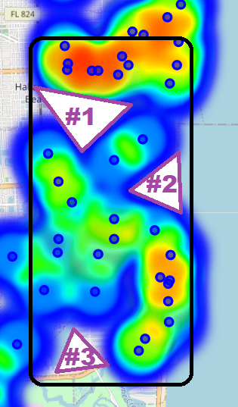Like any business Endeavor, there are multiple risk factors to consider. Currently, our society is trending towards healthier lifestyles and this can pose a benefit to our investors, if they decide to open.

Although it is true that there are multiple gyms in the same area which could lead to lower prices, it can be also a first-hand account of the demand and success that those businesses represent in this particular area.

For future models, it would be better to adjust the weight given to businesses based on other factors such as membership fee, average customer review, perhaps hours of operations, and more, but we were unable to extract that information from Foursquare.

Although lacking much of the information we would have wanted to have, we can positively use what we obtained in order to advise our investors.