Sales Variance Root-Cause Analysis
variance_root_cause | current period vs prior period (2024 vs 2023)

Summary
The difference between current period and prior period is +50. The summary bridge reconciles the movement with 3 selected drivers (South - Price & volume & mix +50, A / North - Price & volume & mix +30, B / North - Price & volume & mix -30) and residual of +0.
The main-row drilldown details the contribution: A / South / Price & volume & mix -10. The contribution is therefore concentrated mainly in A / South / Price & volume & mix.
A more analytical reading confirms that the movement is not evenly distributed: A / South / Price & volume & mix, A / North / Price & volume & mix, B / North / Price & volume & mix, B / Price & volume & mix stand out. This view remains a deep dive because it leaves +0 in residual balance.

Key Source Data
Source | Reading | Key data
Summary bridge | Reconciles the delta with the selected driver sequence. | South - Price & volume & mix +50, A / North - Price & volume & mix +30, B / North - Price & volume & mix -30; residual +0
Price / Units / Mix read | Compares three decompositions of the same movement. | Price +25, Units +25
Standard small multiples | Shows the same standard bridge for each selected dimension member. | B / Price +25, A / Units & mix +20
Product-line drilldown | Breaks the main driver into components. | A / South / Price & volume & mix -10
Mixed-dimension deep dive | Identifies where residual detail adds information. | A / South / Price & volume & mix, A / North / Price & volume & mix, B / North / Price & volume & mix, B / Price & volume & mix
Summary of selected source data.

Reading Notes
- Amounts are presented in EUR; use another currency only when the user or source file states it.
- The standard bridge is dominated by Price (+25); main components: Price +25, Units & mix +25, Balance +0.
- Root-cause bridge rows are residual rows: a later row is not the standalone total for that dimension.

Price / Units / Mix bridge
Reading: The same variance is read at three levels: combined total, Price separated from Units & Mix, and Price / Units / Mix. Main components: Price +25, Units +25.
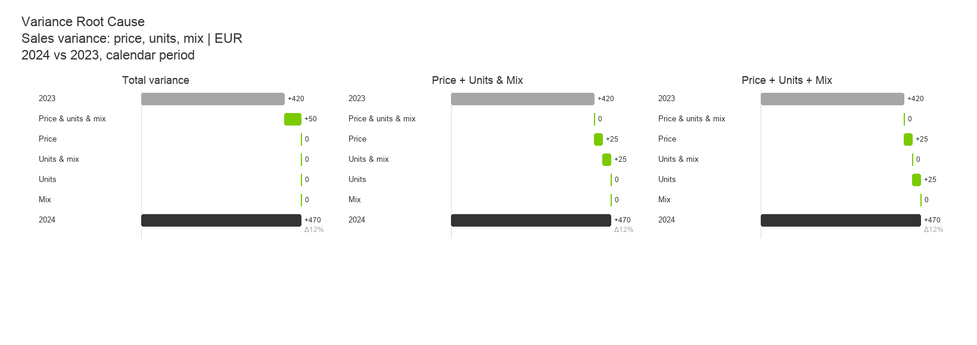
Scale and totals are the same in every panel: only the variance decomposition depth changes.

Standard bridge by product
Reading: The standard bridge by product shows that variance is concentrated mainly in B / Price +25, A / Units & mix +20.
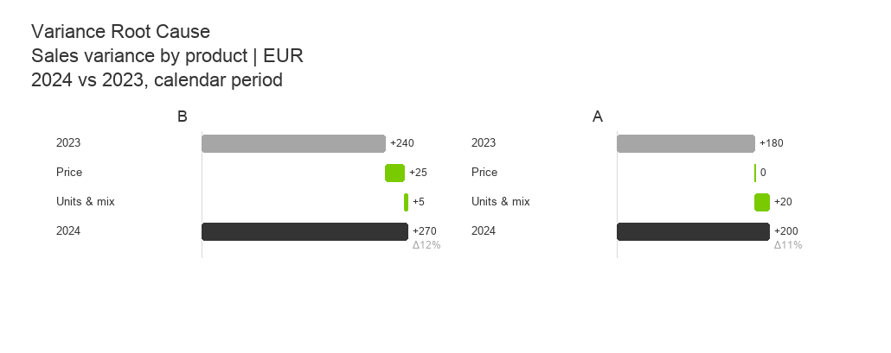
Each panel repeats the compact Price / Units & Mix / Balance bridge; the dimension separates the panels.

Source 1 - Main Driver
Reading: The selected sequence (South - Price & volume & mix +50, A / North - Price & volume & mix +30, B / North - Price & volume & mix -30) reconciles the current period vs prior period (2024 vs 2023) movement with final residual +0.
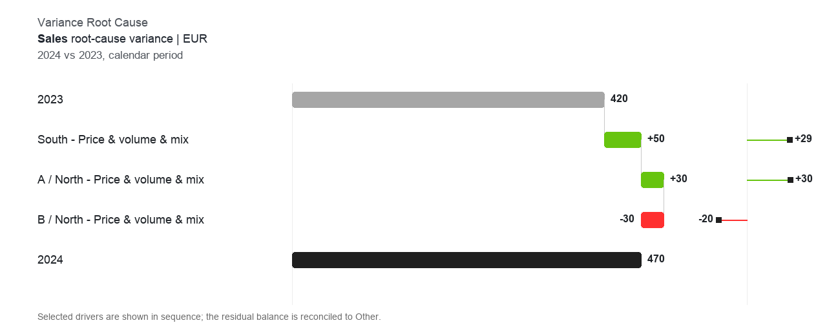
The bridge reconciles the movement between the two periods/scenarios and isolates the main driver.

Source 2 - Product-line Detail
Reading: The main driver is mostly A / South / Price & volume & mix, followed by other product-line contributions.
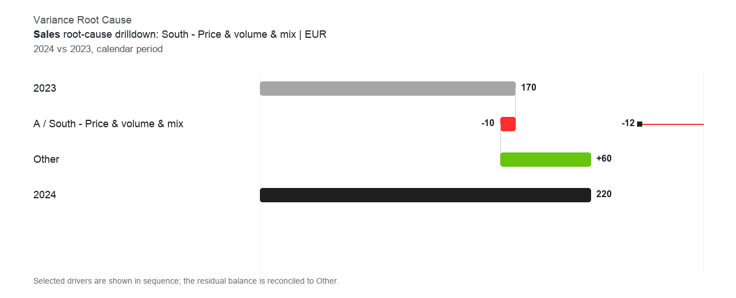
The product-line detail translates the main driver into a commercial reading.

Source 3 - Area And Product-Line Detail
Reading: The second-level analysis shows that useful residual detail is concentrated in A / South / Price & volume & mix, A / North / Price & volume & mix, B / North / Price & volume & mix, B / Price & volume & mix.
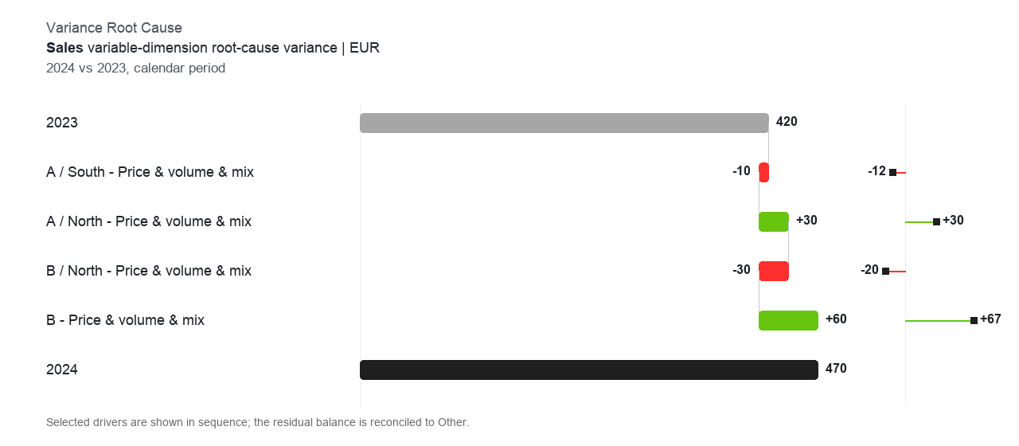
This view should be read as a residual sequence: later rows are net of prior rows.

