**Introduction to Anaconda**

Anaconda is a popular open-source distribution of the Python and R programming languages for scientific computing, data science, and machine learning. It simplifies package management and deployment, making it easier to install, run, and update packages and their dependencies. Anaconda comes with a large number of pre-installed libraries and tools for data analysis and machine learning, such as NumPy, pandas, matplotlib, and scikit-learn, as well as Jupyter Notebook and Spyder for code development.

**Key Features of Anaconda**

* **Comprehensive Package Management**: Manages libraries and dependencies efficiently using conda, a package, and environment management system.
* **Isolated Environments**: Allows the creation of multiple, isolated environments to prevent conflicts between package versions.
* **Pre-installed Libraries**: Includes over 1,500 data science packages, minimizing the need for manual installations.
* **Integrated Development Tools**: Provides IDEs like Jupyter Notebook and Spyder for a seamless coding experience.
* **Cross-Platform**: Available for Windows, macOS, and Linux.

**How to Install Anaconda**

**Step 1: Download Anaconda**

1. **Visit the Anaconda Website**:
   * Go to the official Anaconda download page ([Download Anaconda Distribution | Anaconda](https://www.anaconda.com/download)). Submit your email to download the installer.  
     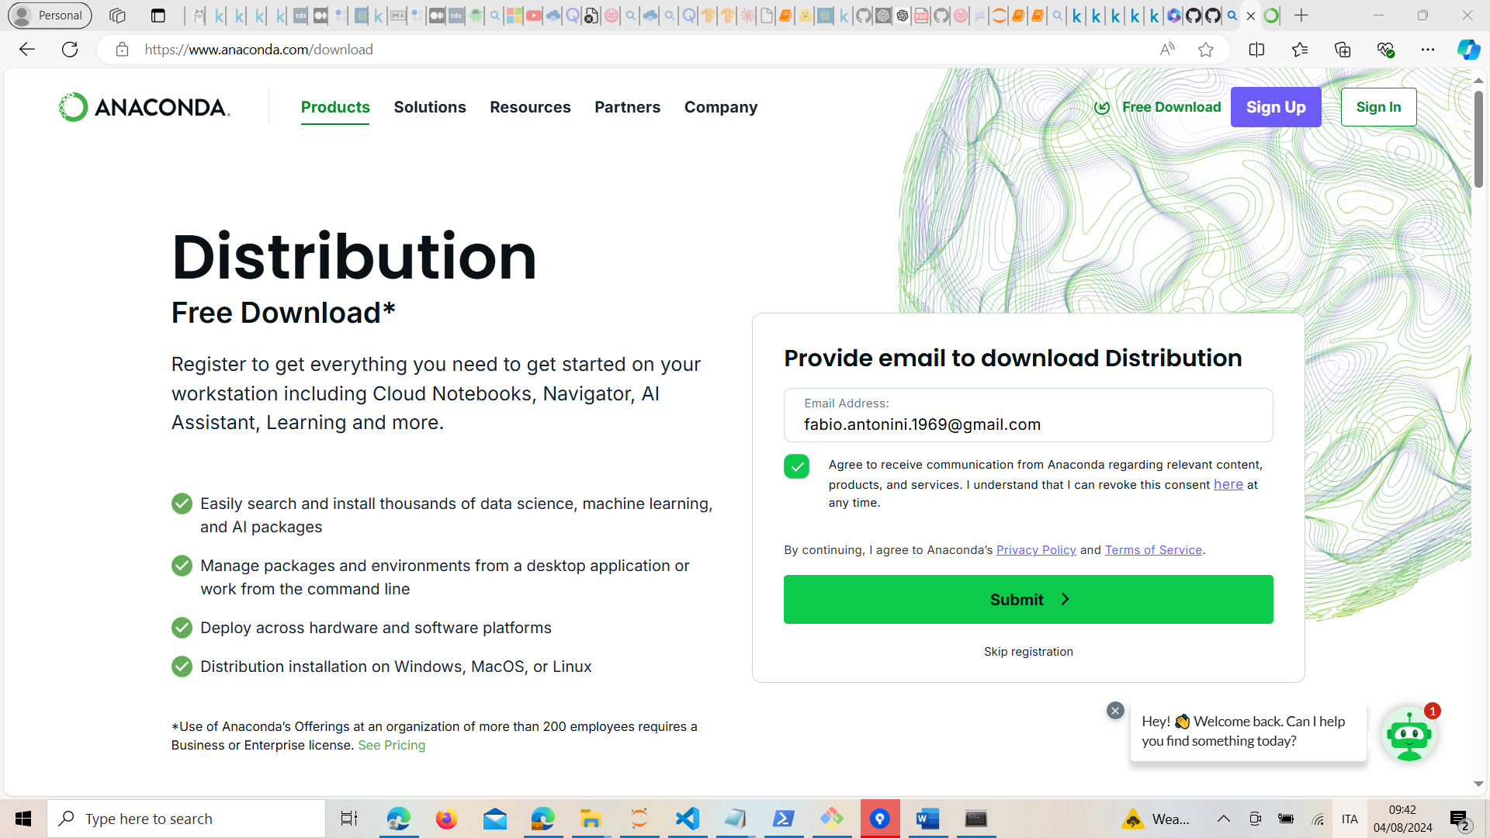
2. **Select Your Operating System**:
   * Choose the installer for your operating system (Windows, macOS, or Linux).  
     Immagine che contiene testo, schermata, software, Icona del computer

     Descrizione generata automaticamente
3. **Download the Installer**:
   * Click the download button for the Python 3.x version (the latest stable version).

**Step 2: Install Anaconda**

**For Windows:**

1. **Run the Installer**:
   * Double-click the downloaded .exe file.
2. **Follow the Installation Instructions**:
   * Click "Next" to start the installation.
   * Agree to the license agreement.
   * Choose whether to install for "Just Me" or "All Users".
   * Select the installation location (default is usually fine).
   * Choose whether to add Anaconda to your PATH (recommended to keep this unchecked as it can interfere with other software).
   * Click "Install".
3. **Complete the Installation**:
   * Click "Finish" after the installation is complete.
   * Optionally, choose to launch the Anaconda Navigator or view the documentation.

**For macOS:**

1. **Run the Installer**:
   * Open the downloaded .pkg file.
2. **Follow the Installation Instructions**:
   * Continue through the installation steps.
   * Agree to the license agreement.
   * Choose the installation location.
   * Click "Install".
3. **Complete the Installation**:
   * Close the installer after it completes.

**For Linux:**

1. **Run the Installer**:
   * Open a terminal window.
   * Navigate to the directory where the installer was downloaded.
   * Run the installer with the following command (replace Anaconda3-x.x.x-Linux-x86_64.sh with the actual file name):

bash Anaconda3-x.x.x-Linux-x86_64.sh

1. **Follow the Installation Instructions**:
   * Press Enter to review the license agreement, then type yes to accept it.
   * Choose the installation location (default is usually fine).
   * Type yes to initialize Anaconda.
2. **Complete the Installation**:
   * Close the terminal or open a new one to start using Anaconda.

**Verifying the Installation**

1. **Open a Terminal or Command Prompt**:
   * On Windows, you can search for "Anaconda Prompt" in the Start menu.
   * On macOS or Linux, open your terminal.
2. **Check the Installation**:
   * Run the following command to check the installed version of conda:

conda --version

* + You should see the version number of conda printed.

**Creating a New Environment**

1. **Create a New Environment**:
   * Use the following command to create a new environment named myenv with Python 3.8:

conda create --name myenv python=3.8

1. **Activate the Environment**:
   * Activate the newly created environment with:

conda activate myenv

1. **Deactivate the Environment**:
   * When you are done, deactivate the environment with:

conda deactivate

**Using Anaconda Navigator**

Anaconda Navigator is a graphical user interface that makes it easy to manage packages, environments, and launch applications.

1. **Open Anaconda Navigator**:
   * On Windows, search for "Anaconda Navigator" in the Start menu.
   * On macOS or Linux, you can launch it from the terminal by typing anaconda-navigator.
2. **Using Navigator**:
   * From the Navigator, you can create and manage environments, install and update packages, and launch applications like Jupyter Notebook, Spyder, and more.

**Conclusion**

Anaconda simplifies package management and deployment for data science and machine learning projects. By following these steps, you can easily install Anaconda and start leveraging its powerful tools and libraries for your projects.

# Virtual Environments installation

## Tensorflow and Scikit-Learn virtual environment

Tensorflow and Scikit-Learn shall be called by a specific virtual environment called ‘tf-env-10’ (see file Setup/tf-env-10.md).

1. **Open a Terminal or Command Prompt**:
   * On Windows, you can search for "Anaconda Powershell Prompt" in the Start menu.
   * On macOS or Linux, open your terminal.
2. **Copy the content of the file Setup/tf-env-3.10.md)**
   * conda create --name tf-env-10 python=3.10
   * conda activate tf-env-3.10
   * conda install jupyter tensorflow scikit-learn numpy pandas matplotlib ipympl seaborn
   * deactivate tf-env-3.10
3. **Virtual Environment creation**
   * Paste the content to the Anaconda Powershell Prompt or execute each command step by step.
4. **Verifying Virtual Environment creation**
   * From the ‘Windows’ menu select ‘Anaconda3 (64-bit)’ and search for ‘Jupyter Notebook (tf-env-3.10)
   * If the item is in place, then the Virtual Environment has been created properly
5. **Running the Virtual Environment**
   * Search for the Jupyter Notebook (tf-env-3.10) and click on it to activate the Virtual Environment and run the Jupyter Notebook interface.