Table of Contents

Artificial Intelligence Readiness Scale:

Extending UTAUT2 for Enterprise AI Adoption

A Dissertation
Presented to the Faculty of
Touro University Worldwide

In Partial Fulfillment
of the Requirements for the Degree
Doctor of Business Administration

by
Fabio Correa
2026

Copyright Notice

© 2026 Fabio Correa
All Rights Reserved
Abstract
This dissertation developed and validated the AI Readiness Scale (AIRS), a 16-item instrument measuring artificial intelligence adoption readiness among academic and professional populations. Extending UTAUT2 with AI-specific constructs, the study examined factors influencing behavioral intention to adopt AI tools.
A sample of 523 United States participants completed the survey. Exploratory and confirmatory factor analyses validated an 8-factor model with excellent fit (CFI = .975, TLI = .960, RMSEA = .065). The structural model revealed Price Value (β = .505, p < .001) as the dominant predictor, with Hedonic Motivation (β = .217, p = .014) and Social Influence (β = .136, p = .024) reaching z-test significance. Together, these constructs explained 89.7% of variance in behavioral intention. Bootstrap validation (1,000 resamples) confirmed Price Value as robust; confidence intervals for Hedonic Motivation and Social Influence included zero, indicating sensitivity to sample composition. The 8-factor model incorporating AI Trust was retained over a more parsimonious 7-factor alternative (R² = .861) because trust provided diagnostic value for organizational assessment. Traditional UTAUT predictors (Performance Expectancy, Effort Expectancy, Facilitating Conditions, Habit) did not significantly predict AI adoption, suggesting AI constituted a distinct technology category where cost-benefit perceptions outweighed conventional utility considerations.
Four proposed constructs (Voluntariness, Explainability, Ethical Risk, AI Anxiety) were excluded due to inadequate reliability (α = .30–.58). Measurement invariance testing across academic (n = 216) and professional (n = 307) populations established configural invariance. Cluster analysis identified three user segments: AI Enthusiasts (31%), Moderate Users (47%), and AI Skeptics (22%).
The study contributed a validated diagnostic instrument enabling identification of adoption barriers and targeted intervention design, establishing a foundation for organizational applications.
Keywords: artificial intelligence, technology adoption, UTAUT2, scale development, psychometric validation, structural equation modeling

Dedication

“The question isn’t whether AI will transform work—it’s whether we’ll be ready.”
— Dario Amodei, 2024
Acknowledgments
I extend my deepest gratitude to the individuals who made this dissertation possible.
To my dissertation chair, Dr. Karina Kasztelnik, thank you for your guidance, patience, and scholarly wisdom throughout this journey. Your expertise in research methodology and commitment to academic excellence shaped both this work and my development as a researcher.
To my committee members, Dr. Jerome Jones and Dr. Donna Day, thank you for your thoughtful feedback, challenging questions, and unwavering support. Your diverse perspectives strengthened this research in countless ways.
To my family, thank you for your understanding during the countless hours devoted to this project. Your encouragement sustained me through the challenges of doctoral study. Special thanks to my wife, Claudia, whose careful review of this manuscript improved its clarity and precision.
To my professional colleagues and the participants who generously shared their experiences with AI tools, thank you for making this research possible. Your insights illuminate the path forward for organizations navigating the AI transformation.
Finally, I acknowledge the broader academic community whose foundational work, particularly Venkatesh and colleagues’ development of UTAUT, provided the theoretical architecture upon which this research was built. Scholarship advances through cumulative contribution, and I am honored to add to this conversation.
Data Availability and Replication Materials
All research materials necessary to replicate the analyses in this dissertation are publicly available at the following repository:
https://github.com/fabioc-aloha/AIRS_Data_Analysis
The repository contains:
- Anonymized Data: Complete survey responses (N = 523) in CSV and JSON formats
- Analysis Code: Python and R scripts for all statistical analyses (EFA, CFA, SEM, cluster analysis)
- Survey Instrument: The full 28-item AIRS questionnaire as administered
- Thesis Source: Markdown source files and build scripts for this document
- Figures and Tables: All visualizations and statistical output
The data and code are released under dual licensing: MIT License for code and CC BY 4.0 for data and documentation. Researchers are encouraged to use these materials for replication, extension, or meta-analytic purposes with appropriate citation.
For questions about the data or methodology, contact the author at the email address provided on the title page.

Chapter 1: Introduction

1.1 Background and Context
Artificial intelligence (AI) has evolved from a specialist capability to a foundational driver of enterprise transformation. Between 2023 and 2025, organizations accelerated AI integration across functions and geographies, fueled by advances in large language models, cloud-based ecosystems, and rapid democratization through enterprise platforms such as Microsoft 365 Copilot and ChatGPT Enterprise.
According to McKinsey’s State of AI series, AI adoption has accelerated dramatically: after hovering around 50 percent for years, adoption jumped to 72 percent in 2024 and reached 88 percent by late 2025 (McKinsey & Company, 2024, 2025). This growth represented a fundamental shift in how organizations approach technology. AI was no longer an experimental capability but an expected component of modern work.
Yet this growth in adoption has not translated proportionally into business impact. Boston Consulting Group reported that only 5 percent of companies achieved measurable business value from AI initiatives, while roughly 74 percent struggled to scale beyond proofs of concept (Boston Consulting Group, 2024, 2025). McKinsey found that only about 6 percent of organizations qualified as “AI high performers,” that is, those attributing meaningful EBIT impact to AI and reporting significant value, while most organizations remained in piloting rather than scaling phases (McKinsey & Company, 2025). IBM’s Global AI Adoption Index found that 37 percent of enterprises cited data complexity and quality as their top barrier to AI success (IBM, 2023), while Capgemini research suggested that organizations embedding AI into redesigned workflows achieved substantially higher returns than those merely layering AI atop legacy processes (Capgemini Research Institute, 2025).
These figures revealed a paradox: AI was nearly ubiquitous, yet most enterprises failed to realize sustained economic or operational returns. MIT Media Lab’s NANDA initiative estimated that 90 to 95 percent of generative-AI pilots failed to scale or yield measurable profit-and-loss improvements (MIT Media Lab, 2025). This persistent gap between adoption rates and value realization (termed the “adoption-value gap”) represented both a significant business challenge and a research opportunity.
Understanding why individuals adopted or resisted AI tools was essential for closing this gap. While organizational-level barriers such as data infrastructure, governance frameworks, and change management had received considerable attention in practitioner literature, individual-level adoption psychology remained underexplored in empirical research. Technology acceptance research offered theoretical frameworks for understanding these individual differences, yet existing instruments were developed for earlier technology generations and did not capture the unique characteristics of AI tools.

1.2 Statement of the Problem
Despite decades of technology acceptance research, organizations lack validated instruments for assessing individual-level AI adoption readiness. This gap creates three interconnected problems:
Theoretical Gap: The dominant technology acceptance framework, the Unified Theory of Acceptance and Use of Technology 2 (UTAUT2), was developed and validated primarily on mobile and consumer technologies (Venkatesh et al., 2012). While UTAUT2 explained significant variance in technology adoption generally, AI tools presented unique characteristics that required theoretical extension. These included concerns about job displacement, questions of algorithmic transparency, and trust in autonomous decision-making systems. Venkatesh (2021) identified nine unique research challenges for AI adoption that existing frameworks did not fully address, calling for empirical investigation of AI-specific adoption factors.
Measurement Gap: Current AI adoption assessments in organizational practice relied largely on ad hoc surveys or general technology readiness measures. No psychometrically validated instrument existed specifically for measuring AI adoption readiness in professional and academic contexts. This measurement gap limited both research comparability and practical diagnostic utility.
Practice Gap: Organizations invested heavily in AI infrastructure and training but often lacked the diagnostic tools to identify which employees were likely to adopt AI tools, which would resist, and why. Without valid measurement instruments, intervention strategies remained poorly targeted. The 90–95 percent pilot failure rate suggested that technology deployment without attention to individual adoption psychology produced limited returns (MIT Media Lab, 2025). Industry research identified skill gaps and governance challenges as primary barriers: Deloitte’s State of Generative AI reports highlighted insufficient AI expertise as a significant constraint (Deloitte, 2024), while Gartner identified governance maturity as a primary differentiator between AI leaders and laggards (Gartner, 2025).

1.3 Purpose of the Study
The purpose of this study was to develop and validate the AI Readiness Scale (AIRS): a psychometrically sound diagnostic instrument extending UTAUT2 for enterprise AI tool adoption. The AIRS served dual purposes: as a research scale for investigating AI adoption phenomena and as a diagnostic tool enabling organizations to identify specific adoption barriers and design targeted interventions. Specifically, this research aimed to:
- Develop a theoretically grounded diagnostic instrument incorporating both established UTAUT2 constructs and AI-specific factors, particularly AI Trust, enabling identification of specific adoption barriers.
- Validate the instrument through rigorous split-sample methodology, using exploratory factor analysis (EFA) on a development sample and confirmatory factor analysis (CFA) on an independent holdout sample.
- Test structural relationships between adoption predictors and behavioral intention through structural equation modeling (SEM).
- Examine measurement invariance across academic and professional populations to establish the instrument’s applicability across diverse workforce contexts.
- Identify moderating factors (including professional experience and AI usage frequency) that influence adoption pathways.
- Establish a validated psychometric foundation for future research and organizational applications.

1.4 Research Questions and Hypotheses

1.4.1 Research Questions
Primary Research Question: How can UTAUT2 be extended with AI-specific constructs to better predict behavioral intention to adopt AI tools in professional and academic contexts?
Secondary Research Questions:
- What is the factor structure of an AI-specific adoption readiness instrument?
- Does the instrument demonstrate measurement invariance across academic and professional populations?
- Which factors most strongly predict behavioral intention to adopt AI tools?
- Does AI Trust significantly predict adoption intention beyond UTAUT2 constructs?
- What moderating factors influence the relationships between predictors and adoption intention?

1.4.2 Research Hypotheses
Based on UTAUT2 theory and AI-specific considerations, this study tests the following hypotheses:
Core UTAUT2 Hypotheses (H1a–H1g):
- H1a–H1g: The seven UTAUT2 constructs (Performance Expectancy, Effort Expectancy, Social Influence, Facilitating Conditions, Hedonic Motivation, Price Value, and Habit) positively predict Behavioral Intention to adopt AI tools.
AI Extension Hypothesis (H2):
- H2: AI Trust positively predicts Behavioral Intention beyond UTAUT2 constructs.
Moderation Hypotheses (H3–H4):
- H3: Professional experience moderates the relationships between predictors and Behavioral Intention.
- H4: Population (Academic vs. Professional) moderates the relationships between predictors and Behavioral Intention.
Behavioral Validation Hypothesis (H5):
- H5: Behavioral Intention positively correlates with actual AI tool usage behavior.
Full hypothesis specifications with theoretical rationales were presented in Chapter 3 §3.3.2.

1.5 Theoretical and Practical Significance

1.5.1 Theoretical Significance
This study made several contributions to technology acceptance scholarship:
Framework Extension: By empirically testing AI-specific constructs alongside established UTAUT2 predictors, this research extended technology acceptance theory to the AI domain. The theoretical extension responded to Venkatesh’s (2021) call for AI-specific adoption research and addressed the unique characteristics of AI technologies that distinguished them from previous technology generations.
Construct Validation: The development of reliable measures for AI Trust provided validated operationalizations for future research. The psychometric validation process (including convergent validity, discriminant validity, and composite reliability assessment) ensured that these constructs met scholarly standards for measurement quality.
Cross-Population Invariance: Testing measurement invariance across academic and professional populations advanced understanding of how adoption factors functioned across diverse workforce contexts. Configural invariance findings supported the instrument’s utility for comparative research across population segments.
Moderation Discovery: Identification of experience as a moderating factor on hedonic motivation pathways contributed novel insights to the technology acceptance literature, suggesting that adoption mechanisms differed based on user characteristics in ways not previously documented.

1.5.2 Practical Significance
Beyond theoretical contributions, this research established foundations for future organizational applications:
Validated Diagnostic Instrument: The validated 16-item AIRS provided researchers and organizations with a psychometrically sound tool for measuring AI adoption readiness constructs. Beyond measurement, the 8-factor structure enabled diagnostic assessment: organizations could identify specific barriers (e.g., low trust, inadequate perceived value) and design targeted interventions. The instrument’s brevity (approximately 5 minutes to complete) enabled deployment at scale while maintaining measurement rigor.
User Typology Discovery: The three-segment user typology identified through cluster analysis (AI Enthusiasts [31%, n=162], Moderate Users [47%, n=246], and AI Skeptics [22%, n=115]; k=3, silhouette=0.271) provided a framework for future intervention research. The typology captured a meaningful readiness gradient, from high-engagement Enthusiasts through pragmatic Moderate Users to resistant Skeptics, offering testable hypotheses about differential treatment effects that warranted experimental validation.
Adoption Driver Insights: The finding that Price Value (β = .505) dominated adoption intention, rather than traditional performance messaging, suggested hypotheses for organizational AI communication strategies that warrant future experimental testing.
Moderation Discovery: The moderating effect of professional experience on hedonic motivation pathways indicated that adoption mechanisms differed by experience level, a finding that suggested hypotheses for experience-tailored training approaches.

1.6 Scope and Delimitations

1.6.1 Scope
This study focused on individual-level adoption of AI tools in professional and academic contexts. The research:
- Examined behavioral intention to adopt AI tools as the primary outcome variable, with actual tool usage as a behavioral validation criterion.
- Encompassed both academic and professional participants across multiple industries, providing cross-population generalizability testing.
- Included common AI tools such as ChatGPT, Microsoft Copilot, and Google Gemini as the technology context.
- Applied established psychometric validation methodology including split-sample EFA/CFA, structural equation modeling, and measurement invariance testing.
- Addressed adoption predictors at the individual psychological level rather than organizational or technological levels.

1.6.2 Delimitations
The following boundaries define what this study did not address:
Organizational Factors: While organizational infrastructure undoubtedly influenced AI adoption, this study focused on individual-level psychological predictors rather than organizational readiness factors such as IT infrastructure, leadership support, or governance frameworks.
Actual Behavior Prediction: The primary outcome was behavioral intention rather than sustained behavioral change. While intention strongly correlated with self-reported usage (ρ = .69), the study did not track actual usage behavior over time.
Specific AI Tool Comparison: The study examined AI tool adoption generally rather than comparing adoption patterns across specific tools (e.g., ChatGPT vs. Copilot).
Cultural Context: Data collection occurred in a single national context (primarily United States respondents). Cross-cultural generalizability requires future investigation.
Dropped Constructs: Four initially proposed AI-specific constructs (Voluntariness, α = .406; Explainability, α = .582; Ethical Risk, α = .546; and AI Anxiety, α = .301) demonstrated inadequate reliability and were excluded from the validated model. These constructs remain theoretically important but require revised operationalization in future research.

1.6.3 Scope Limitation Rationale
This dissertation deliberately limited its scope to scale validation rather than extending into diagnostic application or intervention design. This scope limitation was grounded in both methodological rigor and research ethics considerations.
Foundational Requirements: Psychometric validation must precede diagnostic application. Before the AIRS could serve as an organizational diagnostic tool, the instrument had to demonstrate adequate reliability (α > .70), structural validity (CFA fit indices), discriminant validity (HTMT < .85), and measurement invariance across target populations. This dissertation addressed these foundational requirements.
Validation Sequence: Applied psychometrics follows a validation sequence: scale development -> reliability testing -> structural validation -> invariance testing -> normative data collection -> diagnostic application (DeVellis & Thorpe, 2021). This study completed the first four stages. Diagnostic application requires additional stages (particularly normative data collection across organizational contexts) that exceed doctoral scope.
Statistical Limitations: Certain claims required stronger evidence than cross-sectional self-report data could provide. For example:
- User typology actionability: While cluster analysis identified three distinct user segments, intervention effectiveness cannot be established without experimental designs testing differential treatment effects.
- Adoption-value linkage: The relationship between individual adoption readiness and organizational AI outcomes requires longitudinal data linking AIRS scores to measurable business metrics.
- Cut-score development: Establishing diagnostic thresholds (e.g., “low readiness” vs. “high readiness”) requires validation studies demonstrating predictive validity against criterion outcomes.
Future Research Foundation: By completing rigorous psychometric validation within appropriate scope, this dissertation provided a credible foundation for future research. The AIRS instrument could support subsequent studies examining diagnostic protocols, intervention effectiveness, and organizational applications, research that built upon rather than overextended the current findings.
Appendix E outlines a research roadmap for extending this foundational work through scoring algorithms, diagnostic protocols, and intervention frameworks in future investigations.

1.7 Definition of Key Terms

1.8 Summary and Dissertation Structure
This chapter introduced the research problem, purpose, questions, and significance of this study examining AI adoption readiness in professional and academic contexts.
The dissertation was organized into six chapters:
Chapter 1: Introduction established the research context, problem statement, research questions, and significance of the study.
Chapter 2: Literature Review examined the evolution of technology acceptance models from TAM through UTAUT2, synthesized AI-specific adoption research, and developed the conceptual framework for the study.
Chapter 3: Research Methodology described the research design, sampling procedures, instrument development, and analytical strategy employed in the ten-phase validation approach.
Chapter 4: Findings presented the empirical results from exploratory factor analysis, confirmatory factor analysis, measurement invariance testing, structural equation modeling, and behavioral validation.
Chapter 5: Analysis and Discussion interpreted the findings in relation to existing literature, discussed theoretical and practical implications, and addressed unexpected findings.
Chapter 6: Conclusions, Implications, and Recommendations summarized the study’s contributions, provided recommendations for practitioners and organizations, acknowledged limitations, and suggested directions for future research.

Chapter 2: Literature Review

2.1 Introduction
The rapid enterprise adoption of artificial intelligence had outpaced the explanatory capacity of traditional technology acceptance frameworks. While organizations had embraced AI at unprecedented rates (rising from approximately 50% historically to 72% in 2024 and 88% by late 2025 (McKinsey & Company, 2024, 2025)), most remained in piloting phases rather than scaled deployment. McKinsey reported that only about one-third of organizations had begun scaling AI programs, and just 6% qualified as “AI high performers” with meaningful enterprise-level EBIT impact (McKinsey & Company, 2025). This adoption-value paradox presented both a theoretical puzzle and a practical challenge: why did established technology acceptance models incompletely predict AI adoption, and what additional constructs needed to be incorporated to guide organizational intervention?
This chapter established the theoretical foundation for the Artificial Intelligence Readiness Scale (AIRS) by pursuing three objectives. First, it traced the evolution of technology acceptance research from foundational behavioral theories through the Unified Theory of Acceptance and Use of Technology (UTAUT) and its consumer extension (UTAUT2), establishing the empirical baseline that informed scale development. Second, it examined why AI (as a socio-technical phenomenon characterized by opacity, probabilistic reasoning, and ethical exposure) stresses this baseline in ways that demand construct extension. Third, it synthesized emerging research on AI-specific determinants of adoption, including trust, anxiety, and explainability, to justify the theoretical framework and hypotheses tested in subsequent chapters.
The review drew on three categories of evidence. Academic research provided the theoretical architecture, anchored by Venkatesh et al.’s (2003, 2012) foundational UTAUT work, Blut et al.’s (2022) comprehensive meta-analysis spanning 737,112 users across 1,935 independent samples, and Venkatesh’s (2021) AI-specific research agenda. Industry benchmarks from McKinsey, Boston Consulting Group, and MIT Media Lab contextualized these theoretical insights within the enterprise AI landscape at the time of the study. Finally, empirical studies on AI trust, explainability, and anxiety provided construct-level evidence for the proposed extensions.
This dual-lens approach (integrating academic rigor with business relevance) reflected the Doctor of Business Administration orientation of this thesis. The literature review not only established scholarly grounding but also identified practical implications: why AI adoption programs failed, what organizational levers mattered, and how validated measurement could inform change management. By the chapter’s conclusion, readers understood why AIRS extended UTAUT2 with AI-specific constructs and how the resulting framework addressed both theoretical gaps and practitioner needs.

2.2 Technology Acceptance Models: Foundations and Evolution

2.2.1 Early Behavioral Theories
The study of technology adoption originates in broader behavioral science. Ajzen (1991)’s Theory of Planned Behavior (TPB) explains volitional behavior through three determinants: attitudes toward the behavior, subjective norms reflecting perceived social pressure, and perceived behavioral control representing self-efficacy and resource availability. TPB’s parsimony and empirical generalizability made it adaptable to early information systems research, yet it remains technology-agnostic: it does not model perceptions unique to digital systems such as usefulness or ease of use.
Davis (1989)’s Technology Acceptance Model (TAM) addressed this limitation by introducing two technology-specific beliefs: perceived usefulness (the degree to which a user believes technology will enhance job performance) and perceived ease of use (the degree to which technology use is free of effort). TAM’s elegant specification and consistent empirical support established it as the dominant paradigm in information systems research for over two decades. However, TAM’s parsimony became a limitation when technologies carried salient ethical, organizational, or epistemic properties that instrumental beliefs alone could not capture.
Rogers (2003)’s Diffusion of Innovations theory complements these individual-level models by explaining how innovations spread through social systems over time. Five innovation attributes (relative advantage, compatibility, complexity, trialability, and observability) predict adoption rates across populations. While diffusion theory illuminates organizational uptake and social influence, it is less diagnostic for the psychological mechanisms underlying individual decisions to rely on complex, partially opaque systems such as modern AI.

2.2.2 The Unified Theory of Acceptance and Use of Technology (UTAUT)
Venkatesh et al. (2003) synthesized eight prominent acceptance models into the Unified Theory of Acceptance and Use of Technology (UTAUT), achieving superior explanatory power through theoretical integration. UTAUT specifies four direct determinants of behavioral intention and use:
Performance Expectancy (PE) captures the degree to which using technology will help attain job performance gains, integrating perceived usefulness (TAM), extrinsic motivation, job-fit, relative advantage, and outcome expectations from prior theories.
Effort Expectancy (EE) represents the ease associated with technology use, incorporating perceived ease of use (TAM), complexity (innovation diffusion), and ease of use from other frameworks.
Social Influence (SI) reflects the degree to which important others believe the individual should use the technology, synthesizing subjective norm, social factors, and image constructs.
Facilitating Conditions (FC) captures organizational and technical infrastructure supporting use, including perceived behavioral control, facilitating conditions, and compatibility from prior models.
UTAUT further specifies four moderators (gender, age, experience, and voluntariness) that systematically alter the strength of predictor-intention relationships. In the original validation, UTAUT explained 70% of variance in behavioral intention (Venkatesh et al., 2003), substantially exceeding the explanatory power of its constituent theories.

2.2.3 Meta-Analytic Evidence: The Current State of UTAUT
Blut et al. (2022)’s landmark meta-analysis provided the most comprehensive assessment of UTAUT to date, synthesizing 25,619 effect sizes from 737,112 users across 1,935 independent samples. This analysis not only confirmed UTAUT’s core predictions but also revealed nuanced patterns essential for AI-context extensions.
Performance Expectancy emerged as the consistently strongest predictor of behavioral intention, with a meta-analytic correlation of ρ = .60 and substantial effect sizes across contexts. This finding aligned with decades of TAM research positioning perceived usefulness as the primary adoption driver and had direct implications for AI messaging strategies in organizations.
Effort Expectancy showed moderate effects (ρ = .45) but displayed greater context-dependency. In established technology categories where interfaces had matured, effort expectancy could reach ceiling effects: users assumed baseline usability. This pattern suggested that for contemporary AI tools with polished interfaces, ease-of-use investments showed diminishing returns relative to other adoption levers.
Social Influence demonstrated inconsistent effects across organizational versus consumer contexts, with stronger impact under mandatory use conditions. Facilitating Conditions showed a direct effect on use behavior that strengthened with experience, suggesting infrastructure and support mattered more for sustained engagement than initial adoption.
Critically, Blut et al. (2022) identified substantial unexplained variance and called for domain-specific extensions that incorporated constructs relevant to emerging technologies. They observed that the “red ocean” of UTAUT research had produced diminishing theoretical returns, yet faithful application with appropriate extensions remained productive. This finding directly motivated the present study’s AI-specific extensions.

2.2.4 UTAUT2: Consumer Context Extensions
Venkatesh et al. (2012) extended UTAUT for consumer contexts through UTAUT2, adding three constructs:
Hedonic Motivation (HM) captures fun or pleasure derived from technology use, acknowledging that consumer adoption is driven by intrinsic enjoyment alongside instrumental outcomes.
Price Value (PV) represents the cognitive trade-off between perceived benefits and monetary cost, relevant when users bear technology expenses directly.
Habit (HB) reflects automaticity developed through prior behavior, acknowledging that repeated use becomes self-reinforcing independent of conscious intention.
UTAUT2 explained 74% of variance in behavioral intention (Venkatesh et al., 2012), demonstrating the value of context-appropriate extensions. For the present research, UTAUT2 provided the baseline framework, with modifications appropriate to workplace AI contexts where hedonic motivation and habit remained relevant while price value was less salient (organizational rather than personal expenditure).
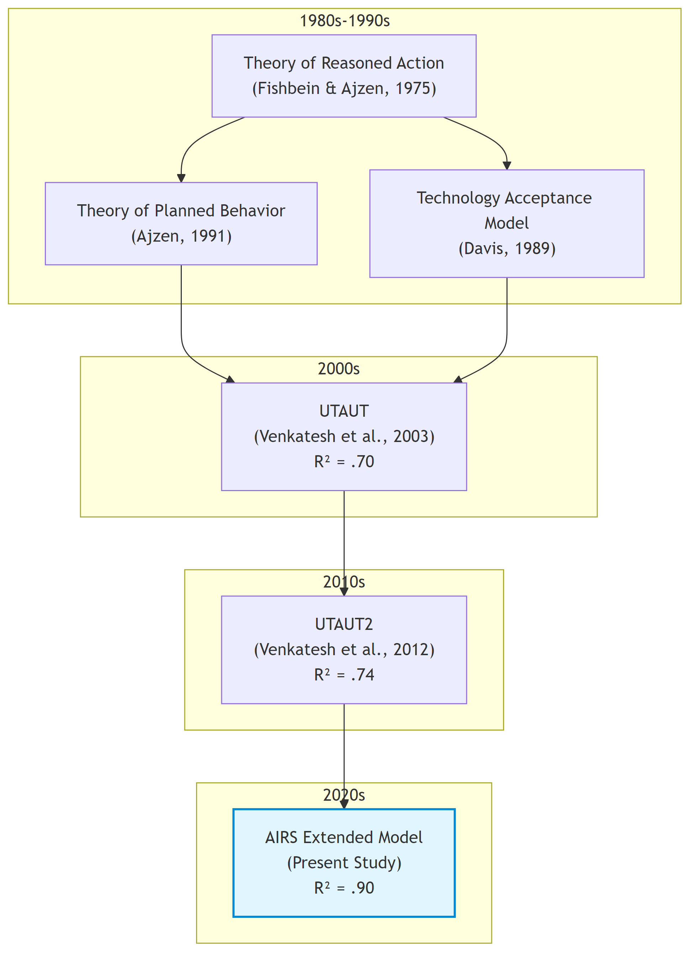
02_literature_review_diagram_0
: Evolution of Technology Acceptance Models from TRA (1975) through UTAUT2 (2012) to the AIRS extension (this study). Source: Compiled by Author {#fig:tam-evolution}

2.3 The AI Adoption-Value Gap: Industry Context

2.3.1 Current State of Enterprise AI Adoption
Before examining why traditional acceptance models required extension for AI, it was essential to understand the practical landscape these models had to explain. Industry benchmarks revealed a striking paradox: AI adoption had reached near-ubiquity, yet value realization remained exceptional.
According to McKinsey’s State of AI series, organizational AI adoption jumped from approximately 50% (where it had hovered for years) to 72% in 2024, and further increased to 88% by late 2025 (McKinsey & Company, 2024, 2025). This acceleration, driven primarily by generative AI capabilities and accessible enterprise platforms, represented one of the fastest technology adoption curves in organizational history.
Yet adoption had not translated into proportional value capture. Boston Consulting Group reported that only 5% of companies achieved measurable business value from AI initiatives, while approximately 74% struggled to scale beyond proofs of concept (Boston Consulting Group, 2024, 2025). McKinsey found that only about 6% of organizations qualified as “AI high performers,” those attributing 5% or more of EBIT to AI use and reporting significant value, while just 39% reported any enterprise-level EBIT impact (McKinsey & Company, 2025). IBM’s Global AI Adoption Index found that 42% of enterprise-scale organizations had deployed AI with another 40% actively piloting solutions, yet 37% cited data complexity as their top barrier (IBM, 2023).
The MIT Media Lab’s NANDA Initiative provided perhaps the most sobering assessment: 90–95% of generative AI pilots failed to scale or deliver measurable profit-and-loss improvements (MIT Media Lab, 2025). Georgian’s AI Benchmark 2025 corroborated this pattern, finding that only 32% of enterprises had deployed AI across multiple business functions (Georgian & NewtonX, 2025). This failure rate exceeded typical technology project failures, suggesting AI-specific barriers that traditional change management and technology deployment frameworks did not adequately address.

2.3.2 Diagnosing the Gap: Why Adoption Does Not Equal Value
Industry analyses converge on three systemic barriers underlying the adoption-value gap:
Scaling Failure: Most organizations could demonstrate AI feasibility in controlled pilots but lacked the operational design, governance architecture, and change infrastructure to move innovations into production. Georgian’s AI Benchmark 2025 found that only 32% of enterprises had deployed AI across multiple business functions (Georgian & NewtonX, 2025), while ISG’s State of Enterprise AI Adoption report confirmed that scaling remained the top challenge across industries (Information Services Group, 2025). These findings indicated that organizational rather than technological constraints limited scaling.
Governance and Trust Deficits: Organizations struggled with ownership, compliance, bias mitigation, and ethical use policies. The gap between AI deployment speed and governance framework development created risk exposure that prudent organizations constrained through limited adoption scope. McKinsey found that AI high performers were three times more likely than their peers to have senior leaders who demonstrated strong ownership and commitment to AI initiatives (McKinsey & Company, 2025). Gartner identified governance maturity as a primary differentiator between AI leaders and laggards, with substantial proportions of AI projects facing delay or cancellation due to unclear governance frameworks (Gartner, 2025).
Capability and Change Barriers: Misalignment across functions, skill gaps, and resistance to workflow redesign inhibited AI integration. Deloitte’s State of Generative AI research identified insufficient AI expertise as a persistent barrier, with skill gaps constraining operational integration (Deloitte, 2024), while Lucidworks found that organizations with company-wide AI literacy programs achieved faster adoption and stronger employee trust (Lucidworks, 2025). Capgemini research suggested that organizations embedding AI into redesigned workflows, rather than layering AI onto legacy processes, achieved substantially higher returns (Capgemini Research Institute, 2025), yet such redesign required capabilities and change tolerance that most organizations lacked.

2.3.3 Implications for Acceptance Research
This industry context had direct implications for technology acceptance research. The adoption-value gap suggested that traditional acceptance constructs (useful for predicting initial adoption intention) incompletely explained the sustained, consequential use that generated organizational value. If 88% of organizations had adopted AI while only 6% achieved meaningful EBIT impact, then factors beyond performance and effort expectancy must have mediated the translation from adoption to value.
Venkatesh (2021) argued that AI tools present unique adoption challenges that existing frameworks did not fully address. Unlike prior technologies, AI systems (1) operate as partially opaque decision aids where underlying models are “blackboxed”; (2) make errors that accumulate and erode trust over time; (3) require learning periods during which performance improves; (4) may develop emergent biases unknown at deployment; and (5) shift the human role from decision-maker to decision-overseer or decision-recipient. These characteristics suggest that trust, transparency, and anxiety (constructs largely peripheral in traditional acceptance models) move to the foreground for AI adoption.

2.4 Why AI Stresses Traditional Acceptance Models

2.4.1 Opacity and Explainability
Many AI systems, particularly those employing deep learning, functioned as partially opaque decision aids. Users (and often developers) could not fully articulate why a model produced specific outputs. This characteristic fundamentally challenged traditional acceptance models, which assumed users could form reasoned judgments about technology usefulness based on observable performance.
Venkatesh (2021) identified model opacity as a primary barrier to AI adoption: when users had “little or no visibility into the underlying algorithm or process that renders the decision,” they could not calibrate trust or develop the performance expectations that drove adoption in transparent systems. Doshi-Velez & Kim (2017) argued that interpretability and explainability became central to justified reliance when systems were opaque and consequential.
The construct of perceived explainability (whether users could understand and utilize reasons behind AI outputs with sufficient clarity to justify action) emerged from this limitation. Shin (2021) distinguished explainability from causability (the user’s ability to infer cause-effect logic adequate for decision-making), demonstrating that higher perceived explainability increased both trust and intention to use. Critically, explainability effects extended beyond system perceptions to trust in the human teams responsible for deployment and oversight, indicating organizational implications beyond individual acceptance.

2.4.2 Probabilistic Behavior and Model Errors
AI systems operated probabilistically, producing outputs that were correct in expectation but not guaranteed for individual cases. This characteristic distinguished AI from deterministic software where identical inputs yielded identical outputs. Venkatesh (2021) noted that “almost by definition, a model is bound to make mistakes, given that it is, after all, a representation of reality.”
For adoption, this probabilistic nature created a trust challenge. Users had to accept that errors would occur while maintaining sufficient confidence to rely on outputs for consequential decisions. Traditional acceptance models did not explicitly address this calibrated-trust requirement. The UTAUT construct of performance expectancy assumes users can assess technology usefulness; probabilistic AI requires users to assess expected utility across a distribution of possible outcomes, some of which will be incorrect.
AI models also learned over time, meaning initial performance did not predict mature performance. Users who experienced early errors formed negative performance expectations that persisted even as systems improved, a dynamic traditional acceptance models did not capture.

2.4.3 Ethical Exposure and Accountability
AI introduced distinctive ethical exposures around bias, privacy, and accountability that shaped willingness to rely on outputs. The widely-publicized case of Amazon’s AI hiring tool (which systematically discriminated against women job applicants) illustrated how AI systems could encode and amplify biases present in training data (Schuetz & Venkatesh, 2020).
Floridi et al. (2018) articulated an ethical framework identifying AI-specific risks: autonomy erosion, privacy invasion, unfair discrimination, and accountability gaps. These risks generated perceived ethical risk, referring to anticipated harms that depressed adoption intention even when performance expectations were favorable. Dwivedi et al. (2021) demonstrated that perceived ethical risk exerted direct negative effects on intention and moderated the influence of traditional predictors like performance expectancy and social influence.
In enterprise contexts, ethical risk connected to organizational legitimacy and governance. Users assessed not only whether AI worked but whether reliance was appropriate given fairness, privacy, and accountability implications. When organizations failed to establish clear governance (bias audits, escalation pathways, human-in-the-loop procedures) users limited consequential reliance regardless of system capability.

2.4.4 Autonomy and Human Role Transformation
AI’s autonomy capabilities fundamentally altered the human role in work processes. Traditional decision support technologies augmented human judgment; AI could supplant it. Venkatesh (2021) observed that “with AI tools, the human decision maker (i.e., employee) could thus be relegated to playing a secondary role or have no role to play.”
This transformation generated AI-related anxiety, understood as affective responses to autonomy, opacity, and rapid change. Unlike technology anxiety rooted in difficulty of use, AI anxiety encompassed concerns about job displacement, loss of professional agency, and erosion of human expertise. Tao et al. (2020) conceptualized AI anxiety through multiple dimensions including privacy-related anxiety, bias-related anxiety, and opacity-related anxiety. Kim et al. (2025) added anticipatory anxiety about future disruptions and existential concerns about human obsolescence.
Research suggested anxiety exhibited nonlinear relationships with exposure. Moderate, calibrated exposure could reduce anxiety as users developed realistic expectations and coping strategies, while minimal exposure left fears unchallenged and intensive exposure overwhelmed adaptive capacity (Frenkenberg & Hochman, 2025). This pattern implied that training and hands-on experience could shift affective responses favorably, an organizational lever absent from traditional acceptance frameworks.

2.5 Trust in AI Systems

2.5.1 Conceptualizing AI Trust
Trust had emerged as a gateway condition for AI adoption: without sufficient trust, users hesitated to rely on outputs even when systems appeared useful. Langer et al. (2023)’s comprehensive review of empirical research on trust in AI positioned trust as mediating the relationship between system properties and behavioral outcomes across application areas.
AI trust adapted the ability-integrity-benevolence triad from interpersonal trust research to algorithmic agents (Siau & Wang, 2018). Ability translated to perceived AI competence and accuracy; integrity became perceptions of fairness and consistency; benevolence mapped to alignment between AI outputs and user or organizational goals. Stevens & Stetson (2023) operationalized these facets in the Trust and Acceptance of AI Technology (TrAAIT) scale, demonstrating that multi-dimensional trust could be measured reliably in professional settings.

2.5.2 Trust as Mediator and Amplifier
Empirical evidence positioned trust as both a direct predictor of adoption intention and a mechanism through which other factors operated. When trust was high, performance expectancy showed stronger effects on intention, as users translated positive system evaluations into adoption when they trusted the system to perform consistently. When trust was low, even objectively capable systems failed to generate adoption intention because users doubted whether observed performance would generalize to their consequential decisions.
Explainability served as a primary antecedent of trust. Shin (2021) demonstrated that when users perceived AI explanations as clear, sufficient, and actionable, trust increased. This explainability-to-trust pathway provided an organizational lever: investing in explanation design could build trust without altering underlying AI capability.
Governance practices also shaped trust. When organizations established bias audits, privacy safeguards, and clear accountability structures, perceived ethical risk decreased and trust increased. Stevens & Stetson (2023) found that trust in the people and processes behind AI deployment contributed to system trust, suggesting that organizational governance operated through trust to influence adoption.

2.5.3 Trust in the Present Research
Given the empirical evidence for trust’s central role in AI adoption, the present research incorporated AI Trust as a core construct extending UTAUT2. AI Trust was operationalized as confidence that the AI system was reliable, competent, and aligned with user and organizational values. This construct was expected to positively predict behavioral intention directly and to mediate effects of explainability and governance perceptions on intention.
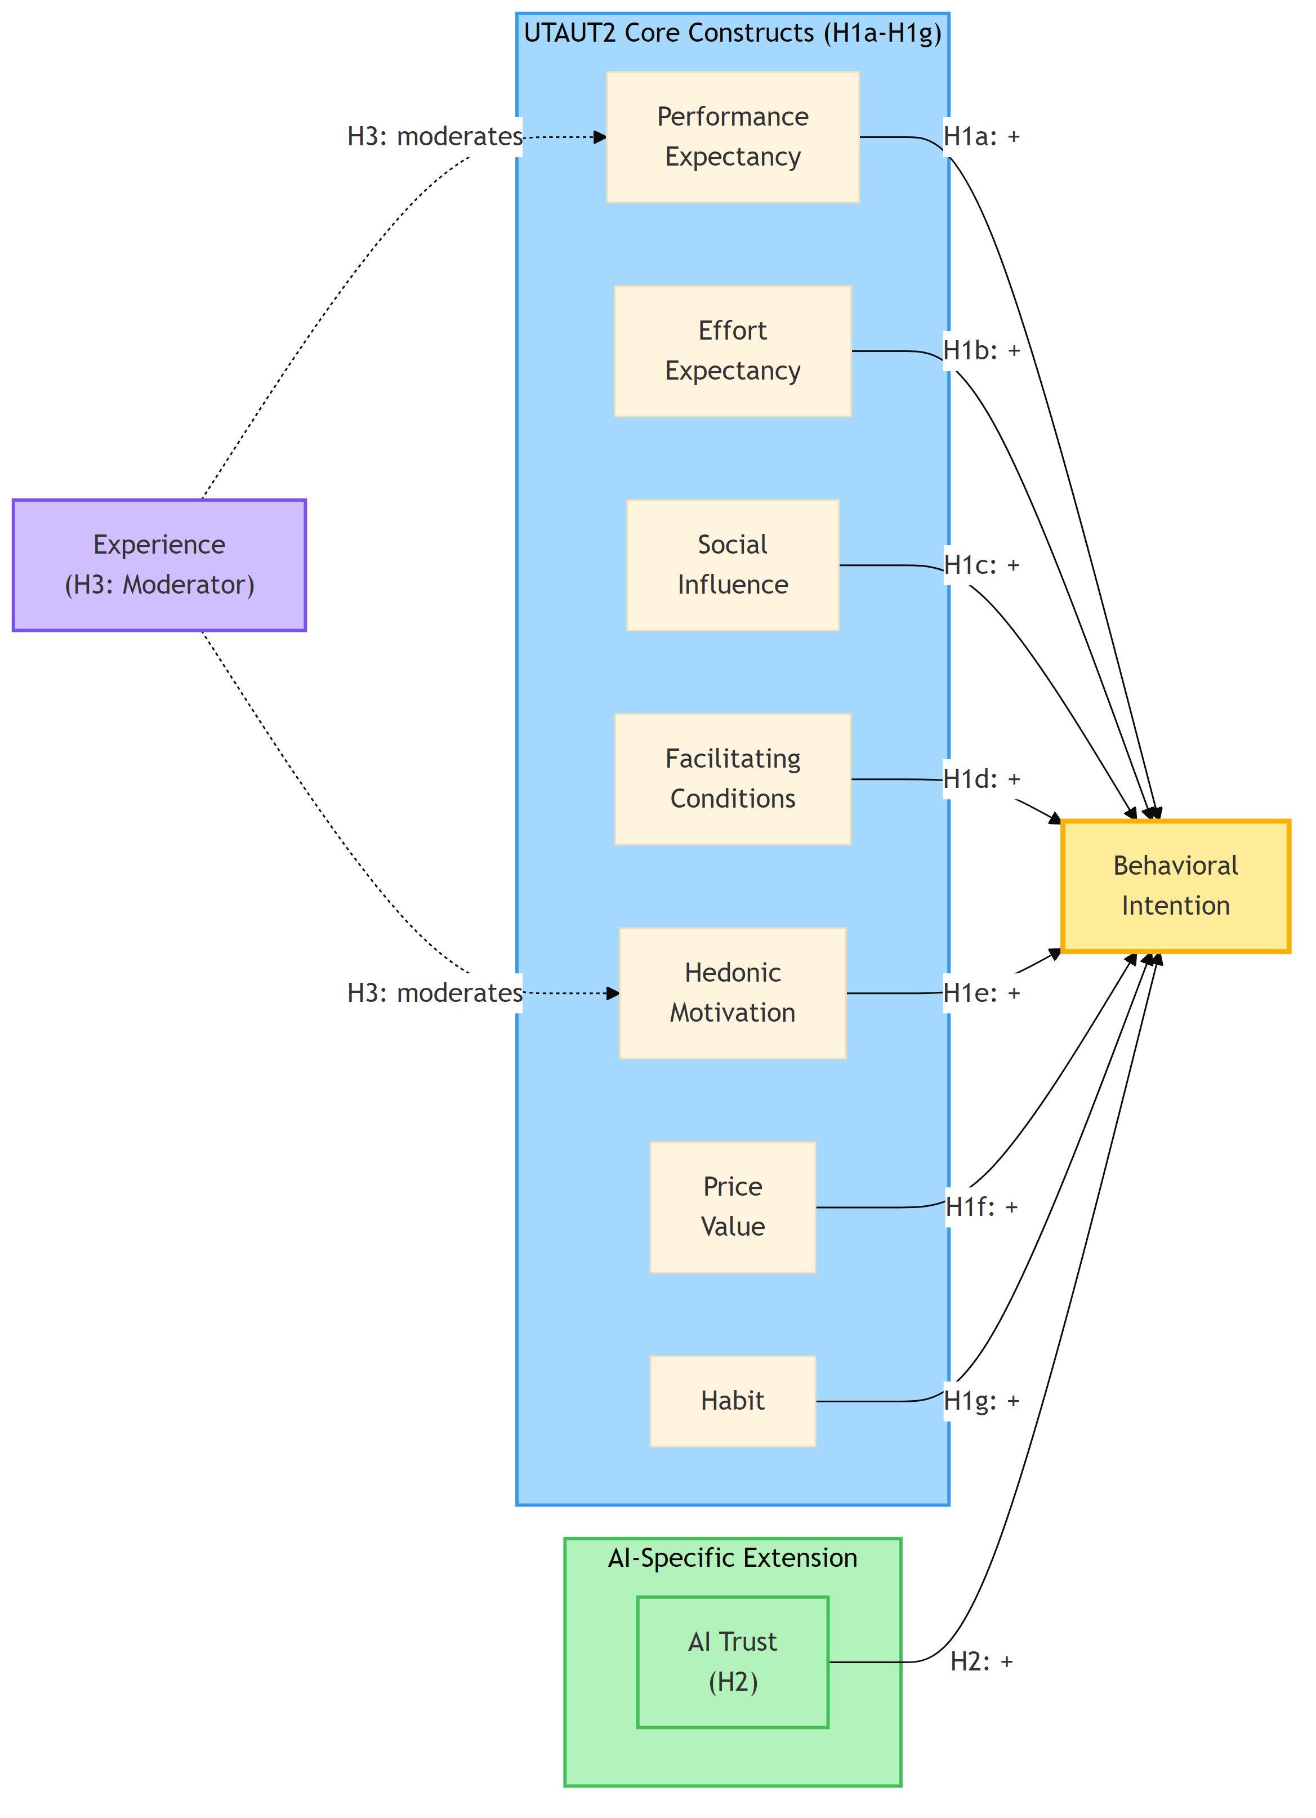
02_literature_review_diagram_1
: AIRS Conceptual Model showing Extended UTAUT2 framework for AI Adoption with AI Trust extension. Source: Compiled by Author {#fig:airs-conceptual-model}
Note: AI Anxiety was initially proposed as an inhibitor construct (H8) but was excluded from the final model due to inadequate reliability (α = .301). See Chapter 4 for details.

2.6 AI-Related Anxiety

2.6.1 Conceptualizing AI Anxiety
AI-related anxiety captures affective responses to AI autonomy, opacity, and the pace of technological change. Unlike general technology anxiety rooted in difficulty of use, AI anxiety encompasses broader concerns about human obsolescence, loss of agency, and unpredictable societal transformation.
Tao et al. (2020) developed a multi-dimensional AI anxiety scale identifying distinct facets: anxiety about AI learning and communication, AI social influence, AI configuration, and AI development trajectory. Frenkenberg & Hochman (2025) added anticipatory dimensions, distinguishing anxiety about current AI from anxiety about future AI capabilities. Kim et al. (2025) identified annihilation anxiety (existential concerns about human relevance) as a component particularly salient among knowledge workers whose expertise AI replicated.

2.6.2 Anxiety as Inhibitor
Anxiety operates as an inhibitor in adoption models, exerting direct negative effects on intention and potentially attenuating the positive influence of performance expectancy and other drivers. Users experiencing high AI anxiety may acknowledge system usefulness while remaining unwilling to rely on AI for consequential decisions.
Anxiety effects may also be nonlinear with exposure. Several studies observed that moderate, structured exposure to AI reduced anxiety by replacing vague fears with realistic expectations and coping strategies. This suggested that enablement programs and hands-on training could shift anxiety levels favorably, an organizational intervention that traditional acceptance models did not explicitly accommodate.

2.6.3 Anxiety in the Present Research
The present research initially proposed AI Anxiety as an inhibitor construct extending UTAUT2, operationalized as affective unease about AI autonomy, opacity, and potential negative consequences. This construct was expected to negatively predict behavioral intention and may moderate the effects of positive predictors, particularly for users with limited AI experience. However, empirical analysis revealed inadequate reliability for the two-item AI Anxiety scale (α = .301), preventing formal hypothesis testing. The measurement challenge and its implications for future research were discussed in Chapter 4 (§4.2) and Chapter 5 (§5.6.2).

2.7 Gaps in Current Research
The literature review revealed several gaps that the present research addressed:
Gap 1: Validated AI-Specific Measurement Instruments. While theoretical arguments for AI-specific constructs were well-developed, validated measurement instruments remained scarce. Most existing AI adoption studies adapted general technology acceptance measures or developed ad hoc items without rigorous scale development. The present research addressed this gap through systematic scale development following established psychometric procedures (DeVellis, 2016; Hinkin, 1998).
Gap 2: Integration of Enablers and Inhibitors. Prior research tended to study AI-specific constructs in isolation. Few studies simultaneously modeled trust and anxiety as enabler and inhibitor within an integrated UTAUT2 framework. The present research tested an integrative model where AI Trust operated as an enabler and AI Anxiety as an inhibitor alongside traditional UTAUT2 predictors.
Gap 3: Cross-Population Validation. Most AI adoption studies examined single populations, limiting generalizability claims. Whether adoption dynamics differed between academic and professional populations, groups with potentially different AI exposure, organizational contexts, and role relationships, remained unexamined. The present research addressed this gap through multi-group analysis across academic and professional samples.
Gap 4: Experience as Moderator. While UTAUT specified experience as a moderator of traditional predictors, the moderating role of AI experience on AI-specific constructs remained unexplored. Given theoretical arguments that anxiety decreased with calibrated exposure, experience moderation was particularly relevant for AI adoption. The present research tested experience moderation across both traditional and AI-specific paths.
Gap 5: Connection to Practitioner Concerns. Academic research on AI adoption often proceeded disconnected from practitioner challenges. The adoption-value gap identified in industry benchmarks reflected organizational barriers (governance, change management, workforce readiness) that acceptance research rarely addressed directly. The present research bridged this gap by developing a validated measurement instrument (AIRS) that provided a foundation for future organizational applications.

2.8 Theoretical Framework and Hypotheses

2.8.1 Conceptual Model
The present research proposed an extended UTAUT2 model for AI adoption that retained the validated core while adding AI-specific enabler and inhibitor constructs. The model specified:
UTAUT2 Core Predictors: Performance Expectancy, Effort Expectancy, Social Influence, Facilitating Conditions, Hedonic Motivation, Price Value, and Habit as direct predictors of Behavioral Intention.
AI-Specific Extension: AI Trust as an enabler positively predicting Behavioral Intention, and AI Anxiety as an inhibitor negatively predicting Behavioral Intention.
Moderation: AI experience moderating predictor-intention relationships, with theoretical expectations that experience strengthens performance expectancy effects and weakens anxiety effects.

2.8.2 Core UTAUT2 Hypotheses
Based on the meta-analytic evidence reviewed above, the following hypotheses reflect established UTAUT2 relationships:
H1a (Performance Expectancy): Performance Expectancy positively predicts Behavioral Intention to use AI tools.
Rationale: Blut et al. (2022)’s meta-analysis confirmed performance expectancy as the consistently strongest predictor (ρ = .60). Users who believed AI would enhance their job performance demonstrated greater adoption intention.
H1b (Effort Expectancy): Effort Expectancy positively predicts Behavioral Intention to use AI tools.
Rationale: While meta-analytic effects were moderate and context-dependent, perceived ease of use remained a relevant consideration, particularly for users with limited AI experience.
H1c (Social Influence): Social Influence positively predicts Behavioral Intention to use AI tools.
Rationale: Perceptions that important others endorse AI use should increase adoption intention, particularly in organizational contexts where peer and supervisor expectations are salient.
H1d (Facilitating Conditions): Facilitating Conditions positively predicts Behavioral Intention to use AI tools.
Rationale: Organizational infrastructure, training, and support should enable adoption by reducing barriers and signaling organizational commitment.
H1e (Hedonic Motivation): Hedonic Motivation positively predicts Behavioral Intention to use AI tools.
Rationale: Users who experience pleasure and enjoyment from AI interaction should demonstrate greater adoption intention, consistent with UTAUT2 findings in consumer contexts.
H1f (Price Value): Price Value positively predicts Behavioral Intention to use AI tools.
Rationale: Users who perceive favorable cost-benefit tradeoffs for AI tools should demonstrate greater adoption intention, particularly where personal or organizational investment is visible.
H1g (Habit): Habit positively predicts Behavioral Intention to use AI tools.
Rationale: Established patterns of AI use predicted continued intention through automaticity and reinforcement mechanisms.

2.8.3 AI-Specific Extension Hypotheses
H2 (AI Trust): AI Trust positively predicts Behavioral Intention to use AI tools beyond UTAUT2 core constructs.
Rationale: Building on Langer et al. (2023)’s review and Stevens & Stetson (2023)’s validation work, trust serves as a gateway condition for AI adoption. Users who trust AI systems to be reliable, competent, and aligned with their interests should demonstrate greater adoption intention.
Proposed Inhibitor (AI Anxiety): AI Anxiety was hypothesized to negatively predict Behavioral Intention to use AI tools. However, empirical analysis revealed inadequate reliability for the AI Anxiety scale (α = .301), preventing formal hypothesis testing. This measurement challenge with anxiety constructs was discussed in Chapter 4 and Chapter 5.
Theoretical Rationale: Drawing on Tao et al. (2020), Kim et al. (2025), and Frenkenberg & Hochman (2025), anxiety about AI autonomy, opacity, and consequences should inhibit adoption intention even when other perceptions are favorable. Future research with improved anxiety measurement is recommended.

2.8.4 Moderation Hypotheses
H3 (Experience Moderation): Experience moderates the relationships between predictors and Behavioral Intention, such that:

  - The effect of Performance Expectancy on Intention strengthens with greater AI experience

  - The effect of Hedonic Motivation on Intention strengthens with greater AI experience
Rationale: Experienced users can more accurately assess AI performance and may derive greater enjoyment from sophisticated use.
H4 (Role Group Moderation): Role group (Academic vs. Professional+Leader) moderates UTAUT2 path coefficients.
Rationale: Academic and professional participants operate in different organizational contexts with distinct resource availability, social pressure patterns, and technology access, which may differentially affect adoption determinants.

2.8.5 Behavioral Validation Hypotheses
H5 (Behavioral Intention -> Usage): Behavioral Intention positively relates to actual AI tool usage breadth.
Rationale: Consistent with UTAUT theory, intention should translate to behavior. Higher adoption intention should correspond to greater engagement with AI tools.
H6 (Role Group Usage Differences): Role groups differ significantly in AI tool usage patterns.
Rationale: Professionals with greater workplace technology demands and resources exhibited different AI tool usage patterns than academic participants.
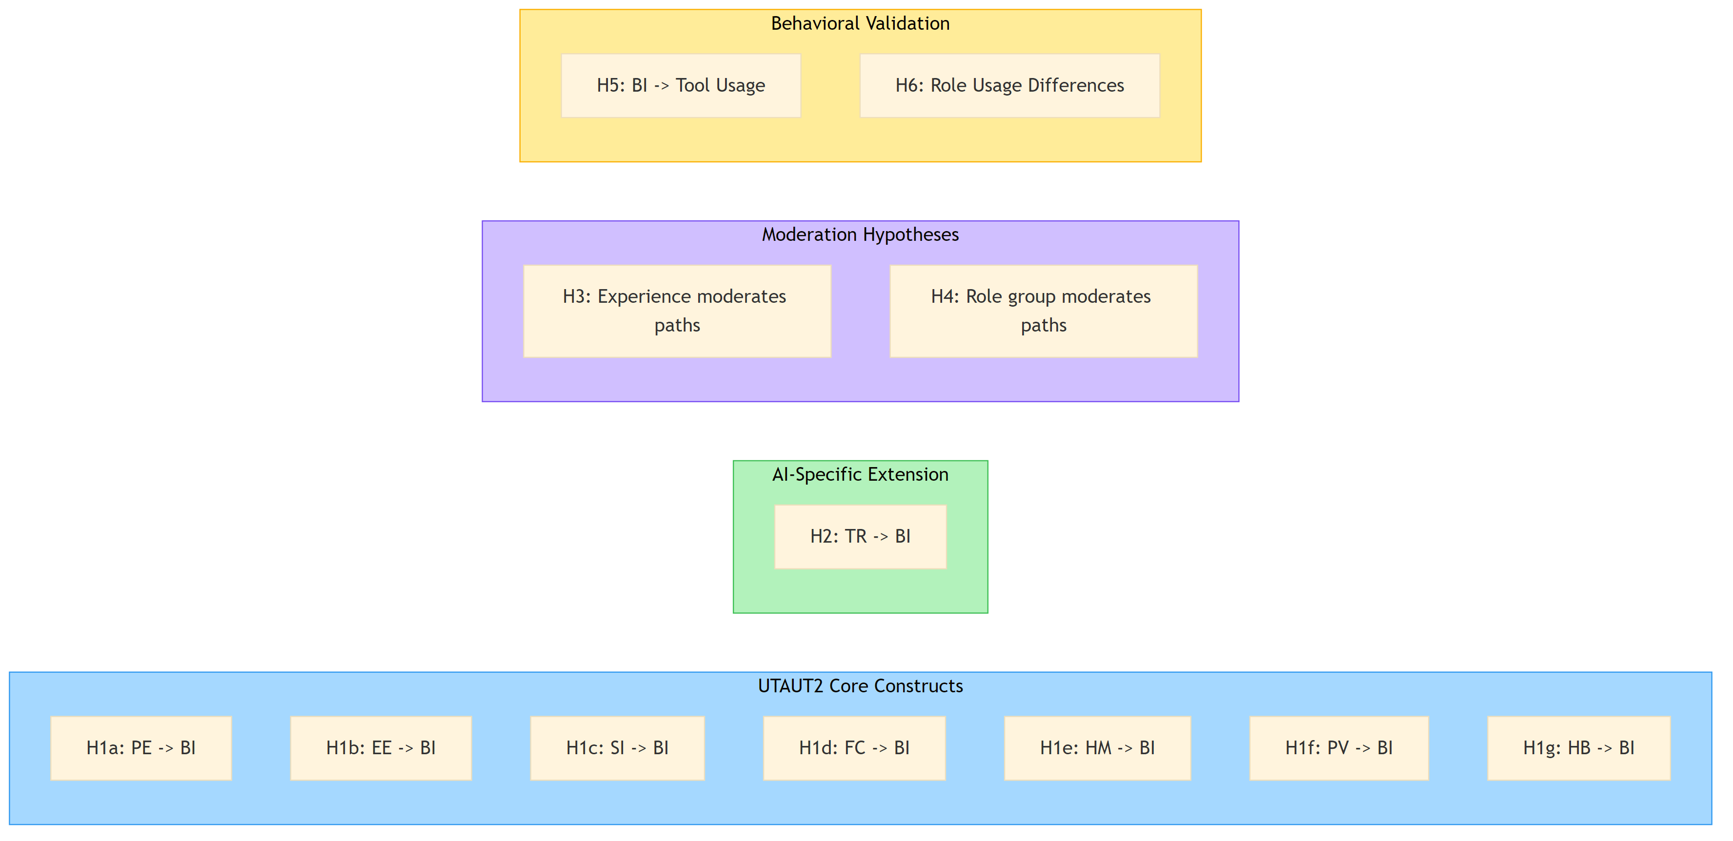
02_literature_review_diagram_2
: Research Hypotheses Summary showing UTAUT2 core constructs, AI-specific extension, moderation hypotheses, and behavioral validation. Source: Compiled by Author {#fig:hypotheses-summary}

2.9 Chapter Summary
This chapter established the theoretical foundation for the Artificial Intelligence Readiness Scale through four contributions.
First, it traced the evolution of technology acceptance research from foundational theories through UTAUT and UTAUT2, emphasizing Blut et al. (2022)’s meta-analytic confirmation of performance expectancy as the strongest adoption predictor while identifying substantial unexplained variance that invites domain-specific extension.
Second, it contextualized the theoretical discussion within the contemporary AI adoption-value gap, using industry benchmarks to demonstrate that traditional acceptance frameworks incompletely explain why 88% organizational adoption yields only 5–6% value realization at enterprise scale. This gap motivates investigation of factors beyond traditional constructs.
Third, it examined AI’s distinctive characteristics (opacity, probabilistic behavior, ethical exposure, and human role transformation) that stress traditional acceptance models. These characteristics justify the incorporation of AI Trust as an enabler within an extended UTAUT2 framework. AI Anxiety was proposed as an inhibitor but was excluded from the final model due to inadequate reliability (α = .301); its theoretical importance and measurement challenges were discussed in Chapters 4 and 5.
Fourth, it articulated the research hypotheses tested in subsequent chapters, specifying both traditional UTAUT2 relationships and AI-specific extensions with experience moderation.
The theoretical framework positioned AIRS as a principled extension that respected the durability of established acceptance research while acknowledging AI’s socio-technical distinctives. The resulting instrument provided both scholarly contribution (validated measurement of AI-specific adoption determinants) and a foundation for future practical applications in organizational AI readiness assessment.
The following chapter described the methodology employed to develop and validate the AIRS instrument, including sample composition, measurement procedures, and analytic approach.

Chapter 3: Research Methodology

3.1 Introduction
This chapter described the research methodology employed to develop and validate the AI Readiness Scale (AIRS), a diagnostic instrument for assessing AI adoption readiness, and test the extended UTAUT model for AI tool adoption in higher education. The study followed established scale development procedures (DeVellis & Thorpe, 2021; Hinkin, 1998) combined with structural equation modeling to examine relationships between latent constructs. The research design prioritized psychometric rigor through split-sample cross-validation, comprehensive validity assessment, and multi-group invariance testing. The resulting 8-factor structure enabled both research applications and organizational diagnostic use, allowing practitioners to identify specific adoption barriers and design targeted interventions.
The chapter was organized as follows: Section 3.2 described the research philosophy and design; Section 3.3 detailed the theoretical framework and hypotheses; Section 3.4 covered instrument development; Section 3.5 addressed sampling and data collection; Section 3.6 presented the analytical strategy; Section 3.7 discussed reliability and validity; Section 3.8 covered ethical considerations; and Section 3.9 acknowledged methodological limitations.

3.2 Research Design

3.2.1 Research Philosophy
This study adopted a post-positivist philosophical stance, recognizing that while objective reality exists, our understanding of it is necessarily imperfect and probabilistic (Creswell & Creswell, 2018). This orientation is appropriate for scale development research, which seeks to measure latent psychological constructs through observable indicators while acknowledging measurement error and the provisional nature of theoretical models.
The post-positivist approach manifested in several methodological choices:
- Emphasis on replication and cross-validation through split-sample design
- Use of probabilistic inference (confidence intervals, effect sizes) rather than binary significance testing
- Recognition of measurement error through latent variable modeling
- Theory-driven hypothesis testing with openness to unexpected findings

3.2.2 Research Approach
The study employed a sequential mixed methods design (Creswell & Clark, 2017) with quantitative primacy:
- Primary Quantitative Component: Structured survey measuring UTAUT constructs on Likert scales, analyzed through factor analysis and structural equation modeling
- Supplementary Qualitative Component: Open-ended feedback questions analyzed through automated content analysis with keyword classification to provide contextual depth and identify emergent themes not captured by closed-ended items
This design allowed triangulation of findings, with qualitative data enriching interpretation of quantitative patterns (e.g., understanding why certain constructs predicted adoption more strongly than others).

3.2.3 Time Horizon
The study employed a cross-sectional design with data collected during October–November 2025. While cross-sectional designs preclude causal inference, they are standard for initial scale validation studies (DeVellis & Thorpe, 2021). The design captures a snapshot of AI adoption readiness during a period of rapid AI tool proliferation in higher education, providing a baseline for future longitudinal research.

3.2.4 Research Context
The study was conducted with United States professionals and students, encompassing:
- Full-time and part-time students (undergraduate and postgraduate)
- Employed professionals (individual contributors, managers, executives)
- Freelancers and self-employed individuals
Students were included because they were transitioning into an AI-infused job market and would soon make adoption decisions inside organizations; their readiness was therefore directly relevant to near-term enterprise contexts (proposal §7.2). This context was selected for theoretical and practical relevance: knowledge-intensive work settings where AI tools had significant potential impact on productivity, yet adoption patterns remained poorly understood.

3.3 Theoretical Framework and Hypotheses

3.3.1 Extended UTAUT Model
The study extended Venkatesh et al. (2012)’s Unified Theory of Acceptance and Use of Technology 2 (UTAUT2) with AI-specific constructs. The theoretical model comprised eight latent factors predicting Behavioral Intention to adopt AI tools:
Core UTAUT2 Constructs:
- Performance Expectancy (PE): The degree to which using AI tools will provide benefits in performing activities
- Effort Expectancy (EE): The degree of ease associated with using AI tools
- Social Influence (SI): The degree to which important others believe one should use AI tools
- Facilitating Conditions (FC): Perceptions of resources and support available for AI tool use
- Hedonic Motivation (HM): The fun or pleasure derived from using AI tools
- Price Value (PV): The cognitive trade-off between perceived benefits and monetary cost of AI tools
- Habit (HB): Automaticity developed through repeated AI tool use
AI-Specific Extensions:
- Trust in AI (TR): Confidence in AI systems’ reliability, accuracy, and benevolence
- AI Anxiety (AX): Apprehension or fear associated with AI technology
Outcome:
- Behavioral Intention (BI): Intent to adopt and use AI tools in professional/academic activities

3.3.2 Research Hypotheses
Based on UTAUT theory and emerging AI adoption literature, the following hypotheses were tested:
Primary Hypotheses (Direct Effects):
- H1a: Performance Expectancy positively predicts Behavioral Intention
- H1b: Effort Expectancy positively predicts Behavioral Intention
- H1c: Social Influence positively predicts Behavioral Intention
- H1d: Facilitating Conditions positively predicts Behavioral Intention
- H1e: Hedonic Motivation positively predicts Behavioral Intention
- H1f: Price Value positively predicts Behavioral Intention
- H1g: Habit positively predicts Behavioral Intention
AI-Specific Extension Hypothesis:
- H2: AI Trust positively predicts Behavioral Intention beyond UTAUT2 core constructs
Note: AI Anxiety (AX) was initially proposed as an inhibitor construct but was excluded from hypothesis testing due to inadequate reliability (α = .301) identified during exploratory factor analysis. See Section 4.2 for construct development outcomes.
Moderation Hypotheses:
- H3: AI Experience moderates UTAUT relationships (strengthening effects for experienced users)
- H4: Role group (Academic vs. Professional) moderates UTAUT path coefficients
Behavioral Validation:
- H5: Behavioral Intention positively relates to actual AI tool usage breadth
- H6: Role groups differ significantly in AI tool usage patterns

3.4 Instrument Development

3.4.1 Initial Item Pool
The initial AIRS instrument comprised 28 items across 12 constructs:
- 7 core UTAUT2 constructs (14 items): PE, EE, SI, FC, HM, PV, HB
- 5 AI-specific extensions (10 items): TR, AX, VO, EX, ER
- 1 outcome construct (4 items): BI
Items were measured on 5-point Likert scales (1 = Strongly Disagree to 5 = Strongly Agree), with negatively-worded items (AX, ER) reverse-scored prior to analysis.
Note: The final validated instrument comprised 16 items across 8 constructs (PE, EE, SI, FC, HM, PV, HB, TR) plus the BI outcome. Four constructs (Voluntariness, Explainability, Ethical Risk, AI Anxiety) were excluded during EFA due to inadequate reliability (α = .301–.582). See Chapter 4, Section 4.2 for detailed item disposition.

3.4.2 Item Sources
Items were adapted from established scales to ensure content validity:

3.4.3 Content Validity
Content validity was established through:
- Literature Review: Items grounded in established UTAUT and technology acceptance literature
- Construct Definition Mapping: Each item mapped to specific construct definition
- Face Validity Review: Items reviewed for clarity and appropriateness to AI context

3.4.4 Construct Exclusion Process
Of the 12 constructs proposed, four AI-specific constructs were excluded during exploratory factor analysis due to inadequate psychometric properties:
Interpretation: These constructs demonstrated poor inter-item correlations, suggesting the two-item scales measured different facets of multi-dimensional phenomena rather than unitary constructs. For example:
- Voluntariness: VO1 assessed choice to use AI, while VO2 assessed freedom not to use, representing conceptually distinct aspects of voluntary adoption
- Explainability: EX1 assessed understanding AI outputs, while EX2 assessed preference for explanations, reflecting comprehension vs. preference dimensions
- Ethical Risk: ER1 assessed job displacement concerns, while ER2 assessed privacy concerns, representing distinct risk categories
- AI Anxiety: AX1 captured technology avoidance, while AX2 captured fear of obsolescence, reflecting avoidance vs. approach motivations
Resolution: All four AI-specific constructs were excluded from the final measurement model due to inadequate reliability. These constructs remain theoretically important for AI adoption research and require more comprehensive operationalization with 3-4 items per sub-dimension in future studies.
This represented an empirical finding, not a design limitation. The proposal committed to testing these constructs; the data revealed inadequate measurement properties. This transparent reporting aligned with best practices in scale development (DeVellis & Thorpe, 2021).

3.4.5 Final Instrument Structure
Following psychometric validation (see Chapter 4), the final AIRS instrument comprised 16 items across 8 factors (7 UTAUT2 predictors + AI Trust extension):
Note: Behavioral Intention (BI) served as the outcome variable in the structural model.

3.5 Sampling and Data Collection

3.5.1 Target Population
The target population comprised adults in the United States who were either students or employed professionals (proposal §7.2). This included:
- Full-time and part-time students at undergraduate and postgraduate levels
- Employed professionals in individual contributor roles
- Employed professionals in managerial and leadership roles
- Freelancers and self-employed individuals

3.5.2 Sampling Strategy
Panel sampling was employed through Centiment, a professional survey research platform maintaining verified respondent panels recruited via social media (Facebook, LinkedIn) and other outlets to achieve broad demographic representation.
While panel sampling has limitations similar to convenience sampling regarding generalizability, it is appropriate for initial scale validation studies where the primary goal is psychometric evaluation rather than population inference (DeVellis & Thorpe, 2021). Centiment’s topic-blinded recruitment protocol, where survey invitations display only completion time and compensation without revealing subject matter, also mitigated self-selection bias common in technology-focused research.

3.5.3 Sample Size Determination
Target sample size was determined based on:
- SEM requirements: Minimum N = 200 for stable Maximum Likelihood estimation (Kline, 2016)
- Factor analysis: Minimum 10:1 subject-to-item ratio (Costello & Osborne, 2005)
- Multi-group analysis: Minimum n = 100 per group (Hair et al., 2019)
- Split-sample cross-validation: N > 500 to enable 50/50 split with adequate subsamples
Achieved sample: N = 523 (exceeded all requirements)

3.5.4 Role Classification
Respondents were classified into three role groups based on self-reported primary role:
Note: For multi-group SEM requiring larger group sizes, Professional and Leader categories were combined (n = 307) to contrast with the Student category (n = 216), designated as “Academic” for multi-group analysis. This grouping reflected meaningful theoretical distinctions between academic-focused and employment-focused roles.

3.5.5 Data Collection Procedures
Platform: Centiment online survey platform
Collection Period: October–November 2025 (3-week window)
Self-Selection Mitigation Strategy: Self-selection bias was mitigated through Centiment’s platform-level recruitment design. According to Centiment’s documented methodology, survey notifications to panel members display only the estimated completion time and compensation amount; the survey topic and subject matter are deliberately concealed “in order to avoid selection bias” (Centiment, 2024). This platform-level blinding ensured that participants could not self-select based on AI interest when deciding whether to participate. Only after accessing the survey link did the informed consent form disclose the specific focus on AI tools, ensuring ethical transparency while maintaining recruitment neutrality. This two-stage approach (blinded recruitment followed by informed consent) attracts a broader cross-section of respondents rather than selectively recruiting those with pre-existing interest in AI topics.
Procedures:
- Participants received blinded survey invitation (topic not disclosed per Centiment protocol)
- Informed consent obtained disclosing AI focus before data collection
- Survey completion time: approximately 10-15 minutes
- All responses anonymous; no personally identifiable information collected
Temporal Note: The literature review (Chapter 2) incorporated industry reports published throughout 2025 to contextualize findings within the current AI adoption landscape. Some cited sources appeared during or shortly after the data collection window; the theoretical framework and hypotheses were specified before fieldwork began.

3.5.6 Data Quality Assurance
Multiple quality checks were implemented:
Final valid sample: N = 523 after quality screening

3.6 Analytical Strategy

3.6.1 Analysis Pipeline
The analysis followed a systematic 10-phase pipeline ensuring replicability and transparency:
Source: Compiled by Author
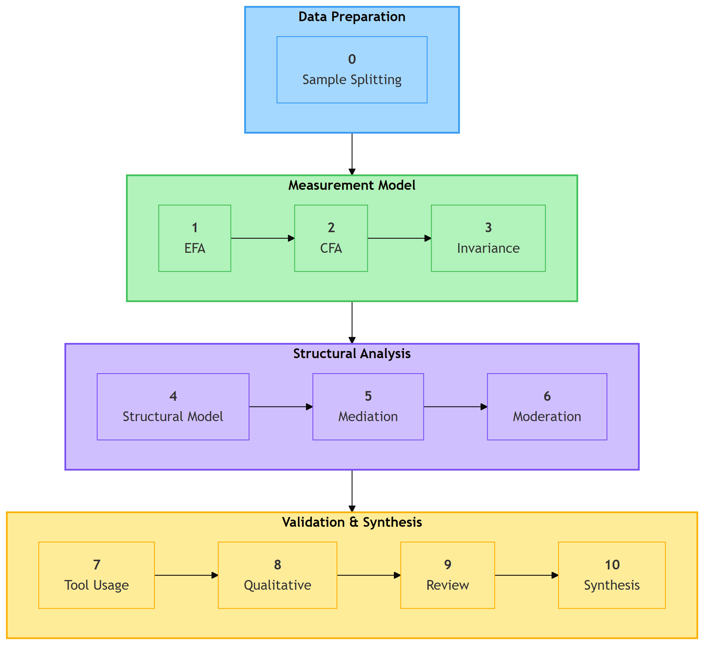
03_methodology_diagram_0
: Ten-Phase Analysis Pipeline showing data preparation, measurement model validation, structural analysis, and synthesis stages. Source: Compiled by Author {#fig:analysis-pipeline}

3.6.2 Sample Splitting Strategy
To ensure independent validation, the sample was randomly split:
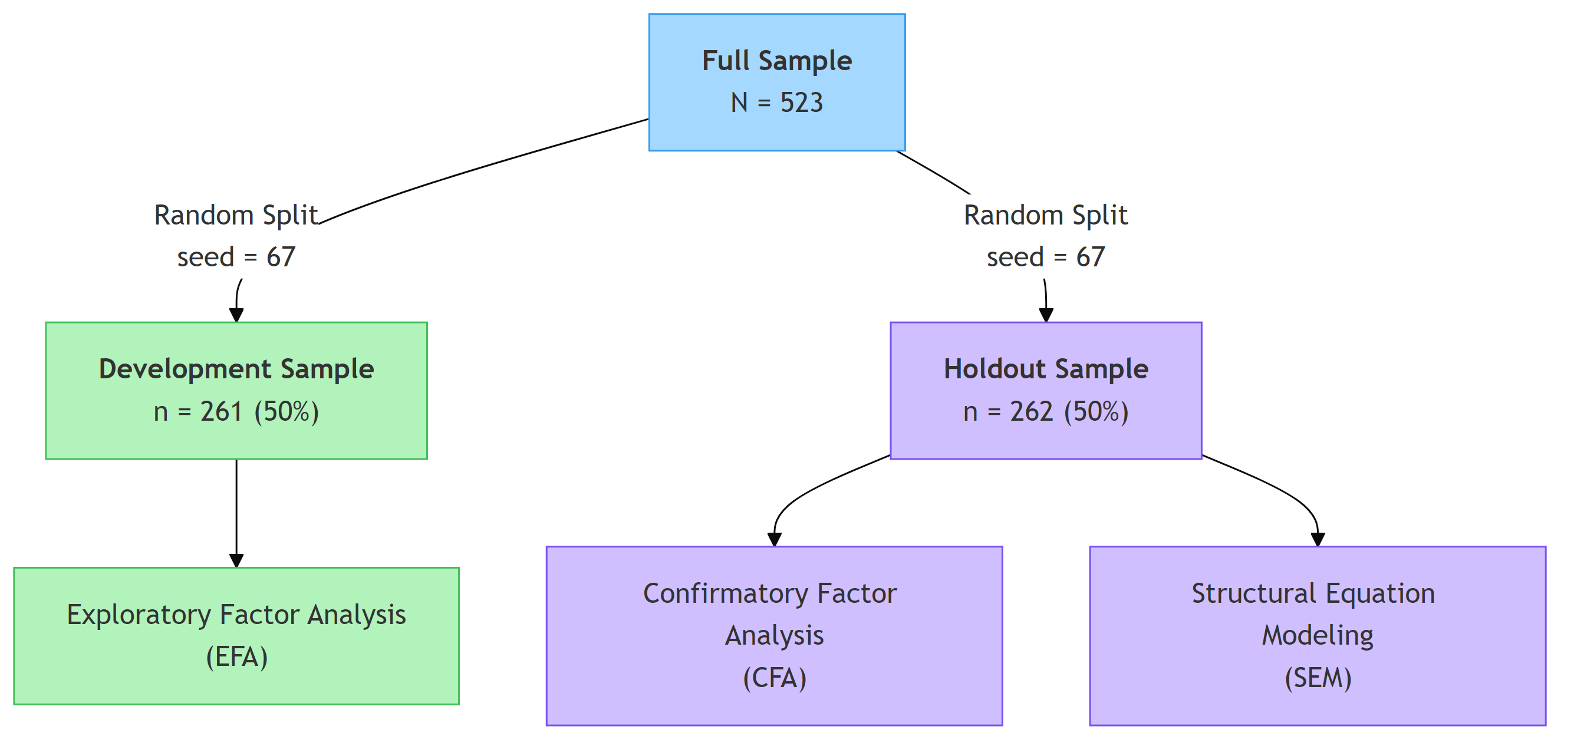
03_methodology_diagram_1
: Split-Sample Cross-Validation Strategy showing random split of N=523 into development (n=261) and holdout (n=262) samples. Source: Compiled by Author {#fig:split-sample}
Stratification: Split stratified by AI adoption status to ensure comparable samples
Reproducibility: Random seed (67) documented for exact replication

3.6.3 Exploratory Factor Analysis (EFA)
Purpose: Identify underlying factor structure and reduce item pool
Sample: Development subsample (n = 261)
Extraction Method: Minimum Residuals (MINRES)
- Minimizes off-diagonal residual correlations
- Does not assume multivariate normality
- Default method in R psych package; recommended for ordinal-like Likert data (Winter et al., 2009)
Rotation: Promax (oblique)
- Allows correlated factors (theoretically appropriate)
- Pattern matrix used for interpretation
Factor Retention Criteria:
- Kaiser criterion (eigenvalue > 1.0)
- Parallel analysis (Horn, 1965)
- Scree plot visual inspection
- Theoretical interpretability
Item Retention Criteria:
Criterion | Threshold | Rationale
Primary loading | λ ≥ .50 | Strong factor association
Cross-loading | Δλ ≥ .20 | Simple structure
Communality | h² ≥ .30 | Adequate shared variance
Software: R psych package (v2.5.6) with GPArotation for oblique rotation

3.6.4 Confirmatory Factor Analysis (CFA)
Purpose: Validate factor structure on independent sample
Sample: Holdout subsample (n = 262)
Estimation Method: Maximum Likelihood (ML)
- Standard for continuous indicators
- Provides χ² test and fit indices
Model Specification: 8-factor correlated model with 16 observed indicators (2 per factor)
Fit Index Thresholds:
Software: Python semopy package (v2.3.10) for development-phase analysis; R lavaan package (v0.6.21) for authoritative fit indices (see §3.6.10)

3.6.5 Measurement Invariance Testing
Purpose: Establish construct comparability across role groups for valid multi-group comparison
Levels Tested:
Criteria for Invariance (Chen, 2007):
- ΔCFI < .010
- ΔRMSEA < .015
- Δχ² non-significant (supplementary)
Groups: Academic (n = 216) vs. Professional+Leader (n = 307)

3.6.6 Structural Equation Modeling (SEM)
Purpose: Test hypothesized relationships between latent constructs
Sample: Full sample (N = 523). Following CFA validation on the independent holdout subsample (n = 262), structural modeling used the complete dataset to maximize statistical power for path estimation. This was standard practice when the measurement model had been confirmed on a separate sample (Kline, 2016).
Model:
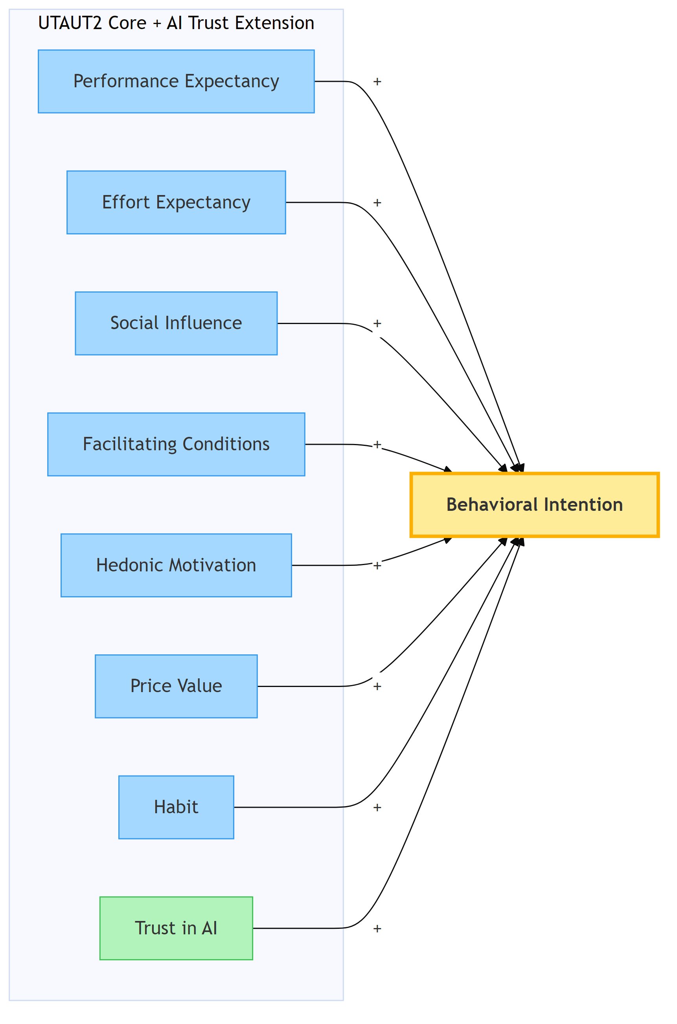
03_methodology_diagram_2
: Structural Model showing Eight Predictors of Behavioral Intention (UTAUT2 Core + AI Trust Extension). Source: Compiled by Author {#fig:structural-model}
Note: AI Anxiety was initially proposed but excluded due to inadequate reliability (α = .301).
Estimation: Maximum Likelihood with robust standard errors
Multi-Group Analysis: Separate models for Academic and Professional+Leader groups
Moderation Testing:
- Experience × UTAUT interactions via latent interaction terms
- Role moderation via multi-group path comparison (Δχ² tests)
Effect Size Interpretation (Cohen, 1988):

3.6.7 Mediation Analysis
Purpose: Examine indirect pathways through the model
Method: Bootstrap estimation (1,000 resamples) for indirect effect confidence intervals
Significance: 95% CI excluding zero

3.6.8 Cluster Analysis
Purpose: Identify distinct user typologies based on UTAUT profile patterns
Method: K-means clustering
Variables: Standardized scores on 8 AIRS constructs
Cluster Selection:
- Elbow method
- Silhouette analysis
- Theoretical interpretability
Optimal Solution: k = 3 clusters (supported by silhouette analysis and theoretical interpretability)

3.6.9 Qualitative Analysis
Purpose: Provide contextual depth and identify emergent themes
Data: Open-ended survey responses (n = 243 substantive responses, 46.5% response rate)
Method: Automated content analysis with keyword classification
- Familiarization with data
- Keyword-based coding using predefined dictionaries aligned with UTAUT2 constructs
- Theme assignment via pattern matching
- Theme prevalence quantification
- Role-based comparison
Note: This approach used deterministic keyword matching rather than the iterative interpretive coding of Braun and Clarke’s (2006) thematic analysis. It was better characterized as automated content analysis.
Themes Identified: 10 distinct themes (see Chapter 4)

3.6.10 Statistical Software
All analyses were conducted using a dual-language pipeline: Python 3.11 for data preparation and exploratory analyses, and R 4.5.2 with lavaan for confirmatory and structural modeling. R/lavaan served as the primary engine for CFA, SEM, and measurement invariance testing, providing authoritative fit indices across all latent variable models.
Environment: Python virtual environment and R 4.5.2 executed in VS Code; R scripts served as the authoritative analysis pipeline
Reproducibility: All random operations used documented seeds (e.g., seed = 67 for sample split); complete analysis pipeline available in GitHub repository

3.7 Reliability and Validity Assessment

3.7.1 Internal Consistency Reliability
Measures:
- Cronbach’s Alpha (α): Classical reliability coefficient
- Composite Reliability (CR): SEM-based reliability accounting for differential loadings
Thresholds:

3.7.2 Convergent Validity
Definition: Extent to which indicators of a construct share variance
Assessment:
- Factor loadings: All standardized loadings ≥ .70
- Average Variance Extracted (AVE): Proportion of variance captured by construct
Threshold: AVE ≥ .50 (Fornell & Larcker, 1981)

3.7.3 Discriminant Validity
Definition: Extent to which constructs were distinct from one another
Assessment Methods:
- Fornell-Larcker Criterion: √AVE > inter-construct correlations
- Heterotrait-Monotrait Ratio (HTMT): HTMT < .85 (Henseler et al., 2015)
- Maximum correlation: |r| < .85 between any construct pair
Known Limitations: Three construct pairs exhibited high inter-factor correlations that violated the Fornell-Larcker criterion: Performance Expectancy × Price Value (r = .898), Performance Expectancy × Hedonic Motivation (r = .911), and Hedonic Motivation × Price Value (r = .898). HTMT analysis confirmed these overlaps: PE × PV (HTMT = .902), PE × HM (HTMT = .900), and HM × PV (HTMT = .904) all exceeded the .85 threshold. These overlaps were consistent with UTAUT2 literature, where motivational constructs often shared substantial variance in technology acceptance contexts (Venkatesh et al., 2012). All remaining pairwise comparisons passed all discriminant criteria. Several mitigating factors supported retaining the eight-factor structure:
- HTMT ratios were computed as a supplementary check; HTMT is considered more robust than Fornell-Larcker for detecting discriminant problems (Henseler et al., 2015)
- Model fit remained excellent (CFI = .975, TLI = .960, RMSEA = .065, SRMR = .026 on holdout; CFI = .979, TLI = .966, RMSEA = .061, SRMR = .022 on full sample), indicating the eight-factor model reproduced the data well
- Theoretical distinctiveness: PE captures utilitarian performance expectations, HM reflects intrinsic enjoyment, and PV represents cost-benefit appraisal, conceptually distinct constructs despite empirical overlap
- Future studies with larger item pools could strengthen discriminant separation among these three constructs

3.7.4 Criterion Validity
Predictive Validity: AIRS constructs predicted actual tool usage behavior (ρ = .69 for BI × tool breadth)
Known-Groups Validity: Constructs differentiated between theoretically-distinct groups (e.g., Leaders vs. Academics)

3.8 Ethical Considerations

3.8.1 Institutional Approval
The study received ethical approval from the institution’s Research Ethics Committee prior to data collection. The research was classified as minimal risk given:
- Anonymous data collection
- Voluntary participation
- Non-sensitive topic
- Adult participants only

3.8.2 Informed Consent
Participants were provided with:
- Study purpose and objectives
- Data handling and storage procedures
- Right to withdraw without penalty
- Researcher contact information
Consent was obtained electronically before survey access. Participants could not proceed without acknowledging consent.

3.8.3 Anonymity and Confidentiality
Anonymity: No personally identifiable information collected
- No names, emails, or employee IDs
- IP addresses not recorded
- Demographic data collected at categorical level only
Confidentiality:
- Data stored on encrypted, password-protected systems
- Access limited to research team
- Data retained according to institutional policy (minimum 5 years)

3.8.4 Data Protection
The study complied with:
- IRB approval requirements
- Institutional data governance policies
- Research ethics standards for human subjects research

3.8.5 Participant Welfare
The survey addressed non-sensitive topics related to technology use attitudes. No anticipated risks to participant welfare were identified. Contact information was provided for questions or concerns.

3.9 Methodological Limitations

3.9.1 Design Limitations
- Cross-sectional design: Precluded causal inference; relationships may have been correlational rather than causal. Future longitudinal studies were needed to establish temporal precedence.
- Self-reported measures: Behavioral Intention was a proxy for actual behavior. While BI strongly predicted behavior in UTAUT studies, some intention-behavior gap was expected.
- Single time point: Attitudes and technology contexts change rapidly; findings reflected an October–November 2025 snapshot.

3.9.2 Sampling Limitations
- Panel sampling: While Centiment’s verified respondent panels provided quality controls and topic-blinded recruitment, panel sampling remained non-probability sampling that limited generalizability to broader populations. Results might not generalize beyond similar United States professional and academic contexts.
- Single country: While diverse roles were represented, findings were limited to U.S. respondents and might not transfer to other cultural contexts.
- Self-selection bias: Self-selection was substantially mitigated through Centiment’s platform-level recruitment design, which conceals survey topics from participants until after they access the survey link (see Section 3.5.5). However, some residual self-selection might have occurred as participants could withdraw after the informed consent disclosure revealed the AI focus, though withdrawal rates were minimal.

3.9.3 Measurement Limitations
- English language only: Non-English speakers excluded; cross-cultural validity not established.
- Two items per construct: While meeting minimum identification requirements for SEM, more indicators would improve reliability and content coverage.
- Adapted scales: Items adapted from existing instruments; some original validation evidence might not have transferred perfectly.

3.9.4 Analytical Limitations
- Normality assumptions: ML estimation assumes multivariate normality; some departures might have affected standard errors (though robust methods were used where possible).
- Common method variance: Single-source, single-time data collection might have inflated correlations. Harman’s single-factor test was conducted as diagnostic.
- Model complexity: Eight-factor model with limited items required careful balance between fit and parsimony.

3.10 Chapter Summary
This chapter has described the research methodology for developing and validating the AI Readiness Scale (AIRS) and testing the extended UTAUT model for AI tool adoption. Key methodological features included:
Research Design:
- Post-positivist philosophy with mixed methods approach
- Cross-sectional survey with qualitative supplementation
- United States professionals and academics context
Instrument:
- 28 initial items across 12 constructs
- Final validated instrument: 16 items across 8 factors
- 5-point Likert scale measurement
Sample:
- N = 523 United States adults
- Two population groups: Academics (216), Professionals (307)
- 50/50 split for cross-validation (EFA n = 261, CFA n = 262)
Analysis:
- 10-phase systematic pipeline
- EFA for structure exploration, CFA for validation
- Multi-group SEM for hypothesis testing
- Cluster analysis for user typology
- Automated content analysis for qualitative insights
Validity:
- Comprehensive reliability and validity assessment
- Measurement invariance across role groups
- Criterion validity through behavioral correlates
The methodology provided a rigorous foundation for the empirical findings presented in Chapter 4, while acknowledging limitations inherent in cross-sectional survey research.

Chapter 4: Findings

4.1 Introduction
This chapter presented the empirical findings from the AI Readiness Scale (AIRS) study examining factors influencing AI tool adoption in higher education. The chapter was organized to progress systematically from sample description through data preparation, quantitative results, and findings organized by research question. Analyses were conducted using a dual-language pipeline: Python (factor_analyzer, scipy, pandas) for data preparation and exploratory analyses, and R 4.5.2 with lavaan for confirmatory factor analysis, structural equation modeling, and bootstrap validation (see §3.6.10). A significance level of α = .05 was used unless otherwise specified.
The presentation separated findings from interpretation, following established methodological practice (Yin, 2018). Theoretical and practical implications were addressed in Chapter 5.

4.2 Research Questions and Hypotheses Overview
This section provided a summary of all research questions examined in this dissertation. Detailed hypothesis testing results were presented in §4.5.

4.2.1 Primary Research Question
RQ: How can UTAUT2 be extended with AI-specific constructs to better predict behavioral intention to adopt AI tools in professional and academic contexts?

4.2.2 Secondary Research Questions

4.3 Description of the Sample
The sample comprised N=523 United States adults with representation from both academic and professional contexts. Table 4.2 presented the demographic composition.

4.3.1 Population Composition

4.3.2 Sample Split for Validation
For psychometric validation, the sample was randomly split (seed=67) into development (n=261, 50%) and holdout (n=262, 50%) subsamples. This split-sample approach enabled exploratory factor analysis on the development sample and independent confirmatory factor analysis on the holdout sample.

4.3.3 Disability Status
Participants who identified as having a disability comprised 13.0% of the sample (n=68), with 11 participants selecting “Prefer not to answer.” The survey question asked respondents whether they identified as a person with a disability, providing examples that spanned physical disabilities (vision, mobility) and neurodivergence (e.g., ADHD, autism, dyslexia). This broad operationalization captured disability status across multiple dimensions rather than disaggregating by disability type. The 13% representation enabled examination of accessibility considerations in AI adoption, though future research with larger disability subsamples could examine whether specific disability types exhibit differential AI adoption patterns.

4.4 Data Screening and Preparation

4.4.1 Data Quality Assessment
Data screening confirmed the suitability of the dataset for factor analytic procedures:
- Missing Data: Complete case analysis with no missing values on key UTAUT constructs
- Outliers: Mahalanobis distance identified 0 multivariate outliers at p < .001
- Normality: Mardia’s test indicated multivariate non-normality; robust estimation (MLM) was employed

4.4.2 Factorability Assessment
The Kaiser-Meyer-Olkin measure of sampling adequacy (KMO = .937) and Bartlett’s test of sphericity (χ² = 4,668.45, p < .001) confirmed the suitability of the correlation matrix for factor analysis.

4.5 Quantitative Findings
This section presented the psychometric validation results, including exploratory and confirmatory factor analyses, reliability assessment, and measurement invariance testing.

4.5.1 Exploratory Factor Analysis (Development Sample)
Exploratory factor analysis was conducted on the development subsample (n=261) to evaluate the underlying factor structure of the AIRS instrument.

Model Selection Process
Multiple factor solutions were examined using minimum residuals (MINRES) extraction with promax rotation. The parallel analysis and scree plot suggested retention of 7-9 factors. Based on theoretical alignment with the extended UTAUT framework, the following models were evaluated:
Model D was selected as the final measurement model based on optimal balance of parsimony and fit, with all items demonstrating factor loadings ≥ .50 and no substantive cross-loadings (< .32). Figure 4.1 presented the scree plot supporting this factor structure.
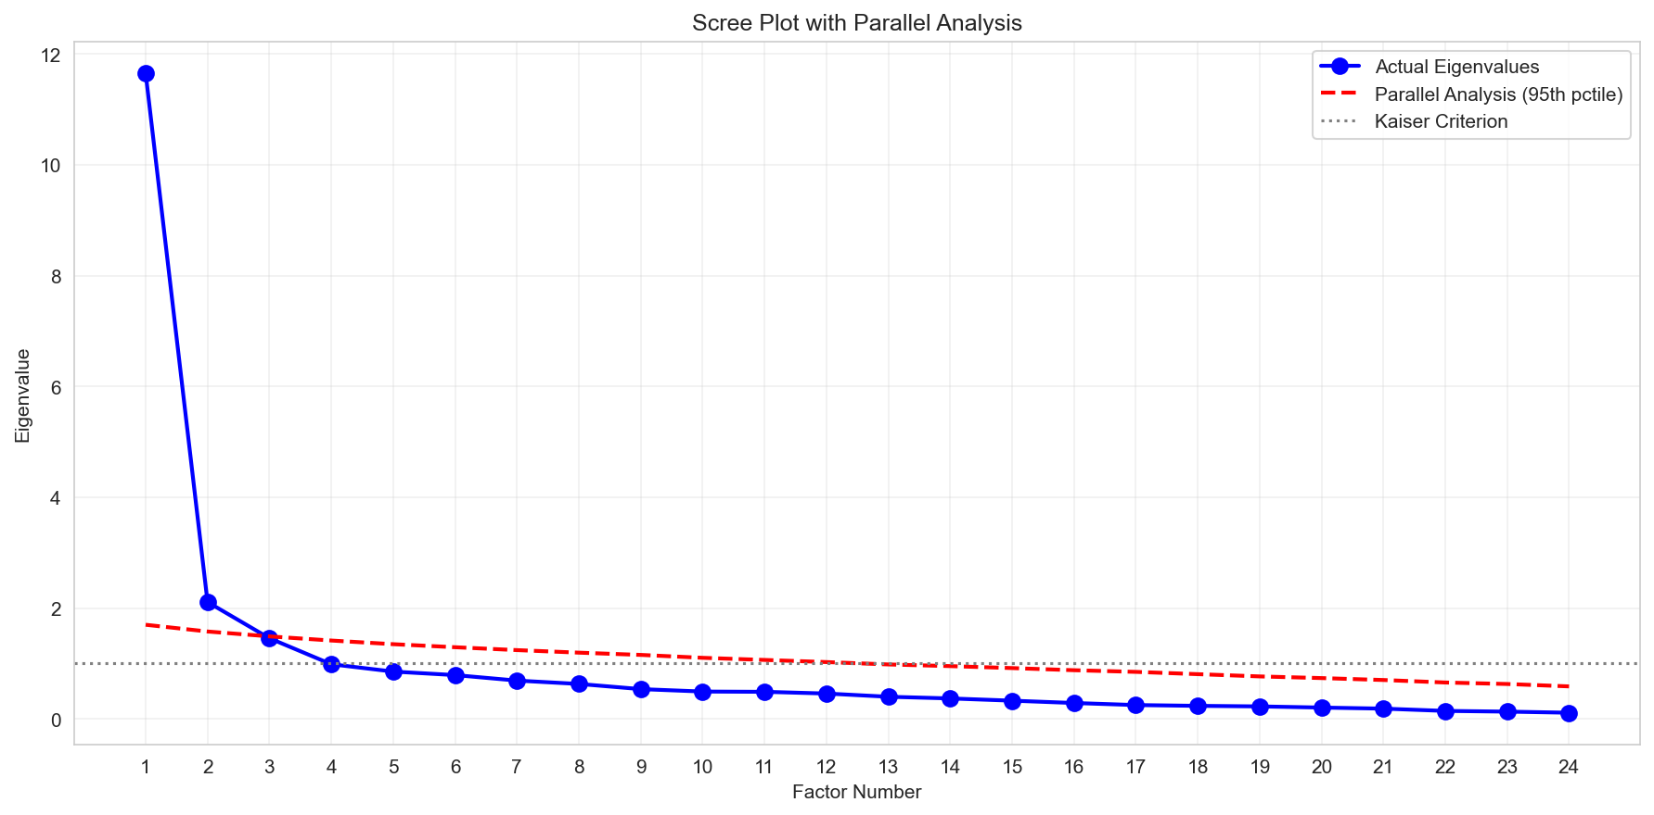
Scree plot showing eigenvalue decline across factors. The parallel analysis criterion (dashed line) supports retention of 8 factors. Source: Compiled by Author

Construct Exclusion Analysis
Four proposed constructs were excluded during EFA due to poor inter-item reliability:
Interpretation: The proposed two-item scales for these AI-specific constructs proved insufficient to capture multi-faceted phenomena. This finding highlighted a key contribution: while these constructs were theoretically important for AI adoption, they required more comprehensive operationalization with additional items representing each sub-dimension.
Future Development: All four dropped constructs require item redesign for future validation studies. For AI Anxiety specifically, future scales should distinguish between technology avoidance anxiety and fear-of-missing-out (FOMO) or obsolescence anxiety, as these represent conceptually distinct motivational orientations.

Final Factor Structure
The validated measurement model comprises 8 predictor factors (16 items) plus Behavioral Intention as the outcome variable (4 items):
Predictor Factors (8 factors, 16 items):
The final measurement model comprises 7 UTAUT2 constructs plus the AI Trust extension:
Note: BI (Behavioral Intention) served as the outcome variable and was modeled separately in the structural model.

4.5.2 Confirmatory Factor Analysis (Holdout Sample)
The 8-factor model was cross-validated on the independent holdout sample (n=262) using confirmatory factor analysis. Initial development-phase CFA was conducted in Python (semopy); authoritative fit indices were obtained from R/lavaan (v0.6.21).

Model Fit Assessment
The model demonstrated excellent fit across all indices, confirming the factor structure derived from the development sample. Figure 4.2 presented the standardized factor loadings for the validated 8-factor model.
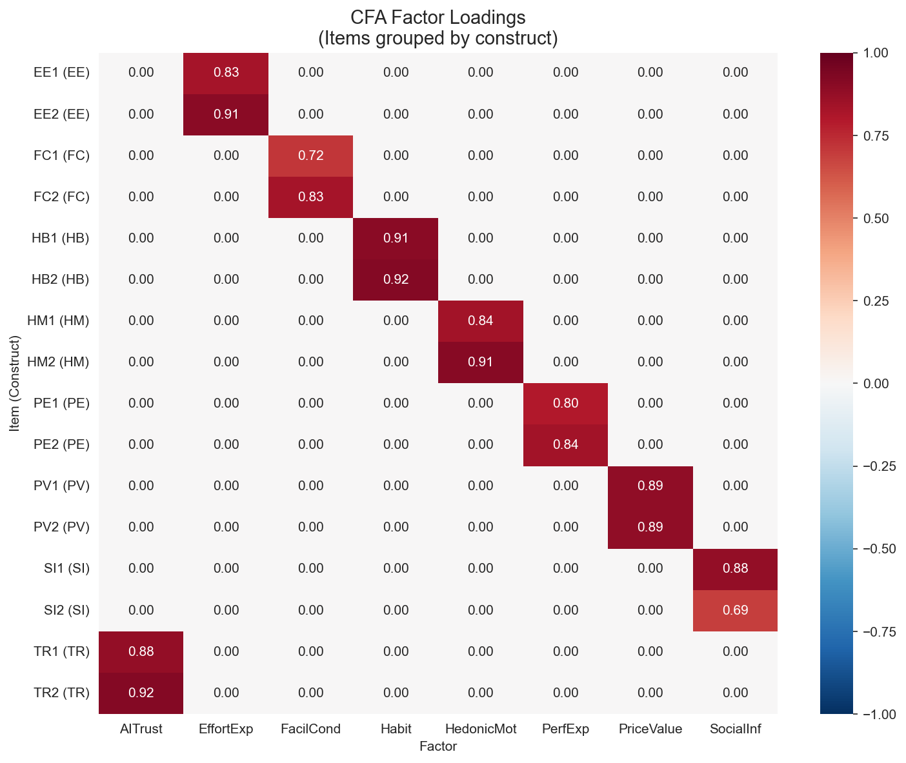
Standardized factor loadings for the 8-factor AIRS measurement model. All loadings exceed .70, supporting convergent validity. Source: Compiled by Author

Factor Correlations
Inter-factor correlations ranged from r = .516 (Effort Expectancy × Social Influence) to r = .911 (Performance Expectancy × Price Value), indicating conceptually meaningful but in some cases high inter-construct relationships. Five factor pairs exceeded the Fornell-Larcker threshold, and four pairs exceeded the HTMT .85 criterion (PE×PV = .902, PE×HM = .900, HM×PV = .904, HM×TR = .850). These violations were concentrated in the PE/HM/PV triad and were characteristic of 2-item-per-factor scales measuring conceptually adjacent constructs (Marsh et al., 1998; Winter et al., 2009). The implications for discriminant validity were addressed in the Discussion (Chapter 5). Figure 4.3 presented the factor correlation matrix.
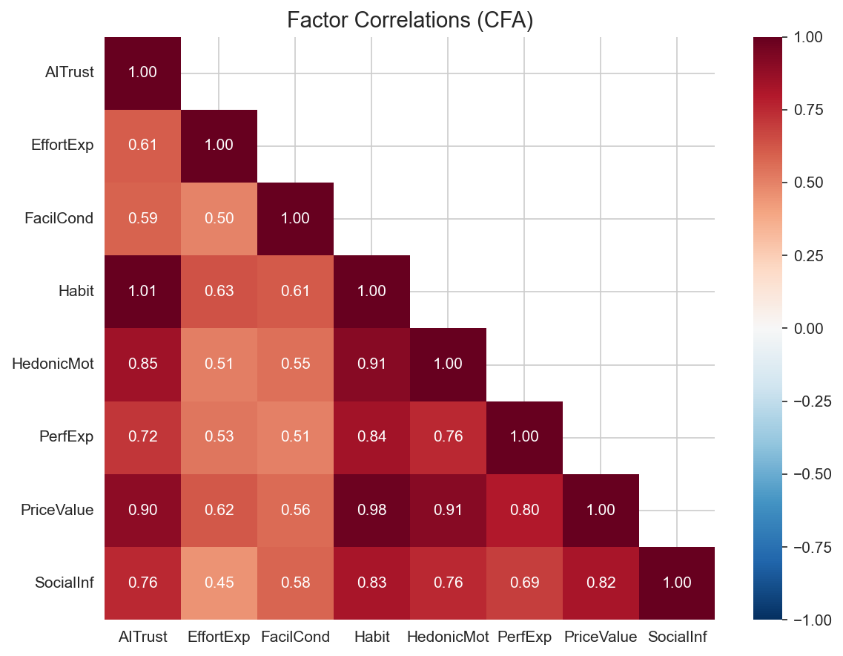
Inter-factor correlations for the 8-factor AIRS model. Several correlations in the PE/HM/PV triad exceed the .85 threshold, reflecting measurement challenges in 2-item scales for conceptually adjacent constructs. Source: Compiled by Author

4.5.3 Reliability and Validity

Composite Reliability
All predictor factors demonstrated acceptable internal consistency:
Figure 4.4 provided a visual comparison of reliability indices across constructs.
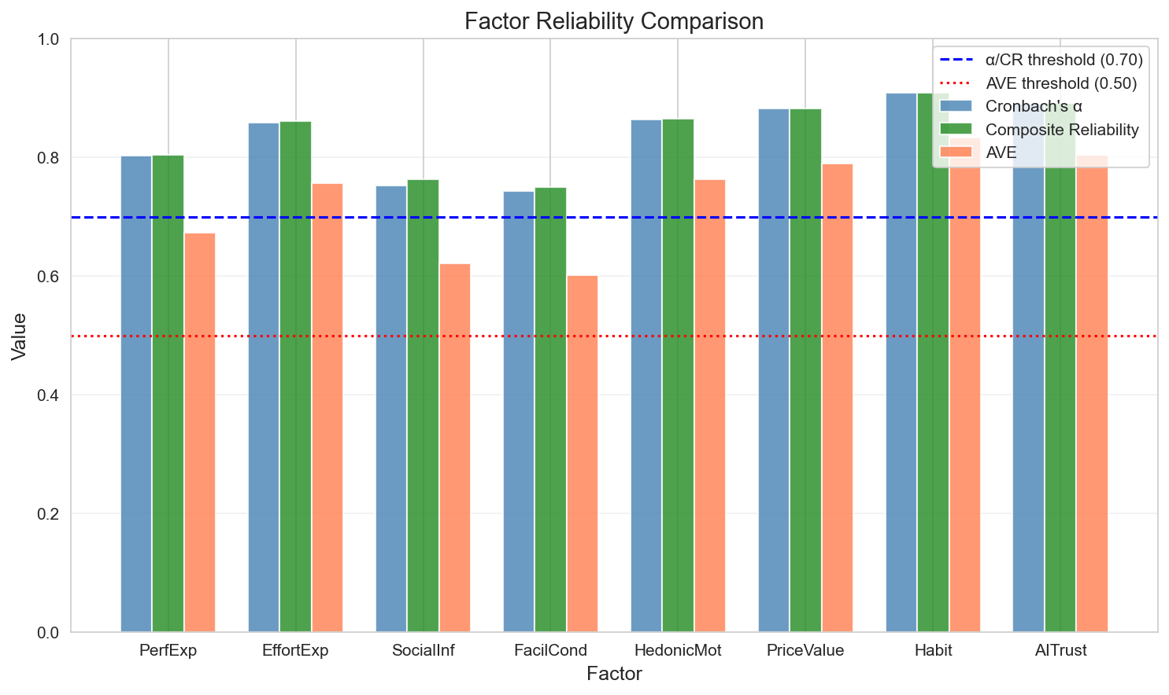
Comparison of Cronbach’s α, Composite Reliability (CR), and Average Variance Extracted (AVE) across the 8 AIRS factors. All factors exceed minimum thresholds (α > .70, CR > .70, AVE > .50). Source: Compiled by Author

Convergent Validity
All standardized factor loadings exceeded .70, and all AVE values exceeded .50, supporting convergent validity (Fornell & Larcker, 1981).

Discriminant Validity
Discriminant validity was assessed using both the Fornell-Larcker criterion and HTMT ratios. Five factor pairs showed Fornell-Larcker violations where the squared inter-factor correlation exceeded one or both AVE values, concentrated in the PE/HM/PV triad. Four HTMT ratios exceeded the .85 threshold: PE×PV (.902), PE×HM (.900), HM×PV (.904), and HM×TR (.850). These violations were expected when 2-item scales measured conceptually adjacent constructs, as measurement error inflated inter-factor correlations (Marsh et al., 1998). Three findings supported retaining separate factors despite this limitation: (a) the constructs served distinct diagnostic functions enabling targeted intervention design, (b) they demonstrated differential population sensitivity (HM: Academic β = 0.449 vs. Professional β = −0.301, p = .041), and (c) theoretical continuity with UTAUT2 supported cumulative science. The planned AIRS-28 expansion (3 items per factor) was expected to improve discriminant separation.

4.5.4 Measurement Invariance (Multi-Group CFA)
Measurement invariance was tested across role groups (Academic n=216 vs. Professional n=307) to establish comparability of latent constructs.
Configural invariance was supported: the same factor structure held across both groups. Metric invariance was not fully achieved (mean loading difference = .082, max = .326), indicating some factor loadings differed across groups. However, configural invariance was sufficient for comparing structural relationships across groups. The maximum factor loading difference (Δλ = .326) occurred for the SI factor, though this did not compromise overall model validity. Figure 4.5 illustrates the loading differences across groups.
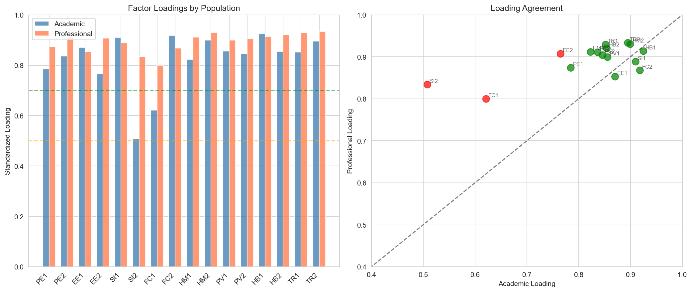
Factor loading comparison across Academic and Professional groups. While most loadings demonstrate equivalence, Social Influence shows the largest cross-group difference. Source: Compiled by Author

4.6 Findings by Research Question
This section presented hypothesis testing results organized by research question. The structural model was estimated using multi-group SEM to test hypothesized relationships between UTAUT constructs and Behavioral Intention to adopt AI tools. The model was estimated separately for Academic (n=216) and Professional+Leader (n=307) groups.

4.6.1 Structural Model Fit
The structural model demonstrated acceptable fit:

4.6.2 Primary Hypotheses (H1a–H1g)
Table 4.10 presented the standardized path coefficients, 95% confidence intervals, and hypothesis test results for the full sample.

Core UTAUT2 Hypotheses

AI Extension Hypothesis
UTAUT2 Summary: 3 of 7 UTAUT2 hypotheses were supported by z-test. Price Value emerged as dominant predictor, departing from traditional UTAUT findings where Performance Expectancy typically dominates. Bootstrap validation confirmed only Price Value as robust; Social Influence and Hedonic Motivation were z-test significant but bootstrap-unstable (see below).
AI Trust Interpretation: AI Trust approached but did not reach conventional significance (p = .064). However, the 8-factor model including AI Trust was retained as the recommended diagnostic instrument because: (1) Trust provided essential diagnostic capability for organizational assessment, (2) Organizations could identify trust deficits and design targeted interventions, and (3) The marginal effect suggested theoretical relevance warranting further investigation with larger samples. Detecting an effect of β = .106 at 80% power requires n > 600; the present sample (N = 523) yields approximately 68% power, leaving a 32% Type II error risk.

Bootstrap Validation
To assess the robustness of the z-test significant paths, bootstrap resampling (1,000 iterations) was conducted using R/lavaan. Bootstrap confidence intervals provide a distribution-free assessment of parameter stability:
The bootstrap results indicated that only Price Value demonstrated robust significance across both inferential methods. Hedonic Motivation and Social Influence were z-test significant but bootstrap-unstable, suggesting their structural effects may be sensitive to sample composition. These constructs nonetheless retained diagnostic value within the AIRS instrument: HM demonstrated differential population sensitivity (Academic β = 0.449 vs Professional β = −0.301, p = .041), and SI captured peer influence dynamics relevant to organizational intervention design.
Key Findings:
- Price Value emerged as the strongest predictor (β = .505, p < .001), explaining the largest portion of variance in Behavioral Intention
- Hedonic Motivation was the second strongest predictor (β = .217, p = .014)
- Social Influence was a significant positive predictor (β = .136, p = .024)
- AI Trust approached but did not reach significance (β = .106, p = .064)
- Performance Expectancy, Effort Expectancy, Facilitating Conditions, and Habit were not significant predictors
- Traditional UTAUT predictors showed unexpectedly weak effects, suggesting AI might represent a distinct technology category
Figure 4.6 summarizes the hypothesis test results for the structural model.
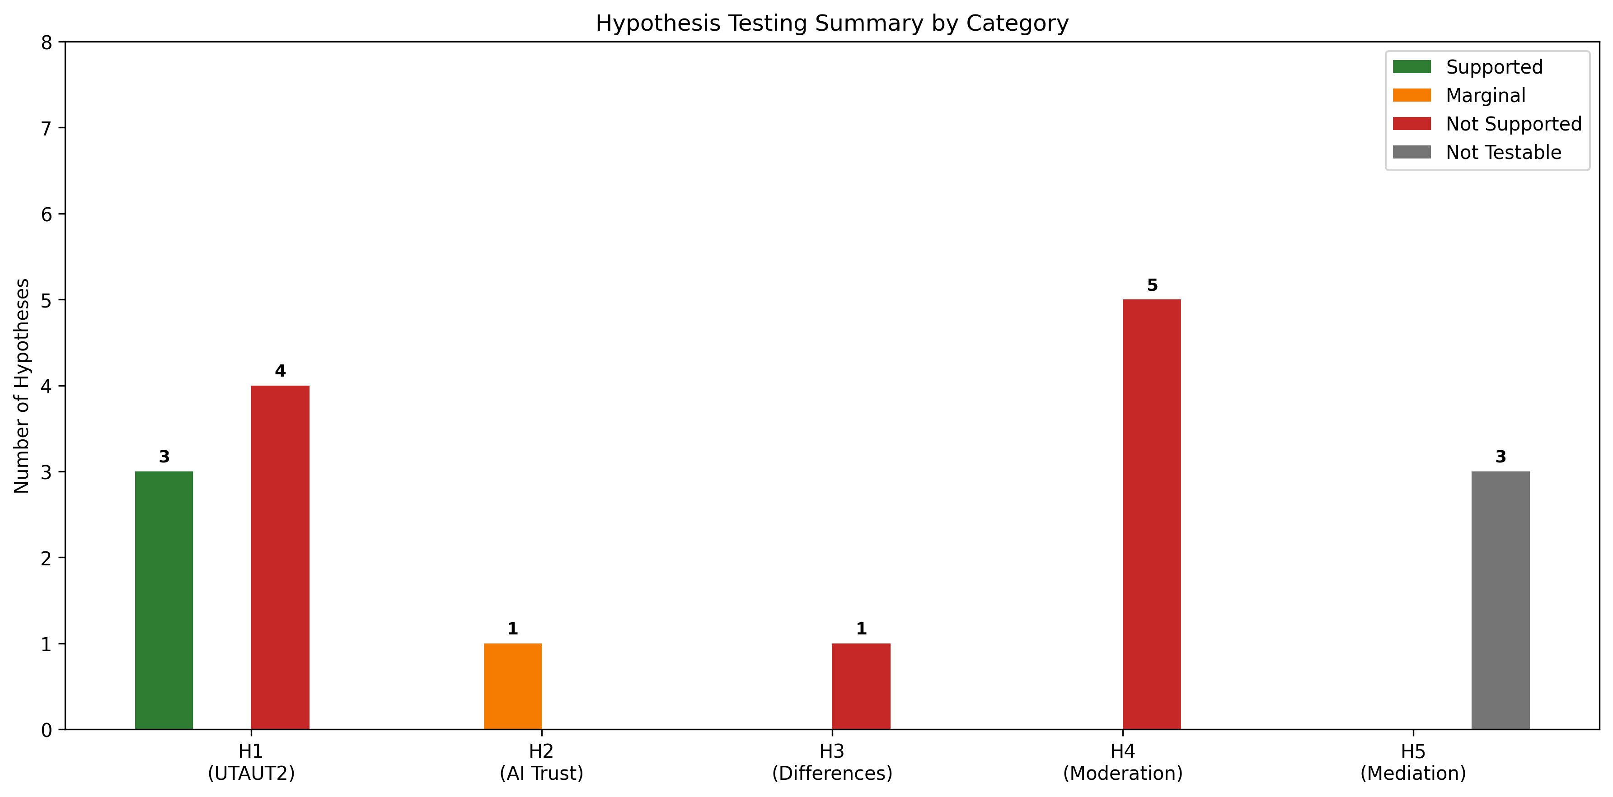
Summary of hypothesis test results. Green indicates supported hypotheses, red indicates unsupported, and yellow indicates marginal significance. Price Value emerged as the dominant predictor. Source: Compiled by Author

4.6.3 Moderation Hypotheses (H3–H4)
Usage frequency was tested as a moderator of UTAUT relationships through multi-group SEM comparison.

Usage Group Path Comparison

Exploratory Experience Moderation (Regression Interactions)
Interpretation:
- Experience moderates HM -> BI (β = .136, p = .007): Experienced professionals (4+ years) weighted hedonic motivation more heavily
- Usage-dependent mechanisms: Performance Expectancy matters for new users; Price Value for heavy users
- Habit is marginally moderated by usage frequency (p = .065)
Figure 4.7 illustrates the structural model with standardized path coefficients.
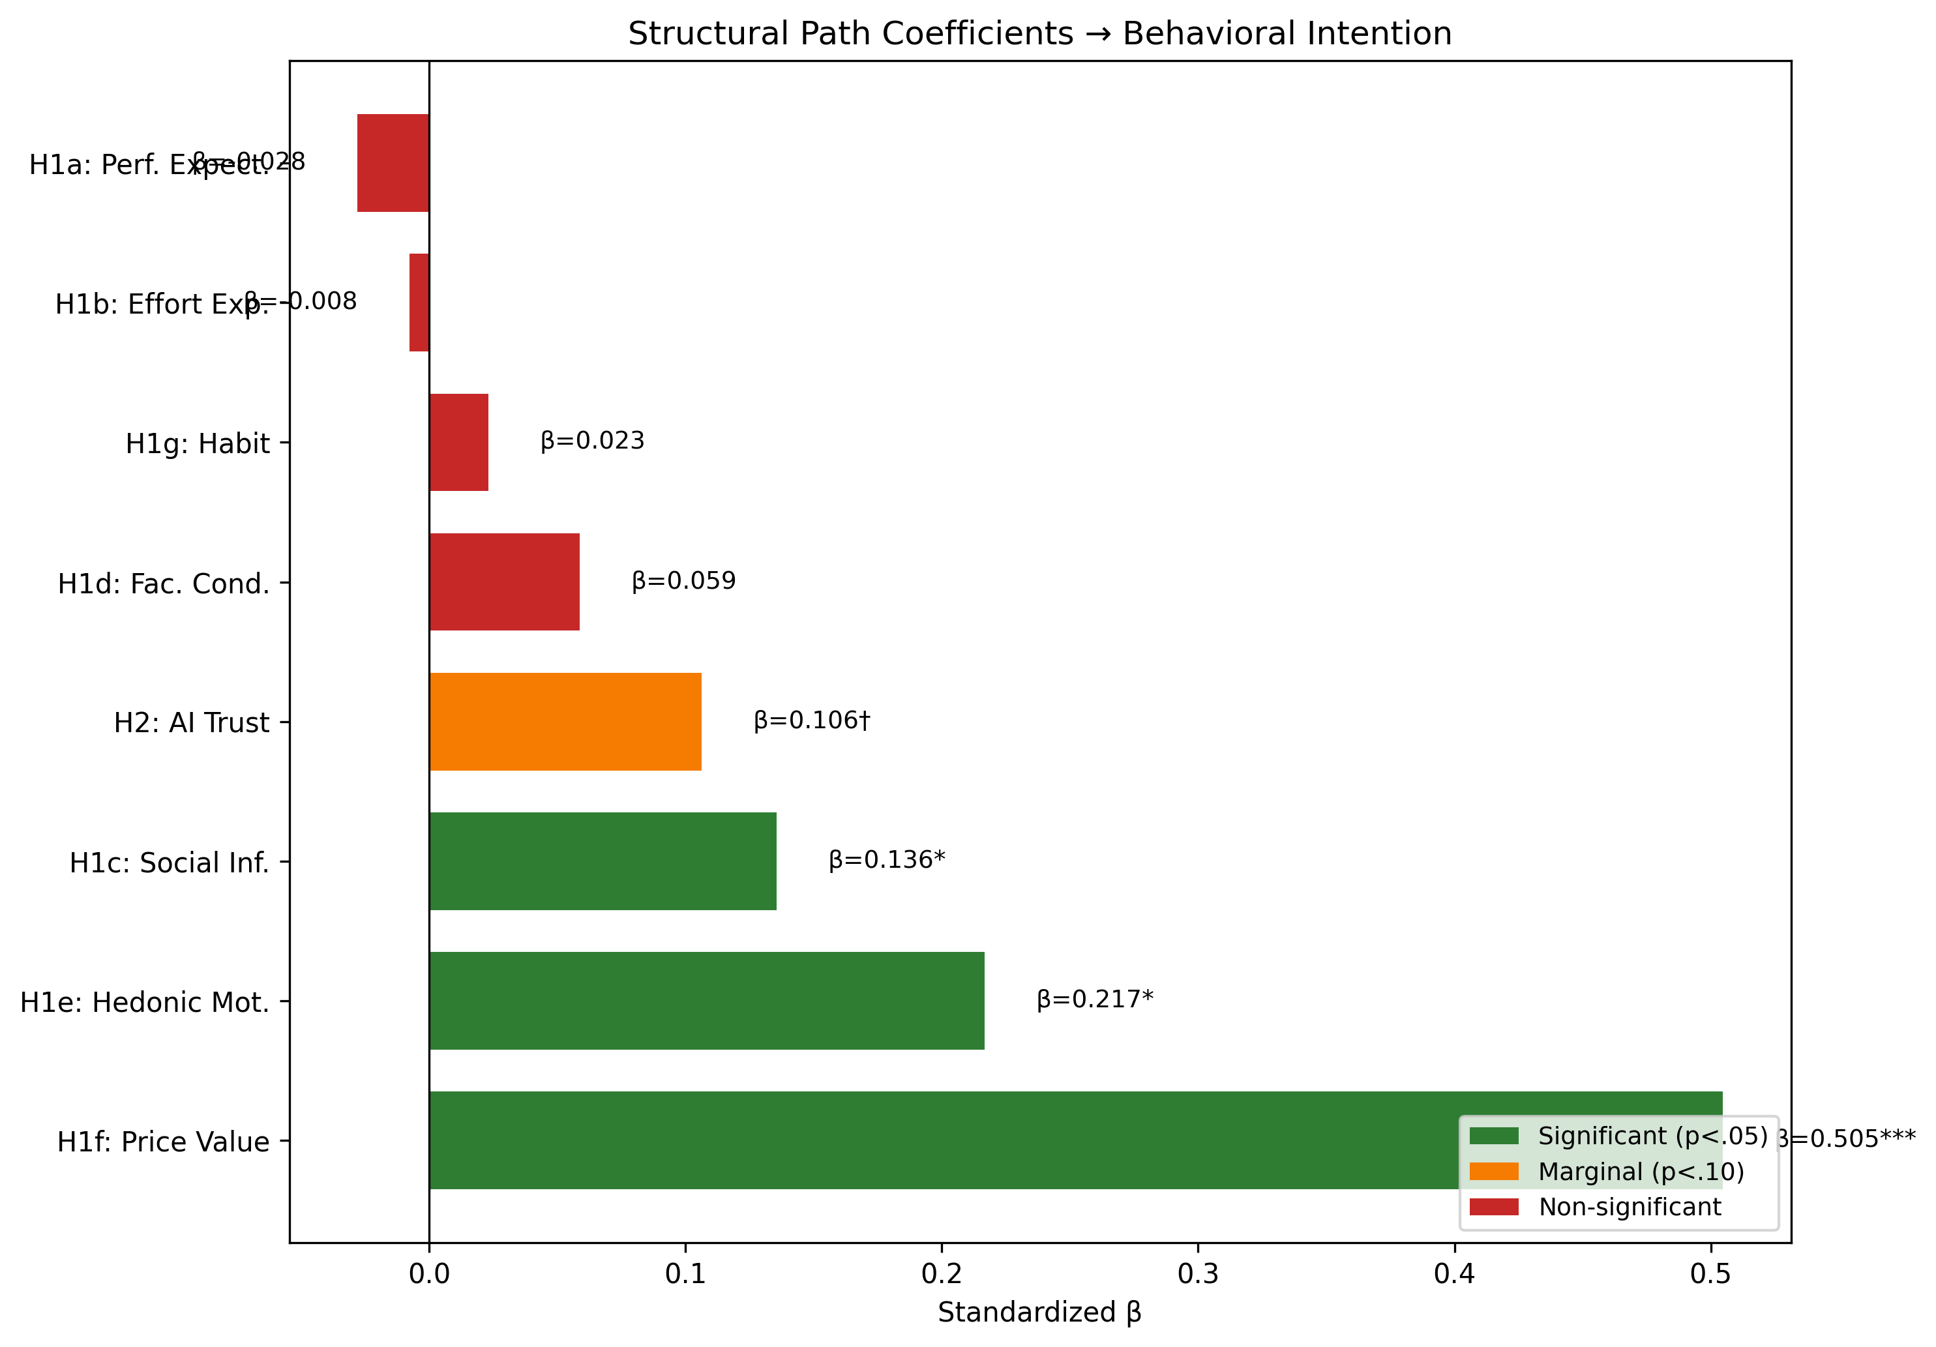
Structural equation model showing standardized path coefficients from UTAUT2 predictors and AI Trust to Behavioral Intention. Solid lines indicate significant paths; dashed lines indicate non-significant paths. Source: Compiled by Author

Population Moderation (H4)
Multi-group comparison tested whether structural path coefficients differed significantly between Academic and Professional populations.
H3 Result: Partially Supported – Experience significantly moderated the HM -> BI path (p = .007). Professionals with 4+ years of experience weighted hedonic motivation more heavily in AI adoption decisions.
H4 Result: Partially Supported – Population significantly moderated HM -> BI (p = .041). Hedonic Motivation was substantially stronger for Academics (β = 0.449) than Professionals (β = -0.301), indicating that enjoyment of AI tools was more important for academic adoption than professional adoption. All other paths showed no significant population differences. Figure 4.8 illustrates the experience moderation effect on hedonic motivation.
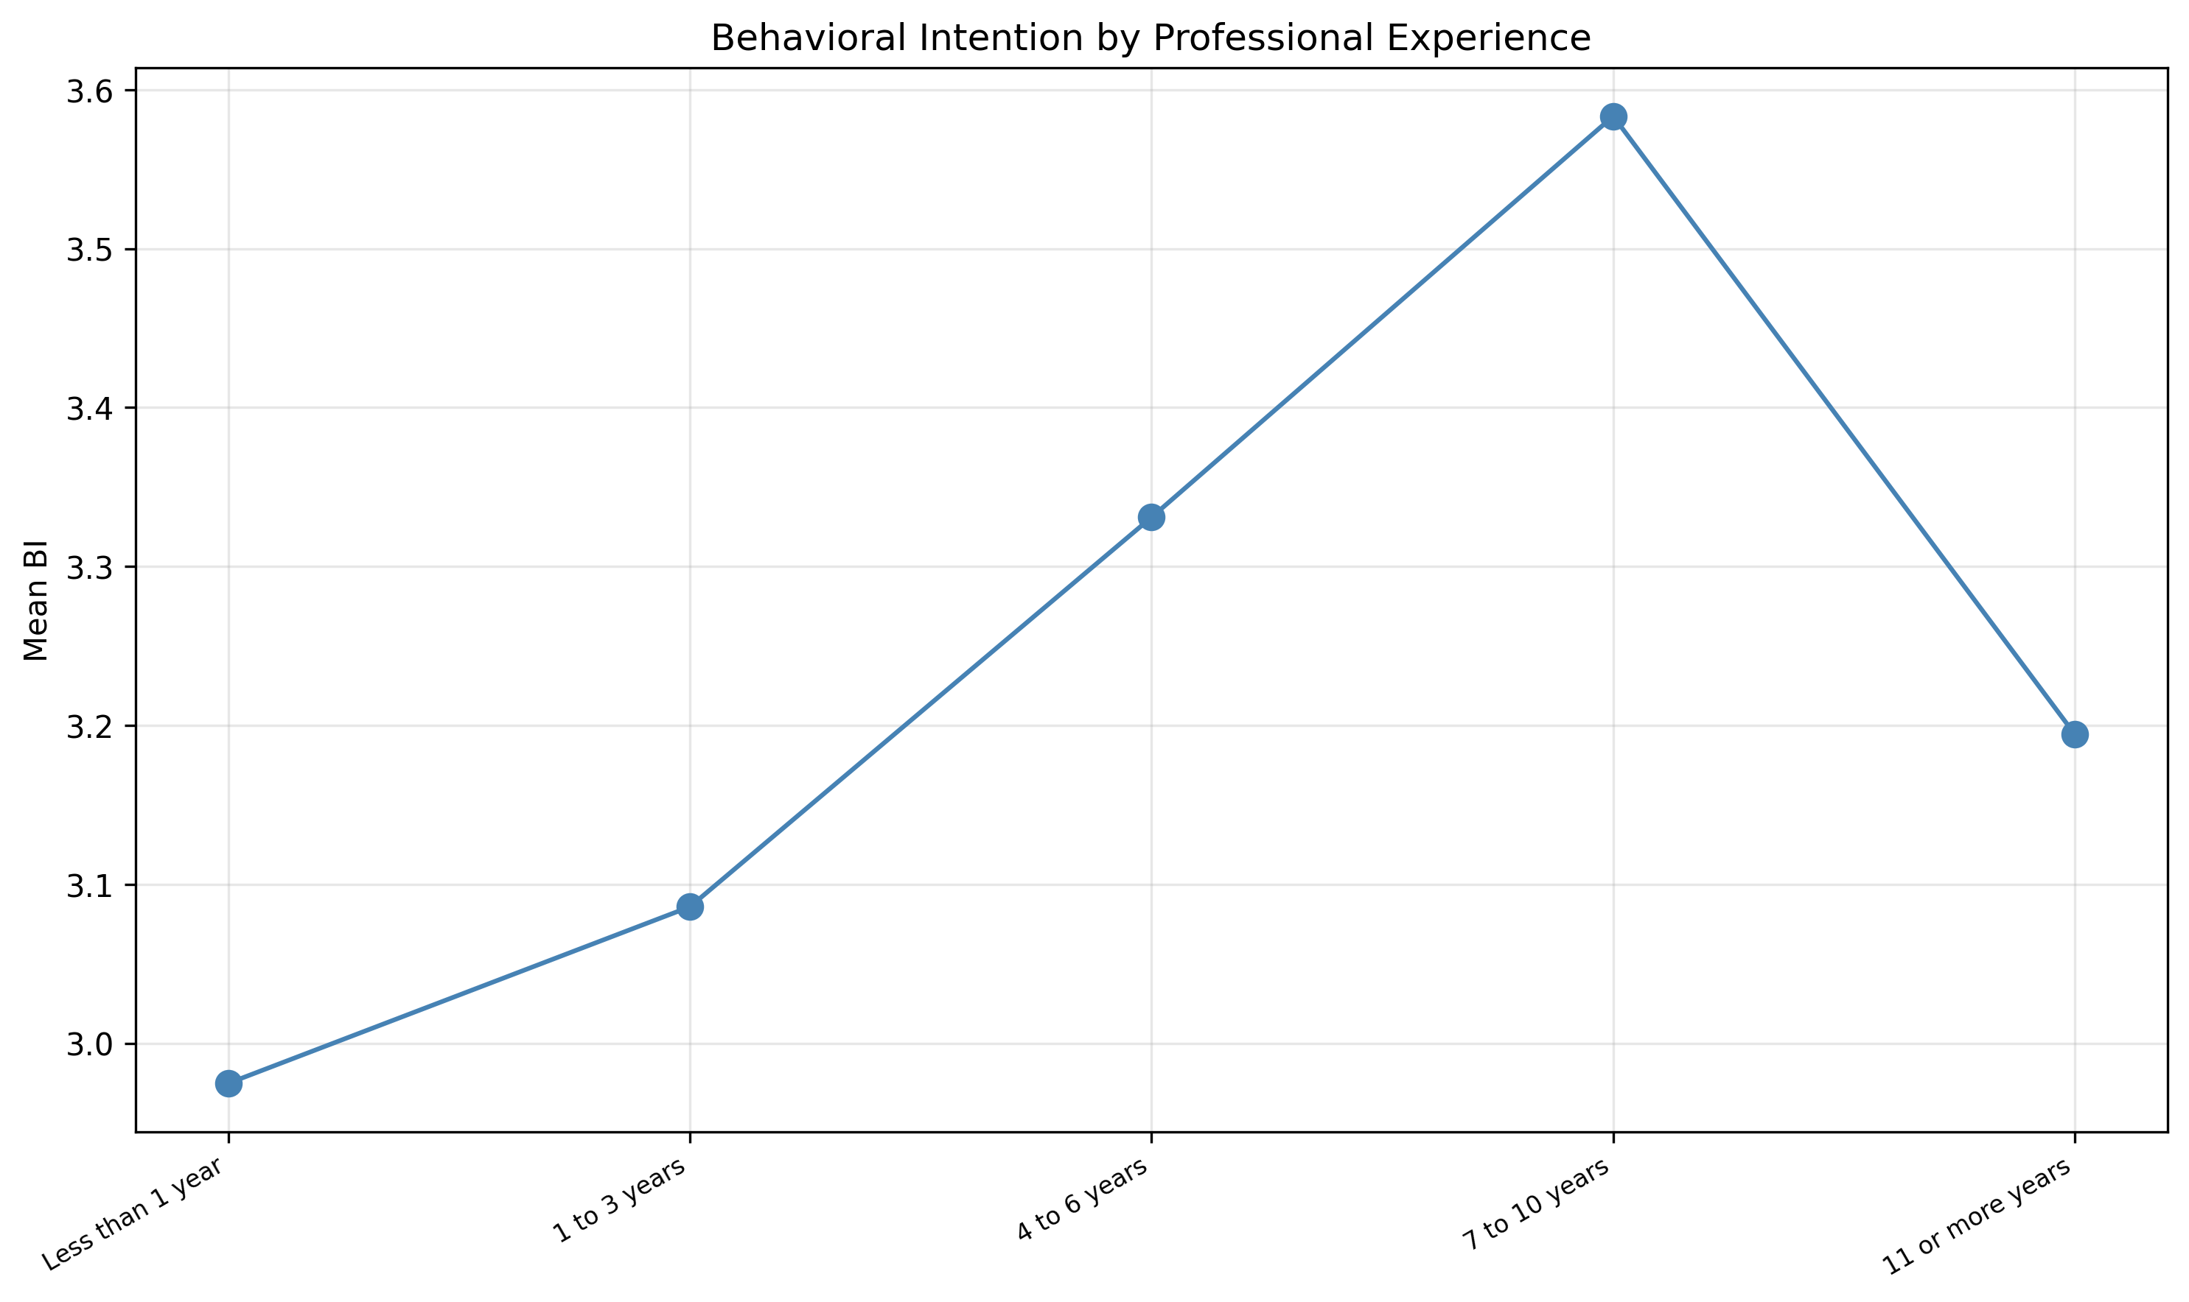
Experience moderation of the Hedonic Motivation -> Behavioral Intention path. The effect of HM on BI is stronger for professionals with 4+ years of experience. Source: Compiled by Author

4.6.4 Incremental Validity: AIRS vs. UTAUT2-Only Model
To assess whether the AI-specific extension (AI Trust) provided incremental predictive validity beyond core UTAUT2 constructs, nested model comparison was conducted:
Result: Although AI Trust showed a marginal effect (β = .106, p = .064), the AIRS model had higher AIC (150.59) than UTAUT2-only (148.58), meaning the simpler model was preferred (ΔAIC = +2.01). Lower AIC indicated better parsimony.
Interpretation: This incremental validity test evaluated predictive parsimony only. AI Trust still had diagnostic value for identifying trust-related barriers to AI adoption, even though it did not improve overall model fit. The marginal significance of AI Trust (p = .064) suggested it might achieve significance with larger samples or in contexts where trust concerns were more salient.

4.6.5 Variance Explained
The structural models explained substantial variance in Behavioral Intention:
Both models demonstrated exceptionally high R² values, indicating that the UTAUT2 framework captured the vast majority of systematic variance in intention to use AI tools. While the UTAUT2-only model achieved marginally higher R², the 8-factor model including AI Trust was recommended as the diagnostic instrument because the trust construct enabled practical intervention design: organizations could identify trust deficits and implement targeted confidence-building strategies, a capability essential for translating research into organizational practice.

4.6.6 Supplementary Analyses

Mediation Hypotheses
Design Note: The originally hypothesized mediation paths (EX -> TR -> BI, ER -> TR -> BI) were not testable because Explainability (EX), Ethical Risk (ER), and Anxiety (AX) were excluded from the final model due to inadequate item reliability identified in Phase 1 (α = .301–.582).
Exploratory Mediation Analysis: Bootstrap mediation testing explored whether AI Trust mediates the effect of Effort Expectancy on Behavioral Intention:
The confidence interval included zero, indicating no significant mediation. While the theoretical pathway remained conceptually relevant, adding AI Trust as a mediator did not significantly improve the model.

4.6.7 Behavioral Validation Hypotheses (H5–H6)
Analysis of actual tool usage behaviors provided behavioral validation of intention constructs.

Tool Usage Frequency
Leadership Dominance: Leaders demonstrated significantly higher usage across ALL tool categories (d = 0.74–1.14), with the largest effect for Microsoft Copilot.

Tool Usage and Behavioral Intention (H5)
The relationship between tool usage frequency and Behavioral Intention was examined using Spearman correlation due to ordinal tool usage distributions.
H5 Result: Supported – Higher behavioral intention was strongly associated with more frequent AI tool usage.

Role Differences in Tool Usage (H6)
One-way ANOVA with Tukey post-hoc tests examined role differences in tool usage patterns.
H6 Result: Supported – Leaders demonstrated significantly higher tool usage than Professionals, who in turn exceeded Academics.

Industry Experience Effect
Among professionals (n=184), correlation between years of industry experience and UTAUT constructs was examined.
Industry experience showed weak, non-significant relationships with UTAUT constructs, suggesting organizational role rather than industry tenure drove AI readiness differences.

4.6.8 Exploratory Findings

User Typology (Cluster Analysis)
K-means cluster analysis with silhouette optimization identified three distinct user profiles (k=3, silhouette=0.271; k=4 silhouette=0.226 fell below the 0.25 defensibility threshold).

Disability Status Analysis
Participants with disabilities (n=68, 13.0%) were compared to participants without disabilities (n=444):
Key Finding: Individuals with disabilities reported significantly higher AI-related anxiety (d = 0.36, p = .006). Because the disability measure aggregated across physical disabilities (vision, mobility) and neurodivergence, this finding warrants disaggregated investigation in future research to identify whether specific disability types drive the anxiety association.

Qualitative Findings
Open-ended responses (n=243, 46.5% response rate) were analyzed using automated content analysis with keyword classification.

Theme Prevalence

Role Differences in Qualitative Themes
Chi-square tests (3-group: Academic n=94, Professional n=83, Leader n=66) identified three themes with significant role differences:
Academics and Leaders reported more positive experiences, while Academics focused more on educational applications.

4.7 Summary of Findings

4.7.1 Comprehensive Hypothesis Outcome Summary

4.7.2 Hypothesis Details
Source: Compiled by Author

4.7.3 Key Contributions
- Price Value Dominance: PV was the overwhelming driver of AI adoption intention (β = .505), substantially exceeding other predictors and departing from traditional UTAUT findings where PE typically dominates
- Experience Moderation Pattern: AI experience amplified the effect of HM (p = .007), suggesting experiential learning reinforced enjoyment perceptions
- Population Moderation: Hedonic Motivation was significantly stronger for Academics (β = 0.449) than Professionals (β = -0.301), indicating role-specific adoption drivers
- Non-Significance of Traditional UTAUT Predictors: PE, EE, FC, and HB were not significant, suggesting AI might represent a distinct technology category where cost-value considerations outweighed traditional utility perceptions
- User Typology: Three distinct adoption profiles (AI Enthusiasts [31%], Moderate Users [47%], AI Skeptics [22%]) formed a clear readiness gradient, with the cluster solution explaining 65.9% of BI variance

4.7.4 Unexpected Findings
- Non-significant Performance Expectancy: Contrary to UTAUT predictions and meta-analytic findings, perceived usefulness did not significantly predict adoption intention (β = -.028, p = .791), possibly because utility is a baseline expectation for AI tools
- Non-significant Effort Expectancy: Perceived ease of use did not significantly predict adoption intention, possibly due to the user-friendly nature of modern AI interfaces
- Price Value as Strongest Predictor: The dominance of cost-value perceptions over utility perceptions represented a notable departure from prior UTAUT research

4.8 Chapter Conclusion
This chapter presented comprehensive empirical validation of the AIRS diagnostic instrument and structural model examining AI adoption in higher education. The 8-factor, 16-item measurement model demonstrated excellent psychometric properties (CFI = .975, α range .74–.91) with configural invariance across role groups. The 8-factor structure was selected over a more parsimonious 7-factor alternative because AI Trust provided essential diagnostic capability: the instrument enabled identification of specific adoption barriers (trust deficits, value perceptions, social influence gaps) that informed targeted intervention design.
Structural equation modeling revealed Price Value as the dominant predictor of Behavioral Intention (β = .505), followed by Hedonic Motivation (β = .217, p = .014) and Social Influence (β = .136, p = .024). AI Trust approached but did not reach significance (β = .106, p = .064). Notably, traditional UTAUT predictors including Performance Expectancy, Effort Expectancy, Facilitating Conditions, and Habit were not significant, suggesting AI tools might represent a distinct technology category. Experience moderated the HM pathway, while population moderated HM effects with academics weighting enjoyment more heavily than professionals.
Exploratory analyses identified three user typologies and qualitative themes reflecting both enthusiasm and concern about AI integration in higher education. These findings provided a robust foundation for the theoretical and practical implications discussed in Chapter 5.

Chapter 5: Analysis and Discussion

5.1 Introduction
This chapter interpreted the empirical findings presented in Chapter 4, connecting the results to the theoretical framework and existing literature. The analysis proceeded systematically through each major finding, examining its meaning, comparing it with prior research, and exploring implications for both theory and practice. Unexpected findings and study limitations specific to interpretation were also addressed. Comprehensive conclusions, recommendations, and future research directions were presented in Chapter 6.

5.2 Interpretation of Findings

5.2.1 AIRS Diagnostic Instrument Validation
The study successfully validated an 8-factor, 16-item AI Readiness Scale extending UTAUT2 with AI Trust. The instrument demonstrated excellent psychometric properties across both development (n = 261) and holdout (n = 262) samples, with fit indices exceeding conventional thresholds (CFI = .975, TLI = .960, RMSEA = .065, SRMR = .026). The 8-factor structure was selected over a more parsimonious 7-factor model because AI Trust enabled diagnostic assessment: organizations could identify trust deficits and design targeted confidence-building interventions.
The cross-validation design (rarely employed in scale development research) provided strong evidence for the generalizability of the factor structure. The successful demonstration of configural invariance across academic and professional populations further supported the instrument’s utility for diverse workplace contexts, though metric invariance was not fully achieved (mean Δλ = .082, max Δλ = .326).

5.2.2 Structural Model Results
Three of seven hypothesized UTAUT2 paths were significant:
- Price Value (β = .505, p < .001): Cost-benefit perception was the dominant driver
- Hedonic Motivation (β = .217, p = .014): Enjoyment significantly predicted adoption
- Social Influence (β = .136, p = .024): Peer influence mattered for AI adoption
The AI Trust extension approached but did not reach significance (β = .106, p = .064). While this fell short of conventional significance, the effect was retained as a diagnostic inclusion rather than a structural claim: detecting β = .106 at 80% power required n > 600, making the sample (N = 523, ~68% power) underpowered for this effect size. AI Trust provided essential diagnostic capability that could not be captured by the other seven constructs, enabling organizations to identify trust-specific barriers and design targeted confidence-building interventions. Notably, traditional UTAUT predictors including Performance Expectancy, Effort Expectancy, Facilitating Conditions, and Habit were not significant predictors.

5.2.3 Diagnostic Purpose Framing
The 8-factor AIRS structure was retained in its entirety, including the marginally significant AI Trust construct (β = .106, p = .064), because the instrument served a diagnostic rather than purely predictive purpose. While a more parsimonious model (e.g., excluding non-significant paths) would marginally improve statistical fit, it would sacrifice the diagnostic breadth required for organizational assessment. Practitioners administering AIRS need to identify which specific readiness dimensions are deficient in their workforce: trust deficits require different interventions than value perception gaps or social influence deficits. This diagnostic orientation aligned with established psychometric practice in clinical and organizational assessment, where construct coverage reflects theoretical breadth rather than empirical parsimony alone (Clark & Watson, 1995; Messick, 1995).
Bootstrap validation (1,000 resamples, R/lavaan) confirmed that only Price Value demonstrated robust significance across both z-test and bootstrap methods. Hedonic Motivation and Social Influence were z-test significant but bootstrap-unstable (CIs including zero), suggesting their structural effects might be sensitive to sample composition. These constructs nonetheless retained diagnostic value: HM demonstrated reversed population effects (Academic β = 0.449 vs. Professional β = −0.301), and SI captured peer influence dynamics relevant to intervention design.

5.2.4 Discriminant Validity Considerations
The high inter-factor correlations among PE, HM, and PV (r = .898–.911) represented a measurement challenge characteristic of 2-item-per-factor scales measuring conceptually adjacent constructs (Marsh et al., 1998). Five Fornell-Larcker violations and four HTMT ratios exceeding .85 (PE×PV = .902, PE×HM = .900, HM×PV = .904, HM×TR = .850) indicated that the current 16-item scale did not fully achieve discriminant separation for the PE/HM/PV triad.
Three findings supported retaining separate factors despite this limitation: (a) the constructs served distinct diagnostic functions enabling targeted intervention design: low PV required value messaging while low HM required engagement redesign; (b) they demonstrated differential population sensitivity, with HM showing reversed effects across academic and professional samples (β = 0.449 vs. −0.301, p = .041); and (c) theoretical continuity with UTAUT2 enabled cumulative science and meta-analytic integration. The AIRS-28 development roadmap (§6.7.3) addressed this limitation through item pool expansion, which was expected to improve discriminant separation (Winter et al., 2009).

5.3 Comparison with Existing Literature

5.3.1 Price Value as Dominant Predictor
Finding: Price Value emerged as the overwhelmingly strongest predictor (β = .505, p < .001), substantially exceeding all other constructs.
Comparison with Prior Research: This finding represented a significant departure from traditional UTAUT research where Performance Expectancy typically dominates. Blut et al. (2022)’s meta-analysis of 737,112 users found Performance Expectancy to be the strongest predictor (ρ = .60) across technology contexts. The reversal observed in this study suggested fundamental differences in how users evaluated AI tools compared to conventional technologies.
Industry Context: This finding gained significance against the adoption-value gap documented in §2.3: despite high adoption rates, few organizations achieved measurable returns. McKinsey’s 2025 global survey reinforced this pattern: while 88% of organizations had adopted AI, only 33% were “scaling” AI beyond isolated pilots, with larger companies (48%) significantly outpacing SMBs (29%) in achieving systematic deployment (McKinsey & Company, 2025). The gap suggested organizations deployed AI without effectively communicating value to end users, precisely the construct captured by Price Value.
Interpretation: In the AI context, users appeared primarily motivated by perceived value relative to cost rather than raw productivity benefits (PE, ns), ease of use (EE, ns), organizational support (FC, ns), or habit (HB, ns). This suggested a hypothesis for future research: AI adoption interventions might be more effective when they prioritize demonstrating clear return on investment rather than focusing solely on capability demonstrations.
Theoretical Implications: The dominance of Price Value over Performance Expectancy suggested AI tools might represent a distinct technology category. Unlike previous technologies where utility perceptions drove adoption, AI adoption appeared more influenced by value propositions, potentially reflecting the freemium pricing models common in AI tools, concerns about ongoing subscription costs, or cost-benefit analyses comparing AI tools to traditional methods.

5.3.2 Non-Significant UTAUT2 Paths
Finding: PE, EE, FC, and HB were not significant predictors.
Comparison with Prior Research: The non-significance of Performance Expectancy (β = -.028, p = .791) was particularly noteworthy given its historical dominance in technology acceptance research. Davis (1989)’s TAM established perceived usefulness as the primary adoption driver, and this finding had been replicated across thousands of studies. The present results challenged this assumption for AI contexts.
Industry Context: The non-significance of Effort Expectancy and Facilitating Conditions aligned with industry observations about modern AI implementation. Deloitte’s State of Generative AI research identified skill gaps as a persistent barrier to AI integration (Deloitte, 2024), yet users in this study did not cite ease-of-use or organizational support as adoption drivers. This disconnect suggested a maturation in AI tool interfaces: contemporary consumer-facing AI (e.g., ChatGPT, GitHub Copilot) had achieved such usability that effort perceptions no longer differentiated adoption decisions. The barrier had shifted from “Can I use this?” to “Is it worth my investment?”
Interpretation: In the AI context, perceived usefulness might have been a baseline expectation rather than a differentiating factor. Users might have assumed AI tools would enhance productivity, making cost-benefit considerations (Price Value) and enjoyment (Hedonic Motivation) the deciding factors.
Similarly, the non-significance of Effort Expectancy (β = -.008, p = .875) and Facilitating Conditions (β = .059, p = .338) might have reflected the increasingly user-friendly nature of modern AI tools and widespread organizational technology infrastructure. Contemporary AI interfaces have achieved remarkable usability, potentially creating ceiling effects for ease-of-use perceptions.

5.3.3 AI Trust Marginality
Finding: TR approached but did not reach significance (β = .106, p = .064).
Comparison with Prior Research: Emerging AI adoption research has increasingly emphasized trust as a critical determinant (Glikson & Woolley, 2020; Siau & Wang, 2018). The marginal effect observed here partially supports this theoretical direction while highlighting the need for more sensitive measurement or larger samples.
Industry Context: The marginal significance of AI Trust resonated with industry findings on governance and accountability barriers. Gartner identified governance maturity as a key differentiator, with substantial proportions of AI projects experiencing delays due to governance, compliance, or accountability issues (Gartner, 2025). The Georgian AI Benchmark found that only 32% of organizations had achieved cross-functional AI deployment, with trust and governance cited as key inhibitors (Georgian & NewtonX, 2025). These industry challenges suggested that trust, while marginally significant at the individual level, might become increasingly central as AI applications matured and governance requirements intensified.
Interpretation: The marginal significance of AI Trust suggested it might become a more important predictor as AI technologies matured and trust concerns became more salient. The current sample may have had insufficient power to detect the effect (β = .106 required n > 600 for 80% power at α = .05), or trust considerations may have been less central for the relatively straightforward AI tools then in use. Future research should examine whether AI Trust becomes more predictive for high-stakes AI applications (e.g., AI-assisted decision-making, autonomous systems).

5.3.4 Experience as Moderator
Finding: Professional experience strengthened HM -> BI (β = .136, p = .007).
Comparison with Prior Research: While UTAUT specified experience as a moderator, it conceptualized experience as technology familiarity rather than career development. The present finding integrated career development theory (Super, 1980) with technology acceptance, suggesting that vocational maturity influenced technology evaluation processes.
Interpretation: The significant moderation effect suggested that experienced professionals placed greater weight on enjoyment when evaluating AI tools. This might reflect that experienced users, having satisfied basic competency needs, prioritized intrinsic satisfaction. Additionally, usage frequency moderated the importance of Performance Expectancy (for new users) versus Price Value (for heavy users).

5.3.5 Converging Literature Validation
An important methodological note is warranted regarding the alignment between this study’s theoretical framework and the broader 2025 literature. The theoretical framework, including the decision to extend UTAUT2 with AI-specific constructs such as Trust and Anxiety, was specified before fieldwork began in October 2025. During the research design, data collection, and writing phases, a rapidly expanding body of industry research and academic work independently corroborated the study’s theoretical positioning and empirical findings.
Industry Validation of the Adoption-Value Gap. When the research framework was designed, the adoption-value gap was an emerging pattern supported primarily by McKinsey’s 2023–2024 State of AI reports and early BCG findings. Throughout 2025, this pattern was confirmed by at least eight additional sources:
- McKinsey’s 2025 report documented adoption reaching 88% while only 6% of organizations achieved meaningful EBIT impact (McKinsey & Company, 2025)
- BCG quantified that just 5% of companies realize measurable AI returns, with 74% stuck at proof-of-concept (Boston Consulting Group, 2025)
- The MIT Media Lab NANDA Initiative estimated 90–95% failure rates for generative AI pilots at scale (MIT Media Lab, 2025)
- Georgian’s AI Benchmark found only 32% cross-functional deployment (Georgian & NewtonX, 2025)
- ISG, Gartner, Deloitte, Lucidworks, and Capgemini each identified governance deficits, skill gaps, and scaling failures as systemic barriers (Capgemini Research Institute, 2025; Deloitte, 2024; Gartner, 2025; Information Services Group, 2025; Lucidworks, 2025)
This converging evidence demonstrated that the adoption-value gap was robust, widespread, and not an artifact of any single report’s methodology. The present study’s finding that traditional UTAUT2 predictors (Performance Expectancy, Effort Expectancy) failed to reach significance while value-oriented constructs dominated aligned with this industry consensus: organizations had moved past questions of whether AI works to questions of whether AI is worth it.
Academic Validation of AI-Specific Constructs. The decision to include AI Anxiety as a proposed inhibitor construct was informed by Tao et al. (2020)’s early dimensional work. Two recent publications further strengthened this theoretical basis:
- Kim et al. (2025) identified “annihilation anxiety” (existential concerns about human relevance) as a distinct dimension particularly salient among knowledge workers, precisely the population this study sampled
- Frenkenberg & Hochman (2025) distinguished anticipatory anxiety (about future AI capabilities) from present-state anxiety, providing a theoretical explanation for why the two-item AX scale in this study (which conflated avoidance and approach motivations) demonstrated inadequate reliability (α = .301)
These findings validated both the theoretical importance of anxiety as an AI adoption construct and this study’s empirical conclusion that more sophisticated, multi-dimensional measurement was required (see §5.6.2).
Significance. The convergence between this study’s a priori theoretical choices and the 2025 evidence base provided a form of concurrent validation. The framework was not retrofitted to accommodate new findings; rather, the constructs selected for investigation (trust, anxiety, value perception, governance) were precisely those the field had independently identified as central to explaining the adoption-value gap.

5.4 Implications for Theory

5.4.1 UTAUT2 Extension
The study extended UTAUT2 with AI-specific constructs, demonstrating that traditional technology acceptance frameworks required context-sensitive modification. The dramatic shift in predictor importance, from Performance Expectancy dominance to Price Value dominance, suggested that AI represented a theoretically distinct technology category.

5.4.2 Context-Specific Model
The findings supported calls for domain-specific UTAUT extensions (Blut et al., 2022). Rather than applying generic technology acceptance models, researchers should develop and validate context-appropriate extensions that capture the unique psychological processes relevant to each technology category.

5.4.3 Price Value Dominance
The finding that Price Value (β = .505) rather than Performance Expectancy drove AI adoption represented a significant theoretical departure from traditional UTAUT research. This suggested AI tools were evaluated through a value lens (“Is it worth it?”) rather than a utility lens (“Will it help me?”). Users might assume AI would be useful but evaluate whether the investment (in time, effort, or cost) was justified.

5.4.4 Non-Significance of Traditional Predictors
The non-significance of PE, EE, FC, and HB suggested AI might represent a distinct technology category requiring tailored theoretical frameworks. Unlike previous technologies where utility perceptions drove adoption, AI adoption appeared more influenced by value propositions, potentially reflecting:
- Freemium pricing models common in AI tools created cost-benefit salience
- Maturation of AI interfaces had created ceiling effects for ease-of-use perceptions
- Widespread organizational technology infrastructure made facilitating conditions a baseline expectation

5.4.5 Experience-Dependent Mechanisms
The experience moderation of HM (p = .007) suggested that adoption mechanisms differed by user characteristics in ways not previously documented in technology acceptance research. Experienced professionals placed greater weight on enjoyment when evaluating AI tools, possibly reflecting that users who had satisfied basic competency needs prioritized intrinsic satisfaction.

5.4.6 Population-Specific Pathways
Differential HM effects across populations (Academic β = 0.449 vs. Professional β = -0.301, p = .041) indicated that adoption interventions might need to be tailored to specific user groups. Academics weighted enjoyment heavily; professionals might have prioritized other factors.

5.4.7 Career Development Integration
The significant experience moderation effect introduced career development as a relevant theoretical domain for technology acceptance research. Future models should consider how career stage and professional identity influence technology evaluation and adoption decisions.

5.4.8 User Typology Framework
The empirically-derived three-segment typology (k=3, silhouette=0.271) provided a framework for understanding adoption heterogeneity:
- AI Enthusiasts (31%, n=162): High adoption readiness across all constructs (~0.9 SD above mean), high Behavioral Intention (mean BI=4.23)
- Moderate Users (47%, n=246): Near-population-mean scores across all constructs, pragmatic orientation
- AI Skeptics (22%, n=115): Below-average scores across all constructs (~1.2 SD below mean), low Behavioral Intention (mean BI=1.71)
This segmentation approach moved beyond mean-level analysis to acknowledge individual differences in adoption psychology. The three-segment solution captured a clear readiness gradient that explained 65.9% of BI variance (F=503.47, p<.001), confirming the typology identified adoption-relevant heterogeneity. Whether these segments responded differentially to targeted interventions required experimental validation. Figure 5.1 illustrated the distribution and characteristics of the three user segments.
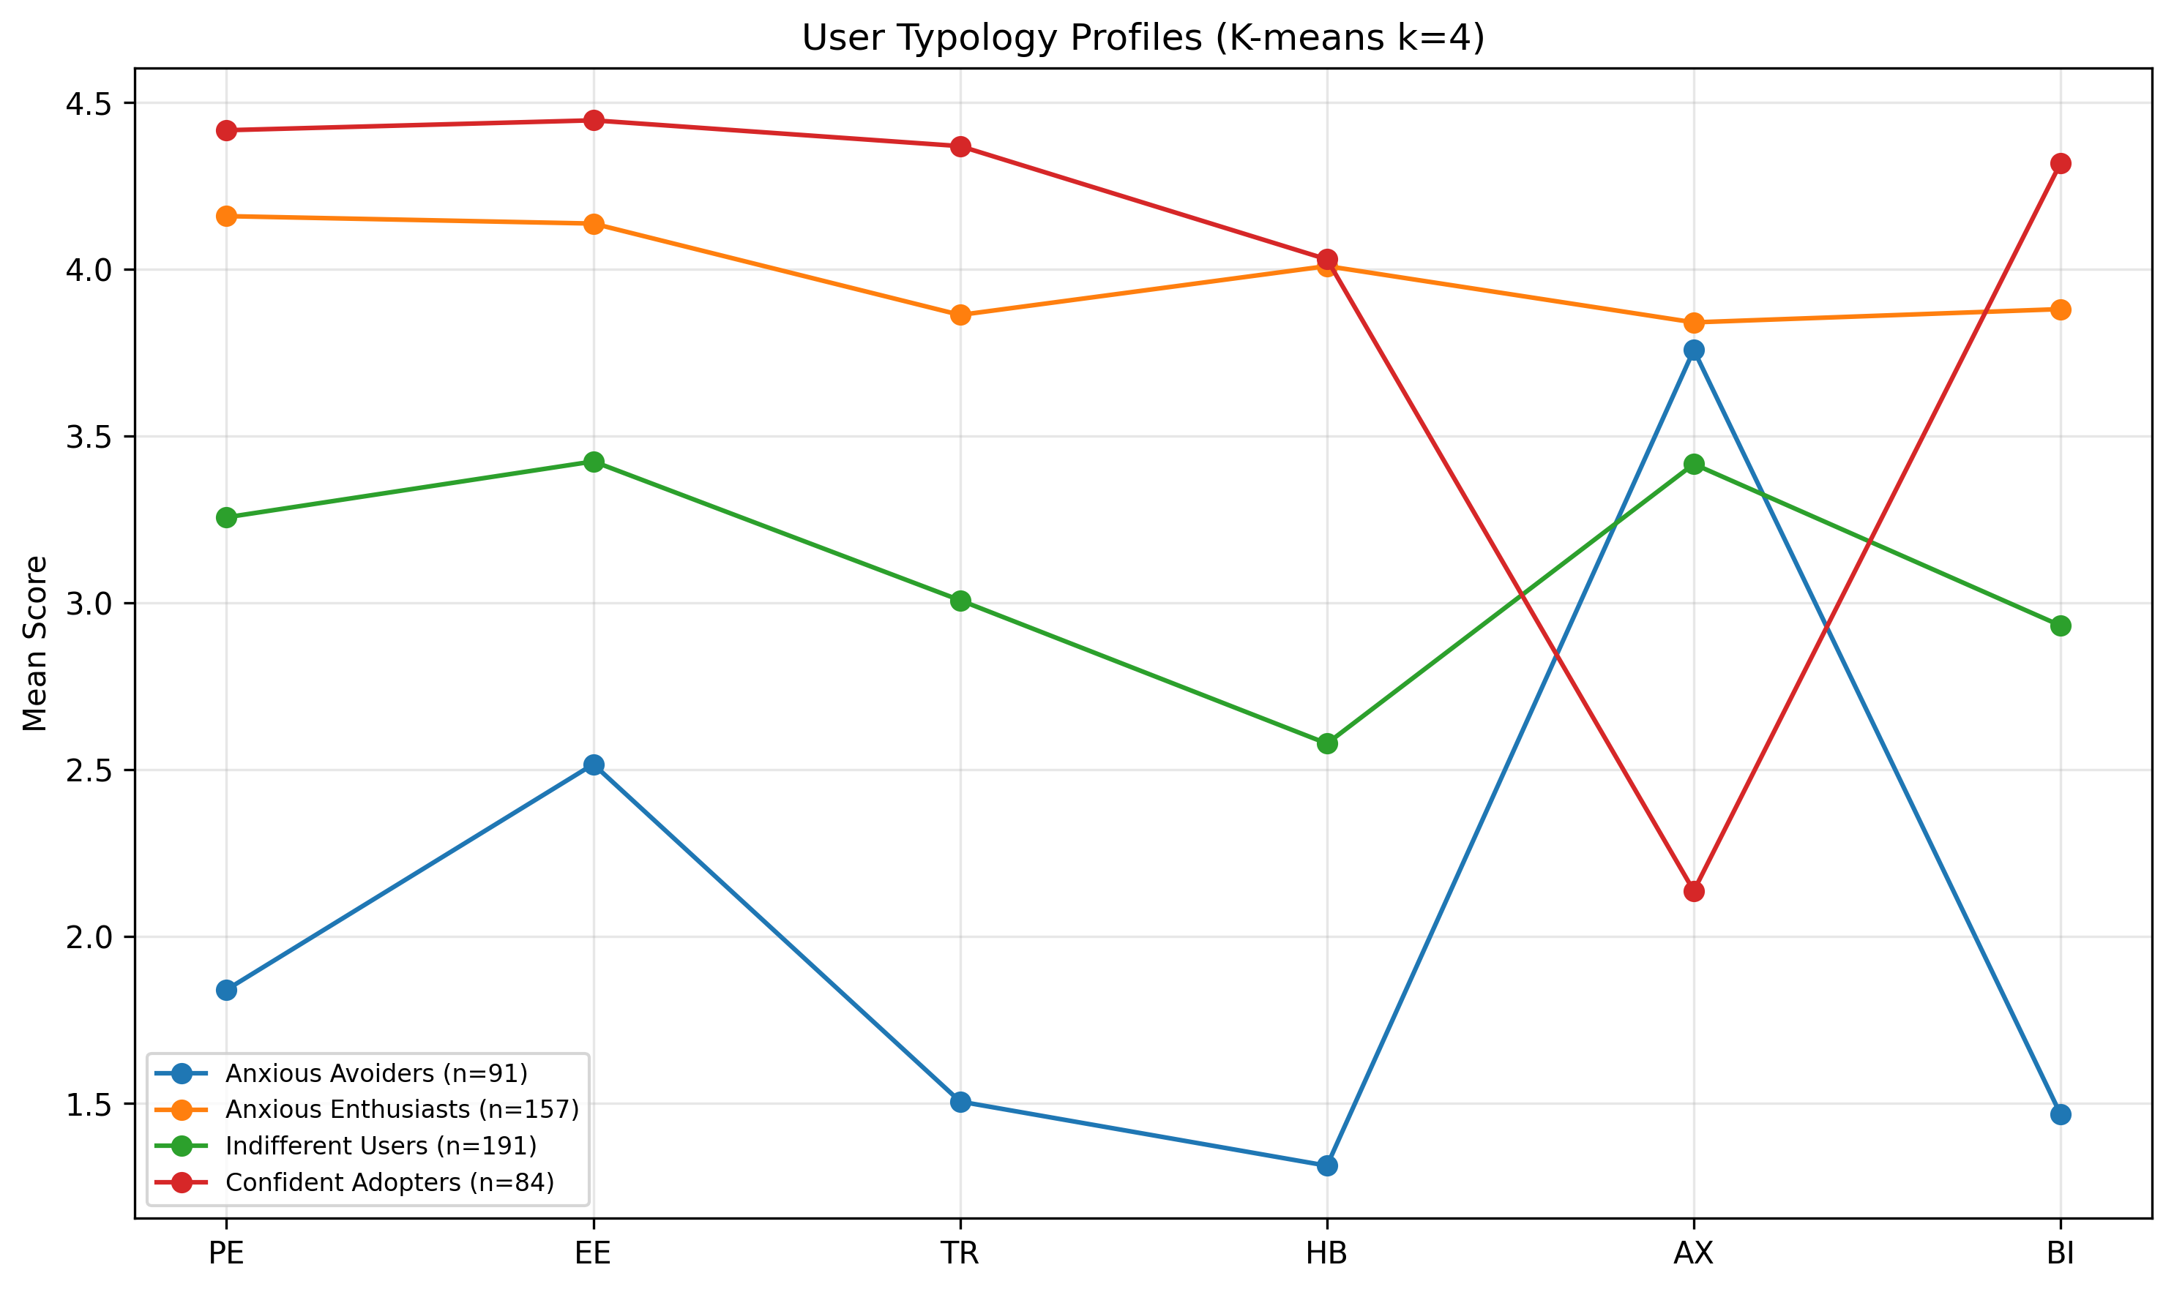
Three-segment user typology derived from cluster analysis. Segment sizes represent proportions of the sample, with distinct profiles across adoption readiness constructs. Source: Compiled by Author
Source: Compiled by Author

5.5 Implications for Practice
The findings offered insights for organizations navigating AI adoption challenges. As documented in §2.3, the gap between adoption and value realization represented a critical business challenge. While this study validated a measurement instrument rather than testing interventions, the empirical findings suggested several evidence-informed directions.
Important Scope Note: The AIRS diagnostic instrument validated in this study provided a psychometrically sound measure of AI adoption readiness constructs. The 8-factor structure enabled identification of specific adoption barriers (e.g., trust deficits, inadequate perceived value, low social influence) that could inform intervention design. The practical applications suggested below were hypotheses derived from the empirical findings. Future experimental research is needed to validate intervention effectiveness. The author’s research roadmap included developing formal AIRS Score algorithms, diagnostic protocols, and intervention frameworks as subsequent research phases.

5.5.1 For Organizations
Lead with Value, Not Capabilities: The dominance of Price Value (β = .505) over Performance Expectancy (ns) suggested a potential shift in how organizations might approach AI implementation communications. Rather than emphasizing AI capabilities and productivity promises, the findings suggested that demonstrating return on investment and cost-effectiveness might be more influential. Capgemini’s research supported this direction, finding that organizations redesigning workflows around AI, rather than simply adding AI to existing processes, achieved substantially higher returns (Capgemini Research Institute, 2025).
Consider Adoption Heterogeneity: The three-segment typology (§4.6) suggested that user populations varied systematically in their AI readiness profiles, with each segment potentially responding to different intervention approaches.
Leadership Engagement: Leaders in this study demonstrated the highest AI tool usage (d = 0.74–1.14). McKinsey’s research confirmed that organizations where senior leadership took ownership of AI initiatives were three times more likely to achieve value from their investments (McKinsey & Company, 2025). Visible leadership engagement might amplify adoption efforts.

5.5.2 For AI Tool Designers
Pricing strategy might significantly influence adoption, potentially more so than feature development. The dominance of Price Value suggested that pricing models (freemium tiers, transparent costs, usage-based billing) warranted careful attention. The significant Hedonic Motivation effect (β = .217) also suggested value in investing in enjoyable user experiences.

5.5.3 For Trainers and Educators
The AI Skeptics segment (22%), characterized by below-average scores across all adoption readiness constructs, suggested that training programs might benefit from addressing resistance barriers alongside technical skills. The disability-anxiety association (d = .36) highlighted the importance of accessibility-centered training design, addressing both physical accessibility (screen readers, motor-accessible interfaces) and neurodivergent considerations (predictable interactions, reduced cognitive load). These findings warranted experimental validation of targeted approaches in AI training contexts.

5.5.4 For Policy Makers
The validated AIRS diagnostic instrument provided a foundation for future organizational AI readiness assessment research. The 8-factor structure enabled identification of population-level adoption barriers that could inform workforce development policy. The differential anxiety findings (disability association d = .36) highlighted equity considerations in AI adoption policy that warranted further investigation.

5.5.5 Understanding the Adoption-Value Gap
The findings illuminated mechanisms that might have contributed to the adoption-value gap documented in §2.3:
- Value Communication Misalignment: Organizations might have led with capability demonstrations when users actually evaluated cost-benefit ratios. Future research should test whether value-focused messaging improves outcomes.
- Heterogeneous Readiness: One-size-fits-all approaches might have failed because user populations varied systematically. The three-segment typology provided a framework for intervention research.
- Neglected Affective Barriers: The AI Skeptics segment and marginal Trust effect suggested psychological barriers might have been underaddressed.
- Context-Inappropriate Frameworks: The shift from Performance Expectancy to Price Value dominance demonstrated why context-specific instruments were valuable.

5.6 Unexpected Findings

5.6.1 Performance Expectancy Non-Significance
The non-significance of Performance Expectancy was unexpected given its historical dominance in technology acceptance research. This finding suggested that AI adoption operated through different psychological mechanisms than conventional technology adoption, potentially because productivity benefits were now assumed rather than evaluated.

5.6.2 Dropped Constructs
Four proposed AI-specific constructs demonstrated inadequate reliability and were excluded from formal hypothesis testing:
Interpretation: Two-item scales proved insufficient for these multi-dimensional constructs. This represented an empirical finding about measurement complexity rather than theoretical invalidity. These constructs remained theoretically important for AI adoption and warranted revised measurement approaches in future research.
Future Development Recommendations: - For AI Anxiety specifically, future scales should distinguish between technology avoidance anxiety and fear-of-missing-out (FOMO) or obsolescence anxiety, as these represent conceptually distinct motivational orientations - Each excluded construct requires 3-4 items per sub-dimension to adequately capture its multi-faceted nature - Context-specific item development may be necessary for constructs like Ethical Risk, which may manifest differently across professional domains

5.6.3 Disability and Accessibility
Finding: Disability status was associated with higher AI-related anxiety responses (d = .36), based on exploratory analysis of original AX items prior to exclusion.
Interpretation: This unexpected finding highlighted accessibility considerations in AI adoption. The disability measure encompassed both physical disabilities (vision, mobility) and neurodivergence (ADHD, autism, dyslexia), so the specific mechanisms driving the anxiety association remain unclear. Possible explanations include: (a) concerns about AI accessibility for users with sensory or motor impairments, (b) neurodivergent users experiencing heightened cognitive load from unpredictable AI outputs, (c) fears of job displacement affecting workers who already face employment barriers, or (d) past negative experiences with technology designed without accessibility in mind. Future research should disaggregate by disability type to identify specific intervention targets. Inclusive AI design and training approaches are warranted.

5.7 Study Limitations Affecting Interpretation
Several limitations should be considered when interpreting these findings:

5.7.1 Methodological Limitations
- Cross-sectional design: The single time-point data collection precluded causal inference. While SEM estimates suggested directional relationships, alternative causal orderings (e.g., behavior -> intention) could not be ruled out.
- Self-reported intention: Behavioral Intention may not perfectly predict actual behavior. However, the strong BI-Usage correlation (ρ = .69) provided behavioral validation.
- Panel sampling: While Centiment’s topic-blinded recruitment mitigated self-selection bias, the United States panel sample limited generalizability to other countries, cultures, and organizational contexts.

5.7.2 Measurement Limitations
- Dropped constructs: The exclusion of four proposed constructs limited the comprehensiveness of the theoretical extension. The originally proposed mediation hypotheses involving Explainability and Ethical Risk could not be tested because these constructs were excluded during EFA due to inadequate reliability.
- Marginal AI Trust: Trust approached but did not reach significance (p = .064). This may have reflected inadequate statistical power (β = .106 requires n > 600 for 80% power at α = .05) or genuine marginality of trust in current AI adoption decisions.
- Western sample: Cultural generalizability was unknown. AI adoption attitudes might differ substantially in collectivist cultures or regions with different AI policy environments.

Chapter 6: Conclusions, Implications, and Recommendations

6.1 Introduction
This concluding chapter synthesized the contributions of this dissertation study and articulated its significance for both scholarly advancement and organizational practice. The chapter summarized the research purpose, methodology, and key findings; discussed theoretical and practical contributions; provided recommendations for practitioners and organizations; acknowledged limitations; suggested directions for future research; and offered closing remarks on the broader implications of this work for AI adoption in professional contexts.

6.2 Summary of Purpose, Methods, and Key Findings

6.2.1 Research Purpose
This study addressed a critical gap in technology acceptance research: the inadequacy of existing frameworks to explain AI-specific adoption patterns. While traditional models like UTAUT2 had demonstrated robust explanatory power for conventional technologies, the unique characteristics of AI systems (including opacity, probabilistic reasoning, and ethical implications) necessitated theoretical extension. The research purpose was twofold: (1) to develop and validate a psychometrically sound AI Readiness Scale (AIRS) extending UTAUT2 with AI-specific constructs, creating both a research scale and organizational diagnostic instrument, and (2) to identify the key drivers of AI adoption intention in professional and academic contexts.

6.2.2 Methodology Summary
The study employed a rigorous ten-phase psychometric validation approach:
- Sample Splitting: Created stratified EFA/CFA subsamples (n = 261/262) with random seed = 67 for reproducibility
- Exploratory Factor Analysis (n = 261): Identified the underlying factor structure through split-sample design
- Confirmatory Factor Analysis (n = 262): Cross-validated the measurement model on an independent holdout sample
- Measurement Invariance Testing: Established configural invariance across academic and professional populations (metric invariance not fully achieved)
- Structural Equation Modeling: Tested hypothesized relationships among latent constructs
- Mediation Analysis: Examined indirect effects within the structural model
- Moderation Analysis: Investigated experience and usage frequency as boundary conditions
- Behavioral Validation: Correlated intentions with actual AI tool usage patterns
- Qualitative Analysis: Automated content analysis of open-ended responses
- Comprehensive Review: Gap analysis and cross-validation of findings
- Final Synthesis: Integration of quantitative and qualitative insights
This multi-phase approach exceeded typical scale development standards and provided strong evidence for the AIRS instrument’s validity.

6.2.3 Key Findings
The study produced several significant findings that advanced both theory and practice:
Diagnostic Instrument Validation: The 8-factor, 16-item AIRS demonstrated excellent psychometric properties (CFI = .975, RMSEA = .065, α range .743-.909, all CR > .750, all AVE > .601) and configural invariance across populations. The 8-factor structure was selected over a more parsimonious 7-factor alternative because AI Trust provided essential diagnostic capability: practitioners could identify trust deficits and design targeted confidence-building interventions, a feature critical for translating research into organizational practice.
Adoption Drivers: The structural model explained 89.7% of variance in Behavioral Intention (R² = .897). Contrary to expectations from traditional UTAUT research, Price Value emerged as the dominant predictor (β = .505, p < .001), followed by Hedonic Motivation (β = .217, p = .014) and Social Influence (β = .136, p = .024). Bootstrap validation (1,000 resamples) confirmed Price Value as robust; Hedonic Motivation and Social Influence confidence intervals included zero, suggesting these effects were sensitive to sample composition. Traditional predictors including Performance Expectancy, Effort Expectancy, and Facilitating Conditions were not significant.
AI Trust Extension: AI Trust approached but did not reach conventional significance (β = .106, p = .064). The construct was retained as a diagnostic inclusion: detecting this effect size at 80% power required n > 600, and AI Trust provided unique diagnostic capability for identifying trust-specific adoption barriers that could not be captured by the other seven constructs. The 2026 transition toward agentic AI systems that act autonomously may elevate trust from a marginal to a dominant predictor in future research.
Moderator Effects: Professional experience strengthened the Hedonic Motivation -> Behavioral Intention path (β = .136, p = .007), suggesting that experienced professionals prioritized enjoyment in AI tool evaluation.
User Typology: Three distinct adoption segments were identified through cluster analysis (k=3, silhouette=0.271): AI Enthusiasts (31%), Moderate Users (47%), and AI Skeptics (22%), forming a readiness gradient that explained 65.9% of BI variance and providing a framework for future intervention research.

6.3 Theoretical Contributions
This dissertation made four primary contributions to technology acceptance theory:

6.3.1 UTAUT2 Extension for AI Contexts
The study extended UTAUT2 with AI-specific constructs, demonstrating that traditional technology acceptance frameworks required modification for AI adoption contexts. AI Trust was retained as a diagnostic inclusion rather than a structural claim: detecting β = .106 at 80% power required n > 600, and the construct provided essential organizational diagnostic capability. The shift from Performance Expectancy to Price Value dominance (detailed in §4.5) suggested that AI represented a theoretically distinct technology category.

6.3.2 Context-Specific Adoption Drivers
As discussed in §5.3.1, Price Value rather than Performance Expectancy drove AI adoption, a significant departure from prior research. Users evaluated AI tools through a value lens (“Is it worth it?”) rather than a utility lens (“Will it help me?”), with implications for both theory and organizational practice.

6.3.3 Career Development Integration
The experience moderation effect (§4.5.4) introduced career development as a relevant theoretical domain for technology acceptance research. As professionals advanced, intrinsic satisfaction became more important, suggesting adoption models should incorporate career-stage considerations.

6.3.4 User Typology Framework
The empirically-derived three-segment typology provided insights into adoption heterogeneity that can inform future intervention research. Rather than treating users as a homogeneous population, the clear readiness gradient, from high-engagement Enthusiasts (31%) through pragmatic Moderate Users (47%) to resistant Skeptics (22%), revealed that different psychological profiles may respond to different adoption strategies, a hypothesis warranting future experimental validation.

6.4 Practical and Managerial Implications

6.4.1 For Organizations Implementing AI
Value Demonstration Over Capability Showcasing: The dominance of Price Value suggests that organizations may benefit from demonstrating clear return on investment rather than simply highlighting AI capabilities. The findings indicate that employees’ cost-benefit mental models may be more influential than capability-focused messaging, a hypothesis warranting experimental validation in organizational contexts.
Segment-Specific Intervention Hypotheses: The three-segment typology (§4.6) provides a framework for tailored change management research. Preliminary hypotheses suggest that each segment might respond to different intervention approaches, from champion programs and advanced training for Enthusiasts, to ROI demonstrations for Moderate Users, to graduated exposure and psychological safety protocols for Skeptics, pending experimental validation.
Social Influence Leverage: The significant Social Influence effect (β = .136) suggests that peer influence matters for AI adoption. The findings indicate that visible AI champions and communities of practice may facilitate adoption, approaches that warrant experimental testing.
Experience-Sensitive Approaches: The moderation finding suggests that experienced professionals may respond differently to AI adoption messaging than newer employees. The findings indicate that senior staff may respond more to intrinsic satisfaction and intellectual engagement aspects of AI tools, while junior staff may respond more to value propositions and career development benefits, hypotheses requiring experimental validation.

6.4.2 For AI Tool Designers and Vendors
Pricing Model Innovation: The Price Value dominance suggests that pricing strategy significantly influences adoption. Freemium models, transparent pricing, and clear ROI documentation might be more important than feature development for driving adoption.
Trust-Building Features: AI Trust was marginally significant (p = .064), and its retention as a diagnostic inclusion reflects the theoretical expectation that trust considerations are emerging concerns in AI adoption. The findings indicate that explainability features, reliability demonstrations, and transparency mechanisms might address trust-related hesitation, a hypothesis for design research. As AI systems transition from tools to autonomous agents, trust requirements are expected to intensify.
Enjoyment-Focused Design: The Hedonic Motivation effect indicates that users value enjoyable experiences. The findings suggest that designing AI tools for engagement, not just utility, may enhance adoption, though experimental validation is needed.

6.4.3 For Trainers and Educators
Anxiety-Informed Pedagogy: The AI Skeptics segment (22%), characterized by below-average scores across all adoption readiness constructs, suggests that training programs might benefit from addressing resistance barriers before technical skills. Graduated exposure approaches, peer support, and psychological safety might be more effective when preceding capability training, though this hypothesis requires experimental validation.
Accessibility Considerations: The finding that disability status was associated with higher AI anxiety (d = .36) highlights the importance of inclusive AI training design. The disability measure captured both physical disabilities (vision, mobility) and neurodivergence (ADHD, autism, dyslexia), suggesting that accessibility considerations span multiple dimensions: screen reader compatibility and motor-accessible interfaces for users with sensory/physical disabilities, predictable interaction patterns for neurodivergent users, and reduced cognitive load for learners who experience technology anxiety. Training program development should address this full spectrum of accessibility needs.

6.4.4 For Policy Makers and Organizational Leaders
Workforce Readiness Research: The validated AIRS instrument provides a foundation for future organizational AI readiness assessment research. Policy makers may benefit from population-level assessments, though such applications require additional validation beyond the scope of this scale development study.
Equity Considerations: The differential anxiety findings suggest that AI adoption may create or exacerbate workforce inequities. The findings highlight the importance of ensuring that all employees, regardless of experience level, disability status, or initial anxiety, have equitable access to AI benefits.

6.5 Recommendations

6.5.1 Recommendations for Scholars
Based on the empirical findings and identified research gaps, the following recommendations are offered for the academic community:
- Replicate with larger samples: The marginal AI Trust effect (β = .106, p = .064) warrants replication with n > 600 to achieve adequate statistical power for detecting small-to-medium effects in AI adoption contexts.
- Develop improved AI-specific measures: The dropped constructs (Voluntariness, Explainability, Ethical Risk) represent important theoretical concepts that require more comprehensive operationalization with 3-4 items per sub-dimension and rigorous cognitive interviewing.
- Investigate Price Value dominance: The unexpected finding that Price Value rather than Performance Expectancy drove AI adoption merits theoretical attention. Scholars should explore whether this reflects AI’s unique characteristics or broader shifts in technology evaluation patterns.
- Examine career development integration: The significant experience moderation effect on Hedonic Motivation suggests that career development theory should be integrated with technology acceptance models. Longitudinal research linking career stages to adoption trajectories is warranted.
- Validate the user typology framework: The three-segment typology (AI Enthusiasts, Moderate Users, AI Skeptics) should be validated across populations and used to develop segment-specific theoretical models.
- Conduct cross-cultural research: The Western sample limits generalizability. Comparative studies in collectivist cultures, developing economies, and regions with different AI policy environments are essential for theory refinement.
- Apply longitudinal designs: Cross-sectional limitations preclude causal inference. Panel studies tracking intention-behavior relationships over 6-12 months will strengthen theoretical claims.

6.5.2 Recommendations for Practitioners
The following recommendations are offered with an important caveat: this study validated a measurement instrument and identified adoption drivers, but did not experimentally test interventions. The recommendations below represent evidence-informed hypotheses derived from the empirical findings, pending future intervention research:
- Consider baseline AIRS assessment before implementing AI initiatives to understand the distribution of adoption readiness in the population. The validated instrument can inform planning, though formal diagnostic protocols require additional development.
- Lead with value propositions rather than capability demonstrations. The dominance of Price Value (β = .505) over Performance Expectancy (ns) suggests communicating AI benefits in terms of time savings, cost reduction, and ROI rather than technical features.
- Attend to affective barriers: The 22% AI Skeptics segment (mean BI=1.71) and marginal Trust effect (β=.106, p=.064) suggest that emotional responses to AI warrant attention. Future research should test whether anxiety-reduction approaches (gradual exposure, peer support, psychological safety) improve adoption outcomes.
- Leverage social influence by identifying and supporting AI champions who can model positive adoption behaviors. Social Influence is a significant predictor (β = .136), suggesting peer effects matter.
- Differentiate by experience level: The significant experience moderation effect suggests that newer employees might weight different factors than senior professionals when evaluating AI tools.
- Monitor trust perceptions as AI applications become more consequential. The marginal Trust effect (p = .064) suggests that trust might become more important as AI moves into higher-stakes decision-making roles.
- Design for accessibility to ensure that AI adoption does not disadvantage employees with disabilities, whether physical (vision, mobility) or neurodivergent (ADHD, autism, dyslexia), who experience higher baseline technology anxiety (d = .36 disability-anxiety association).
- Consider segment heterogeneity: The three-segment user typology suggests that different groups might respond to different approaches. Experimental research is needed to determine whether segment-specific interventions outperform one-size-fits-all approaches.

6.6 Limitations of the Study
While this study employed rigorous methodology and produced sound findings, several limitations should be acknowledged:

6.6.1 Methodological Limitations
Cross-Sectional Design: The single time-point data collection precluded causal inference. While structural equation modeling suggested directional relationships, alternative causal orderings could not be ruled out. Longitudinal research was needed to establish temporal precedence.
Self-Reported Intention: Behavioral Intention did not perfectly predict actual behavior. However, the strong correlation between intention and self-reported usage (ρ = .69) provided behavioral validation.
Panel Sampling: While Centiment’s topic-blinded recruitment mitigated self-selection bias, the United States panel sample limited generalizability to other countries, cultures, and organizational contexts. Replication in diverse settings was recommended.

6.6.2 Measurement Limitations
Dropped Constructs: Four proposed AI-specific constructs (Voluntariness, Explainability, Ethical Risk, and AI Anxiety) demonstrated inadequate reliability (α = .301–.582) and were excluded from the validated model. This represented an empirical finding about measurement challenges rather than a design failure, but it limited the comprehensiveness of the theoretical extension.
Marginal AI Trust Effect: The Trust effect (β = .106, p = .064) did not reach conventional significance, possibly due to inadequate statistical power. Larger samples were required to detect this effect reliably.
Western Sample: Cultural generalizability was unknown. AI adoption attitudes might differ substantially in collectivist cultures or regions with different AI policy environments.

6.7 Recommendations for Future Research

6.7.0 2026 Contextual Developments
The October–November 2025 data collection positioned this AIRS validation as a pre-agentic baseline. Three developments in early 2026 create urgent research opportunities: (a) the open-source AI economics shift (exemplified by DeepSeek R1) may redefine what “price value” means when powerful AI becomes freely available; (b) the emergence of agentic AI systems that act autonomously, rather than responding to queries, fundamentally changes the trust equation, potentially elevating Trust from a marginal to a dominant predictor; and (c) the EU AI Act’s enforcement timeline introduces regulatory context as a moderator of adoption drivers. Longitudinal AIRS administration across this transition period would provide uniquely valuable data on how adoption psychology evolves as AI capabilities and governance frameworks mature.

6.7.1 Immediate Research Priorities
- Larger Sample Replication: Achieve n > 600 to provide adequate power (80%) for detecting small effects like the Trust coefficient (β ≈ .106).
- Dropped Construct Development: Redesign measures for Voluntariness, Explainability, Ethical Risk, and Anxiety sub-dimensions using 3-4 items per dimension and cognitive interviewing procedures.
- Longitudinal Validation: Track actual AI adoption behavior over 6-12 months following intention measurement to validate the intention-behavior pathway.
- Mediation Hypothesis Testing: With improved measures, test the originally hypothesized mediation paths through Explainability and Ethical Risk.

6.7.2 Extended Research Agenda and Future Hypotheses
The following research directions and testable hypotheses emerge from the empirical findings and the 2026 contextual developments:
- Cross-Cultural Validation: Replicate the AIRS in collectivist cultures, developing economies, and regions with different AI policy environments. Social Influence may become the dominant predictor in collectivist cultures, while Trust may strengthen significantly in regulated environments (EU AI Act).
- Industry-Specific Adaptation (H24): Examine whether AI adoption drivers differ across industries (e.g., healthcare, finance, education) where AI applications and risk profiles vary. Hypothesis: PV dominates in cost-sensitive sectors (education, SMB), Trust dominates in high-stakes sectors (healthcare, finance, legal). Design: multi-sector sample, 200+ per industry × 4 industries.
- Intervention Effectiveness Studies (H21): Design and evaluate segment-specific interventions based on the user typology framework. Hypothesis: the 3 empirical clusters (Enthusiasts, Moderate Users, Skeptics) respond differentially to targeted interventions, enabling more efficient allocation of training budgets. Design: RCT with 3 intervention types × 3 segments.
- Accessibility Research: Investigate the mechanisms underlying the disability-anxiety association. Because the disability measure aggregated physical disabilities and neurodivergence, future research should disaggregate by disability type to identify whether specific accessibility barriers (sensory, motor, cognitive) drive the anxiety effect, enabling targeted intervention development.
- Agentic Trust Escalation (H9): As AI transitions from tool to autonomous agent, Trust may shift from marginal (β ≈ .10) to dominant predictor (β > .30) of Behavioral Intention. Design: compare AIRS factor weights for query-based AI versus agentic AI contexts.
- Open-Source Value Reframing (H10): In free/open-source AI contexts, PV’s meaning may shift from monetary cost to time/effort investment, maintaining its predictive dominance through semantic evolution. Design: compare AIRS in paid versus free AI tool contexts.
- Temporal Construct Drift (H14): The relative importance of AIRS factors may shift predictably over a 12-month period as AI matures in the organizational context. Design: longitudinal panel with AIRS administered at baseline, 6 months, and 12 months (n > 600).
- Anxiety Sub-Dimensionality (H16): AI Anxiety comprises at least 3 distinct dimensions (avoidance anxiety, obsolescence anxiety (Kim et al., 2025), and anticipatory anxiety (Frenkenberg & Hochman, 2025)), each with differential effects on Behavioral Intention. Design: develop 9–12 item AX scale (3 items × 3–4 dimensions).
- AIRS Score Predictive Validity (H22): Baseline AIRS composite scores predict actual AI tool adoption rates at 6-month follow-up with r > .50. This would validate AIRS as a practical pre-deployment assessment instrument.
- 3-Item Scale Improvement (H20): Expanding from 2 to 3 items per factor (AIRS-28) will resolve discriminant validity violations in the PE/HM/PV triad while maintaining fit. Design: 28-item CFA comparison with the current 16-item model.
- Longitudinal Acceptance Tracking: Recent evidence revealed that public sentiment toward AI had shifted post-ChatGPT, with “not acceptable” responses increasing from 23% to 30% in one year (Baumann et al., 2025). This suggested the need for longitudinal AIRS studies tracking how individual adoption factors changed as AI technologies matured and social discourse evolved.

6.7.3 Research Roadmap: From Validated Scale to Organizational Applications
This dissertation established the AIRS as a validated diagnostic instrument. The 8-factor structure already enables identification of specific adoption barriers; the following roadmap outlines the research program required to develop formalized protocols for organizational applications:
Phase 1: AIRS-28 Development and Score Validation (2026–2027)
- Expand from 16 to 28 items: add a 3rd item to each existing factor (8 × 3 = 24 items) and reintroduce AI Anxiety as a 4-item sub-dimensional scale (avoidance, obsolescence, anticipatory, FOMO). Expected outcome: resolve discriminant validity violations in the PE/HM/PV triad, recover the AX construct, and maintain excellent fit
- Develop a scoring algorithm that transforms raw item responses into interpretable individual and organizational readiness scores
- Establish normative benchmarks across populations (academics, professionals, leaders)
- Create percentile rankings and readiness classifications (e.g., “emerging,” “developing,” “proficient,” “advanced”)
- Validate score interpretations through criterion-related validity studies linking scores to actual adoption outcomes
- Practitioner value: a 28-item instrument takes ~7 minutes to administer (vs. ~4 for 16 items) while providing substantially richer diagnostic profiles
Phase 2: Longitudinal Panel Study and Diagnostic Protocol Development (2026–2027)
- Administer AIRS at 3 time points (baseline, 6 months, 12 months) with n > 600 to resolve power issues for Trust detection, test temporal construct drift (H14), and validate predictive utility (H22)
- Design administration protocols for organizational AI readiness assessment
- Develop reporting frameworks that translate AIRS results into actionable organizational insights
- Pilot diagnostic protocols with partner organizations
- Capture the pre-agentic to agentic AI transition in real time
- Practitioner value: provides normative benchmarks, validates AIRS as a pre-deployment assessment tool, and establishes temporal stability/change patterns
Phase 2b: Cross-Cultural Validation (2027–2028)
- Replicate AIRS in collectivist cultures (East Asia, Latin America), regulatory-intensive environments (EU), developing economies, and non-English languages
- Translation, back-translation, and measurement invariance testing
- Practitioner value: multinational organizations need culturally validated assessment tools; current AIRS is US-only

6.7.4 Appropriate Reliance Research
Critically, adoption readiness represents only the first step in effective AI integration. Microsoft’s AETHER group synthesized appropriate reliance research around two core constructs (Passi et al., 2024): Capability-Appropriate Reliance on AI (CAIR), matching human reliance to actual AI capability, and Context-Sensitive Reliance (CSR), adapting behavior based on situational factors like stakes and uncertainty. The New Future of Work Report further cautioned that interventions designed to improve AI acceptance might inadvertently increase over-reliance (Butler et al., 2025), creating a paradox: successfully deploying AI through AIRS-identified pathway optimizations may set the stage for over-reliance problems.
Future research should therefore extend beyond the adoption decision to investigate:
- AIRS-to-Reliance Calibration: Do individuals with higher Price Value scores rely more appropriately on AI outputs? Does the marginal Trust effect (β = .106) predict reliance calibration quality?
- Segment-Specific Reliance Patterns: Do the three user segments (AI Enthusiasts, Moderate Users, AI Skeptics) exhibit different over-reliance or under-reliance tendencies?
- Intervention Sequencing: Determine whether appropriate reliance training should precede, accompany, or follow adoption interventions to optimize both willingness and calibration.
- Establish reliability of organizational-level aggregated scores
Phase 3: Intervention Framework Development (2028–2029)
- Design experimental studies testing segment-specific interventions (H21):
  - AI Enthusiasts: Champion programs, advanced training, early access to emerging tools
  - Moderate Users: ROI demonstrations, use-case targeting, value-focused messaging
  - AI Skeptics: Graduated exposure protocols, psychological safety, peer support, anxiety reduction
- Conduct randomized controlled trials to establish intervention effectiveness
- Develop practitioner guides for evidence-based intervention selection
- Test industry moderation effects (H24) across healthcare, education, finance, and technology sectors
Phase 4: Comprehensive AI Readiness System (2029+)
- Integrate validated AIRS Score, diagnostic protocols, and intervention frameworks into a comprehensive organizational AI readiness system
- Develop longitudinal tracking capabilities for monitoring readiness progression
- Create industry-specific adaptation guidelines
- Establish training and certification for AIRS practitioners
This roadmap positions the current validated scale as the essential foundation for a research-to-practice pipeline that can ultimately deliver the diagnostic and intervention tools that organizations need to close the AI adoption-value gap.

6.8 Closing Remarks
This dissertation addressed a timely challenge: understanding why individuals adopt or resist AI tools in professional contexts. As documented throughout this study, the gap between AI adoption rates and value realization demanded scholarly attention.
The findings revealed that AI adoption operated through different mechanisms than previous technology adoption. The dominance of Price Value, the significant role of Hedonic Motivation, and experience as a moderator suggested that AI represented a distinct technology category. Users evaluated AI tools through a value-and-enjoyment lens rather than a pure utility lens, a finding with implications for organizational practice.
The validated AIRS diagnostic instrument provided researchers with a psychometrically sound foundation for investigating AI adoption. The 8-factor structure enabled organizations to identify specific adoption barriers, whether trust deficits, inadequate perceived value, or social influence gaps, and to design targeted interventions. The three-segment typology offered preliminary evidence of adoption heterogeneity warranting experimental investigation. The theoretical extensions contributed to scholarly conversations about how technology acceptance models must evolve.
As AI transformed professional work, understanding adoption psychology became critical. This dissertation established a validated foundation that could enable future diagnostic tools, intervention protocols, and assessment systems. The path forward required continued research, experimental studies, and commitment to inclusive adoption benefiting all members of the workforce.

References
Ajzen, I. (1991). The theory of planned behavior. Organizational Behavior and Human Decision Processes, 50(2), 179–211. https://doi.org/10.1016/0749-5978(91)90020-T
Baumann, J., Urman, A., Leicht-Deobald, U., Roman, Z. J., Hannák, A., & Christen, M. (2025). Reduced AI acceptance after the generative AI boom: Evidence from a two-wave survey study. arXiv Preprint arXiv:2510.23578.
Blut, M., Chong, A., Tsigna, Z., & Venkatesh, V. (2022). Meta-analysis of the unified theory of acceptance and use of technology (UTAUT): Challenging its validity and charting a research agenda in the red ocean. Journal of the Association for Information Systems, 23(1), 13–95. https://doi.org/10.17705/1jais.00719
Boston Consulting Group. (2024). AI at scale: Overcoming the barriers to enterprise AI adoption [Research Report]. Boston Consulting Group. https://www.bcg.com/publications/2024/overcoming-barriers-to-enterprise-ai-adoption
Boston Consulting Group. (2025). The widening AI value gap: Why only 5 percent of companies realize measurable returns from AI [Research Report]. Boston Consulting Group. https://www.bcg.com/publications/2025/widening-ai-value-gap
Braun, V., & Clarke, V. (2006). Using thematic analysis in psychology. Qualitative Research in Psychology, 3(2), 77–101. https://doi.org/10.1191/1478088706qp063oa
Butler, J., Jaffe, S., Janssen, R., et al. (2025). New future of work report 2025 (Nos. MSR-TR-2025-58). Microsoft. https://www.microsoft.com/en-us/research/publication/new-future-of-work-report-2025/
Capgemini Research Institute. (2025). AI in action: How generative AI and agentic AI redefine business operations [Research Report]. Capgemini Research Institute. https://www.capgemini.com/research/ai-in-action-2025
Centiment. (2024). IRB approval FAQ: How do we notify respondents of a survey?
urlhttps://help.centiment.co/irb-approval-faq.
Chen, F. F. (2007). Sensitivity of goodness of fit indexes to lack of measurement invariance. Structural Equation Modeling, 14(3), 464–504. https://doi.org/10.1080/10705510701301834
Clark, L. A., & Watson, D. (1995). Constructing validity: Basic issues in objective scale development. Psychological Assessment, 7(3), 309–319. https://doi.org/10.1037/1040-3590.7.3.309
Cohen, J. (1988). Statistical power analysis for the behavioral sciences (2nd ed.). Lawrence Erlbaum Associates.
Costello, A. B., & Osborne, J. W. (2005). Best practices in exploratory factor analysis: Four recommendations for getting the most from your analysis. Practical Assessment, Research, and Evaluation, 10(7), 1–9. https://doi.org/10.7275/jyj1-4868
Creswell, J. W., & Clark, V. L. P. (2017). Designing and conducting mixed methods research (3rd ed.). SAGE Publications.
Creswell, J. W., & Creswell, J. D. (2018). Research design: Qualitative, quantitative, and mixed methods approaches (5th ed.). SAGE Publications.
Davis, F. D. (1989). Perceived usefulness, perceived ease of use, and user acceptance of information technology. MIS Quarterly, 13(3), 319–340. https://doi.org/10.2307/249008
Deloitte. (2024). State of generative AI in the enterprise (2nd ed.) [Research Report]. Deloitte Insights. https://www.deloitte.com/insights/state-of-generative-ai
DeVellis, R. F. (2016). Scale development: Theory and applications (4th ed.). SAGE Publications.
DeVellis, R. F., & Thorpe, C. T. (2021). Scale development: Theory and applications (5th ed.). SAGE Publications.
Doshi-Velez, F., & Kim, B. (2017). Towards a rigorous science of interpretable machine learning. arXiv Preprint arXiv:1702.08608.
Dwivedi, Y. K., Hughes, L., Ismagilova, E., Aarts, G., Coombs, C., Crick, T., Duan, Y., Dwivedi, R., Edwards, J., Eirug, A., et al. (2021). Artificial intelligence (AI): Multidisciplinary perspectives on emerging challenges, opportunities, and agenda for research, practice and policy. International Journal of Information Management, 57, 101994. https://doi.org/10.1016/j.ijinfomgt.2019.08.002
Floridi, L., Cowls, J., Beltrametti, M., Chatila, R., Chazerand, P., Dignum, V., Luetge, C., Madelin, R., Pagallo, U., Rossi, F., et al. (2018). AI4People—an ethical framework for a good AI society: Opportunities, risks, principles, and recommendations. Minds and Machines, 28(4), 689–707. https://doi.org/10.1007/s11023-018-9482-5
Fornell, C., & Larcker, D. F. (1981). Evaluating structural equation models with unobservable variables and measurement error. Journal of Marketing Research, 18(1), 39–50. https://doi.org/10.2307/3151312
Frenkenberg, M., & Hochman, O. (2025). Anticipatory AI anxiety: A new dimension of technology-related anxiety. Cyberpsychology, Behavior, and Social Networking.
Gartner. (2025). How your CEO is thinking about AI: The rise of responsible AI leadership [Executive Report]. Gartner. https://www.gartner.com/en/documents/how-your-ceo-is-thinking-about-ai-2025
Georgian & NewtonX. (2025). AI benchmark 2025: Enterprise and growth-stage adoption trends [Benchmark Report]. Georgian Partners. https://www.georgian.io/research/ai-benchmark-2025
Glikson, E., & Woolley, A. W. (2020). Human trust in artificial intelligence: Review of empirical research. Academy of Management Annals, 14(2), 627–660. https://doi.org/10.5465/annals.2018.0057
Hair, J. F., Black, W. C., Babin, B. J., & Anderson, R. E. (2019). Multivariate data analysis (8th ed.). Cengage.
Henseler, J., Ringle, C. M., & Sarstedt, M. (2015). A new criterion for assessing discriminant validity in variance-based structural equation modeling. Journal of the Academy of Marketing Science, 43(1), 115–135. https://doi.org/10.1007/s11747-014-0403-8
Hinkin, T. R. (1998). A brief tutorial on the development of measures for use in survey questionnaires. Organizational Research Methods, 1(1), 104–121. https://doi.org/10.1177/109442819800100106
Horn, J. L. (1965). A rationale and test for the number of factors in factor analysis. Psychometrika, 30(2), 179–185. https://doi.org/10.1007/BF02289447
IBM. (2023). Global AI adoption index 2023: Enterprise trends and insights [Survey Report]. IBM. https://newsroom.ibm.com/global-ai-adoption-index-2023
Information Services Group. (2025). State of enterprise AI adoption report 2025 [Research Report]. ISG. https://www.isg-one.com/research/enterprise-ai-adoption-2025
Kim, J., Kim, H., & Park, S. (2025). AI anxiety in knowledge workers: Dimensions and measurement. Computers in Human Behavior.
Kline, R. B. (2016). Principles and practice of structural equation modeling (4th ed.). Guilford Press.
Langer, M., König, C. J., & Fitili, A. (2023). The effects of transparency on trust in and acceptance of a content-based art recommender. Computers in Human Behavior Reports, 9, 100262. https://doi.org/10.1016/j.chbr.2023.100262
Lucidworks. (2025). 2025 generative AI global benchmark: Agentic systems and governance insights [Benchmark Report]. Lucidworks. https://www.lucidworks.com/research/2025-generative-ai-benchmark
Marsh, H. W., Hau, K.-T., Balla, J. R., & Grayson, D. (1998). Is more ever too much? The number of indicators per factor in confirmatory factor analysis. Multivariate Behavioral Research, 33(2), 181–220. https://doi.org/10.1207/s15327906mbr3302_1
McKinsey & Company. (2024). The state of AI in early 2024: Gen AI adoption spikes and starts to generate value [Survey Report]. McKinsey Global Institute. https://www.mckinsey.com/capabilities/quantumblack/our-insights/the-state-of-ai
McKinsey & Company. (2025). The state of AI in 2025: Building the AI-powered organization [Survey Report]. McKinsey Global Institute. https://www.mckinsey.com/capabilities/mckinsey-digital/our-insights/the-state-of-ai-in-2025
Messick, S. (1995). Validity of psychological assessment: Validation of inferences from persons’ responses and performances as scientific inquiry into score meaning. American Psychologist, 50(9), 741–749. https://doi.org/10.1037/0003-066X.50.9.741
MIT Media Lab. (2025). The GenAI divide: State of enterprise AI in 2025 [Research Report]. MIT Media Lab. https://www.media.mit.edu/research/genai-divide-2025
Passi, S., Dhanorkar, S., & Vorvoreanu, M. (2024). Why does appropriate reliance on GenAI matter? A research synthesis. Microsoft Research AETHER UX Research & Education.
Rogers, E. M. (2003). Diffusion of innovations (5th ed.). Free Press.
Schuetz, S., & Venkatesh, V. (2020). Research perspectives: The rise of human machines: How cognitive computing systems challenge assumptions of user-system interaction. Journal of the Association for Information Systems, 21(2), 460–482. https://doi.org/10.17705/1jais.00608
Shin, D. (2021). The effects of explainability and causability on perception, trust, and acceptance: Implications for explainable AI. International Journal of Human-Computer Studies, 146, 102551. https://doi.org/10.1016/j.ijhcs.2020.102551
Siau, K., & Wang, W. (2018). Building trust in artificial intelligence, machine learning, and robotics. Cutter Business Technology Journal, 31(2), 47–53.
Stevens, C. J., & Stetson, G. (2023). Trust and acceptance of AI technology (TrAAIT) scale: Development and validation. Technology in Society, 74, 102310. https://doi.org/10.1016/j.techsoc.2023.102310
Super, D. E. (1980). A life-span, life-space approach to career development. Journal of Vocational Behavior, 16(3), 282–298. https://doi.org/10.1016/0001-8791(80)90056-1
Tao, W., He, P., Wang, Y., & Yao, Q. (2020). Development and validation of the AI anxiety scale.
Venkatesh, V. (2021). Adoption and use of AI tools: A research agenda grounded in UTAUT. Annals of Operations Research, 1–12. https://doi.org/10.1007/s10479-020-03918-9
Venkatesh, V., Morris, M. G., Davis, G. B., & Davis, F. D. (2003). User acceptance of information technology: Toward a unified view. MIS Quarterly, 27(3), 425–478. https://doi.org/10.2307/30036540
Venkatesh, V., Thong, J. Y. L., & Xu, X. (2012). Consumer acceptance and use of information technology: Extending the unified theory of acceptance and use of technology. MIS Quarterly, 36(1), 157–178. https://doi.org/10.2307/41410412
Winter, J. C. F. de, Dodou, D., & Wieringa, P. A. (2009). Exploratory factor analysis with small sample sizes. Multivariate Behavioral Research, 44(2), 147–181. https://doi.org/10.1080/00273170902794206
Yin, R. K. (2018). Case study research and applications: Design and methods (6th ed.). SAGE Publications.

Appendices

Appendix A: AI Readiness Scale (AIRS) Final 16-Item Diagnostic Instrument
The final validated 16-item AIRS diagnostic instrument consisted of eight constructs measured using a 5-point Likert scale (1 = Strongly Disagree to 5 = Strongly Agree). The 8-factor structure enabled both research applications and organizational diagnostic use: practitioners could identify specific adoption barriers (e.g., trust deficits, inadequate perceived value, low social influence) and design targeted interventions.

Performance Expectancy (PE)
- PE1: AI tools help me accomplish tasks more quickly.
- PE2: Using AI improves the quality of my work or studies.

Effort Expectancy (EE)
- EE1: Learning to use AI tools is easy for me.
- EE2: Interacting with AI tools is clear and understandable.

Social Influence (SI)
- SI1: People whose opinions I value encourage me to use AI tools.
- SI2: Leaders in my organization or school support the use of AI tools.

Facilitating Conditions (FC)
- FC1: I have access to training or tutorials for the AI tools I use.
- FC2: The AI tools I use are compatible with other tools or systems I use.

Hedonic Motivation (HM)
- HM1: Using AI tools is stimulating and engaging.
- HM2: AI tools make my work or studies more interesting.

Price Value (PV)
- PV1: I get more value from AI tools than the effort they require.
- PV2: Using AI tools is worth the learning curve.

Habit (HB)
- HB1: Using AI tools has become a habit for me.
- HB2: I tend to rely on AI tools by default when I need help with tasks.

Trust in AI (TR)
- TR1: I trust AI tools to provide reliable information.
- TR2: I trust the AI tools that are available to me.

Appendix B: Survey Materials

B.1 Participant Information Sheet
The online survey was administered via Centiment following institutional ethics approval. Self-selection bias was mitigated through Centiment’s platform-level recruitment design: survey invitations to panel members display only the estimated completion time and reward amount, with the survey topic deliberately concealed "in order to avoid selection bias" (Centiment, 2024). After accessing the survey link, participants received full disclosure about the AI focus through the informed consent form, which described the study purpose, voluntary participation, data confidentiality, and right to withdraw at any time without penalty. This two-stage approach (blinded recruitment followed by informed consent) ensured ethical transparency while reducing systematic bias in participant self-selection.

B.2 Informed Consent Form
Electronic informed consent was obtained prior to survey administration. Participants confirmed they were 18 years or older, understood the study purpose, and agreed to participate voluntarily. Consent was recorded through affirmative response before access to survey items.

B.3 Demographic Questions
Demographic items collected included:
- Role: Current employment/student status (Full-time student, Part-time student, Employed - individual contributor, Employed - manager, Employed - executive, Freelancer/self-employed, Not currently employed, Other)
- Education: Highest level completed (High school or less, Some college/vocational, Associate’s degree, Bachelor’s degree, Master’s degree, Doctoral/professional degree)
- Industry: Primary field of work or study (Technology/IT, Healthcare, Education, Finance/Banking, Manufacturing, Government/Public sector, Retail/Hospitality, Nonprofit, Other)
- Experience: Years of experience in field (Less than 1 year, 1-3 years, 4-6 years, 7-10 years, 11 or more years)
- Disability Status: Self-disclosed (Yes, No, Prefer not to say)
- AI Tool Usage: Frequency of use for Microsoft Copilot, ChatGPT, Google Gemini, and other AI tools (Never, Rarely, Sometimes, Often, Very Often)

Appendix C: Supplementary Statistical Tables

C.1 Construct Reliability Summary

C.2 Model Fit Indices Summary

C.3 Constructs Removed During Validation

Appendix D: Supplementary Figures
This appendix presented additional visualizations from the empirical analysis that supported the findings reported in Chapters 4 and 5.

D.1 Sample Preparation
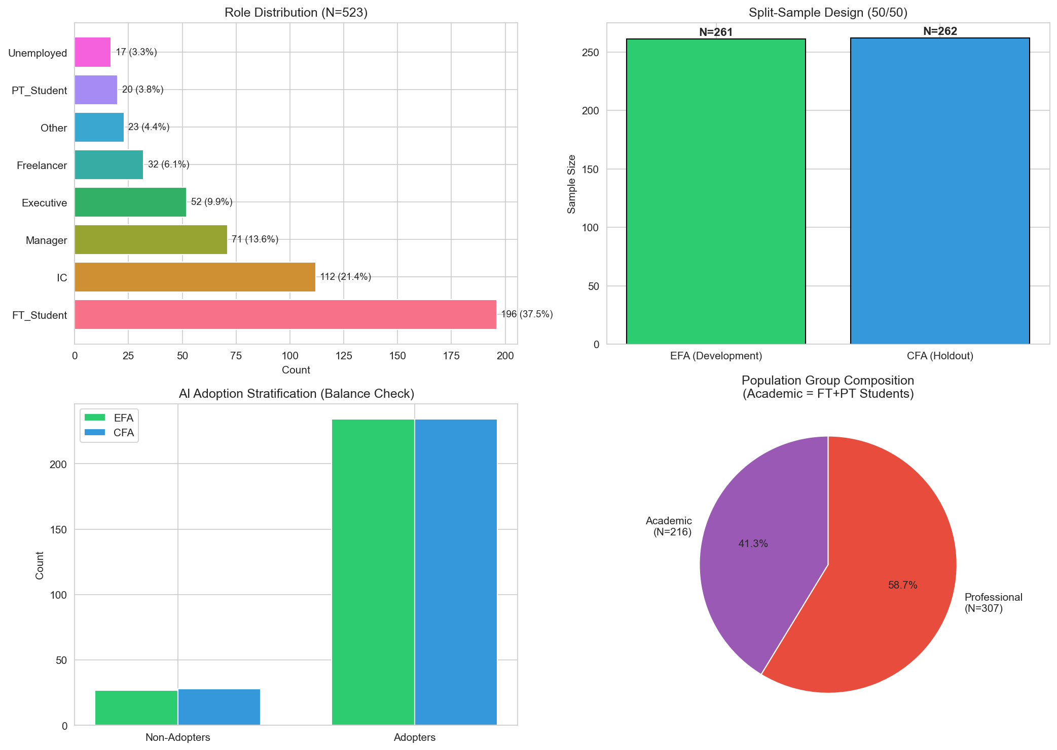
Figure D.1: Overview of sample preparation process, including data cleaning, split-sample design, and final sample composition across academic and professional populations.
Source: Compiled by Author

D.2 AI Tool Usage Patterns
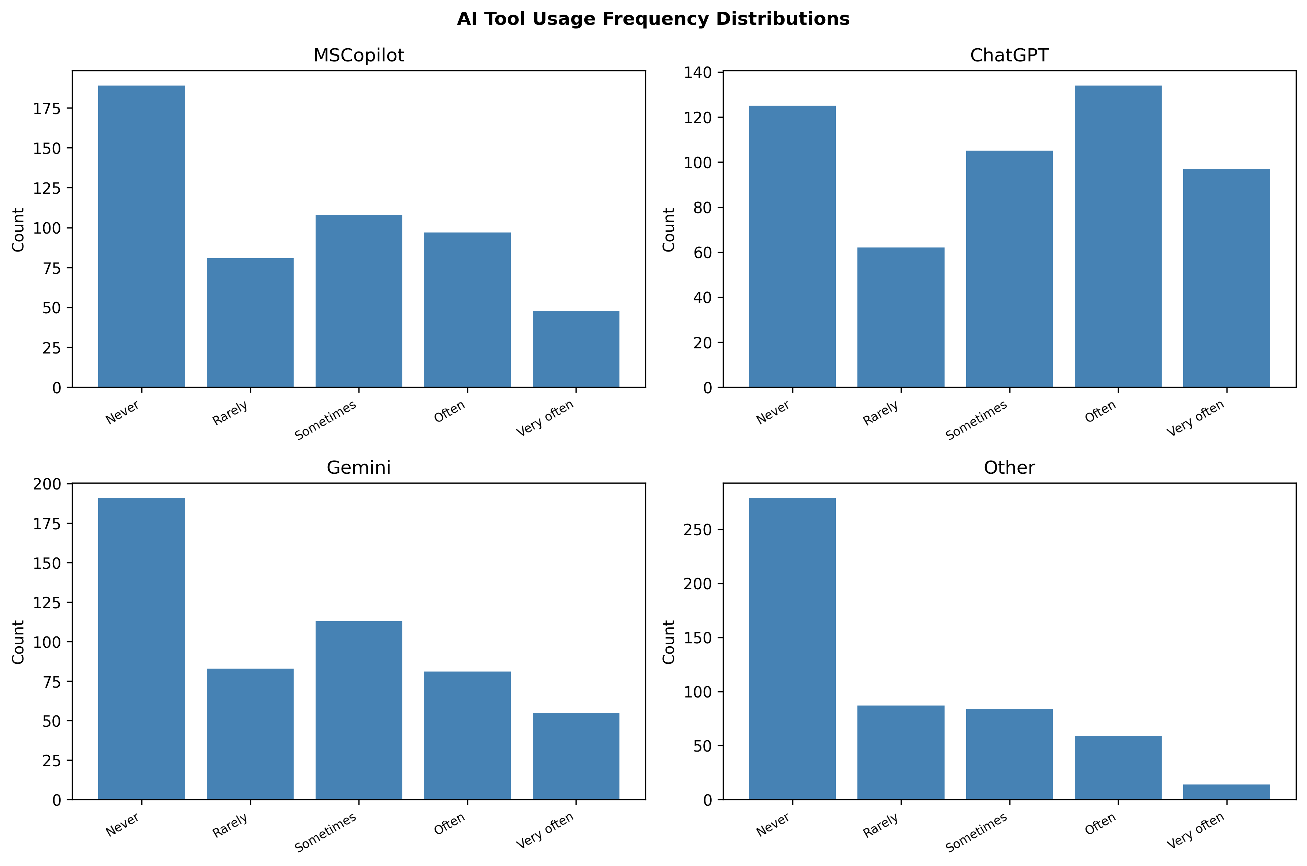
Figure D.2: Distribution of AI tool usage frequency across the sample. ChatGPT demonstrates the highest adoption rates, followed by Microsoft Copilot and Google Gemini.
Source: Compiled by Author

D.3 Disability and AI Anxiety
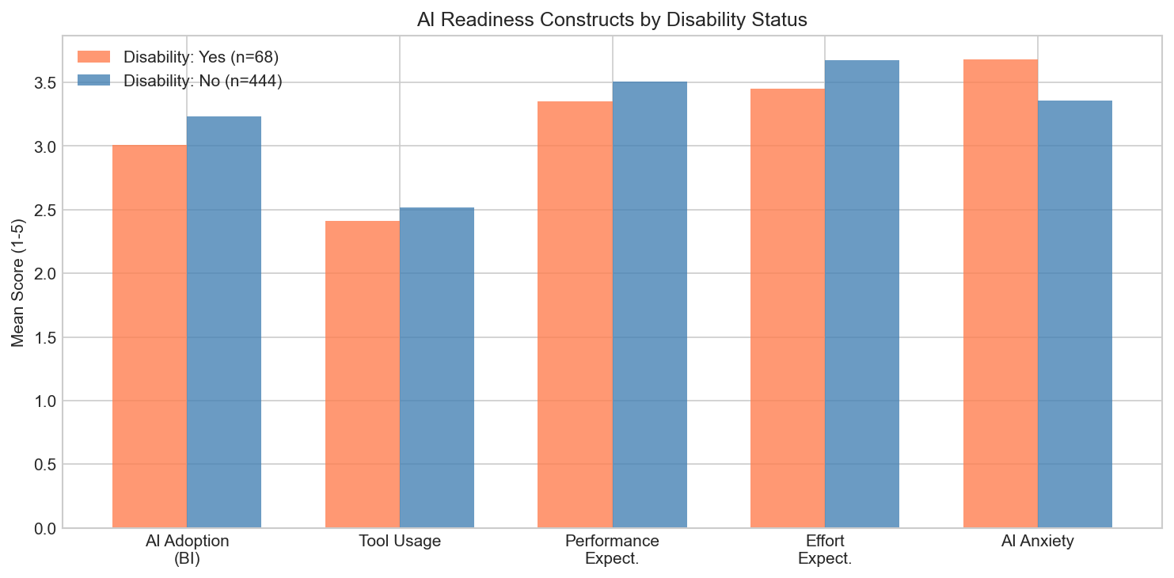
Figure D.3: Comparison of AI anxiety levels between participants with and without disclosed disabilities. Effect size d = .36 indicates moderate elevation of anxiety for participants with disabilities.
Source: Compiled by Author

Appendix E: AIRS Research Roadmap and Future Applications
This appendix outlined the research program envisioned to extend the validated AIRS diagnostic instrument into practical organizational applications. The 8-factor structure already enabled identification of specific adoption barriers; this roadmap represented a multi-phase research agenda to develop formalized protocols that built systematically on the foundation established in this dissertation.

E.1 Research Program Overview
The AI Readiness Scale (AIRS) validated in this dissertation represented Phase 0 of a comprehensive research program aimed at bridging the gap between AI adoption measurement and organizational AI maturity. The 8-factor diagnostic structure was selected over a more parsimonious 7-factor model because AI Trust provided essential diagnostic capability: organizations could identify trust deficits and design targeted interventions. The roadmap below outlined subsequent research phases, each requiring independent empirical validation.

E.2 Phase 1: AIRS Score Development
Research Objective: Develop a scoring methodology that transforms raw AIRS responses into interpretable individual readiness scores with established normative benchmarks.
Key Research Questions:
- How should construct scores be weighted to optimize predictive validity?
- What normative distributions exist across student, professional, and leadership populations?
- What classification system best communicates readiness levels to practitioners?

E.3 Phase 2: Organizational Diagnostics
Research Objective: Develop validated protocols for assessing AI readiness at team and organizational levels.
Key Research Questions:
- What aggregation methods preserve construct validity at organizational levels?
- Do organizational readiness profiles predict AI implementation success?
- What reporting formats maximize practitioner utility?

E.4 Phase 3: Intervention Research
Research Objective: Design and empirically test segment-specific interventions based on the user typology framework.
The three-segment typology identified in this dissertation (AI Enthusiasts 31%, Moderate Users 47%, AI Skeptics 22%) suggested that different user populations might respond to different intervention approaches. Future research should employ randomized controlled trials to test whether segment-matched interventions outperform generic approaches.
Key Research Questions:
- Do segment-specific interventions outperform one-size-fits-all approaches?
- What intervention components drive segment-specific effectiveness?
- Do intervention effects persist over 6-12 month follow-up periods?

E.5 Phase 4: Comprehensive AI Readiness Ecosystem
Research Objective: Develop an integrated system combining validated assessment, diagnostics, and intervention protocols.
Long-Term Vision:
- Longitudinal Tracking: Systems for monitoring organizational AI readiness progression
- Industry Adaptations: Validated modifications for healthcare, finance, education, and manufacturing contexts
- Cross-Cultural Validation: Replication across collectivist cultures, developing economies, and varying policy environments
- Practitioner Resources: Administration guides, interpretation frameworks, and training pathways

E.6 Contribution to the Field
This research program addressed a critical gap in the technology adoption literature: while validated measurement instruments existed, the translation of assessment into organizational action remained underdeveloped. The AIRS diagnostic structure provided the foundation for this translation by enabling identification of specific adoption barriers. By systematically building from validated diagnostic measurement through scoring, formalized protocols, intervention research, and ecosystem development, this roadmap offered a research-to-practice pipeline that could ultimately deliver the evidence-based tools organizations needed to close the AI adoption-value gap.

E.7 Collaboration and Licensing
The AIRS diagnostic instrument validated in this dissertation was made available for academic research purposes. Organizations interested in applying the AIRS framework for organizational diagnostic assessment should contact the author to discuss appropriate use, validation requirements, and potential research collaboration opportunities.
Contact: Dr. Fabio Correa | Touro University Worldwide

Appendix F: Institutional Review Board Documentation

F.1 IRB Approval
This study was reviewed and approved by the Touro University Worldwide Institutional Review Board (IRB) prior to data collection. The study was classified as exempt under 45 CFR 46.104(d)(2) as research involving survey procedures where responses are recorded anonymously.
IRB Protocol Number: T00571337
Application Date: October 29, 2025
Principal Investigator: Fabio Correa, DBA Candidate
Faculty Advisor (Chair of Committee): Dr. Karina Kasztelnik
Institution: Touro University Worldwide, School of Business
The signed IRB approval letter follows on the next page.

F.2 Research Purpose and Methodology
As stated in the IRB application, the purpose of this research was to examine the psychological, motivational, and contextual factors that influence enterprise employees’ readiness to adopt artificial intelligence (AI) tools. The study extended the UTAUT2 framework by adding four AI-specific constructs (trust in AI, explainability, perceived ethical risk, and AI-related anxiety) to develop and validate the Artificial Intelligence Readiness Scale (AIRS).
Research Questions:
- What psychological, motivational, and contextual factors influence individual readiness to adopt AI technologies within large enterprises?
- To what extent do UTAUT2 constructs predict AI adoption readiness?
Participant Recruitment: Participants were recruited externally through Centiment, a professional survey research platform maintaining verified panels of adult participants across diverse industries, roles, and geographic regions. Centiment recruits panelists through social media platforms (Facebook, LinkedIn) and other outlets to achieve broad demographic representation. Critically, Centiment’s recruitment methodology includes built-in self-selection bias mitigation: survey notifications to panel members display only the estimated completion time and reward amount, deliberately concealing the survey topic and subject matter “in order to avoid selection bias” (Centiment, 2024). This platform-level blinding ensured participants could not self-select based on AI interest. Target sample size was n ≈ 500 respondents.
Risk Classification: Exempt (minimal risk limited to potential discomfort reflecting on AI-related attitudes or privacy concerns).

F.3 Informed Consent Statement
The following informed consent statement was presented to all participants prior to survey administration via the Centiment platform:

Participation in a Research Study
Institutional Review Board – Touro University Worldwide
Enterprise AI Readiness Research
You are invited to participate in a research study conducted by Fabio Correa, a doctoral candidate in the Doctor of Business Administration program at Touro University Worldwide. The purpose of this study is to understand how individual, psychological, and contextual factors influence employee readiness to adopt artificial intelligence (AI) tools in the enterprise workplace. This study explores constructs from the Unified Theory of Acceptance and Use of Technology (UTAUT2) and AI-specific enablers and inhibitors, including trust in AI, explainability, perceived ethical risk, and AI-related anxiety.
Your participation will involve completing an online survey that takes approximately 10–15 minutes. The survey includes questions about your experiences and perceptions of AI tools, such as Microsoft 365 Copilot, ChatGPT, and other AI applications. Participation is voluntary, and you may withdraw at any time without penalty or consequence.
Risks and Discomforts: The risks involved in this study are minimal. Some participants may experience minor discomfort when reflecting on their attitudes or experiences with AI, or concerns related to privacy or job impact. You may skip any question that makes you uncomfortable.
Potential Benefits: While there are no direct benefits to you, your participation will contribute to advancing understanding of how employees and organizations can prepare for AI adoption responsibly and effectively.
Protection of Confidentiality: All survey responses will be kept confidential. Data collection will occur through a secure online platform (Centiment) with no personally identifiable information collected. Results will be reported in aggregate form, and no individual responses will be identifiable.
Voluntary Participation: Your participation in this study is entirely voluntary. You may choose not to participate or may withdraw at any time without penalty or loss of benefits.
Contact Information: If you have questions about this study, contact Fabio Correa, Doctoral Candidate, Touro University Worldwide. If you have questions about your rights as a research participant, contact the Touro University Worldwide IRB at (818) 874-4115.
Consent: By clicking “Yes, I agree” below and completing the online survey, you confirm that you have read this consent form, are at least 18 years of age, and voluntarily agree to participate in this research study.
[ ] Yes, I agree to participate [ ] No, I do not wish to participate

F.4 Data Management and Privacy
Data Collection Platform: Centiment online survey panel
Data Storage: Survey responses were collected and stored on Centiment’s secure servers, then exported to the researcher’s encrypted institutional storage for analysis.
Anonymity: No personally identifiable information (names, email addresses, IP addresses) was collected or retained. Responses cannot be linked to individual participants.
Data Retention: De-identified data will be retained until January 2028 in accordance with federal regulations requiring researchers to keep data for a minimum of three years (45 CFR 46).

F.5 Ethical Principles Certification
The researcher certified compliance with the Touro University Worldwide Ethical Principles & Guidelines for Research Involving Human Subjects, adapted from The National Commission for the Protection of Human Subjects of Biomedical and Behavioral Research (April 18, 1979), including:
- Informed Consent: Subjects were given the opportunity to choose what shall or shall not happen to them
- Comprehension: Information was conveyed clearly with adequate time for consideration
- Voluntariness: Participation was free of coercion and undue influence
- Assessment of Risks and Benefits: Systematic review confirmed minimal risk classification
- Justice: Fair selection of subjects without favoritism or bias
- Social Justice: Appropriate consideration of participant burden and class selection

Appendix G: Complete Survey Instrument as Administered
This appendix reproduces the complete AI Readiness Scale (AIRS) survey instrument exactly as administered to participants via the Centiment online panel in October–November 2025.

Survey Introduction
Thank you for participating in this study. Your perspective matters, whether you use generative AI often, rarely, or not at all. Your responses are anonymous and will be reported only in aggregate. By sharing your experience, you help us understand both adoption and non-use so we can design better tools, training, and support. Please answer each question honestly based on your work or study experience.

Informed Consent
By clicking “Yes, I agree” below and completing the online survey, you confirm that you:
- Have read this consent form and understand the information contained in it.
- Are at least 18 years of age.
- Voluntarily agree to participate in this research study.
Response options: Yes, I agree | No, I do not agree

Participant Status
What is your current status?
- Full-time student
- Part-time student
- Employed - individual contributor
- Employed - manager
- Employed - executive or leader
- Freelancer or self-employed
- Not currently employed
- Other
Note: This question was administered before the scale items to enable role-based conditional logic.

Section 1: UTAUT2 Core Constructs
Please indicate your level of agreement with each statement based on your current work or study experience.
Scale: 1 = Strongly disagree | 2 = Disagree | 3 = Neutral | 4 = Agree | 5 = Strongly agree

Performance Expectancy
- AI tools help me accomplish tasks more quickly.
- Using AI improves the quality of my work or studies.

Effort Expectancy
- Learning to use AI tools is easy for me.
- Interacting with AI tools is clear and understandable.

Social Influence
- People whose opinions I value encourage me to use AI tools.
- Leaders in my organization or school support the use of AI tools.

Facilitating Conditions
- I have access to training or tutorials for the AI tools I use.
- The AI tools I use are compatible with other tools or systems I use.

Hedonic Motivation
- Using AI tools is stimulating and engaging.
- AI tools make my work or studies more interesting.

Price Value
- I get more value from AI tools than the effort they require.
- Using AI tools is worth the learning curve.

Habit
- Using AI tools has become a habit for me.
- I tend to rely on AI tools by default when I need help with tasks.

Voluntariness
- I choose to use AI tools in my work because I find them helpful, not because I am required to.
- I could choose not to use AI tools in my work or studies if I preferred.

Section 2: AI-Specific Constructs

Trust in AI
- I trust AI tools to provide reliable information.
- I trust the AI tools that are available to me.

Explainability
- I understand how the AI tools I use generate their outputs.
- I prefer AI tools that explain their recommendations.
- To show that you are paying attention please select “Disagree.” (Attention check item; excluded from scale scoring)

Perceived Ethical Risk
- I worry that AI tools could replace jobs in my field.
- I am concerned about privacy risks when using AI tools.

AI Anxiety
- I feel uneasy about the increasing use of AI.
- I worry that I may be left behind if I do not keep up with AI.

Section 3: AI Adoption Readiness (Behavioral Intention)
- I am ready to use more AI tools in my work or studies.
- I would recommend AI tools to others.
- I see AI as an important part of my future.
- I plan to increase my use of AI tools in the next six months.

Section 4: AI Tool Usage Frequency
How often do you use each of the following AI tools?
Scale: 1 = Never | 2 = Rarely | 3 = Sometimes | 4 = Often | 5 = Very often (Daily)
- Microsoft 365 Copilot or Microsoft Copilot
- ChatGPT
- Google Gemini
- Other AI tools (for example, Claude, Perplexity, Grok)

Section 5: Demographics
- What is your highest level of education completed?
  - High school or less
  - Some college or vocational training
  - Bachelor’s degree
  - Master’s degree
  - Doctoral or professional degree
- Which industry or field best describes your primary area of work or study?
  - Technology or IT
  - Education
  - Healthcare
  - Finance or Banking
  - Manufacturing
  - Retail or Hospitality
  - Government or Public sector
  - Nonprofit
  - Other
- How many years of work or study experience do you have in your field?
  - Less than 1 year
  - 1 to 3 years
  - 4 to 6 years
  - 7 to 10 years
  - 11 or more years
- Do you identify as a person with a disability (for example, vision, mobility, neurodivergence)?
  - Yes
  - No
  - Prefer not to answer

Section 6: Open Feedback (Optional)
- Do you have any other feedback about your experiences with AI tools or reasons for using or not using AI?
[Open text response field]

Survey Completion
Thank you for completing this survey. Your responses will contribute to research on AI adoption in academic and professional settings.
If you have questions about this study, please contact the research team.

Note: Items 15-16 (Voluntariness), 19-20 (Explainability), 21-22 (Perceived Ethical Risk), and 23-24 (AI Anxiety) were administered but subsequently removed from the final validated instrument due to insufficient reliability (α < .70) as documented in Chapter 4.

Appendix H: Data Availability and Reproducibility
This appendix provides instructions for accessing the research data, analysis code, and thesis materials from the public GitHub repository.

H.1 Repository Access
GitHub Repository: https://github.com/fabioc-aloha/AIRS_Data_Analysis
The complete research materials are publicly available under dual licensing:
- Code: MIT License (open source, free to use and modify)
- Documentation: CC BY 4.0 (attribution required)
To access the repository:
- Visit the URL above in any web browser
- Click “Code” -> “Download ZIP” for a complete download, or
- Clone using Git: git clone https://github.com/fabioc-aloha/AIRS_Data_Analysis.git

H.2 Repository Structure
The repository contains the following key directories:

H.3 Data Files
Primary Data File: data/AIRS_clean.csv
This file contains the anonymized survey responses (N=523) with the following characteristics:
- All personally identifiable information has been removed
- Variables are labeled according to the Data Dictionary (docs/DATA_DICTIONARY.md)
- Missing values are coded consistently throughout
Supporting Data Files:

H.4 Analysis Scripts
The analysis was conducted using standalone Python and R scripts executed sequentially. Each script is self-contained with documentation.
Script Execution Order:

H.5 Quick Start Guide
Prerequisites:
- Python 3.9 or higher
- R 4.5 or higher (with lavaan, semTools, psych packages)
- Required Python packages listed in requirements.txt
Installation:
# Clone the repository
git clone https://github.com/fabioc-aloha/AIRS_Data_Analysis.git
cd AIRS_Data_Analysis
# Create virtual environment (recommended)
python -m venv .venv
.venv\Scripts\activate # Windows
source .venv/bin/activate # macOS/Linux
# Install dependencies
pip install -r requirements.txt
Running the Analysis:
# Navigate to experiment folder
cd airs_experiment/python
# Run scripts in order
python run_00_split_samples.py
python run_01_efa.py
# ... continue through run_10_synthesis.py
# Run R cross-validation (requires R 4.5+ with lavaan)
cd ../R
Rscript run_r_validation.R
Run Python scripts in numerical order (00 through 10), then the R validation script to reproduce the complete analysis pipeline.

H.6 Key Dependencies

H.7 Thesis PDF Generation
The dissertation PDF can be regenerated from source files:
cd thesis-v2
.\build.ps1 # Windows PowerShell
Requirements: Pandoc, XeLaTeX (via MiKTeX or TeX Live), Mermaid CLI (optional for diagrams)

H.8 Citation
When using this data or code in academic work, please cite:
@phdthesis{correa2026airs,
author = {Correa, Fabio},
title = {Artificial Intelligence Readiness Scale: Extending UTAUT2
for Enterprise AI Adoption},
school = {Touro University Worldwide},
year = {2026},
type = {Doctoral dissertation},
url = {https://github.com/fabioc-aloha/AIRS_Data_Analysis}
}

H.9 Data Retention Policy
In accordance with federal regulations (45 CFR 46) and institutional policy:
Privacy Protections:
- No personally identifiable information (PII) was collected
- No IP addresses, names, or email addresses retained
- Responses cannot be linked to individual participants
- All demographic variables are categorical (no birthdates, specific locations)
Public Repository Note: The GitHub repository contains only de-identified data that poses no privacy risk. The public availability supports research transparency and reproducibility while maintaining participant anonymity.

H.10 Contact and Support
For questions about the data, methodology, or reproducing the analysis:
- Repository Issues: Use GitHub Issues for technical questions
- Research Inquiries: Contact the author through the repository
All materials are provided as-is for research and educational purposes.

Appendix I: Research Questions and Hypotheses Summary
Note: The content from this appendix has been incorporated into the main body of the dissertation. See Chapter 4 (§4.2 Research Questions and Hypotheses Overview, §4.6 Findings by Research Question, §4.7 Summary of Findings) and Chapter 5 (§5.4 Implications for Theory, §5.6 Unexpected Findings) for the integrated presentation of research questions, hypotheses, and their outcomes.
The following summary is retained for quick reference.

I.1 Research Questions Summary

Primary Research Question
RQ: How can UTAUT2 be extended with AI-specific constructs to better predict behavioral intention to adopt AI tools in professional and academic contexts?

Secondary Research Questions

I.2 Core UTAUT2 Hypotheses (H1a–H1g)

I.3 AI Extension Hypothesis (H2)
Interpretation: AI Trust approached but did not reach conventional significance (p = .064). However, the 8-factor model including AI Trust was retained as the recommended diagnostic instrument because:
- Trust provided essential diagnostic capability for organizational assessment
- Organizations could identify trust deficits and design targeted interventions
- The marginal effect suggested theoretical relevance warranting further investigation with larger samples

I.4 Moderation Hypotheses (H3–H4)

H3: Experience Moderation
H3 Result: [!] Partially Supported – Experience significantly moderates the HM -> BI path (p = .007). Professionals with 4+ years of experience weight hedonic motivation more heavily in AI adoption decisions.

H4: Population Moderation
H4 Result: [!] Partially Supported – Population significantly moderates HM -> BI (p = .041). Hedonic Motivation is substantially stronger for Academics (β = 0.449) than Professionals (β = -0.301), indicating that enjoyment of AI tools is more important for academic adoption than professional adoption.

I.5 Behavioral Validation Hypotheses (H5–H6)
H5 Detail: Behavioral Intention strongly correlates with actual AI tool usage:
H6 Detail: Significant role differences in tool usage (Leaders > Professionals > Academics):

I.6 Comprehensive Hypothesis Outcome Summary

I.7 Constructs Not Testable
Four initially proposed AI-specific constructs demonstrated inadequate reliability during psychometric validation and could not be formally tested:
These constructs remained theoretically important for AI adoption and warranted revised measurement approaches in future research.

I.8 Key Theoretical Implications
- Price Value Dominance: The finding that PV (β = .505) rather than PE drove AI adoption represented a significant theoretical departure from traditional UTAUT research, suggesting AI tools were evaluated through a value lens (“Is it worth it?”) rather than a utility lens (“Will it help me?”).
- Non-Significance of Traditional Predictors: PE, EE, FC, and HB were not significant, suggesting AI might represent a distinct technology category requiring tailored theoretical frameworks.
- Experience-Dependent Mechanisms: The experience moderation of HM suggested that adoption mechanisms differed by user characteristics in ways not previously documented in technology acceptance research.
- Population-Specific Pathways: Differential HM effects across populations indicated that adoption interventions might need to be tailored to specific user groups.

