Alex Cognitive Architecture — Application Description
Prepared for: TRIP Review / Responsible AI Assessment
Author: Fabio Correa
Date: March 17, 2026
Application Version: 6.7.0
Service Tree ID: a87e327f-0d3e-4682-a325-8b8e936a244f
Document Version: 1.0

Executive Summary
Alex Cognitive Architecture is a free, open-source Visual Studio Code extension that adds persistent memory and domain skills to GitHub Copilot. It runs entirely on the user’s local machine with no backend infrastructure, no data collection, and no AI models of its own. All AI inference is performed by GitHub Copilot (a Microsoft product with its own RAI certification). The extension reads and writes only local markdown and JSON files in the user’s workspace.
Key facts for reviewers:
- No AI models contained, trained, or fine-tuned
- No personal data collected or processed
- No cloud infrastructure or backend services
- No network calls made by the extension itself
- Open source (Apache 2.0), published on VS Code Marketplace

1. Purpose
Alex Cognitive Architecture is a Visual Studio Code extension published on the VS Code Marketplace. It enhances the GitHub Copilot AI coding assistant by adding persistent memory, domain skills, and structured cognitive workflows to the developer experience.
The extension exists because GitHub Copilot is stateless by default — it does not remember previous conversations, learn user preferences, or maintain project-specific knowledge across sessions. Alex solves this by deploying a lightweight file-based architecture (.github/ folder) into the user’s workspace, giving Copilot a persistent memory layer and structured capabilities.
Why we need it: Developers using GitHub Copilot lose context between sessions and must repeatedly explain project conventions, preferences, and domain knowledge. Alex eliminates this repetition by persisting that context locally, making the AI assistant more effective over time.

What is Visual Studio Code?
For reviewers unfamiliar with the platform: Visual Studio Code (VS Code) is a free code editor made by Microsoft, used by millions of developers to write software. It supports extensions — add-on packages that enhance its functionality. Extensions run inside VS Code’s security sandbox and are distributed through the official VS Code Marketplace, which is managed by Microsoft.
GitHub Copilot is Microsoft’s AI coding assistant that runs as a VS Code extension. Alex is a separate extension that enhances how Copilot remembers and organizes information.

2. Application Overview
Field | Value
Application Name | Alex Cognitive Architecture
Type | Visual Studio Code Extension
Publisher | fabioc-aloha (VS Code Marketplace)
License | Apache 2.0 (open source)
Current Version | 6.7.0
Platform | VS Code 1.110+ (Windows, macOS, Linux)
Backend Infrastructure | None — fully client-side
Cloud Services | None required (optional external services listed below)
Data Storage | Local filesystem only (user’s machine)

3. Functionality

What the Extension Does
- Deploys a file-based cognitive architecture into the user’s workspace (.github/ folder containing markdown and JSON files)
- Registers a chat participant (@alex) in VS Code’s Copilot Chat, providing 26 slash commands
- Provides 13 Language Model Tools that Copilot’s agent mode can invoke (memory search, knowledge save, synapse health, etc.)
- Loads 128+ domain skills as structured markdown files that VS Code auto-loads based on file patterns and task context
- Offers 7 specialist agents (Researcher, Builder, Validator, Documentarian, Azure, M365, and the orchestrating Alex agent)
- Maintains a sidebar UI with a welcome panel, memory tree view, status bar health indicator, and quick settings

What the Extension Does NOT Do
- Does not run any backend server or cloud infrastructure
- Does not collect telemetry, analytics, or usage metrics
- Does not transmit user code, workspace content, or conversation transcripts
- Does not make any network calls on its own (all AI inference is handled by GitHub Copilot’s existing infrastructure)
- Does not require user accounts, logins, or registration

4. How Users Leverage the Application
- Install from the VS Code Marketplace (search “Alex Cognitive Architecture” or run code --install-extension fabioc-aloha.alex-cognitive-architecture)
- Initialize via Command Palette → “Alex: Initialize Architecture” (deploys .github/ files)
- Chat by typing @alex in VS Code’s Copilot Chat panel
- Work with skills, agents, and memory that persist across sessions in local files
The extension enhances the existing GitHub Copilot subscription the user already has. Alex itself is free; the AI inference cost is covered by the user’s Copilot plan.

5. Architecture and Data Flow

5.1 Component Architecture
The extension is a single VS Code extension package (.vsix) that runs entirely within the VS Code process on the user’s machine. There is no backend, database, or cloud service.
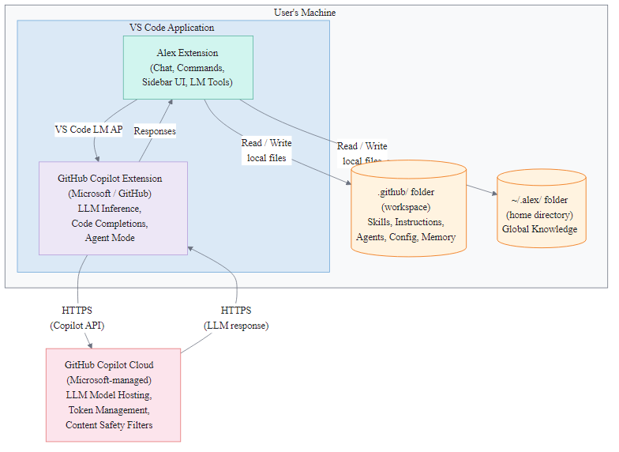
Diagram 1
Boundary note: Everything inside the “User’s Machine” box is local. The only network boundary is between GitHub Copilot Extension and GitHub Copilot Cloud — that connection is managed by Microsoft, not by Alex.

5.2 Data Flow Description
Step | Action | Data | Source | Destination | Network?
1 | User installs extension | Extension package (.vsix) | VS Code Marketplace | User’s VS Code | Yes (one-time download)
2 | User initializes architecture | Markdown/JSON template files | Extension bundle | User’s .github/ folder | No
3 | User chats with @alex | Chat message text | User keyboard input | VS Code Copilot Chat API (local) | No (local API)
4 | Copilot processes request | Prompt + context | VS Code (local) | GitHub Copilot Cloud (Microsoft) | Yes (HTTPS)
5 | LLM response returned | Generated text | GitHub Copilot Cloud | VS Code (local) | Yes (HTTPS)
6 | Alex reads/writes memory | Markdown/JSON files | .github/ and ~/.alex/ | .github/ and ~/.alex/ | No (local filesystem)
7 | Response displayed to user | Text in chat panel | VS Code | User’s screen | No

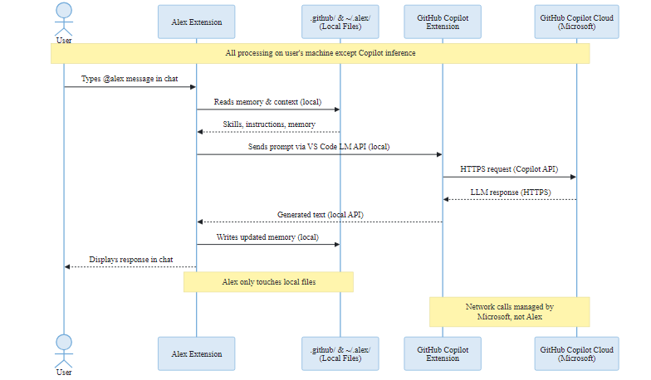
Diagram 2
Key points:
- Steps 4–5 (LLM inference) are handled entirely by GitHub Copilot’s existing infrastructure, which the user already has a subscription for. Alex does not make these network calls; VS Code’s Copilot extension does.
- Alex’s own code only performs local file read/write operations (steps 2, 3, 6, 7).
- No user data leaves the machine through Alex. The only network communication is the standard Copilot flow managed by Microsoft/GitHub.

5.3 Optional External Services (User Opt-In)
These are not required and are disabled by default. Users must explicitly configure API keys to enable them:
Service | Purpose | Data Sent | When Used
Microsoft Edge TTS | Text-to-speech voice synthesis | Text to be read aloud | User triggers “Read Aloud”
Replicate API | AI image generation | Text prompts only | User requests image generation
Gamma API | Presentation generation | Slide content text | User requests presentation
API keys for these services are stored encrypted via VS Code’s SecretStorage API on the user’s machine.

6. AI Components Assessment

Does this application use AI?
The extension itself does not contain or run any AI models. It is a structured layer on top of GitHub Copilot, which is a separate Microsoft product with its own RAI reviews.
Question | Answer
Does the extension contain or train AI models? | No
Does the extension perform LLM inference? | No — GitHub Copilot handles all inference
Does the extension fine-tune models? | No
Does the extension collect training data? | No
Does the extension process personal data with AI? | No
Does the extension make autonomous decisions? | No — all actions require user initiation or Copilot agent mode approval

Relationship to GitHub Copilot
Alex uses the VS Code Language Model API (vscode.lm), which is the standard public API provided by VS Code for extensions to interact with whatever Copilot model the user has access to. This is the same API available to all VS Code extensions.
- Alex does not bypass Copilot’s content safety filters
- Alex does not access models outside the user’s Copilot subscription
- Alex does not modify request routing or model selection
- All content safety and responsible AI controls applied by GitHub Copilot remain fully in effect

7. Privacy and Security

Data Collection Summary
Category | Collected? | Details
Personal information | No | No names, emails, or identifiers collected
Usage telemetry | No | No analytics or metrics
User code or workspace content | No | Never transmitted
Conversation transcripts | No | Not stored or sent anywhere
IP addresses | No | No server to receive them
Device identifiers | No | Not accessed

Security Measures
- Local-first architecture: All data stored in readable local files the user controls
- VS Code sandbox: Extension runs within VS Code’s extension host security sandbox
- SecretStorage API: Any API keys encrypted via VS Code’s native credential store
- Content Security Policy: Webviews enforce CSP to prevent XSS
- No inline scripts: All JavaScript in separate files
- HTTPS only: All optional external communication over encrypted channels
- No eval(): No dynamic code execution
- Minimal dependencies: Reduced supply chain attack surface
- Open source: Full source code available for inspection (Apache 2.0)
Full policies: PRIVACY.md | SECURITY.md

8. Data Classification
Data Category | Classification | Rationale
Extension source code | Public | Open source (Apache 2.0), published on GitHub
Deployed .github/ files | User-controlled | Local workspace files; content varies by project
Global knowledge (~/.alex/) | User-controlled | Local files on user’s home directory
API keys (optional) | Confidential | Encrypted via VS Code SecretStorage; never transmitted by Alex
User code / workspace | Not accessed | Alex does not read, index, or transmit user source code
Conversation content | Not stored | Handled by GitHub Copilot; Alex does not persist chat transcripts

9. Risk Assessment
Risk Category | Risk Level | Justification
Data exfiltration | None | No backend; no outbound network calls from Alex
Personal data processing | None | No PII collected, stored, or processed
AI bias / harmful output | Not applicable | Alex does not perform AI inference; all content safety is managed by GitHub Copilot (Microsoft)
Autonomous decision-making | None | All actions require explicit user initiation
Supply chain | Low | Minimal dependencies; open-source; VS Code Marketplace security scanning
Credential exposure | Low | Secrets stored via VS Code SecretStorage (OS-level encryption); no secrets in logs or files
Third-party data sharing | None | No data shared with third parties; optional services (Edge TTS, Replicate, Gamma) are user-initiated and user-configured

10. Review Recommendation
Based on the architecture described above, this application:
- Does not contain AI models — it extends an existing Microsoft AI product (GitHub Copilot)
- Has no backend infrastructure — runs entirely on the user’s machine
- Collects no data — zero telemetry, zero personal information
- Makes no autonomous decisions — all actions are user-initiated or require Copilot agent mode approval
- Has no data flows to external systems — the only network traffic is Copilot’s standard API calls, managed by Microsoft
Recommendation: This extension functions as a local file-based configuration and memory layer on top of GitHub Copilot. It does not independently perform AI inference, process personal data, or communicate with external services. The RAI review team should determine whether this qualifies as a non-AI application (proceeding under regular review) or requires further assessment given its dependency on GitHub Copilot.
If further review is needed, the extension’s open-source codebase is fully available for inspection.

Appendix A: Technology Stack
Component | Technology
Language | TypeScript
Runtime | VS Code Extension Host (Node.js)
UI Framework | VS Code Webview API
Chat Integration | VS Code Chat API / Language Model API
File Storage | Markdown (.md) and JSON (.json)
Package Format | VSIX (VS Code Extension Package)
Marketplace | VS Code Marketplace
License | Apache 2.0

Appendix B: Feature Summary
Feature | Description
Chat participant (@alex) | Conversational AI interface in Copilot Chat
26 slash commands | Structured operations (e.g., /dream, /meditate, /status)
13 Language Model Tools | Agent-mode tools for memory, knowledge, and health
128+ domain skills | Portable expertise loaded by file pattern matching
7 specialist agents | Role-based AI modes (Researcher, Builder, Validator, etc.)
Memory systems | Procedural, episodic, and domain memory in local files
Welcome sidebar | Interactive panel with quick actions and settings
TTS voice synthesis | Read documents aloud via Edge TTS (optional)
AI image generation | Generate images via Replicate API (optional, user-configured)
Presentation generation | Create slides via Gamma API (optional, user-configured)

Appendix C: Contacts
Role | Name | Contact
Application Owner | Fabio Correa | (e-mail to be added)
Publisher | fabioc-aloha | VS Code Marketplace
Source Repository | GitHub | github.com/fabioc-aloha/Alex_Plug_In

Appendix D: Document History
Version | Date | Author | Changes
1.0 | March 17, 2026 | Fabio Correa | Initial document created for TRIP review

