Codigo configuración

/* USER CODE BEGIN PV */

uint32_t value_adc = 0;

uint32_t value_dac = 0;

uint16_t ValPrint[5];

/* USER CODE END PV */

/* USER CODE BEGIN 2 */

HAL_DAC_Start(&hdac, DAC_CHANNEL_1);

HAL_DAC_SetValue(&hdac, DAC_CHANNEL_1, DAC_ALIGN_12B_R, value_dac);

HAL_ADC_Start_IT(&hadc1);

/* USER CODE END 2 */

/* USER CODE END WHILE */

HAL_GPIO_TogglePin(LD2_GPIO_Port, LD2_Pin);

**itoa** (value_adc,ValPrint,10);

HAL_UART_Transmit(&huart3, ValPrint, 5, 0xFFFF);

HAL_UART_Transmit(&huart3, "\n", 1, 0xFFFF);

HAL_Delay(100);

HAL_ADC_Start_IT(&hadc1);

/* USER CODE BEGIN 3 */

/* USER CODE BEGIN 4 */

**void** **HAL_ADC_ConvCpltCallback**(ADC_HandleTypeDef *hadc) {

value_adc = HAL_ADC_GetValue(hadc);

HAL_DAC_SetValue(&hdac, DAC_CHANNEL_1, DAC_ALIGN_12B_R, value_dac);

value_dac = value_dac + 10;

**if**(value_dac>4095) {

value_dac = 0;

}

}

/* USER CODE END 4 */

Configuración ADC

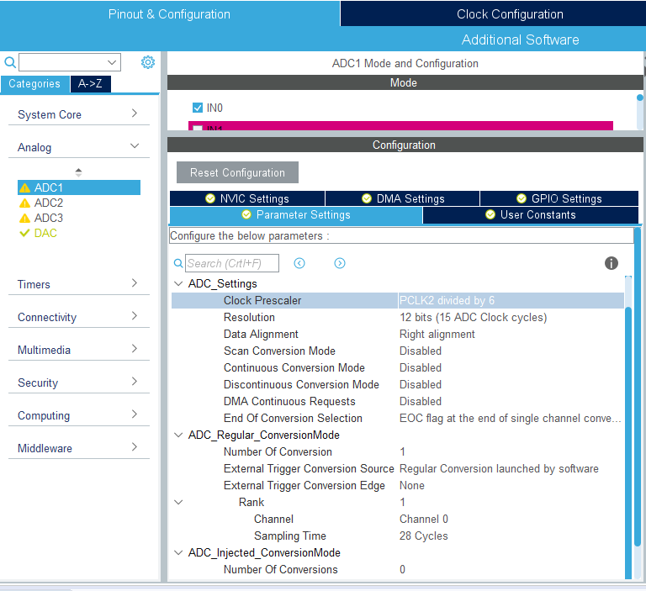

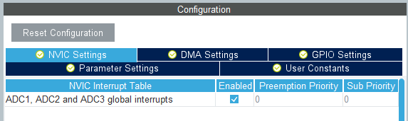

Configuración DAC

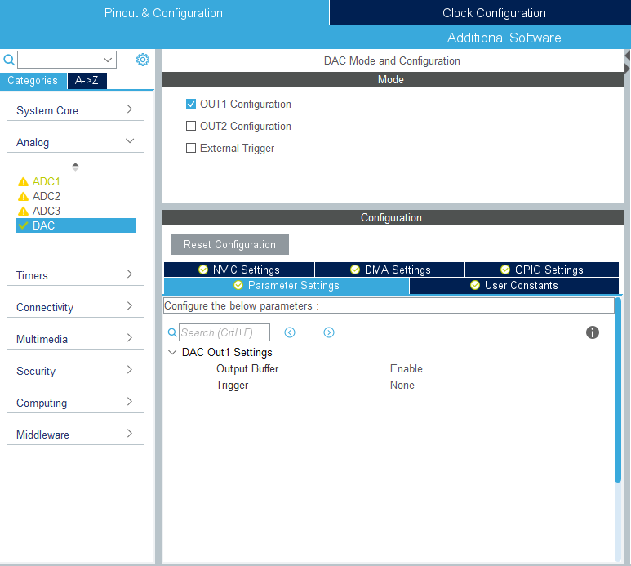

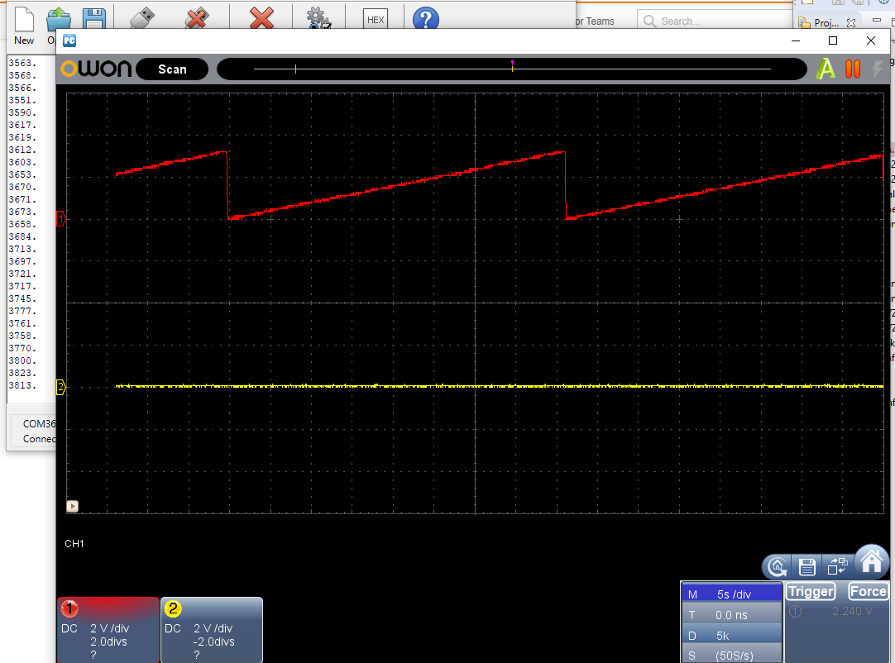

DAC

/* USER CODE BEGIN Includes */

**#include** "math.h"

/* USER CODE END Includes */

/* USER CODE BEGIN PV */

uint32_t valDAC = 0;

**float** value = 0;

uint32_t t = 0;

/* USER CODE END PV */

/* USER CODE BEGIN 2 */

HAL_DAC_Start(&hdac, DAC_CHANNEL_1);

HAL_DAC_SetValue(&hdac, DAC_CHANNEL_1, DAC_ALIGN_12B_R, valDAC);

/* USER CODE END 2 */

/* Infinite loop */

/* USER CODE BEGIN WHILE */

**while** (1)

{

/* USER CODE END WHILE */

value = 2000\***sin**(2*3.14159*t*0.001) + 2000;

valDAC = (uint32_t) value;

HAL_DAC_SetValue(&hdac, DAC_CHANNEL_1, DAC_ALIGN_12B_R, valDAC);

t++;

HAL_Delay(1);

/* USER CODE BEGIN 3 */

}

