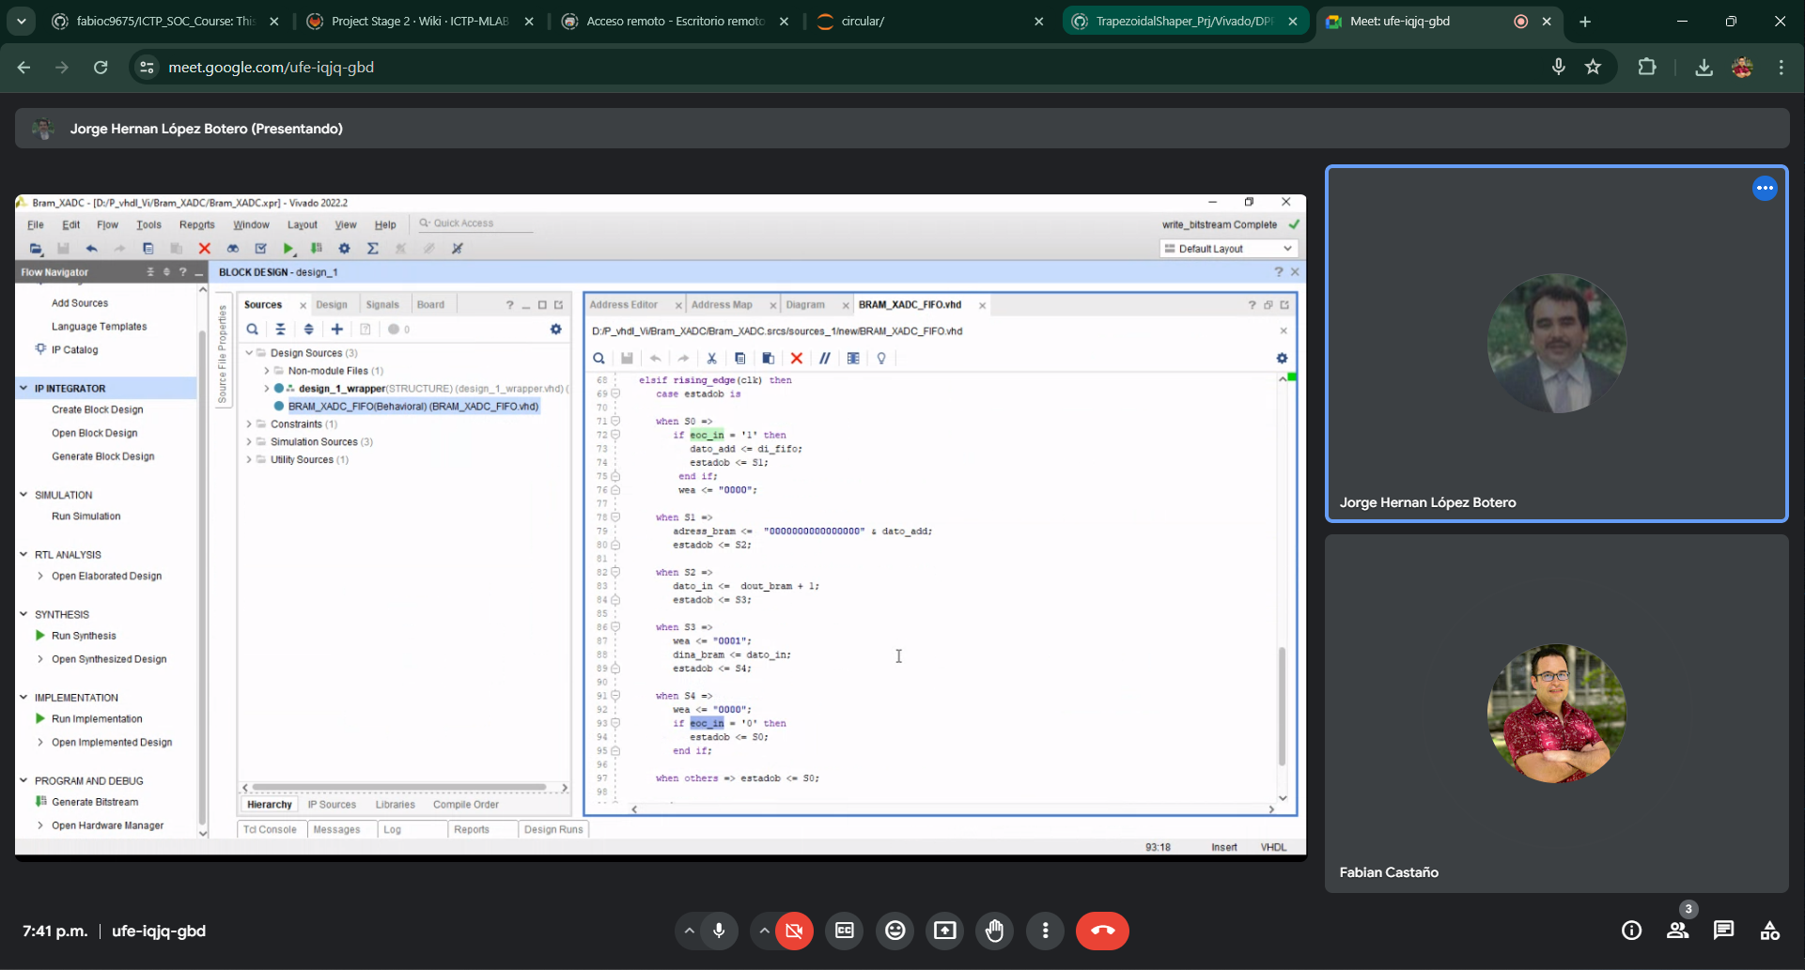

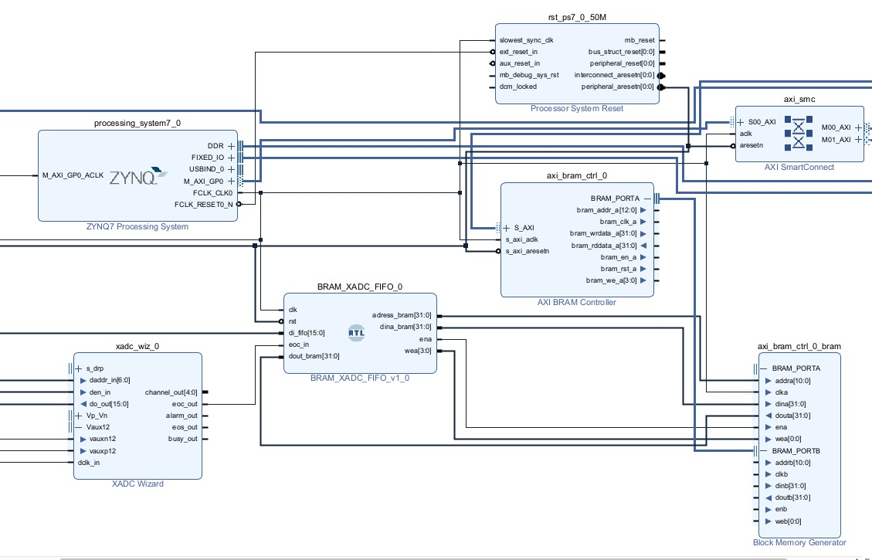

----------------------------------------------------------------------------------

-- Company: IAEA

-- Engineer: M.B.

--

-- Create Date: 10.12.2017 15:27:29

-- Design Name:

-- Module Name: bram_incr - Behavioral

-- Project Name: MCA

-- Target Devices: Zynq

-- Tool Versions:

-- Description:

--

-- Dependencies:

--

-- Revision:

-- Revision 0.01 - File Created

-- Additional Comments:

--

----------------------------------------------------------------------------------

library IEEE;

use IEEE.STD_LOGIC_1164.ALL;

use IEEE.NUMERIC_STD.ALL;

use IEEE.std_logic_unsigned.all;

-- Uncomment the following library declaration if using

-- arithmetic functions with Signed or Unsigned values

--use IEEE.NUMERIC_STD.ALL;

-- Uncomment the following library declaration if instantiating

-- any Xilinx leaf cells in this code.

--library UNISIM;

--use UNISIM.VComponents.all;

entity bram_incr is

Generic( BRAM_ADDRESS_SIZE: INTEGER := 11);

port

(

--bram address is byte address

bram_addr : out STD_LOGIC_VECTOR ( BRAM_ADDRESS_SIZE - 1 downto 0 );

bram_dout : in STD_LOGIC_VECTOR ( 31 downto 0 );

bram_we : out STD_LOGIC;

bram_din : out STD_LOGIC_VECTOR ( 31 downto 0 );

peak_amp : in STD_LOGIC_VECTOR ( 15 downto 0 );

peak_amp_rdy : in STD_LOGIC;

rstn : STD_LOGIC;

clk : STD_LOGIC

);

end bram_incr;

architecture Behavioral of bram_incr is

signal doutb : std_logic_vector(31 downto 0) := (others => '0');

signal wea : std_logic := '0';

signal uData, uSum : unsigned(31 downto 0); -- := (others => '0');

signal Data, Sum : std_logic_vector(31 downto 0);

--state machine

type state_type is (st1_idle, st2_read, st3_increment, st4_store);

signal state, next_state : state_type;

signal web :std_logic := '0';

signal inc :std_logic := '0';

begin

--bram address is byte address; lowest two bits must be zero

bram_addr <= peak_amp(14 downto 15 - BRAM_ADDRESS_SIZE);

Data <= bram_dout;

bram_we <= web;

bram_din <= Sum;

--

-- MOORE State-Machine for 'Add 1' cycle to write on port B

--

SYNC_PROC: process ( clk)

begin

if ( clk'event and clk = '1') then

if (rstn = '0') then

state <= st1_idle;

else

state <= next_state;

end if;

end if;

end process;

OUTPUT_DECODE: process (state)

begin

--decode internal output signals

if state = st1_idle then

web <= '0';

inc <= '0';

elsif state = st2_read then

web <= '0';

inc <= '0';

elsif state = st3_increment then

web <= '0';

inc <= '1';

elsif state = st4_store then

web <= '1';

inc <= '0';

else

web <= '0';

inc <= '0';

end if;

end process;

NEXT_STATE_DECODE: process (state, peak_amp_rdy)

begin

--declare default state for next_state to avoid latches

next_state <= state; --default is to stay in current state

--insert statements to decode next_state

--below is a simple example

case (state) is

when st1_idle =>

if peak_amp_rdy = '1' then

next_state <= st2_read;

else

next_state <= st1_idle;

end if;

when st2_read =>

next_state <= st3_increment;

when st3_increment =>

next_state <= st4_store;

when st4_store =>

next_state <= st1_idle;

when others =>

next_state <= st1_idle;

end case;

end process;

--

--increment and latch

--

regadder: process(inc,uData)

begin

if inc = '1' then

uSum <= uData + 1;

end if;

end process;

Sum <= std_logic_vector(uSum);

uData <= unsigned(Data);

end Behavioral;