Se crea el proyecto

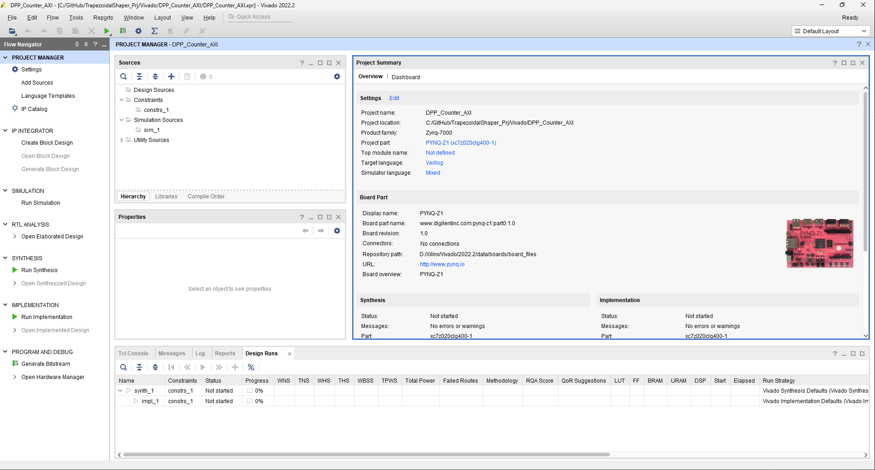

Se verifica que el lenguaje sea VHDL

Now you need to create a block design to add the different modules to the project

Also, create a constrain file with the follow code

## This file is a general .xdc for the PYNQ-Z1 board Rev. C

## To use it in a project:

## - uncomment the lines corresponding to used pins

## - rename the used ports (in each line, after get_ports) according to the top level signal names in the project

## Clock signal 125 MHz

#set_property -dict { PACKAGE_PIN H16 IOSTANDARD LVCMOS33 } [get_ports { sysclk }]; #IO_L13P_T2_MRCC_35 Sch=sysclk

#create_clock -add -name sys_clk_pin -period 8.00 -waveform {0 4} [get_ports { sysclk }];

##Switches

#set_property -dict { PACKAGE_PIN M20 IOSTANDARD LVCMOS33 } [get_ports { sw[0] }]; #IO_L7N_T1_AD2N_35 Sch=sw[0]

#set_property -dict { PACKAGE_PIN M19 IOSTANDARD LVCMOS33 } [get_ports { sw[1] }]; #IO_L7P_T1_AD2P_35 Sch=sw[1]

##RGB LEDs

#set_property -dict { PACKAGE_PIN L15 IOSTANDARD LVCMOS33 } [get_ports { led_0[4] }]; #IO_L22N_T3_AD7N_35 Sch=led4_b

#set_property -dict { PACKAGE_PIN G17 IOSTANDARD LVCMOS33 } [get_ports { led_0[5] }]; #IO_L16P_T2_35 Sch=led4_g

#set_property -dict { PACKAGE_PIN N15 IOSTANDARD LVCMOS33 } [get_ports { led_0[6] }]; #IO_L21P_T3_DQS_AD14P_35 Sch=led4_r

#set_property -dict { PACKAGE_PIN G14 IOSTANDARD LVCMOS33 } [get_ports { led_0[7] }]; #IO_0_35 Sch=led5_b

#set_property -dict { PACKAGE_PIN L14 IOSTANDARD LVCMOS33 } [get_ports { led_rst_0 }]; #IO_L22P_T3_AD7P_35 Sch=led5_g

#set_property -dict { PACKAGE_PIN M15 IOSTANDARD LVCMOS33 } [get_ports { led_1 }]; #IO_L23N_T3_35 Sch=led5_r

##LEDs

#set_property -dict { PACKAGE_PIN R14 IOSTANDARD LVCMOS33 } [get_ports { led_0[0] }]; #IO_L6N_T0_VREF_34 Sch=led[0]

#set_property -dict { PACKAGE_PIN P14 IOSTANDARD LVCMOS33 } [get_ports { led_0[1] }]; #IO_L6P_T0_34 Sch=led[1]

#set_property -dict { PACKAGE_PIN N16 IOSTANDARD LVCMOS33 } [get_ports { led_0[2] }]; #IO_L21N_T3_DQS_AD14N_35 Sch=led[2]

#set_property -dict { PACKAGE_PIN M14 IOSTANDARD LVCMOS33 } [get_ports { led_0[3] }]; #IO_L23P_T3_35 Sch=led[3]

##Buttons

#set_property -dict { PACKAGE_PIN D19 IOSTANDARD LVCMOS33 } [get_ports { in_sig_0 }]; #IO_L4P_T0_35 Sch=btn[0]

#set_property CLOCK_DEDICATED_ROUTE FALSE [get_nets { in_sig_0_IBUF }];

#set_property -dict { PACKAGE_PIN D20 IOSTANDARD LVCMOS33 } [get_ports { fifo_en_0 }]; #IO_L4N_T0_35 Sch=btn[1]

#set_property -dict { PACKAGE_PIN L20 IOSTANDARD LVCMOS33 } [get_ports { btn[2] }]; #IO_L9N_T1_DQS_AD3N_35 Sch=btn[2]

#set_property -dict { PACKAGE_PIN L19 IOSTANDARD LVCMOS33 } [get_ports { btn[3] }]; #IO_L9P_T1_DQS_AD3P_35 Sch=btn[3]

##Pmod Header JA

#set_property -dict { PACKAGE_PIN Y18 IOSTANDARD LVCMOS33 } [get_ports { ja[0] }]; #IO_L17P_T2_34 Sch=ja_p[1]

#set_property -dict { PACKAGE_PIN Y19 IOSTANDARD LVCMOS33 } [get_ports { ja[1] }]; #IO_L17N_T2_34 Sch=ja_n[1]

#set_property -dict { PACKAGE_PIN Y16 IOSTANDARD LVCMOS33 } [get_ports { ja[2] }]; #IO_L7P_T1_34 Sch=ja_p[2]

#set_property -dict { PACKAGE_PIN Y17 IOSTANDARD LVCMOS33 } [get_ports { ja[3] }]; #IO_L7N_T1_34 Sch=ja_n[2]

#set_property -dict { PACKAGE_PIN U18 IOSTANDARD LVCMOS33 } [get_ports { ja[4] }]; #IO_L12P_T1_MRCC_34 Sch=ja_p[3]

#set_property -dict { PACKAGE_PIN U19 IOSTANDARD LVCMOS33 } [get_ports { ja[5] }]; #IO_L12N_T1_MRCC_34 Sch=ja_n[3]

#set_property -dict { PACKAGE_PIN W18 IOSTANDARD LVCMOS33 } [get_ports { ja[6] }]; #IO_L22P_T3_34 Sch=ja_p[4]

#set_property -dict { PACKAGE_PIN W19 IOSTANDARD LVCMOS33 } [get_ports { ja[7] }]; #IO_L22N_T3_34 Sch=ja_n[4]

##Pmod Header JB

#set_property -dict { PACKAGE_PIN W14 IOSTANDARD LVCMOS33 } [get_ports { jb[0] }]; #IO_L8P_T1_34 Sch=jb_p[1]

#set_property -dict { PACKAGE_PIN Y14 IOSTANDARD LVCMOS33 } [get_ports { jb[1] }]; #IO_L8N_T1_34 Sch=jb_n[1]

#set_property -dict { PACKAGE_PIN T11 IOSTANDARD LVCMOS33 } [get_ports { jb[2] }]; #IO_L1P_T0_34 Sch=jb_p[2]

#set_property -dict { PACKAGE_PIN T10 IOSTANDARD LVCMOS33 } [get_ports { jb[3] }]; #IO_L1N_T0_34 Sch=jb_n[2]

#set_property -dict { PACKAGE_PIN V16 IOSTANDARD LVCMOS33 } [get_ports { jb[4] }]; #IO_L18P_T2_34 Sch=jb_p[3]

#set_property -dict { PACKAGE_PIN W16 IOSTANDARD LVCMOS33 } [get_ports { jb[5] }]; #IO_L18N_T2_34 Sch=jb_n[3]

#set_property -dict { PACKAGE_PIN V12 IOSTANDARD LVCMOS33 } [get_ports { jb[6] }]; #IO_L4P_T0_34 Sch=jb_p[4]

#set_property -dict { PACKAGE_PIN W13 IOSTANDARD LVCMOS33 } [get_ports { jb[7] }]; #IO_L4N_T0_34 Sch=jb_n[4]

##Audio Out

#set_property -dict { PACKAGE_PIN R18 IOSTANDARD LVCMOS33 } [get_ports { aud_pwm }]; #IO_L20N_T3_34 Sch=aud_pwm

#set_property -dict { PACKAGE_PIN T17 IOSTANDARD LVCMOS33 } [get_ports { aud_sd }]; #IO_L20P_T3_34 Sch=aud_sd

##Mic input

#set_property -dict { PACKAGE_PIN F17 IOSTANDARD LVCMOS33 } [get_ports { m_clk }]; #IO_L6N_T0_VREF_35 Sch=m_clk

#set_property -dict { PACKAGE_PIN G18 IOSTANDARD LVCMOS33 } [get_ports { m_data }]; #IO_L16N_T2_35 Sch=m_data

##ChipKit Single Ended Analog Inputs

##NOTE: The ck_an_p pins can be used as single ended analog inputs with voltages from 0-3.3V (Chipkit Analog pins A0-A5).

## These signals should only be connected to the XADC core. When using these pins as digital I/O, use pins ck_io[14-19].

set_property -dict { PACKAGE_PIN D18 IOSTANDARD LVCMOS33 } [get_ports { Vaux1_0_v_n }]; #IO_L3N_T0_DQS_AD1N_35 Sch=ck_an_n[0]

set_property -dict { PACKAGE_PIN E17 IOSTANDARD LVCMOS33 } [get_ports { Vaux1_0_v_p }]; #IO_L3P_T0_DQS_AD1P_35 Sch=ck_an_p[0]

#set_property -dict { PACKAGE_PIN E19 IOSTANDARD LVCMOS33 } [get_ports { Vaux9_0_v_n }]; #IO_L5N_T0_AD9N_35 Sch=ck_an_n[1]

#set_property -dict { PACKAGE_PIN E18 IOSTANDARD LVCMOS33 } [get_ports { Vaux9_0_v_p }]; #IO_L5P_T0_AD9P_35 Sch=ck_an_p[1]

#set_property -dict { PACKAGE_PIN J14 IOSTANDARD LVCMOS33 } [get_ports { Vaux6_0_v_n }]; #IO_L20N_T3_AD6N_35 Sch=ck_an_n[2]

#set_property -dict { PACKAGE_PIN K14 IOSTANDARD LVCMOS33 } [get_ports { Vaux6_0_v_p }]; #IO_L20P_T3_AD6P_35 Sch=ck_an_p[2]

#set_property -dict { PACKAGE_PIN J16 IOSTANDARD LVCMOS33 } [get_ports { Vaux15_0_v_n }]; #IO_L24N_T3_AD15N_35 Sch=ck_an_n[3]

#set_property -dict { PACKAGE_PIN K16 IOSTANDARD LVCMOS33 } [get_ports { Vaux15_0_v_p }]; #IO_L24P_T3_AD15P_35 Sch=ck_an_p[3]

#set_property -dict { PACKAGE_PIN H20 IOSTANDARD LVCMOS33 } [get_ports { ck_an_n[4] }]; #IO_L17N_T2_AD5N_35 Sch=ck_an_n[4]

#set_property -dict { PACKAGE_PIN J20 IOSTANDARD LVCMOS33 } [get_ports { ck_an_p[4] }]; #IO_L17P_T2_AD5P_35 Sch=ck_an_p[4]

#set_property -dict { PACKAGE_PIN G20 IOSTANDARD LVCMOS33 } [get_ports { ck_an_n[5] }]; #IO_L18N_T2_AD13N_35 Sch=ck_an_n[5]

#set_property -dict { PACKAGE_PIN G19 IOSTANDARD LVCMOS33 } [get_ports { ck_an_p[5] }]; #IO_L18P_T2_AD13P_35 Sch=ck_an_p[5]

##ChipKit Digital I/O Low

#set_property -dict { PACKAGE_PIN T14 IOSTANDARD LVCMOS33 } [get_ports { ck_io[0] }]; #IO_L5P_T0_34 Sch=ck_io[0]

#set_property -dict { PACKAGE_PIN U12 IOSTANDARD LVCMOS33 } [get_ports { ck_io[1] }]; #IO_L2N_T0_34 Sch=ck_io[1]

#set_property -dict { PACKAGE_PIN U13 IOSTANDARD LVCMOS33 } [get_ports { ck_io[2] }]; #IO_L3P_T0_DQS_PUDC_B_34 Sch=ck_io[2]

#set_property -dict { PACKAGE_PIN V13 IOSTANDARD LVCMOS33 } [get_ports { ck_io[3] }]; #IO_L3N_T0_DQS_34 Sch=ck_io[3]

#set_property -dict { PACKAGE_PIN V15 IOSTANDARD LVCMOS33 } [get_ports { ck_io[4] }]; #IO_L10P_T1_34 Sch=ck_io[4]

#set_property -dict { PACKAGE_PIN T15 IOSTANDARD LVCMOS33 } [get_ports { ck_io[5] }]; #IO_L5N_T0_34 Sch=ck_io[5]

#set_property -dict { PACKAGE_PIN R16 IOSTANDARD LVCMOS33 } [get_ports { ck_io[6] }]; #IO_L19P_T3_34 Sch=ck_io[6]

#set_property -dict { PACKAGE_PIN U17 IOSTANDARD LVCMOS33 } [get_ports { ck_io[7] }]; #IO_L9N_T1_DQS_34 Sch=ck_io[7]

#set_property -dict { PACKAGE_PIN V17 IOSTANDARD LVCMOS33 } [get_ports { ck_io[8] }]; #IO_L21P_T3_DQS_34 Sch=ck_io[8]

#set_property -dict { PACKAGE_PIN V18 IOSTANDARD LVCMOS33 } [get_ports { ck_io[9] }]; #IO_L21N_T3_DQS_34 Sch=ck_io[9]

#set_property -dict { PACKAGE_PIN T16 IOSTANDARD LVCMOS33 } [get_ports { ck_io[10] }]; #IO_L9P_T1_DQS_34 Sch=ck_io[10]

#set_property -dict { PACKAGE_PIN R17 IOSTANDARD LVCMOS33 } [get_ports { ck_io[11] }]; #IO_L19N_T3_VREF_34 Sch=ck_io[11]

#set_property -dict { PACKAGE_PIN P18 IOSTANDARD LVCMOS33 } [get_ports { ck_io[12] }]; #IO_L23N_T3_34 Sch=ck_io[12]

#set_property -dict { PACKAGE_PIN N17 IOSTANDARD LVCMOS33 } [get_ports { ck_io[13] }]; #IO_L23P_T3_34 Sch=ck_io[13]

##ChipKit Digital I/O On Outer Analog Header

##NOTE: These pins should be used when using the analog header signals A0-A5 as digital I/O (Chipkit digital pins 14-19)

#set_property -dict { PACKAGE_PIN Y11 IOSTANDARD LVCMOS33 } [get_ports { ck_io[14] }]; #IO_L18N_T2_13 Sch=ck_a[0]

#set_property -dict { PACKAGE_PIN Y12 IOSTANDARD LVCMOS33 } [get_ports { ck_io[15] }]; #IO_L20P_T3_13 Sch=ck_a[1]

#set_property -dict { PACKAGE_PIN W11 IOSTANDARD LVCMOS33 } [get_ports { ck_io[16] }]; #IO_L18P_T2_13 Sch=ck_a[2]

#set_property -dict { PACKAGE_PIN V11 IOSTANDARD LVCMOS33 } [get_ports { ck_io[17] }]; #IO_L21P_T3_DQS_13 Sch=ck_a[3]

#set_property -dict { PACKAGE_PIN T5 IOSTANDARD LVCMOS33 } [get_ports { ck_io[18] }]; #IO_L19P_T3_13 Sch=ck_a[4]

#set_property -dict { PACKAGE_PIN U10 IOSTANDARD LVCMOS33 } [get_ports { ck_io[19] }]; #IO_L12N_T1_MRCC_13 Sch=ck_a[5]

##ChipKit Digital I/O On Inner Analog Header

##NOTE: These pins will need to be connected to the XADC core when used as differential analog inputs (Chipkit analog pins A6-A11)

#set_property -dict { PACKAGE_PIN B20 IOSTANDARD LVCMOS33 } [get_ports { ck_io[20] }]; #IO_L1N_T0_AD0N_35 Sch=ad_n[0]

#set_property -dict { PACKAGE_PIN C20 IOSTANDARD LVCMOS33 } [get_ports { ck_io[21] }]; #IO_L1P_T0_AD0P_35 Sch=ad_p[0]

#set_property -dict { PACKAGE_PIN F20 IOSTANDARD LVCMOS33 } [get_ports { ck_io[22] }]; #IO_L15N_T2_DQS_AD12N_35 Sch=ad_n[12]

#set_property -dict { PACKAGE_PIN F19 IOSTANDARD LVCMOS33 } [get_ports { ck_io[23] }]; #IO_L15P_T2_DQS_AD12P_35 Sch=ad_p[12]

#set_property -dict { PACKAGE_PIN A20 IOSTANDARD LVCMOS33 } [get_ports { ck_io[24] }]; #IO_L2N_T0_AD8N_35 Sch=ad_n[8]

#set_property -dict { PACKAGE_PIN B19 IOSTANDARD LVCMOS33 } [get_ports { ck_io[25] }]; #IO_L2P_T0_AD8P_35 Sch=ad_p[8]

##ChipKit Digital I/O High

#set_property -dict { PACKAGE_PIN U5 IOSTANDARD LVCMOS33 } [get_ports { ck_io[26] }]; #IO_L19N_T3_VREF_13 Sch=ck_io[26]

#set_property -dict { PACKAGE_PIN V5 IOSTANDARD LVCMOS33 } [get_ports { ck_io[27] }]; #IO_L6N_T0_VREF_13 Sch=ck_io[27]

#set_property -dict { PACKAGE_PIN V6 IOSTANDARD LVCMOS33 } [get_ports { ck_io[28] }]; #IO_L22P_T3_13 Sch=ck_io[28]

#set_property -dict { PACKAGE_PIN U7 IOSTANDARD LVCMOS33 } [get_ports { ck_io[29] }]; #IO_L11P_T1_SRCC_13 Sch=ck_io[29]

#set_property -dict { PACKAGE_PIN V7 IOSTANDARD LVCMOS33 } [get_ports { ck_io[30] }]; #IO_L11N_T1_SRCC_13 Sch=ck_io[30]

#set_property -dict { PACKAGE_PIN U8 IOSTANDARD LVCMOS33 } [get_ports { ck_io[31] }]; #IO_L17N_T2_13 Sch=ck_io[31]

#set_property -dict { PACKAGE_PIN V8 IOSTANDARD LVCMOS33 } [get_ports { ck_io[32] }]; #IO_L15P_T2_DQS_13 Sch=ck_io[32]

#set_property -dict { PACKAGE_PIN V10 IOSTANDARD LVCMOS33 } [get_ports { ck_io[33] }]; #IO_L21N_T3_DQS_13 Sch=ck_io[33]

#set_property -dict { PACKAGE_PIN W10 IOSTANDARD LVCMOS33 } [get_ports { ck_io[34] }]; #IO_L16P_T2_13 Sch=ck_io[34]

#set_property -dict { PACKAGE_PIN W6 IOSTANDARD LVCMOS33 } [get_ports { ck_io[35] }]; #IO_L22N_T3_13 Sch=ck_io[35]

#set_property -dict { PACKAGE_PIN Y6 IOSTANDARD LVCMOS33 } [get_ports { ck_io[36] }]; #IO_L13N_T2_MRCC_13 Sch=ck_io[36]

#set_property -dict { PACKAGE_PIN Y7 IOSTANDARD LVCMOS33 } [get_ports { ck_io[37] }]; #IO_L13P_T2_MRCC_13 Sch=ck_io[37]

#set_property -dict { PACKAGE_PIN W8 IOSTANDARD LVCMOS33 } [get_ports { ck_io[38] }]; #IO_L15N_T2_DQS_13 Sch=ck_io[38]

#set_property -dict { PACKAGE_PIN Y8 IOSTANDARD LVCMOS33 } [get_ports { ck_io[39] }]; #IO_L14N_T2_SRCC_13 Sch=ck_io[39]

#set_property -dict { PACKAGE_PIN W9 IOSTANDARD LVCMOS33 } [get_ports { ck_io[40] }]; #IO_L16N_T2_13 Sch=ck_io[40]

#set_property -dict { PACKAGE_PIN Y9 IOSTANDARD LVCMOS33 } [get_ports { ck_io[41] }]; #IO_L14P_T2_SRCC_13 Sch=ck_io[41]

#set_property -dict { PACKAGE_PIN Y13 IOSTANDARD LVCMOS33 } [get_ports { ck_io[42] }]; #IO_L20N_T3_13 Sch=ck_ioa

## ChipKit SPI

#set_property -dict { PACKAGE_PIN W15 IOSTANDARD LVCMOS33 } [get_ports { ck_miso }]; #IO_L10N_T1_34 Sch=ck_miso

#set_property -dict { PACKAGE_PIN T12 IOSTANDARD LVCMOS33 } [get_ports { ck_mosi }]; #IO_L2P_T0_34 Sch=ck_mosi

#set_property -dict { PACKAGE_PIN H15 IOSTANDARD LVCMOS33 } [get_ports { ck_sck }]; #IO_L19P_T3_35 Sch=ck_sck

#set_property -dict { PACKAGE_PIN F16 IOSTANDARD LVCMOS33 } [get_ports { ck_ss }]; #IO_L6P_T0_35 Sch=ck_ss

## ChipKit I2C

#set_property -dict { PACKAGE_PIN P16 IOSTANDARD LVCMOS33 } [get_ports { ck_scl }]; #IO_L24N_T3_34 Sch=ck_scl

#set_property -dict { PACKAGE_PIN P15 IOSTANDARD LVCMOS33 } [get_ports { ck_sda }]; #IO_L24P_T3_34 Sch=ck_sda

##HDMI Rx

#set_property -dict { PACKAGE_PIN H17 IOSTANDARD LVCMOS33 } [get_ports { hdmi_rx_cec }]; #IO_L13N_T2_MRCC_35 Sch=hdmi_rx_cec

#set_property -dict { PACKAGE_PIN P19 IOSTANDARD TMDS_33 } [get_ports { hdmi_rx_clk_n }]; #IO_L13N_T2_MRCC_34 Sch=hdmi_rx_clk_n

#set_property -dict { PACKAGE_PIN N18 IOSTANDARD TMDS_33 } [get_ports { hdmi_rx_clk_p }]; #IO_L13P_T2_MRCC_34 Sch=hdmi_rx_clk_p

#set_property -dict { PACKAGE_PIN W20 IOSTANDARD TMDS_33 } [get_ports { hdmi_rx_d_n[0] }]; #IO_L16N_T2_34 Sch=hdmi_rx_d_n[0]

#set_property -dict { PACKAGE_PIN V20 IOSTANDARD TMDS_33 } [get_ports { hdmi_rx_d_p[0] }]; #IO_L16P_T2_34 Sch=hdmi_rx_d_p[0]

#set_property -dict { PACKAGE_PIN U20 IOSTANDARD TMDS_33 } [get_ports { hdmi_rx_d_n[1] }]; #IO_L15N_T2_DQS_34 Sch=hdmi_rx_d_n[1]

#set_property -dict { PACKAGE_PIN T20 IOSTANDARD TMDS_33 } [get_ports { hdmi_rx_d_p[1] }]; #IO_L15P_T2_DQS_34 Sch=hdmi_rx_d_p[1]

#set_property -dict { PACKAGE_PIN P20 IOSTANDARD TMDS_33 } [get_ports { hdmi_rx_d_n[2] }]; #IO_L14N_T2_SRCC_34 Sch=hdmi_rx_d_n[2]

#set_property -dict { PACKAGE_PIN N20 IOSTANDARD TMDS_33 } [get_ports { hdmi_rx_d_p[2] }]; #IO_L14P_T2_SRCC_34 Sch=hdmi_rx_d_p[2]

#set_property -dict { PACKAGE_PIN T19 IOSTANDARD LVCMOS33 } [get_ports { hdmi_rx_hpd }]; #IO_25_34 Sch=hdmi_rx_hpd

#set_property -dict { PACKAGE_PIN U14 IOSTANDARD LVCMOS33 } [get_ports { hdmi_rx_scl }]; #IO_L11P_T1_SRCC_34 Sch=hdmi_rx_scl

#set_property -dict { PACKAGE_PIN U15 IOSTANDARD LVCMOS33 } [get_ports { hdmi_rx_sda }]; #IO_L11N_T1_SRCC_34 Sch=hdmi_rx_sda

##HDMI Tx

#set_property -dict { PACKAGE_PIN G15 IOSTANDARD LVCMOS33 } [get_ports { hdmi_tx_cec }]; #IO_L19N_T3_VREF_35 Sch=hdmi_tx_cec

#set_property -dict { PACKAGE_PIN L17 IOSTANDARD TMDS_33 } [get_ports { hdmi_tx_clk_n }]; #IO_L11N_T1_SRCC_35 Sch=hdmi_tx_clk_n

#set_property -dict { PACKAGE_PIN L16 IOSTANDARD TMDS_33 } [get_ports { hdmi_tx_clk_p }]; #IO_L11P_T1_SRCC_35 Sch=hdmi_tx_clk_p

#set_property -dict { PACKAGE_PIN K18 IOSTANDARD TMDS_33 } [get_ports { hdmi_tx_d_n[0] }]; #IO_L12N_T1_MRCC_35 Sch=hdmi_tx_d_n[0]

#set_property -dict { PACKAGE_PIN K17 IOSTANDARD TMDS_33 } [get_ports { hdmi_tx_d_p[0] }]; #IO_L12P_T1_MRCC_35 Sch=hdmi_tx_d_p[0]

#set_property -dict { PACKAGE_PIN J19 IOSTANDARD TMDS_33 } [get_ports { hdmi_tx_d_n[1] }]; #IO_L10N_T1_AD11N_35 Sch=hdmi_tx_d_n[1]

#set_property -dict { PACKAGE_PIN K19 IOSTANDARD TMDS_33 } [get_ports { hdmi_tx_d_p[1] }]; #IO_L10P_T1_AD11P_35 Sch=hdmi_tx_d_p[1]

#set_property -dict { PACKAGE_PIN H18 IOSTANDARD TMDS_33 } [get_ports { hdmi_tx_d_n[2] }]; #IO_L14N_T2_AD4N_SRCC_35 Sch=hdmi_tx_d_n[2]

#set_property -dict { PACKAGE_PIN J18 IOSTANDARD TMDS_33 } [get_ports { hdmi_tx_d_p[2] }]; #IO_L14P_T2_AD4P_SRCC_35 Sch=hdmi_tx_d_p[2]

#set_property -dict { PACKAGE_PIN R19 IOSTANDARD LVCMOS33 } [get_ports { hdmi_tx_hpdn }]; #IO_0_34 Sch=hdmi_tx_hpdn

#set_property -dict { PACKAGE_PIN M17 IOSTANDARD LVCMOS33 } [get_ports { hdmi_tx_scl }]; #IO_L8P_T1_AD10P_35 Sch=hdmi_tx_scl

#set_property -dict { PACKAGE_PIN M18 IOSTANDARD LVCMOS33 } [get_ports { hdmi_tx_sda }]; #IO_L8N_T1_AD10N_35 Sch=hdmi_tx_sda

##Crypto SDA

#set_property -dict { PACKAGE_PIN J15 IOSTANDARD LVCMOS33 } [get_ports { crypto_sda }]; #IO_25_35 Sch=crypto_sda

Add the zynq processor, run the block automation and double click to modify the block,

Just add S AXI HP0 interface to add Slave axi stream support

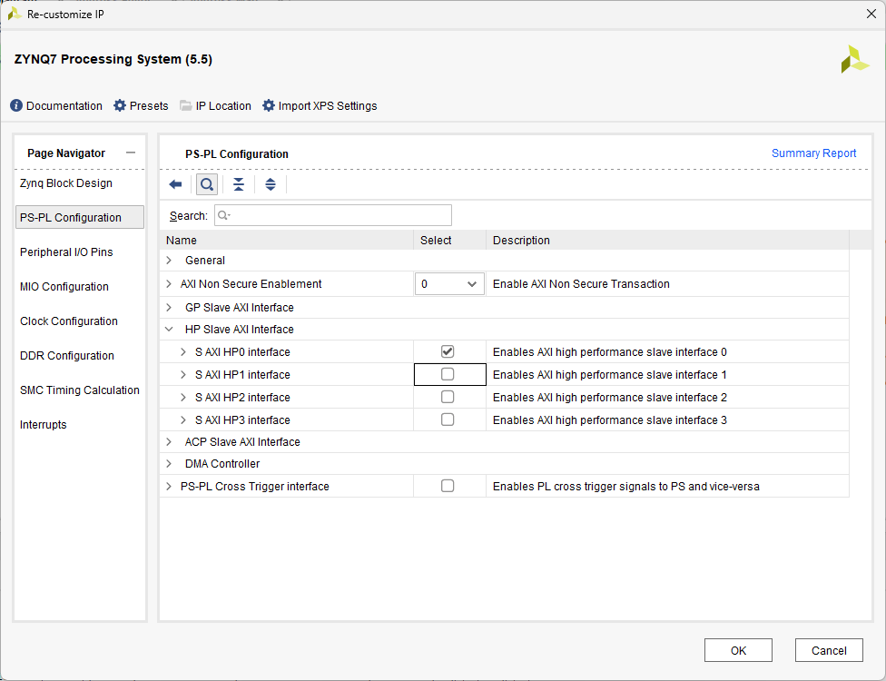

Also add XADC module, double click on it, and apply the next modifications

Then make external the Vaux1 bus, it will connect externally with the pins in the constrain file defined as Vaux1_0

Until this point it looks like this

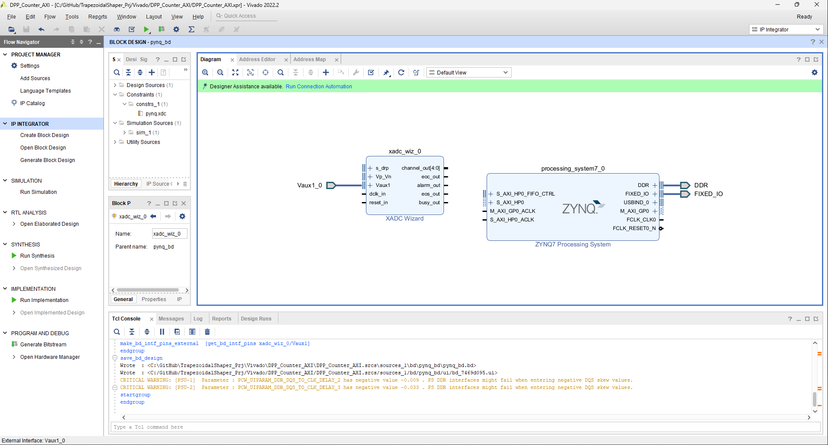

Add a clock wizard block aand configurate the outpuyt to 104 MHz and Reset as active low

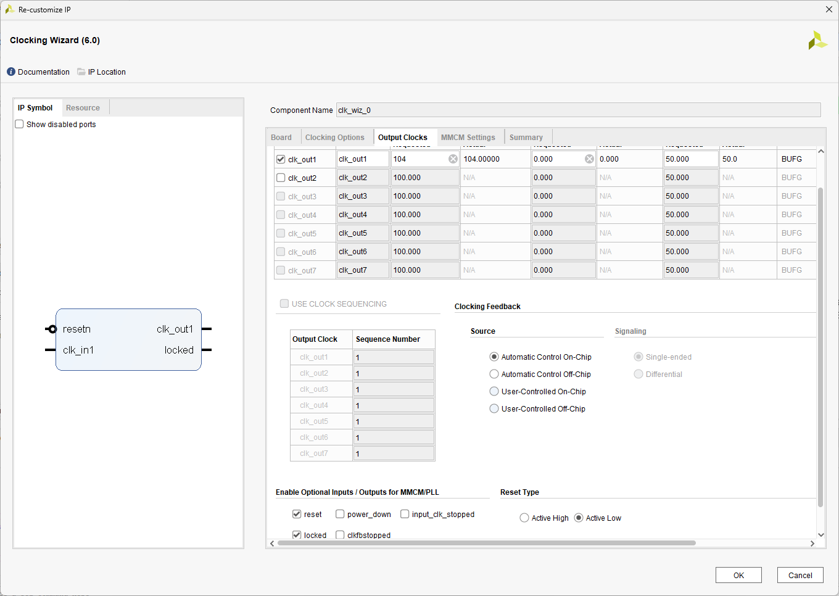

Make the connections as follow

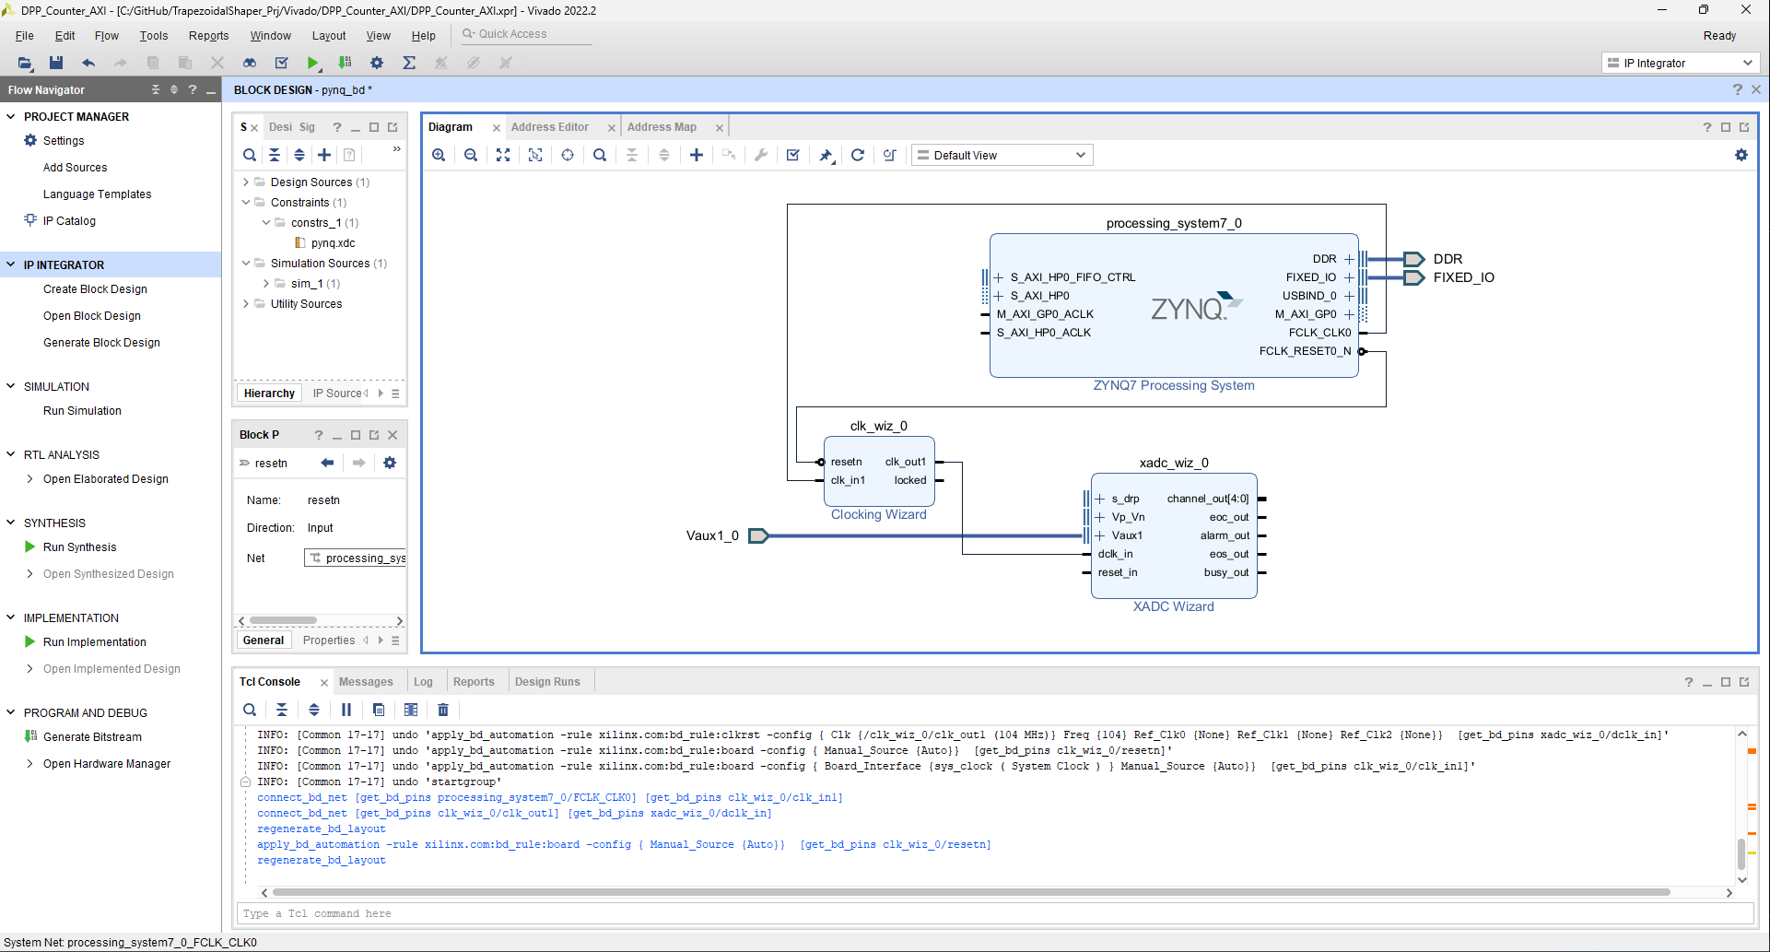

%%%%%%%%%%%%%%%%%%%%%%%%%%%%%%

Now create the XADC buffer block

----------------------------------------------------------------------------------

-- Company: Universidad de Antioquia

-- Engineer: Fabian Castano

-- Description: This modules convert the 16 bits data from XADC in

-- 32 bits data, also syncronize with clock

----------------------------------------------------------------------------------

library IEEE;

use IEEE.STD_LOGIC_1164.ALL;

use IEEE.STD_LOGIC_ARITH.ALL;

use IEEE.STD_LOGIC_UNSIGNED.ALL;

-- Entity creation

entity xadc_buffer is

Port ( adc_clk : in std_logic;

adc_rst : in std_logic;

adc_in : in std_logic_vector (15 downto 0);

adc_out : out std_logic_vector (31 downto 0)

);

end xadc_buffer;

architecture Behavioral of xadc_buffer is

signal buf_xadc : std_logic_vector (31 downto 0);

begin

BUFFER_PROCESS: process (adc_clk, adc_rst)

begin

if (adc_rst = '0') then

buf_xadc <= X"00000000";

else

if rising_edge(adc_clk) then

buf_xadc <= X"0000" & adc_in;

end if;

end if;

end process;

adc_out <= buf_xadc;

end Behavioral;

%%%%%%%%%%%%%%%%%%%%%%%%%%%%%%%%%%%%%%

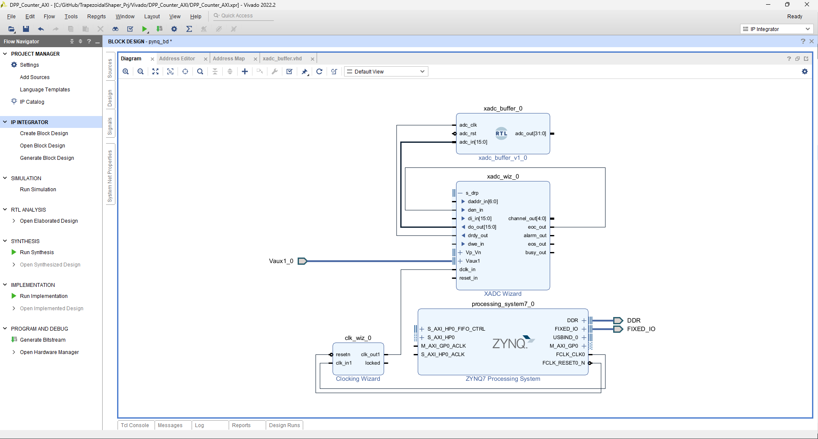

Add an constant to handled XADC addres. (17 for Vaux1 channel)

