In this documentation, i will explain the code created and as it was planned for

meet the required specification.

I tryed use the spring boot for start aplication, used the anotation @SpringBootApplication, but i had problem with the other containner jpa and decided to use the configuration aplicationContext for start.

I decided to use the H2 database to stay up practice and test the application, it was implemented

the connection class however did not complete the entire flow. The test was a lot of work and it was necessary to think about it before you start. I did not give up and I was trying to draw the solution to meet the requisite maximum.

To show what has been created will start the tomcat server and use the URL: http: // localhost: 8080 / fabio-web / faces / index.xhtml to the index screen of the application.

this must be the result:

My first screen

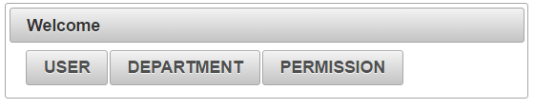

Select any of the options, in my navigation will use the "USER".

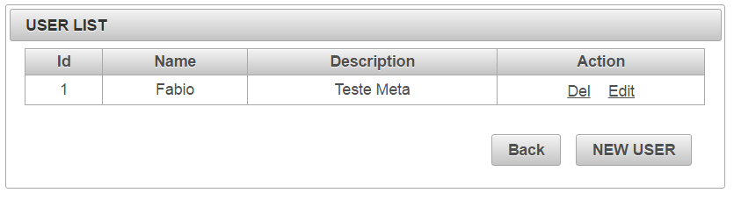

This screen should load a list users registered with the action fields for possible exclusions and edition.

if you delete a confirmation must be made.

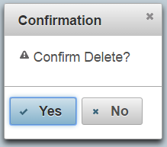

To register a new user must select the "New User" button on the list screen

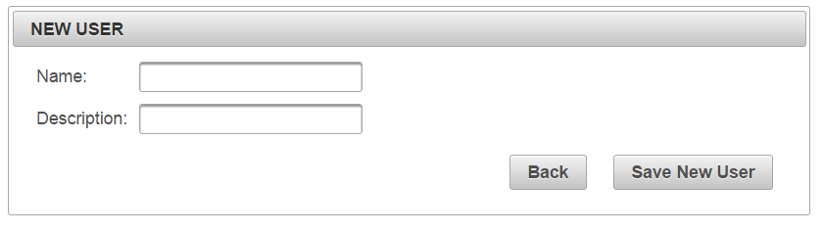

the name and description fields must be completed and saved.

The system is not completely implemented, the major classes were built, mappings, and connection screens and a part of REST. JMS with xml was not Constructed.

I dont tried running the application in a jboss server, because I did not finish the tomcat application. But if I try to change my application for an EJB application. the biggest impact would be in dependancy, JBOSS is more complete and supports Hibernate for example and let my dependancy as provied.

thanks for the opportunity.