|  |
| --- |
| Ciconi’s Games |
| **AIRFIRE** |
| **Space War** |
| Version #1  All work Copyright © 2017 by Ciconi’s Games.  All rights reserved. |
| **Andre Lemos, Fabio Ciconi, Rodrigo Geronimo** |
|  |

**Insert a Company Logo here**

|  |
| --- |
| August 04th 2017 |

**Table of Contents**

[Your Table of Contents should go here. Make sure that your document’s sections are hyperlinked to their corresponding pages.]

**Version History**

Version 1.0 – Document start

[This is the body of your video game design document. You should add and delete sections as they pertain to your game’s design.]

1. **Game Overview**

Are you prepared to face the best adventure of your life? You need to protect planet earth from asteroids and other enemies. Embark on the AirFire007 ship and do not let land be destroyed.

1. **Game Play Mechanics**

The mechanics is simple; the player need to eliminated the asteroids and kill the wave of enemy ships. The player need to define what is the best position to stay to defeat the enemy ships and escape the asteroids. The player can destroy the ships with fire and the asteroids they can escape or destroy.

1. **Camera**

The game user a 2D, the camera does not change position.

1. **Controls**

The game uses a simple up, down, left and right keyboard buttons and space bar to fire.

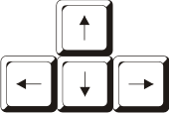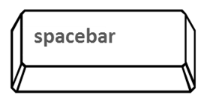

1. **Saving and Loading**

Do not Have

1. **Interface Sketch**

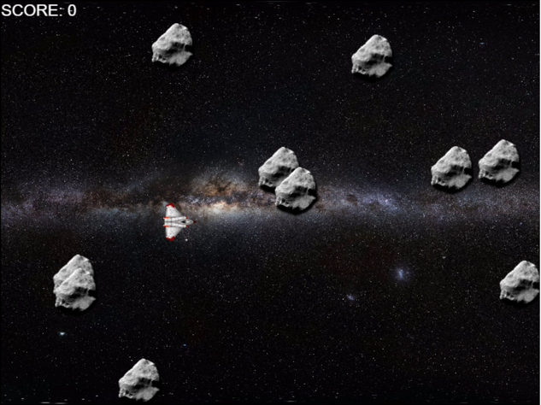

Scream shoot of the game in level 1.

1. **Menu and Screen Descriptions**

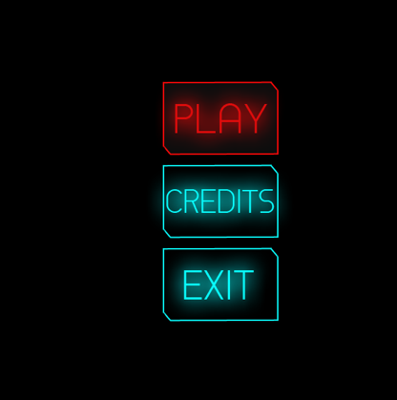

Menu is divide in three option play, credits and exit.

1. **Game World**

The game happens in 2100 and the humanity remains living in earth. However, we discovered that life in universe life beyond us. Some aliens are peaceful, but other are extremely dangerous. Second, the earth lost ozone layer and we humanity face some problems with asteroids.

1. **Levels**

The game has 3 levels.

1. **Game Progression**
2. Easy: only asteroids.
3. Normal: asteroids and enemy’s ships.
4. Hard: Boss enemies ship.
5. **Characters**

*(Describe Your game avatar if applicable)*

1. **Non-player Characters**

The plays do not have control in the enemies and the space.

1. **Enemies**

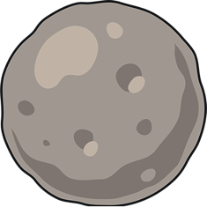Asteroid

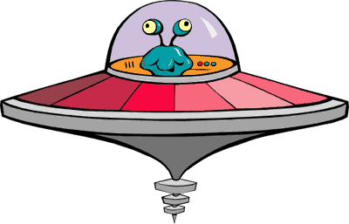Alien space ship

1. **Weapons**

*(Describe any weapons available to the user)*

1. **Items**

*(Describe any in-game items that can help or hinder the user)*

1. **Abilities**
2. **Vehicles**

**../AirFire/images/spaceship.png**Space ship

1. **Script**
2. **Scoring**
3. **Puzzles/Mini-games**
4. **Bonuses**
5. **Cheat Codes**
6. **Sound Index**

*(Include an index of all your sound clips)*

1. **Story Index**

The galaxy protects recruit new pilots to protect the earth. The mission of the new pilots need destroy the asteroids and enemies space ship.

1. **Art / Multimedia Index**

*(Include an index of all your graphic and video assets here)*

1. **Design Notes**

*(Include additional design notes here)*

1. **Future Features**

*(Include any future features that are planned to be implemented)*