Assignment #1 – VM and Storage

Fabio Alexandre Ciconi - 300930989

Centennial College

Contents

Question 1 [5 marks] 3

Question2 [10 marks] 3

2.1 Explain different Google cloud storage options, SQL, Storage, Bigtable and Datastore. [4 marks] 3

2.2 Create a PostgreSQL database server instance, create a table, called Course, to hold all information about course [1 mark] 4

2.3 For storage, create a bucket to hold some of your favorite pictures or/and video clips [1 mark] 6

2.4 Create a Bigtable instance, and add one table which holds some health data, such as heartrate, sent by wearable devices [2 marks] 7

2.5 Create a Datastore instance, and store game reviews in it [2 marks] 8

# Question 1 [5 marks]

Finish the tutorial <https://cloud.google.com/tools/visual-studio/docs/quickstart> and demonstrate the published app during the lab.

It failed because a problem on the VM or GoogleCloud

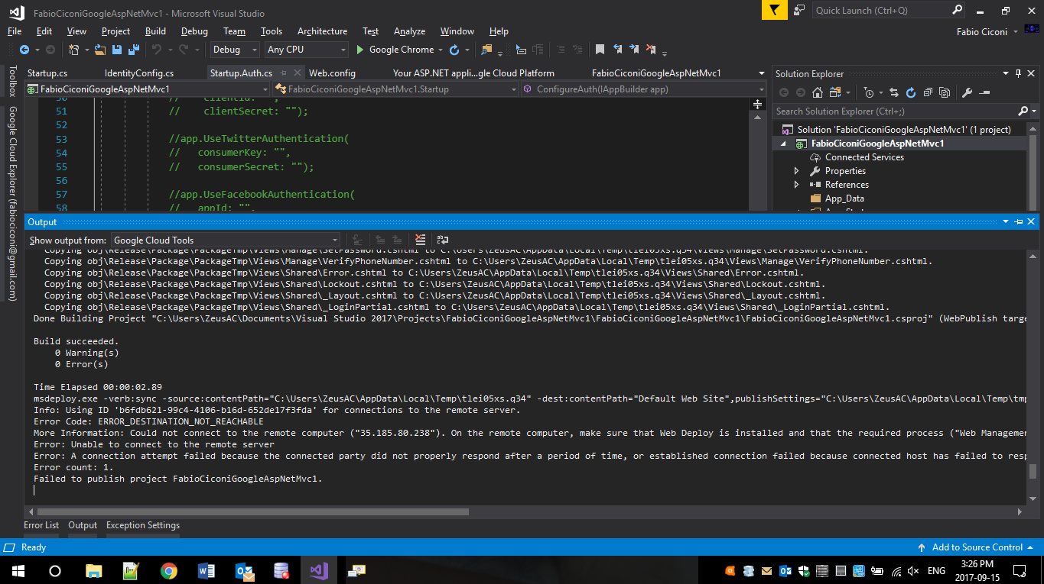

# **Question2 [10 marks]**

## 2.1 Explain different Google cloud storage options, SQL, Storage, Bigtable and Datastore. [4 marks]

* SQL: It is a fully-managed database service. Provide relational databases, and you can use either MySQL or PostgreSQL. According to Google this service is ideal for web frameworks, structured data and, OLTP workloads.
* Storage: A scalable, fully-managed, high reliable. It is ideal for images, pictures, and videos.
* Bigtable: it is a NoSQL Bigdata service. It is scalable and fully-managed wide-column database. It is a service for large-workload application.
* Datastore. It is NoSQL document database for web and mobile applications. It has Semi-structured application data, hierarchical data and durable key value data. Datastore is ideal for applications that rely on highly available structured data at scale.

## 2.2 Create a PostgreSQL database server instance, create a table, called Course, to hold all information about course [1 mark]

PostgreSQL database server instance

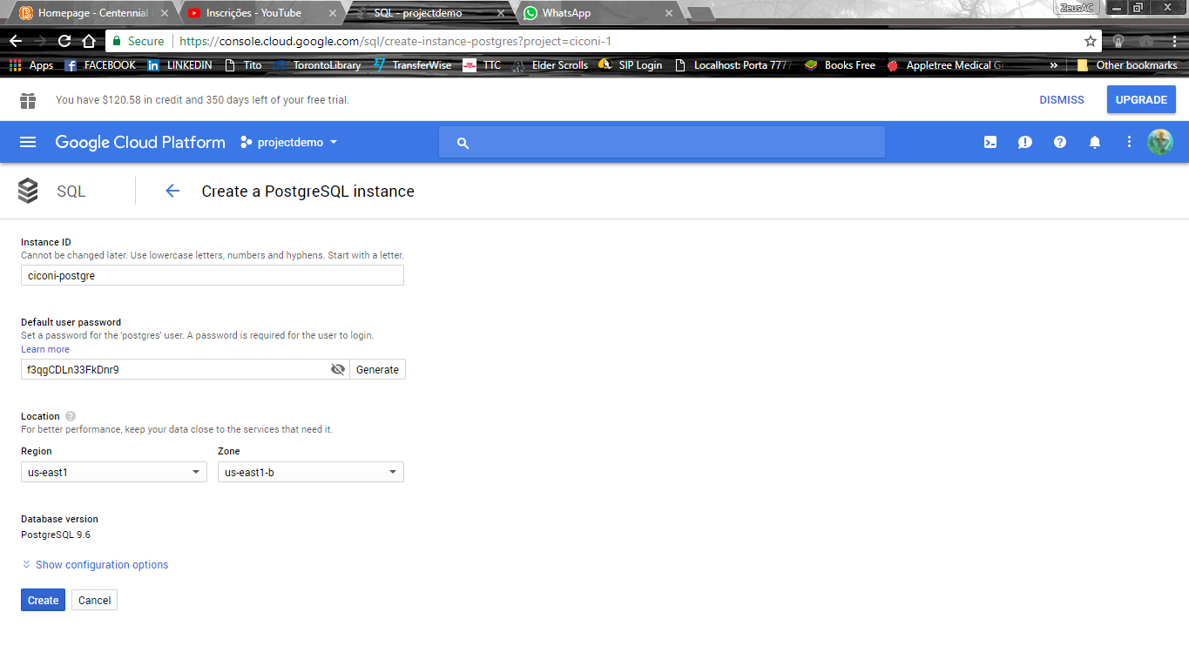

Table Description:

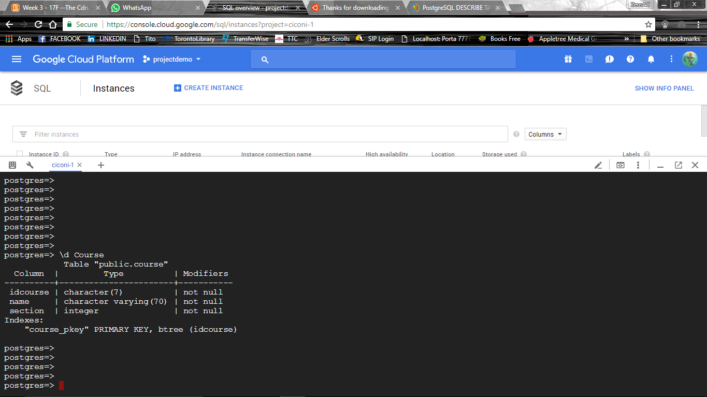

Table Select:

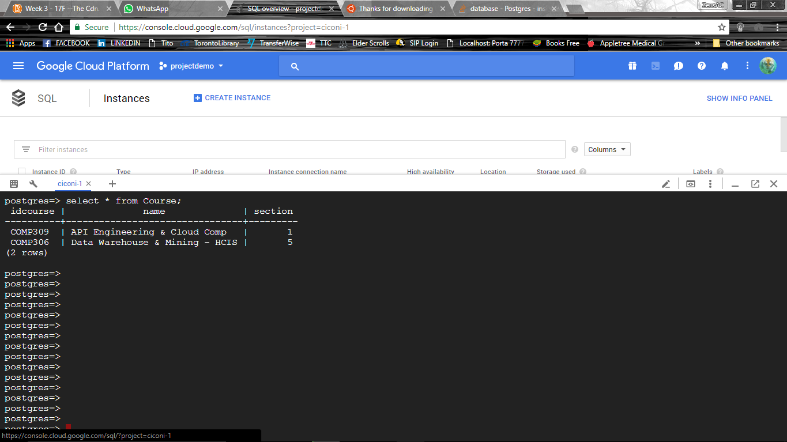

## 2.3 For storage, create a bucket to hold some of your favorite pictures or/and video clips [1 mark]

create a bucket

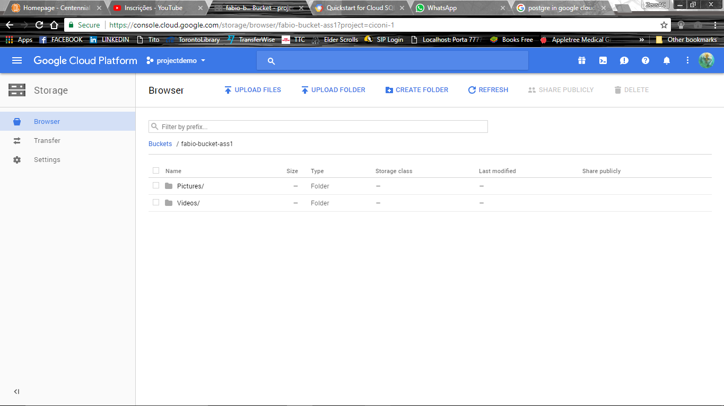

Pictures

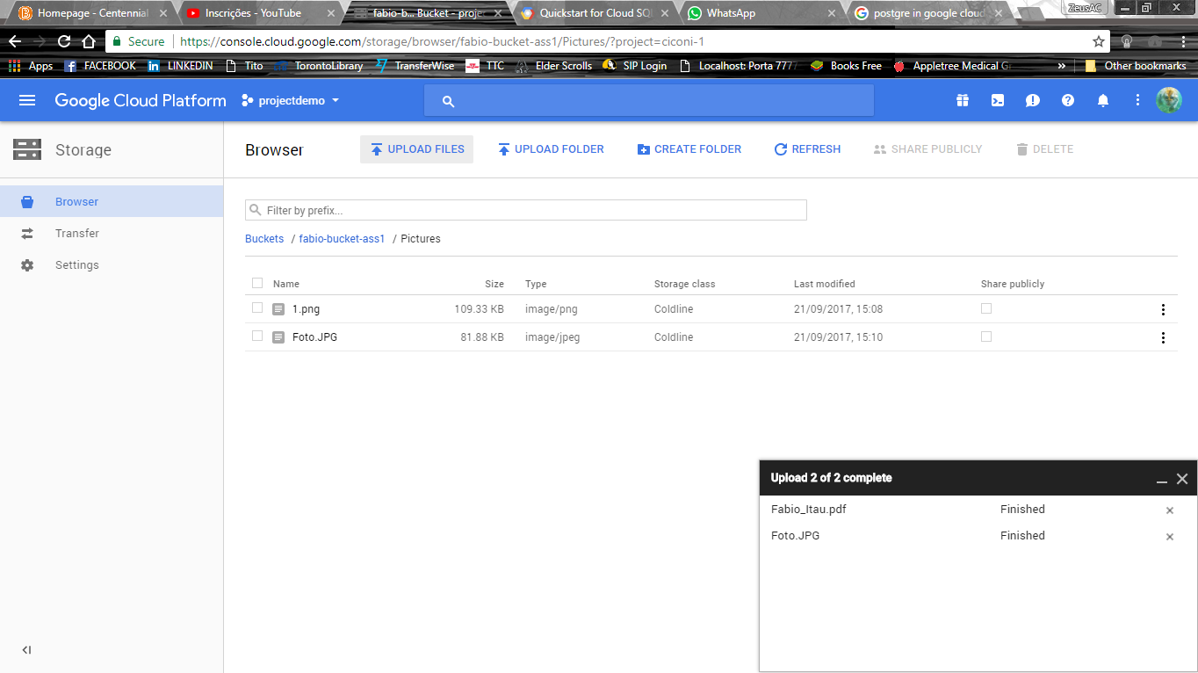

Videos:

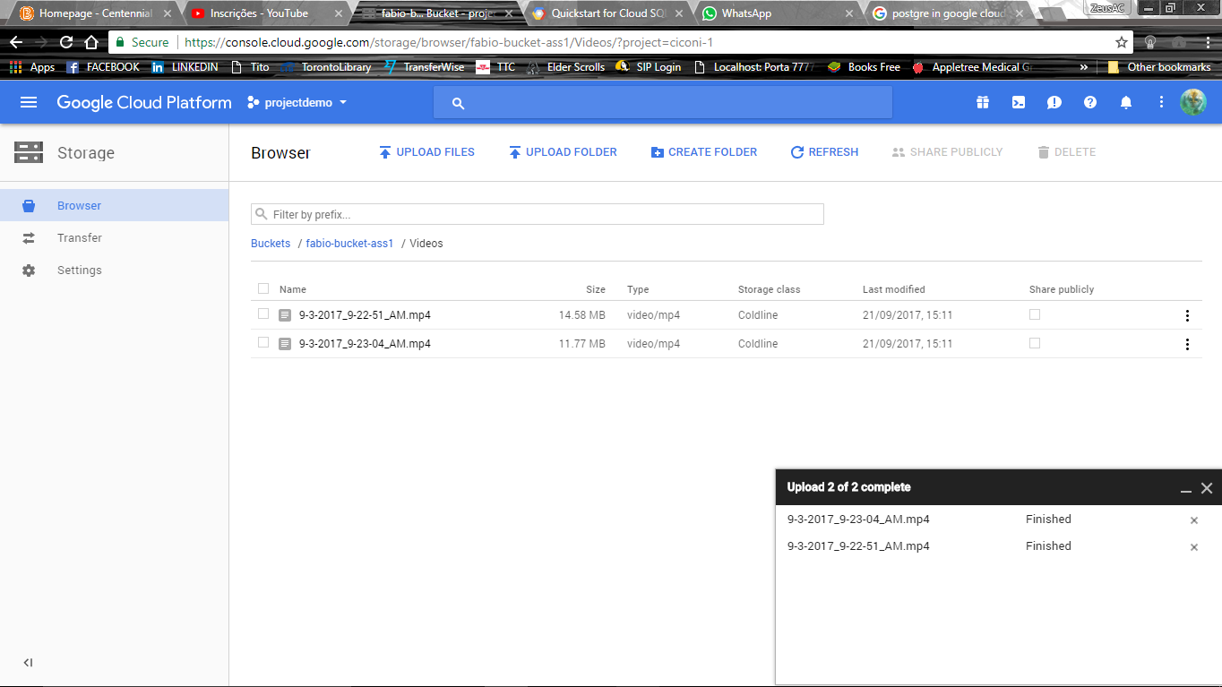

## 2.4 Create a Bigtable instance, and add one table which holds some health data, such as heartrate, sent by wearable devices [2 marks]

BigTable Instance:

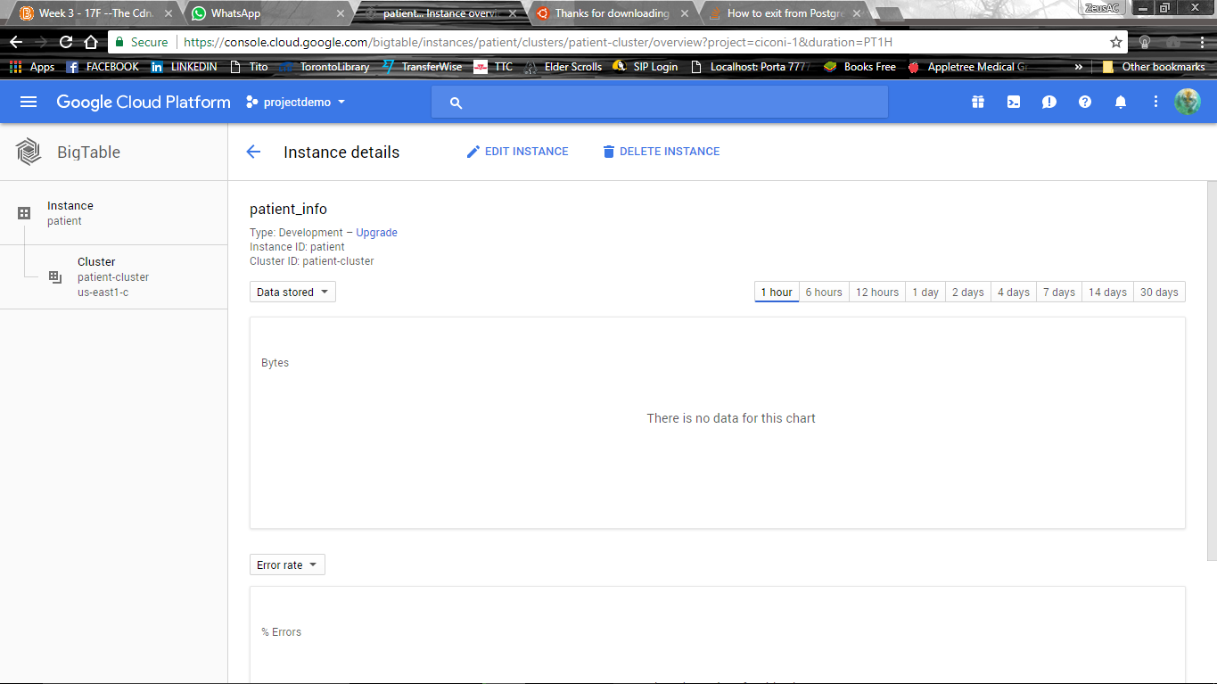

**Table:**

**I have the following problem…**

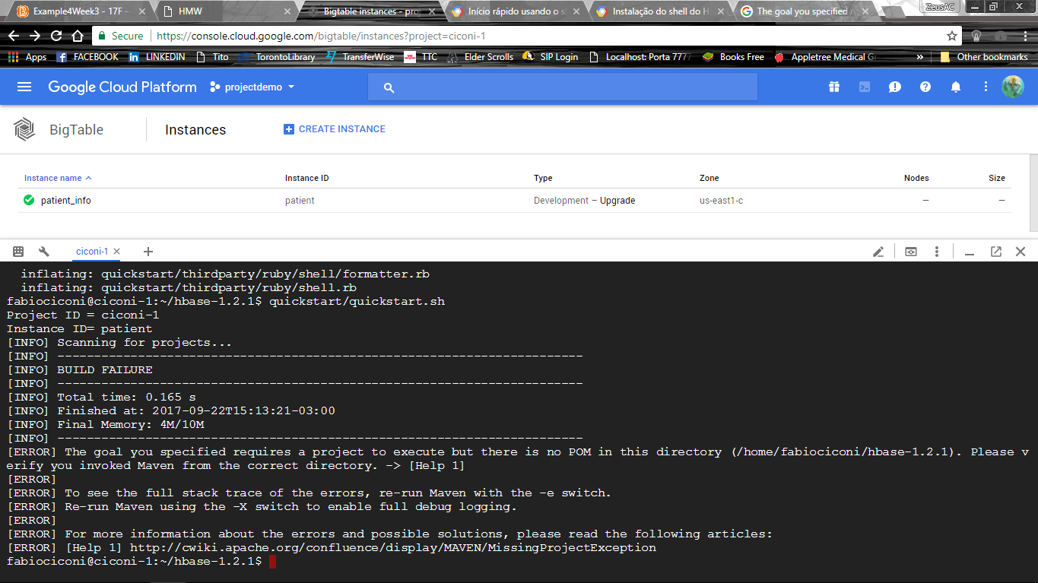

## 2.5 Create a Datastore instance, and store game reviews in it [2 marks]

Games

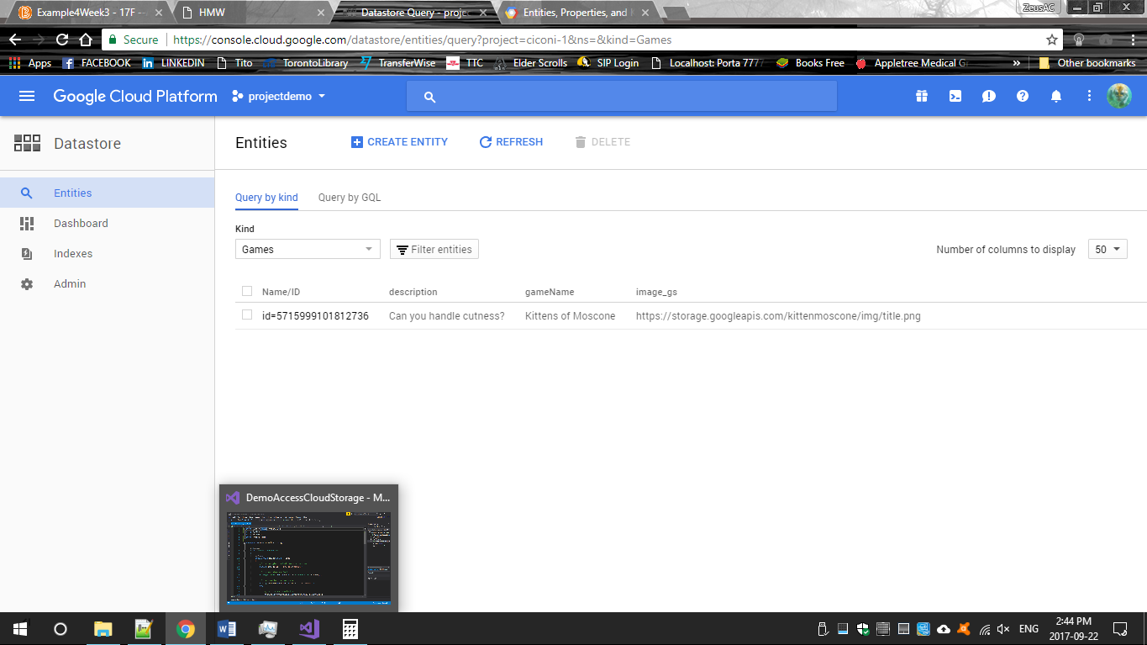

Review:

