Assignment#1 – VM and Storage

**Due Date:** Midnight of September 22 (Friday)

**Purpose:** The purpose of this assignment is to help you:

1. Understand Google Compute Engine
2. Become familiar with storage options

**Instructions**: Be sure to read the following general instructions carefully:

This assignment should be completed individually by all students. You need to demonstrate your solution during lab session, and submit your solution **through the dropbox**. Your submission must be a word document or a pdf document which contains necessary screenshot, and be named following the pattern of **studentID(yourlastname)_ASSnumber.pdf**. e.g., 300123456(**smith)_ASS#1**.pdf

**Question 1 [5 marks]**

Finish the tutorial <https://cloud.google.com/tools/visual-studio/docs/quickstart> and demonstrate the published app during the lab.

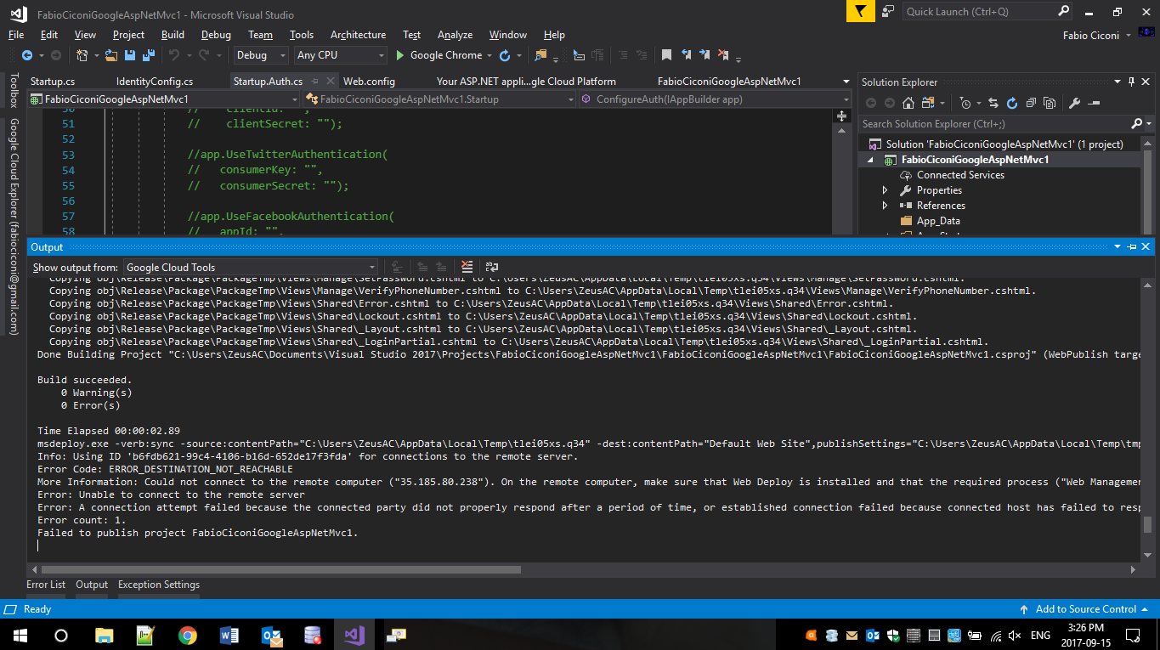

**Question2 [10 marks]**

2.1 Explain different Google cloud storage options, SQL, Storage, Bigtable and Datastore. [4 marks]

* SQL:
* Storage:
* Bigtable:
* Datastore

2.2 Create a PostgreSQL database server instance, create a table, called Course, to hold all information about course [1 mark]

2.3 For storage, create a bucket to hold some of your favorite pictures or/and video clips [1 mark]

2.4 Create a Bigtable instance, and add one table which holds some health data, such as heartrate, sent by wearable devices [2 marks]

2.5 Create a Datastore instance, and store game reviews in it [2 marks]

