**Deploy .NET core 2.0 Restful API to Heroku**

First set up working environment by installing: (details can be found at https://blog.devcenter.co/tagged/heroku)

1. Docker
2. Heroku CLI
3. ASP.NET core 2.0 runtime

Step 1. Generate a package for publishing

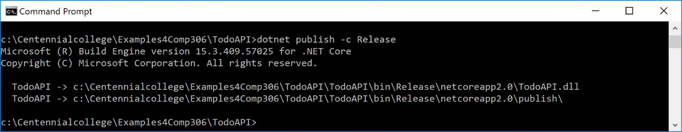

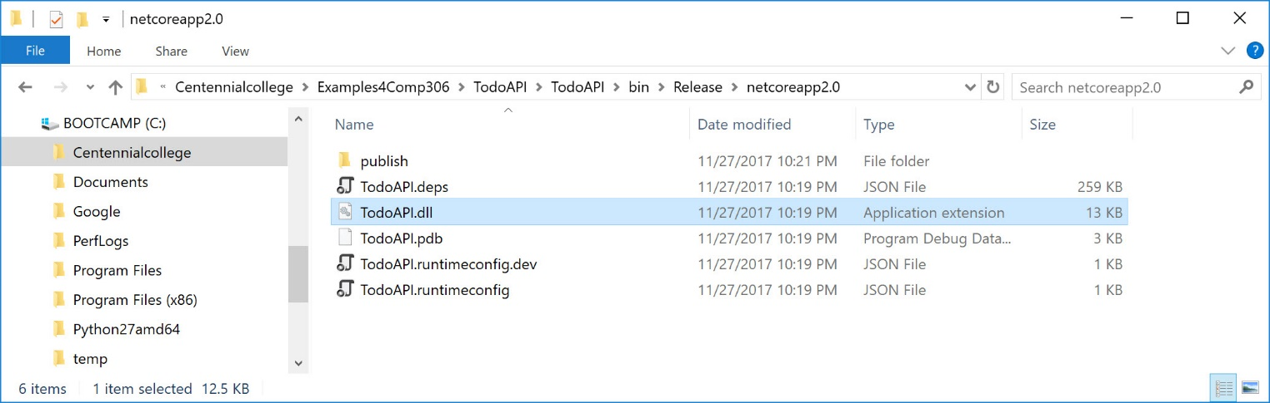

Step 2: Add a Dockerfile to the root of your project

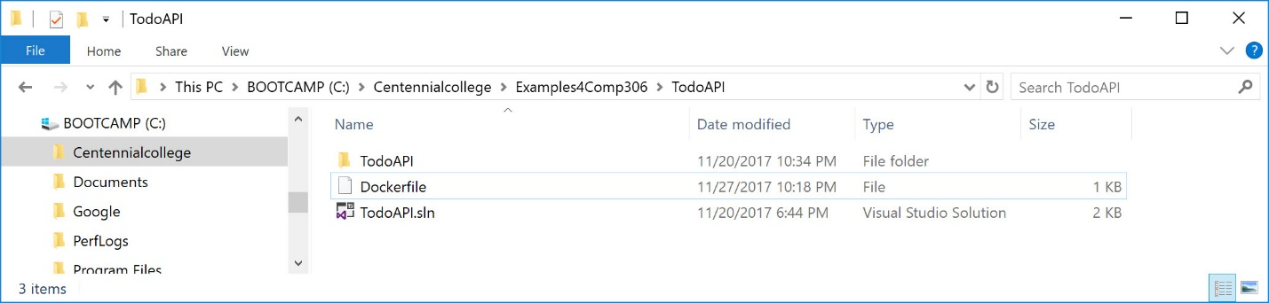

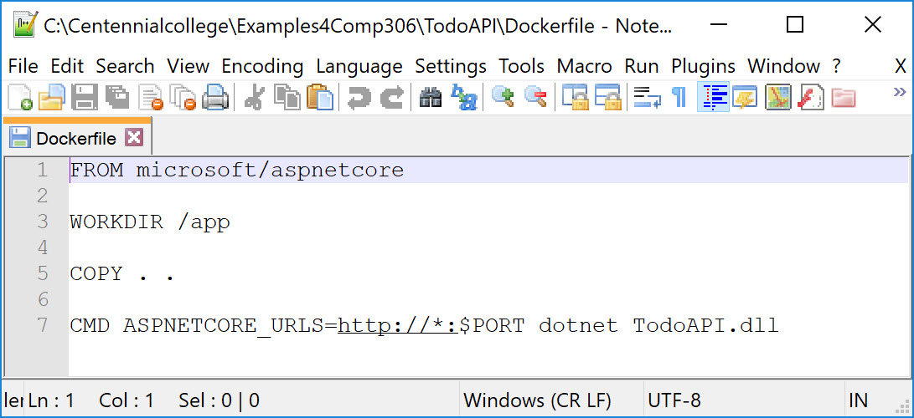

Step 3. Copy the dockerfile to publish directory

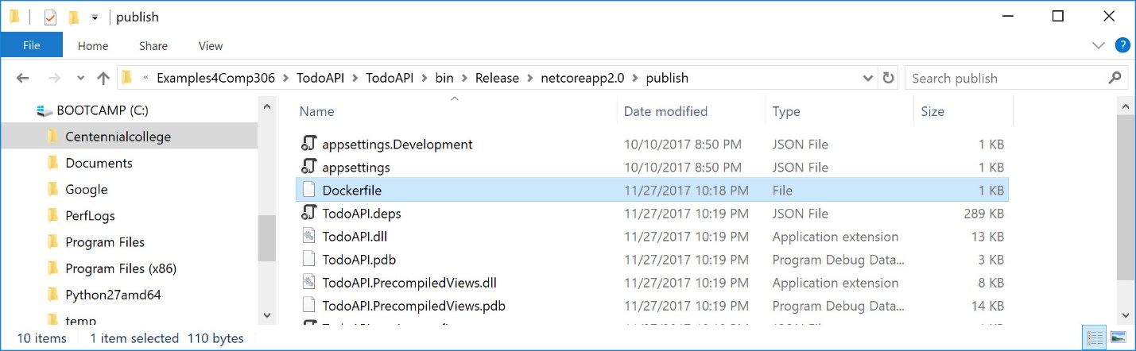

Step 4. Build Docker image

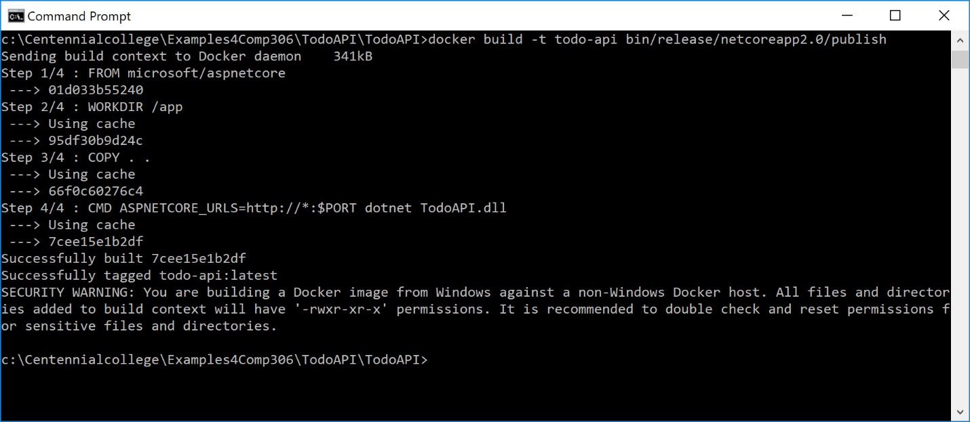

Step 5. Create an app in Heroku

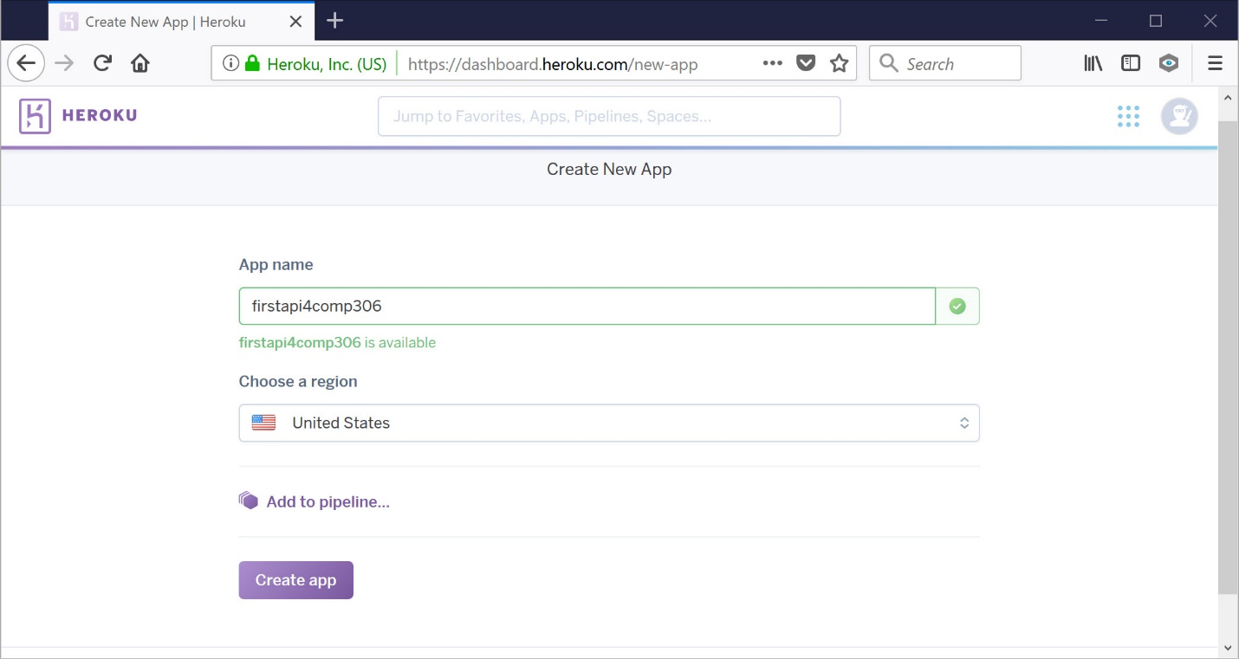

Step 6. Tag the Heroku target image

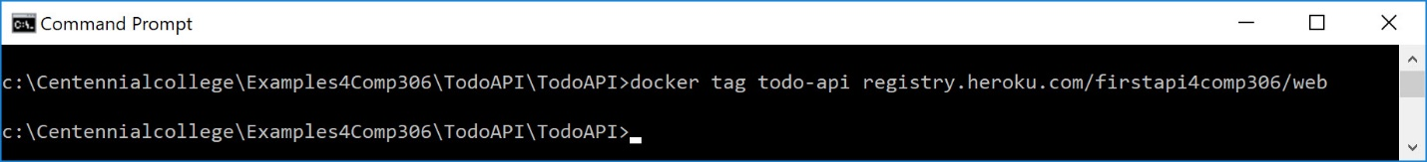

Step 7. Login and Push the docker image to Heroku

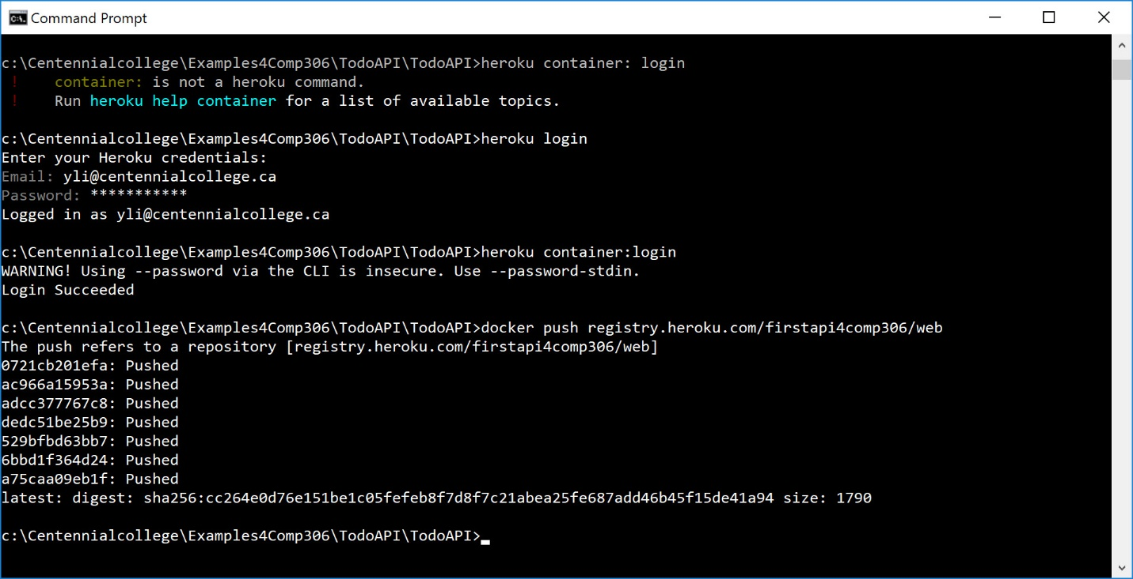

Step 8. Check app

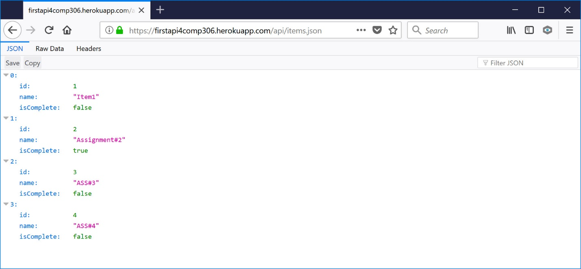

Reference

1. https://blog.devcenter.co/tagged/heroku