Hospital Project - Conceptual Design
Rationale for Class Structure, Design of Algorithm, Order of Decision Constructs
Fabio Curcio Madeira SBA18010

First Brainstorm:
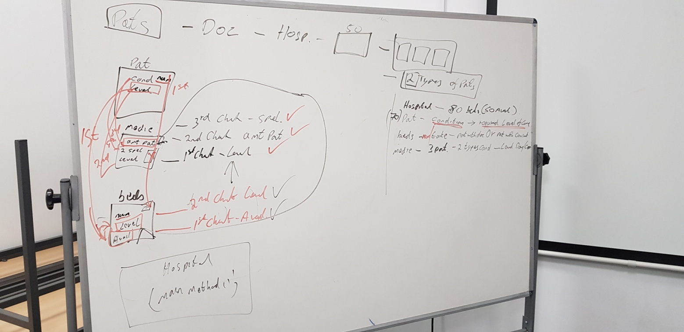

First Scenario:
The project is a Hospital with a set of specific classes - but not limited to - and specific conditions and requirements. During briefing and team meeting (class), we come up with a series of lines of thought and from then, a development would need to be made on how those classes and parameters would interact, depend and rely on each other. From then, each individual should come up with the order of the situations, creating checks, assigning the construction of the algorithms and the line of thought.

Conditions:
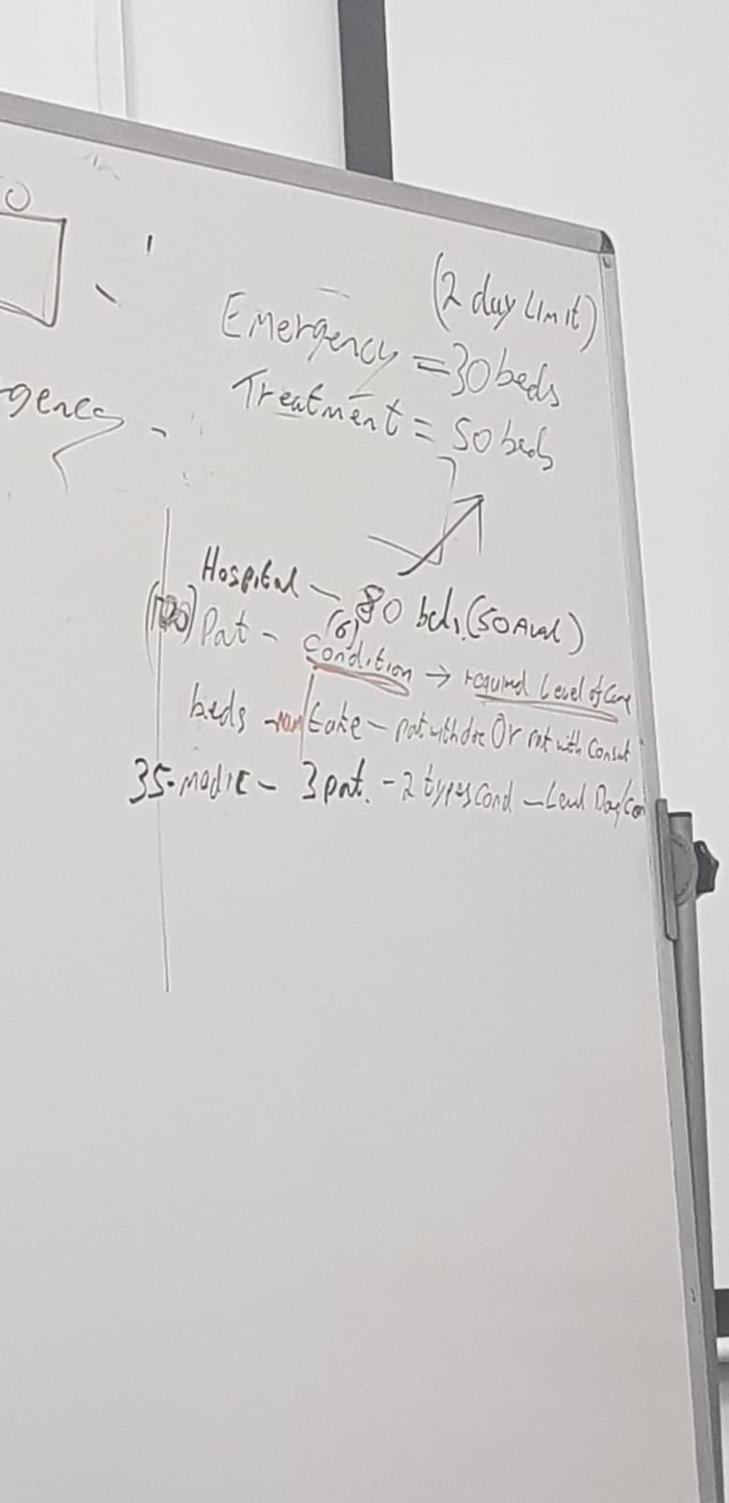

A set of information on Hospital were given, such as number of beds in each department, number of medics (doctors and consultants) and number of patients. Patients had conditions when they got to the hospital and each condition would require a level of care. Medics could only treat 3 patients at a time, on the condition that each medic has only two specialities. Medics can be assigned to either/or/both Emergency and Treatment departments. The beds on emergency department can only accommodate patients for no more than two days while in treatment they can stay a minimum of 3 days and a maximum of 7 days.

Considering the requirements and the basic set up of classes, I decided to go on with the following checks and approach:

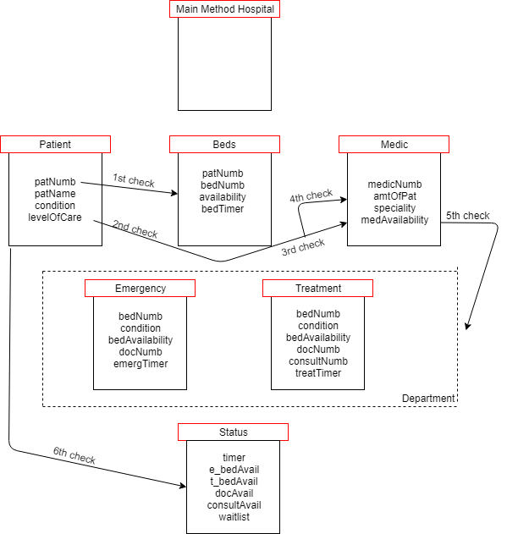

And the reasoning for those choices:
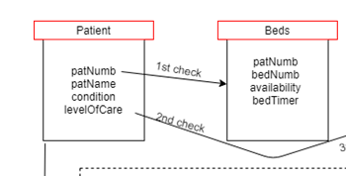
As soon as a patient comes in, I need to collect information. Patient name, condition and level of care. Each patient will automatically have a unique number linked to him/her. The first check will be checking if there are beds available for the patients in the order they come in. There's no reason to continue dealing with a patient if there are no beds available.
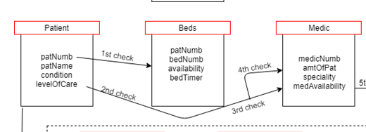
If a bed is available but there are no medics available, there is no point keeping the bed occupied so the second check is making sure there are doctors or consultants available to treat the patient, depending on the condition and level of care that is required. The third and fourth check is seeing if the free doctor can treat the patient considering the amount of patients he already has under care and if the speciality is enough for the condition of the patient, considering the requirement that each medic has 2 specialities and can treat 3 patients.

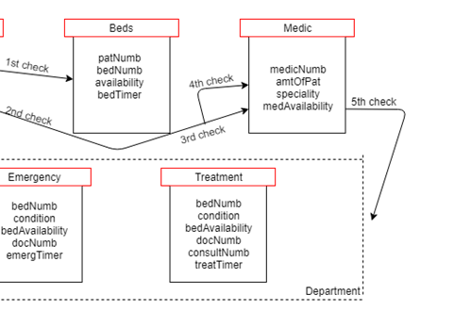
The fifth check is making sure where the patients being treated and where the medics treating are. Beds will be changing from unavailable to available all the time considering random checks and timer ser up on both departments. Each department will have a specific bed number that will be linked to the patient using the bed, the condition patient is in, availability of beds in each department, a timer, and medics. Emergency department will only have doctors working on but Treatment department could have both doctors and consultants working.
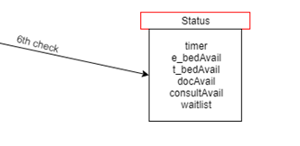
The last check that I want to do is run a status at any given time, even if the timer has not closed up yet for the next wave of people from the waitlist, to have a better idea of what is happening at a given time and what is the general status on the hospital, the availability of the beds, doctors, and an updated waitlist with whoever could not be treated. Patients that come in afterwards will have priority over patients on waitlist if they require a higher level of care than the ones waiting.

