1. Given the two tables bellow and their structure :

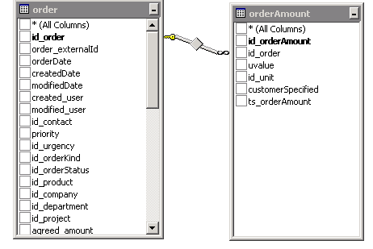

1. Display all orders created in the last 10 days.

**ANSWER**: SELECT order_externalId, createdDate FROM Orders ORDER BY createdDate ASC

Table “order amount” contains information about the amounts for each order. One order has 3 amounts: KG, PAL,M3.

Id_unit represents the name of unit : KG,PAL , M3.

Uvalue represents the actual amount for a unit.

Ex: id_order =2 has:

orderAmount.uvalue=20 for id_unit=KG

orderAmount.uvalue=1.2 for id_unit=PAL

orderAmount.uvalue=0.3 for id_unit=M3

1. Display for all orders, the total number of PAL.

**ANSWER**: SELECT SUM(uvalue) FROM orderAmount WHERE id_unit= ‘PAL’;

1. Display for all orders a table like :

|  |  |  |
| --- | --- | --- |
| id_order | number of PAL | number of KG |
|  |  |  |
|  |  |  |
|  |  |  |
|  |  |  |
|  |  |  |

**ANSWER**:

CREATE VIEW view_KG AS SELECT id_order, uvalue FROM orderAmount WHERE id_unit = 'KG';

CREATE VIEW view_PAL AS SELECT id_order, uvalue FROM orderAmount WHERE id_unit = 'PAL';

SELECT * FROM view_KG FULL JOIN view_PAL;

1. Having the tables described below:

|  |  |  |  |  |  |  |
| --- | --- | --- | --- | --- | --- | --- |
| **table_cars** |  | **table_distances** |  | **table_equipments** |  | **table_cars_equipments** |
| id |  | id_car |  | id |  | id_car |
| brand |  | date |  | name |  | id_equipment |
| type |  | distance |  | description |  |  |
| license |  |  |  |  |  |  |

Write the following queries:

1. Show all cars that have equipment "fire extinguisher" and have been driving yesterday

**ANSWER**: SELECT * FROM table_cars INNER JOIN table_equipments WHERE table_equipments.name = “fire extinguisher”;

1. Show all brands with no equipments

**ANSWER**: SELECT table_cars.brand FROM table_cars INNER JOIN table_equipments WHERE table_equipments.name = NULL;

1. Show total distance driven by car "B-01-TST" in the last month

**ANSWER**: SELECT SUM(distance) FROM table_cars INNER JOIN table_distances WHERE table_cars.license = ‘B-01-TST’;

1. Show average distance per day driven by cars from Ilfov

**ANSWER**: SELECT AVG(distance) FROM table_cars INNER JOIN table_distances WHERE table_cars.type = ‘Ilfov’;

1. Create a vbs script that will move from folder A to folder B the oldest file every 2 min.
2. Given the XML file bellow:

<?xml version="1.0" ?>

<message-in>

<realised-gps>

<id>**64172068**</id>

<resourceId>**B-06-KXO**</resourceId>

<position>

<coordinatesystem>**Standard**</coordinatesystem>

<latitude>**44.380765**</latitude>

<longitude>**25.9952**</longitude>

</position>

<time>**2011-05-23T10:34:46**</time>

<temperature>**21.01**</temperature>

<door>**0**</door>

</realised-gps>

</message-in>

1. Create a .xsl file that will check if the temperature is >20 then will remove the tag <temperature>.

Example: if temperature>20 then the xml output file:

<?xml version="1.0" ?>

<message-in>

<realised-gps>

<id>**64172068**</id>

<resourceId>**B-06-KXO**</resourceId>

<position>

<coordinatesystem>**Standard**</coordinatesystem>

<latitude>**44.380765**</latitude>

<longitude>**25.9952**</longitude>

</position>

<time>**2011-05-23T10:34:46**</time>

<door>**0**</door>

</realised-gps>

</message-in>

If temperature <=20 then the xml output file:

<?xml version="1.0" ?>

<message-in>

<realised-gps>

<id>**64172068**</id>

<resourceId>**B-06-KXO**</resourceId>

<position>

<coordinatesystem>**Standard**</coordinatesystem>

<latitude>**44.380765**</latitude>

<longitude>**25.9952**</longitude>

</position>

<time>**2011-05-23T10:34:46**</time>

<temperature>**21.01**</temperature>

<door>**0**</door>

</realised-gps>

</message-in>