Quarterly facilities report, Q3
Prepared by: Dana Whitfield, Facilities Manager Date: 05 October 2026

1. Summary
This report covers planned and reactive maintenance across the four sites managed by Alder Row Facilities Ltd between July and September. Work order volumes rose by 6% on the previous quarter, mainly because of the cooling demand in August. Overall completion stayed above the 90% service level target.
- Completion rate across all sites: 93.1% (target 90%).
- Two lift outages at Riverside Office, both resolved within four hours.
- Annual fire safety inspection passed at all sites with no major findings.

2. Work orders per site
Site | Raised | Closed | Completion
Riverside Office | 412 | 398 | 96.6%
Elm Park Depot | 188 | 171 | 91.0%
Canal Street Studio | 96 | 95 | 99.0%
Westfield Warehouse | 265 | 233 | 87.9%
Total | 961 | 897 | 93.3%

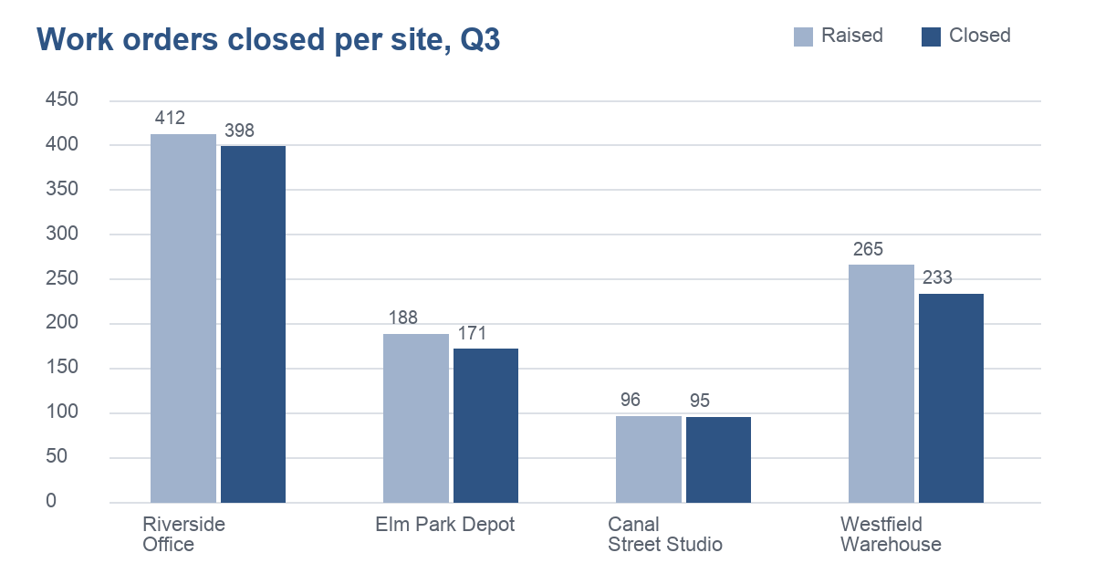
Figure 1. Work orders raised and closed per site.

3. Notable issues

3.1 Westfield Warehouse cooling
The roof-mounted cooling unit tripped three times during the August heat. A replacement compressor was fitted on 22 August. Completion at this site fell to 87.9% while engineers were redirected to the cooling fault.
Action: schedule a pre-summer inspection of all roof plant in May, before the first heat wave.

3.2 Next quarter
- Replace the emergency lighting batteries at Elm Park Depot.
- Tender the cleaning contract for Canal Street Studio.
- Survey the Riverside Office roof before winter.

