Animal Rescue in Ireland

Fabio Tavares

21/12/2022

# 1 Problem Statement

The purpose of this report is to provide information on the costs associated with animal rescues in Ireland. By analyzing data on the expenses incurred and the types of animals and interventions involved, was aimed to identify ways to reduce the annual expenditure on animal rescues through preventive measures.

# 2 Solution Statement

An exploratory analysis of a dataset containing records of animal rescues in Ireland from 2009 to 2022 will be conducted with the goal of identifying the animal groups and service types per animal groups that contribute the most to the expenses incurred. By understanding the factors contributing to these costs, recommendations for further studies and interventions that will help to create preventive approaches to these issues and ultimately reduce the expenditure on animal rescues in Ireland can be made. The aim of this solution is to gain a better understanding of the areas where the greatest expenses are incurred in animal rescues.

# 3 Exploratory Analyses

## 3.1 Data Cleaning

First was checked the attributes formats and content.

### 3.1.1 Check Formats and samples

## DateTimeOfCall HourlyNotionalCost IncidentNotionalCost AnimalGroupParent   
## Length:8939 Min. :255 Length:8939 Length:8939   
## Class :character 1st Qu.:260 Class :character Class :character   
## Mode :character Median :326 Mode :character Mode :character   
## Mean :310   
## 3rd Qu.:346   
## Max. :364   
## PropertyCategory SpecialServiceTypeCategory SpecialServiceType  
## Length:8939 Length:8939 Length:8939   
## Class :character Class :character Class :character   
## Mode :character Mode :character Mode :character   
##   
##   
##   
## Area   
## Length:8939   
## Class :character   
## Mode :character   
##   
##   
##

### 3.1.2 Check unique values in nominal attributes

**AnimalGroupParent**

## [1] "Dog"   
## [2] "Fox"   
## [3] "Horse"   
## [4] "Ra^&it"   
## [5] "Unknown - Heavy Livestock Animal"   
## [6] "Squirrel"   
## [7] "Cat"   
## [8] "Bird"   
## [9] "D+g"   
## [10] "Unknown - Domestic Animal Or Pet"   
## [11] "Ca&"   
## [12] "Sheep"   
## [13] "Ca$"   
## [14] "Bir*"   
## [15] "Deer"   
## [16] "Unknown - Wild Animal"   
## [17] "Snake"   
## [18] "Lizard"   
## [19] "Bi^&"   
## [20] "Hedgehog"   
## [21] "cat"   
## [22] "Hamster"   
## [23] "Lamb"   
## [24] "Rabbit"   
## [25] "Fish"   
## [26] "Bull"   
## [27] "Cow"   
## [28] "Ferret"   
## [29] "Budgie"   
## [30] "Unknown - Animal rescue from water - Farm animal"   
## [31] "Pigeon"   
## [32] "Goat"   
## [33] "Tortoise"   
## [34] "Unknown - Animal rescue from below ground - Farm animal"

**PropertyCategory**

## [1] "Dwelling" "Outdoor Structure" "Non Residential"   
## [4] "Outdoor" "Road Vehicle" "Other Residential"  
## [7] "Dwe^&ing" "Dwe!!ing" "Boat"

**SpecialServiceTypeCategory**

## [1] "Other animal assistance" "Animal rescue from below ground"  
## [3] "Animal rescue from water" "Animal rescue from height"

**SpecialServiceType**

## [1] "Animal assistance involving livestock - Other action"   
## [2] "Animal rescue from below ground - Domestic pet"   
## [3] "Animal rescue from water - Farm animal"   
## [4] "Animal rescue from water - Domestic pet"   
## [5] "Wild animal rescue from height"   
## [6] "Animal rescue from height - Domestic pet"   
## [7] "Animal rescue from water - Bird"   
## [8] "Animal rescue from height - Bird"   
## [9] "Wild animal rescue from water or mud"   
## [10] "Animal assistance - Lift heavy livestock animal"   
## [11] "Wild animal rescue from below ground"   
## [12] "Animal rescue from below ground - Bird"   
## [13] "Animal rescue from height - Farm animal"   
## [14] "Animal rescue from below ground - Farm animal"   
## [15] "Assist trapped domestic animal"   
## [16] "Animal harm involving domestic animal"   
## [17] "Animal assistance involving wild animal - Other action"   
## [18] "Animal assistance involving domestic animal - Other action"  
## [19] "Animal harm involving wild animal"   
## [20] "Assist trapped livestock animal"   
## [21] "Assist trapped wild animal"   
## [22] "Animal assistance - Lift heavy wild animal"   
## [23] "Animal assistance - Lift heavy domestic animal"   
## [24] "Animal harm involving livestock"

**Area**

## [1] "Ranelagh" "Sutton" "Smithfield" "Perrystown"   
## [5] "Crumlin" "Milltown" "Belfield" "Rathfarnham"   
## [9] "Terenure" "Rathmines" "Templeogue" "Dundrum"   
## [13] "Walkinstown" "Leopardstown" "Stepaside" "Tallaght"   
## [17] "Clontarf" "Harolds Cross" "Donnybrook" "Killester"   
## [21] "Ballymun" "Ballyfermot" "Drumcondra" "Clonsilla"   
## [25] "Dalkey" "Cabra" "Glasnevin" "Santry"   
## [29] "Portobello" "Killiney" "Blackrock" "Dun laoighre"   
## [33] "Temple Bar" "Rathm&^es" "Drumco\"!ra" "Ta!!aght"   
## [37] "Donnybr$*k" "Clondalkin" "Finglas" "Castleknock"   
## [41] "Tandridge" "SUTTON" NA

The Dataset has 8 columns with a total of 8,939 rows. There are data format issues and type mistakes on the variables to correct:

**Data formats:**

* DateTimeOfCall: It’s in character format. It will be converted to datetime.
* IncidentNotionalCost: It’s numeric value as in column HourlyNotionalCost. It will be converted to integer.

**Type mistakes:**

* AnimalGroupParent
* Property Category
* Area

### 3.1.3 Convert column DateTimeOfCall in datetime and Incident Notional Cost in integer

## Rows: 8,939  
## Columns: 8  
## $ DateTimeOfCall <dttm> 2009-01-01 03:01:00, 2009-01-01 08:51:00, …  
## $ HourlyNotionalCost <dbl> 255, 255, 255, 255, 255, 255, 255, 255, 255…  
## $ IncidentNotionalCost <int> 510, 255, 255, 255, 255, 255, 255, 255, 255…  
## $ AnimalGroupParent <chr> "Dog", "Fox", "Dog", "Horse", "Ra^&it", "Un…  
## $ PropertyCategory <chr> "Dwelling", "Outdoor Structure", "Outdoor S…  
## $ SpecialServiceTypeCategory <chr> "Other animal assistance", "Other animal as…  
## $ SpecialServiceType <chr> "Animal assistance involving livestock - Ot…  
## $ Area <chr> "Ranelagh", "Ranelagh", "Sutton", "Smithfie…

### 3.1.4 Fix up type mistakes

## Rows: 8,939  
## Columns: 3  
## $ AnimalGroupParent <chr> "Dog", "Fox", "Dog", "Horse", "Rabbit", "Unknown - H…  
## $ PropertyCategory <chr> "Dwelling", "Outdoor Structure", "Outdoor Structure"…  
## $ Area <chr> "Ranelagh", "Ranelagh", "Sutton", "Smithfield", "Per…

### 3.1.5 Missing values

There are some missing values on the columns “IncidentNotionalCost” and “Area”. Those missing values represents less than 1% of the Data, so was chosen to delete them.

## # A tibble: 8 × 3  
## variable n_miss pct_miss  
## <chr> <int> <dbl>  
## 1 IncidentNotionalCost 63 0.705  
## 2 Area 11 0.123  
## 3 DateTimeOfCall 0 0   
## 4 HourlyNotionalCost 0 0   
## 5 AnimalGroupParent 0 0   
## 6 PropertyCategory 0 0   
## 7 SpecialServiceTypeCategory 0 0   
## 8 SpecialServiceType 0 0

## 3.2 Understanding the Data

**First and last record:**

## # A tibble: 1 × 2  
## first_record last_record   
## <dttm> <dttm>   
## 1 2009-01-01 03:01:00 2022-09-30 23:35:00

**Notional Cost per hour:**

## [1] 255 260 290 295 298 326 328 333 339 346 352 364

The Dataset samples are from 01/01/2009 to 30/09/2022 and each record corresponds to an Animal rescue. The column “HourlyNotionalCost” have the estimate cost per hour and the total cost is represented in the column “IncidentNotionalCost”. Notional Cost, or Implicit cost, for each incident registered is an estimation and it raised up throughout the years.

The column “AnimalGroupParent” records the Animal specie rescued in each intervention.

## 3.3 NotionalCost per year

As it possible to see on graph 1, the amount spent in Animal Rescue throughout the years increased significantly, with strong increases in 2016 (23%), 2018 (17%), 2020 (27%) and 2021 (13%) . Alike The amount spent, the hourly cost increased, highlighting an increase of 12% in 2013 and 9% in 2016 (graph 2). Although the raise on the Hourly Notional Cost was consistent, doesn’t seems to be the main reason for the substantial increase on the amount expended in 2016, 2018, 2020 and 2021.

## # A tibble: 14 × 3  
## year cost `increase_rate (%)`  
## <fct> <int> <dbl>  
## 1 2009 176055 NA  
## 2 2010 187460 6  
## 3 2011 193960 3  
## 4 2012 182780 -6  
## 5 2013 194780 7  
## 6 2014 199855 3  
## 7 2015 184415 -8  
## 8 2016 227272 23  
## 9 2017 206322 -9  
## 10 2018 240477 17  
## 11 2019 239220 -1  
## 12 2020 304919 27  
## 13 2021 345396 13  
## 14 2022 341196 -1

## # A tibble: 14 × 3  
## year cost `increase_rate (%)`  
## <fct> <dbl> <dbl>  
## 1 2009 260 NA  
## 2 2010 260 0  
## 3 2011 260 0  
## 4 2012 260 0  
## 5 2013 290 12  
## 6 2014 295 2  
## 7 2015 298 1  
## 8 2016 326 9  
## 9 2017 328 1  
## 10 2018 333 2  
## 11 2019 339 2  
## 12 2020 346 2  
## 13 2021 352 2  
## 14 2022 364 3

### 3.3.1 Plot total cost per year

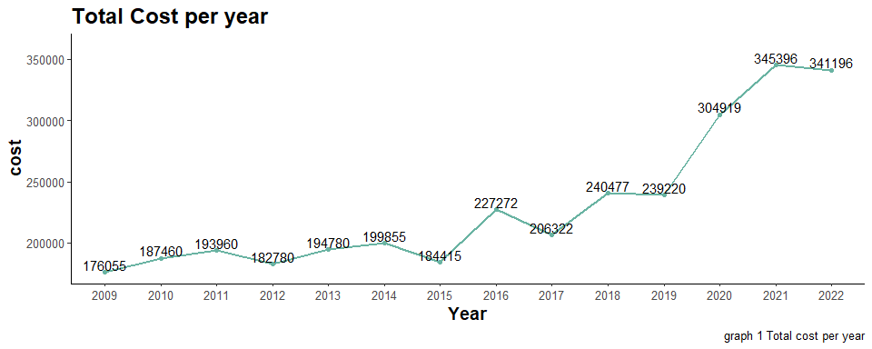

### 3.3.2 Plot hourly cost per year

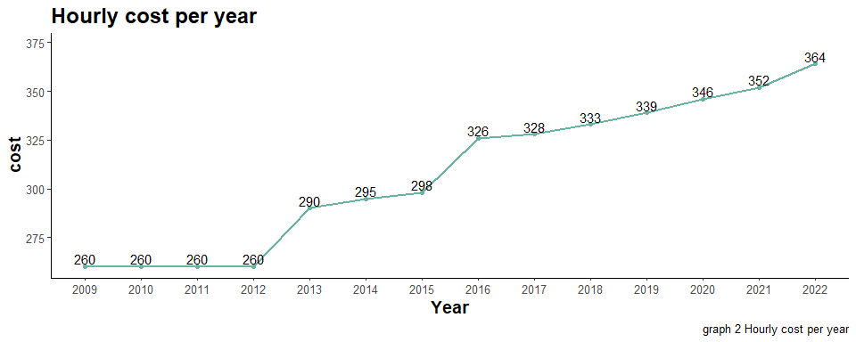

Looking at the number of interventions per year (graph 3), it’s possible to see a significant growth in the years 2016 (11%), 2018 (12%), 2020 (26%) and 2021(16%). By visual inspection is possible to see that the number of interventions seems to have a positive correlation with the total implicit cost per year in animal rescues.

Now on we are going to see the animal groups that most have occurrences per year.

### 3.3.3 Plot number of interventions per year

## # A tibble: 14 × 3  
## year count `increase_rate(%)`  
## <fct> <int> <dbl>  
## 1 2009 565 NA  
## 2 2010 611 8  
## 3 2011 615 1  
## 4 2012 596 -3  
## 5 2013 584 -2  
## 6 2014 577 -1  
## 7 2015 537 -7  
## 8 2016 598 11  
## 9 2017 537 -10  
## 10 2018 601 12  
## 11 2019 596 -1  
## 12 2020 752 26  
## 13 2021 872 16  
## 14 2022 824 -6

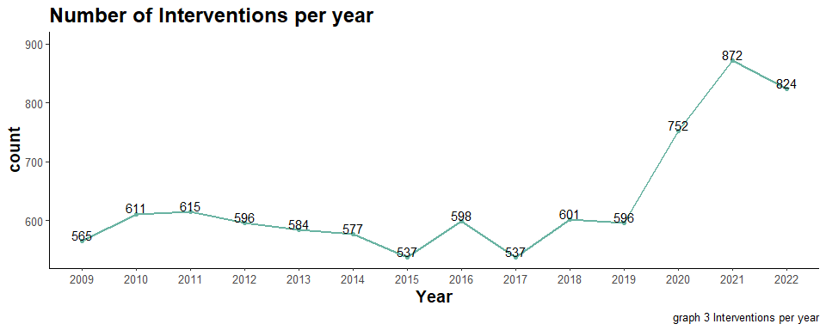

## 3.4 Ocurrences per Animal Group

Cats accounted for the majority of incidents, representing 48.96% of all occurrences. They were followed by birds, which made up 20.68% of incidents, and dogs, which accounted for 15.07%. In total, these three animal groups represented 84.72% of all incidents as visualized in graph 4.

## # A tibble: 27 × 4  
## AnimalGroupParent Count Occurrences Cumulative  
## <fct> <int> <dbl> <dbl>  
## 1 Cat 4341 49.0 49.0  
## 2 Bird 1834 20.7 69.7  
## 3 Dog 1336 15.1 84.7  
## 4 Fox 458 5.17 89.9  
## 5 Unknown - Domestic Animal Or Pet 216 2.44 92.3  
## 6 Horse 197 2.22 94.6  
## 7 Deer 152 1.71 96.3  
## 8 Unknown - Wild Animal 101 1.14 97.4  
## 9 Squirrel 78 0.880 98.3  
## 10 Unknown - Heavy Livestock Animal 49 0.553 98.8  
## # … with 17 more rows

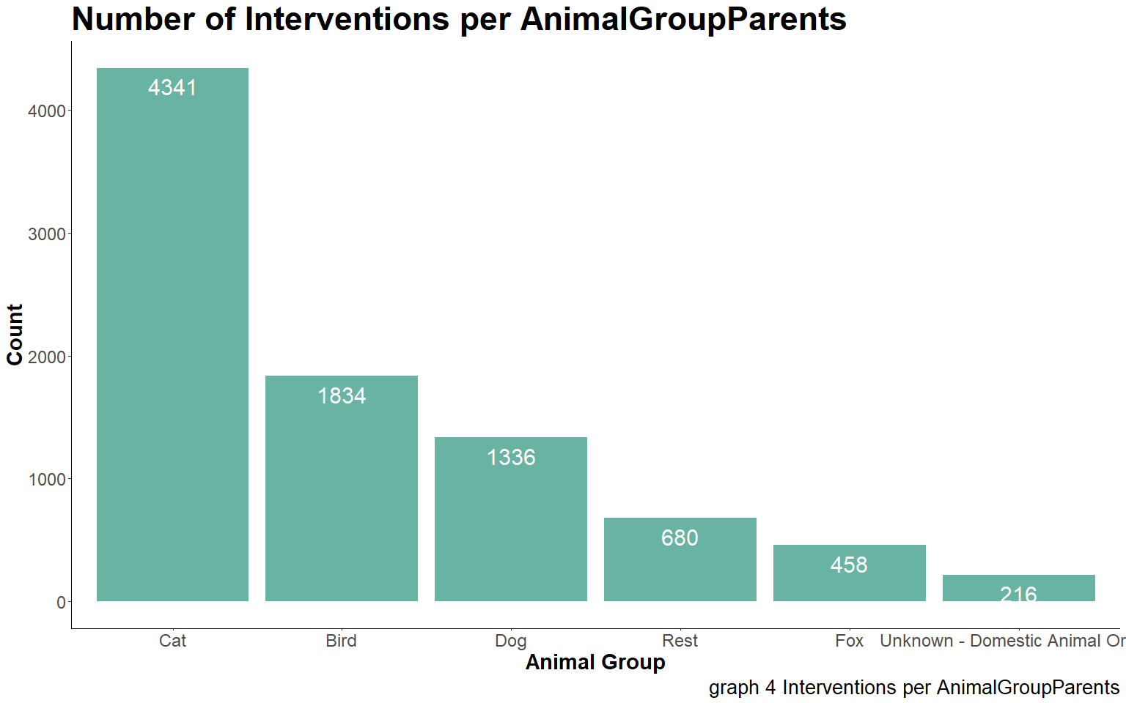

## 3.5 Service category to Cat rescues

Of the incidents involving cats (graph 5), 81.48% can be broken down into three service categories: animal rescue from height (42.25%), assist trapped domestic animal (28.27%), and animal rescue from below ground (10.97%).

## # A tibble: 13 × 4  
## SpecialServiceType Count Occurrences Cumulative  
## <fct> <int> <dbl> <dbl>  
## 1 "Animal rescue from height " 1834 42.2 42.2  
## 2 "Assist trapped domestic animal" 1227 28.3 70.5  
## 3 "Animal rescue from below ground " 476 11.0 81.5  
## 4 "Animal assistance involving domestic animal " 347 7.99 89.5  
## 5 "Animal assistance involving livestock " 286 6.59 96.1  
## 6 "Animal rescue from water " 69 1.59 97.7  
## 7 "Animal harm involving domestic animal" 56 1.29 98.9  
## 8 "Assist trapped wild animal" 17 0.392 99.3  
## 9 "Animal assistance involving wild animal " 13 0.299 99.6  
## 10 "Assist trapped livestock animal" 5 0.115 99.7  
## 11 "Wild animal rescue from below ground" 5 0.115 99.9  
## 12 "Wild animal rescue from height" 5 0.115 100.   
## 13 "Animal harm involving wild animal" 1 0.0230 100

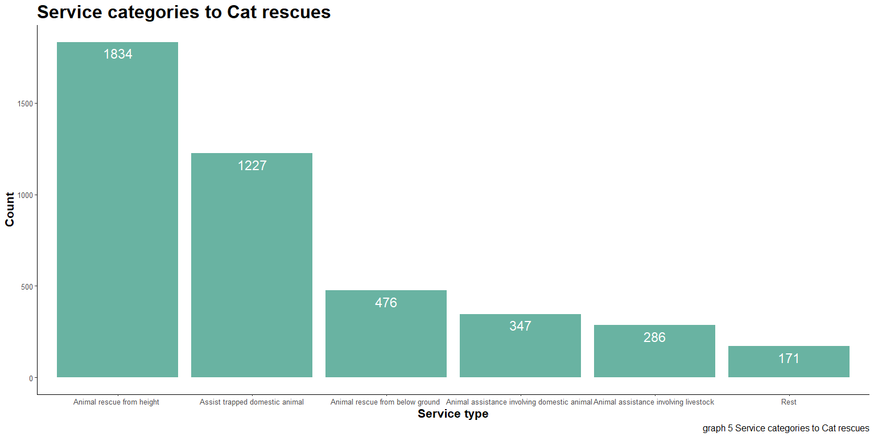

## 3.6 Service category to Bird Rescues

For bird rescues (graph 6), two categories stood out: animal rescue from height and assist trapped wild animal, with 1141 and 331 cases recorded from 2009 to 2022, respectively. Together, these categories made up 80.26% of all incidents involving bird rescue.

## # A tibble: 15 × 4  
## SpecialServiceType Count Occurrences Cumulative  
## <fct> <int> <dbl> <dbl>  
## 1 "Animal rescue from height " 1141 62.2 62.2  
## 2 "Assist trapped wild animal" 331 18.0 80.3  
## 3 "Animal assistance involving wild animal " 87 4.74 85.0  
## 4 "Animal rescue from below ground " 83 4.53 89.5  
## 5 "Animal rescue from water " 59 3.22 92.7  
## 6 "Animal assistance involving livestock " 42 2.29 95.0  
## 7 "Wild animal rescue from height" 31 1.69 96.7  
## 8 "Assist trapped domestic animal" 19 1.04 97.8  
## 9 "Animal harm involving wild animal" 14 0.763 98.5  
## 10 "Animal assistance involving domestic animal " 8 0.436 99.0  
## 11 "Wild animal rescue from below ground" 8 0.436 99.4  
## 12 "Assist trapped livestock animal" 5 0.273 99.7  
## 13 "Wild animal rescue from water or mud" 4 0.218 99.9  
## 14 "Animal harm involving livestock" 1 0.0545 99.9  
## 15 "Animal harm involving domestic animal" 1 0.0545 100

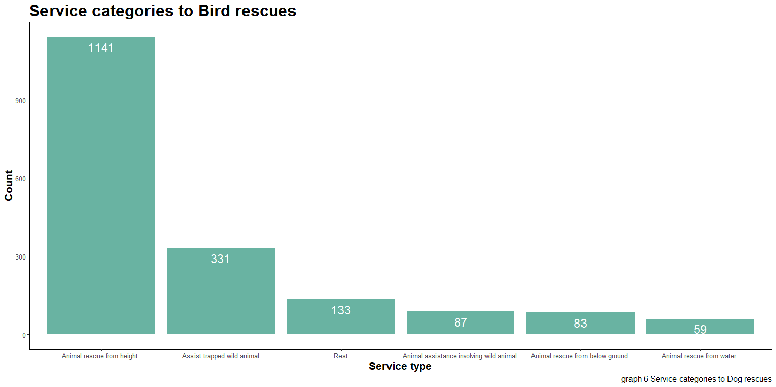

## 3.7 Service categories to Dog rescues

Of the three animal groups, dogs had the most diverse range of service types (graph 7). The most common reason for rescue among this group was being trapped domestic animal, accounting for 35.62% of cases. This was followed by rescue from below ground (13.92%), water (12.95%), assistance involving livestock (12.87%), rescue from height (10.63%), and assistance involving domestic animals (9.43%). These service categories made up 95.43% of all incidents involving dogs.

## # A tibble: 13 × 4  
## SpecialServiceType Count Occurrences Cumulative  
## <fct> <int> <dbl> <dbl>  
## 1 "Assist trapped domestic animal" 476 35.6 35.6  
## 2 "Animal rescue from below ground " 186 13.9 49.6  
## 3 "Animal rescue from water " 173 12.9 62.5  
## 4 "Animal assistance involving livestock " 172 12.9 75.4  
## 5 "Animal rescue from height " 142 10.6 86.0  
## 6 "Animal assistance involving domestic animal " 126 9.43 95.4  
## 7 "Animal harm involving domestic animal" 30 2.25 97.7  
## 8 "Animal assistance " 9 0.674 98.4  
## 9 "Animal assistance involving wild animal " 6 0.449 98.8  
## 10 "Wild animal rescue from water or mud" 6 0.449 99.3  
## 11 "Wild animal rescue from below ground" 5 0.374 99.6  
## 12 "Assist trapped livestock animal" 3 0.225 99.9  
## 13 "Assist trapped wild animal" 2 0.150 100

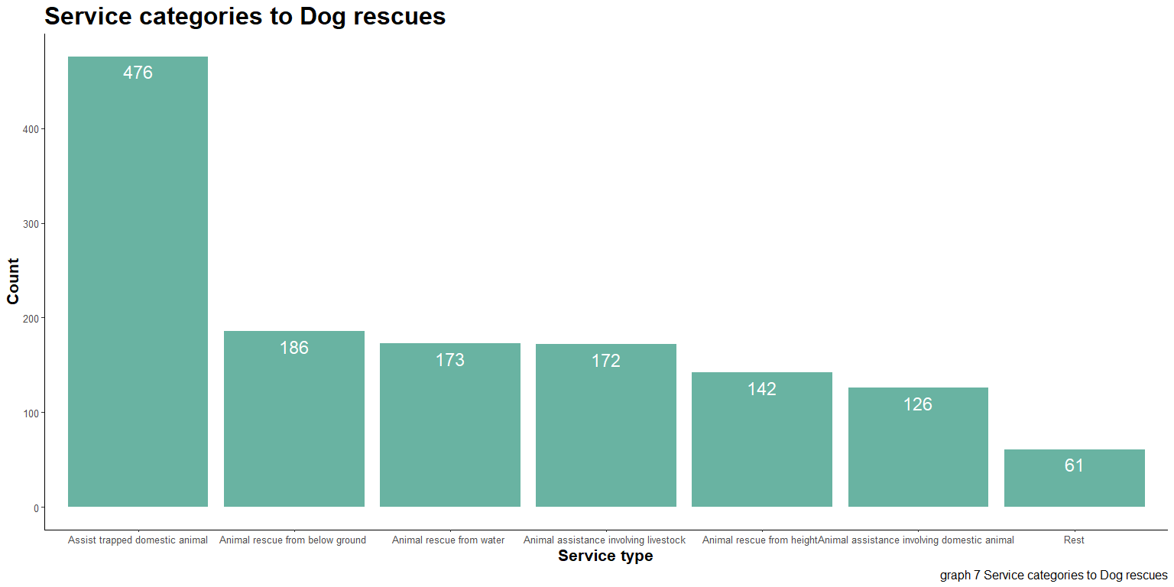

## 3.8 Amount expended per year by top 3 animal groups

From 2019 to 2022, there was an increase of more than 80% in the amount spent on interventions for cats. In contrast, there was a 13% decrease in the amount spent on bird rescues from 2020 to 2022, and a 14% decrease in the amount spent on dog rescues from 2021 to 2022 as displayed in graph 8.

## # A tibble: 42 × 3  
## # Groups: AnimalGroupParent [3]  
## AnimalGroupParent year CostPerYear  
## <fct> <dbl> <int>  
## 1 Bird 2009 25095  
## 2 Cat 2009 76945  
## 3 Dog 2009 39295  
## 4 Bird 2010 27300  
## 5 Cat 2010 88920  
## 6 Dog 2010 38480  
## 7 Bird 2011 36140  
## 8 Cat 2011 89440  
## 9 Dog 2011 31200  
## 10 Bird 2012 32240  
## # … with 32 more rows

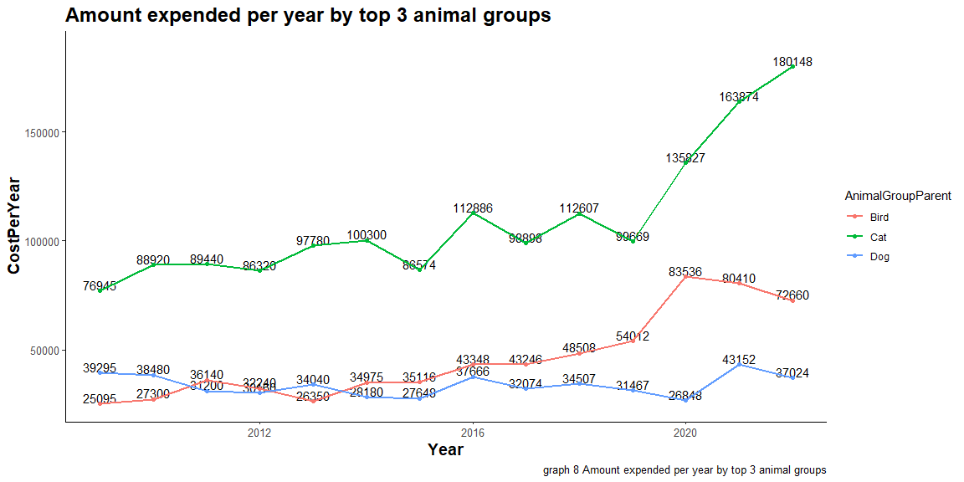

On average, €188,919 is spent on animal rescues for these three animal groups, with the majority (57.85%) being allocated to Cat rescues.

## # A tibble: 3 × 4  
## AnimalGroupParent MeanTotalCostPerYear CostPct Cumulative  
## <fct> <dbl> <dbl> <dbl>  
## 1 Cat 109299 57.9 57.9  
## 2 Bird 45924 24.3 82.2  
## 3 Dog 33696 17.8 100

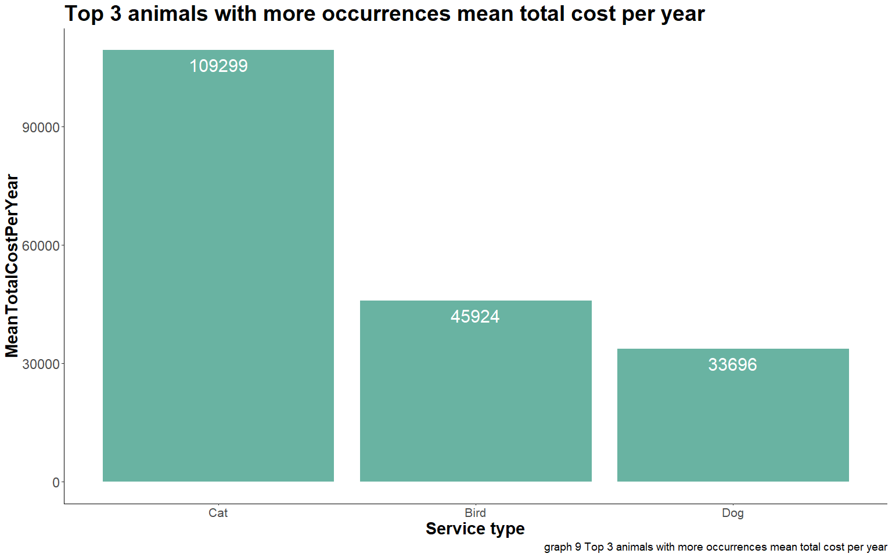

# 4 Conclusion

Cats are frequently in need of rescue, and this has become a growing issue, with costs rising more than 80% from 2019 to 2022. The main cause of these interventions is cats being stuck in high places, accounting for 42.2% of cases from 2009 to 2022, followed by incidents involving traps, which represent 28.3% of the total events.

An interesting finding is that livestock animals represents a small part of the total amount expended registered from the period analysed, with about 5% of the incidents.

During warm periods, a phenomenon known as High-Rise Syndrome often occurs, as people tend to leave windows open, increasing the likelihood of cats falling or getting stuck in places they cannot escape from on their own[1](Pet%20Assure(2018).%20Understanding%20Why%20Cats%20Like%20High%20Places). Risk communication can be an effective way to reduce the number of incidents and inform cat owners of the risks to their pets and how to mitigate them. Multidisciplinary studies are needed to understand the causes of these issues and identify ways to reduce them, as well as to answer questions such as:

* When do the cases start to increase during the year?
* Are there any modifications that need to be made to the homes of owners to reduce the risk of these issues?
* Who is the main audience for effective risk communication, taking into consideration areas with a higher number of cases, the age of pet owners, and the main media (social media, television, magazines, etc.)?

Rescue from height continues to be a problem, with birds being rescued 1141 times between 2009 and 2022, representing 62.2% of incidents related to this issue. Fledgling (ready to fly) and nestling (too young to fly) birds are a critical period when birds may be injured by falls or become stuck[2](Best%20Friends(2019).%20Baby%20Bird%20Rescue). Further studies are necessary to understand:

Is there a specific period of the year when these cases occur more frequently? - What are the main species that this happens to and what is their normal behavior? - Where do they typically build their nests? - What is their size? - Are there engineering solutions or is it possible to create ones that will reduce the number of occurrences? - In Ireland, an average of more than €150,000 is spent each year on cat and bird rescues. Further studies are needed to determine how much could be saved in implicit costs by taking the recommended actions above. A reduction of 20% in the number of cases would represent a saving of €30,000 per year and €150,000 over a period of 5 years.

In conclusion, this report can serve as a valuable resource for new multidisciplinary studies in the years ahead, and we hope that it will help to guide efforts to reduce animal rescues in Ireland. By combining the insights and expertise of various disciplines, such as veterinary medicine, animal behavior, and public policy, it’s possible to develop more comprehensive and effective strategies.

# 5 References

Retrieved from <https://www.petassure.com/new-newsletters/understanding-why-cats-like-high-places/>.

Retrieved from <https://resources.bestfriends.org/article/baby-bird-rescue>.