**Mobile Apps Project**

Fabio Lelis

G00330441

<https://github.com/fabiolelis/mobileapps>

1. Depedences:

SQLite 3.11

<http://igrali.com/2015/05/01/using-sqlite-in-windows-10-universal-apps/>

1. Application

This app is a diet helper, to watch if the user is following a health feeding standard.

First of all, the user must put his information on Menu->Edit user.

Then the main screen will show how long until the next meal or if it is time to eat.

The app will notify when it is time for a meal.

However, the user can, anytime, have his meal or a snack.

Everyday the app get a list of new meals from a server at Azure.

**Cycle:**

. The day starts

. Application updates the meals from server

. Every 10 seconds update the interface

. When it is time for a meal, notify and show on main page

. The user decides to eat something

. Chooses a meal

. If it is a Breakfest, Lunch or Dinner the stats are updated and a countdown for the next meal starts

. If it is a snack just the stats are updated

. When user have eaten the tree main meals, the countdown is no longer on the screen.

. The user may, anytime update meals or his own info.

. The user may, anytime check for past stats.

1. Some screenshots:

MainPage:

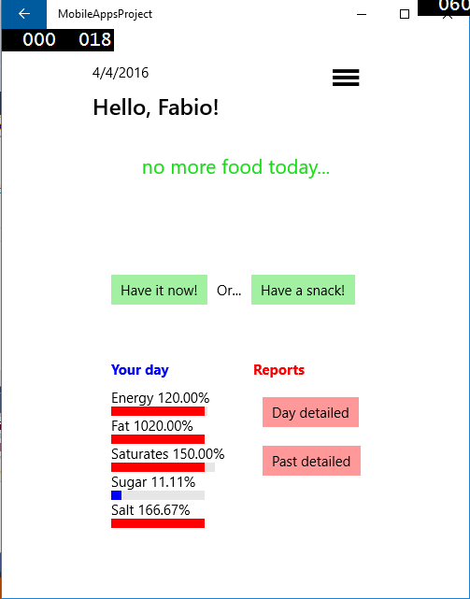

Add/edit meal:

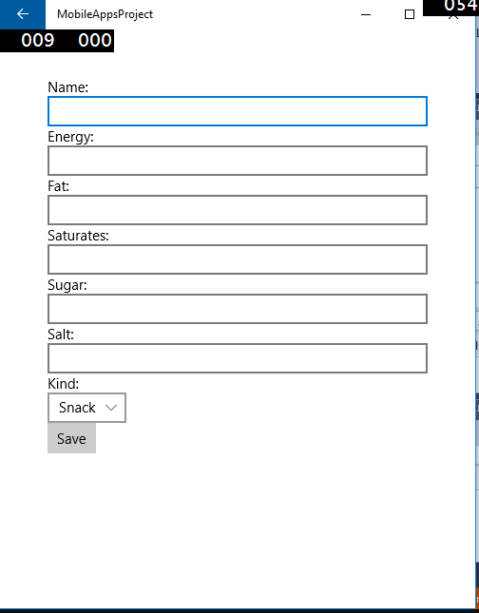

List meal:

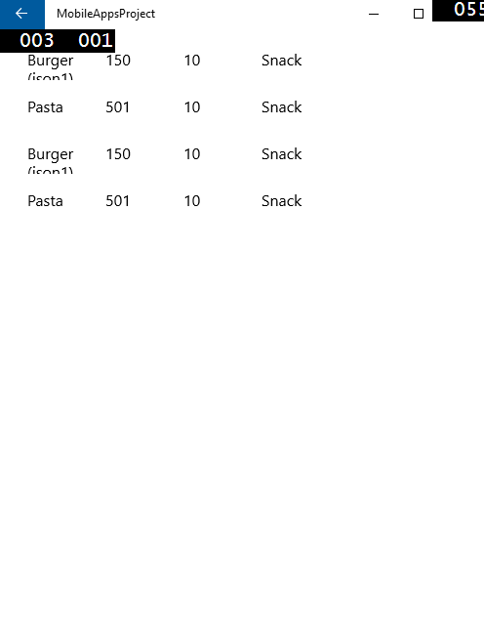

Add/Edit user:

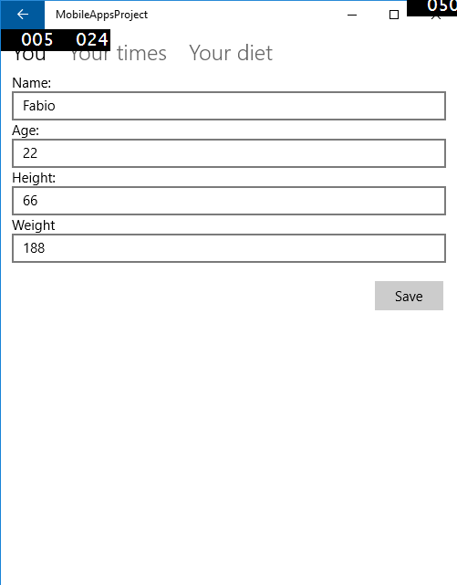

Have meal/Have snack

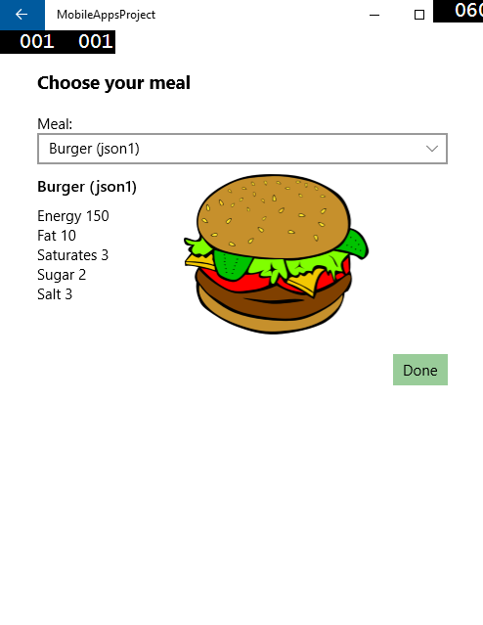

Stats

