Images in Wordingo
Embedded Images
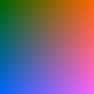
The image above is a 100x100 gradient PNG embedded as a DrawingML inline element with a locked aspect ratio and stretch-to-fill behavior.

