DLU Educational Knowledge Graph (EKG) 1.1
UI/UX & Experience Design Reference Guide
Role-based knowledge visualization for Student, Faculty, Dean & Provost
Target design environment: Paper Design / paper.design workflow
Version 1.0 · August 2026

1. Purpose and Design Mandate
This guide translates DLU EKG 1.1 from a semantic platform architecture into an experience architecture. It is written for UI Designers, Product/Experience Designers, Design Engineers and front-end architects who must expose graph-derived knowledge without forcing end users to understand graph databases, ontology terminology or dense node-link diagrams.
North-star rule — Never expose the entire Educational Knowledge Graph to an end user. Display the smallest graph projection capable of supporting the user’s current decision.

The EKG remains the semantic control plane. The interface presents task-oriented projections (“Lenses”) tailored to role, intent, scope and confidence. The same node can therefore appear as a progress item for a student, an outcome-risk signal for Faculty, a curriculum-coverage cell for a Dean and an institutional KPI for a Provost.

1.1 Design outcomes
- Reduce cognitive load while retaining semantic traceability.
- Make every metric explainable through progressive drill-down to source outcomes/evidence.
- Preserve mastery and confidence as distinct visual concepts.
- Use graph visualization only when topology itself answers the user’s question.
- Provide consistent cross-role navigation from signal → cause → evidence → action.
- Ensure authorization/ACL boundaries are reflected in every projection and drill-down.

1.2 Relationship to EKG 1.1
This guide assumes the EKG 1.1 production architecture: UI clients never query Neo4j directly; projection/view-model services sit between the graph and the experience layer. GraphRAG, Mastery Engine, Learning Path, Assessment, Credit Recognition and curriculum analytics all contribute role-specific read models.

2. Experience Architecture: Graph Underneath, Lenses Above
The experience layer SHALL introduce an explicit EKG Lens abstraction. A Lens is not merely a dashboard configuration: it is a governed projection contract defining visible entities, metrics, allowed graph depth, ranking logic, actions and explainability level for a specific role and intent.
Dimension | Definition | Example
Role | Who is making the decision | Student, Faculty, Dean, Provost
Intent | What question is being answered | What next? Why are students failing? Is the program aligned?
Scope | Where the query is bounded | Learner, cohort, course, program, school, institution
Projection | Subset and aggregation of EKG | CLO/MLO health; prerequisite chain; skill gap
Depth | Maximum semantic drill-down | L0 signal → L3 local graph
Actions | Permitted next operations | Open lesson, intervene, redesign curriculum, request review
ACL | Visibility constraints | Own evidence vs cohort aggregate vs institutional metrics

2.1 Canonical interaction model
- Start with a decision signal, not a graph.
- Offer a plain-language explanation of the signal.
- Allow drill-down into contributing outcomes, concepts or evidence.
- Reveal a local graph only when relationship topology is useful.
- Finish with a recommended or available action.
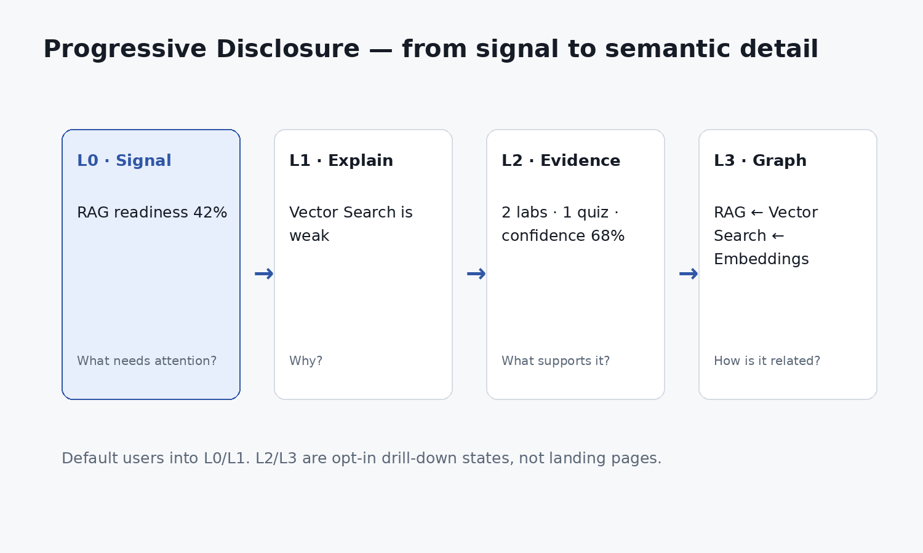
Figure 1 — Four levels of progressive disclosure recommended across all EKG experiences.

3. Role × Intent × View Pattern Matrix
Role | Primary intent | Default view | Secondary view | Graph exposure | Primary action
Student | What do I know? What should I do next? | Progress + Next Best Action | Learning path / skill gap | Local dependency path only | Learn / practice / reassess
Student | Why am I blocked? | Prerequisite explanation | Evidence detail | 1–2 hop local graph | Remediate prerequisite
Faculty | Which outcomes are weak? | Outcome health table/heatmap | Cohort distribution | Local root-cause graph | Intervene / adjust teaching
Faculty | Is assessment valid? | Outcome ↔ assessment coverage | Rubric/evidence view | Rare | Revise assessment
Dean | Does the curriculum cover program outcomes? | Course × outcome matrix | Program health dashboard | Dependency diagnostics only | Redesign curriculum
Dean | Where are duplication/gaps? | Coverage matrix | Concept/skill overlap list | Local course-concept graph | Consolidate / add content
Provost | Which programs need attention? | Academic control tower | School/program drill-down | None by default | Prioritize review
Provost | Can we evidence attainment/accreditation? | Institutional outcome/evidence coverage | Traceability chain | Trace path, not network | Request assurance/remediation
Decision rule — If a user can answer the current question with a table, matrix, path or ordered list, do not use a node-link graph.

4. EKG Visualization Grammar
The design system should treat knowledge visualization as a small set of reusable primitives. Designers should select the primitive by question type, not by data source.
Question type | Preferred pattern | Avoid
Status / attention | Metric card, status row, ordered list | Graph
Coverage / alignment | Heatmap or matrix | Hundreds of edges
Progress over time | Timeline / trend | Static graph
Prerequisite sequence | Path / dependency ladder | Heatmap
Root cause | Expandable hierarchy + local graph | Global graph
Evidence provenance | Evidence list / trace chain | Force-directed layout
Portfolio comparison | Ranked table / small multiples | Course node cloud
Semantic neighborhood | Local graph ≤ 12–20 nodes | Unbounded traversal

4.1 Core visual semantics
Semantic object | Default visual | Required metadata
Outcome (CLO/MLO) | Outcome row/card | attainment, confidence, assessment coverage
Concept | Knowledge chip / local node | mastery/readiness + prerequisite state
Skill | Skill row / readiness bar | target level, current level, external mapping
Assessment | Evidence/assessment card | coverage, score, rubric, date
Evidence | Provenance row | source, evaluator, freshness, authenticity
Gap | Priority card | delta, confidence, impact, recommended remediation
Learning activity | Action card | effort, unlocks, due/availability
Job role | Target card | readiness, required skills, gap count

4.2 Mastery vs Confidence
Mastery and confidence MUST NOT be collapsed into one percentage. Mastery expresses estimated proficiency; confidence expresses how strongly the available evidence supports that estimate. A high-mastery/low-confidence state is materially different from high-mastery/high-confidence.
Mastery | Confidence | UI meaning | Recommended treatment
High | High | Stable strength | Positive status; no warning
High | Low | Promising but under-evidenced | Show “needs more evidence”
Low | High | Confirmed gap | Prioritize remediation
Low | Low | Uncertain gap | Request diagnostic evidence before strong recommendation

5. Student Lens
Student experiences should optimize for orientation and action. Translate ontology terms into learner language; technical identifiers such as CLO-03/MLO-4.2 may be available in details but should not dominate the default UI.
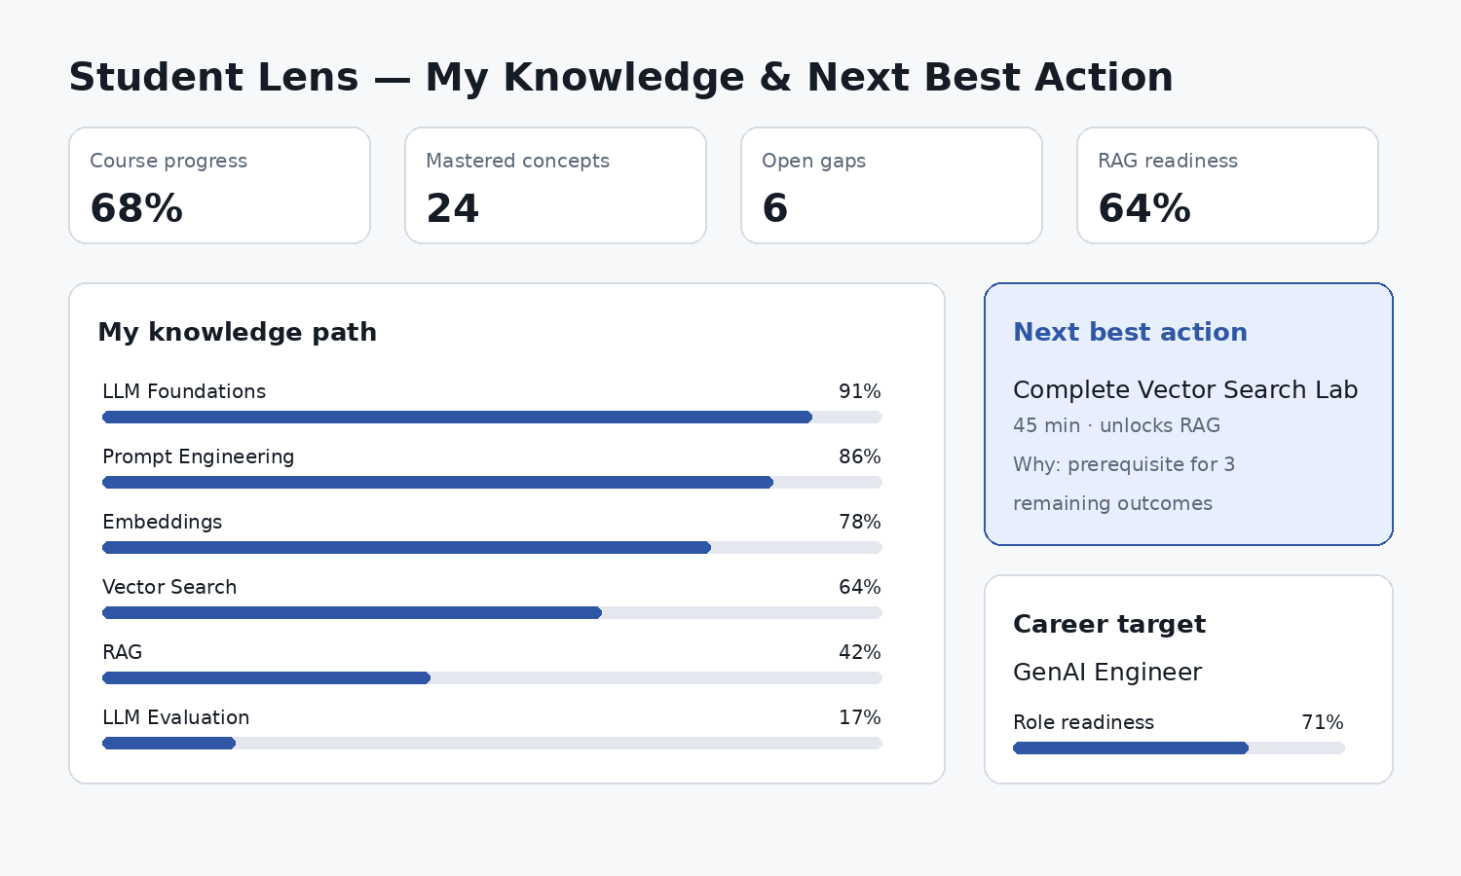
Figure 2 — Recommended Student Lens: progress, knowledge path, next-best action and career readiness.

5.1 Default Student Workspace hierarchy
- Today / Next Best Action: one primary recommendation, maximum three alternatives.
- My Progress: course/program progress and outcome readiness.
- My Knowledge: mastered, developing and blocked concepts.
- Evidence: what demonstrates mastery and where evidence is insufficient.
- Targets: course completion, degree outcomes and optional career role readiness.

5.2 Student interaction patterns
Pattern | Use | Interaction
Next Best Action | Prioritize one activity | Open → see “why this” → start activity
Knowledge Path | Show ordered dependencies | Select concept → prerequisites + unlocks
Gap Card | Show actionable deficiency | Explain gap → recommended remediation
Evidence Drawer | Build trust in mastery | Expand score into evidence provenance
Career Readiness | Optional motivational layer | Role → required skills → learning opportunities
Student language — Prefer “What you can do”, “What to strengthen”, “What this unlocks” over ontology labels such as “node”, “edge”, “MLO association” or “semantic relation”.

6. Faculty Lens
Faculty experiences should optimize for cohort diagnosis, outcome attainment and instructional intervention. The main object is the outcome, not the student list. Student-level detail is a drill-down constrained by faculty authorization.
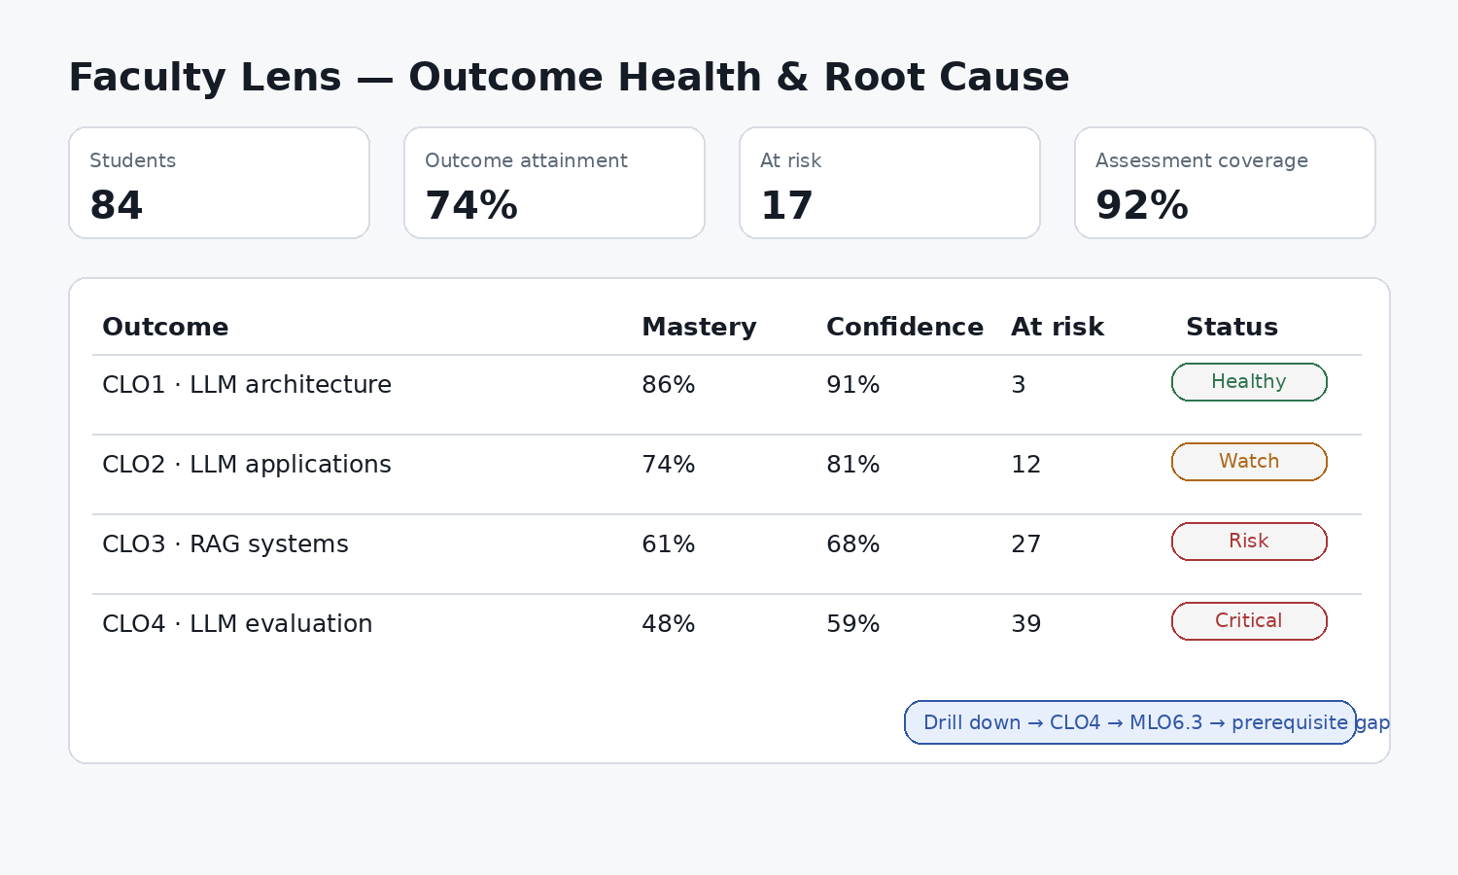
Figure 3 — Faculty Lens: outcome health first, drill-down into root cause second.

6.1 Faculty view hierarchy
- Course health summary.
- Outcome health table/heatmap.
- At-risk cohorts or clusters, not individual names by default.
- Root-cause analysis: weak MLOs → concepts → prerequisites.
- Assessment validity and coverage.
- Intervention candidates and expected impact.

6.2 Root-cause drill-down
A Faculty user selecting a weak CLO should not land in a generic graph explorer. The system should construct a ranked explanation: contributing MLOs, affected learner percentage, prerequisite weaknesses, assessment coverage and evidence confidence. The local graph is an optional fourth-level visualization.

7. Dean / Program Director Lens
Dean-level views answer curriculum questions across courses and cohorts. Matrices and exception queues are superior to node-link views because the user is comparing coverage, gaps, duplication, progression and quality assurance.
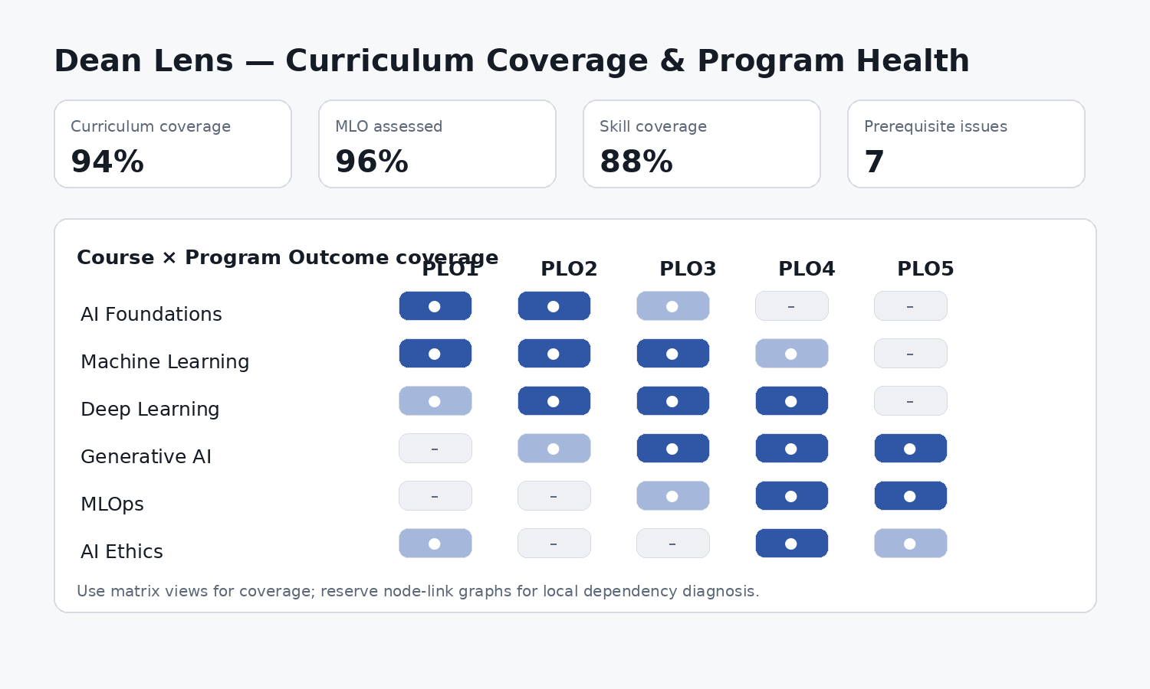
Figure 4 — Dean Lens: a coverage matrix compresses hundreds of EKG relations into an actionable program-level view.

7.1 Required Dean views
- Program Health Overview
- Course × Program Outcome coverage matrix
- Course × Skill coverage matrix
- Outcome assessment/evidence coverage
- Prerequisite integrity report
- Curriculum duplication / orphan concept report
- External-framework mapping quality (ESCO/CASE/SFIA/DigComp/EQF)
- Accreditation traceability view

7.2 Exception-first design
Do not make the Dean inspect every cell. Surface exceptions first: unassessed outcomes, weakly supported mappings, concepts taught before prerequisites, duplicated learning outcomes, missing evidence, courses with sustained attainment below threshold.

8. Provost / Executive Academic Lens
Provost views are portfolio-management interfaces. They should suppress ontology complexity and expose institutional health, risk concentration, trend and traceability. The Provost normally should never see a force-directed graph.
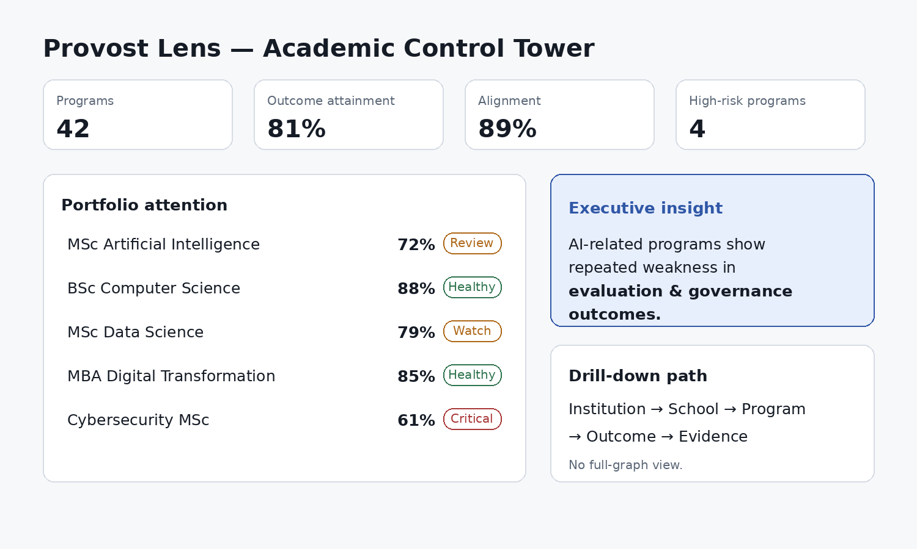
Figure 5 — Provost Lens: control tower, portfolio attention and governed drill-down.

8.1 Executive information hierarchy
- Institution KPIs and directional trends.
- Schools/programs requiring attention.
- Reason codes for risk (attainment, evidence, alignment, assessment, employability).
- Program-level drill-down.
- Outcome/evidence trace only when assurance or governance requires it.

9. When a Graph Is Actually the Right Visualization
Use a node-link representation only when the topology is itself the answer: prerequisite dependency, semantic neighborhood, causal/root-cause chain, traceability between outcome and evidence, or curriculum dependency diagnosis.
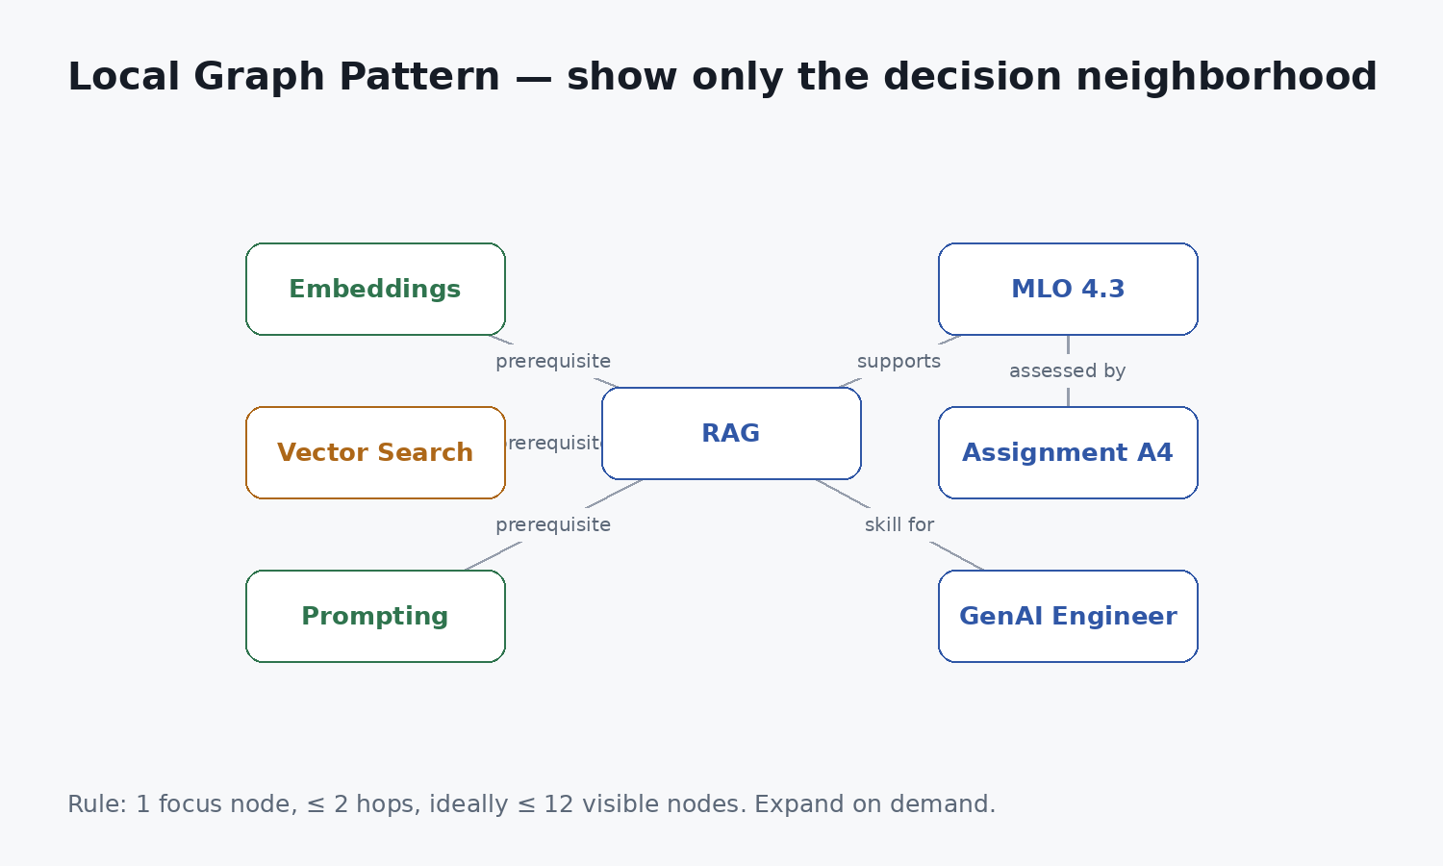
Figure 6 — Local Graph Pattern. The user sees the decision neighborhood, not the EKG universe.

9.1 Local graph constraints
- One explicit focus node.
- Default depth: 1 hop; maximum normal drill-down: 2 hops.
- Target 8–12 visible nodes; hard UX warning above 20.
- Edge labels displayed only for relevant relation types.
- Hide unrelated node classes by default.
- Cluster repeated leaf nodes into counts (e.g., “+14 assessments”).
- Provide “Why am I seeing this?” and “Back to summary”.
- Never rely on color alone to encode node type or risk.

10. Cross-role Information Architecture
Level | Student | Faculty | Dean | Provost
L0: Signal | Next action / readiness | Outcome alerts | Program exceptions | Portfolio risks
L1: Explain | Why recommended | Why outcome weak | Why curriculum gap | Why program flagged
L2: Evidence | My evidence | Cohort evidence | Coverage/mapping evidence | Assurance trace
L3: Topology | Local prerequisite graph | Root-cause graph | Dependency graph | Usually not exposed
L4: Raw semantics | Not exposed | Rare/admin | Rare/admin | Not exposed
Navigation invariant — Any aggregate metric should be drillable to an explanation, and any explanation should be traceable to governed evidence without exposing data outside the viewer’s ACL.

11. Component Inventory for Paper Design
Create the following as reusable design-system patterns in Paper. Component names below are semantic contracts; implementation may map them to the project’s actual Paper/token/component naming conventions.
Component | Purpose | Variants / states
EKGMetricCard | Single KPI/status | neutral, positive, warning, critical, stale
OutcomeHealthRow | Outcome comparison | healthy, watch, risk, critical, insufficient evidence
MasteryBar | Proficiency | with confidence marker and target marker
ConfidenceBadge | Evidence certainty | high, medium, low, unknown
NextBestActionCard | Recommended action | primary, alternate, blocked
KnowledgePath | Ordered dependency/progression | completed, current, locked, recommended
GapCard | Skill/concept gap | confirmed, uncertain, closed
CoverageMatrix | Course/outcome or course/skill alignment | coverage strength + exception overlay
EvidenceRow | Provenance | assessment, project, prior credit, external credential
ExplainabilityDrawer | Why/How computed | summary, factors, evidence, model/version
LocalGraph | Focused topology | prerequisite, root-cause, traceability
TraceabilityChain | Linear provenance | Outcome → Assessment → Evidence
RiskQueue | Exception-first workflow | filter, owner, severity, status
RoleTargetCard | Career readiness | current/target/gap

12. State Design: Empty, Uncertain, Stale, Restricted
EKG-derived data is probabilistic, temporal and authorization-sensitive. The UI must therefore design states beyond “loaded / error”.
State | Required copy/indicator | Forbidden behavior
No evidence | “Not enough evidence yet” + next diagnostic action | Render 0% mastery as if known
Low confidence | Confidence indicator + reason | Hide uncertainty
Stale evidence | Last updated + refresh/remediation action | Present as current without warning
Blocked prerequisite | Name prerequisite + unlock relation | Generic “locked” with no explanation
ACL restricted | Explain aggregate/detail boundary | Show redacted names as a tease
Mapping under review | Proposed mapping / confidence / owner | Present external mapping as authoritative
Model recalculating | Last stable state + processing indicator | Flash temporary zeroes

13. Visual Design Rules
- Use a restrained semantic palette: accent for focus/selection; separate accessible semantics for healthy/watch/risk/critical.
- Use typography and spacing to communicate hierarchy before color.
- Prefer labels + values + status text; never encode meaning with a colored dot alone.
- Display percentages only when the underlying metric is meaningful and sufficiently evidenced.
- Prefer “insufficient evidence” to false numerical precision.
- Keep identifiers (CLO-03, MLO-4.2, ESCO URI) secondary; expose them in details for faculty/governance.
- Keep main-page density low: 3–5 KPI cards, one dominant analytical view, one exception/action area.

14. Paper Design Workflow and Canvas Organization
Paper’s current product documentation describes an HTML/CSS-based canvas, design tokens/themes and MCP connectivity between design files and agents/code. Use those capabilities to make the EKG experience library a design-to-code contract rather than a static mockup set.

14.1 Recommended Paper file structure
Page/area | Content
00 Foundations | tokens, typography, spacing, semantic statuses, accessibility notes
01 EKG Primitives | metric, mastery, confidence, outcome, evidence, gap, path, graph-node patterns
02 Student Lens | desktop + responsive Student Workspace flows
03 Faculty Lens | course health, outcome detail, intervention flow
04 Dean Lens | program health, coverage matrix, curriculum diagnostics
05 Provost Lens | control tower, portfolio drill-down, assurance trace
06 Cross-role Patterns | filters, breadcrumbs, drawers, explainability, permissions, states
07 Prototypes | task-based clickable journeys
08 Handoff | component mapping, API/view-model fields, acceptance annotations

14.2 Frame set for every critical view
- Desktop reference: 1440 px logical frame.
- Compact desktop/tablet: 1024 px.
- Mobile/student-critical flows: 390 px.
- Do not force Dean/Provost analytical matrices into mobile parity; provide summary + exception queue on small screens.

14.3 Token strategy
Define tokens for surface, text, muted text, border, focus/accent and semantic state. Keep graph-node styling driven by semantic tokens, not arbitrary per-node colors. Where design tokens are synchronized with code, token names should describe meaning (e.g., status-risk-bg) rather than a raw hue.

15. Annotated Screen Specifications
Screen | Must show above fold | Primary interaction | Drill-down target
Student Home | Next Best Action, progress, 1–2 risk/gap signals | Start recommended activity | Concept → prerequisite/evidence
Student Knowledge | Knowledge path + filter by course/skill | Select concept | Concept detail/local graph
Faculty Course Health | Outcome attainment + at-risk count | Select weak outcome | MLO/concept/root cause
Faculty Assessment Coverage | Outcome × assessment mapping | Select uncovered outcome | Assessment redesign
Dean Program Health | Program KPIs + exception queue | Select exception | Course/outcome/mapping detail
Dean Curriculum Map | Coverage matrix | Select cell | Evidence + course contribution
Provost Control Tower | Portfolio KPIs + ranked risks | Select program | Program executive summary
Assurance Trace | Outcome → assessment → evidence | Open trace step | Source provenance

16. UI View-Model Contracts
Design annotations should reference view-model fields, not Neo4j labels/queries. This preserves the EKG 1.1 rule that UI clients do not access the graph directly.
View model | Representative fields
StudentKnowledgeSummary | overallProgress, nextActions[], conceptStates[], gaps[], targetReadiness[]
OutcomeHealthView | outcomeId, title, attainment, confidence, assessedCoverage, affectedLearners, status, reasonCodes[]
ProgramCoverageView | courses[], outcomes[], cells{coverage,strength,evidenceCount,flags}
ExecutiveProgramRisk | programId, healthScore, trend, riskReasons[], evidenceCoverage, alignmentScore
ExplainabilityView | metricId, humanSummary, contributingFactors[], evidenceRefs[], calculatedAt, modelVersion
LocalGraphView | focusNode, nodes[], edges[], depth, hiddenNodeCount, availableExpansions[]

17. Interaction and Motion Guidelines
- Prefer in-place expansion and side drawers over navigation into a disconnected “graph page”.
- Animate drill-down modestly to preserve spatial context; avoid physics-based force animations in end-user views.
- Keep filters persistent within analytical workspaces.
- Breadcrumbs must express semantic scope: Institution › School › Program › Course › Outcome.
- When a recommendation changes because evidence changes, expose a short reason rather than silently reordering.
- Allow users to copy/share a stable deep link to the current Lens + scope + filter state where policy permits.

18. AI and Explainability Patterns
Any AI-generated recommendation, learning path or root-cause hypothesis should expose a compact “Why?” layer. Do not overwhelm users with model internals; expose the evidence and rules relevant to the decision.
AI output | Minimum explanation
Next Best Action | gap addressed, prerequisite relation, expected unlock, evidence freshness
At-risk flag | affected outcomes, evidence confidence, threshold/reason code
Learning path | target, skipped/mastered prerequisites, ordering rationale
Career gap | target requirement, learner estimate, confidence, source framework
Credit recognition suggestion | mapped outcomes, similarity/equivalence evidence, policy status, human-review requirement

19. Accessibility and Inclusive Design
- Target WCAG 2.2 AA for all core EKG workflows.
- Keyboard-accessible matrix cells, drawers and local-graph nodes.
- Provide list/table alternative for every local graph.
- Never depend on color alone for mastery, confidence or risk.
- Use readable labels for acronyms; expand CLO/MLO on first contextual use when appropriate.
- Support zoom/reflow; keep essential explanatory text outside hover-only tooltips.
- Use meaningful focus order matching the decision hierarchy, not DOM artifacts from visual layout.

20. Anti-pattern Catalogue
Anti-pattern | Why it fails | Replacement
The Hairball | Hundreds of nodes/edges destroy orientation | Task-scoped projection
Dashboard Christmas Tree | Too many KPIs compete for attention | 3–5 primary KPIs + exception queue
Percentage Without Evidence | False precision | Mastery + confidence / insufficient evidence
Ontology Leakage | Users see IDs/edge names instead of meaning | Plain-language labels + optional technical detail
One UI for All Roles | Different decisions require different abstraction | Role-based Lens
Graph as Navigation Menu | Topology is not IA | Hierarchical scope + contextual graph
Red Means Everything | Risk, low confidence and missing evidence get conflated | Separate semantic states
AI Oracle | Recommendation has no rationale | Explainability drawer + evidence trace

21. Designer Workflow: From User Question to Paper Prototype
- Write the user’s decision question in one sentence.
- Identify role and authorized scope.
- Select required EKG entities and metrics only.
- Choose the lowest-complexity visualization primitive that answers the question.
- Define L0 signal and L1 explanation before designing deeper detail.
- Add L2 evidence and only then decide whether L3 local graph is justified.
- Define primary action and what success looks like.
- Design empty/low-confidence/stale/restricted states.
- Prototype desktop and required responsive states in Paper.
- Annotate each component with view-model fields and interaction contract.
- Run a task-based usability review using realistic EKG data, not lorem ipsum.
- Hand off with semantic tokens, component mapping and acceptance criteria.

22. UX Acceptance Criteria for EKG Features
ID | Criterion
UX-EKG-01 | A first-time role user can identify the primary attention/action item within 10 seconds.
UX-EKG-02 | No default end-user screen renders an unbounded graph traversal.
UX-EKG-03 | Every mastery value exposes confidence or an explicit evidence-quality state.
UX-EKG-04 | Every aggregate risk/attainment signal has an authorized explanation path.
UX-EKG-05 | Local graphs default to ≤2 hops and provide a non-graph accessible alternative.
UX-EKG-06 | Ontology IDs and framework URIs do not dominate student/executive default views.
UX-EKG-07 | Empty, stale, low-confidence and ACL-restricted states have explicit designs.
UX-EKG-08 | UI uses view-model contracts; no direct Neo4j dependency exists in screen specs.
UX-EKG-09 | Role lenses preserve scope and breadcrumbs during drill-down.
UX-EKG-10 | Critical workflows meet WCAG 2.2 AA design criteria.

23. Required UI/UX Deliverables
- Paper design file organized according to Section 14.
- EKG foundations/tokens and semantic state definitions.
- Reusable component library for Section 11 primitives.
- Student, Faculty, Dean and Provost reference screens.
- Responsive Student flows and compact executive exception views.
- Prototype journeys for: learning recommendation, faculty root-cause diagnosis, curriculum gap analysis, executive program drill-down.
- State library: empty, uncertain, stale, blocked, restricted, mapping-under-review.
- Accessibility annotations and graph/list equivalents.
- View-model/API field annotations for engineering handoff.
- Usability test script and acceptance checklist based on Section 22.

Appendix A — Quick Selection Guide
If the user asks… | Show…
“What should I do next?” | Next Best Action + path
“What do I still need to learn?” | Gap list + mastery/readiness
“Why can’t I start this?” | Prerequisite path
“Which CLO is weak?” | Outcome health table/heatmap
“Why is this CLO weak?” | Ranked explanation + optional local graph
“Do courses cover program outcomes?” | Coverage matrix
“Which program needs attention?” | Ranked portfolio risk table
“Can we prove this outcome?” | Traceability chain to evidence
“How are these concepts related?” | Local graph

Appendix B — Paper Design Implementation Notes
At the time of this guide (August 2026), Paper documentation describes Paper Desktop/web, an HTML/CSS-based design canvas, MCP connectivity, token/theme support, and workflows to move between design and code. The guide intentionally defines semantic components and patterns rather than depending on unstable product-specific component names. Designers should map these patterns to the active Paper workspace and DLU codebase tokens/components.
Reference sources: paper.design (product overview); paper.design/docs (documentation); paper.design/docs/support (canvas/tools/export/support). Accessed August 2026.

Appendix C — Handoff Note to Engineering
Architecture boundary — The UI/UX design may visualize graph-derived data, but must never require direct Neo4j access. Every screen should be satisfiable by a versioned projection/view-model API with tenant/ACL enforcement inherited from EKG 1.1.

