Summary report of CHAEA learning styles by CHAEA³S package

This report contains the most important results of the analysis that is conducted to unveil the learning styles that are present in the group of students under study. The analysis is based on the learning styles considered by CHAEA: active, reflector, theorists, and pragmatist. Unless otherwise stated, the uncertainties throughout the document (in parenthesis) have been obtained using a t-Student distribution with a confidence interval of 95%.

The report is structured as follows. First, Section 1 is devoted to the individual and global statistical analysis. Here, the importance of the different learning styles for each individual student can be found (both quantitatively as well as qualitatively). Then, average means and confidence intervals are presented, along with the affinities and the Probability Density Functions. Second, Section 2 discusses the principal component analysis. The eigenvalues and eigenvectors of the covariance matrix are first introduced. Subsequently, the learning styles of the students in the principal components basis set is presented. Finally, a reduced dimensional representation of the data is conducted. Third, the participation ratios are finally presented in Section 3. The values for the original (active, theorist, pragmatic, and reflector) and in the principal components basis sets are listed. To conclude, a statistical analysis of the distribution of the participation ratios is performed.

*Further information at: J. Ablanque, V. Gabaldon, P. Almendros, J. C. Losada, R. M. Benito, and F. Revuelta. CHAEA3S: A software for the automated principal-component analysis of learning styles. Journal of Science Education and Technology (2024).*

# 1. Individual and global statistical analysis

In this section we present the individual and global statistical analysis of the learning styles as originally defined in CHAEA (activist, reflector, theorist, and pragmatist). This section is divided in two parts. First, the (quantitative and qualitative) importance of the different learning styles for each individual student can be found. Second, a global analysis is performed, where average means, confidence intervals, affinities, and the probability density functions can be found.

## 1.1 Individual analysis

### Quantitative description of the learning styles for each individual student

Table 1 shows the number of points (from 0 to 20) that each student gets in CHAEA for the different learning styles.

**Table 1. Points related the learning styles for each of the students.**

|  |  |  |  |  |
| --- | --- | --- | --- | --- |
| Student | Activist | Reflector | Theorist | Pragmatist |
| fisicaI_2022-23_01.xls | 14.0 | 14.0 | 14.0 | 15.0 |
| fisicaI_2022-23_02.xls | 13.0 | 18.0 | 12.0 | 10.0 |
| fisicaI_2022-23_03.xls | 13.0 | 15.0 | 14.0 | 13.0 |
| fisicaI_2022-23_04.xlsx | 9.0 | 17.0 | 13.0 | 8.0 |
| fisicaI_2022-23_05.xlsx | 15.0 | 18.0 | 12.0 | 13.0 |
| fisicaI_2022-23_06.xls | 17.0 | 13.0 | 16.0 | 12.0 |
| fisicaI_2022-23_07.xlsx | 14.0 | 17.0 | 11.0 | 11.0 |
| fisicaI_2022-23_08.xls | 8.0 | 18.0 | 20.0 | 15.0 |
| fisicaI_2022-23_09.xls | 6.0 | 15.0 | 15.0 | 12.0 |
| fisicaI_2022-23_11.xls | 14.0 | 16.0 | 12.0 | 14.0 |
| fisicaI_2022-23_12.xls | 17.0 | 15.0 | 19.0 | 18.0 |
| fisicaI_2022-23_13.xlsx | 17.0 | 15.0 | 13.0 | 17.0 |
| fisicaI_2022-23_14.xls | 6.0 | 17.0 | 8.0 | 9.0 |
| fisicaI_2022-23_15.xlsx | 10.0 | 13.0 | 11.0 | 10.0 |
| fisicaI_2022-23_17.xls | 9.0 | 16.0 | 12.0 | 13.0 |
| fisicaI_2022-23_18.xls | 9.0 | 19.0 | 14.0 | 13.0 |
| fisicaI_2022-23_19.xls | 10.0 | 16.0 | 15.0 | 16.0 |
| fisicaI_2022-23_20.xls | 10.0 | 12.0 | 13.0 | 13.0 |
| fisicaI_2022-23_21.xls | 15.0 | 16.0 | 11.0 | 15.0 |
| fisicaI_2022-23_22.xlsx | 15.0 | 13.0 | 11.0 | 19.0 |
| fisicaI_2022-23_23.xls | 11.0 | 18.0 | 17.0 | 12.0 |
| fisicaI_2022-23_24.xls | 10.0 | 12.0 | 13.0 | 16.0 |
| fisicaI_2022-23_25.xls | 12.0 | 15.0 | 13.0 | 10.0 |
| fisicaI_2022-23_26.xls | 13.0 | 16.0 | 11.0 | 11.0 |
| fisicaI_2022-23_27.xls | 13.0 | 19.0 | 15.0 | 14.0 |
| fisicaI_2022-23_30.xls | 9.0 | 16.0 | 12.0 | 14.0 |
| fisicaI_2022-23_31.xls | 15.0 | 19.0 | 9.0 | 15.0 |
| fisicaI_2022-23_33.xlsx | 10.0 | 9.0 | 11.0 | 14.0 |
| fisicaI_2022-23_34.xls | 15.0 | 10.0 | 13.0 | 20.0 |
| fisicaI_2022-23_35.xls | 16.0 | 18.0 | 8.0 | 9.0 |
| fisicaI_2022-23_36.xls | 10.0 | 15.0 | 11.0 | 14.0 |
| fisicaI_2022-23_37.xls | 8.0 | 15.0 | 12.0 | 13.0 |
| fisicaI_2022-23_38.xlsx | 10.0 | 15.0 | 8.0 | 7.0 |
| fisicaI_2022-23_39.xls | 4.0 | 20.0 | 18.0 | 13.0 |
| fisicaI_2022-23_40.xls | 9.0 | 19.0 | 11.0 | 19.0 |
| fisicaI_2022-23_41.xls | 11.0 | 15.0 | 16.0 | 16.0 |
| fisicaI_2022-23_42.xls | 11.0 | 17.0 | 15.0 | 12.0 |
| fisicaI_2022-23_43.xls | 9.0 | 16.0 | 14.0 | 13.0 |
| fisicaI_2022-23_44.xls | 12.0 | 15.0 | 13.0 | 14.0 |
| fisicaI_2022-23_45.xlsx | 14.0 | 13.0 | 15.0 | 12.0 |
| fisicaI_2022-23_46.xls | 8.0 | 18.0 | 12.0 | 12.0 |
| fisicaI_2022-23_47.xls | 11.0 | 15.0 | 10.0 | 10.0 |
| fisicaI_2022-23_48.xls | 8.0 | 19.0 | 19.0 | 15.0 |
| fisicaI_2022-23_49.xls | 12.0 | 16.0 | 13.0 | 12.0 |
| fisicaI_2022-23_50.xls | 5.0 | 19.0 | 17.0 | 11.0 |
| fisicaI_2022-23_51.xls | 2.0 | 16.0 | 14.0 | 7.0 |
| fisicaI_2022-23_52.xls | 6.0 | 16.0 | 13.0 | 11.0 |
| fisicaI_2022-23_53.xlsx | 12.0 | 18.0 | 14.0 | 17.0 |
| fisicaI_2022-23_54.xlsx | 11.0 | 17.0 | 15.0 | 12.0 |
| fisicaI_2022-23_55.xls | 12.0 | 16.0 | 15.0 | 10.0 |
| fisicaI_2022-23_56.xls | 11.0 | 18.0 | 10.0 | 12.0 |
| fisicaI_2022-23_57.xls | 13.0 | 12.0 | 13.0 | 14.0 |
| fisicaI_2022-23_58.xlsx | 12.0 | 17.0 | 16.0 | 12.0 |
| fisicaI_2022-23_59.xls | 5.0 | 15.0 | 13.0 | 8.0 |
| fisicaI_2022-23_61.xls | 12.0 | 12.0 | 10.0 | 12.0 |
| fisicaI_2022-23_62.xls | 7.0 | 14.0 | 14.0 | 12.0 |
| fisicaI_2022-23_63.xlsx | 10.0 | 16.0 | 14.0 | 11.0 |
| fisicaI_2022-23_64.xlsx | 7.0 | 13.0 | 8.0 | 8.0 |
| fisicaI_2022-23_65.xls | 9.0 | 13.0 | 16.0 | 14.0 |
| fisicaI_2022-23_66.xls | 6.0 | 15.0 | 9.0 | 7.0 |
| fisicaI_2022-23_67.xls | 12.0 | 14.0 | 11.0 | 15.0 |
| fisicaI_2022-23_68.xls | 13.0 | 15.0 | 11.0 | 9.0 |
| fisicaI_2022-23_69.xls | 15.0 | 14.0 | 12.0 | 12.0 |
| fisicaI_2022-23_70.xls | 13.0 | 13.0 | 6.0 | 7.0 |
| fisicaI_2022-23_71.xls | 0.0 | 0.0 | 0.0 | 0.0 |
| fisicaI_2022-23_72.xls | 13.0 | 17.0 | 16.0 | 12.0 |
| fisicaI_2022-23_73.xls | 12.0 | 17.0 | 14.0 | 14.0 |
| fisicaI_2022-23_74.xlsx | 6.0 | 15.0 | 15.0 | 7.0 |
| fisicaI_2022-23_75.xls | 12.0 | 12.0 | 14.0 | 10.0 |
| fisicaI_2022-23_76.xls | 14.0 | 10.0 | 7.0 | 10.0 |
| fisicaI_2023-24_01.xls | 13.0 | 16.0 | 10.0 | 13.0 |
| fisicaI_2023-24_02.xls | 10.0 | 17.0 | 18.0 | 19.0 |
| fisicaI_2023-24_03.xlsx | 14.0 | 17.0 | 18.0 | 15.0 |
| fisicaI_2023-24_04.xls | 17.0 | 16.0 | 12.0 | 13.0 |
| fisicaI_2023-24_05.xls | 17.0 | 11.0 | 9.0 | 9.0 |
| fisicaI_2023-24_06.xlsx | 9.0 | 20.0 | 17.0 | 14.0 |
| fisicaI_2023-24_07.xlsx | 8.0 | 18.0 | 17.0 | 14.0 |
| fisicaI_2023-24_08.xls | 15.0 | 11.0 | 9.0 | 14.0 |
| fisicaI_2023-24_09.xls | 13.0 | 15.0 | 14.0 | 16.0 |
| fisicaI_2023-24_10.xls | 9.0 | 17.0 | 13.0 | 13.0 |
| fisicaI_2023-24_11.xlsx | 7.0 | 16.0 | 15.0 | 11.0 |
| fisicaI_2023-24_12.xls | 9.0 | 13.0 | 16.0 | 14.0 |
| fisicaI_2023-24_13.xls | 10.0 | 18.0 | 12.0 | 8.0 |
| fisicaI_2023-24_14.xls | 11.0 | 15.0 | 13.0 | 12.0 |
| fisicaI_2023-24_15.xls | 11.0 | 20.0 | 15.0 | 10.0 |
| fisicaI_2023-24_16.xls | 8.0 | 19.0 | 15.0 | 13.0 |
| fisicaI_2023-24_17.xls | 12.0 | 17.0 | 15.0 | 10.0 |
| fisicaI_2023-24_18.xls | 9.0 | 16.0 | 16.0 | 18.0 |
| fisicaI_2023-24_20.xls | 3.0 | 17.0 | 18.0 | 12.0 |
| fisicaI_2023-24_21.xls | 7.0 | 17.0 | 15.0 | 11.0 |
| fisicaI_2023-24_22.xls | 10.0 | 9.0 | 15.0 | 9.0 |
| fisicaI_2023-24_23.xls | 9.0 | 15.0 | 14.0 | 11.0 |
| fisicaI_2023-24_24.xls | 14.0 | 13.0 | 8.0 | 15.0 |
| fisicaI_2023-24_25.xls | 16.0 | 11.0 | 15.0 | 15.0 |
| fisicaI_2023-24_26.xls | 8.0 | 18.0 | 17.0 | 10.0 |
| fisicaI_2023-24_27.xls | 15.0 | 18.0 | 18.0 | 18.0 |
| fisicaI_2023-24_28.xls | 6.0 | 20.0 | 17.0 | 13.0 |
| fisicaI_2023-24_29.xlsx | 6.0 | 1.0 | 3.0 | 6.0 |
| fisicaI_2023-24_30.xls | 14.0 | 17.0 | 15.0 | 13.0 |
| fisicaI_2023-24_31.xls | 17.0 | 17.0 | 15.0 | 20.0 |
| fisicaI_2023-24_32.xls | 12.0 | 11.0 | 18.0 | 11.0 |
| fisicaI_2023-24_33.xls | 15.0 | 17.0 | 13.0 | 13.0 |
| fisicaI_2023-24_34.xls | 16.0 | 13.0 | 14.0 | 18.0 |
| fisicaI_2023-24_35.xls | 11.0 | 19.0 | 12.0 | 12.0 |
| fisicaI_2023-24_36.xls | 12.0 | 16.0 | 15.0 | 16.0 |
| fisicaI_2023-24_37.xls | 14.0 | 13.0 | 7.0 | 11.0 |
| fisicaI_2023-24_38.xlsx | 6.0 | 17.0 | 16.0 | 15.0 |
| fisicaI_2023-24_39.xlsx | 15.0 | 19.0 | 14.0 | 14.0 |
| fisicaI_2023-24_40.xls | 10.0 | 18.0 | 14.0 | 13.0 |
| fisicaI_2023-24_41.xls | 2.0 | 17.0 | 13.0 | 12.0 |
| fisicaI_2023-24_42.xls | 15.0 | 12.0 | 10.0 | 13.0 |
| fisicaI_2023-24_43.xls | 9.0 | 19.0 | 15.0 | 11.0 |
| fisicaI_2023-24_44.xlsx | 3.0 | 17.0 | 15.0 | 9.0 |
| fisicaI_2023-24_45.xls | 8.0 | 18.0 | 16.0 | 17.0 |
| fisicaI_2023-24_46.xls | 5.0 | 20.0 | 14.0 | 11.0 |
| fisicaI_2023-24_47.xls | 10.0 | 13.0 | 15.0 | 14.0 |
| fisicaI_2023-24_48.xls | 16.0 | 13.0 | 11.0 | 16.0 |
| fisicaI_2023-24_49.xlsx | 9.0 | 15.0 | 12.0 | 14.0 |
| fisicaI_2023-24_50.xlsx | 5.0 | 17.0 | 16.0 | 12.0 |
| fisicaI_2023-24_51.xls | 13.0 | 17.0 | 10.0 | 12.0 |
| fisicaI_2023-24_52.xlsx | 11.0 | 15.0 | 15.0 | 14.0 |
| fisicaI_2023-24_53.xlsx | 11.0 | 18.0 | 16.0 | 14.0 |
| fisicaI_2023-24_54.xlsx | 11.0 | 15.0 | 14.0 | 13.0 |
| fisicaI_2023-24_55.xls | 13.0 | 12.0 | 16.0 | 17.0 |
| fisicaI_2023-24_56.xls | 12.0 | 13.0 | 15.0 | 10.0 |
| fisicaI_2023-24_57.xlsx | 11.0 | 15.0 | 16.0 | 13.0 |
| fisicaI_2023-24_58.xls | 9.0 | 19.0 | 18.0 | 16.0 |
| fisicaI_2023-24_59.xls | 14.0 | 18.0 | 16.0 | 16.0 |
| fisicaI_2023-24_60.xlsx | 14.0 | 18.0 | 18.0 | 18.0 |

### Qualitative description of the learning styles for each individual student

Table 2 shows the individual qualitative tendency (very low, low, moderate, high, or very high) that each student has towards each of the learning styles.

**Table 2. Tendency towards the learning styles for each of the students.**

|  |  |  |  |  |
| --- | --- | --- | --- | --- |
| Student | Activist | Reflector | Theorist | Pragmatist |
| fisicaI_2022-23_01.xls | High | Moderate | High | High |
| fisicaI_2022-23_02.xls | High | High | Moderate | Low |
| fisicaI_2022-23_03.xls | High | Moderate | High | Moderate |
| fisicaI_2022-23_04.xlsx | Moderate | Moderate | Moderate | Very low |
| fisicaI_2022-23_05.xlsx | Very high | High | Moderate | Moderate |
| fisicaI_2022-23_06.xls | Very high | Low | Very high | Moderate |
| fisicaI_2022-23_07.xlsx | High | Moderate | Moderate | Moderate |
| fisicaI_2022-23_08.xls | Low | High | Very high | High |
| fisicaI_2022-23_09.xls | Very low | Moderate | High | Moderate |
| fisicaI_2022-23_11.xls | High | Moderate | Moderate | High |
| fisicaI_2022-23_12.xls | Very high | Moderate | Very high | Very high |
| fisicaI_2022-23_13.xlsx | Very high | Moderate | Moderate | Very high |
| fisicaI_2022-23_14.xls | Very low | Moderate | Low | Low |
| fisicaI_2022-23_15.xlsx | Moderate | Low | Moderate | Low |
| fisicaI_2022-23_17.xls | Moderate | Moderate | Moderate | Moderate |
| fisicaI_2022-23_18.xls | Moderate | High | High | Moderate |
| fisicaI_2022-23_19.xls | Moderate | Moderate | High | Very high |
| fisicaI_2022-23_20.xls | Moderate | Low | Moderate | Moderate |
| fisicaI_2022-23_21.xls | Very high | Moderate | Moderate | High |
| fisicaI_2022-23_22.xlsx | Very high | Low | Moderate | Very high |
| fisicaI_2022-23_23.xls | Moderate | High | Very high | Moderate |
| fisicaI_2022-23_24.xls | Moderate | Low | Moderate | Very high |
| fisicaI_2022-23_25.xls | Moderate | Moderate | Moderate | Low |
| fisicaI_2022-23_26.xls | High | Moderate | Moderate | Moderate |
| fisicaI_2022-23_27.xls | High | High | High | High |
| fisicaI_2022-23_30.xls | Moderate | Moderate | Moderate | High |
| fisicaI_2022-23_31.xls | Very high | High | Low | High |
| fisicaI_2022-23_33.xlsx | Moderate | Very low | Moderate | High |
| fisicaI_2022-23_34.xls | Very high | Very low | Moderate | Very high |
| fisicaI_2022-23_35.xls | Very high | High | Low | Low |
| fisicaI_2022-23_36.xls | Moderate | Moderate | Moderate | High |
| fisicaI_2022-23_37.xls | Low | Moderate | Moderate | Moderate |
| fisicaI_2022-23_38.xlsx | Moderate | Moderate | Low | Very low |
| fisicaI_2022-23_39.xls | Very low | Very high | Very high | Moderate |
| fisicaI_2022-23_40.xls | Moderate | High | Moderate | Very high |
| fisicaI_2022-23_41.xls | Moderate | Moderate | Very high | Very high |
| fisicaI_2022-23_42.xls | Moderate | Moderate | High | Moderate |
| fisicaI_2022-23_43.xls | Moderate | Moderate | High | Moderate |
| fisicaI_2022-23_44.xls | Moderate | Moderate | Moderate | High |
| fisicaI_2022-23_45.xlsx | High | Low | High | Moderate |
| fisicaI_2022-23_46.xls | Low | High | Moderate | Moderate |
| fisicaI_2022-23_47.xls | Moderate | Moderate | Moderate | Low |
| fisicaI_2022-23_48.xls | Low | High | Very high | High |
| fisicaI_2022-23_49.xls | Moderate | Moderate | Moderate | Moderate |
| fisicaI_2022-23_50.xls | Very low | High | Very high | Moderate |
| fisicaI_2022-23_51.xls | Very low | Moderate | High | Very low |
| fisicaI_2022-23_52.xls | Very low | Moderate | Moderate | Moderate |
| fisicaI_2022-23_53.xlsx | Moderate | High | High | Very high |
| fisicaI_2022-23_54.xlsx | Moderate | Moderate | High | Moderate |
| fisicaI_2022-23_55.xls | Moderate | Moderate | High | Low |
| fisicaI_2022-23_56.xls | Moderate | High | Moderate | Moderate |
| fisicaI_2022-23_57.xls | High | Low | Moderate | High |
| fisicaI_2022-23_58.xlsx | Moderate | Moderate | Very high | Moderate |
| fisicaI_2022-23_59.xls | Very low | Moderate | Moderate | Very low |
| fisicaI_2022-23_61.xls | Moderate | Low | Moderate | Moderate |
| fisicaI_2022-23_62.xls | Low | Moderate | High | Moderate |
| fisicaI_2022-23_63.xlsx | Moderate | Moderate | High | Moderate |
| fisicaI_2022-23_64.xlsx | Low | Low | Low | Very low |
| fisicaI_2022-23_65.xls | Moderate | Low | Very high | High |
| fisicaI_2022-23_66.xls | Very low | Moderate | Low | Very low |
| fisicaI_2022-23_67.xls | Moderate | Moderate | Moderate | High |
| fisicaI_2022-23_68.xls | High | Moderate | Moderate | Low |
| fisicaI_2022-23_69.xls | Very high | Moderate | Moderate | Moderate |
| fisicaI_2022-23_70.xls | High | Low | Very low | Very low |
| fisicaI_2022-23_71.xls | Very low | Very low | Very low | Very low |
| fisicaI_2022-23_72.xls | High | Moderate | Very high | Moderate |
| fisicaI_2022-23_73.xls | Moderate | Moderate | High | High |
| fisicaI_2022-23_74.xlsx | Very low | Moderate | High | Very low |
| fisicaI_2022-23_75.xls | Moderate | Low | High | Low |
| fisicaI_2022-23_76.xls | High | Very low | Low | Low |
| fisicaI_2023-24_01.xls | High | Moderate | Moderate | Moderate |
| fisicaI_2023-24_02.xls | Moderate | Moderate | Very high | Very high |
| fisicaI_2023-24_03.xlsx | High | Moderate | Very high | High |
| fisicaI_2023-24_04.xls | Very high | Moderate | Moderate | Moderate |
| fisicaI_2023-24_05.xls | Very high | Low | Low | Low |
| fisicaI_2023-24_06.xlsx | Moderate | Very high | Very high | High |
| fisicaI_2023-24_07.xlsx | Low | High | Very high | High |
| fisicaI_2023-24_08.xls | Very high | Low | Low | High |
| fisicaI_2023-24_09.xls | High | Moderate | High | Very high |
| fisicaI_2023-24_10.xls | Moderate | Moderate | Moderate | Moderate |
| fisicaI_2023-24_11.xlsx | Low | Moderate | High | Moderate |
| fisicaI_2023-24_12.xls | Moderate | Low | Very high | High |
| fisicaI_2023-24_13.xls | Moderate | High | Moderate | Very low |
| fisicaI_2023-24_14.xls | Moderate | Moderate | Moderate | Moderate |
| fisicaI_2023-24_15.xls | Moderate | Very high | High | Low |
| fisicaI_2023-24_16.xls | Low | High | High | Moderate |
| fisicaI_2023-24_17.xls | Moderate | Moderate | High | Low |
| fisicaI_2023-24_18.xls | Moderate | Moderate | Very high | Very high |
| fisicaI_2023-24_20.xls | Very low | Moderate | Very high | Moderate |
| fisicaI_2023-24_21.xls | Low | Moderate | High | Moderate |
| fisicaI_2023-24_22.xls | Moderate | Very low | High | Low |
| fisicaI_2023-24_23.xls | Moderate | Moderate | High | Moderate |
| fisicaI_2023-24_24.xls | High | Low | Low | High |
| fisicaI_2023-24_25.xls | Very high | Low | High | High |
| fisicaI_2023-24_26.xls | Low | High | Very high | Low |
| fisicaI_2023-24_27.xls | Very high | High | Very high | Very high |
| fisicaI_2023-24_28.xls | Very low | Very high | Very high | Moderate |
| fisicaI_2023-24_29.xlsx | Very low | Very low | Very low | Very low |
| fisicaI_2023-24_30.xls | High | Moderate | High | Moderate |
| fisicaI_2023-24_31.xls | Very high | Moderate | High | Very high |
| fisicaI_2023-24_32.xls | Moderate | Low | Very high | Moderate |
| fisicaI_2023-24_33.xls | Very high | Moderate | Moderate | Moderate |
| fisicaI_2023-24_34.xls | Very high | Low | High | Very high |
| fisicaI_2023-24_35.xls | Moderate | High | Moderate | Moderate |
| fisicaI_2023-24_36.xls | Moderate | Moderate | High | Very high |
| fisicaI_2023-24_37.xls | High | Low | Low | Moderate |
| fisicaI_2023-24_38.xlsx | Very low | Moderate | Very high | High |
| fisicaI_2023-24_39.xlsx | Very high | High | High | High |
| fisicaI_2023-24_40.xls | Moderate | High | High | Moderate |
| fisicaI_2023-24_41.xls | Very low | Moderate | Moderate | Moderate |
| fisicaI_2023-24_42.xls | Very high | Low | Moderate | Moderate |
| fisicaI_2023-24_43.xls | Moderate | High | High | Moderate |
| fisicaI_2023-24_44.xlsx | Very low | Moderate | High | Low |
| fisicaI_2023-24_45.xls | Low | High | Very high | Very high |
| fisicaI_2023-24_46.xls | Very low | Very high | High | Moderate |
| fisicaI_2023-24_47.xls | Moderate | Low | High | High |
| fisicaI_2023-24_48.xls | Very high | Low | Moderate | Very high |
| fisicaI_2023-24_49.xlsx | Moderate | Moderate | Moderate | High |
| fisicaI_2023-24_50.xlsx | Very low | Moderate | Very high | Moderate |
| fisicaI_2023-24_51.xls | High | Moderate | Moderate | Moderate |
| fisicaI_2023-24_52.xlsx | Moderate | Moderate | High | High |
| fisicaI_2023-24_53.xlsx | Moderate | High | Very high | High |
| fisicaI_2023-24_54.xlsx | Moderate | Moderate | High | Moderate |
| fisicaI_2023-24_55.xls | High | Low | Very high | Very high |
| fisicaI_2023-24_56.xls | Moderate | Low | High | Low |
| fisicaI_2023-24_57.xlsx | Moderate | Moderate | Very high | Moderate |
| fisicaI_2023-24_58.xls | Moderate | High | Very high | Very high |
| fisicaI_2023-24_59.xls | High | High | Very high | Very high |
| fisicaI_2023-24_60.xlsx | High | High | Very high | Very high |

## 1.2 Global analysis

### Global tendencies towards the learning styles of the students (I)

Table 3 presents the number and percentage of students with the same tendency (very low, low, moderate, high, or very high) towards each of the learning styles. The bottom line shows the average tendency. These results are also shown as a barr graphic in Fig. 1.

**Table 3. Number and percentage of students with the same tendency towards each of the learning styles.**

|  |  |  |  |  |  |
| --- | --- | --- | --- | --- | --- |
| Tendency | Very low | Low | Moderate | High | Very high |
|  | No. % | No. % | No. % | No. % | No. % |
| Activist | 18 14.0 | 12 9.3 | 55 42.6 | 23 17.8 | 21 16.3 |
| Reflector | 6 4.7 | 25 19.4 | 65 50.4 | 28 21.7 | 5 3.9 |
| Theorist | 3 2.3 | 11 8.5 | 44 34.1 | 40 31.0 | 31 24.0 |
| Pragmatist | 11 8.5 | 17 13.2 | 51 39.5 | 28 21.7 | 22 17.1 |
| Total | 38 10.0 | 65 14.1 | 215 42.5 | 119 24.1 | 79 18.8 |

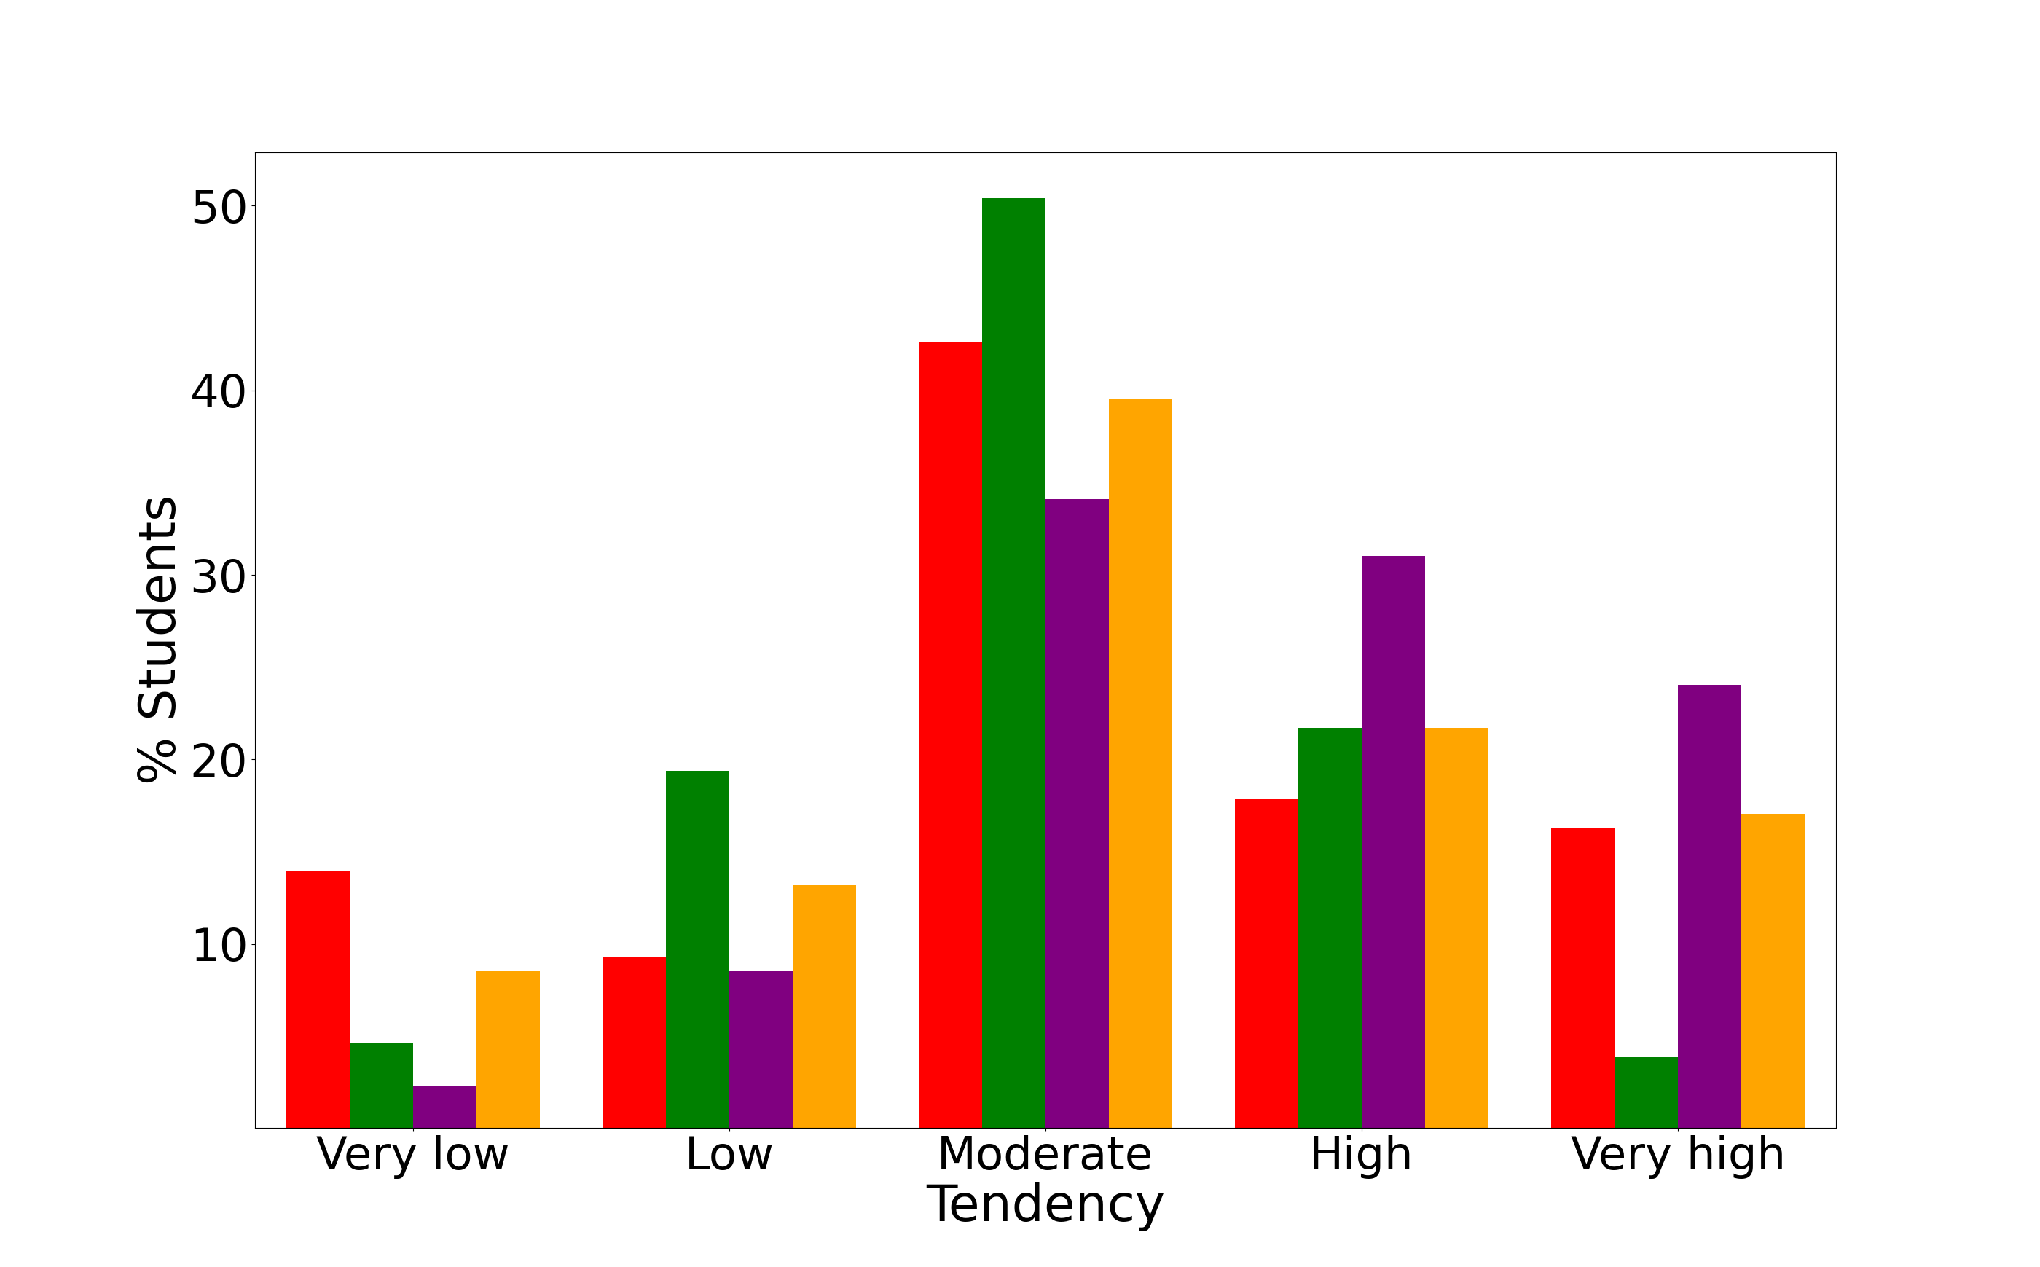

**Figure 1. Bar graphic showing the percentage of students with a very low (leftmost), low (left), moderate (middle), high (right) and very high (rightmost) tendency towards the active (red), reflector (green), theorist (purple) and pragmatist (orange) learning styles. The shown results correspond to the values of Table 3.**

### Global tendencies towards the learning styles of the students (II)

Table 4 shows the average mean and the uncertainties for the different learning styles, along with the corresponding qualitative tendency, and the corresponding affinity. For the shake of clarity, the average profile of the students given by the average means and the corresponding uncertainties is shown in Fig. 2, while the affinities are represented as a barr graphic in Fig. 3.

**Table 4. Numerical average values of each learning style with the uncertainties (in parenthesis) along with their qualitative tendency, and the corresponding affinity.**

|  |  |  |  |
| --- | --- | --- | --- |
| Learning style | Average mean (Uncertainty) | Tendency | Affinity (%) |
| Activist | 10.8(0.6) | Moderate | 76.7 |
| Reflector | 15.5(0.5) | Moderate | 76.0 |
| Theorist | 13.4(0.5) | Moderate/ High | 89.1 |
| Pragmatist | 12.7(0.5) | Moderate | 78.3 |

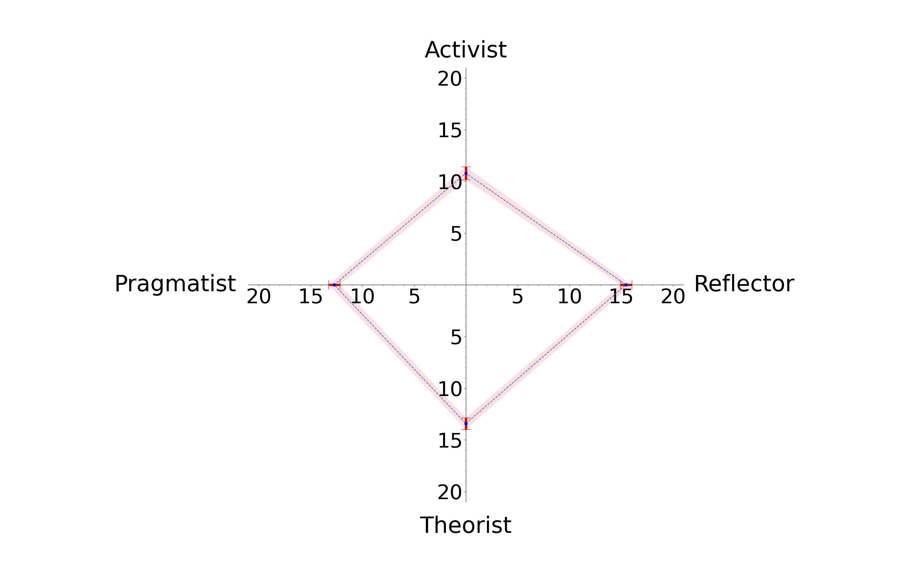

**Figure 2. Average profile of the learning styles of the students.**

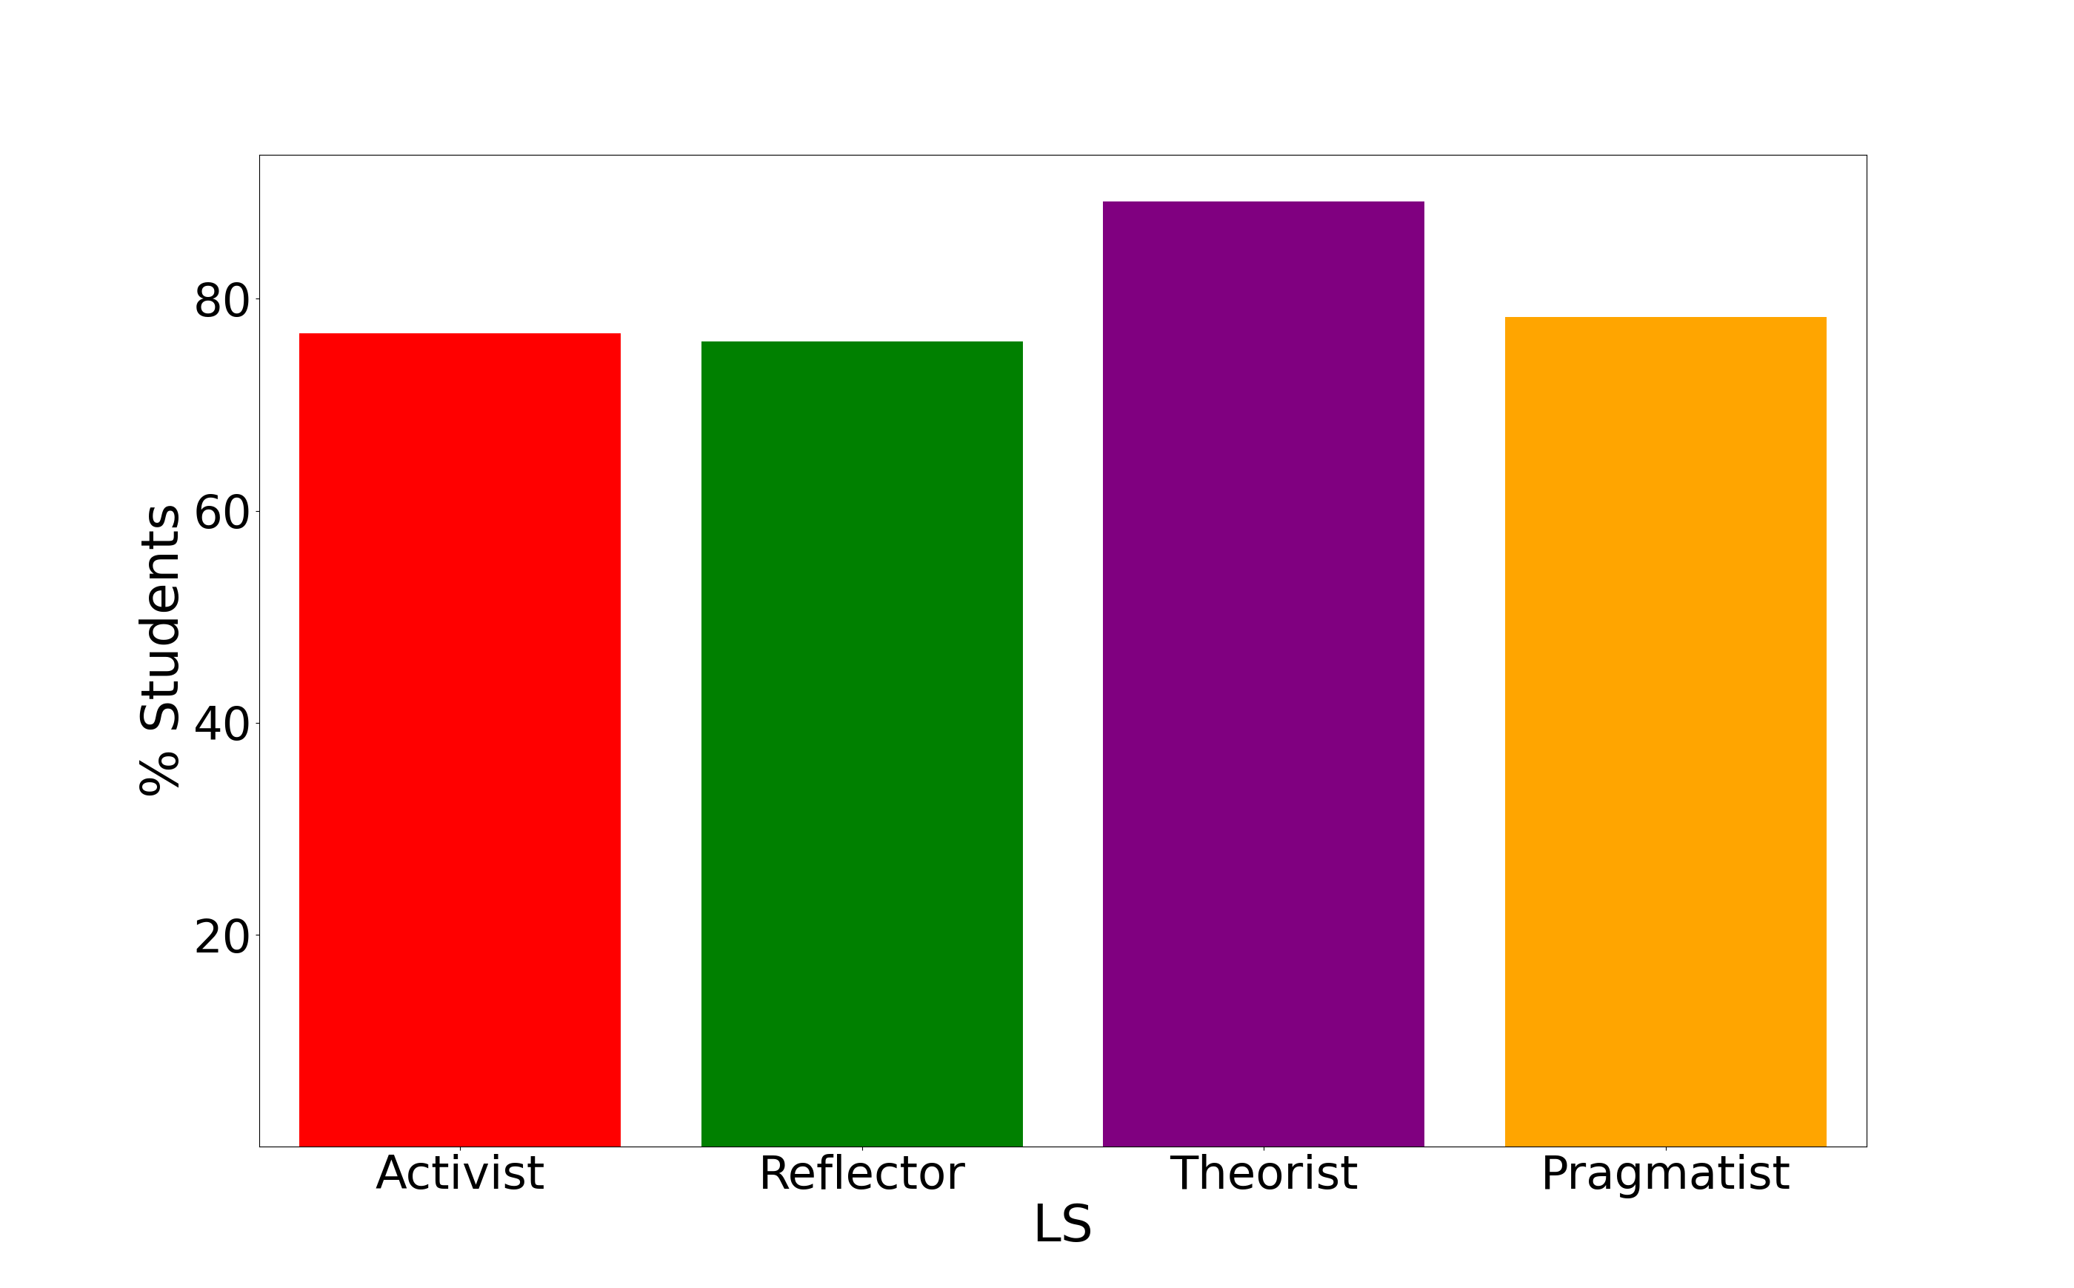

**Figure 3. Affinity of the learning styles. The bar graphic gives the percentage of students that have a noticeable tendency towards the active (red), reflector (green), theorist (purple) and pragmatist (orange) learning styles.**

Figure 4 shows histograms with the probability distributions of the results of Table 1. The continuous lines show fittings with Weibull distributions with the parameters shown in Table 5. These fittings have been performed on the corresponding cumulative distributions given by the staircases shown in Figure 5.

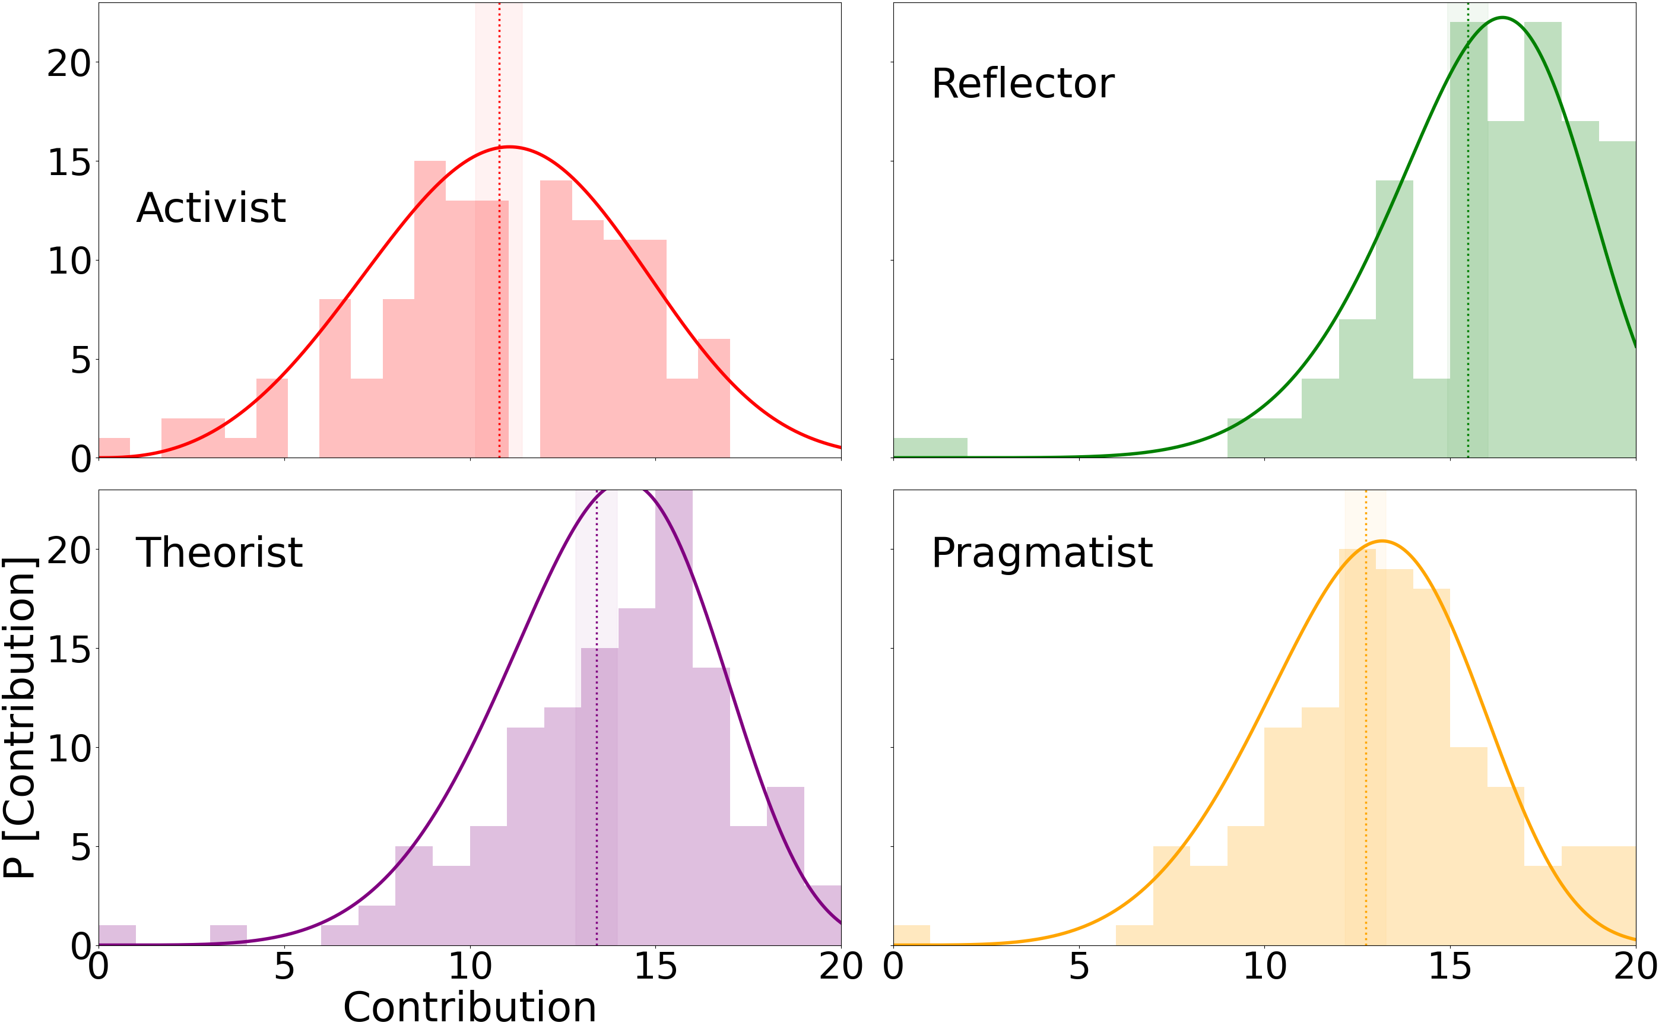

**Figure 4. Histograms showing the probability distributions for the activist (red), reflector (green), theorist (purple), and pragmatist (yellow) learning styles. The continuous lines show fittings provided by the Weibull distributions with the parameters contained in Table 5. The vertical dotted lines mark the average values, and the shaded areas around them the corresponding confidence intervals.**

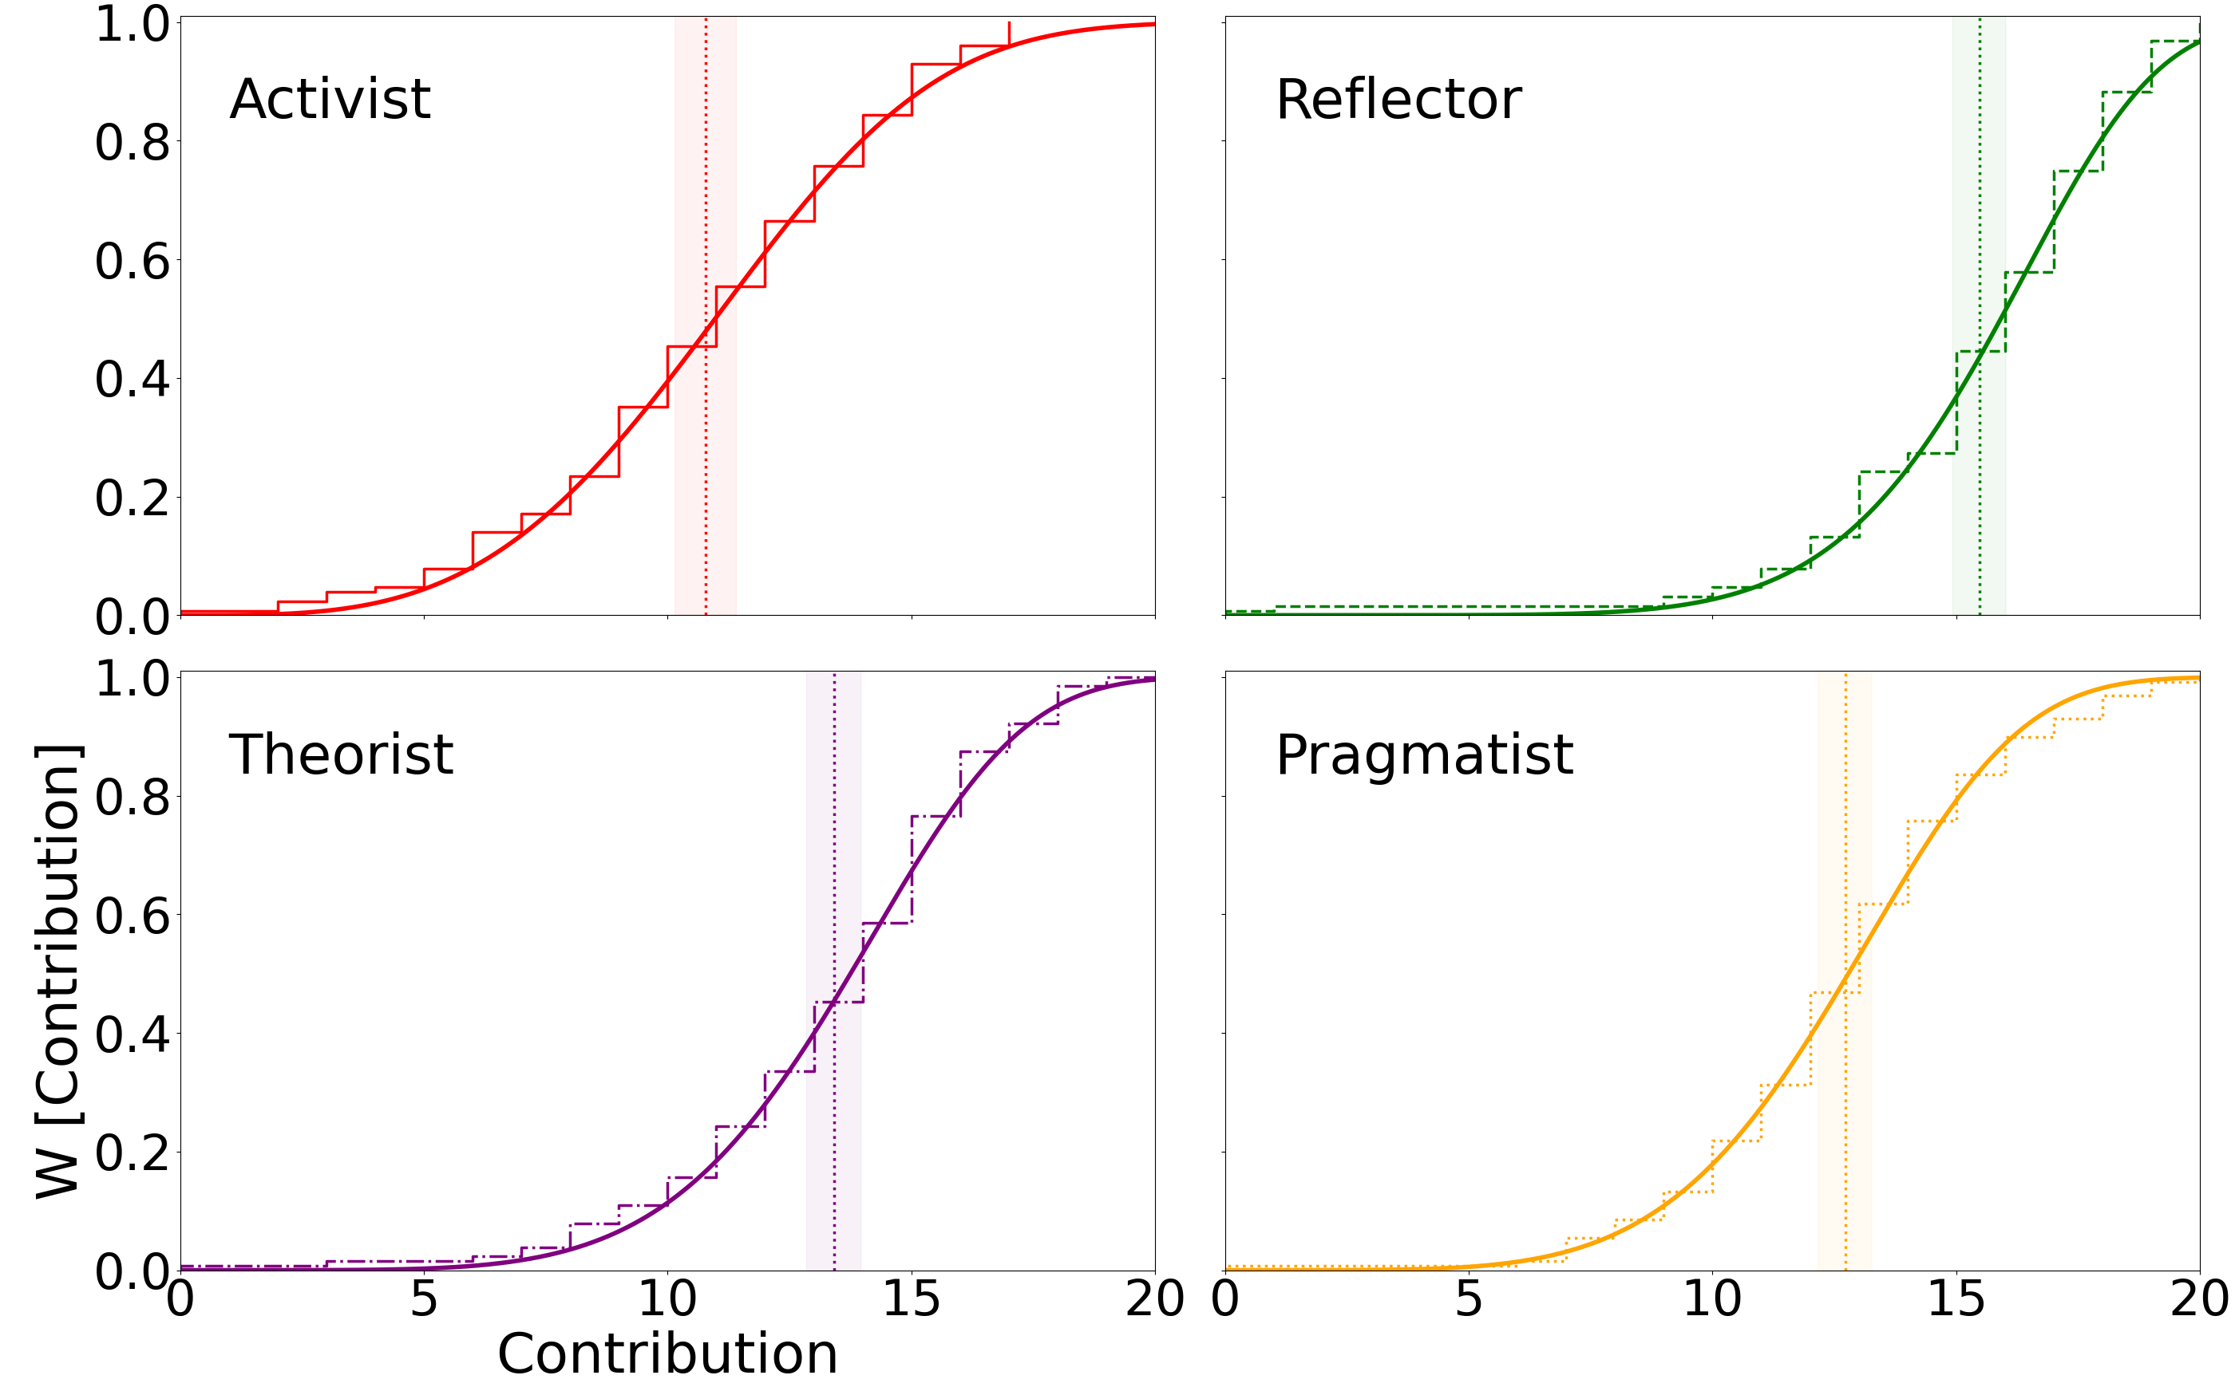

**Figure 5. Same as Fig. 4 for the cumulative distributions (staircases).**

**Table 5. Parameters of the Weibull distributions that fit the probability distributions (histograms) shown in Figs. 4 and 5. The location parameter is set equal to θ = 0.**

|  |  |  |
| --- | --- | --- |
| Learning style | α | k |
| Activist | 12.2 | 3.48 |
| Reflector | 16.78 | 6.97 |
| Theorist | 14.7 | 5.48 |
| Pragmatist | 13.74 | 5.12 |

# 2. Principal component analysis

This section presents the principal component analysis of the learning styles. It is organized as follows. First, the eigenvalues and eigenvectors of the covariance matrix are presented. Second, the description of the learning styles of the students in the principal components basis set is discussed. Finally, a reduced dimensional representation of the data is conducted.

## 2.1 Structure of the principal components

### Eigenvalues and dispersion of the covariance matrix

In this section, we discuss the essentials of the principal components. For this purpose, Table 6 shows the four eigenvalues of the covariance matrix. Here, not only their values are listed but also their contribution to the total dispersion (given by the trace of the covariance matrix tr(K)=43.09, which equals the sum of all the eigenvalues) as a percentage. Likewise, the dispersion accounted by solely the principal component with the largest eigenvalue Σ_0(%)=λ_0*100/tr(K), and by combining the principal components with the two, three, and four largest eigenvalues Σ_1(%)=(λ_0+λ_1)*100/tr(K), Σ_2(%)=(λ_0+λ_1+λ_2)*100/tr(K), and by four Σ_3(%)=(λ_0+λ_1+λ_2+λ_3)*100/tr(K)=100%, respectively, are given.

**Table 6. Eigenvalues of the covariance matrix given by their corresponding values λ_i and as a percentage of the total dispersion, and percentage of total dispersion Σ_i accounted by combination of the principal components with the eigenvalues λ_j, being j≤i.**

|  |  |  |  |
| --- | --- | --- | --- |
| Principal component (i) | λ_i | λ_i(%) | Σ_i(%) |
| 0 | 19.08 | 44.3 | 44.3 |
| 1 | 14.93 | 34.6 | 78.9 |
| 2 | 5.64 | 13.1 | 92.0 |
| 3 | 3.44 | 8.0 | 100.0 |

### Eigenvectors of the covariance matrix

Table 7 shows the structure of the eigenvectors of the covariance matrix in the basis set of CHAEA learning styles. Each cell contains the percentage of the eigenvector of the principal component 0, 1, 2, and 3 that is projected on the corresponding learning style (activist, reflector, theorist, and pragmatist).

**Table 7. Structure (as percentages) of the eigenvectors of the covariance matrix in the basis set of CHAEA learning styles.**

|  |  |  |  |  |
| --- | --- | --- | --- | --- |
| Principal component | Activist | Reflector | Theorist | Pragmatist |
| 0 | 11.7 | 64.8 | 11.3 | 12.1 |
| 1 | 21.0 | 16.3 | 56.7 | 6.0 |
| 2 | 31.6 | 14.6 | 11.2 | 42.6 |
| 3 | 35.6 | 4.3 | 20.8 | 39.2 |

## 2.2 Individual analysis of the principal components

### Quantitive description of the students in the basis set of the principal components

Table 8 shows (as percentages) the structure of the learning styles in the basis set formed by the principal components. The table also includes the percentage of the learning styles of each student that is described by combining the two (sum of the percentages for the principal components 0 and 1) or three (sum of the percentages for the principal components 0, 1, and 2) principal components with the largest eigenvalues. Recall that when the four principal components are considered, 100% of the learning style of the student is reproduced.

**Table 8. Structure of the learning styles of each of the students in the basis set of principal components.**

|  |  |  |  |  |  |  |
| --- | --- | --- | --- | --- | --- | --- |
| Student | 0 | 1 | 2 | 3 | 0+1 | 0+1+2 |
| fisicaI_2022-23_01.xls | 24.84 | 65.25 | 8.84 | 1.07 | 90.09 | 98.93 |
| fisicaI_2022-23_02.xls | 1.21 | 2.64 | 91.92 | 4.23 | 3.85 | 95.77 |
| fisicaI_2022-23_03.xls | 19.44 | 58.8 | 0.08 | 21.68 | 78.24 | 78.32 |
| fisicaI_2022-23_04.xlsx | 31.32 | 29.57 | 28.86 | 10.25 | 60.89 | 89.75 |
| fisicaI_2022-23_05.xlsx | 14.87 | 33.68 | 51.21 | 0.23 | 48.56 | 99.77 |
| fisicaI_2022-23_06.xls | 7.85 | 45.51 | 0.18 | 46.46 | 53.36 | 53.54 |
| fisicaI_2022-23_07.xlsx | 1.58 | 30.01 | 68.12 | 0.29 | 31.59 | 99.71 |
| fisicaI_2022-23_08.xls | 44.29 | 44.82 | 8.26 | 2.63 | 89.12 | 97.37 |
| fisicaI_2022-23_09.xls | 7.4 | 74.62 | 17.96 | 0.01 | 82.02 | 99.99 |
| fisicaI_2022-23_11.xls | 12.1 | 71.05 | 13.11 | 3.74 | 83.15 | 96.26 |
| fisicaI_2022-23_12.xls | 68.72 | 17.65 | 6.6 | 7.03 | 86.37 | 92.97 |
| fisicaI_2022-23_13.xlsx | 31.27 | 67.94 | 0.01 | 0.77 | 99.22 | 99.23 |
| fisicaI_2022-23_14.xls | 56.28 | 14.74 | 13.59 | 15.39 | 71.02 | 84.61 |
| fisicaI_2022-23_15.xlsx | 96.27 | 2.62 | 0.03 | 1.08 | 98.89 | 98.92 |
| fisicaI_2022-23_17.xls | 17.93 | 20.0 | 0.36 | 61.7 | 37.94 | 38.3 |
| fisicaI_2022-23_18.xls | 14.11 | 57.04 | 18.69 | 10.16 | 71.15 | 89.84 |
| fisicaI_2022-23_19.xls | 56.32 | 4.17 | 25.31 | 14.2 | 60.49 | 85.8 |
| fisicaI_2022-23_20.xls | 28.67 | 7.51 | 63.67 | 0.14 | 36.18 | 99.86 |
| fisicaI_2022-23_21.xls | 9.83 | 72.07 | 8.61 | 9.49 | 81.9 | 90.51 |
| fisicaI_2022-23_22.xlsx | 10.57 | 63.36 | 9.05 | 17.02 | 73.92 | 82.98 |
| fisicaI_2022-23_23.xls | 40.11 | 28.2 | 6.15 | 25.53 | 68.32 | 74.47 |
| fisicaI_2022-23_24.xls | 0.08 | 10.97 | 76.08 | 12.88 | 11.04 | 87.12 |
| fisicaI_2022-23_25.xls | 29.55 | 6.26 | 22.1 | 42.09 | 35.81 | 57.91 |
| fisicaI_2022-23_26.xls | 13.68 | 32.65 | 53.51 | 0.16 | 46.34 | 99.84 |
| fisicaI_2022-23_27.xls | 75.6 | 0.0 | 24.3 | 0.1 | 75.6 | 99.9 |
| fisicaI_2022-23_30.xls | 2.24 | 10.04 | 1.4 | 86.32 | 12.28 | 13.68 |
| fisicaI_2022-23_31.xls | 6.87 | 31.1 | 37.06 | 24.98 | 37.97 | 75.02 |
| fisicaI_2022-23_33.xlsx | 29.33 | 20.08 | 48.35 | 2.25 | 49.4 | 97.75 |
| fisicaI_2022-23_34.xls | 9.21 | 52.42 | 34.34 | 4.03 | 61.64 | 95.97 |
| fisicaI_2022-23_35.xls | 7.01 | 26.1 | 66.89 | 0.0 | 33.11 | 100.0 |
| fisicaI_2022-23_36.xls | 14.0 | 6.73 | 1.9 | 77.37 | 20.73 | 22.63 |
| fisicaI_2022-23_37.xls | 32.15 | 21.04 | 8.95 | 37.87 | 53.18 | 62.13 |
| fisicaI_2022-23_38.xlsx | 76.7 | 0.31 | 22.97 | 0.02 | 77.01 | 99.98 |
| fisicaI_2022-23_39.xls | 7.14 | 92.05 | 0.33 | 0.49 | 99.19 | 99.51 |
| fisicaI_2022-23_40.xls | 18.99 | 0.66 | 0.0 | 80.35 | 19.65 | 19.65 |
| fisicaI_2022-23_41.xls | 60.36 | 0.02 | 39.46 | 0.17 | 60.38 | 99.83 |
| fisicaI_2022-23_42.xls | 28.24 | 26.46 | 19.2 | 26.11 | 54.7 | 73.89 |
| fisicaI_2022-23_43.xls | 0.43 | 84.88 | 7.16 | 7.53 | 85.31 | 92.47 |
| fisicaI_2022-23_44.xls | 15.28 | 72.34 | 4.4 | 7.98 | 87.62 | 92.02 |
| fisicaI_2022-23_45.xlsx | 0.95 | 41.07 | 4.95 | 53.03 | 42.02 | 46.97 |
| fisicaI_2022-23_46.xls | 6.22 | 49.53 | 18.77 | 25.48 | 55.75 | 74.52 |
| fisicaI_2022-23_47.xls | 70.32 | 6.3 | 22.81 | 0.57 | 76.62 | 99.43 |
| fisicaI_2022-23_48.xls | 47.17 | 50.07 | 2.5 | 0.26 | 97.24 | 99.74 |
| fisicaI_2022-23_49.xls | 0.0 | 24.5 | 66.16 | 9.34 | 24.5 | 90.66 |
| fisicaI_2022-23_50.xls | 0.64 | 98.75 | 0.14 | 0.47 | 99.38 | 99.53 |
| fisicaI_2022-23_51.xls | 30.96 | 68.47 | 0.02 | 0.55 | 99.43 | 99.45 |
| fisicaI_2022-23_52.xls | 26.8 | 69.18 | 0.32 | 3.7 | 95.98 | 96.3 |
| fisicaI_2022-23_53.xlsx | 75.03 | 1.47 | 0.1 | 23.4 | 76.5 | 76.6 |
| fisicaI_2022-23_54.xlsx | 28.24 | 26.46 | 19.2 | 26.11 | 54.7 | 73.89 |
| fisicaI_2022-23_55.xls | 0.04 | 1.4 | 19.67 | 78.88 | 1.45 | 21.12 |
| fisicaI_2022-23_56.xls | 6.69 | 0.51 | 63.86 | 28.94 | 7.21 | 71.06 |
| fisicaI_2022-23_57.xls | 0.48 | 69.33 | 28.55 | 1.64 | 69.81 | 98.36 |
| fisicaI_2022-23_58.xlsx | 41.58 | 5.44 | 9.47 | 43.51 | 47.02 | 56.49 |
| fisicaI_2022-23_59.xls | 49.04 | 49.85 | 0.0 | 1.11 | 98.89 | 98.89 |
| fisicaI_2022-23_61.xls | 48.33 | 48.59 | 2.11 | 0.97 | 96.92 | 99.03 |
| fisicaI_2022-23_62.xls | 24.69 | 46.06 | 29.17 | 0.08 | 70.75 | 99.92 |
| fisicaI_2022-23_63.xlsx | 12.43 | 48.4 | 12.4 | 26.77 | 60.83 | 73.23 |
| fisicaI_2022-23_64.xlsx | 95.46 | 1.29 | 0.95 | 2.3 | 96.75 | 97.7 |
| fisicaI_2022-23_65.xls | 1.28 | 7.65 | 86.74 | 4.33 | 8.93 | 95.67 |
| fisicaI_2022-23_66.xls | 79.78 | 13.3 | 5.97 | 0.95 | 93.08 | 99.05 |
| fisicaI_2022-23_67.xls | 0.44 | 60.12 | 5.94 | 33.5 | 60.56 | 66.5 |
| fisicaI_2022-23_68.xls | 37.15 | 18.18 | 33.76 | 10.92 | 55.33 | 89.08 |
| fisicaI_2022-23_69.xls | 0.92 | 85.34 | 5.48 | 8.25 | 86.27 | 91.75 |
| fisicaI_2022-23_70.xls | 64.17 | 19.83 | 15.98 | 0.02 | 84.0 | 99.98 |
| fisicaI_2022-23_71.xls | 96.35 | 0.0 | 3.57 | 0.08 | 96.35 | 99.92 |
| fisicaI_2022-23_72.xls | 42.66 | 0.01 | 12.76 | 44.58 | 42.67 | 55.42 |
| fisicaI_2022-23_73.xls | 84.39 | 2.83 | 10.46 | 2.32 | 87.21 | 97.68 |
| fisicaI_2022-23_74.xlsx | 32.82 | 51.01 | 0.02 | 16.15 | 83.83 | 83.85 |
| fisicaI_2022-23_75.xls | 28.62 | 11.88 | 6.33 | 53.17 | 40.5 | 46.83 |
| fisicaI_2022-23_76.xls | 49.61 | 50.26 | 0.13 | 0.0 | 99.86 | 100.0 |
| fisicaI_2023-24_01.xls | 3.33 | 50.89 | 27.49 | 18.28 | 54.23 | 81.72 |
| fisicaI_2023-24_02.xls | 72.07 | 4.53 | 19.45 | 3.96 | 76.59 | 96.04 |
| fisicaI_2023-24_03.xlsx | 84.7 | 1.24 | 0.3 | 13.76 | 85.94 | 86.24 |
| fisicaI_2023-24_04.xls | 7.41 | 70.86 | 19.57 | 2.16 | 78.27 | 97.84 |
| fisicaI_2023-24_05.xls | 23.25 | 64.83 | 3.91 | 8.01 | 88.08 | 91.99 |
| fisicaI_2023-24_06.xlsx | 47.23 | 49.92 | 2.75 | 0.09 | 97.15 | 99.91 |
| fisicaI_2023-24_07.xlsx | 31.16 | 66.5 | 2.33 | 0.01 | 97.66 | 99.99 |
| fisicaI_2023-24_08.xls | 9.17 | 86.82 | 1.9 | 2.11 | 95.99 | 97.89 |
| fisicaI_2023-24_09.xls | 49.36 | 36.43 | 10.46 | 3.75 | 85.79 | 96.25 |
| fisicaI_2023-24_10.xls | 0.01 | 58.58 | 5.45 | 35.96 | 58.59 | 64.04 |
| fisicaI_2023-24_11.xlsx | 7.02 | 88.83 | 1.93 | 2.22 | 95.85 | 97.78 |
| fisicaI_2023-24_12.xls | 1.28 | 7.65 | 86.74 | 4.33 | 8.93 | 95.67 |
| fisicaI_2023-24_13.xls | 23.67 | 13.99 | 58.16 | 4.18 | 37.67 | 95.82 |
| fisicaI_2023-24_14.xls | 67.37 | 14.47 | 3.5 | 14.66 | 81.85 | 85.34 |
| fisicaI_2023-24_15.xls | 6.61 | 26.16 | 57.66 | 9.56 | 32.77 | 90.44 |
| fisicaI_2023-24_16.xls | 13.05 | 77.86 | 4.94 | 4.15 | 90.91 | 95.85 |
| fisicaI_2023-24_17.xls | 1.08 | 4.76 | 37.47 | 56.69 | 5.84 | 43.31 |
| fisicaI_2023-24_18.xls | 47.25 | 6.24 | 31.78 | 14.73 | 53.48 | 85.27 |
| fisicaI_2023-24_20.xls | 0.04 | 91.35 | 8.46 | 0.15 | 91.39 | 99.85 |
| fisicaI_2023-24_21.xls | 2.4 | 96.72 | 0.08 | 0.81 | 99.12 | 99.19 |
| fisicaI_2023-24_22.xls | 35.37 | 0.61 | 26.78 | 37.24 | 35.98 | 62.76 |
| fisicaI_2023-24_23.xls | 34.57 | 49.76 | 2.01 | 13.65 | 84.34 | 86.35 |
| fisicaI_2023-24_24.xls | 5.77 | 73.72 | 0.0 | 20.51 | 79.49 | 79.49 |
| fisicaI_2023-24_25.xls | 7.2 | 62.74 | 18.46 | 11.6 | 69.94 | 88.4 |
| fisicaI_2023-24_26.xls | 1.05 | 78.45 | 2.95 | 17.55 | 79.5 | 82.45 |
| fisicaI_2023-24_27.xls | 95.03 | 4.05 | 0.53 | 0.4 | 99.07 | 99.6 |
| fisicaI_2023-24_28.xls | 12.21 | 86.73 | 0.4 | 0.66 | 98.95 | 99.34 |
| fisicaI_2023-24_29.xlsx | 85.27 | 5.4 | 9.2 | 0.13 | 90.67 | 99.87 |
| fisicaI_2023-24_30.xls | 53.58 | 13.29 | 16.19 | 16.94 | 66.87 | 83.06 |
| fisicaI_2023-24_31.xls | 67.45 | 29.06 | 0.39 | 3.1 | 96.51 | 96.9 |
| fisicaI_2023-24_32.xls | 0.01 | 1.0 | 30.21 | 68.78 | 1.01 | 31.22 |
| fisicaI_2023-24_33.xls | 21.23 | 44.03 | 32.65 | 2.09 | 65.27 | 97.91 |
| fisicaI_2023-24_34.xls | 27.78 | 59.86 | 11.96 | 0.4 | 87.64 | 99.6 |
| fisicaI_2023-24_35.xls | 1.46 | 4.92 | 83.06 | 10.56 | 6.38 | 89.44 |
| fisicaI_2023-24_36.xls | 81.91 | 4.71 | 9.91 | 3.46 | 86.62 | 96.54 |
| fisicaI_2023-24_37.xls | 35.95 | 53.28 | 7.63 | 3.14 | 89.23 | 96.86 |
| fisicaI_2023-24_38.xlsx | 9.52 | 66.89 | 15.06 | 8.52 | 76.41 | 91.48 |
| fisicaI_2023-24_39.xlsx | 53.62 | 12.59 | 33.68 | 0.11 | 66.21 | 99.89 |
| fisicaI_2023-24_40.xls | 25.97 | 44.45 | 23.3 | 6.28 | 70.42 | 93.72 |
| fisicaI_2023-24_41.xls | 10.99 | 73.59 | 2.23 | 13.19 | 84.58 | 86.81 |
| fisicaI_2023-24_42.xls | 8.69 | 91.22 | 0.08 | 0.02 | 99.9 | 99.98 |
| fisicaI_2023-24_43.xls | 3.61 | 69.24 | 25.28 | 1.87 | 72.85 | 98.13 |
| fisicaI_2023-24_44.xlsx | 13.67 | 86.12 | 0.11 | 0.1 | 99.79 | 99.9 |
| fisicaI_2023-24_45.xls | 45.42 | 28.83 | 8.75 | 17.0 | 74.25 | 83.0 |
| fisicaI_2023-24_46.xls | 0.63 | 87.18 | 7.36 | 4.83 | 87.81 | 95.17 |
| fisicaI_2023-24_47.xls | 0.6 | 0.01 | 96.41 | 2.98 | 0.61 | 97.02 |
| fisicaI_2023-24_48.xls | 3.15 | 92.67 | 1.27 | 2.9 | 95.83 | 97.1 |
| fisicaI_2023-24_49.xlsx | 10.45 | 2.76 | 16.21 | 70.59 | 13.2 | 29.41 |
| fisicaI_2023-24_50.xlsx | 0.15 | 95.58 | 4.13 | 0.14 | 95.73 | 99.86 |
| fisicaI_2023-24_51.xls | 4.08 | 27.79 | 58.36 | 9.77 | 31.87 | 90.23 |
| fisicaI_2023-24_52.xlsx | 51.77 | 0.01 | 44.09 | 4.13 | 51.78 | 95.87 |
| fisicaI_2023-24_53.xlsx | 80.68 | 16.63 | 1.88 | 0.81 | 97.32 | 99.19 |
| fisicaI_2023-24_54.xlsx | 18.15 | 5.66 | 53.02 | 23.16 | 23.82 | 76.84 |
| fisicaI_2023-24_55.xls | 24.04 | 22.68 | 52.32 | 0.96 | 46.72 | 99.04 |
| fisicaI_2023-24_56.xls | 11.96 | 3.7 | 3.15 | 81.19 | 15.66 | 18.81 |
| fisicaI_2023-24_57.xlsx | 31.06 | 4.53 | 23.09 | 41.32 | 35.59 | 58.68 |
| fisicaI_2023-24_58.xls | 64.82 | 32.55 | 2.0 | 0.62 | 97.37 | 99.38 |
| fisicaI_2023-24_59.xls | 94.14 | 4.67 | 1.14 | 0.06 | 98.81 | 99.94 |
| fisicaI_2023-24_60.xlsx | 97.27 | 1.28 | 1.4 | 0.06 | 98.55 | 99.94 |

## 2.3 Global analysis of the principal components

Figure 6 shows a four-dimensional representation of the learning styles of the students as a function of the contributions to three of the CHAEA learning styles. The tendency towards the remaining learning style is impliclity shown in the size and color shades of the points (bigger and darker colors imply a larger tendency). The principal directions shown as continuous lines (PC0 , red; PC1, green; PC2, purple; PC3, orange) emerge from centroid, which is given by the average mean of the data set and is shown as a black star. The projection of the points and the average mean is shown in gray. The projection confidence interval of the average mean is also shown. The origin, which is defined as (0, 0, 0, 0) in the 4D space of the learning styles is shown as a black triangle. The colored points correspond to the maximal pure learning styles (e.g., (20, 0, 0, 0) for activist (red), or (0, 20, 0, 0) for reflector (green)) are also marked.

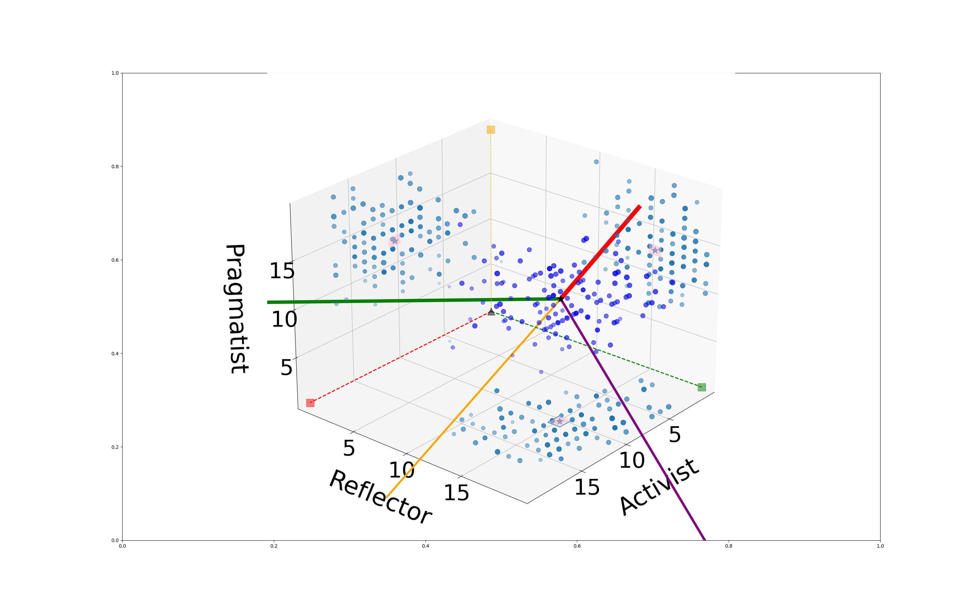

**Figure 6. Four-dimensional representation of the learning styles of the students as a function of the CHAEA learning styles.**

The central panel in Fig. 7 shows the projection of the learning styles of the student represented in Fig. 6 on the two main principal components (PC0 and PC1), along with their histograms. The data surround the average mean (gray star). The points (20, 0, 0, 0), (0, 20, 0, 0), (0, 0, 20, 0), and (0, 0, 0, 20), which correspond, respectively, to the maximal pure activist (red), reflector (green), theorist (purple), and pragmatist (orange) learning styles in the original basis set are also marked, and joined with a dashed line to the corresponding origin (0, 0, 0, 0) (black triangle). The point (20, 20, 20, 20) is also shown (brown diamond).

The reduced dimensional representation of the data given by Fig. 7 is usually meaningful if Σ_1(%)≥70.0%; in the case under study we have that Σ_1(%)=92.0. The top and left panels of Fig. 7 show the histrograms of the data as a function of PC0 (red) and PC1 (green), which are fitted using Weibull distributions with the parameters listed in Table 9.

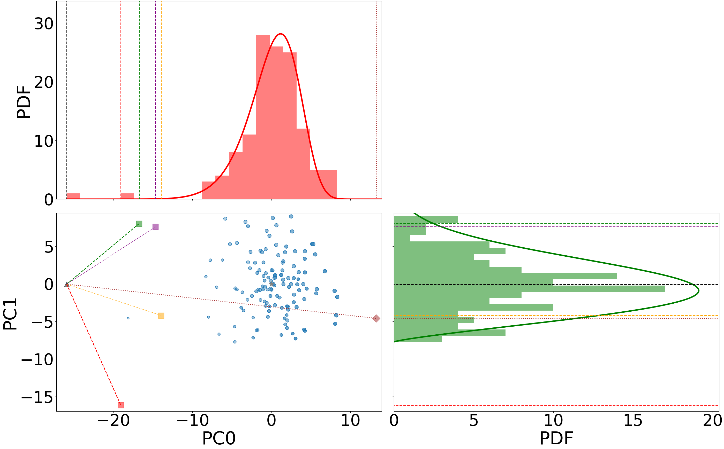

**Figure 7. The projection of the learning styles of the students represented in Fig. 6 on the two main principal components (PC0 and PC1), along with their histograms as a function of PC0 (red) and PC1 (green).**

**Table 9. Parameters of the Weibull distributions that fit the probability distributions (histograms) of the projection of the learning styles on the principal-components basis set (see histograms in Fig. 7). The location parameter θ is set equal to the smallest projection for each component.**

|  |  |  |  |
| --- | --- | --- | --- |
| Principal component | α | k | θ |
| 0 | 27.4 | 9.54 | -25.92 |
| 1 | 8.87 | 2.25 | -7.72 |
| 2 | 6.74 | 3.03 | -5.96 |
| 3 | 7.51 | 4.95 | -6.99 |

# 3. Participation ratios

Third, the participation ratios are finally presented in Section 3. The values for the CHAEA (active, theorist, pragmatic, and reflector) and for the principal-components basis sets are listed. To conclude, a statistical analysis of the distribution of the participation ratios is performed.

## 3.1 Individual analysis of the participation ratios

Table 10 shows the participation ratios of each individual student for CHAEA (active, theorist, pragmatic, and reflector) and for the principal-components basis sets. For the case under study, this parameter lies between 1 and 4. The smaller the participation ratio, the better.

**Table 10. Participation ratios of each individual student for CHAEA learning styles (LS) and for the principal-components (PC) basis sets.**

|  |  |  |
| --- | --- | --- |
| Student | LS | PC |
| fisicaI_2022-23_01.xls | 3.98 | 2.02 |
| fisicaI_2022-23_02.xls | 3.31 | 1.18 |
| fisicaI_2022-23_03.xls | 3.94 | 2.32 |
| fisicaI_2022-23_04.xlsx | 2.96 | 3.58 |
| fisicaI_2022-23_05.xlsx | 3.63 | 2.51 |
| fisicaI_2022-23_06.xls | 3.71 | 2.33 |
| fisicaI_2022-23_07.xlsx | 3.5 | 1.8 |
| fisicaI_2022-23_08.xls | 3.21 | 2.47 |
| fisicaI_2022-23_09.xls | 3.22 | 1.68 |
| fisicaI_2022-23_11.xls | 3.85 | 1.86 |
| fisicaI_2022-23_12.xls | 3.89 | 1.95 |
| fisicaI_2022-23_13.xlsx | 3.84 | 1.79 |
| fisicaI_2022-23_14.xls | 2.31 | 2.63 |
| fisicaI_2022-23_15.xlsx | 3.8 | 1.08 |
| fisicaI_2022-23_17.xls | 3.48 | 2.21 |
| fisicaI_2022-23_18.xls | 3.19 | 2.56 |
| fisicaI_2022-23_19.xls | 3.65 | 2.48 |
| fisicaI_2022-23_20.xls | 3.86 | 2.03 |
| fisicaI_2022-23_21.xls | 3.77 | 1.83 |
| fisicaI_2022-23_22.xlsx | 3.42 | 2.22 |
| fisicaI_2022-23_23.xls | 3.44 | 3.23 |
| fisicaI_2022-23_24.xls | 3.59 | 1.65 |
| fisicaI_2022-23_25.xls | 3.7 | 3.15 |
| fisicaI_2022-23_26.xls | 3.61 | 2.43 |
| fisicaI_2022-23_27.xls | 3.65 | 1.59 |
| fisicaI_2022-23_30.xls | 3.49 | 1.32 |
| fisicaI_2022-23_31.xls | 3.34 | 3.32 |
| fisicaI_2022-23_33.xlsx | 3.56 | 2.77 |
| fisicaI_2022-23_34.xls | 3.21 | 2.48 |
| fisicaI_2022-23_35.xls | 2.9 | 1.92 |
| fisicaI_2022-23_36.xls | 3.63 | 1.6 |
| fisicaI_2022-23_37.xls | 3.48 | 3.34 |
| fisicaI_2022-23_38.xlsx | 2.86 | 1.56 |
| fisicaI_2022-23_39.xls | 2.81 | 1.17 |
| fisicaI_2022-23_40.xls | 3.03 | 1.47 |
| fisicaI_2022-23_41.xls | 3.75 | 1.92 |
| fisicaI_2022-23_42.xls | 3.58 | 3.93 |
| fisicaI_2022-23_43.xls | 3.54 | 1.37 |
| fisicaI_2022-23_44.xls | 3.89 | 1.8 |
| fisicaI_2022-23_45.xlsx | 3.89 | 2.21 |
| fisicaI_2022-23_46.xls | 3.04 | 2.86 |
| fisicaI_2022-23_47.xls | 3.5 | 1.82 |
| fisicaI_2022-23_48.xls | 3.24 | 2.11 |
| fisicaI_2022-23_49.xls | 3.75 | 1.97 |
| fisicaI_2022-23_50.xls | 2.77 | 1.03 |
| fisicaI_2022-23_51.xls | 2.4 | 1.77 |
| fisicaI_2022-23_52.xls | 3.08 | 1.81 |
| fisicaI_2022-23_53.xlsx | 3.67 | 1.62 |
| fisicaI_2022-23_54.xlsx | 3.58 | 3.93 |
| fisicaI_2022-23_55.xls | 3.58 | 1.51 |
| fisicaI_2022-23_56.xls | 3.16 | 2.02 |
| fisicaI_2022-23_57.xls | 3.95 | 1.78 |
| fisicaI_2022-23_58.xlsx | 3.64 | 2.67 |
| fisicaI_2022-23_59.xls | 2.78 | 2.04 |
| fisicaI_2022-23_61.xls | 3.92 | 2.13 |
| fisicaI_2022-23_62.xls | 3.42 | 2.79 |
| fisicaI_2022-23_63.xlsx | 3.52 | 2.97 |
| fisicaI_2022-23_64.xlsx | 3.06 | 1.1 |
| fisicaI_2022-23_65.xls | 3.54 | 1.32 |
| fisicaI_2022-23_66.xls | 2.51 | 1.52 |
| fisicaI_2022-23_67.xls | 3.78 | 2.1 |
| fisicaI_2022-23_68.xls | 3.54 | 3.37 |
| fisicaI_2022-23_69.xls | 3.85 | 1.35 |
| fisicaI_2022-23_70.xls | 2.94 | 2.1 |
| fisicaI_2022-23_71.xls | 1.0 | 1.08 |
| fisicaI_2022-23_72.xls | 3.71 | 2.52 |
| fisicaI_2022-23_73.xls | 3.76 | 1.38 |
| fisicaI_2022-23_74.xlsx | 2.73 | 2.54 |
| fisicaI_2022-23_75.xls | 3.79 | 2.61 |
| fisicaI_2022-23_76.xls | 3.26 | 2.01 |
| fisicaI_2023-24_01.xls | 3.63 | 2.71 |
| fisicaI_2023-24_02.xls | 3.51 | 1.78 |
| fisicaI_2023-24_03.xlsx | 3.85 | 1.36 |
| fisicaI_2023-24_04.xls | 3.71 | 1.83 |
| fisicaI_2023-24_05.xls | 2.94 | 2.07 |
| fisicaI_2023-24_06.xlsx | 3.23 | 2.11 |
| fisicaI_2023-24_07.xlsx | 3.3 | 1.85 |
| fisicaI_2023-24_08.xls | 3.52 | 1.31 |
| fisicaI_2023-24_09.xls | 3.91 | 2.57 |
| fisicaI_2023-24_10.xls | 3.41 | 2.1 |
| fisicaI_2023-24_11.xlsx | 3.18 | 1.26 |
| fisicaI_2023-24_12.xls | 3.54 | 1.32 |
| fisicaI_2023-24_13.xls | 2.86 | 2.41 |
| fisicaI_2023-24_14.xls | 3.79 | 2.01 |
| fisicaI_2023-24_15.xls | 3.04 | 2.41 |
| fisicaI_2023-24_16.xls | 3.14 | 1.59 |
| fisicaI_2023-24_17.xls | 3.48 | 2.15 |
| fisicaI_2023-24_18.xls | 3.47 | 2.86 |
| fisicaI_2023-24_20.xls | 2.8 | 1.19 |
| fisicaI_2023-24_21.xls | 3.09 | 1.07 |
| fisicaI_2023-24_22.xls | 3.22 | 2.98 |
| fisicaI_2023-24_23.xls | 3.52 | 2.59 |
| fisicaI_2023-24_24.xls | 3.51 | 1.7 |
| fisicaI_2023-24_25.xls | 3.77 | 2.24 |
| fisicaI_2023-24_26.xls | 2.98 | 1.54 |
| fisicaI_2023-24_27.xls | 3.92 | 1.11 |
| fisicaI_2023-24_28.xls | 2.92 | 1.3 |
| fisicaI_2023-24_29.xlsx | 2.51 | 1.35 |
| fisicaI_2023-24_30.xls | 3.84 | 2.78 |
| fisicaI_2023-24_31.xls | 3.83 | 1.85 |
| fisicaI_2023-24_32.xls | 3.25 | 1.77 |
| fisicaI_2023-24_33.xls | 3.8 | 2.89 |
| fisicaI_2023-24_34.xls | 3.76 | 2.22 |
| fisicaI_2023-24_35.xls | 3.18 | 1.42 |
| fisicaI_2023-24_36.xls | 3.83 | 1.46 |
| fisicaI_2023-24_37.xls | 3.41 | 2.38 |
| fisicaI_2023-24_38.xlsx | 3.23 | 2.06 |
| fisicaI_2023-24_39.xlsx | 3.71 | 2.4 |
| fisicaI_2023-24_40.xls | 3.42 | 3.09 |
| fisicaI_2023-24_41.xls | 2.76 | 1.75 |
| fisicaI_2023-24_42.xls | 3.7 | 1.19 |
| fisicaI_2023-24_43.xls | 3.07 | 1.84 |
| fisicaI_2023-24_44.xlsx | 2.59 | 1.32 |
| fisicaI_2023-24_45.xls | 3.37 | 3.07 |
| fisicaI_2023-24_46.xls | 2.58 | 1.3 |
| fisicaI_2023-24_47.xls | 3.73 | 1.07 |
| fisicaI_2023-24_48.xls | 3.69 | 1.16 |
| fisicaI_2023-24_49.xlsx | 3.59 | 1.86 |
| fisicaI_2023-24_50.xlsx | 2.99 | 1.09 |
| fisicaI_2023-24_51.xls | 3.45 | 2.33 |
| fisicaI_2023-24_52.xlsx | 3.81 | 2.15 |
| fisicaI_2023-24_53.xlsx | 3.6 | 1.47 |
| fisicaI_2023-24_54.xlsx | 3.82 | 2.7 |
| fisicaI_2023-24_55.xls | 3.71 | 2.61 |
| fisicaI_2023-24_56.xls | 3.7 | 1.48 |
| fisicaI_2023-24_57.xlsx | 3.73 | 3.1 |
| fisicaI_2023-24_58.xls | 3.4 | 1.9 |
| fisicaI_2023-24_59.xls | 3.88 | 1.13 |
| fisicaI_2023-24_60.xlsx | 3.86 | 1.06 |

## 3.2 Global analysis of the participation ratios

Figure 8 shows the probability distribution functions of the participation ratios for the learning-styles basis set (red) and for the principal components (blue). The vertical dashed lines mark the average means along with their corresponding confidence intervals (shaded areas), whose values can be found in Table 11. The corresponding cumulative distributions used in the fitting are shown in Fig. 9.

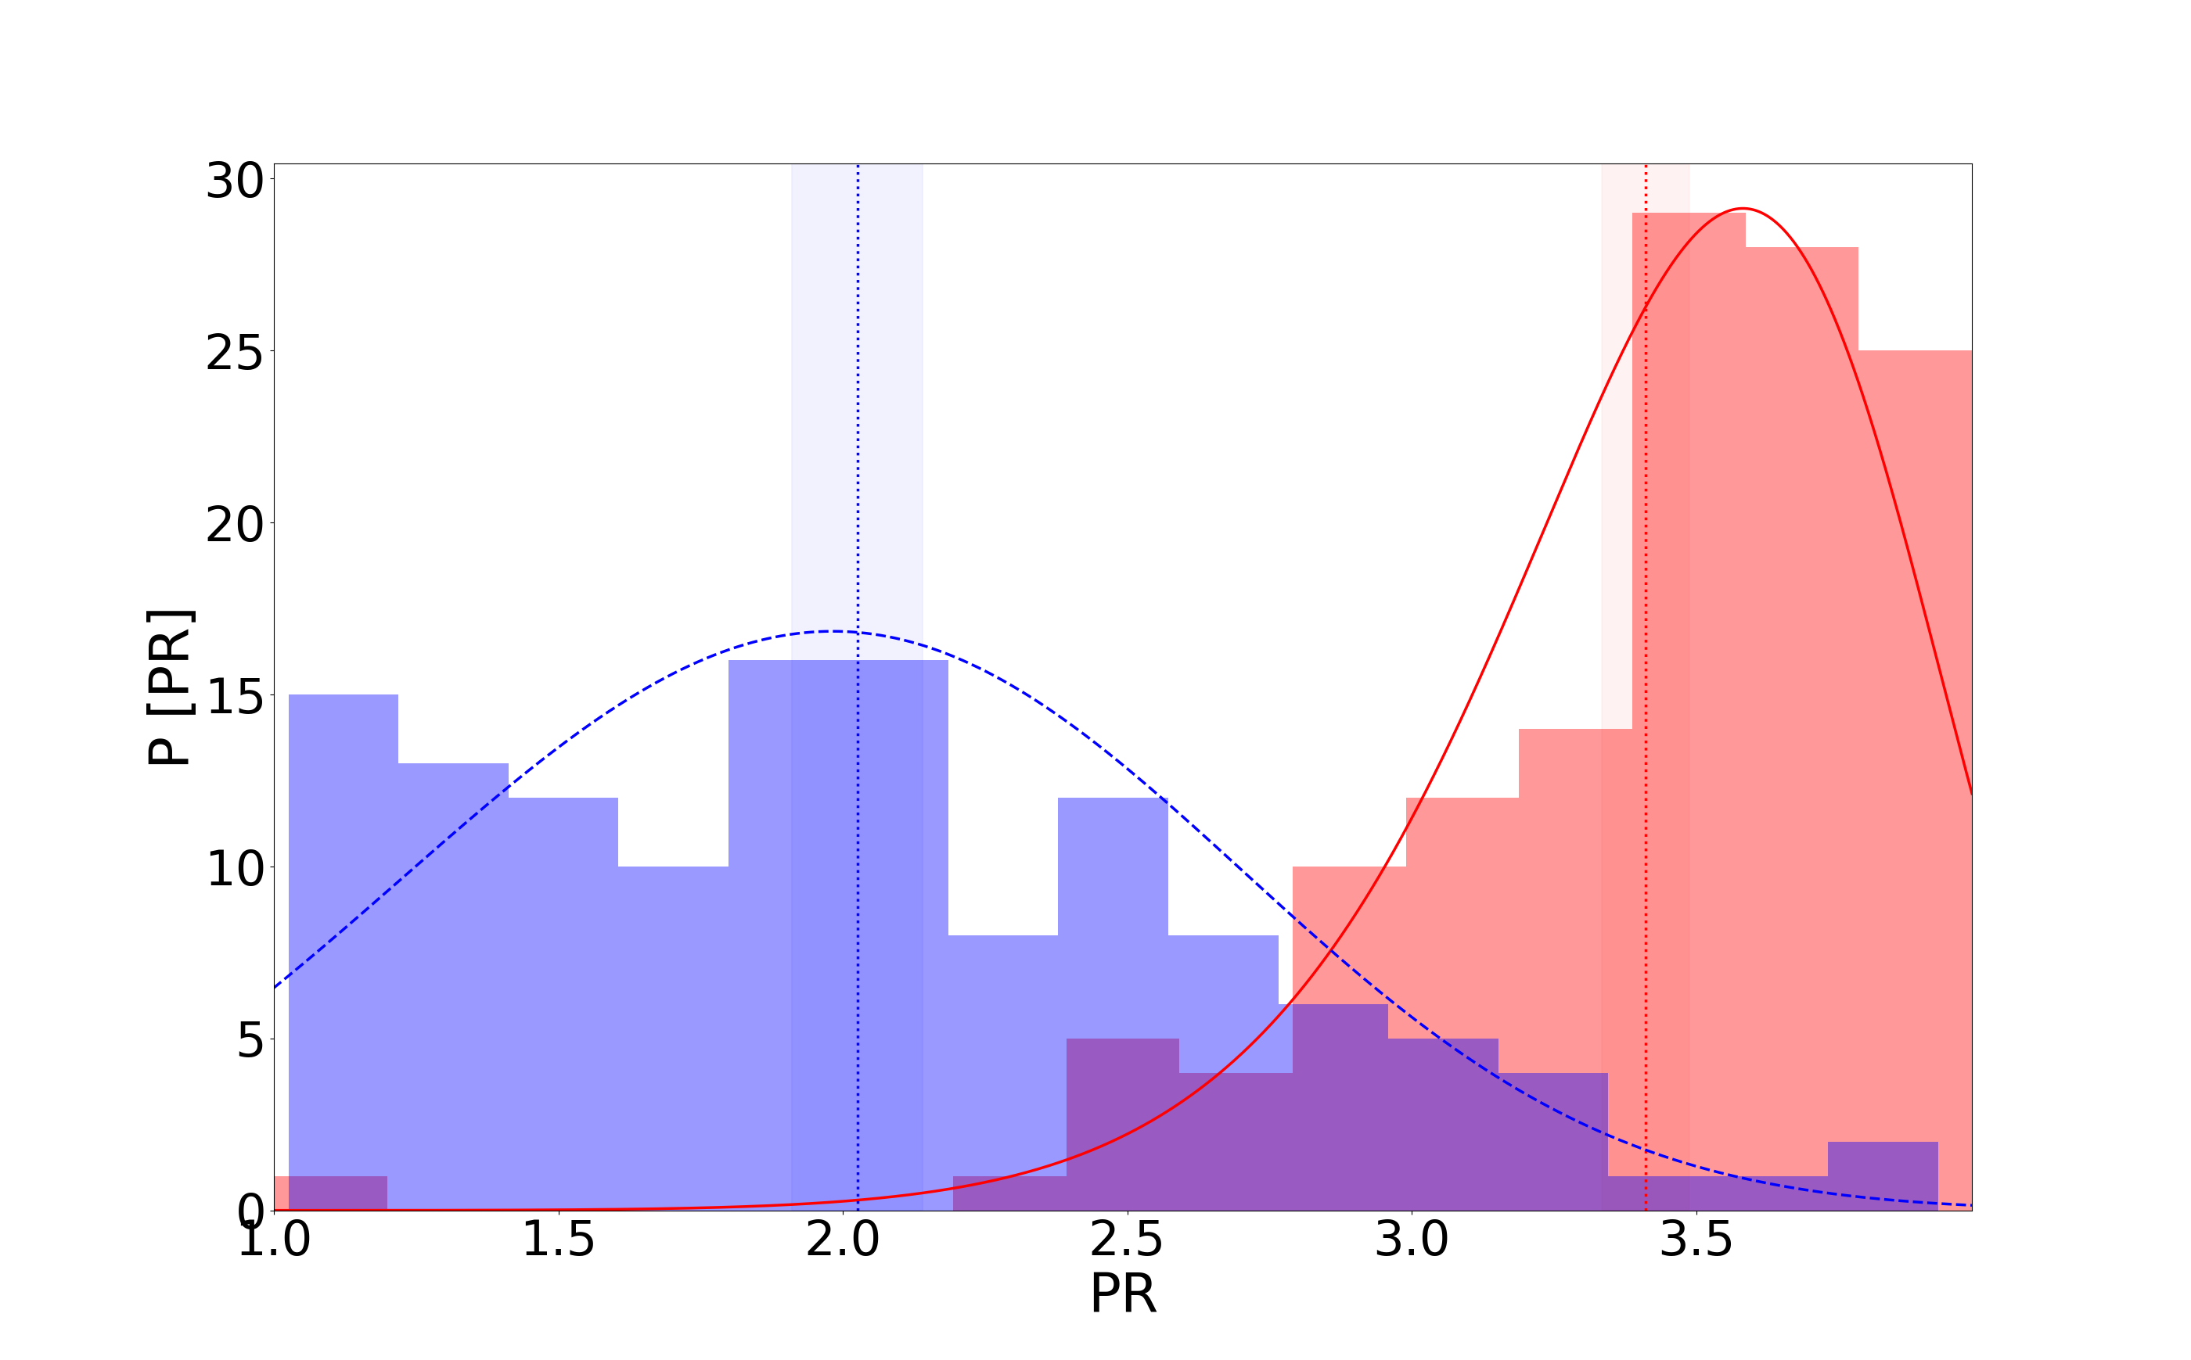

**Figure 8. Probability distribution functions of the participation ratios associated with the learning-styles basis set (red) and with the principal components (blue). The vertical dashed lines mark the average means along with their corresponding confidence intervals (shaded areas), whose values can be found in Table 11. The continuous lines show fitting functions given by Weibull distributions with parameters shown in Table 11.**

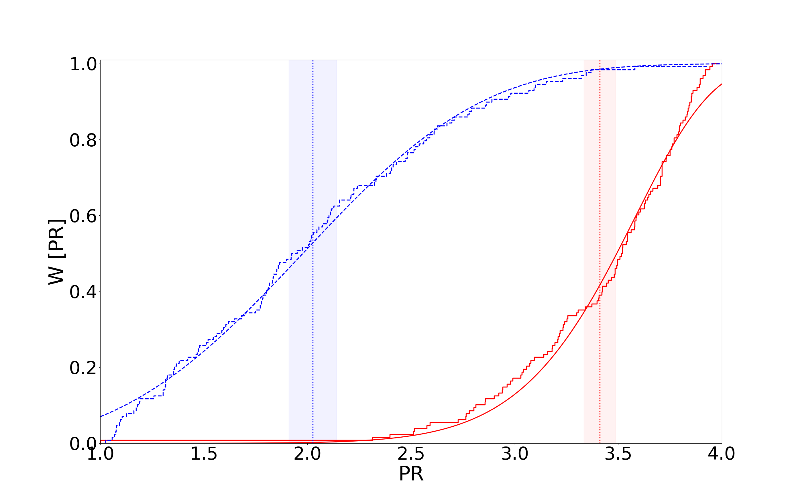

**Figure 9. Cumulative distributions for the results of Fig. 8.**

**Table 11. Average mean and corresponding uncertainty (in parenthesis) of the participation ratios for the learning-styles basis set and for the principal components. α and k are, respectively, the shape and scale parameters of the Weibull distributions the fit the probability distributions (histograms) of Fig. 8. The location parameter is set equal to θ = 0.**

|  |  |  |  |
| --- | --- | --- | --- |
| Basis set | Average mean (Uncertainty) | α | k |
| Learning styles | 3.41(0.07) | 3.62 | 10.62 |
| Principal components | 2.03(0.11) | 2.21 | 3.31 |